Worksheet — Energy Conservation Simulation
Use with Simulation - Energy conservation.html · energy stores, conservation of energy and the flying-spring practical (Block 10)
Biljana Taneska · Physics teacher · btaneska@vis.ac.at

Name: ______________________________ Class: ________ Date: _______________
How to use this worksheet  Scan the QR code or open school.taneski.com/physics/dp/20-energy-conservation/ in a browser (offline: Simulation - Energy conservation.html). Choose the example at the top: Ramp & track · Pendulum · Flying spring · Drop. Pick a preset in Example or set the values yourself (type a value and press Enter).  Press ▶ Start; ◂ / ▸ step through the motion. The middle column shows the free-body diagram and the energy stores (switch Energy chart to Sankey). The dashed total line on E–t stays flat: energy is conserved.  Part 1 before the lab (≈ 15 min) · Part 2 during the lab (≈ 20 min) · Part 3 homework (≈ 30 min). E_{k} = ½mv² · ΔE_{p} = mgΔh · E_{H} = ½kx². g = 9.81 N kg⁻¹. Answers to 3 s.f. with units. | Scan to open

Part 1 — Pre-lab: predict, then test
Question | My prediction (before) | What the simulation showed | Physics explanation
1. 🎳 A heavy ball on a rope is held against the teacher's nose and released (not pushed). On the way back, does it hit the nose?
2. Two smooth tracks drop 2.0 m: a steep curved one and a straight ramp. Which gives the higher speed at the bottom?
3. A 0.50 kg and a 3.0 kg ball are dropped from the same height (no air). Which hits the ground faster?
4. 🌀 A spring is stretched twice as far before it is released. How much higher does it fly?
5. 🛹 A skater in a half-pipe with a little friction: where does the 'lost' mechanical energy go? Does the total energy change?

6. Calculate the kinetic energy of a 0.50 kg ball moving at 4.0 m s⁻¹.
Working

7. Calculate the work needed to stretch a spring (k = 100 N m⁻¹) by 0.20 m.
Working

8. Calculate the GPE gained by a 3.0 kg bag lifted 2.0 m. Check: Drop → Retrieval: 3.0 kg bag.
Working

9. (exit question) A ball is dropped from 5.0 m. Use energy conservation to find its speed at the ground. Check: Drop → Exit question.
Working

Part 2 — During the lab
PASCO Smart Cart demo (lab 06): energy on a ramp. Simulation: Ramp & track → Class demo (0.500 kg, 1.00 m along a 6° ramp). Press ▶ Start, step to the bottom and copy the values. The grey row has the class data (Capstone sample).
run | GPE at release / J | KE at the bottom / J | v at the bottom / m s⁻¹ | √(2gh) / m s⁻¹ | energy 'lost' / % | average friction / N
simulation
class data | 0.513 | 0.483 | 1.39

10. Where did the 'lost' energy go? Draw a Sankey diagram to scale for the cart (switch Energy chart to Sankey to check).
Sankey diagram (scale: ______ = 0.1 J)

11. 🎳 Pendulum to the nose: run the hook demo with air resistance on, then 'The same pendulum in a vacuum'. How far short of the nose does it stop each time? Explain.
__________________________________________________________________________________________________
__________________________________________________________________________________________________
__________________________________________________________________________________________________
Flying spring (Oxford practical). ⚠ Safety glasses on. Stretch the spring by x, release it and measure the highest point h (three times). Simulation: Flying spring (10 g, k = 25 N m⁻¹); run 1.0–6.0 cm and ● Record each.
x / cm | x² / cm² | h₁ / cm | h₂ / cm | h₃ / cm | mean h / cm | h (simulation) / cm
1.0
2.0
3.0
4.0
5.0
6.0

12. Plot h against x² and draw the best-fit line. Use the gradient to find k (gradient = k/2mg; for x in cm and h in cm, k = 2mg × gradient × 100).
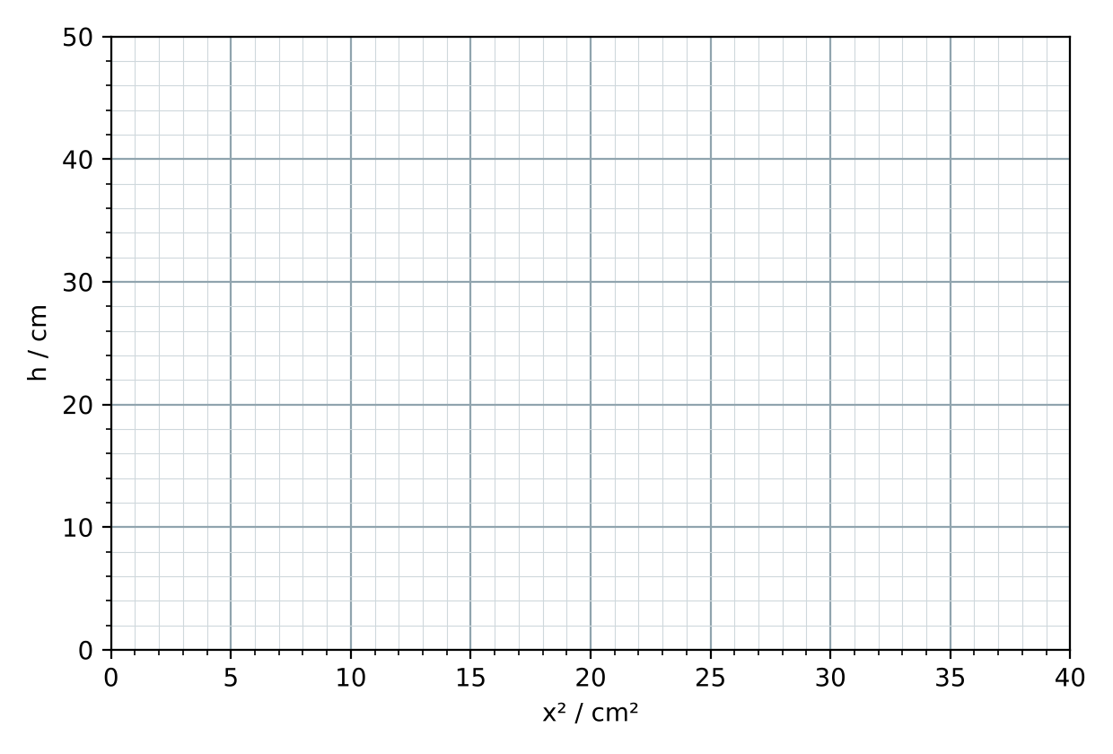
Working

Part 3 — Homework
13. A frictionless roller coaster drops 20 m from rest. Calculate its speed at the bottom.
Working

14. A pendulum 2.0 m long is released from 30° to the vertical. Calculate the height it falls through and its speed at the bottom (no air resistance).
Working

15. Flying spring: 10 g, k = 25 N m⁻¹, stretched 4.0 cm. Calculate the height it reaches (no losses).
Working

16. A real spring loses 30 % of its elastic energy as vibration and sound when it is released. Will the k from your h–x² gradient be correct, too big or too small? By how much?
__________________________________________________________________________________________________
__________________________________________________________________________________________________
__________________________________________________________________________________________________
17. A 0.50 kg cart is released from 0.30 m and reaches the bottom at 2.2 m s⁻¹. What percentage of its GPE was dissipated? Where did it go?
Working

18. In the simulation, double the mass of the Smart Cart (friction μ unchanged). Does its speed at the bottom change? Explain using energy.
__________________________________________________________________________________________________
__________________________________________________________________________________________________
__________________________________________________________________________________________________

