Worksheet — Hanging on Two Threads Simulation
Use with Simulation - Hanging on two threads.html · one mass on two threads tied to two fixed supports · equilibrium of three forces (Blocks 3–4)
Biljana Taneska · Physics teacher · btaneska@vis.ac.at

Name: ______________________________ Class: ________ Date: _______________
How to use this worksheet  Scan the QR code or open school.taneski.com/physics/dp/24-hanging-two-threads/ in a browser (offline: Simulation - Hanging on two threads.html). Choose an example at the top: 🧪 Lab · 🐦 Bird · 🚶 Walker · 🏮 Lantern · 🚦 Traffic · 🪧 Sign · 🧺 Washing. The Example list has more set-ups for each one. Set m, θ_{L}, θ_{R} and the thread with ▼ ▲ or type a value. Press ▶ Let go: the mass hangs at rest, or a thread snaps.  Part 1 before the lab (≈ 15 min) · Part 2 during the lab (≈ 25 min) · Part 3 homework (≈ 30 min). g = 9.81 N kg⁻¹. Answers to 3 s.f.  Angles θ_{L} and θ_{R} are measured below the horizontal. At rest: T_{L} cos θ_{L} = T_{R} cos θ_{R} and T_{L} sin θ_{L} + T_{R} sin θ_{R} = mg. |   Scan to open

Part 1 — Pre-lab: predict, then test
Question | My prediction (before) | What the simulation showed | Physics explanation
1. 🧪 A 2.0 kg mass hangs from the middle of two threads, each at 30° below the horizontal. Is the tension in each thread half the weight, equal to the weight or more than the weight?
2. 🧪 You make both threads flatter (smaller θ). Does the tension increase, decrease or stay the same?
3. 🧪 Can the threads be pulled perfectly straight (θ = 0°) with the mass still hanging on them?
4. 🐦 A 30 g bird lands on a cotton thread (breaks above 20 N) pulled almost straight: 0.4° each side. Does the thread hold?
5. 🚦 A traffic light hangs from cables at 30° (left) and 60° (right). Which cable has the larger tension?
6. 🚶 A tightrope walker stands near the left end: 12° on the left, 3° on the right. Which part of the wire has the larger tension — by a lot or a little?

7. Calculate the tension in each thread when a 2.0 kg mass hangs at 10° on both sides. Check: 🧪 Lab → Example 2.0 kg, both threads at 10°.
Working: FBD of the mass → ΣF_{y} = 0

Part 2 — During the lab: a string between two stands
Apparatus: two clamp stands with bosses (same height), strong string, two newton meters (0–10 N), 500 g mass hanger, protractor, metre rule.
Method: tie the string between the stands with a newton meter in each half; hang the 500 g mass from the middle. Move the stands apart or together to change the angle. Measure each angle below the horizontal with the protractor and read both newton meters.
⚠ Safety: keep feet away from under the mass; clamp the stands to the bench (or hold the bases) — they are pulled towards each other. Do not go below about 10°: the readings rise very fast and can go off the newton-meter scale.

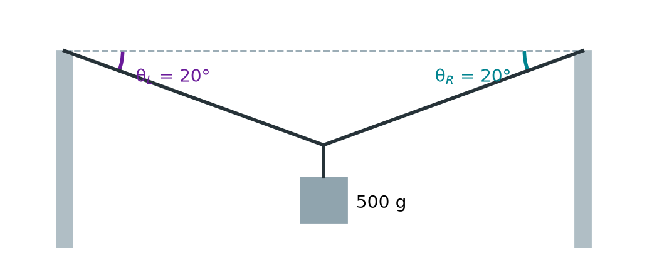
8. Calculate the tension at 20° — what each newton meter should read. Check: 🧪 Lab → 500 g on cotton thread, 20°.
Working

Results (m = 0.500 kg, same angle on both sides). Theory: T = mg / (2 sin θ).
θ / ° | left reading / N | right reading / N | mean T / N | T from theory / N | 1 / sin θ
60
45
30
20
10

9. Cotton thread breaks above 20 N. Calculate the smallest angle at which it can still hold the 500 g mass. Test it in the sim 1° above and 1° below.
Working: 2T sin θ = mg

10. Set 20° on the left and 50° on the right (500 g). Calculate T_{L} and T_{R}, then compare with the newton meters and the sim (500 g, angles 20° and 50°).
Working: ΣF_{x} = 0 and ΣF_{y} = 0

11. Explain why the newton-meter readings rise so much when the string is nearly straight.
Explanation

Part 3 — Homework: analyse
12. 🧪 Lab → 1.0 kg, unbreakable. Set θ = 10°, 20°, 30°, 45°, 60° and 80° (same both sides), press ▶ Let go and ● Record each one. Plot T against 1/sin θ on the grid, draw the best-fit line and find its gradient. Use it to find the mass (gradient = mg/2).
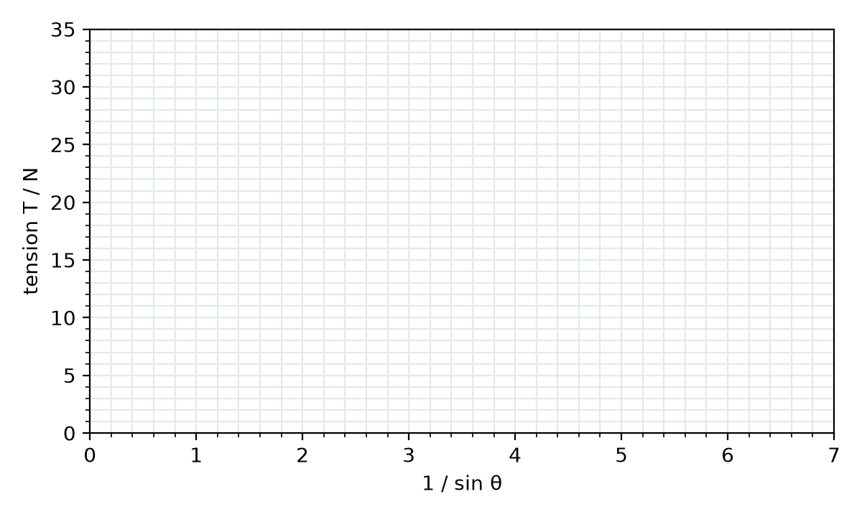
Gradient and mass

13. 🚶 A 70 kg tightrope walker makes the wire dip 5.0° on each side. Calculate the tension in the wire and how many times the walker's weight it is.
Working

14. 🚶 A nylon cord breaks above 2.0 kN. Calculate the smallest angle at which it could hold the 70 kg walker.
Working

15. 🚦 A 15 kg traffic light hangs from two cables at 30° (left) and 60° (right) below the horizontal. Calculate the tension in each cable.
Working: FBD → ΣF_{x} = 0 and ΣF_{y} = 0 (or a vector triangle)

16. 🐦 A 30 g bird sits in the middle of a wire that dips 3.0° on each side. Calculate the tension in the wire.
Working

17. 🏮 A 2.0 kg lantern hangs from the middle of a string; each half makes 40° with the horizontal. Calculate the tension.
Working

18. 🪧 (Problem set Q19) A 15 kg sign hangs from two cables, each at 40° to the horizontal. Calculate the tension in each cable.
Working

19. 🧺 3.0 kg of wet washing hangs in the middle of a line pulled tight (4° each side). Fishing line breaks above 100 N. (a) Show that the line snaps. (b) Calculate the smallest angle the line may make with the horizontal.
Working

