Advanced Big Data Analytics
Project 2: Mobile Money Investigations with PostgreSQL and Neo4j
Adventist University of Central Africa (AUCA), Kigali

Member | Student ID
BIZIMUNGU Theoneste | 101398
NIYITANGA Eric | 101393
NDASHIMYE Janvier | 101363

Submitted 26 October 2026
Code and raw results: https://github.com/bibabbly/auca-abda-p2-mobile-money

Summary
- September 2026 data (20,993,500 records, 20,003,300 transfers) captured from the unchanged generator, loaded into PostgreSQL 18.4 and Neo4j 2026.10.1 Community; all counts and audit totals reconcile.
- Q1–Q7 implemented as SQL/Cypher pairs; all 61 cases return identical answers in both databases, confirmed again by two checks recomputed directly from the CSV files.
- PostgreSQL is faster for indexed lookups (Q1/Q3/Q5/Q6: 0.4–3 ms vs 5.5–8.4 ms). Neo4j is faster for deep traversals (Q4 depth 10: 4–6 ms vs 23 ms; Q7: 8–14 ms).
- Plain recursive SQL for Q7 bound 6 timed out (>60 s); a bidirectional SQL rewrite gives the same answers in ≈80 ms, so most of that gap was the algorithm, not the model.
- Under concurrent load both engines saturate the 8 CPU threads at 8 clients; Neo4j delivered 12–32× higher throughput for Q4/Q7 on this machine.
- Investigate A (998), B (147228) and C (206978) before D, E, F: same device and network profile, but only A–C show rapid onward chains and/or circular payments.

1 Capture the data

1.1 Workspace
Item | Value
CPU / RAM / OS | Intel Core i7-1165G7 (4 cores, 8 threads) / 34.1 GB / Windows 11 Pro 10.0.22631
PostgreSQL | 18.4, database mobile_money, TimeZone Africa/Kigali; shared_buffers 8 GB, effective_cache_size 18 GB, work_mem 64 MB, maintenance_work_mem 2 GB, max_wal_size 8 GB
Neo4j | 2026.10.1 Community, default neo4j database; heap 8 GB, page cache 10 GB, transaction memory 6 GB; Java 21.0.11
Python / drivers | Python 3.13.6; psycopg 3.3.6 (libpq 18.0.4); neo4j 6.4.1; numpy 2.5.4; pandas 3.1.0; matplotlib 3.11.2
Generator | mobile_money_generator.py unchanged, SHA-256 2ea0e59d…9455a

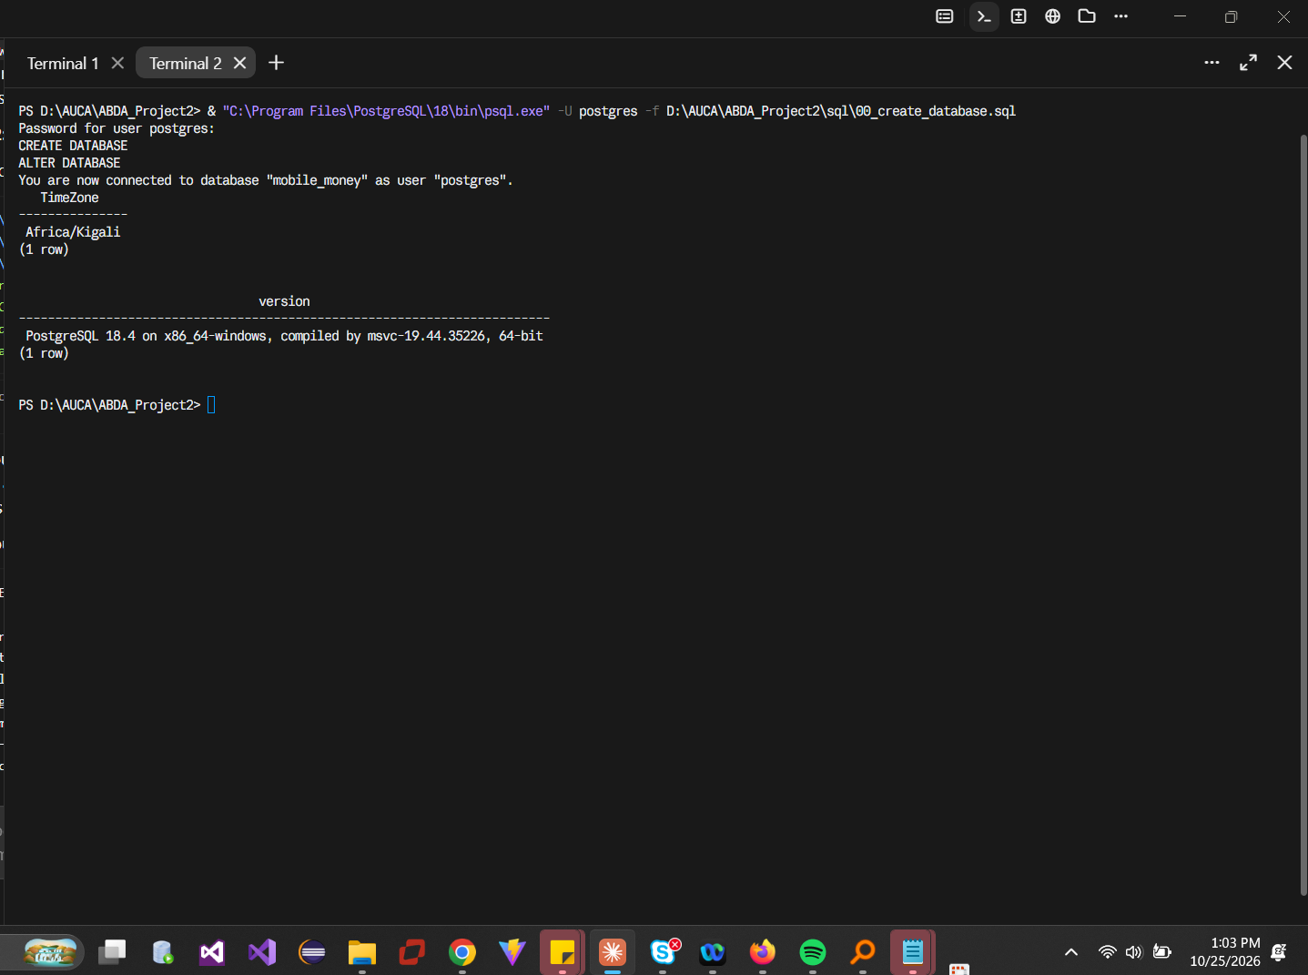
Figure 1. PostgreSQL database created with time zone Africa/Kigali.
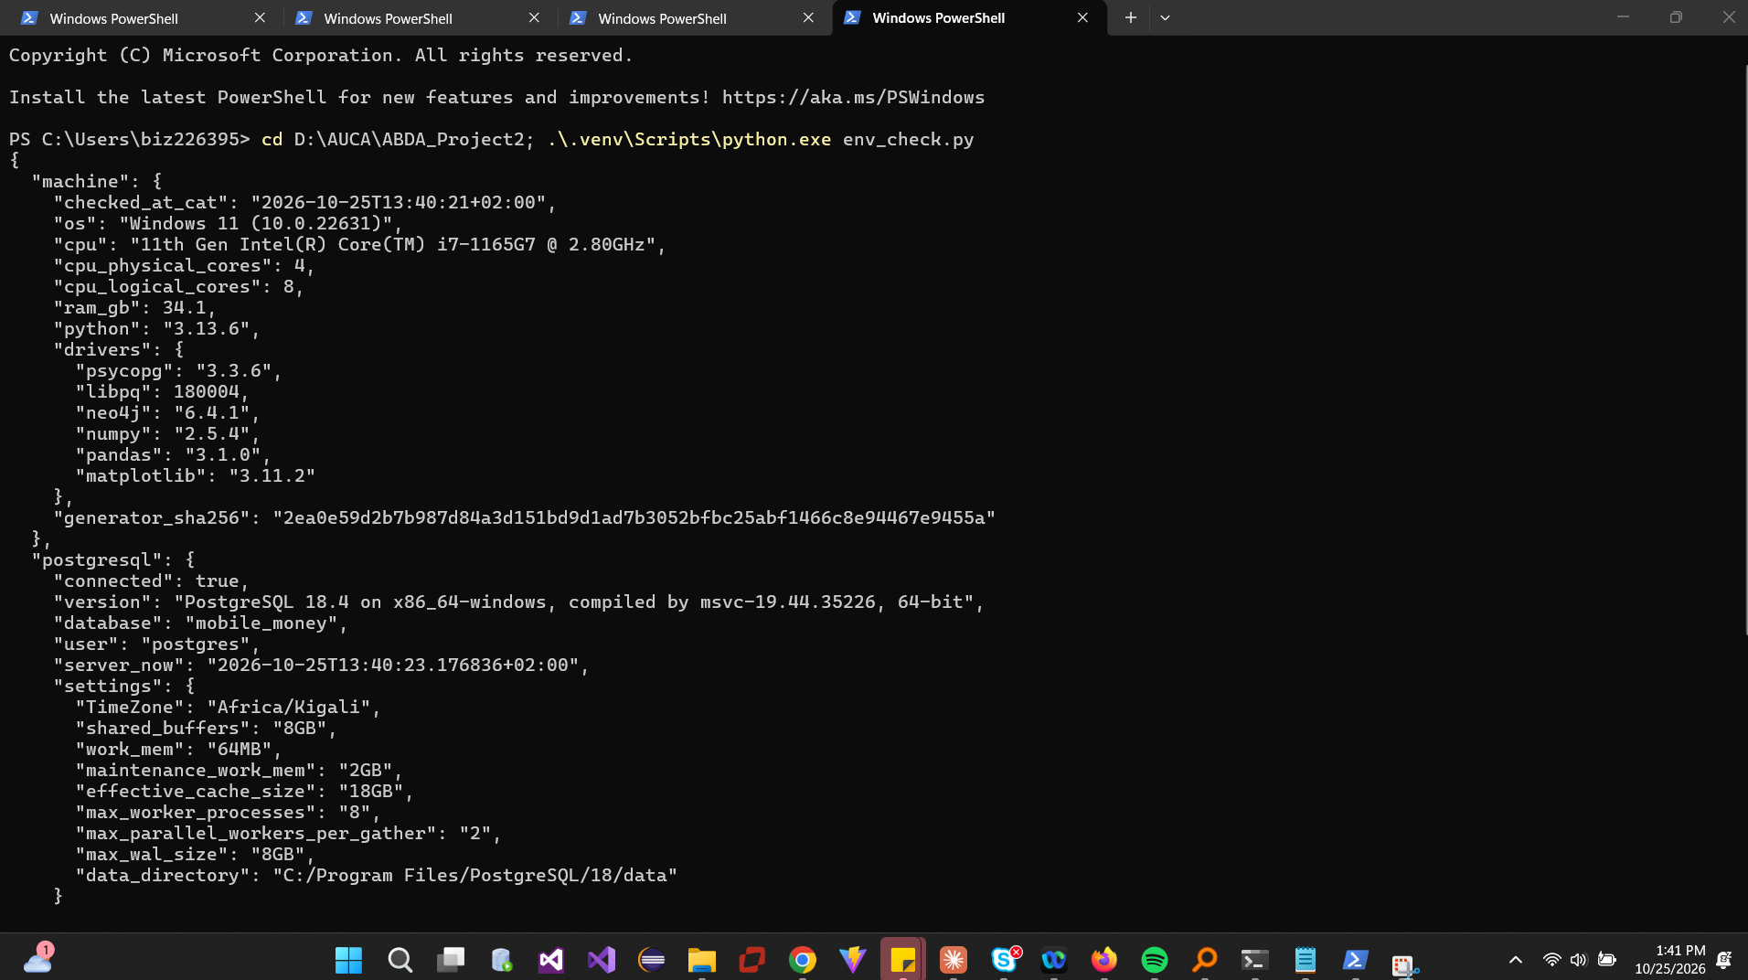
Figure 2. env_check.py: machine, drivers, PostgreSQL settings.
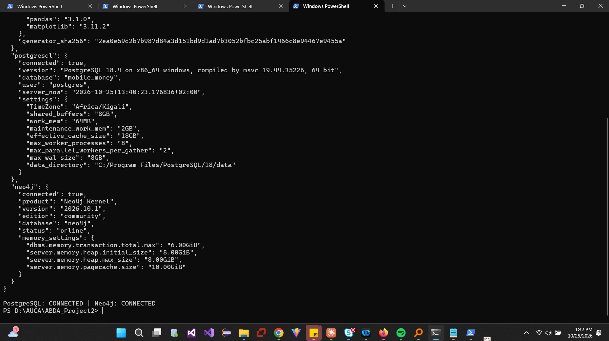
Figure 3. env_check.py: Neo4j version and memory settings; both connections succeed.

1.2 capture.py
capture.py imports the generator as g, previews ten records per stream with itertools.islice, and streams each iterator straight into csv.DictWriter, counting consumed and written rows. The full stream is never held in memory. Transfer audit totals are accumulated while writing.
Stream | Written | Expected | Status | Seconds | CSV GB
customers | 228,000 | 228,000 | OK | 0.5 | 0.004
accounts | 248,000 | 248,000 | OK | 0.5 | 0.005
devices | 228,600 | 228,600 | OK | 0.3 | 0.004
account_devices | 285,600 | 285,600 | OK | 0.7 | 0.006
transfers | 20,003,300 | 20,003,300 | OK | 81.7 | 0.780
TOTAL | 20,993,500 | 20,993,500 | OK | 83.8 | 0.799

Transfer audit: count 20,003,300; earliest 1788235200 (2026-09-01T06:00:00 CAT); latest 1790798399 (2026-09-30T21:59:59 CAT); sum amount_rwf 231,482,327,870 RWF.
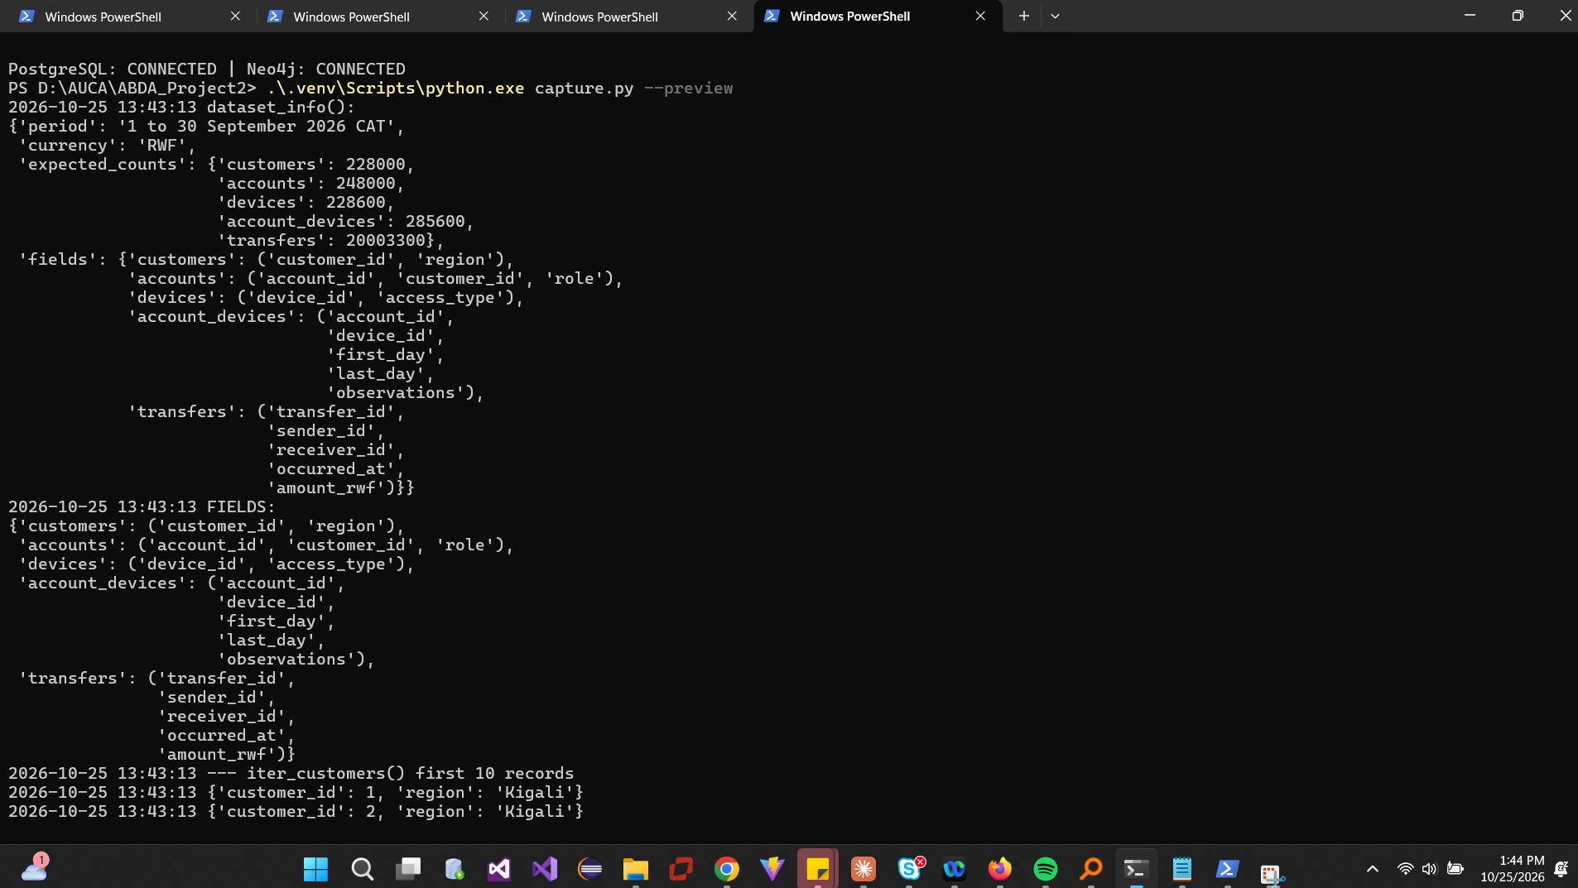
Figure 4. Preview: dataset_info() and FIELDS.
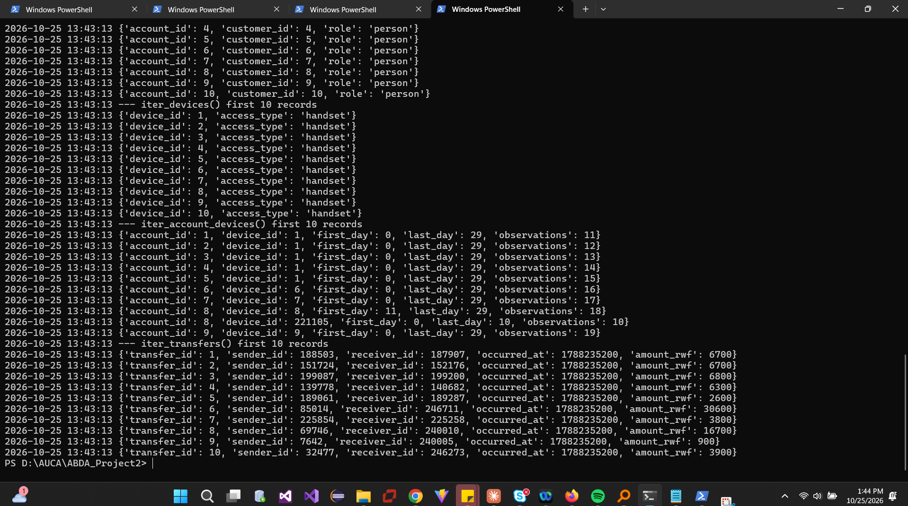
Figure 5. Preview: first ten records of each stream.
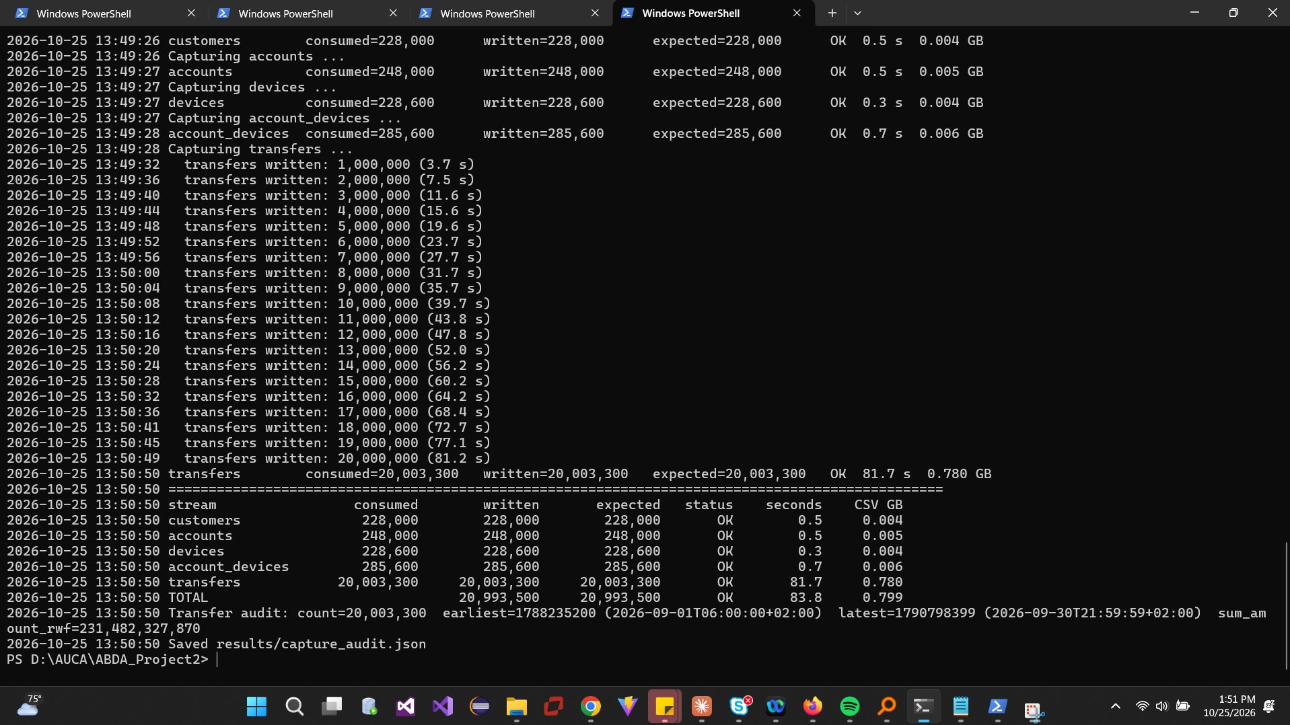
Figure 6. Completed five-stream capture with counts, timings, CSV sizes and audit totals.

2 Build PostgreSQL

2.1 Five tables
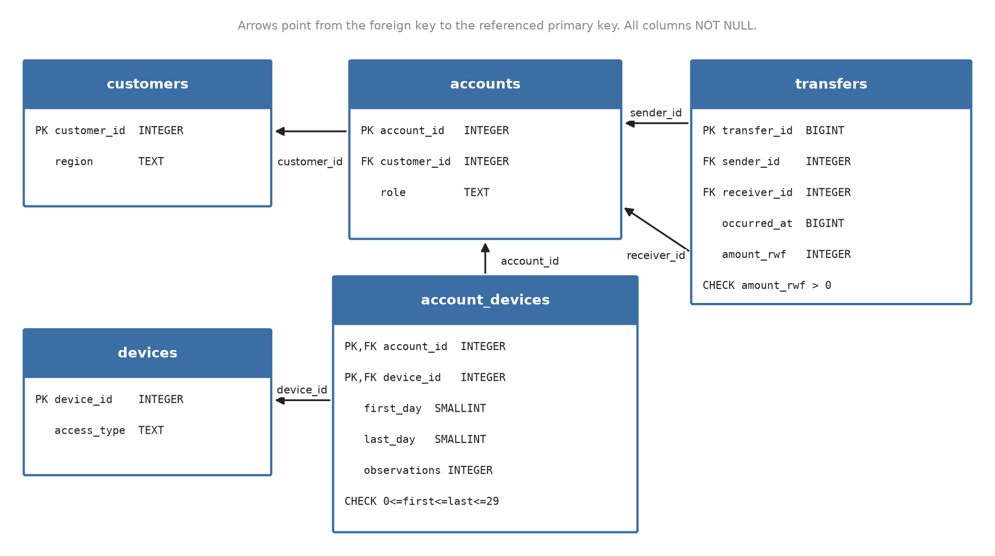
Figure 7. PostgreSQL schema: primary keys, foreign keys and checks.
Field | Meaning and unit
customer_id / region | Customer identifier; home region (Kigali, Northern, Southern, Eastern, Western)
account_id / role | Wallet identifier; person (1–240,000), merchant (240,001–246,000), agent (246,001–248,000)
device_id / access_type | Device identifier; handset or public_terminal
first_day / last_day | Inclusive observation days, 0 = 1 Sep 2026 CAT, 29 = 30 Sep (SMALLINT)
observations | Count of sightings of the account on the device within the interval
transfer_id | Unique payment event (BIGINT)
sender_id / receiver_id | Paying and receiving wallets (FKs to accounts)
occurred_at | Unix epoch seconds (BIGINT); displayed in CAT = UTC+02:00
amount_rwf | Whole Rwandan francs, > 0 (INTEGER)

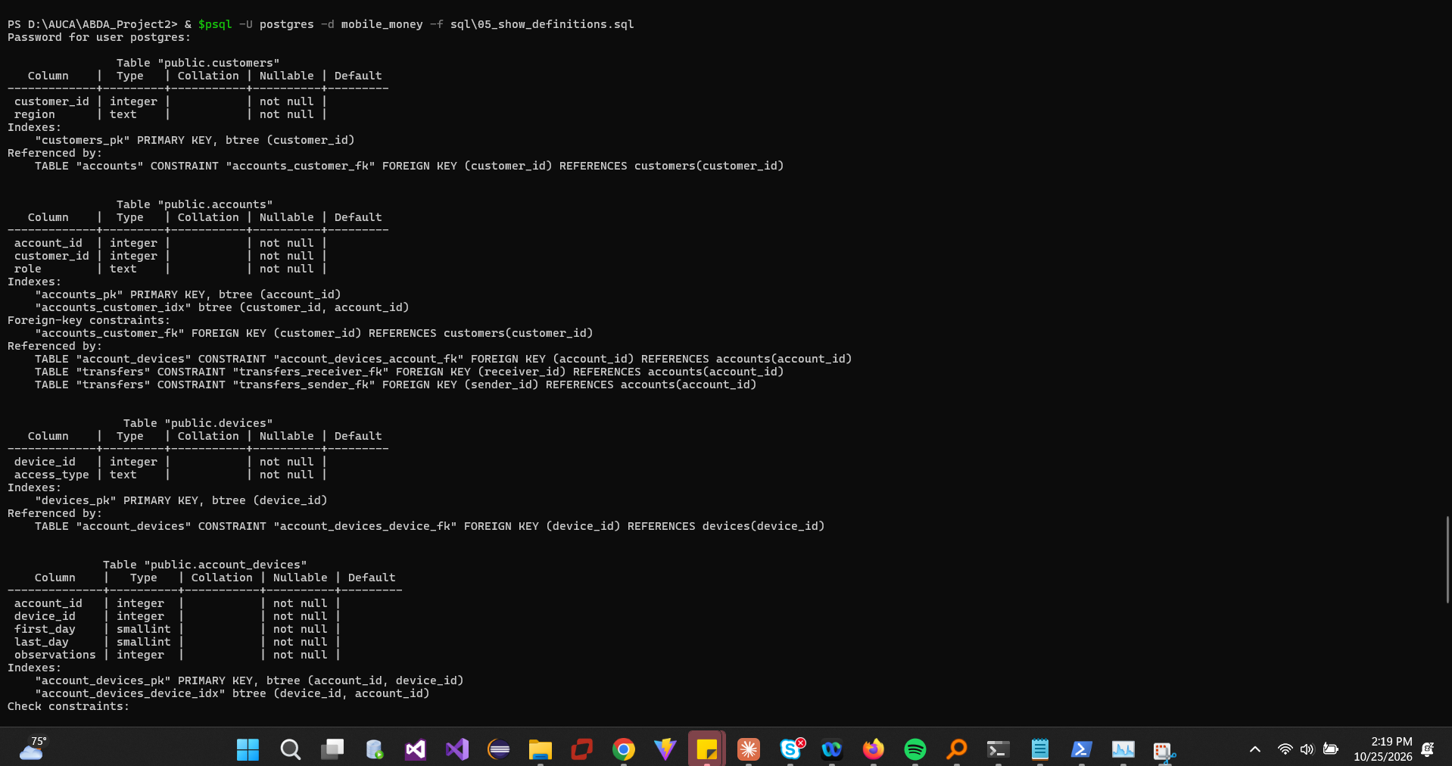
Figure 8. Table definitions (\d).
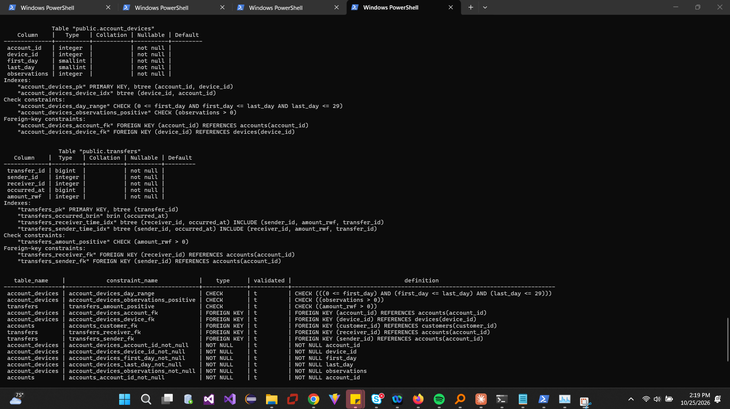
Figure 9. Table definitions, indexes and foreign keys.
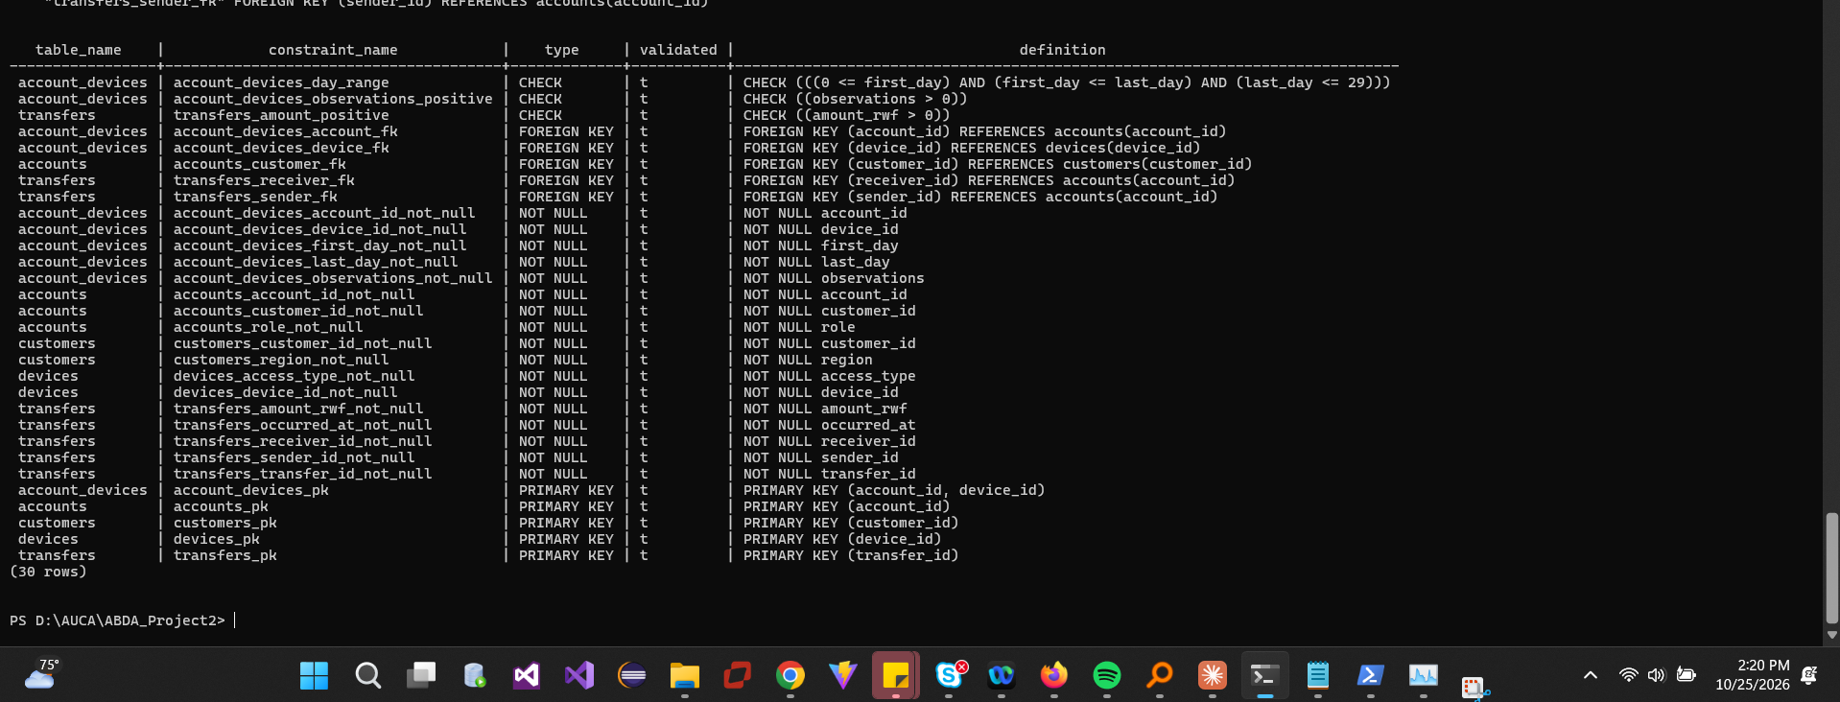
Figure 10. All constraints validated.

2.2 Bulk load and checks
Tables were created with NOT NULL columns only, loaded with \copy (customers and devices, then accounts, account_devices, transfers), and only then given keys, foreign keys, checks, indexes and ANALYZE, so load and setup times are separate.
Step | Seconds
\copy load (5 files) | 34.6
Keys, FKs, checks, 5 indexes, ANALYZE | 96.8
Total | 131.4

Counts, transfer audit totals and roles (240,000 / 6,000 / 2,000) all match capture.py; 13 constraints validated; 17/17 columns NOT NULL. Size: data 1.250 GB, indexes 2.468 GB, database 3.727 GB (1 GB = 10^9 bytes). The two covering transfer indexes are ≈ 0.99 GB each.
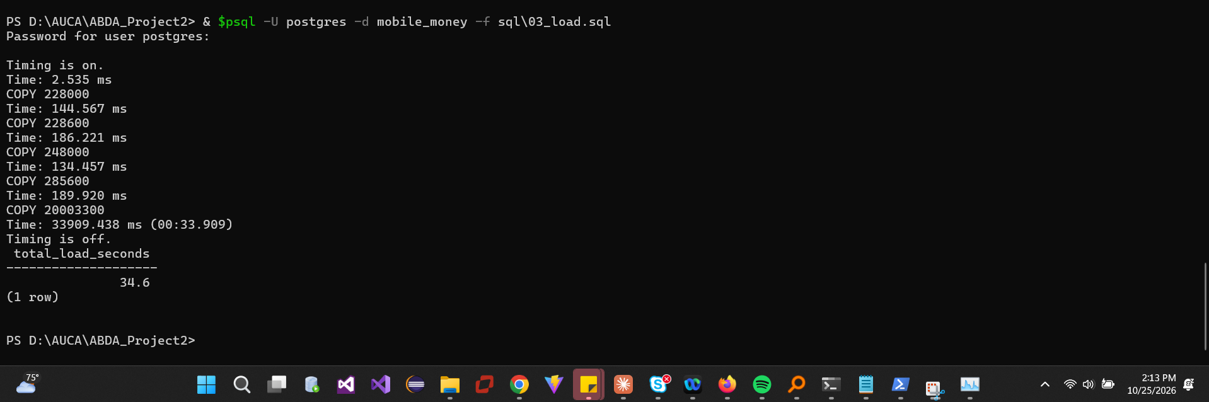
Figure 11. \copy load with per-file timings: 34.6 s.
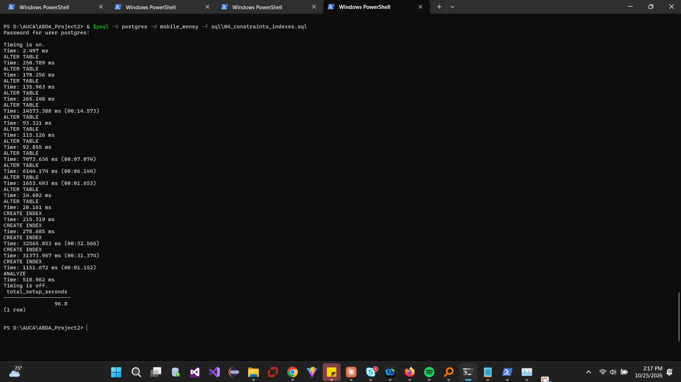
Figure 12. Constraints, indexes and ANALYZE: 96.8 s.
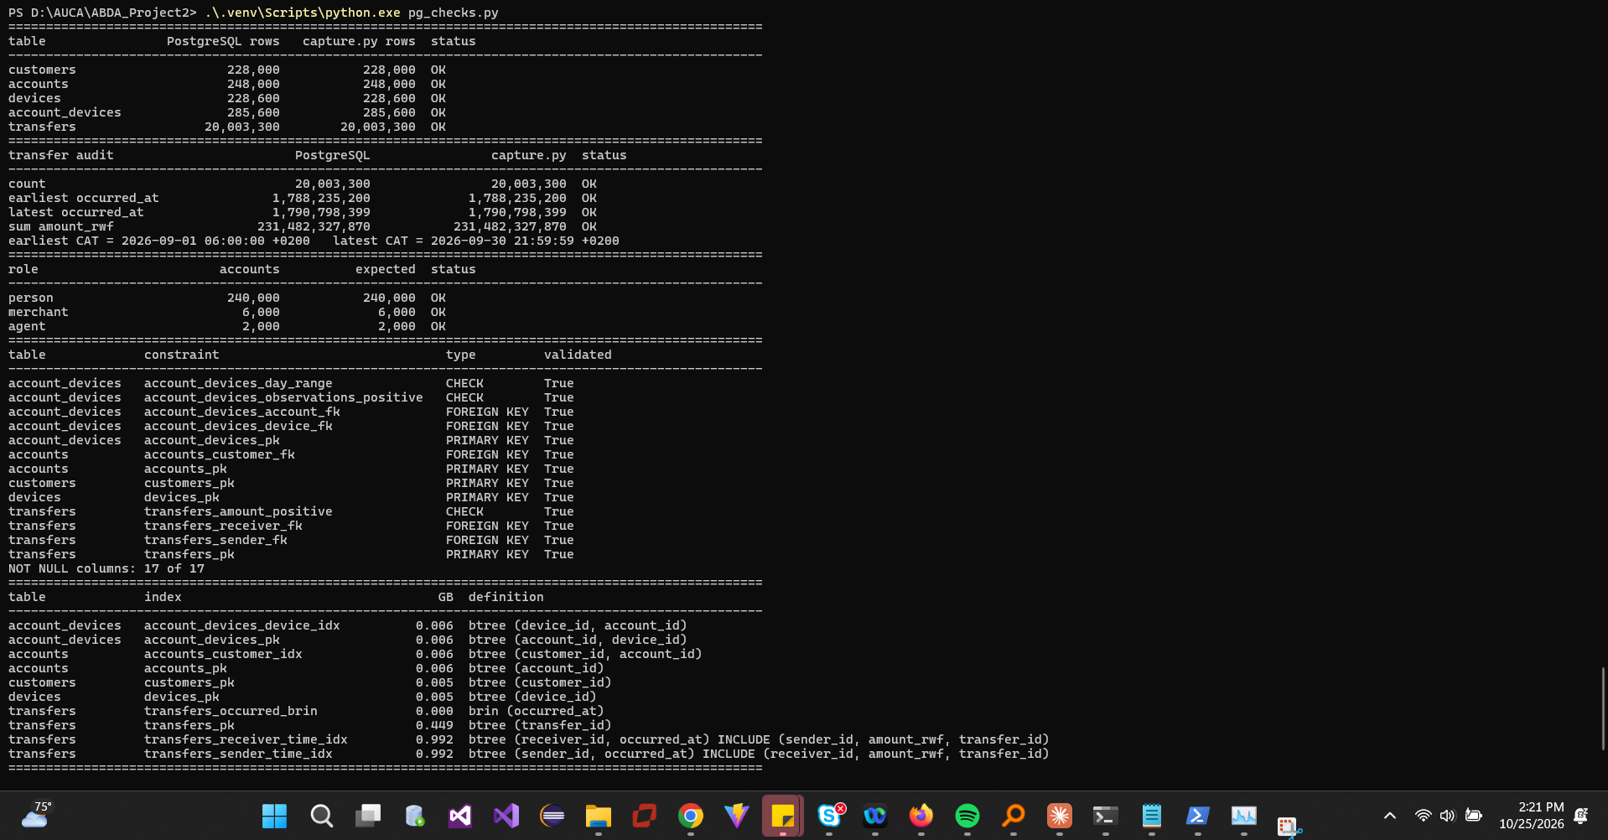
Figure 13. pg_checks.py: counts, audit totals, roles, constraints, indexes.
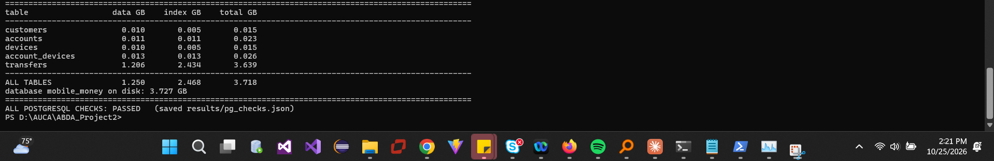
Figure 14. pg_checks.py: data/index sizes and PASSED.

3 Build Neo4j

3.1 Graph model
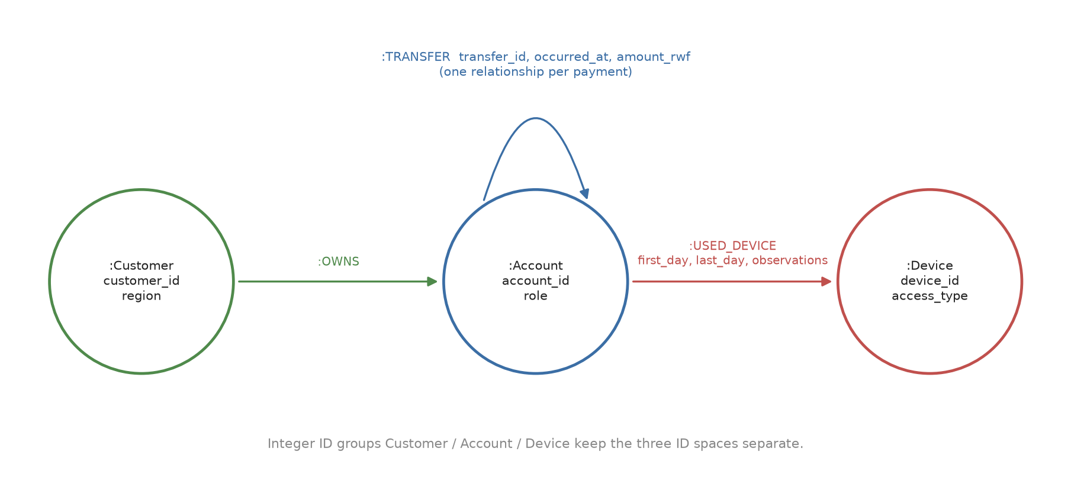
Figure 15. Graph schema: Customer, Account, Device nodes; OWNS, USED_DEVICE, TRANSFER.
Source field | Graph element
customers.customer_id, region | :Customer {customer_id, region}
accounts.account_id, role | :Account {account_id, role}
accounts.customer_id | (:Customer)-[:OWNS]->(:Account) (ignored on the node)
devices.device_id, access_type | :Device {device_id, access_type}
account_devices.* | (:Account)-[:USED_DEVICE {first_day, last_day, observations}]->(:Device)
transfers.* | (:Account)-[:TRANSFER {transfer_id, occurred_at, amount_rwf}]->(:Account), one per row

3.2 Import
prepare_import.py writes temporary copies with typed headers (ID groups Customer, Account, Device; :int/:long numbers) and derives owns.csv in (customer_id, account_id) order; the source CSVs are unchanged. neo4j-admin database import full ran with --id-type=integer, three node and three relationship files.
Measure | Value
Offline import | 58.1 s
Constraints + range index online | 31.7 s
Store size | 2.049 GB
Transaction logs | 0.000 GB
Nodes / relationships | 704,600 / 20,536,900 (all checks passed)

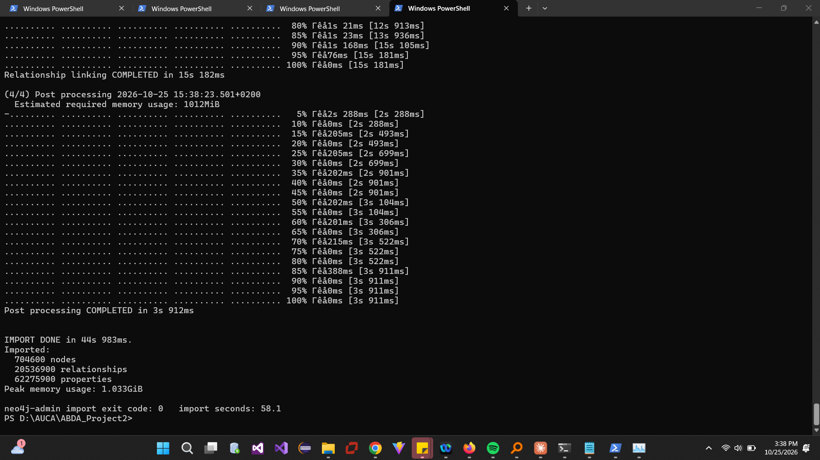
Figure 16. neo4j-admin full import completed.
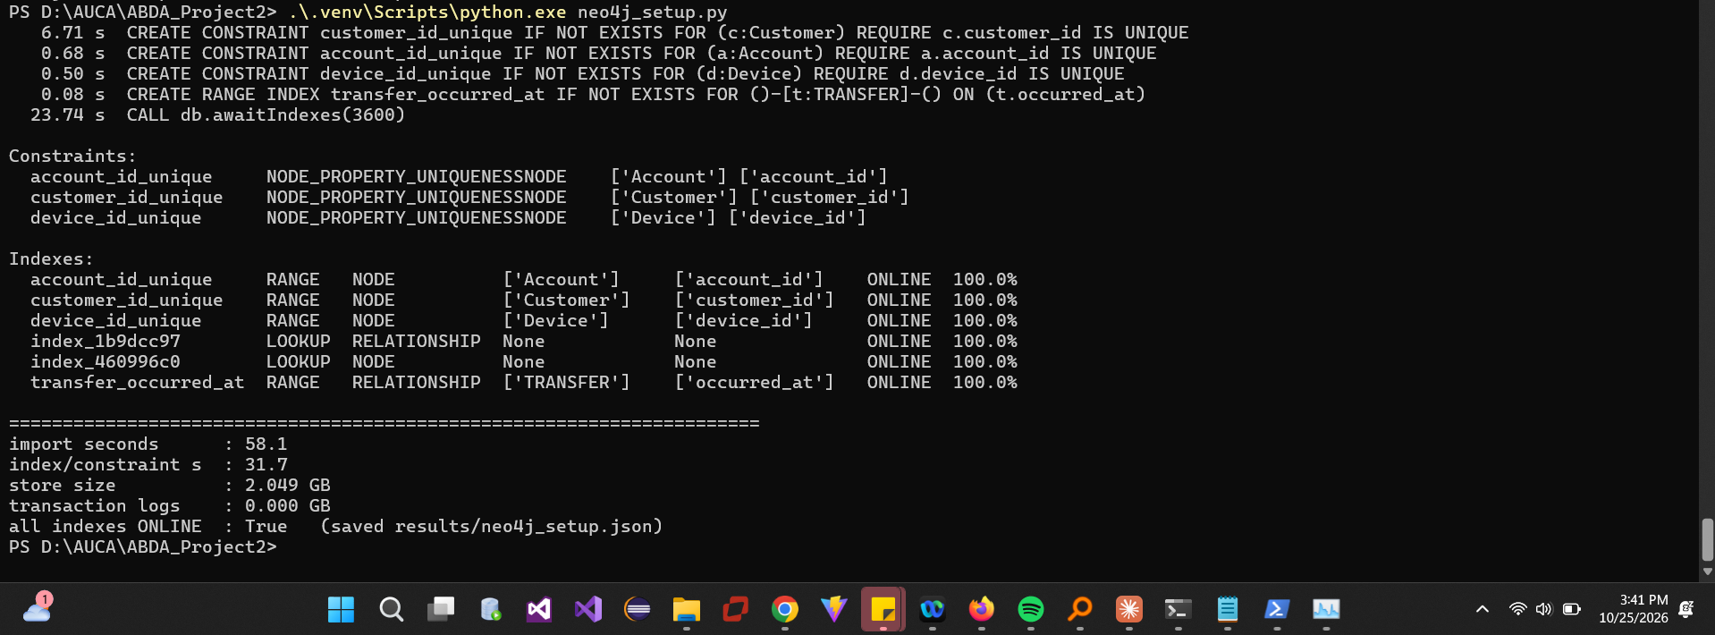
Figure 17. Unique constraints and TRANSFER.occurred_at range index online; store and log sizes.
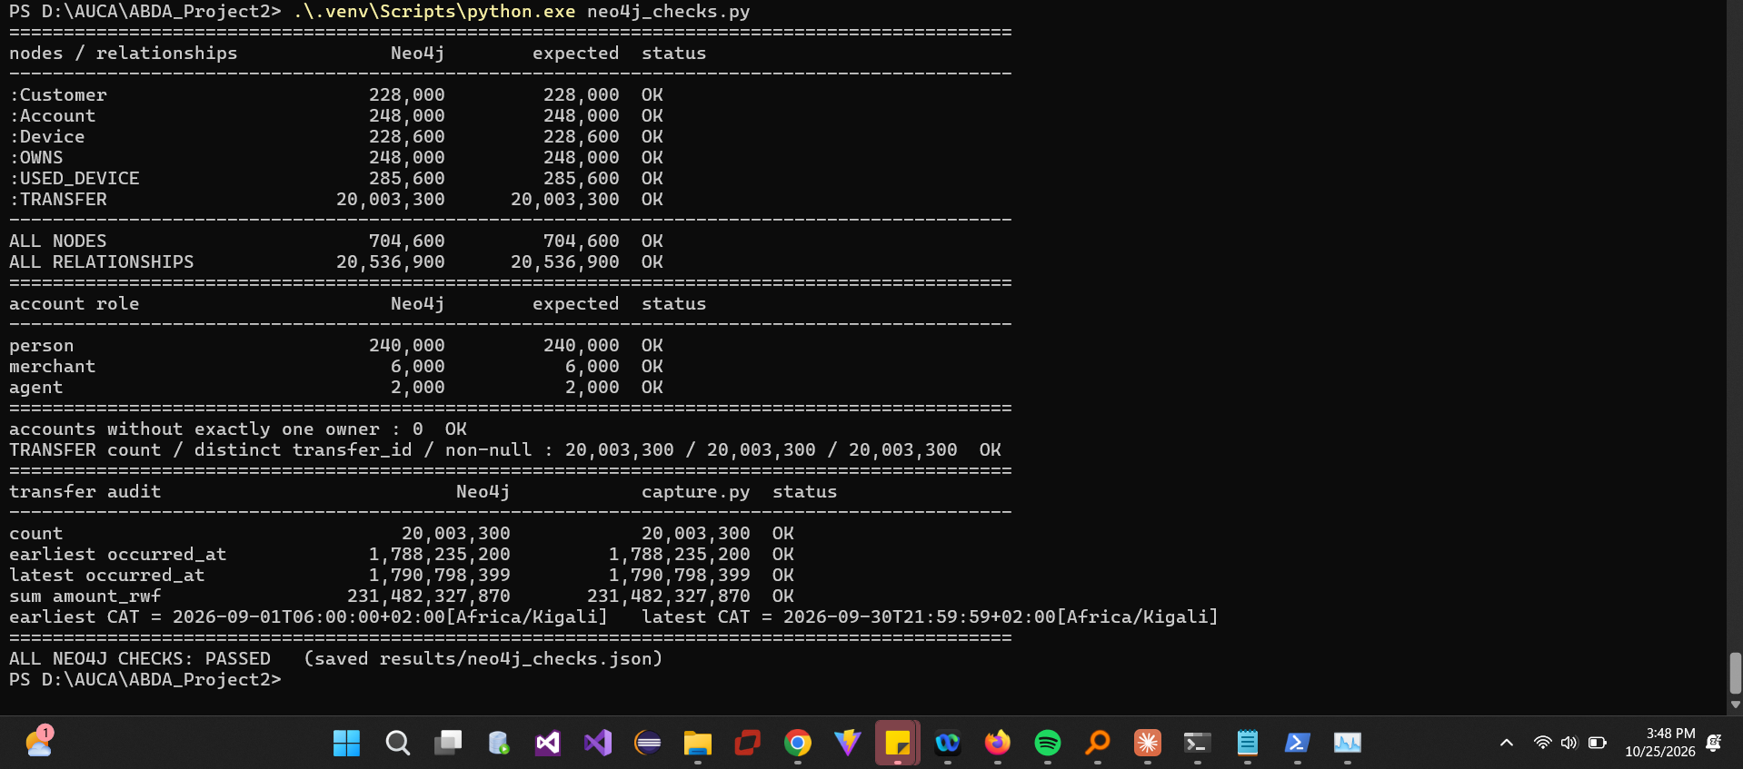
Figure 18. Node/relationship counts, roles, one owner per account, unique transfer_id, audit totals.
Figure 19. Temporary import copies removed.

3.3 One account in both models
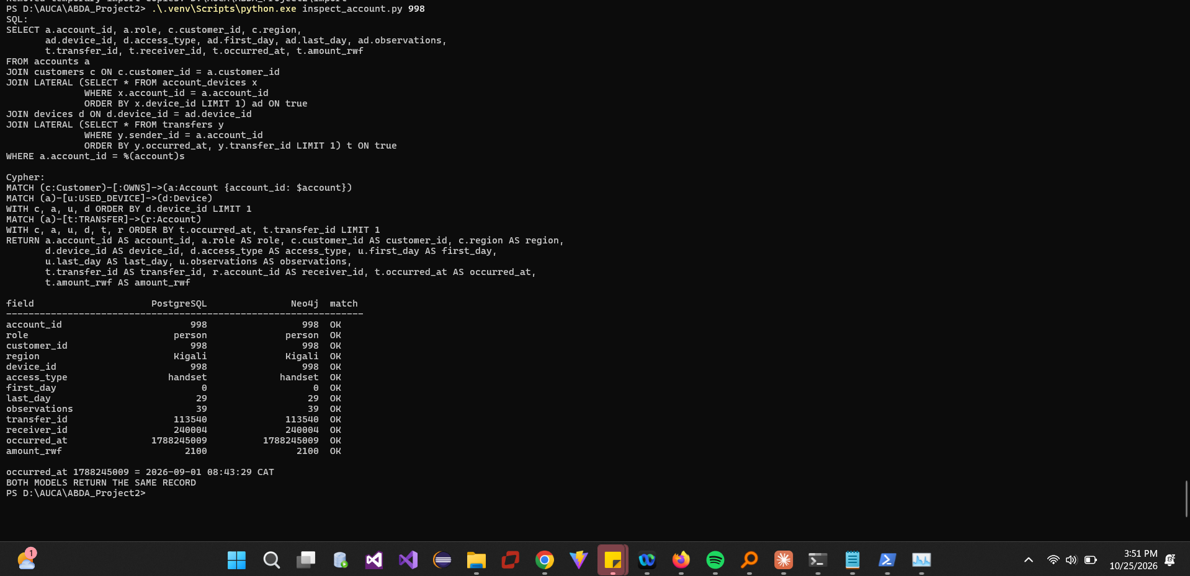
Figure 20. Account 998 traced to its owner, a device and an outgoing transfer: identical in SQL and Cypher.
A foreign key stores the other row's key and must be joined at query time; in the graph the same fact is a stored relationship, so accounts.customer_id becomes OWNS and account_devices becomes USED_DEVICE with its interval as properties. If repeated payments between two accounts were collapsed into one edge, each payment's transfer_id, occurred_at and amount_rwf would be lost (or reduced to a count/sum), so Q1 hourly totals, the time-ordered chains of Q5 and the cycles of Q6 could no longer be evaluated.

4 Routine business questions
Review hour: 09:45:00 inclusive to 10:45:00 exclusive CAT on each set's date, converted to epoch seconds in Python. Sets: A 998 (6 Sep), B 147228 (13 Sep), C 206978 (8 Sep), D 237998 (6 Sep), E 144228 (13 Sep), F 203978 (8 Sep).

4.1 Q1 Account activity
Set | A | B | C | D | E | F
Count | 1 | 1 | 1 | 1 | 1 | 1
Total RWF | 200,000 | 1,050,000 | 300,000 | 45,000 | 40,000 | 30,000

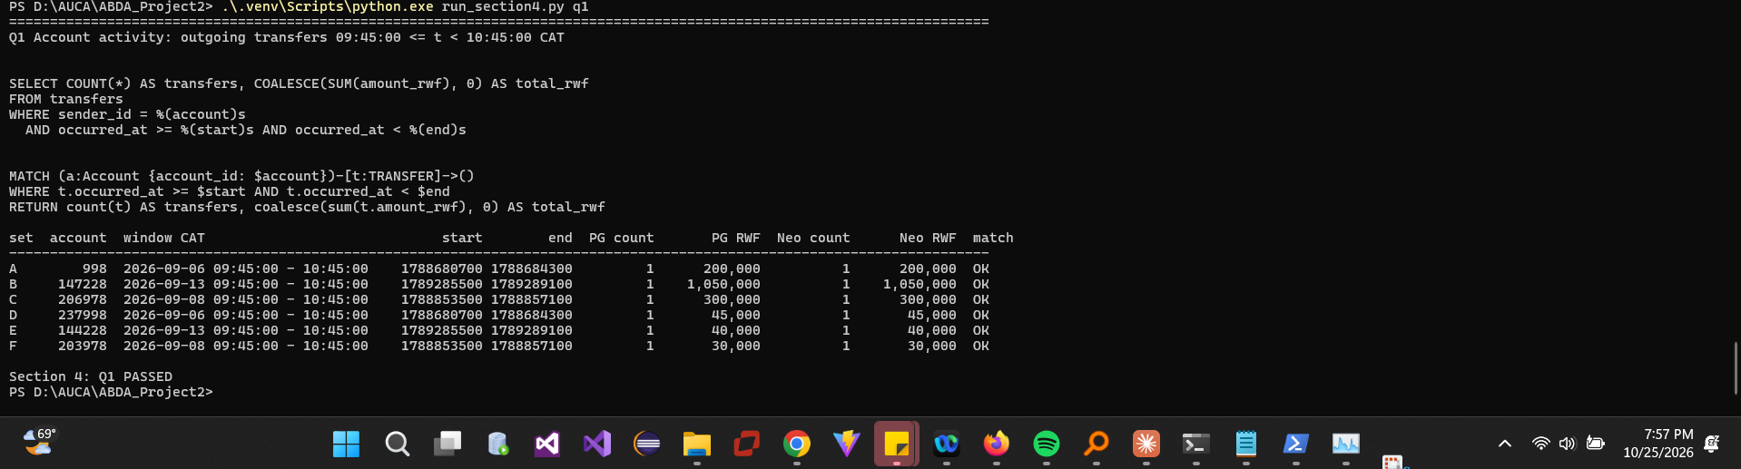
Figure 21. Q1 SQL and Cypher results for all six sets (identical).
Outgoing value is not a balance: a balance needs the opening balance, all incoming transfers, agent cash-in/out, fees and reversals, which this dataset does not contain. An account can send 1,050,000 RWF it received minutes earlier.

4.2 Q2 Daily activity
30 CAT days; both engines identical; sums reconcile with capture.py (20,003,300 transfers, 231,482,327,870 RWF). Activity runs from 06:00 to 21:59:59 CAT each day.
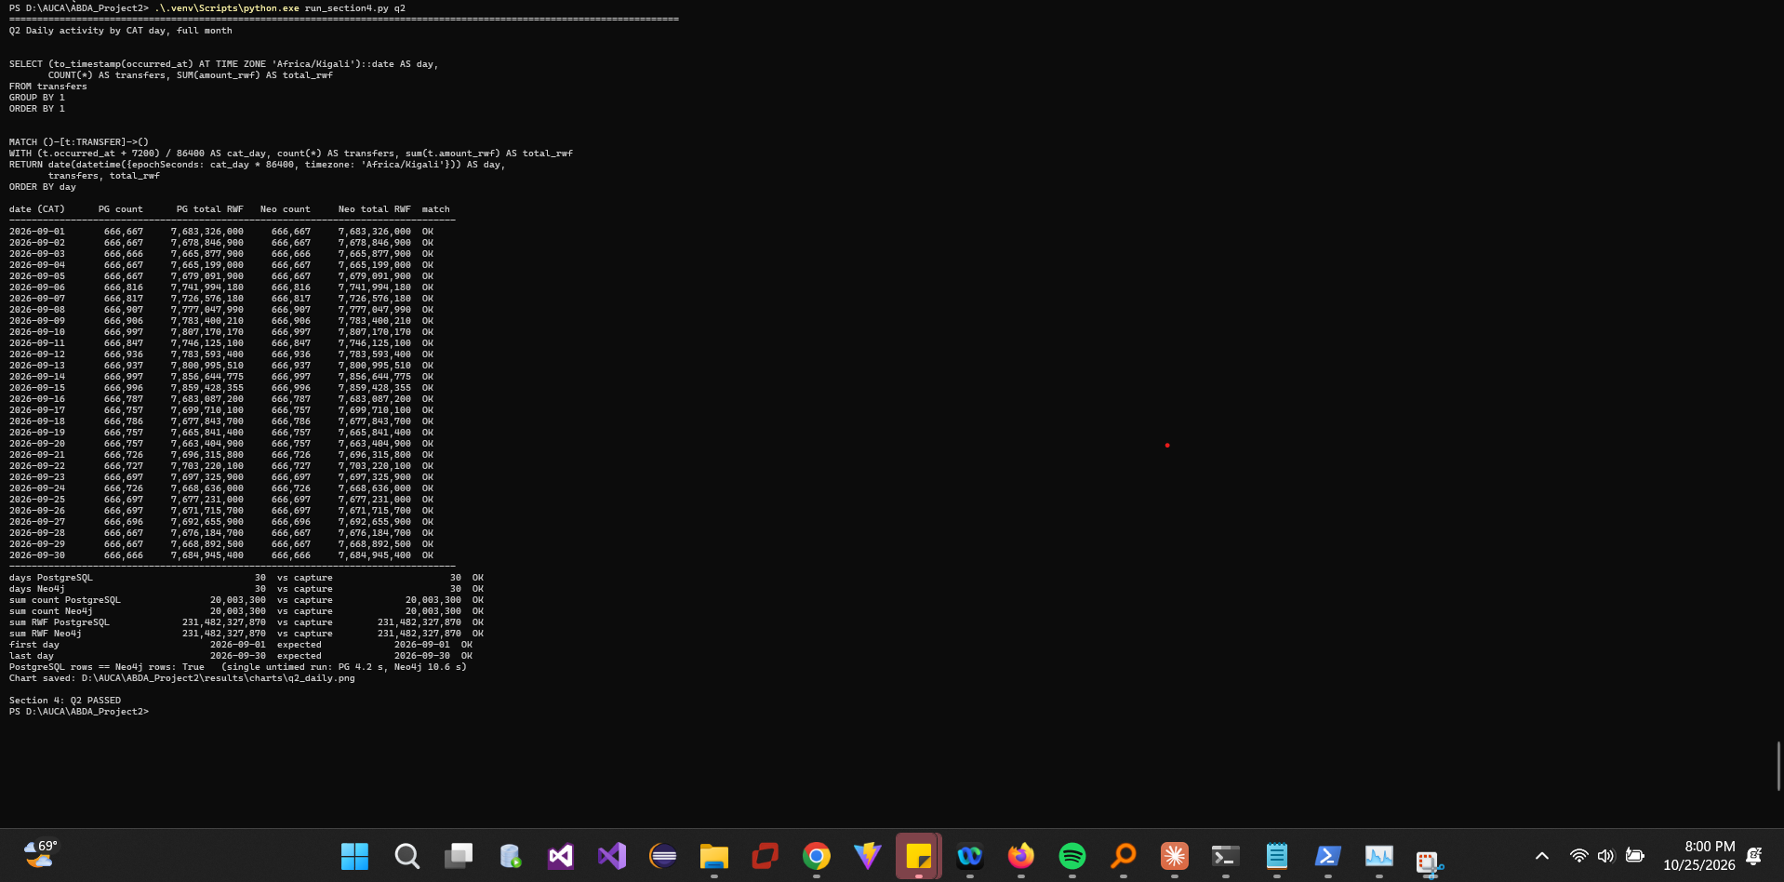
Figure 22. Q2 daily counts and totals with reconciliation checks.
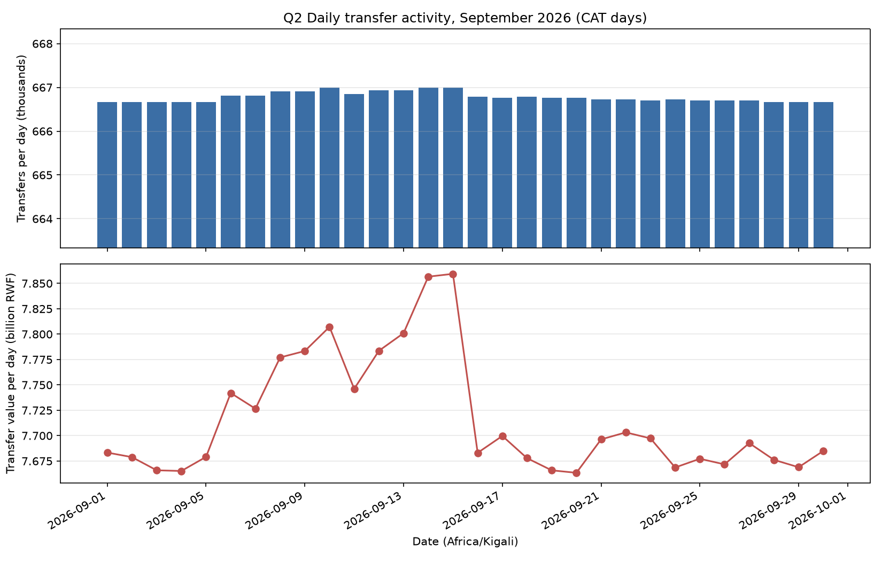
Figure 23. Q2 daily transfer count (thousands) and value (billion RWF).
Pattern: counts are almost flat (≈666,667 per day), but 6–15 September carry 150–330 extra transfers per day and noticeably higher value (≈7.74–7.86 bn RWF vs ≈7.66–7.70 bn). Transfer value is not provider revenue: revenue comes from fees and commissions that are not recorded, many P2P transfers may be free, and money passing through several wallets is counted at every hop.
Implementation note: the literal per-row Cypher (datetime() on each of 20 million relationships) took ≈190 s; grouping by the CAT day number first and converting only the 30 keys returns the same rows in 8.8–40 s.

4.3 Q3 Shared devices
Rows per set (identical in both engines): A 4, B 9, C 9, D 4, E 9, F 9.
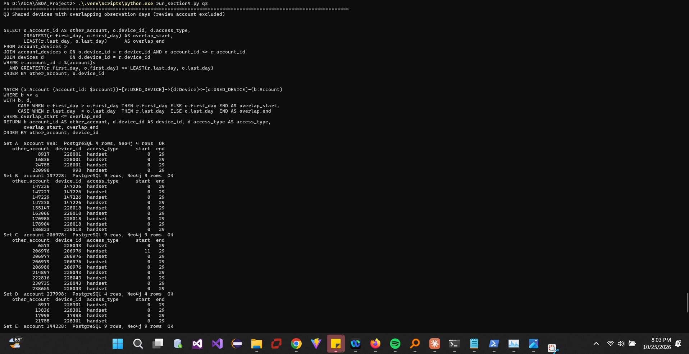
Figure 24. Q3 overlapping device use, sets A–C.
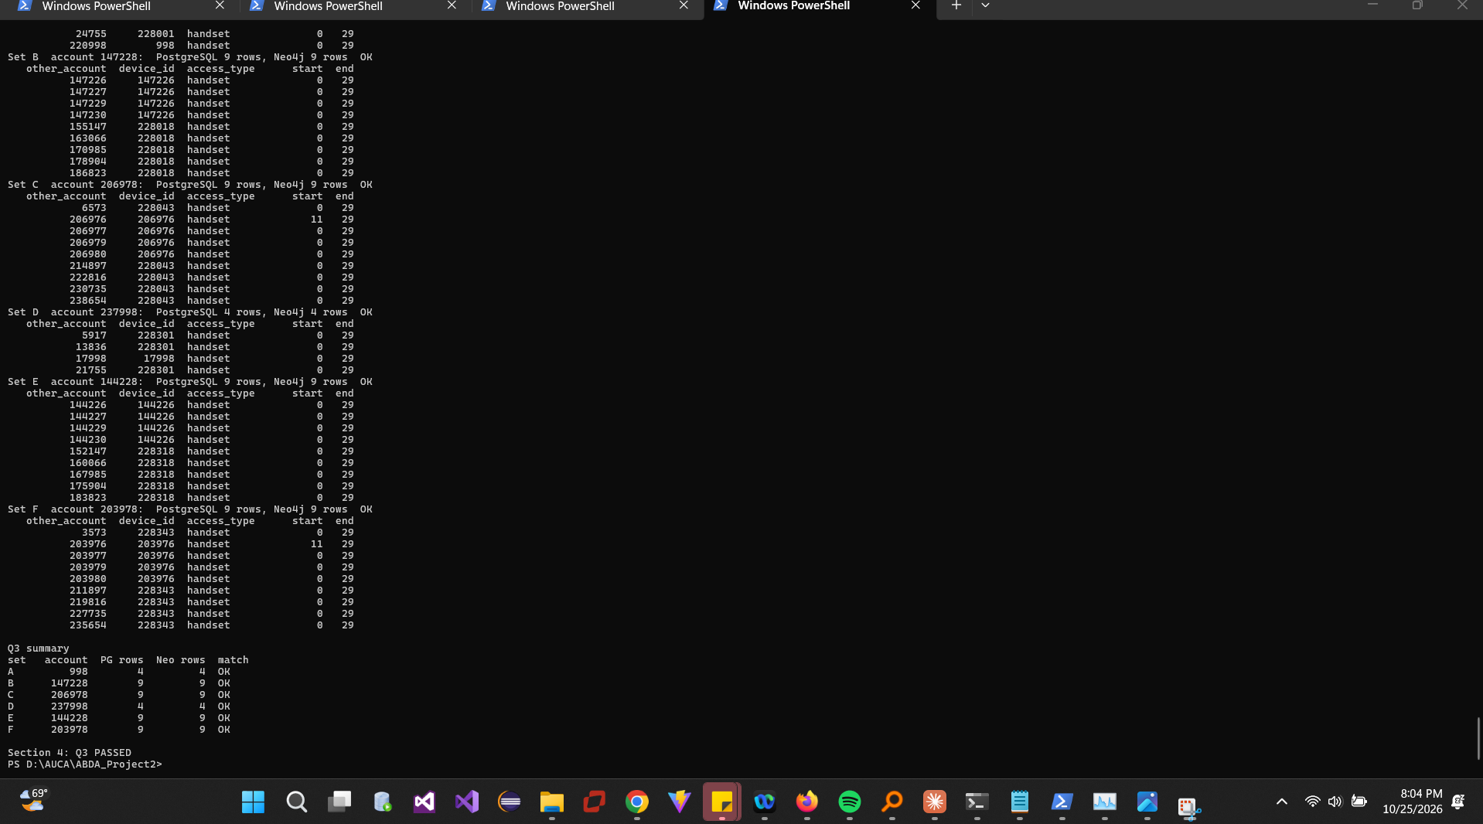
Figure 25. Q3 sets D–F and summary.
Legitimate sharing: in set B, accounts 147226, 147227, 147229 and 147230 share handset 147226 with 147228 for the whole month, consistent with a household phone; in set A, 220998 shares handset 998 because it is a second wallet of the same customer. Overlap does not prove simultaneous use: intervals [2,7] and [5,11] overlap on days 5–7, but the accounts could have used the phone at different times on those days, and observations do not say which device initiated a payment.

5 Connected accounts

5.1 Q4 Ownership and device network
Set | 4 links | 6 links | 8 links | 10 links
A | 10 | 43 | 175 | 187
B | 46 | 178 | 188 | 228
C | 146 | 483 | 832 | 1,433
D | 10 | 44 | 180 | 192
E | 47 | 183 | 193 | 230
F | 147 | 488 | 837 | 1,426

24/24 comparisons identical (counts by owner region in the screenshots).
Prediction from the 4- and 6-link results: networks grew about 3–4× between 4 and 6 links, so we expected a similar 3–4× per two extra links (A ≈ 150 and ≈ 500 at depths 8 and 10; C ≈ 1,600 and ≈ 5,000). The prediction held only partly. A, B, D and E flattened (A 175 then 187) because they run out of new household and replacement phones. C and F kept growing, but more slowly (×1.7 per two links, 1,433 at depth 10), as the public terminals they reach link a large but finite group of accounts.
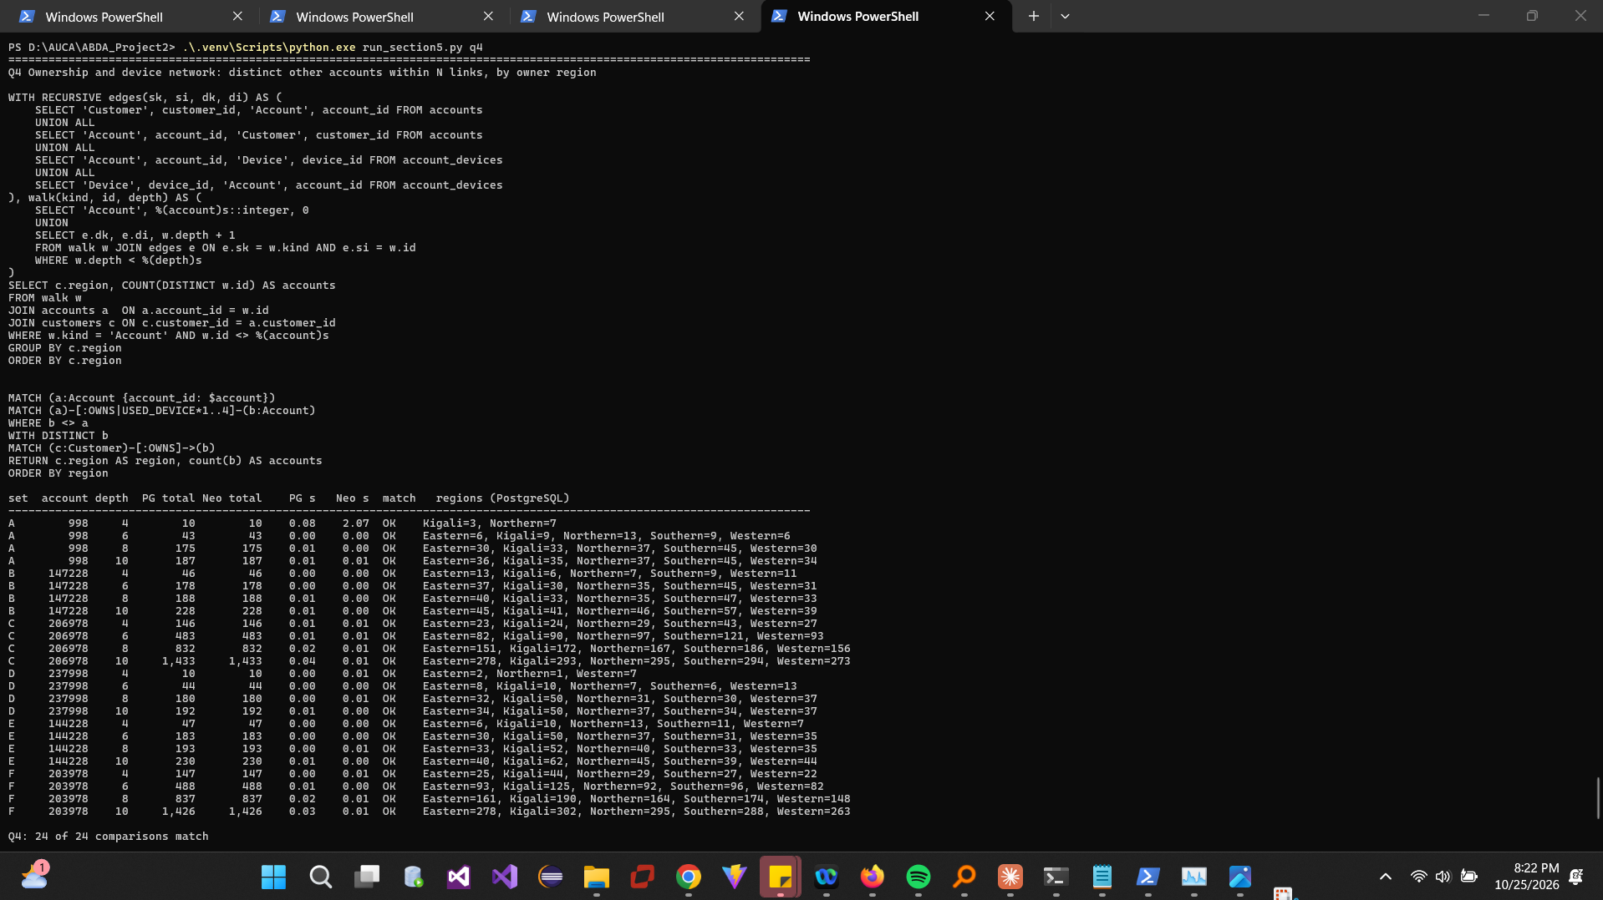
Figure 26. Q4 queries and the 24 comparisons.
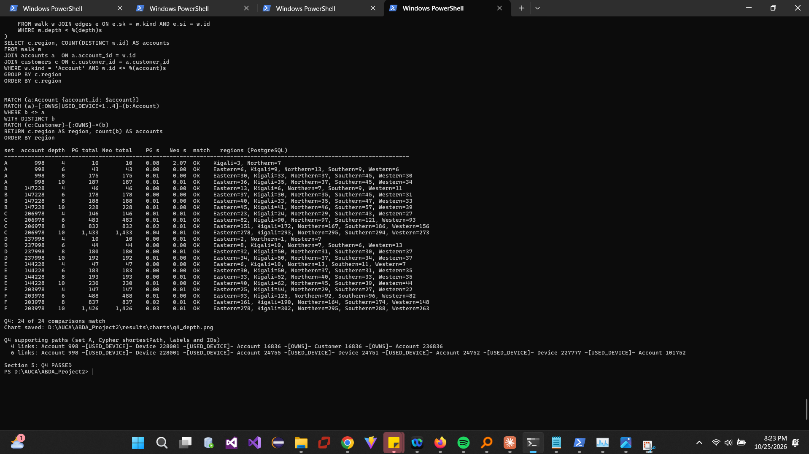
Figure 27. Q4 comparisons (continued) and supporting paths.
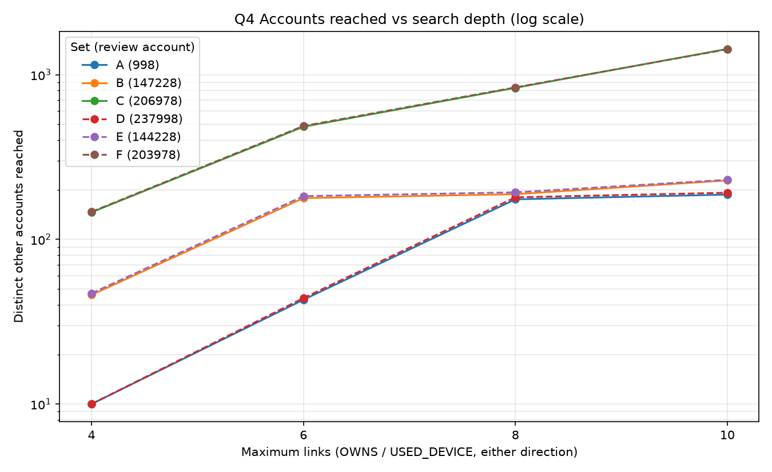
Figure 28. Q4 distinct accounts reached against depth (log scale).
Deeper links create weak associations: each hop adds accounts linked only through someone else's phone, an old replacement handset or a public terminal. C and F reach a public terminal (220020, 220170) within 4 links, so they grow to ≈1,430 accounts at 10 links; the 6-link path from 998 reaches account 101752 via a household phone and a replacement handset, with no direct relationship to 998.

5.2 Q5 Rapid onward payments
Matches: A 1, B 1, C 1, D 0, E 0, F 0. Example (A): 20000001 998→8917 10:00:00 200,000 RWF; 20000002 8917→16836 10:00:40 196,000 (98%); 20000003 16836→24755 10:01:20 192,080 (98%).
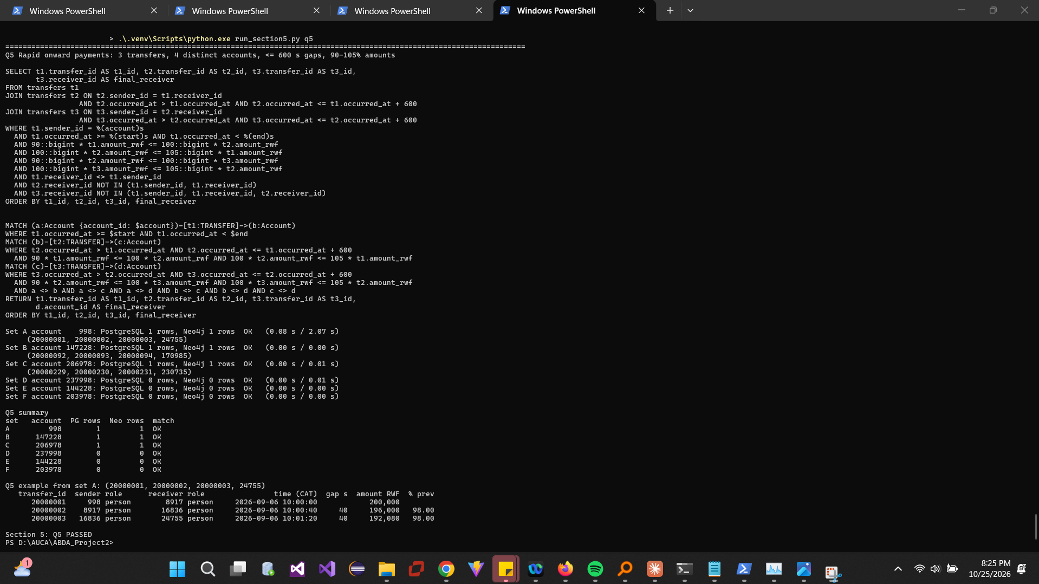
Figure 29. Q5 pair, six counts and the set A chain with IDs, CAT times and amounts.
This does not prove that the same funds moved: wallet money is fungible, 8917 may have paid from an existing balance, and similar amounts 40 s apart can be coincidence or pre-arranged payments. Balances and the holders' explanations would be needed.

5.3 Q6 Circular payments
Matches: A 1 (4 transfers), C 1 (6 transfers), others 0. Set A: 20000001→20000002→20000003→20000004 back to 998 at 10:02:00, 120 s span, each amount 98% of the previous.
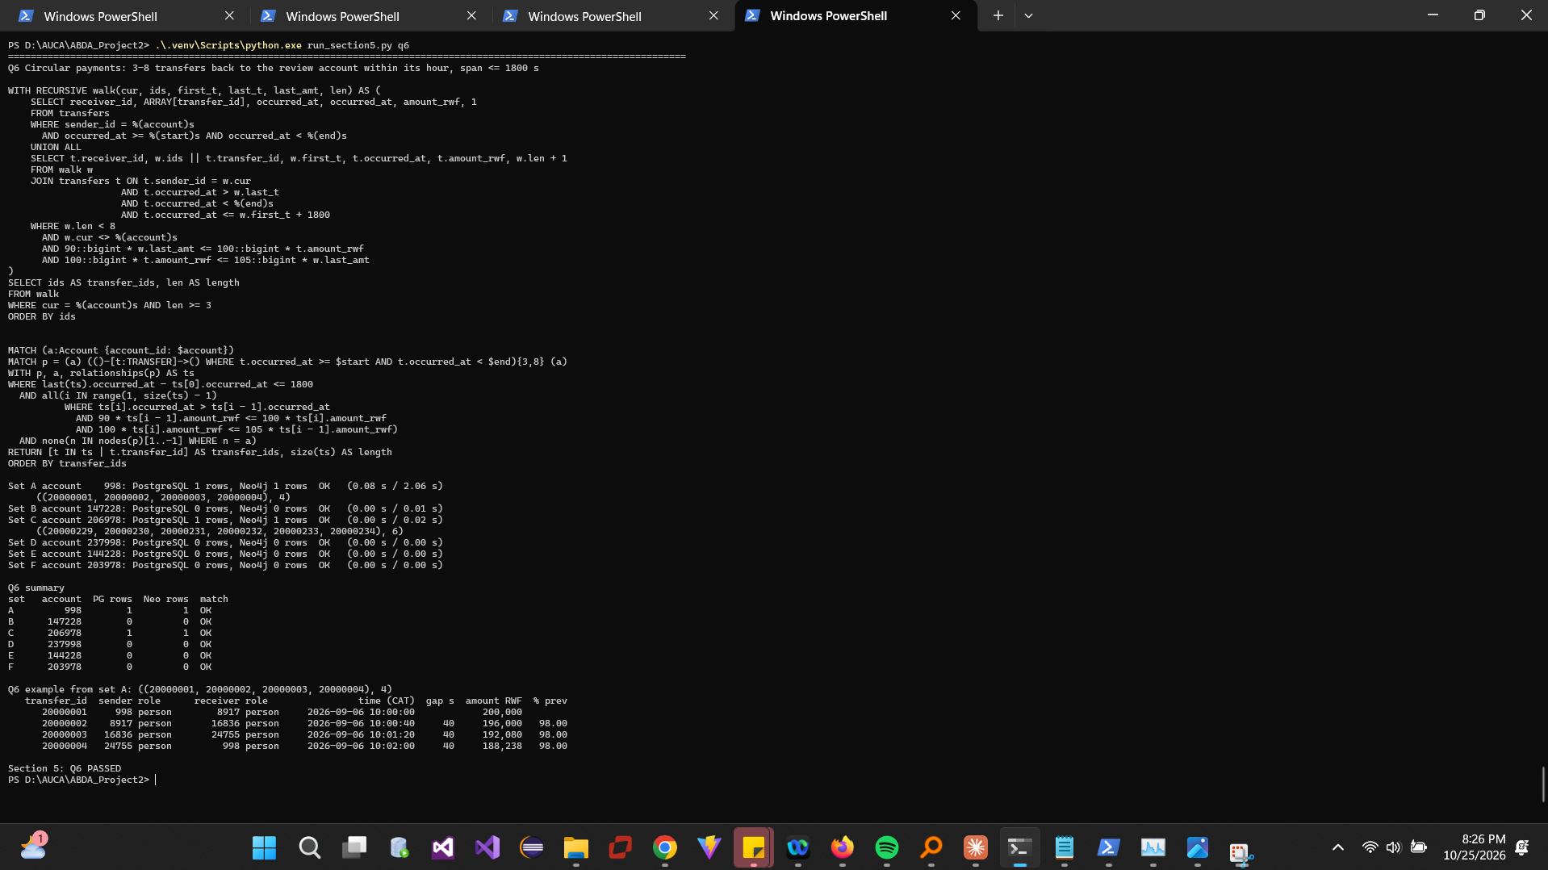
Figure 30. Q6 pair, six counts and the set A cycle.
Further evidence: KYC relationships between the accounts, balances before and after, the device that initiated each payment, similar cycles on other days, and any later cash-out at an agent.

5.4 Q7 Shortest transfer connection
Set | Review → destination | ≤ 4 | ≤ 6
A | 998 → 24755 | 3 | 3
B | 147228 → 186823 | none | 5
C | 206978 → 6573 | none | 5
D | 237998 → 21755 | 3 | 3
E | 144228 → 183823 | none | 5
F | 203978 → 3573 | none | 5

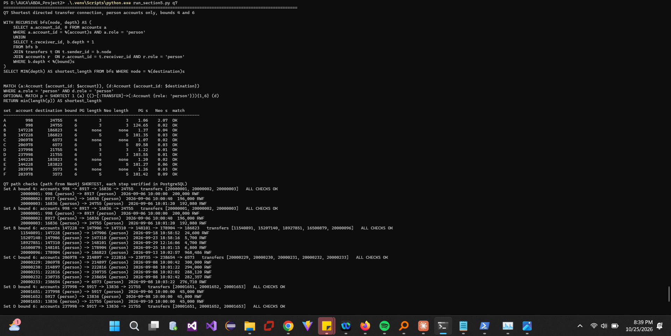
Figure 31. Q7 pair and the 12 length comparisons.
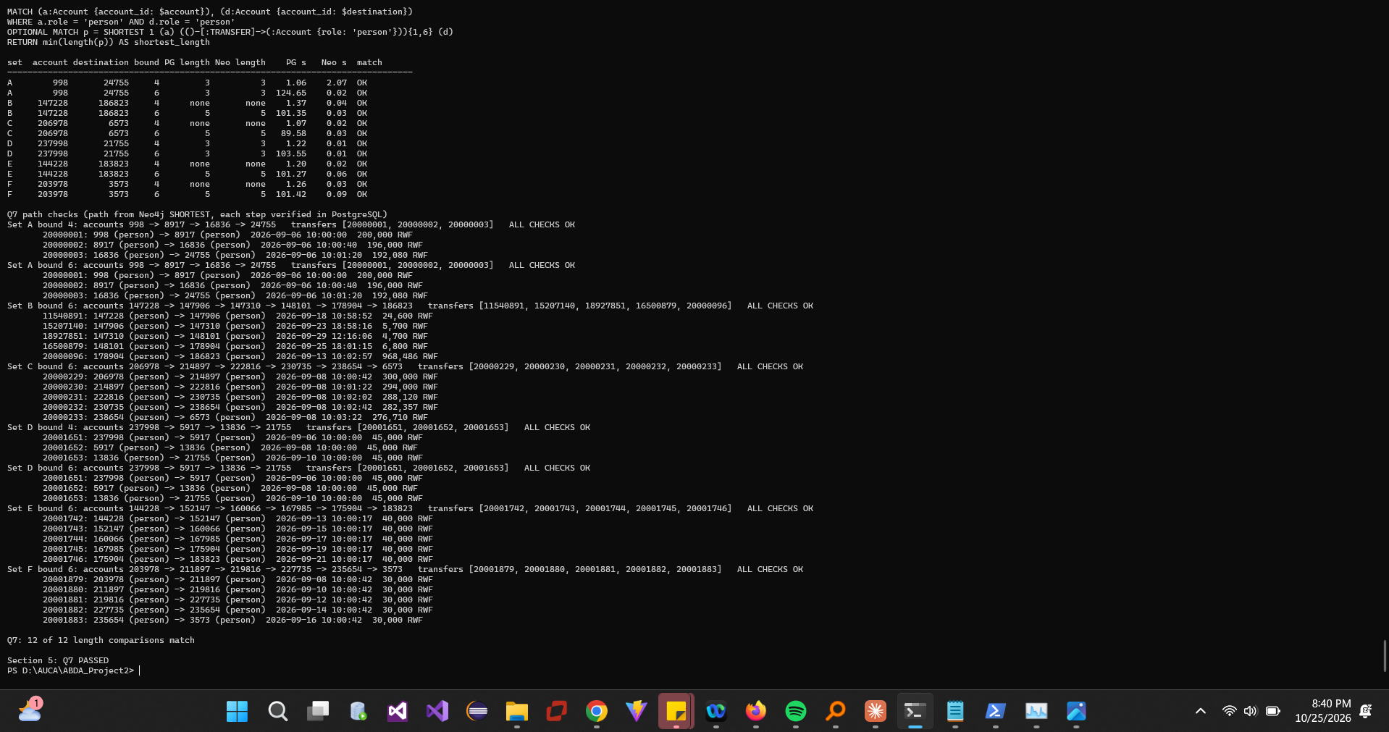
Figure 32. Q7 supporting paths verified in PostgreSQL (IDs, direction, roles, existence, length).
No route within four transfers is not evidence of no connection: B, C, E and F connect in five, and accounts may also be linked via merchants/agents (excluded), cash, other providers or other months. A structural route need not show onward movement: the B route's transfers fall on 18, 23, 29, 25 and 13 September and range from 4,700 to 968,486 RWF, so money from 147228 cannot have flowed along it.

6 Correctness and performance

6.1 One comparison program
compare_61.py uses run_pg(query, params) and run_neo(query, params) over persistent connections, normalizes integers, sorts rows and compares exactly. 61/61 cases match (Q1 6, Q2 1, Q3 6, Q4 24, Q5 6, Q6 6, Q7 12); Q7 lengths are compared separately and all 8 supporting paths are valid. Independent Python checks on the CSVs: the Q3 overlap of 998 and 8917 on device 228001 = [0,29]; the Q6 cycle 20000001–20000004 satisfies every rule. No mismatches had to be resolved.
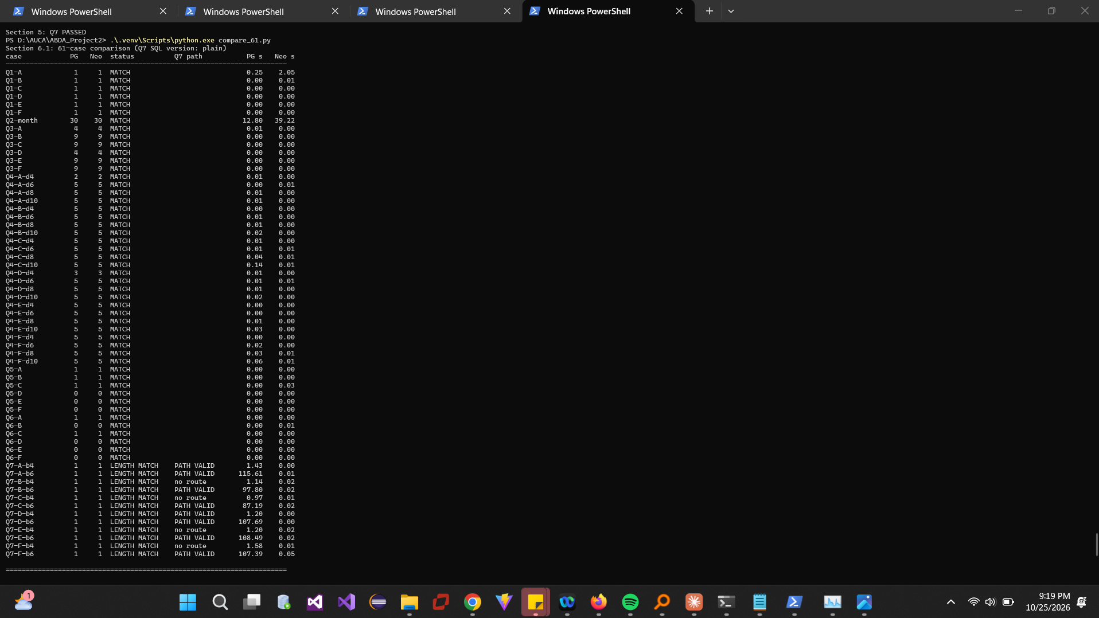
Figure 33. 61-case status table.
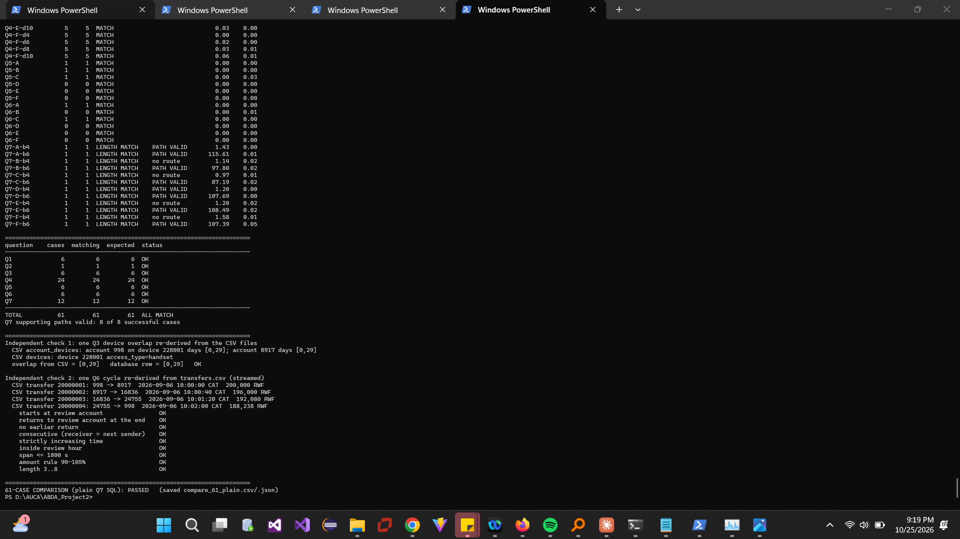
Figure 34. Per-question summary and the two independent CSV checks.

6.2 Timing a fixed selection
One service at a time, persistent connections, fixed memory settings; 3 untimed warm-ups (180 s) and 5 measured runs (60 s) per case, perf_counter from submission to the final row; errors and timeouts recorded separately.
Case | PostgreSQL median (min–max) ms | Neo4j median (min–max) ms | PG/Neo
Q1-B | 1.2 (0.8–1.5) | 8.4 (7.9–9.6) | 0.14
Q1-E | 0.5 (0.5–0.6) | 7.9 (6.9–8.5) | 0.06
Q3-B | 1.4 (1.4–1.5) | 7.5 (6.3–8.3) | 0.19
Q3-E | 0.5 (0.4–0.5) | 8.4 (7.1–10.9) | 0.06
Q5-B | 3.2 (2.9–4.1) | 6.9 (5.8–7.6) | 0.46
Q5-E | 0.4 (0.4–0.6) | 6.1 (5.2–7.8) | 0.07
Q6-B | 1.3 (1.1–1.7) | 6.3 (5.1–6.4) | 0.21
Q6-E | 0.5 (0.4–1.2) | 5.5 (5.0–5.8) | 0.09
Q2-month | 12,508.3 (12,159.2–12,963.0) | 8,751.5 (8,655.3–8,926.4) | 1.43
Q4-B-d4 | 3.0 (2.6–4.1) | 6.3 (5.1–6.9) | 0.48
Q4-B-d6 | 6.1 (6.0–8.6) | 7.2 (6.6–7.7) | 0.84
Q4-B-d8 | 11.7 (6.7–17.1) | 7.3 (6.8–7.9) | 1.60
Q4-B-d10 | 23.0 (20.5–26.4) | 6.2 (4.7–23.6) | 3.69
Q4-E-d4 | 2.0 (2.0–3.0) | 3.9 (3.5–4.5) | 0.50
Q4-E-d6 | 5.8 (5.6–6.5) | 4.9 (4.6–5.3) | 1.19
Q4-E-d8 | 7.6 (6.2–13.0) | 4.6 (4.0–6.3) | 1.67
Q4-E-d10 | 23.8 (21.9–27.8) | 4.3 (3.8–5.1) | 5.50
Q7-B-b4 | 1,154.2 (1,147.4–1,210.7) | 10.5 (8.5–13.8) | 110.22
Q7-B-b6 | 5/5 timeouts | 10.4 (8.8–10.9) | –
Q7-E-b4 | 1,173.1 (1,041.2–1,234.8) | 8.2 (7.5–10.0) | 142.99
Q7-E-b6 | 5/5 timeouts | 13.5 (12.3–13.9) | –

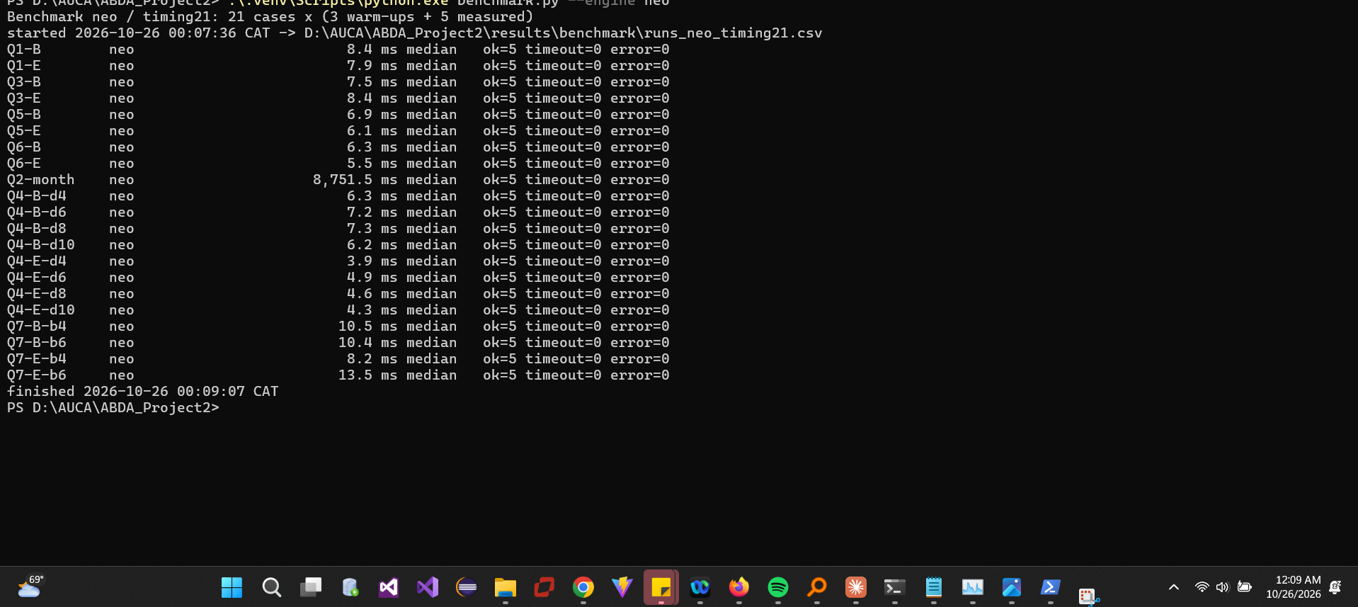
Figure 35. Neo4j benchmark run (PostgreSQL stopped). The PostgreSQL run is summarized in the next figure; raw runs in results/benchmark/runs_pg_timing21.csv.
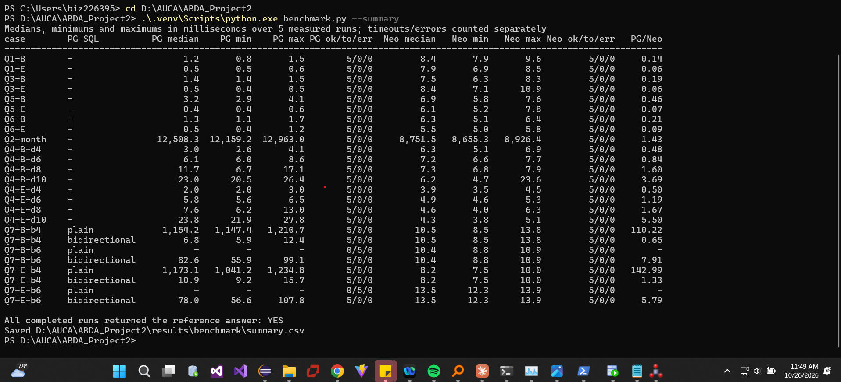
Figure 36. Benchmark summary with PG/Neo median ratios; all completed runs correct.
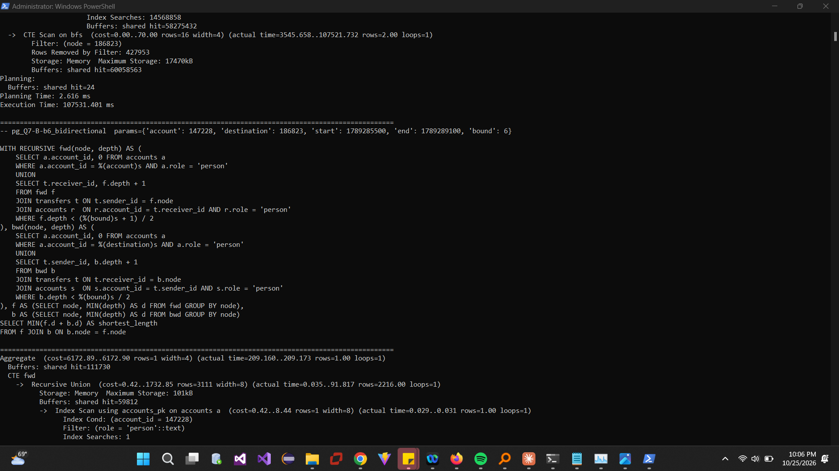
Figure 37. EXPLAIN (ANALYZE, BUFFERS) for Q2, Q4 B depth 10 and Q7 B bound 6.
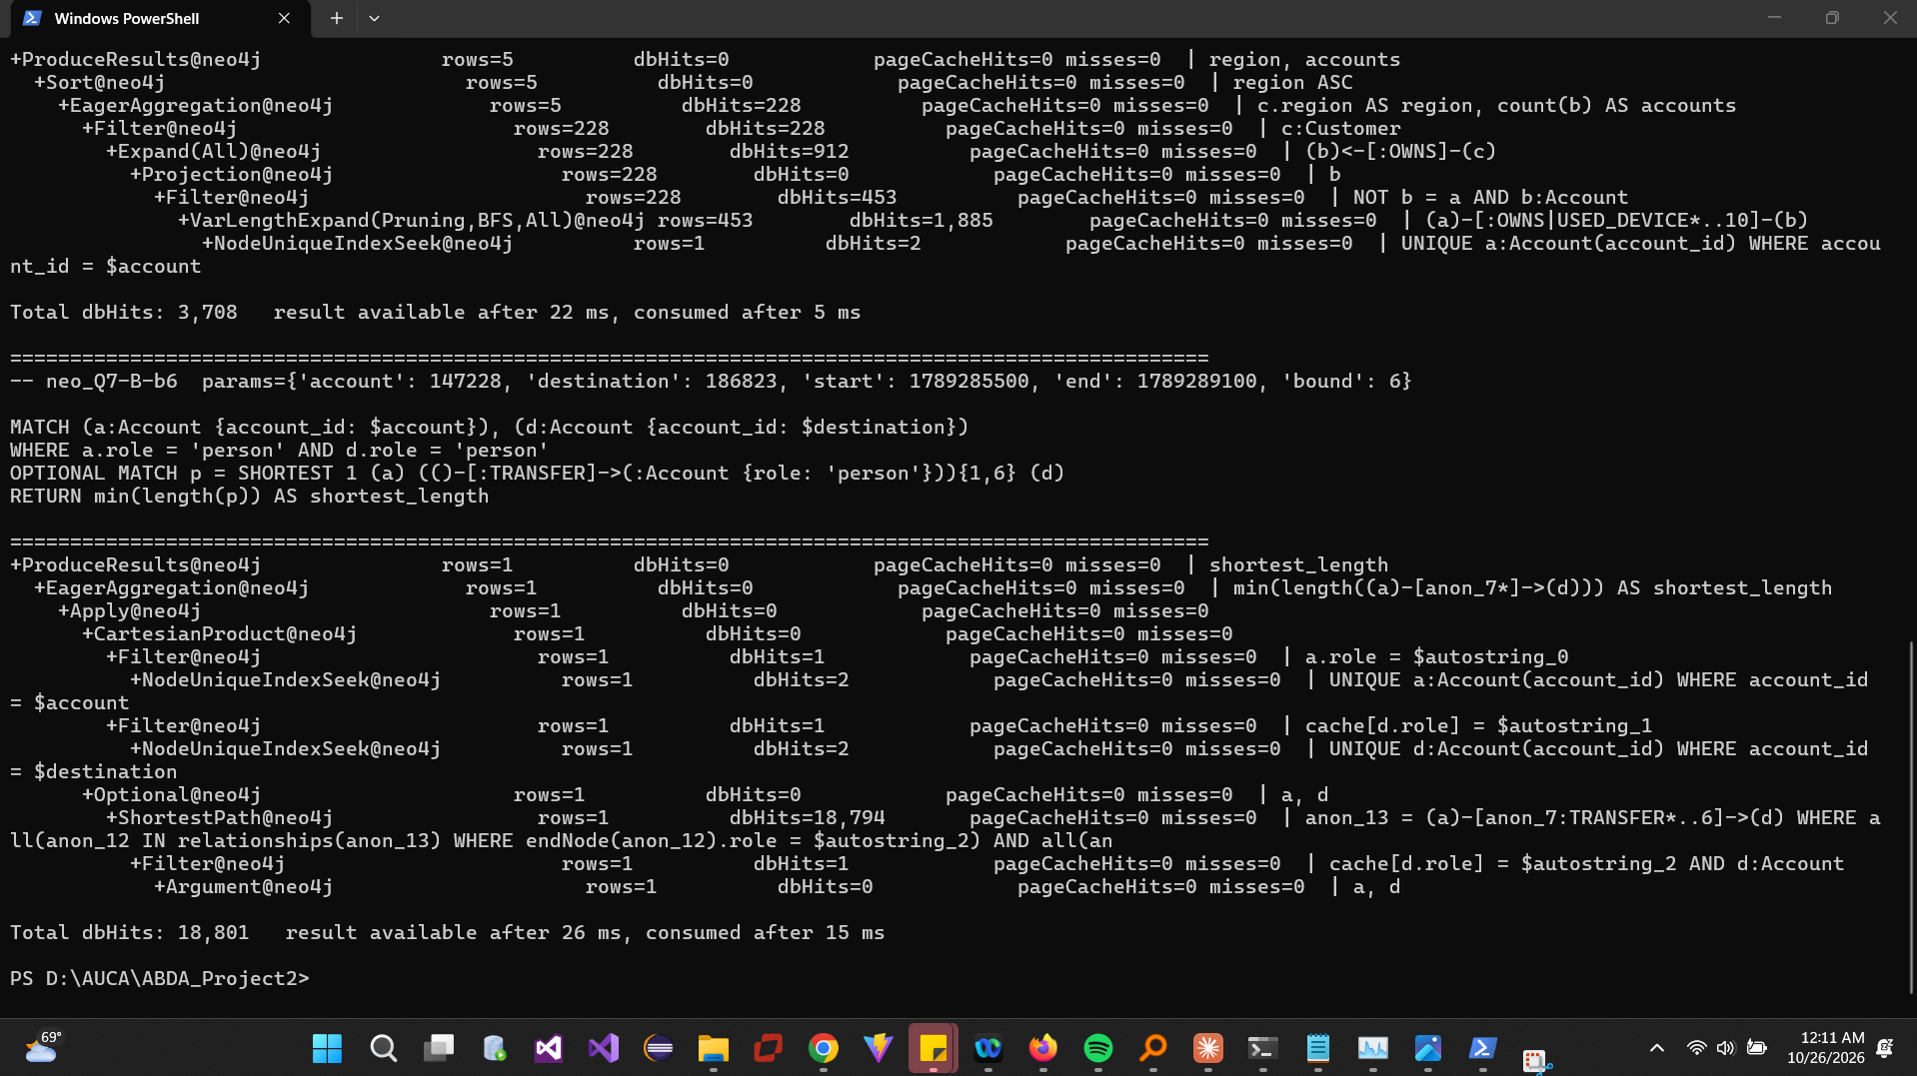
Figure 38. Neo4j PROFILE for Q2, Q4 B depth 10 and Q7 B bound 6.
Processing difference (Q7 B, bound 6): the PostgreSQL recursive CTE (107.5 s without a timeout) expanded 427,953 (account, depth) states over 7 iterations: 187,957 index-only scans returned 14.6 million transfer rows and 14.6 million account lookups checked the person role (60 million buffer hits). UNION only removes duplicate (account, depth) pairs, so accounts are re-expanded at every depth, and the search continues after reaching the destination. Neo4j used one ShortestPath operator (breadth-first, person filter applied during the search, stops at the first hit): 18,794 db hits. For Q2 both do full scans: PostgreSQL a Parallel Seq Scan with 2 workers and HashAggregate (12.1 s), Neo4j a relationship-type scan with 60 million db hits (8.6 s).

6.3 One SQL improvement
Prediction: searching from both ends should reduce the work from about d^6 to 2·d^3 states (d ≈ 16 person contacts per account), i.e. by hundreds of times. Implementation: forward ⌈bound/2⌉ steps from the review account and backward ⌊bound/2⌋ steps from the destination (incoming transfers from person senders), minimum depth per account on each side, join on shared accounts, MIN(forward + backward). Both versions are kept.
Case | Plain SQL ms | Bidirectional SQL ms | Neo4j ms | New PG/Neo
Q7-B-b4 | 1,154.2 | 6.8 | 10.5 | 0.65
Q7-B-b6 | 5/5 timeouts | 82.6 | 10.4 | 7.91
Q7-E-b4 | 1,173.1 | 10.9 | 8.2 | 1.33
Q7-E-b6 | 5/5 timeouts | 78.0 | 13.5 | 5.79

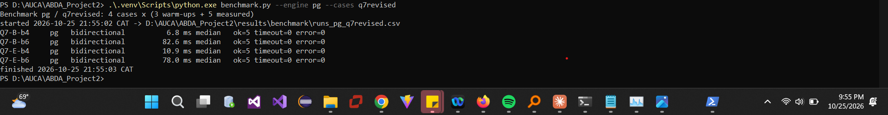
Figure 39. Four revised SQL cases timed (B/E at both bounds).
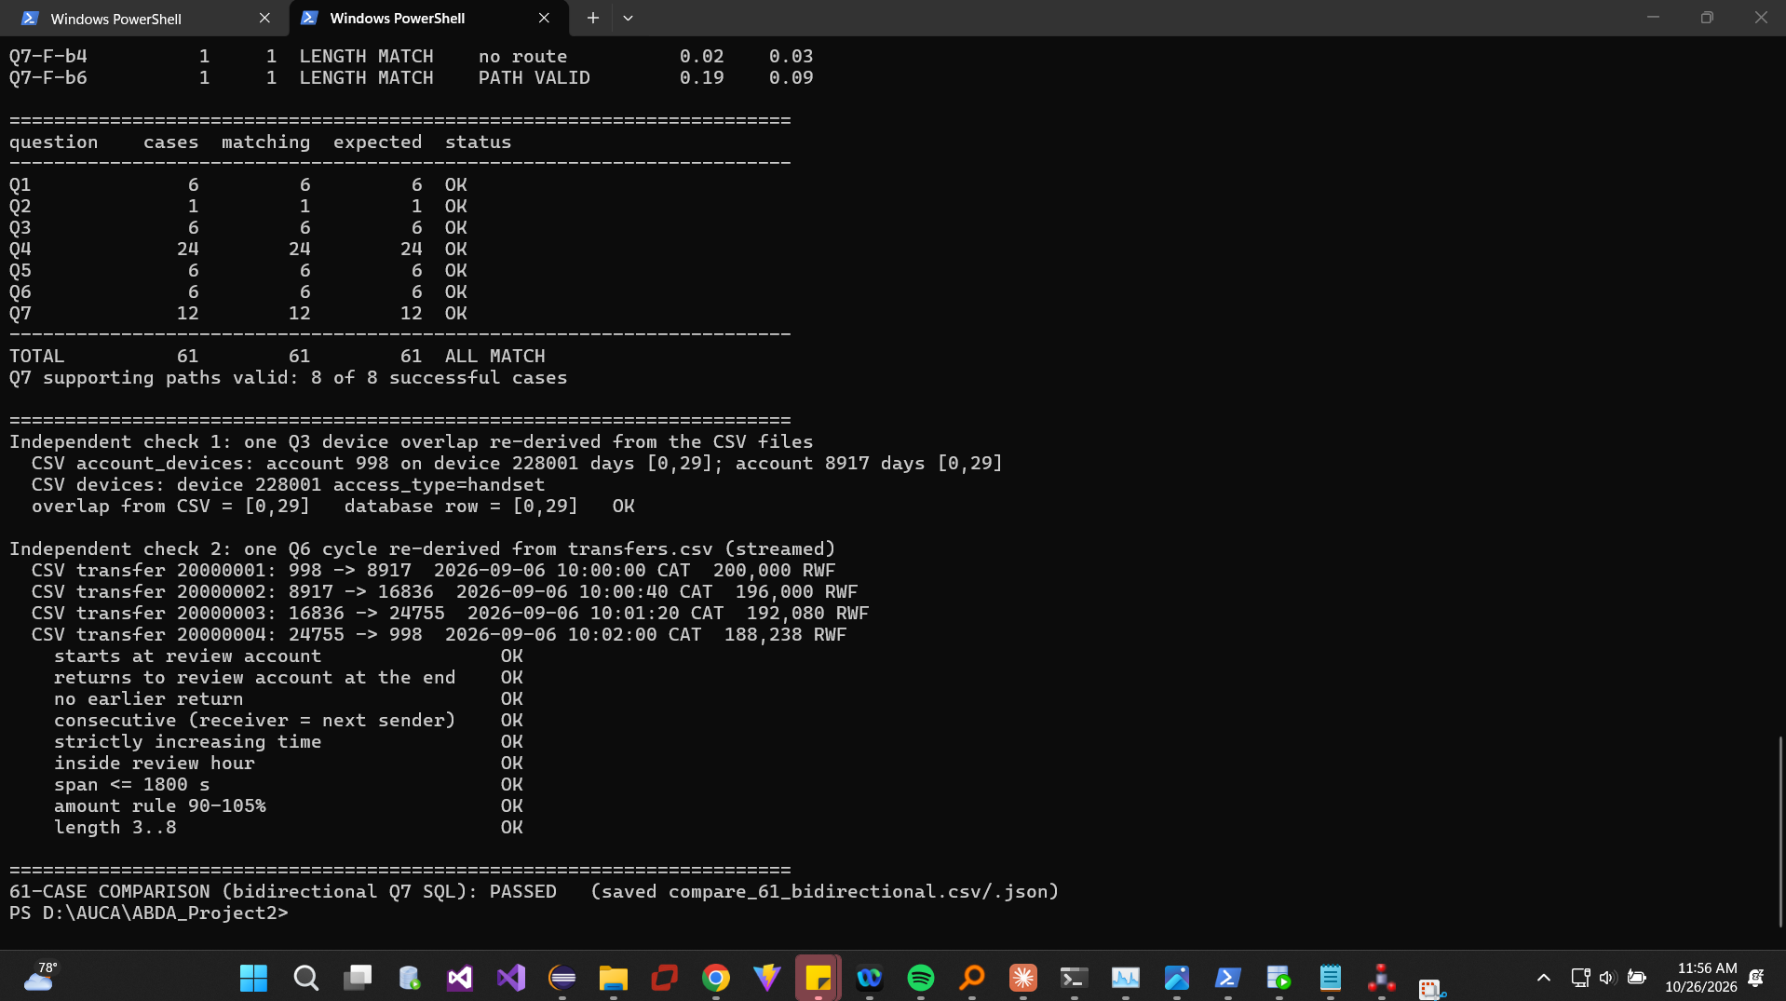
Figure 40. All 61 cases recheck correctly with the bidirectional Q7.
Outcome: the bidirectional version is selected for Section 7. B/E bound-6 medians fell from >60 s (timeouts) to ≈80 ms, more than 700× faster; plan execution fell from 107.5 s to 0.21 s. Neo4j remains ≈6–8× faster at bound 6, but the gap is now milliseconds, so most of the original difference came from the SQL algorithm, not the relational model.

7 Concurrent requests

7.1 Load test
loadtest.py starts 1, 4, 8 or 16 processes, each with one persistent connection; each warms up A-B-C once, waits at a Barrier, then runs A-B-C cycles until 15 s after the common start, finishing any started cycle. Q4 depth 10 and Q7 bound 6 (bidirectional SQL) were tested separately, three repetitions each; correctness checked after timing. Values below are medians of the three repetitions; there were no errors, timeouts or wrong answers.
Engine | Workload | Clients | Req/s | Median ms | p95 ms | CPU avg %
Neo4j | Q4-d10 | 1 | 396.5 | 1.9 | 4.4 | 6
Neo4j | Q4-d10 | 4 | 1,398.5 | 1.9 | 6.0 | 9
Neo4j | Q4-d10 | 8 | 1,497.3 | 3.4 | 10.7 | 97
Neo4j | Q4-d10 | 16 | 1,331.2 | 5.6 | 35.1 | 99
Neo4j | Q7-b6 | 1 | 221.7 | 5.5 | 7.2 | 4
Neo4j | Q7-b6 | 4 | 652.5 | 7.3 | 10.5 | 10
Neo4j | Q7-b6 | 8 | 849.8 | 11.1 | 16.9 | 97
Neo4j | Q7-b6 | 16 | 876.4 | 11.7 | 71.7 | 97
PostgreSQL | Q4-d10 | 1 | 22.2 | 20.8 | 139.5 | 9
PostgreSQL | Q4-d10 | 4 | 82.8 | 19.3 | 162.0 | 27
PostgreSQL | Q4-d10 | 8 | 120.9 | 22.3 | 210.8 | 98
PostgreSQL | Q4-d10 | 16 | 115.7 | 31.5 | 464.4 | 98
PostgreSQL | Q7-b6 | 1 | 6.8 | 163.2 | 204.4 | 10
PostgreSQL | Q7-b6 | 4 | 22.5 | 190.9 | 264.8 | 29
PostgreSQL | Q7-b6 | 8 | 28.8 | 283.0 | 391.3 | 97
PostgreSQL | Q7-b6 | 16 | 27.8 | 524.0 | 925.8 | 99

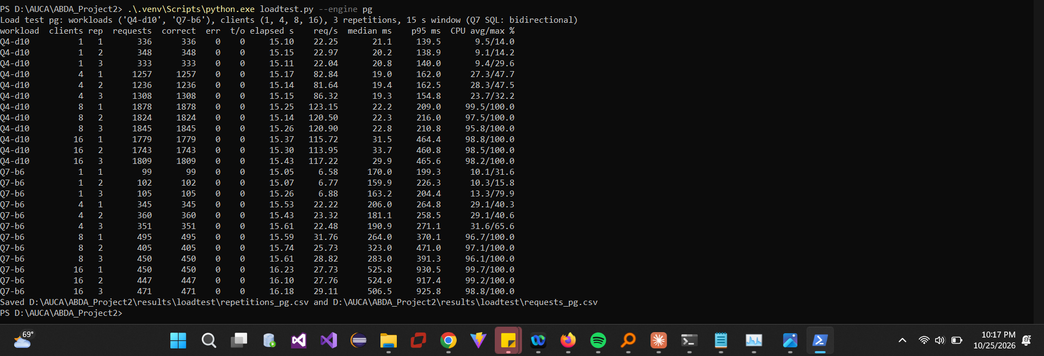
Figure 41. PostgreSQL load test: 24 repetitions.
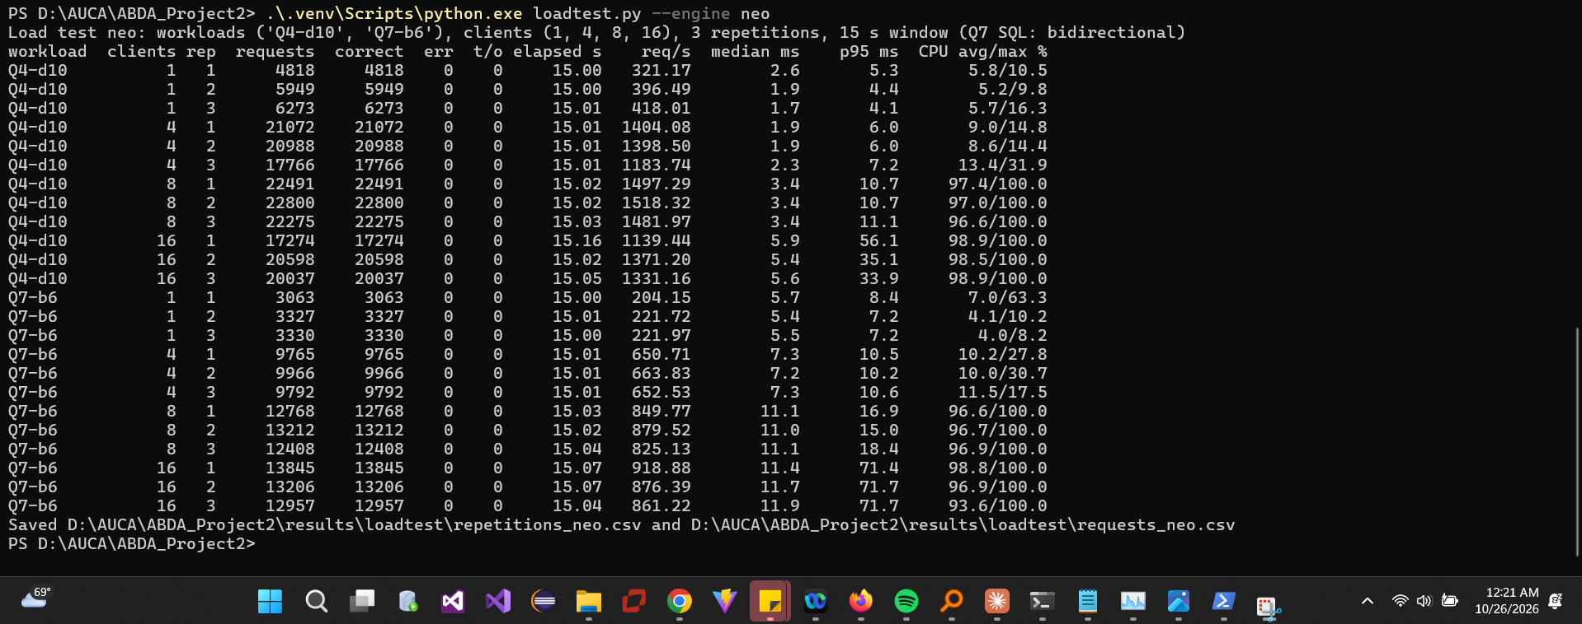
Figure 42. Neo4j load test: 24 repetitions.
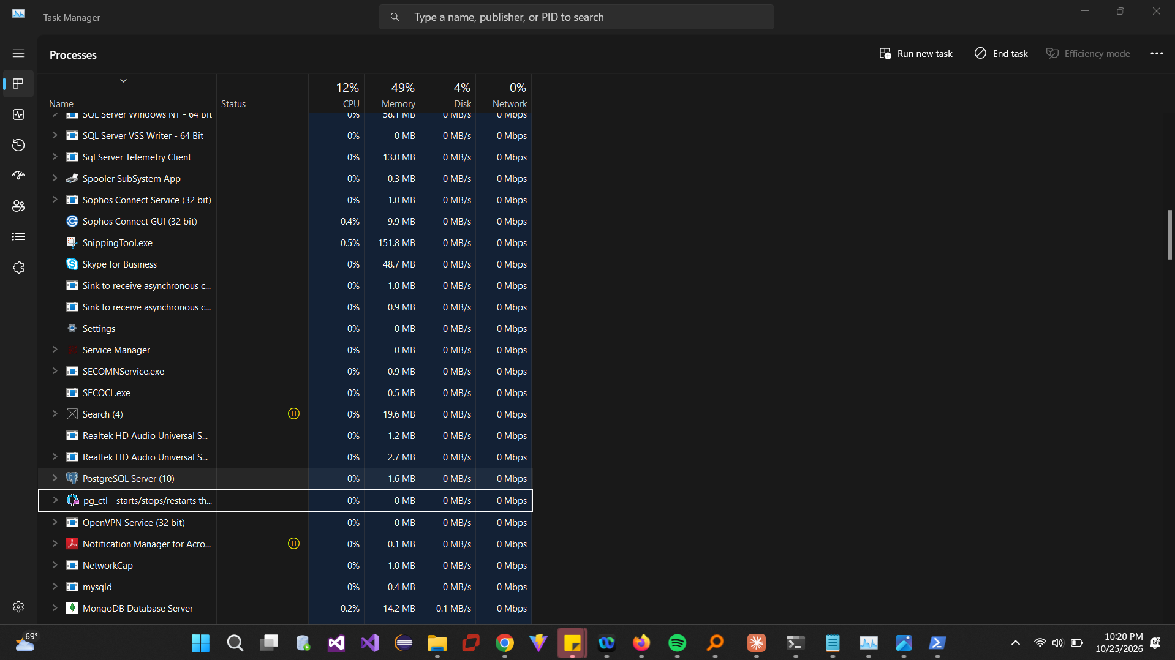
Figure 43. Active client processes during a 16-client test (Task Manager).
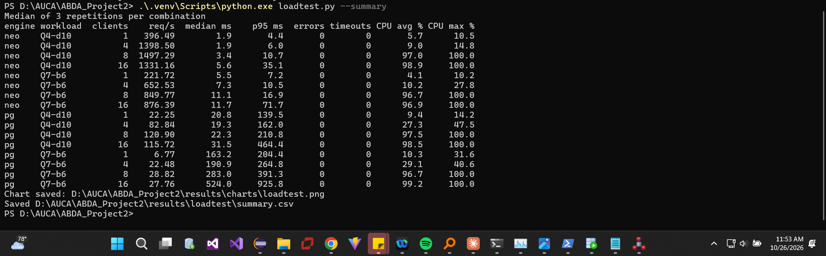
Figure 44. All 16 engine/workload/client-count summaries.

7.2 Scaling
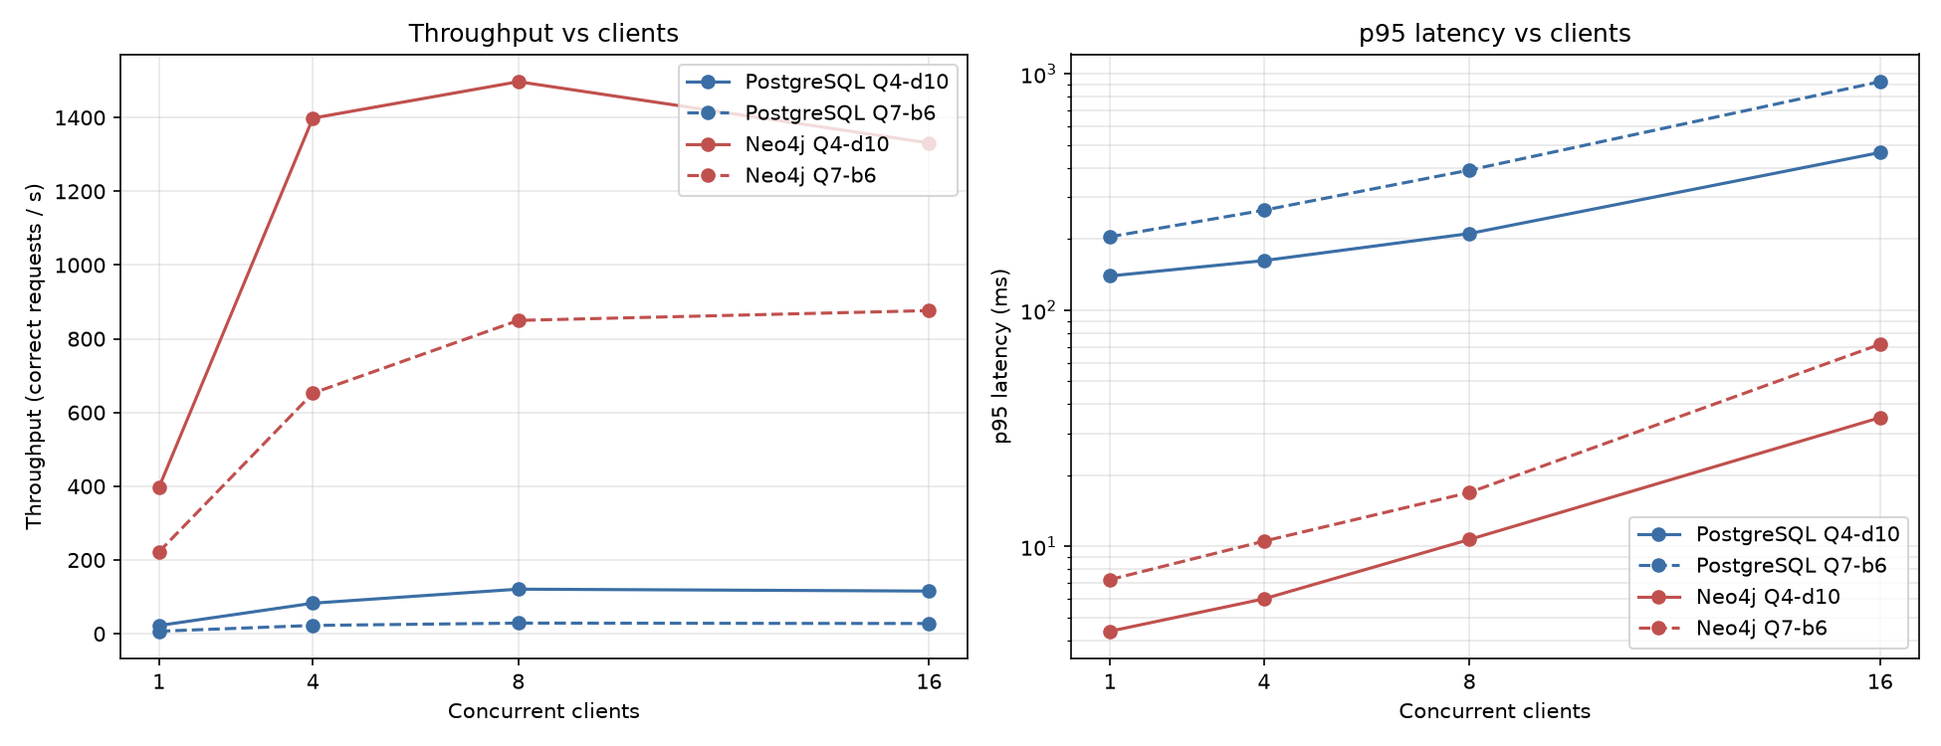
Figure 45. Throughput and p95 latency against client count.
Both engines scale almost linearly from 1 to 4 clients, then flatten: average CPU rises from 9–30% at 4 clients to 96–99% at 8 and 16, so the 8 hardware threads (shared by clients and database) are saturated. From 8 to 16 clients throughput stays flat or falls slightly while p95 roughly doubles (PostgreSQL Q4 211→464 ms; Neo4j Q7 17→72 ms): extra clients only queue. Throughput is total completed work per second; response time is what one analyst waits. At 16 clients PostgreSQL still completes ≈116 Q4 requests/s, but an analyst's p95 wait is 0.46 s instead of 0.14 s. In this experiment the graph advantage survives the SQL improvement: at 8 clients Neo4j handled ≈12× (Q4) and ≈30× (Q7) more requests per second. Limits: one laptop, clients and server on the same CPU, three accounts, 15 s windows, warm caches.

8 Decisions

8.1 Investigation priority
Pair | Q3 devices | Q4 d10 | Q5 chains | Q6 cycles | Q7 ≤4 / ≤6 | Review first
A 998 / D 237998 | 4 / 4 | 187 / 192 | 1 / 0 | 1 (4 hops) / 0 | 3,3 / 3,3 | A
B 147228 / E 144228 | 9 / 9 | 228 / 230 | 1 / 0 | 0 / 0 | –,5 / –,5 | B
C 206978 / F 203978 | 9 / 9 | 1,433 / 1,426 | 1 / 0 | 1 (6 hops) / 0 | –,5 / –,5 | C

Within each pair, device sharing, network size and shortest routes are almost identical; the difference is the money pattern. A, B and C each show a rapid onward chain within their review hour (A and C also a cycle); D, E and F show none. D/E/F still reach their destinations, but through payments days apart (D: 45,000 RWF on 6, 8 and 10 September).
A vs D in detail: on 6 September at 10:00:00, 998 sent 200,000 RWF to 8917; 40 s later 8917 sent 196,000 to 16836; at 10:01:20 16836 sent 192,080 to 24755; at 10:02:00 24755 returned 188,238 to 998. All four person accounts were observed on handset 228001 for the whole month. D (237998) has a similar device network, but its 45,000 RWF payments to 5917 → 13836 → 21755 are two days apart and never return.
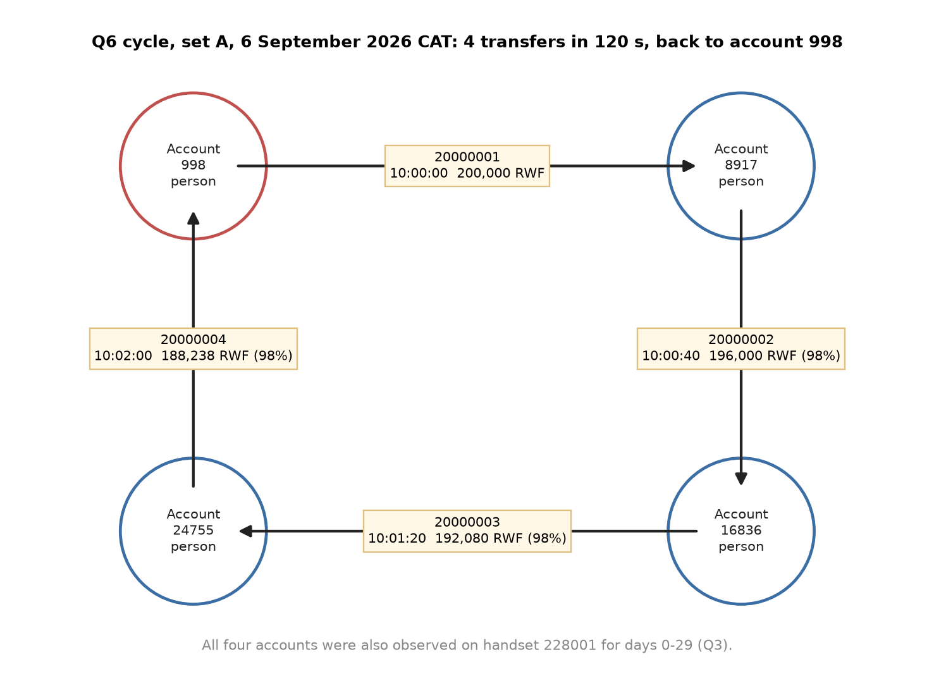
Figure 46. Transfer cycle for set A (Q6).
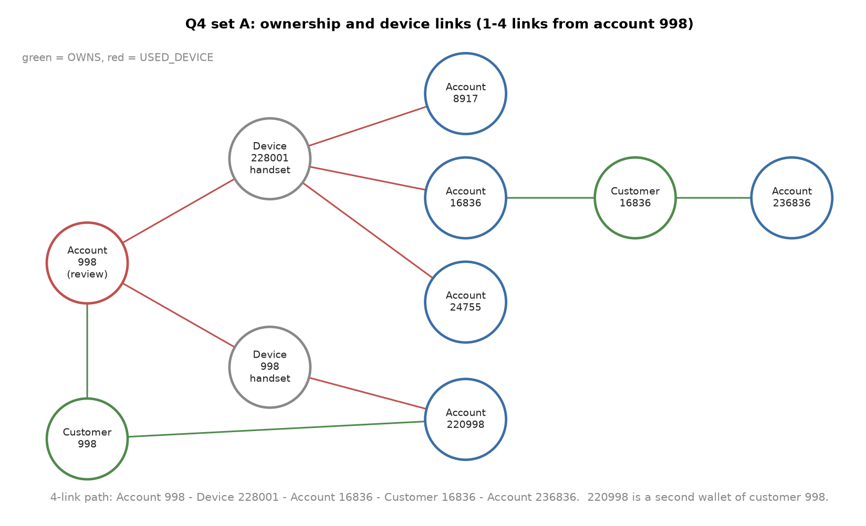
Figure 47. Ownership and device links around account 998 (Q3/Q4).
Ordinary explanation: four relatives or friends sharing one phone could be passing a savings-group (ikimina) contribution around, each keeping 2%, or testing a new wallet. Missing evidence: KYC relationships, balances, the device that initiated each payment, other months, and any cash-out at an agent. A documented savings group would lower the priority; a quick cash-out after the cycle would raise it. These records justify enquiries, not a finding of fraud.

8.2 Model recommendation
Reporting → PostgreSQL. Q1 hourly activity took 0.5–1.2 ms in PostgreSQL vs ≈8 ms in Neo4j. Daily totals (Q2) are a natural SQL GROUP BY with time-zone functions. Evidence against: Neo4j scanned the month faster (8.8 s vs 12.5 s), but only after rewriting the Cypher (the literal per-row form took ≈190 s).
Investigations → Neo4j. Device networks (Q4), cycles (Q6) and shortest routes (Q7) are path problems. Cypher states them as patterns with predicates inside the search; SQL needs long recursive CTEs. Neo4j stayed at 4–14 ms for Q4 depth 10 and Q7 bound 6, where PostgreSQL took 23 ms and 80 ms (after the rewrite) or timed out (before).
Concurrency. At 8–16 clients on this laptop Neo4j delivered 12–32× the throughput with 13–23× lower p95; both were CPU-bound from 8 clients.
Load time and storage. PostgreSQL: 34.6 s load + 96.8 s keys/indexes, 3.73 GB. Neo4j: 58.1 s offline import + 31.7 s constraints/index, 2.05 GB store. The covering transfer indexes (≈2 GB) explain most of PostgreSQL's size.
Plan comparison. For Q7 the recursive CTE re-expanded 14.6 million transfer rows; Neo4j's ShortestPath operator needed 18,794 db hits. The graph model's benefit is stored adjacency and readable path patterns; the rest was algorithm: Neo4j's breadth-first search with early stop versus a CTE without a visited set. Our bidirectional SQL recovered more than 700× without changing the schema.
Freshness. Keep PostgreSQL as the system of record and copy to Neo4j for investigations, at most 15 minutes behind (change data capture or micro-batches). Stale data would miss a cycle completed in the last minutes or show closed accounts: acceptable for retrospective investigation, not for real-time blocking.
Limits. (1) One laptop, clients and server sharing 8 threads, warm caches, one month of synthetic data. (2) Six review accounts and no concurrent writes: production load and data growth could change the ranking.

8.3 Individual judgement
BIZIMUNGU Theoneste (101398)
At first I thought PostgreSQL was bad at path-finding and that the graph database was the clear winner, because our first Q7 SQL query for bound 6 ran for more than 60 seconds and timed out. I now think the query design mattered more than the database. The bidirectional SQL used the same data but answered in about 80 ms, roughly 700 times faster. Neo4j was still faster at about 10 ms, but the gap became milliseconds, not minutes.
The plan explains why. The plain recursive query revisited the same accounts at every depth and did not stop after reaching the destination, so it read 14.6 million transfer rows. It behaves like a recursive Java method with no visited HashSet and no return when the answer is found. The bidirectional query searches from both accounts and meets in the middle, while Neo4j's shortest-path search never revisits an account and stops at the first hit, using only 18,794 database hits.
I would test this on a very busy account with thousands of transfers. If bidirectional SQL slowed down badly there while Neo4j stayed fast, I would accept that the graph model has a real advantage on highly connected data.
NIYITANGA Eric (101393)
In Q4, sets A, B, D and E grow for a while and then flatten at around 190 to 230 accounts within 10 links, while C and F keep climbing to about 1,430. By 10 steps most of the accounts reached are strangers: account 998 reaches 101752 only through a chain of shared phones. For an investigator, a link within 10 steps does not mean two people are related. Short links can be trusted more; long ones need checking.
The cause is the device type. Within 4 links, C and F reach a public terminal (devices 220020 and 220170) that many unrelated customers use. Once the search touches it, it jumps to every account that used the terminal, then to their phones, so the number grows fast. It is like a public phone booth: a family phone links a few relatives, but a phone booth links half the town. A, B, D and E only meet household and replacement phones, so their networks stay small.
To test this, I would remove the public terminals and run Q4 again for C and F. If they still grew much faster than the others, my explanation would be wrong.
NDASHIMYE Janvier (101363)
In the load test, going from 1 to 4 clients made throughput grow almost four times. From 4 to 8 it grew a little more, but from 8 to 16 it stopped growing and even dropped slightly, while the p95 waiting time doubled. Throughput is how much work the whole system finishes per second; latency is how long one analyst waits. At 16 clients PostgreSQL still answered about 116 Q4 requests per second, but an unlucky analyst waited almost half a second instead of 0.14 s.
The laptop has 4 cores and 8 threads, and the database and the client programs share them. At 8 clients average CPU was already about 97%, so 8 more clients added no power; they only joined the queue. It is like a bank with 8 tellers: with 16 customers it serves the same number per hour, but everyone waits longer. Neo4j handled 12 to 30 times more requests than PostgreSQL, but both hit the same CPU wall.
To test this, I would run the clients on a second computer. If the database CPU then stayed well below 100% but throughput still stopped at 8 clients, my explanation would be wrong.

Contributions
Member | Contribution
BIZIMUNGU Theoneste | Installed both databases, imported the data, executed queries, benchmarks and load tests, compiled the report
NIYITANGA Eric | Examined Q4 network findings and public-terminal analysis, verified screenshots, authored his 8.3 note
NDASHIMYE Janvier | Examined load-test results and charts, proofread the report, authored his 8.3 note

LLM and external assistance
Claude (Anthropic, Claude Opus 5.5, via Claude Code) helped write and debug the Python, SQL and Cypher code, the benchmark and load-test programs, the diagrams and this report, and drafted the explanation text. AI tools also helped each member draft and edit their 8.3 note from their own answers to three questions about their finding; each member reviewed their note and checked its numbers. We checked the technical work by: comparing every query pair across both engines (61 cases); recomputing one device overlap and one cycle directly from the CSV files in plain Python; verifying every Q7 path in PostgreSQL; reading the execution plans; and running all scripts ourselves on our own machine.

9 Reproducible work
GitHub: https://github.com/bibabbly/auca-abda-p2-mobile-money (the ZIP matches the final commit). The README lists all commands in execution order; .env.example holds placeholder secrets; captured CSVs and database stores stay local. The generator is unchanged (SHA-256 2ea0e59d2b7b987d84a3d151bd9d1ad7b3052bfbc25abf1466c8e94467e9455a).
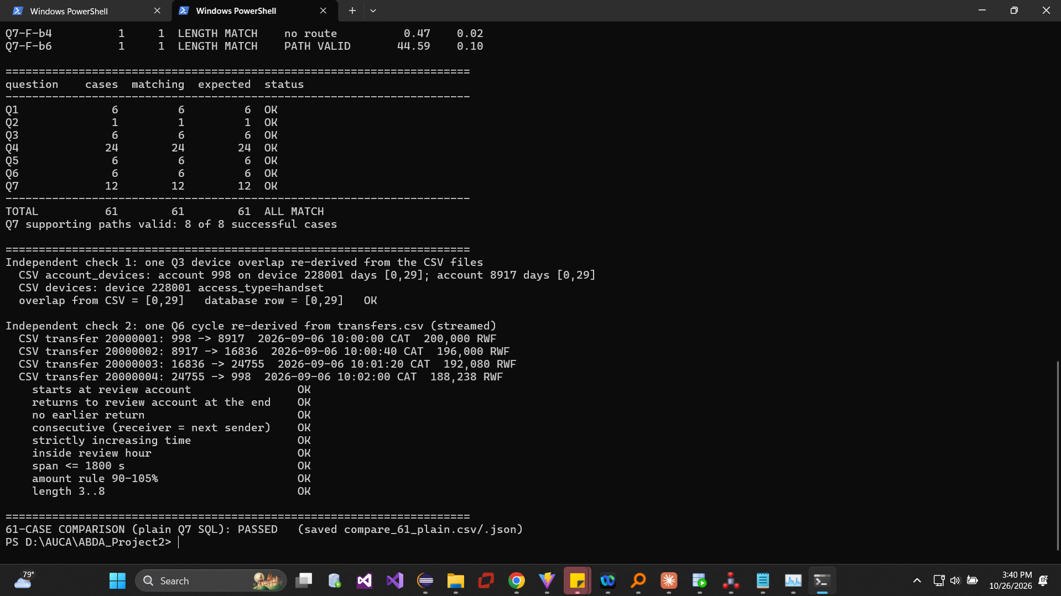
Figure 48. Final rerun of the 61-case comparison.
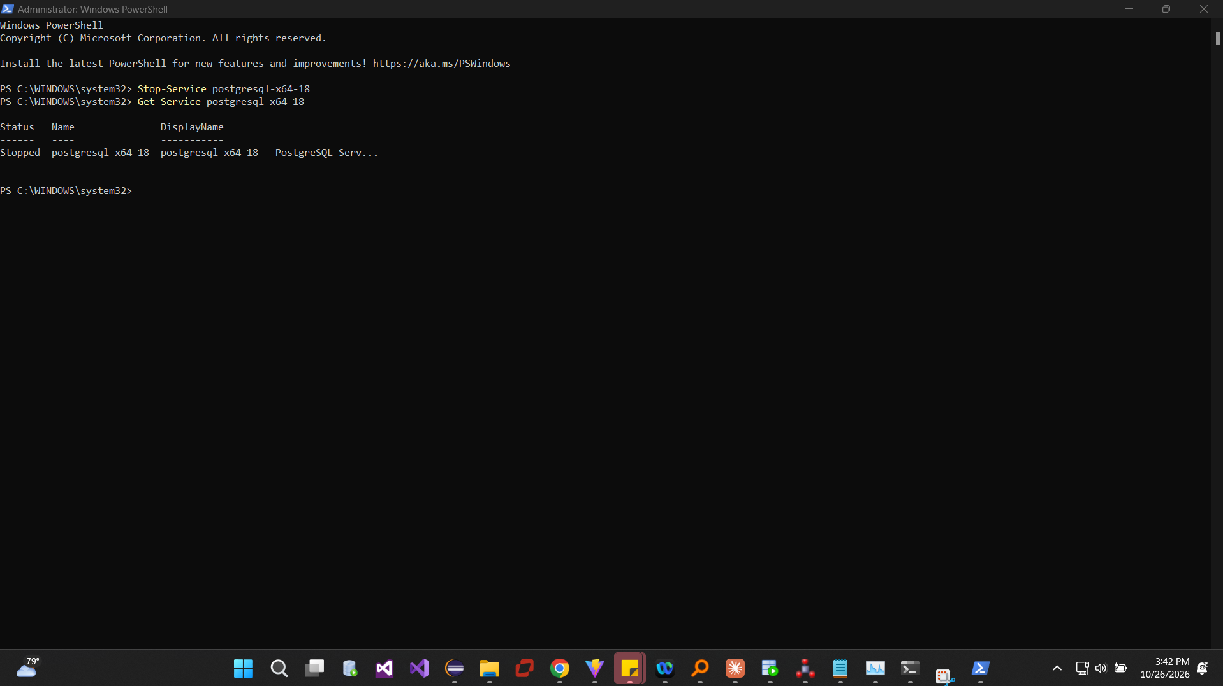
Figure 49. PostgreSQL and Neo4j services stopped; stores retained.

