LAB-3: Use of Rollback and Commit

- Creating Database:
Query: CREATE DATABASE LAB3;
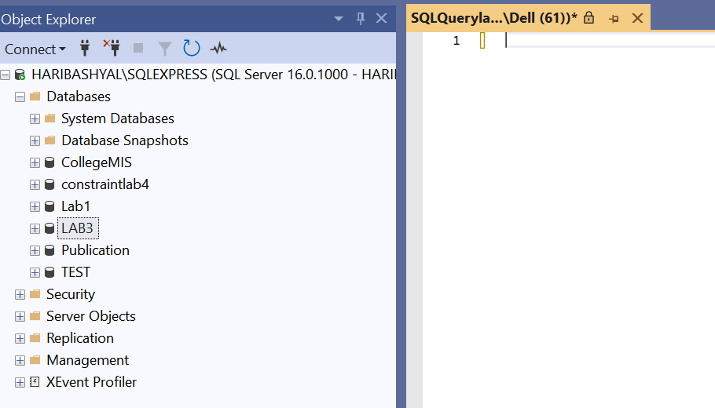
- Creating Table:
Query: create table student(
sid int identity(1,1) primary key,
sname varchar(20) NOT NULL,
saddress varchar(20),
DOB DATE,
Marks float
);
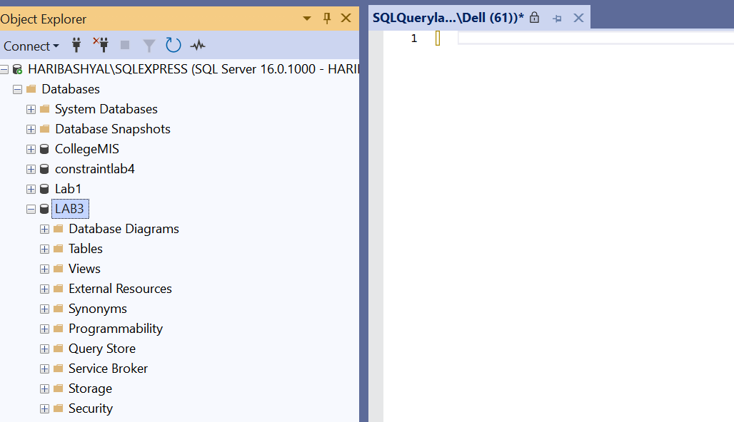

- Display Student table.
Query: select *
from student;
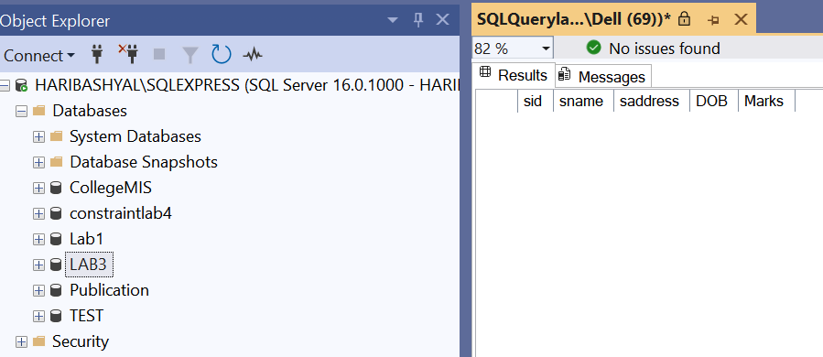
- Insert 20 students.
Query: INSERT INTO student (sname, saddress, DOB, Marks) VALUES
('Gautam Rai', 'Ilam', '2003-02-17', 88.5),
('Sita Devi', 'Lalitpur', '2002-07-22', 78.0),
('Ram Karki', 'Chitwan', '2003-01-05', 72.3),
('Anjana Tharu', 'Pokhara', '2004-02-28', 98.7),
('Bikesh Gurung', 'Biratnagar', '2004-09-12', 64.5),
('Nisha Roy', 'Dharan', '2005-06-18', 91.2),
('Pramoon Lama', 'Butwal', '2006-04-25', 79.8),
('Sunita Yadav', 'Hetauda', '2005-12-10', 40.1),
('Manisha Joshi', 'Janakpur', '2004-08-03', 86.4),
('Kartik Poudel', 'Nepalgunj', '2003-02-14', 84.9),
('Dipesh Bista', 'Kathmandu', '2005-03-20', 83.6),
('Rina Koirala', 'Itahari', '2004-10-28', 87.0),
('Suman Thapa', 'Bharatpur', '2006-03-09', 79.5),
('Ajay Sharma', 'Kirtipur', '2005-07-01', 91.3),
('Roshan Sah', 'Saptari', '2002-07-25', 98.2),
('Sneha Yadav', 'Saptari', '2001-06-09', 82.7),
('Aakash Gurung', 'Gorkha', '2005-09-25', 75.9),
('Manish Regmi', 'Besisahar', '2004-11-11', 89.4),
('Bibek Sah', 'Saptari', '2006-01-05', 77.8),
('Laxmi Sah', 'Saptari', '2005-08-19', 86.6);
- Check Rollback and commit
Query: ROLLBACK
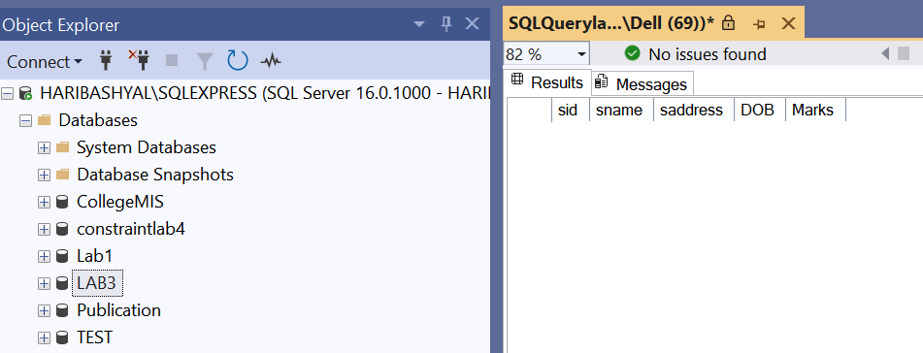

Again we have to insert those data as well as resave then,
Querry: COMMIT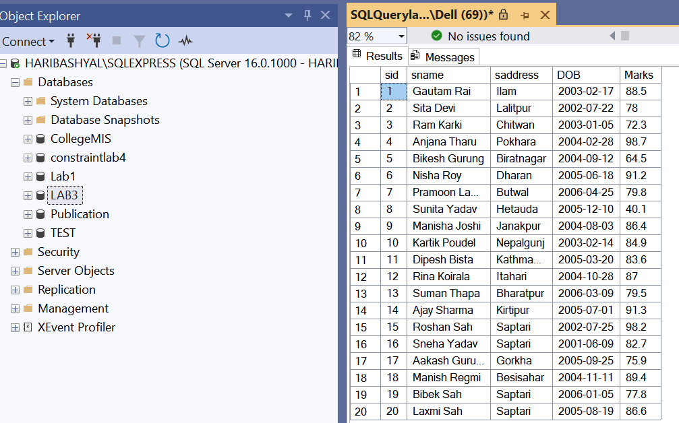

- Delete Records
Querry: DELETE FROM student
WHERE saddress = 'kathmandu';
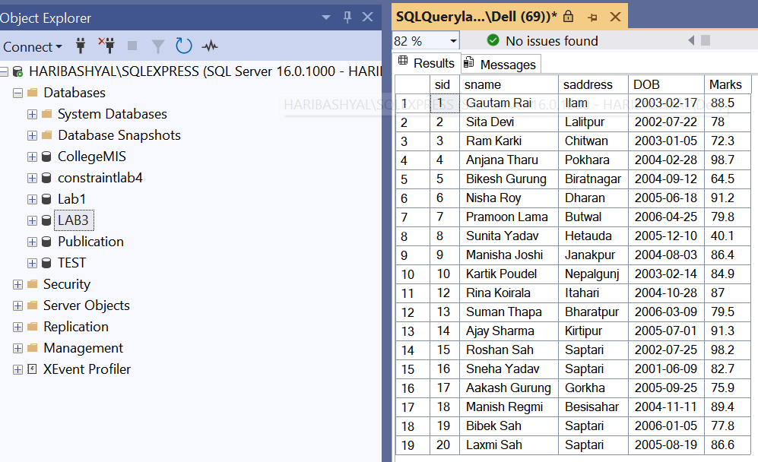

- Check Rollback and Commit
Querry: ROLLBACK
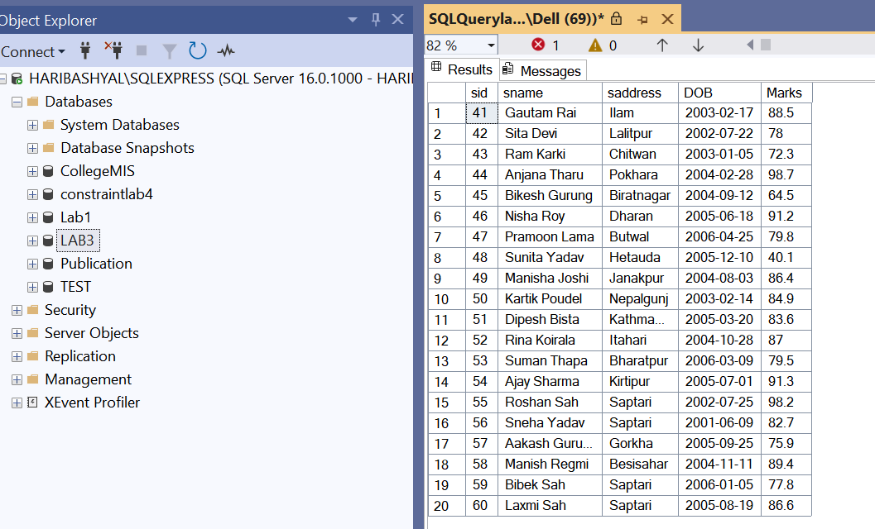
Again, we have to execute Delete record then,
Querry: Commit
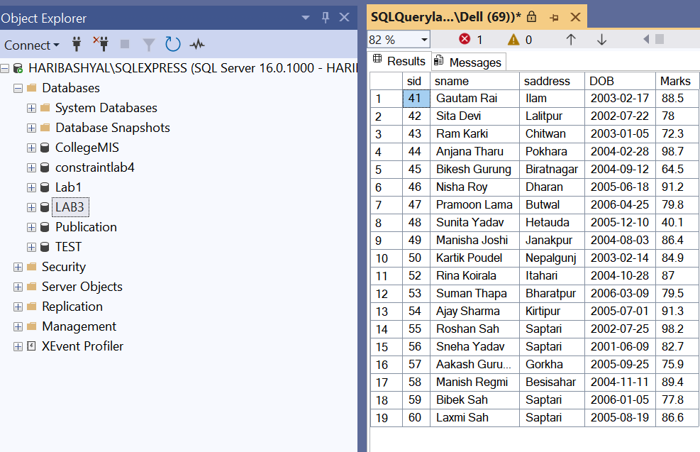

- Update Data
Querry: UPDATE student
SET saddress = 'Kathmandu'
WHERE Marks > 80
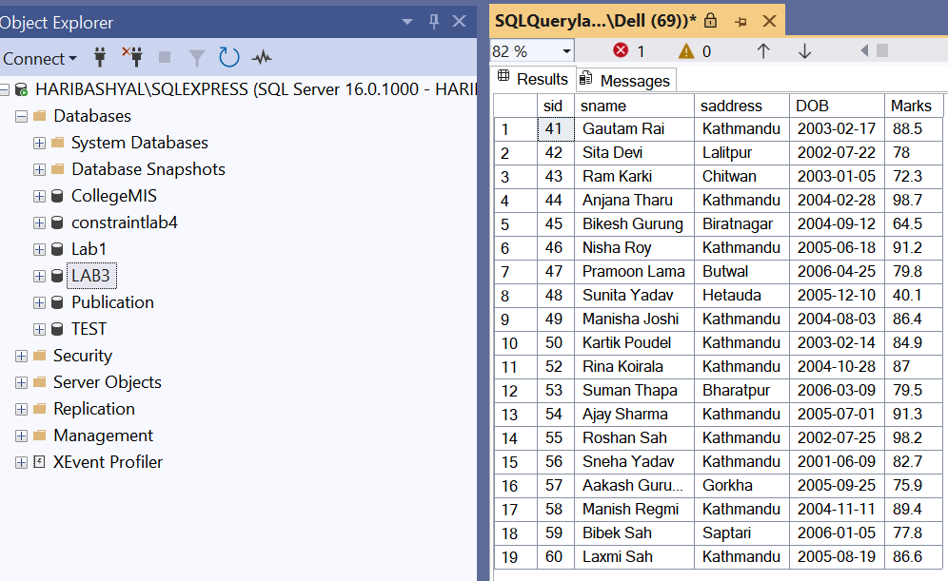

- Check Rollback and Commit
Querry: ROLLBACK
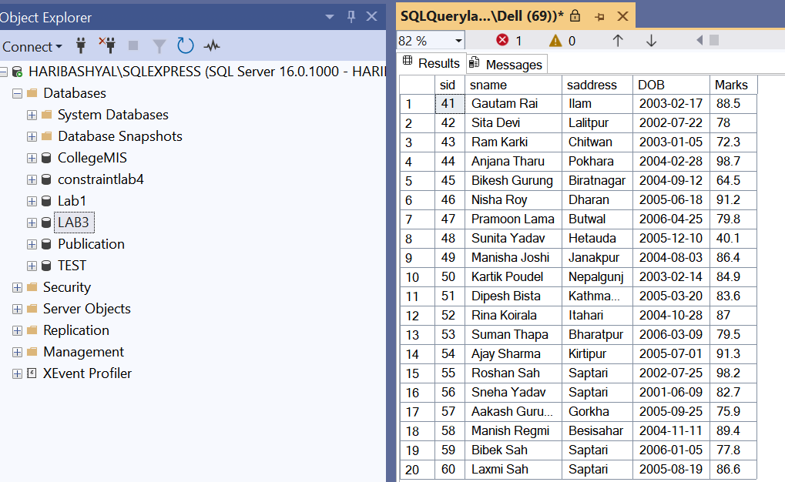
Again, we have to execute update code then,
Querry: COMMIT
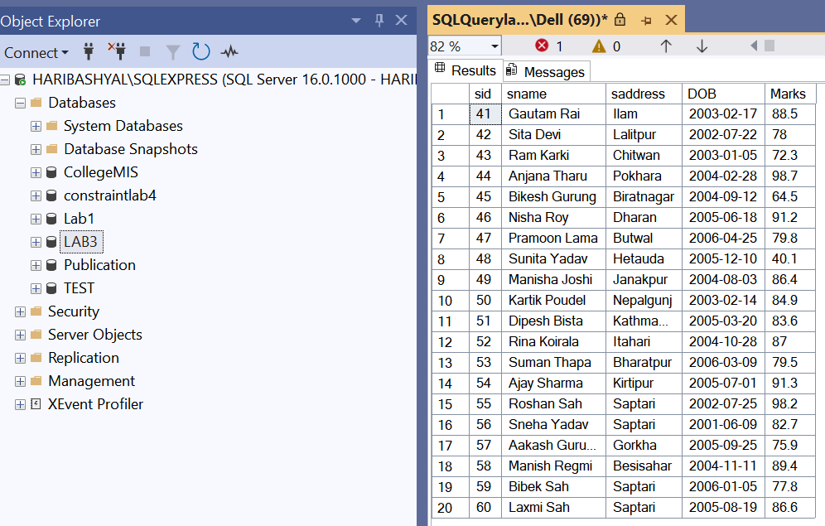

- Drope Table
Querry: DROP TABLE student; 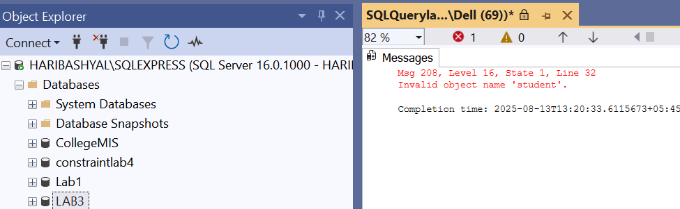

- Check Rollback and Commit
Querry: ROLLBACK
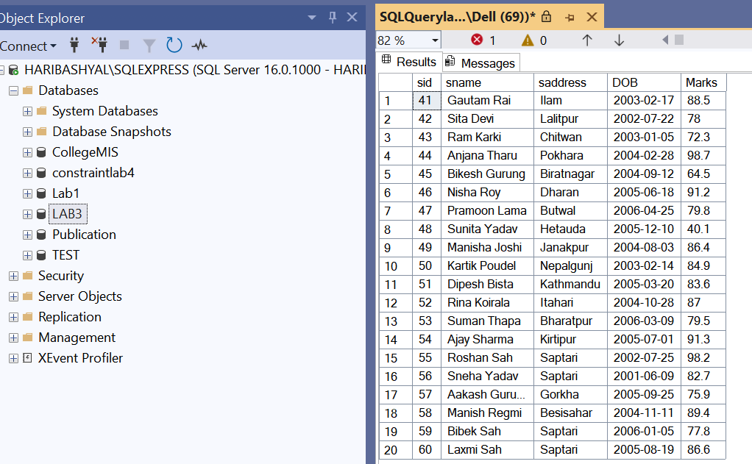

Again, we have to execute Drop Table code then,
Querry: COMMIT


