LAB-4: Use of Constraints
- Creating Database:
Query: CREATE DATABASE constraintlab4 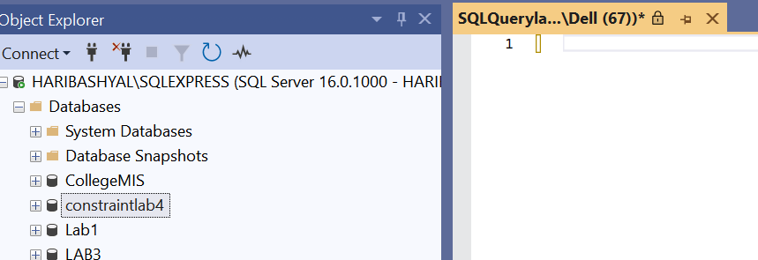

- Creating Table of Department:
Query: CREATE TABLE department(
did int primary key,
dname varchar(20) NOT NULL,
location varchar(20) default 'head office'
)
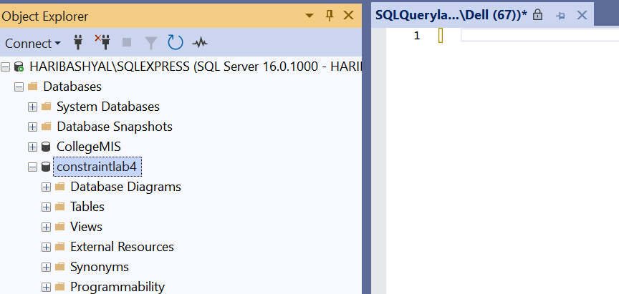

- Creating Table of Employee:
Query: CREATE TABLE employee(
eid int identity(1,1) primary key,
fname varchar(20) NOT NULL,
mname varchar(20),
lname varchar(20) NOT NULL,
Email varchar(20) unique,
salary decimal(10,2) check(salary >= 18000),
did int , foreign key(did) references department(did),
joindate date default getdate()
)
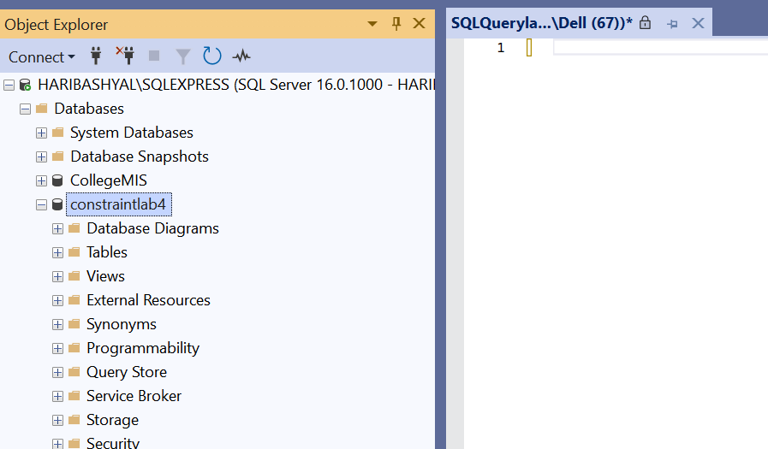

- Insert sample data into all tables (Department, Employee).
Query: INSERT INTO department (did, dname, location) VALUES
(1, 'Human Resources', 'Kathmandu'),
(2, 'Finance', 'Pokhara'),
(3, 'IT', 'Lalitpur'),
(4, 'Marketing', 'Biratnagar'),
(5, 'Sales', 'Butwal'),
(6, 'Operations', 'Dharan'),
(7, 'Legal', 'Bhaktapur'),
(8, 'Research', 'Janakpur'),
(9, 'Customer Service', 'Nepalgunj'),
(10, 'Administration', 'head office');

INSERT INTO employee (fname, mname, lname, Email, salary, did, joindate) VALUES
('Rajan', 'Kumar', 'Joshi', 'rajan.joshi@ex.com', 24000.00, 1, '2024-05-10'),
('Sneha', NULL, 'Tamang', 'sneha.tamang@ex.com', 22000.00, 2, '2023-10-01'),
('Bibek', 'Prasad', 'Shah', 'bibek.shah@ex.com', 26000.00, 3, '2022-08-15'),
('Laxmi', NULL, 'Malla', 'laxmi.malla@ex.com', 20000.00, 4, '2025-02-20'),
('Kamal', 'Raj', 'Thapa', 'kamal.thapa@ex.com', 23000.00, 3, '2023-06-30'),
('Nabin', NULL, 'Rai', 'nabin.rai123@ex.com', 21000.00, 6, '2024-07-12'),
('Pooja', 'Devi', 'Shrestha', 'pooja.shres@ex.com', 25000.00, 1, '2022-11-05'),
('Suman', NULL, 'Lama', 'suman.lama12@ex.com', 19500.00, 8, '2023-03-18'),
('Asha', 'Kumari', 'Yadav', 'asha.yadav12@ex.com', 21500.00, 9, '2024-09-25'),
('Manoj', NULL, 'Karki', 'manoj.karki@ex.com', 27000.00, 2, '2025-01-01');

- Display all Department.
Querry: select*
from department
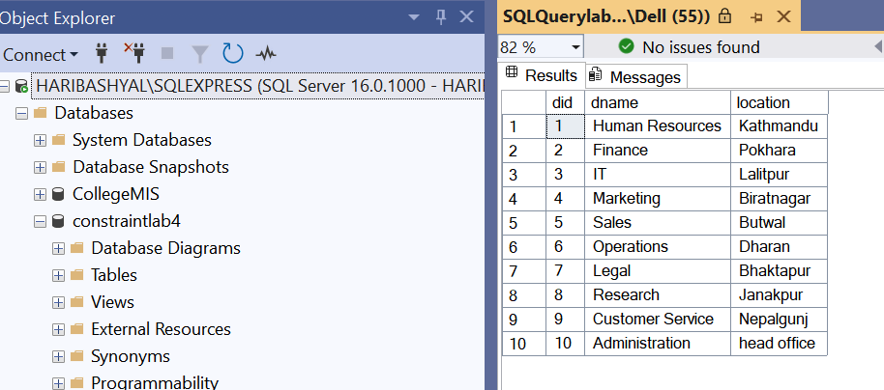
- Show all Employee.
Querry: select*
from Employee
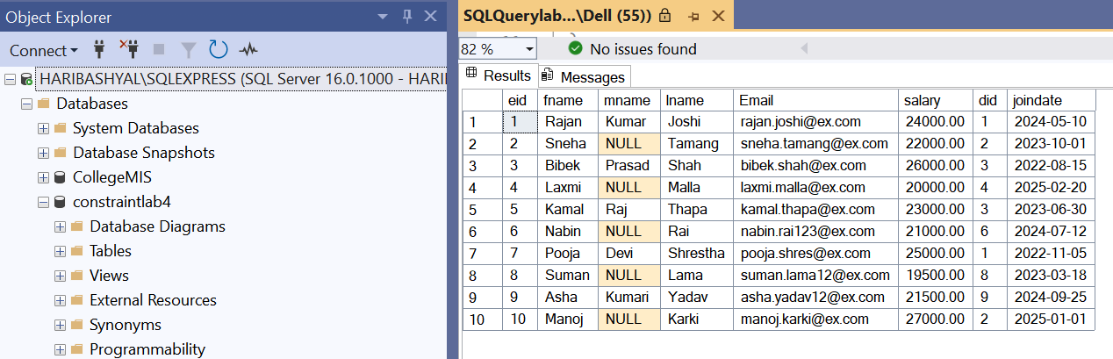
- Insert a new employee without their joindata.
Querry: INSERT INTO employee(fname, mname, lname, Email, salary, did)
VALUES('uncle','kumar','jha','adsss@gmail.com',20000,1)
- Insert a new employee of salary 15000.
Querry: INSERT INTO employee(fname, mname, lname, Email, salary, did)
VALUES('uncle','kumar','jha','adsss@gmail.com',15000,1)
- Insert two new employee of email same.
Querry: INSERT INTO employee(fname, mname, lname, Email, salary, did)
VALUES('anuj','kumar','jha','abd@gmail.com',150000,1),
('bobby','kumar','jha','abd@gmail.com',150000,1)
- Delete IT department.
Querry: DELETE from department
WHERE dname = 'IT'
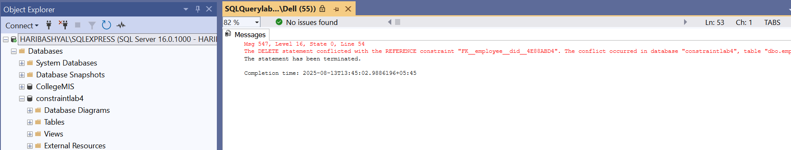
- List all employees who do not join any department.
Querry: SELECT *
from employee e
LEFT JOIN department d
ON e.did = d.did
WHERE d.did IS NULL;
