
Lab Number : 1 Date:2025/06/13
Title: Understanding the basic network equipment
THEORY:
Network Equipment:
Network equipment refers to the physical devices used to connect and manage computers, printers, phones, and other devices in a network. These devices help in transmitting data across networks. For example, Repeater , Hub, Bridge, Switch, Routers, Gateway, Router, Network interface Card , Firewall , WAP and NIC, etc.
- Repeater:
A repeater regenerates and amplifies the signal over the same network before it becomes too weak or corrupted.
Function: A repeater regenerates and amplifies the signal over the same network before it becomes too weak or corrupted.

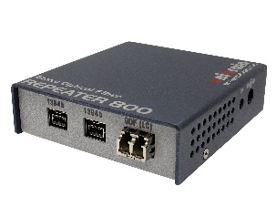

Fig : Repeater

- Hub:
A hub is a basic networking device that connects multiple Ethernet devices, making them act as a single network segment.
Function: A hub is a basic networking device that connects multiple Ethernet devices, making them act as a single network segment.

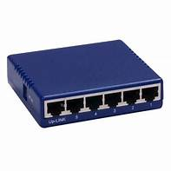

Fig : Hub
- Switch:
A switch is a device that connects devices within a network and uses packet switching to forward data to its destination.
Function: A switch connects devices within a network and uses packet switching to forward data to its destination.
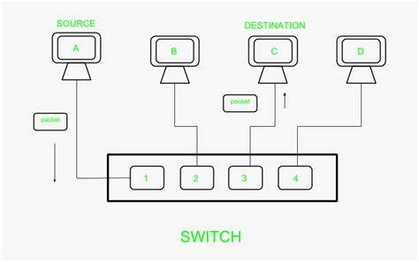

Fig : Switch

- Bridge:
A bridge is a device that connects two separate networks to make them function as a single network.
Function: A bridge connects two separate networks to make them function as a single network.
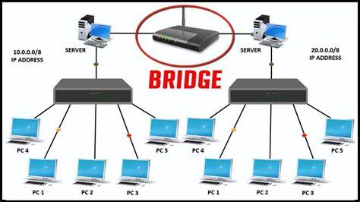

Fig : Bridge
- Rouer:
A router is a networking device that forwards data packets between computer networks.
Function: A router routes data from one network to another, typically connecting a local network to the internet.
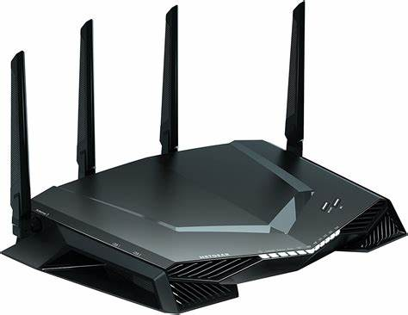

Fig : Router

- Modem:
A modem modulates and demodulates signals for data transmission over telephone lines, cable systems, or satellite systems.
Function: It modulate outgoing digital data from a device into analog signals that can be transmitted over traditional communication lines and to demodulate incoming analog signals back into digital data that the device can understand.
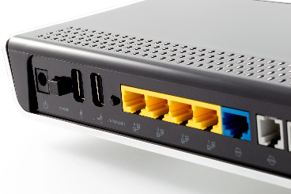

Fig : Modem
- Network Interface Card:
A network interface card is a hardware component that allows a computer or other device to connect to a network.
Function: It provides the physical interface for a computer to communicate over a network. It converts data from the computer into electrical signals for transmission over the network and receives incoming signals to convert them back into usable data. It can support wired (Ethernet) or wireless (Wi-Fi) connections.
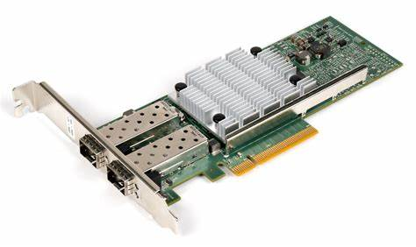
Fig : Network Interface Card

- Firewall:
A firewall is a network security device (hardware or software) that monitors and controls incoming and outgoing network traffic based on predetermined security rules.
Function:
It acts as a barrier between a trusted internal network and untrusted external networks (like the internet). It filters traffic, blocks unauthorized access, and protects devices from malicious attacks by allowing only safe data packets based on defined rules.
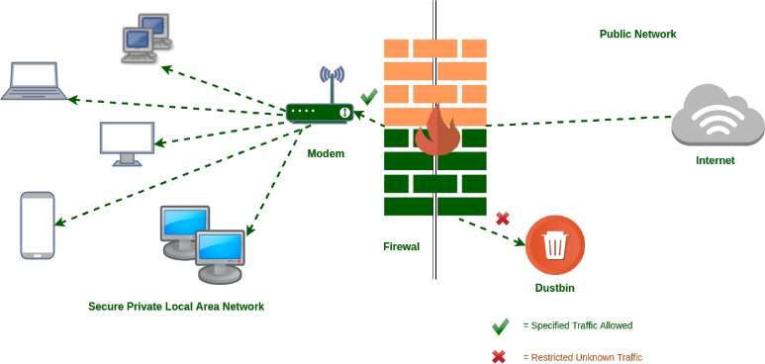
Fig : Firewall

- Wireless Access Point (WAP):
A WAP allows wireless devices to connect to a wired network using Wi-Fi.
Function: A WAP allows wireless devices to connect to a wired network using Wi-Fi.
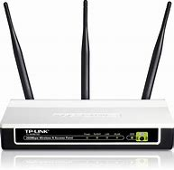

Fig : Wireless Access Point
- VoIP Endpoint:
A VoIP endpoint is a device that connects to a VoIP network to make voice.

Function: VoIP allows voice calls over the internet by converting analog voice signals into digital data packets.

Fig : VoIP Endpoint
CONCLUSION:
In this lab, we explored the fundamental components of a computer network and their respective roles in establishing efficient and secure communication. Devices like repeaters, hubs, switches, bridges, and routers are essential for data transmission and network structuring. Advanced components such as modems, firewalls, wireless access points, and VoIP endpoints extend network capabilities to include internet access, wireless connectivity, security, and voice communication over IP. Understanding these devices provides the foundation for designing, configuring, and maintaining real-world networks. This knowledge is critical for troubleshooting issues, optimizing performance, and building scalable network infrastructures.

