
Lab Number: 10 Date: 2025/08/17
Title: Implementation of Dynamic Interior/ Exterior Routing (RIP, OSPF, BGP)
THEORY:
Dynamic Interior Routing / Exterior Routing
- Dynamic Interior Routing deals with automatic route exchange and updates inside a single Autonomous System (AS). It enables routers within one organization or network to communicate and decide the most efficient path to reach destinations. Protocols such as RIP, OSPF, and EIGRP are commonly used to achieve this.
- Dynamic Exterior Routing is responsible for routing between multiple Autonomous Systems. It allows data to move across the boundaries of organizations and is vital for global Internet communication. The main protocol used is BGP (Border Gateway Protocol), which ensures proper route sharing and connectivity across different Assess worldwide.
RIP, OSPF, BGP
RIP: Routing Information Protocol (RIP) is a distance-vector routing protocol that selects the best route based on hop count. It has a maximum hop count limit of 15, making it most suitable for smaller networks. Although it is easy to set up, RIP has slow convergence and lacks the scalability needed for larger or more complex networks.
OSPF: Open Shortest Path First (OSPF) is a link-state routing protocol that uses the Dijkstra algorithm to determine the shortest path. OSPF is well-suited for large networks as it supports hierarchical structuring by splitting the network into areas. It offers faster convergence, advanced features like route summarization, and supports variable-length subnet masks, though it is more challenging to configure than RIP.
BGP: Border Gateway Protocol (BGP) is a path-vector routing protocol primarily used for routing between different autonomous systems, such as ISPs (Internet Service Providers) and large organizations. BGP focuses on policy-based routing, making it crucial for managing traffic across the internet. It is highly scalable but requires more careful and complex configuration due to its slower convergence compared to internal protocols like OSPF.

Network Diagram
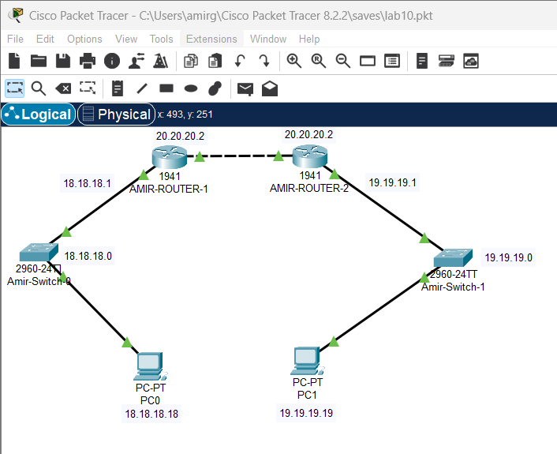
Fig: Network Diagram
IMPLEMENTATION SEQUENCE
Here is the implementation sequence for Implementation of Dynamic Interior/ Exterior Routing (RIP, OSPF, BGP).
- Configuring Network
Configure the network for PCs and Routers
Step 1: Open Packet Tracer and setup the devices.
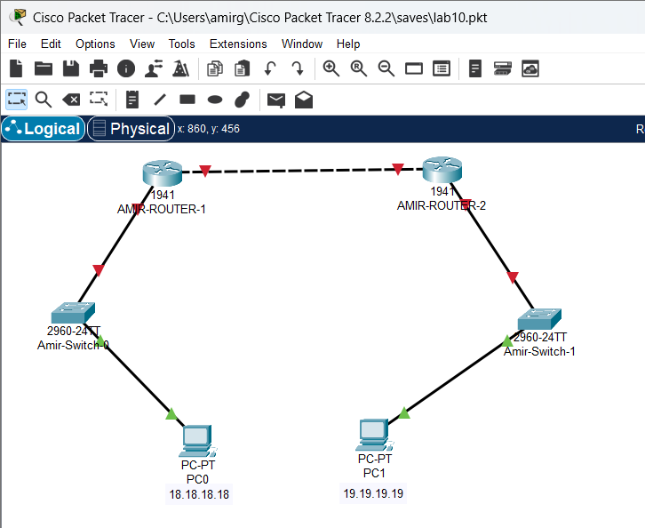
Fig: Simple Network setup
Step 2: Assign IP addresses to each PC.
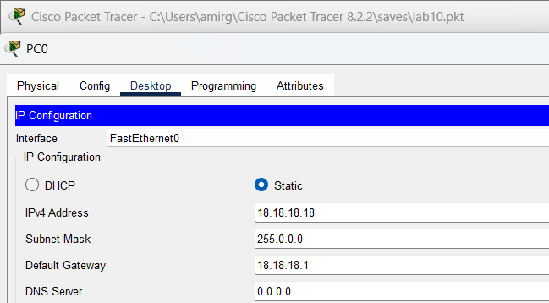
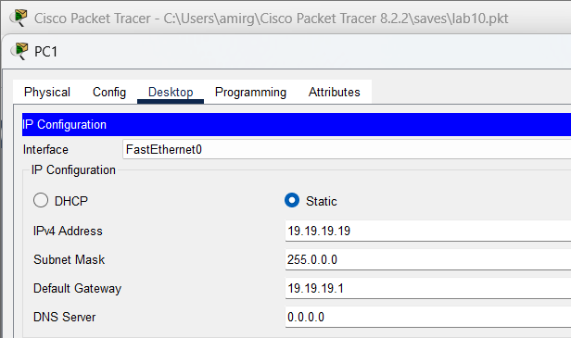
Fig: IP configuration
Step 3: Assign IP addresses to router interfaces.
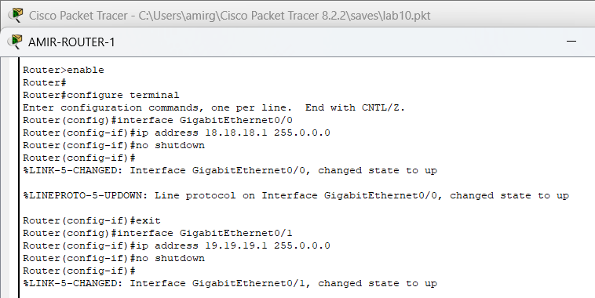
Fig: Gigabit Ethernet configuration on router0

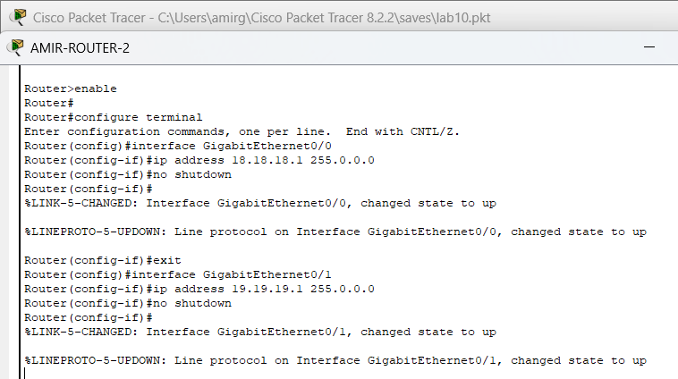Fig: Gigabit Ethernet configuration on router1
Implementation of Dynamic Routing:
Dynamic routing protocols, such as RIP, OSPF, and BGP, are used to enable routers to automatically exchange and update routing information based on changes in the network. The implementation process involves:
- Network Configuration: Set up our network by configuring routers and PCs and assigning IP addresses to each device.
- Dynamic Routing Setup: Enable the chosen dynamic routing protocol (RIP, OSPF, or BGP) on each router. This allows routers to automatically share and update routing information.
- Testing: Use tools like ping to verify that the network configuration is correct and that connectivity is established across the routers.
Need for Dynamic Routing:
Dynamic routing is crucial for modern networks due to the following reasons:
- Automatic Route Updates: As network conditions change-such as when links fail or new devices are added-dynamic routing protocols automatically update the routing tables. This keeps the network connected without requiring manual adjustments.
- Scalability: In large or rapidly changing networks, manually configuring static routes can be impractical. Dynamic routing protocols handle the growth of the network efficiently, making it easier to scale.

- Efficient Path Selectin: Dynamic protocols continuously evaluate network conditions and choose the best path for data. This helps in optimizing performance and reducing delays.
- Redundancy and Fault Tolerance: These protocols improve network reliability by quickly adapting to failures and rerouting traffic through alternative paths, minimizing downtime.
- Improve Load Balancing: Dynamic routing protocols can distribute network traffic evenly across multiple paths.
b) Dynamic Routing Configuration
- Using RIP Command
Network Diagram:
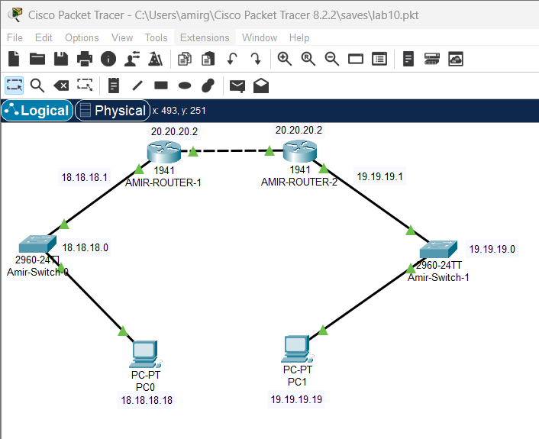
Fig: Network Diagram
Code for Dynamic Routing Configuration using RIP command
For AMIR-ROUTER-1:
Router>enable
Router#configure terminal
Router(config)#router rip
Router(config-router)#version 2
Router(config-router)#network 18.18.18.0
Router(config-router)#network 20.20.20.0
Router(config-router)#exit
For AMIR-ROUTER-2:
Router>enable
Router#configure terminal
Router(config)#router rip
Router(config-router)#version 2
Router(config-router)#network 19.19.19.0
Router(config-router)#network 20.20.20.0
Router(config-router)#exit
Steps for Dynamic Routing Configuration using RIP Command
Step 1: Access the Router CLI
- Open Packet Tracer
- Click on the router we want to configure to access its CLI (Command Line Interface).
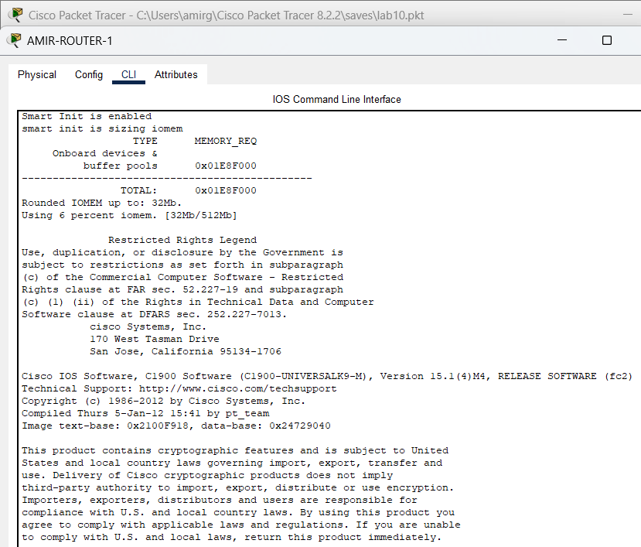
Fig: Accessing Router CLI via Console Cable
Step 2: Enter Global Configuration Mode
- Enable RIP Routing Protocol
- Specify the RIP Version
- Configure the RIP Networks
- Exit RIP Configuration Mode
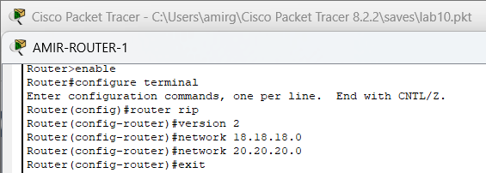
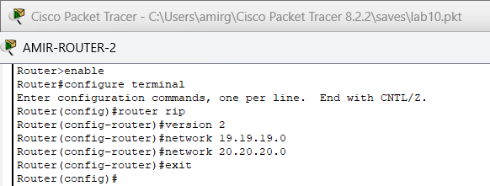Fig: Router configuration of AMIR-ROUTER-1 and AMIR-ROUTER-2 using RIP command
Testing
To test whether the network is working, we can ping other devices on the network from
Each PC. If the ping is successful, we should see replies from the other device.
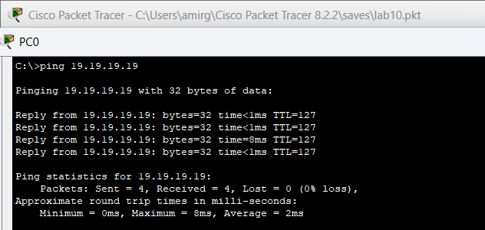Fig: Connectivity test from PC0 to PC1
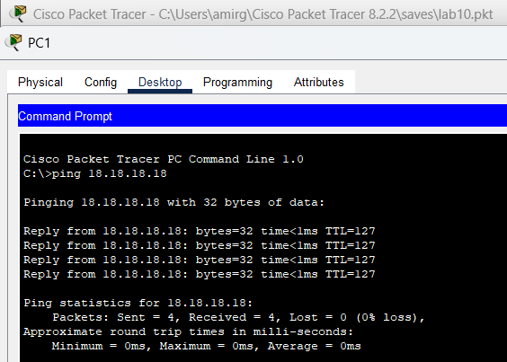
Fig: Connectivity test between PC1 to PC0
Above figure shows the results of a ping test between two PCs on a network. The ping test was successful, indicating that there is connectivity between the two devices.
Addressing Table:
The addressing table of the RIP Configuration is as follows:
Device | Interface | IPv4 address | Subnet | Router No
PCO | NIC | 18.18.18.18 | 18.18.18.0 | 1
PC1 | NIC | 19.19.19.19 | 19.19.19.0 | 2

- Using OSPF Command
Network Diagram
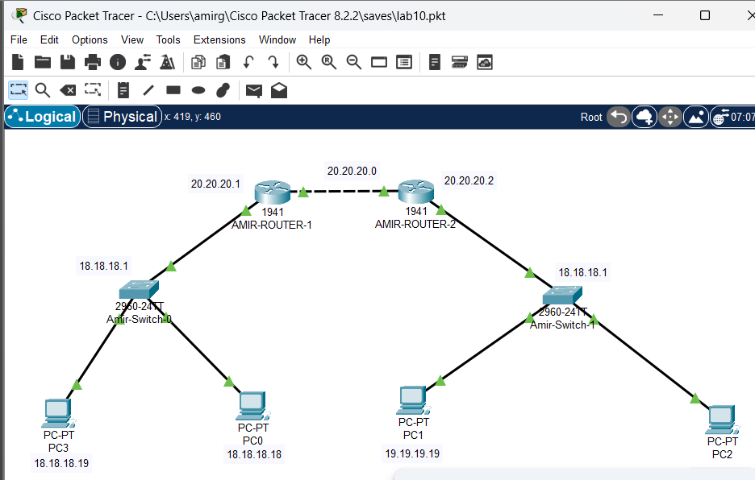
Fig: Network Diagram
Code for Dynamic Routing Configuration Using OSPF Command
For AMIR-ROUTER-1:
Router>enable
Router#config t
Router(config)#router ospf 1
Router(config-router)#network 18.18.18.0 0.255.255.255 area 0
Router(config-router)#network 20.20.20.0 0.255.255.255 area 0
Router(config-router)#exit
For AMIR-ROUTER-2:
Router>enable
Router#config t
Router(config)#router ospf 2
Router(config-router)#network 19.19.19.0 0.255.255.255 area 0
Router(config-router)#network 20.20.20.0 0.255.255.255 area 0
Router(config-router)#exit
Steps for Dynamic Routing Configuration using OSPF command
Step 1: Access the Router CLI
- Open Packet Tracer.
- Click on the router we want to configure to access its CLI (Command Line Interface).
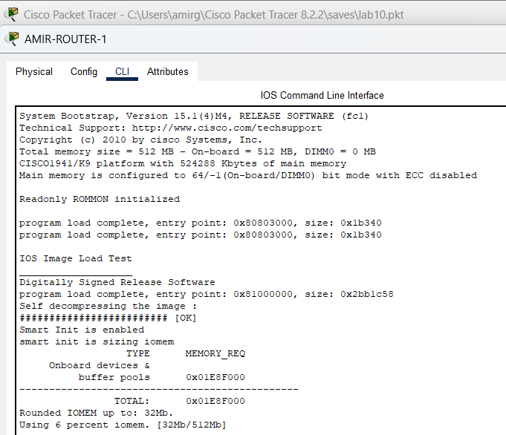
Fig: Accessing Router Command-Line Interface via Console Cable
Step 2: Enter Global Configuration Mode
- Enable OSPF Routing Protocol
- Start the OSPF process and assign it a process ID
- Assign a router ID
- Specify the networks connected to Router 1, and define the areas.
- Exit OSPF configuration.
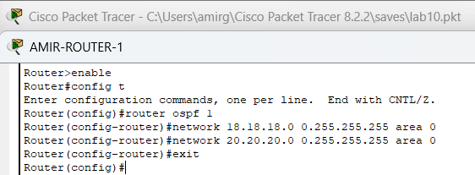
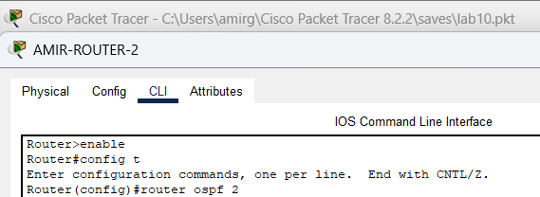
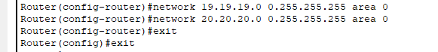Fig: Router configuration for AMIR-ROUTER-1 and AMIR-ROUTER-2 using OSPF command
Testing
To test whether the network is working, we can ping other devices on the network from each PC. If the ping is successful, we should see replies from the other device.
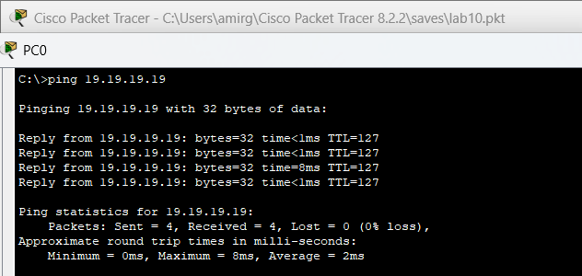
Fig: Connectivity test from PC0 to PC1
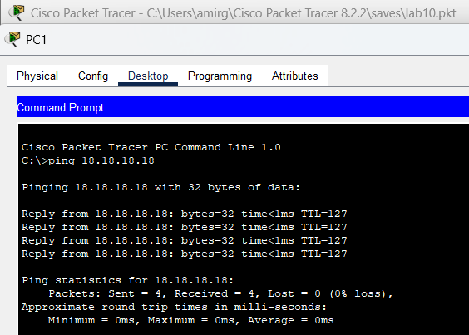
Fig: Connectivity test from PC1 to PC0
Above figure shows the results of a ping test between two PCs on a network. The ping test was successful, indicating that there is connectivity between the two devices. The ping output of the ping test shows the number of packets sent, received, and lost, as well as the approximate round trip time for each packet.
Addressing Table:
The addressing table of the OSPF configuration is as follows:
Device | Interface | IPv4 Address | Subnet | Router no.
PC0 | NIC | 18.18.18.18 | 255.0.0.0 | 1
PC1 | NIC | 19.19.19.19 | 255.0.0.0 | 2
PC2 | NIC | 19.19.19.18 | 255.0.0.0 | 2
PC3 | NIC | 18.18.18.19 | 255.0.0.0 | 1

- Using BGP Command
Network Diagram
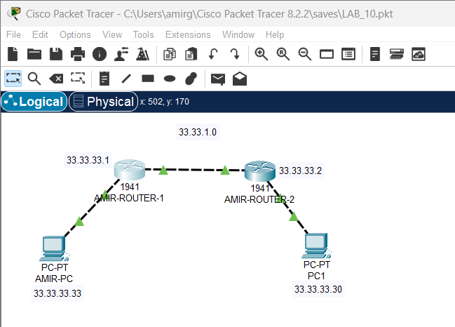Fig: Network Diagram
Code for Dynamic Routing Configuration Using BGP Command
For AMIR-ROUTER-1:
Router0> enable
Router0# configure terminal
Router(config)# router bgp 200
Router(config-router)# network 33.33.1.0
Router(config-router)# network 33.33.2.0
Router(config-router)# neighbor 33.33.33.1 remote-as 100
Router(config-router)# neighbor 33.33.33.33 remote-as 100
Router(config-router)# exit
For AMIR-ROUTER-2:
Router0> enable
Router0# configure terminal
Router(config)# router bgp 100
Router(config-router)# network 33.33.1.0
Router(config-router)# network 33.33.2.0
Router(config-router)# neighbor 33.33.33.2 remote-as 200
Router(config-router)# neighbor 33.33.33.30 remote-as 200
Router(config-router)# exit
Steps For Dynamic Routing Configuration Using BGP Command
Step 1: Access the Router CLI
- Open Packet Tracer
- Click on the router we want to configure to access its CLI (Command Line Interface).
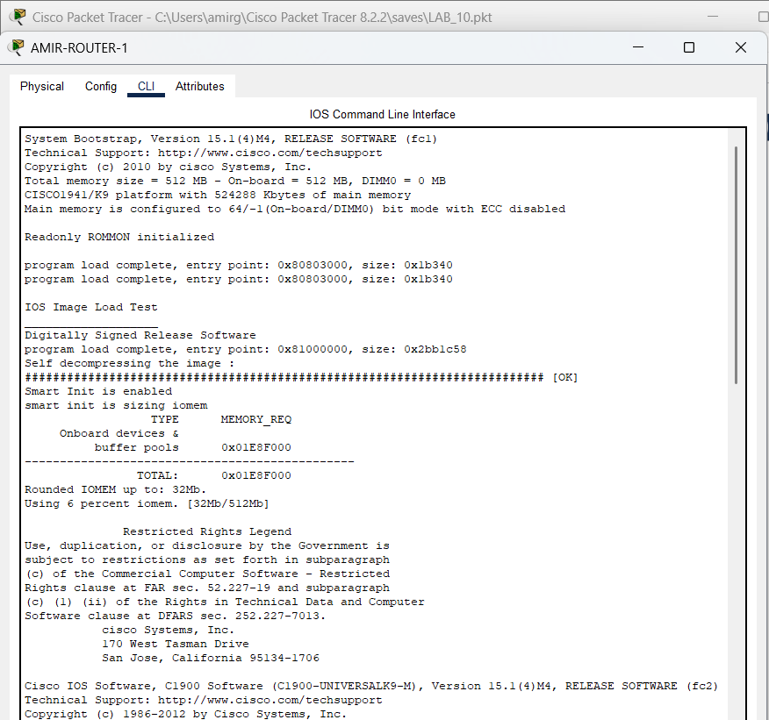
Fig: Accessing Router CLI via Console Cable
Step 2: Enter Global Configuration Mode
- Enable BGP Routing Protocol
- Start the BGP process and specify the AS number
- Configure Neighbor
- Advertise Networks
- Exit BGP configuration
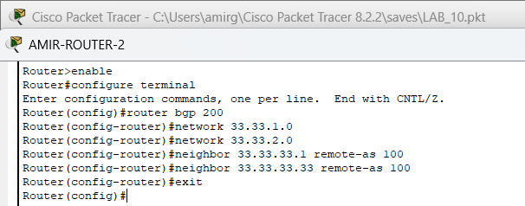
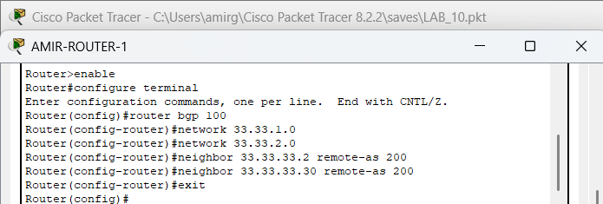
Fig: Router configuration for AMIR-ROUTER-1 and AMIR-ROUTER-2 using BGP command
Testing
To test whether the network is working, we can ping other devices on the network from each PC. If the ping is successful, we should see replies from the other device.
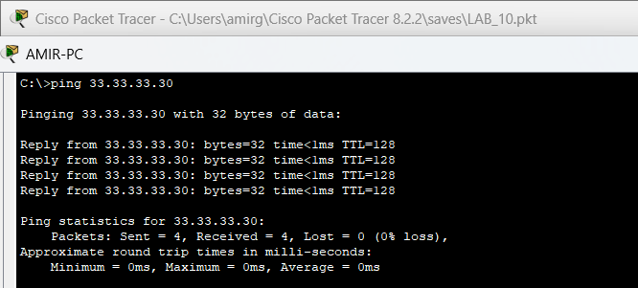
Fig: Connectivity test from AMIR-PC to PC1
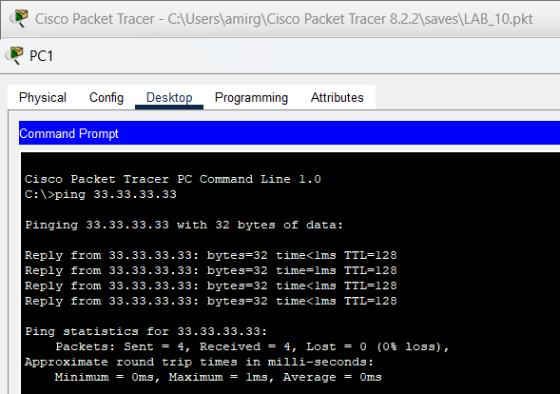
Fig: Connectivity test from PC1 to AMIR-PC
Above figure shows the results of a ping test between two PCs on a network. The ping test was successful, indicating that there is connectivity between the two devices.
Addressing Table:
The addressing table of the BGP Configuration is as follows:
Device | Interface | IPv4 Address | Subnet | Router  No | Link
AMIR-PC | NIC | 33.33.33.33 | 255.0.0.0 | 1 | Access
PC1 | NIC | 33.33.33.30 | 255.0.0.0 | 2 | Access

CONCLUSION
In this lab, we configured dynamic routing protocols RIP, OSPF, and BGP to automate route updates and ensure efficient network connectivity. RIP is ideal for small networks, OSPF offers fast convergence for larger networks, and BGP manages communication between autonomous systems on the internet. Successful ping tests confirmed correct configuration and smooth operation of all protocols.

