
Lab Number : 2 Date:2025/06/13
Title: Understanding Ethernet Wiring in detail.
THEORY:
Network Equipment Details:
  - RJ45 Connectors:
Purpose: RJ45 connectors are used to terminate the ends of Ethernet cables. These connectors enable the physical connection of cables to networking devices such as switches, routers, and computers.
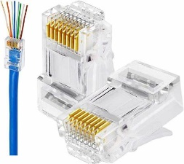

Fig : RJ45 Connectors
  - Crimping Tool:
Purpose: The crimping tool is used to attach RJ45 connectors to the ends of the Ethernet cables. It ensures that the connector pins make a secure and proper connection with the wire ends inside the cable.
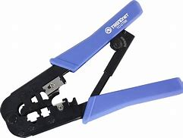

Fig : Crimping Tool
  - Cable Tester:
Purpose: A cable tester is used to verify the integrity and functionality of the Ethernet cables. It checks for correct wiring, continuity, and the presence of any faults such as open circuits or crossed wire.
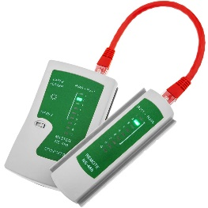

Fig : Cable Tester
  - UTP Cable (Category 5e or 6):
Purpose: UTP (Unshielded Twisted Pair) cables are the medium through which data is transmitted in a LAN. Category 5e and 6 cables are commonly used for Ethernet networks, supporting data transfer rates up to 1 Gbps and 10 Gbps, respectively.
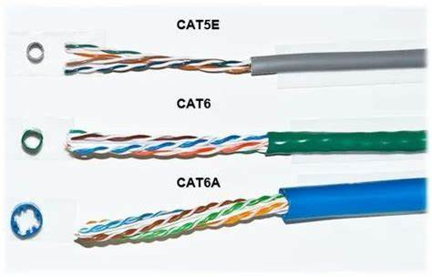
Fig : UTP Cable

  - Wire Stripper:
Purpose: A wire stripper is used to remove the outer jacket of the Ethernet cable without damaging the inner wires. It also helps with untwisting and straightening the pairs of wires inside the cable.
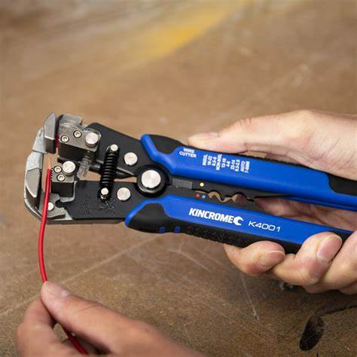

Fig : Wire Stripper
  - Punch Down Tool:
Purpose: Used for inserting wires into punch down blocks or keystone jacks, ensuring a secure and reliable connection for structured cabling systems.
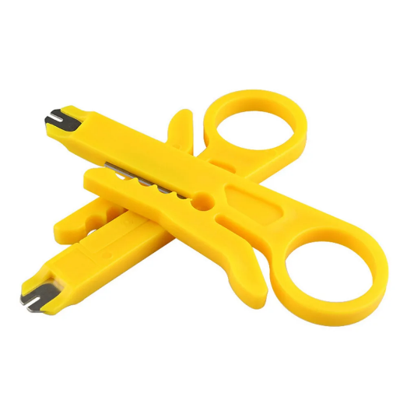

Fig : Punch Down Tool

Wiring Details:
  - Straight-Through UTP Cable
Description: A straight-through UTP (Unshielded Twisted Pair) cable is typically used to connect different types of devices within a network, such as a computer to a switch or a router. This type of cabling ensures that the same wire pairs are connected to the same pins on each end of the cable.
T568B Color Code:
Pin 1 | White/Orange
Pin 2 | Orange
Pin 3 | White/Green
Pin 4 | Blue
Pin 5 | White/Blue
Pin 6 | Green
Pin 7 | White/Brown
Pin 8 | Brown
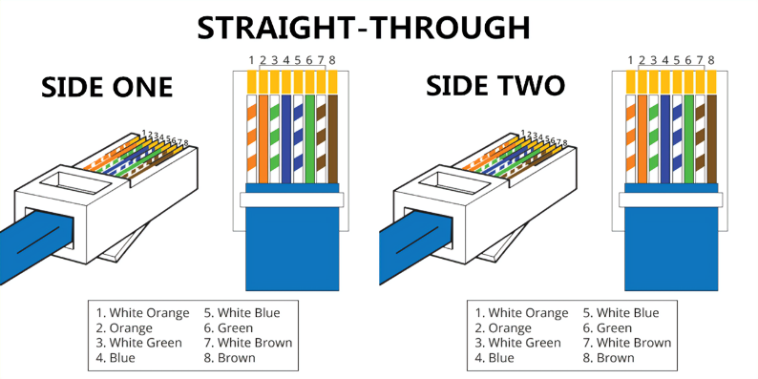
It can be represented as:

Fig : Straight through UTP Cable

2.2 ) Crossover UTP Cable:
Description: A straight-through UTP (Unshielded Twisted Pair) cable is typically used to connect different types of devices within a network, such as a computer to a switch or a router.
One end of the cable follows the T568A standard, and the other end follows the T568B standard.
T568A Color Code:
Pin 1 | White/Green
Pin 2 | Green
Pin 3 | White/Orange
Pin 4 | Blue
Pin 5 | White/Blue
Pin 6 | Orange
Pin 7 | White/Brown
Pin 8 | Brown
T568B Color Code:
Pin 1 | White/Orange
Pin 2 | Orange
Pin 3 | White/Green
Pin 4 | Blue
Pin 5 | White/Blue
Pin 6 | Green
Pin 7 | White/Brown
Pin 8 | Brown
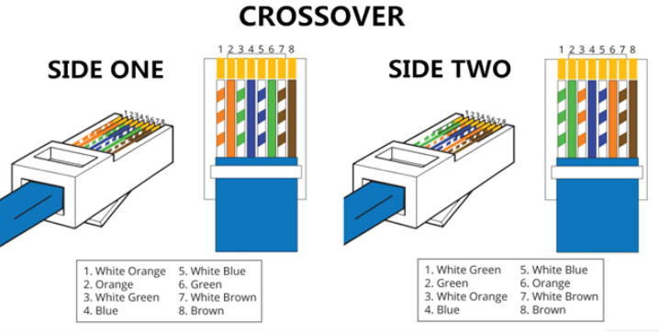

Fig : Crossover through UTP Cable
STEPS REQUIRED:
Algorithm for STRAIGHT-THROUGH:
1. Use a wire cutter to cut the UTP cable to your desired length.
2. With a wire stripper, remove about 1-2 inches of the outer jacket from both ends of the cable.
be careful not to nick the inner wires.
3. Separate and untwist the pairs of wires, then arrange them following the T568B wiring standard.
4. Trim the wires evenly, leaving approximately 0.5 inches exposed from the jacket.
5. Gently insert the wires into the RJ45 connector, making sure each wire is fully seated in its slot with the pins facing up.
6. Place the RJ45 connector into the crimping tool and squeeze it firmly to lock the wires in place.
7. Repeat the process for the other end of the cable, ensuring the T568B wiring order is consistent.
8. Finally, use a cable tester to verify the wiring, continuity, and to ensure there are no faults.

Algorithm for STRAIGHT-THROUGH:
1. Use a wire cutter to cut the UTP cable to the length you need.
2. Carefully strip about 1-2 inches of the outer jacket from both ends of the cable using a wire stripper, ensuring the inner wires remain undamaged.
3. Separate and untwist the pairs of wires, then arrange them according to the T568A standard for one end (End 1) and the T568B standard for the other end (End 2).
4. Trim the wires evenly, leaving about 0.5 inches of the wires exposed from the jacket.
5. Gently insert the wires into the RJ45 connector, making sure each wire is fully seated in its slot with the pins facing up.
6. Place the RJ45 connector into the crimping tool and firmly squeeze it to secure the wires in place.
7. Use a cable tester to verify the wiring, check for continuity, and ensure there are no faults

CONCLUSION:
In this lab, we gained a comprehensive understanding of Ethernet wiring, specifically focusing on straight-through and crossover UTP cables. We explored the essential network equipment such as crimpers, RJ-45 connectors, and cable testers, and learned how to use them effectively. By following standard wiring color codes (T568A and T568B), we practiced preparing and terminating both types of cables. We also learned to verify the cable connections using a LAN tester to ensure proper functionality and signal transmission. This knowledge is fundamental for setting up reliable wired networks and helps build a strong foundation for understanding computer networking.

