
Lab Number : 3 Date:2025/07/1
Title: OS Installation & Practice on Basic Networking Command
THEORY:
Linux
Linux is an open-source, Unix-like operating system kernel that serves as the foundation for a wide range of operating systems, collectively known as Linux distributions (e.g., Ubuntu, Fedora, Debian). It is renowned for its stability, security, and flexibility, making it a popular choice for servers, desktops, and embedded systems. Developed by a global community of contributors, Linux supports a vast array of hardware platforms and is widely used in various fields, from web servers to mobile devices. Its open-source nature allows users to freely modify and distribute the software.
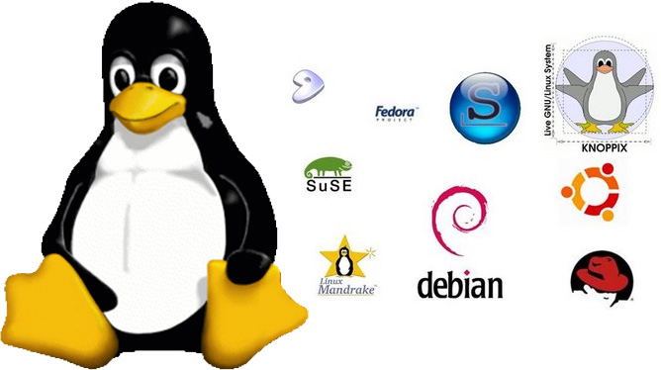

Fig 1: Various types of Linux
VirtualBox
VirtualBox is an open-source virtualization software developed by Oracle, allowing users to run multiple operating systems simultaneously on a single physical machine. It supports a wide range of guest OS types and is available on various host platforms, making it a versatile tool for testing, development, and learning environments.

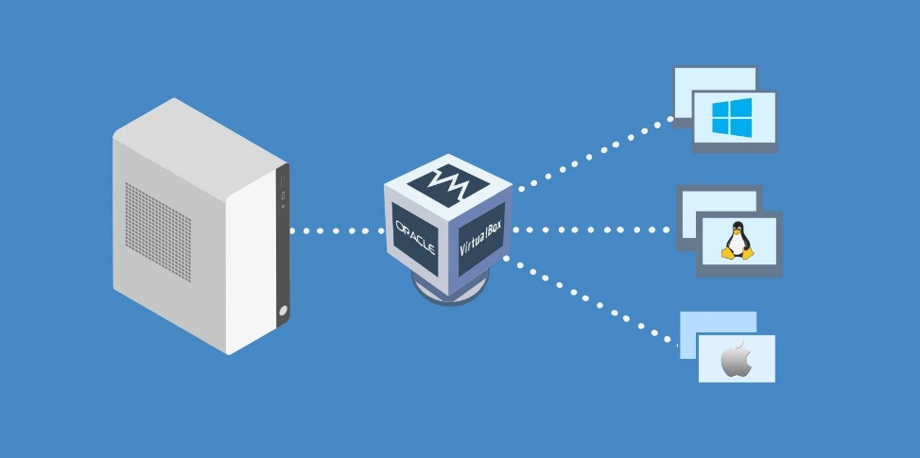
Fig 2 : VirtualBox logo

VMware
VMware is a top provider of virtualization solutions, offering tools like VMware Workstation and VMware vSphere. These products enable users to create and manage virtual machines on a single physical host, known for their robust performance and enterprise features. VMware is widely used in IT environments for server consolidation, application testing, and cloud computing.
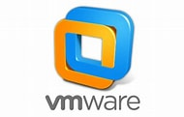

Fig 3 : VMware logo

INSTALLING THE VIRTUAL BOX:
Oracle VM Virtual Box is cross-platform virtualization software that allows users to run multiple operating systems including Microsoft Windows, Mac OS X, Linux, and Oracle Solaris, at the same time on a single physical machine as virtual machine. It is a versatile tool that can meet a wide range of virtualization needs.
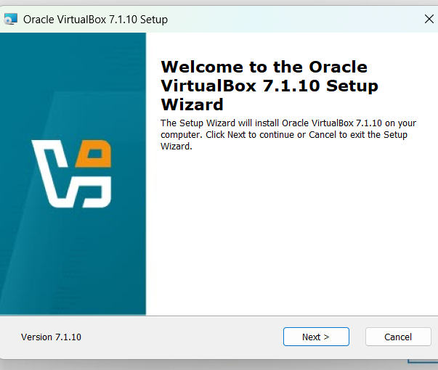

Here, click Next and proceed.

Once Virtual Box is installed then we can create, add or import new VMs using toolbar buttons.
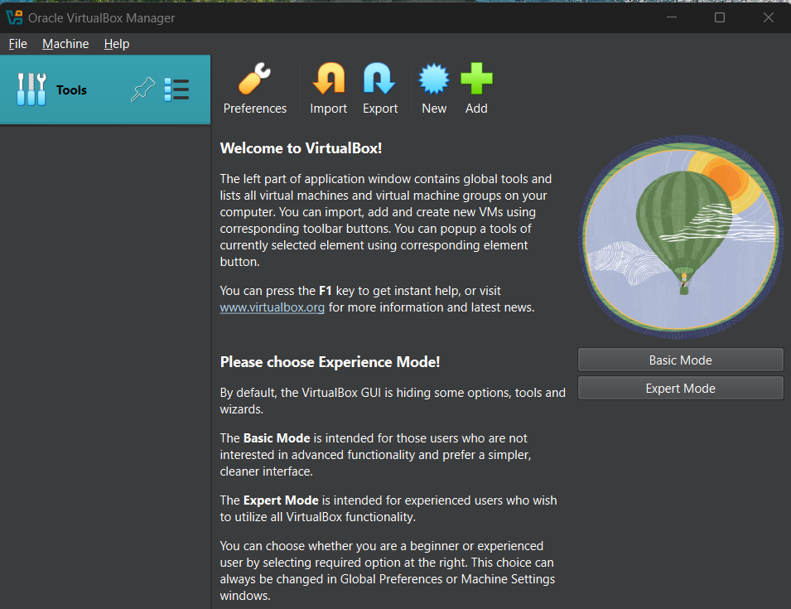
INSTALLING LINUX (UBUNTU) DESKTOP OS:
Step 1: Click New on Virtual Machine toolbar and add details about the new VM and required OS.
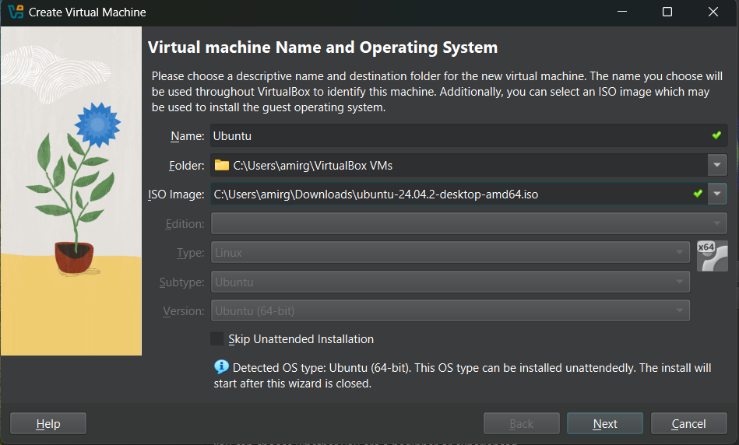
Step 2: Select the Base Memory and Processors to be allocated to the Virtual Machine as per your need.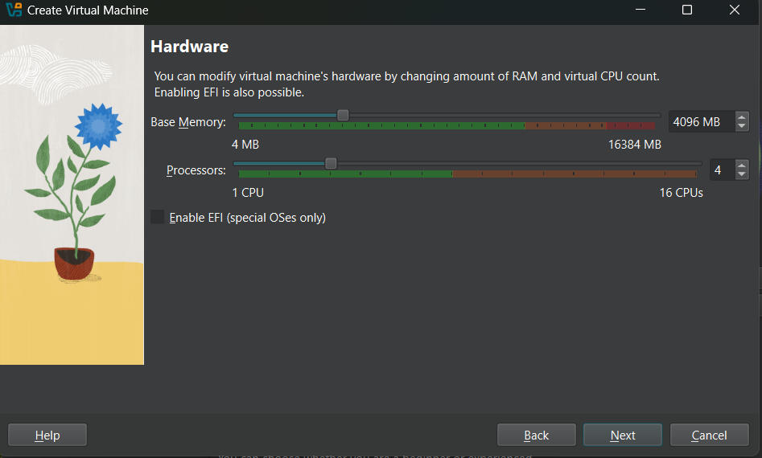

Step 3: Select the size of memory to be allocated for Virtual Hard Disk.
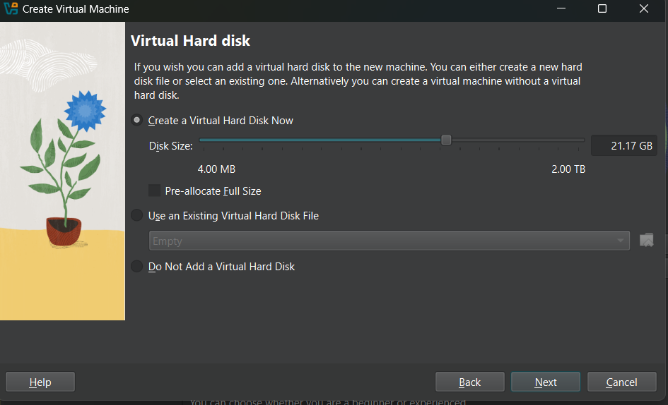
Step 4: This is the interface for the newly created Virtual Machine for Ubuntu Desktop OS. Select Server and click on Start to run the Virtual Machine
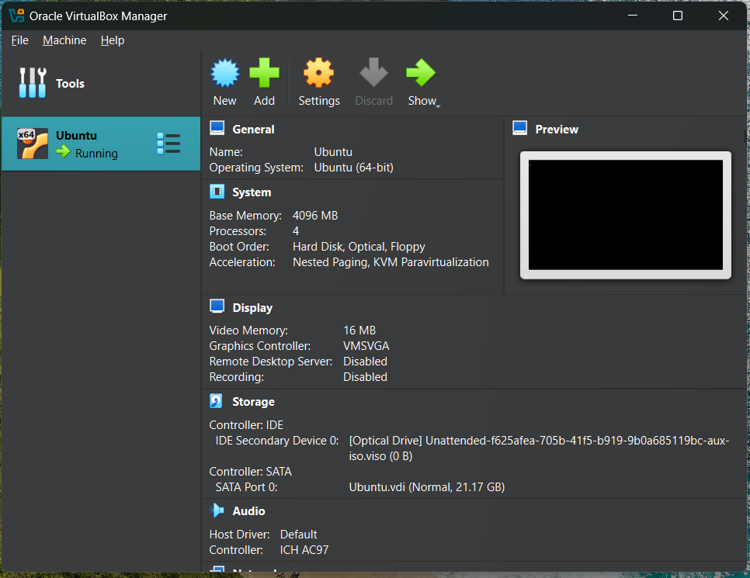
Step 5: Press Enter to install Ubuntu Server.
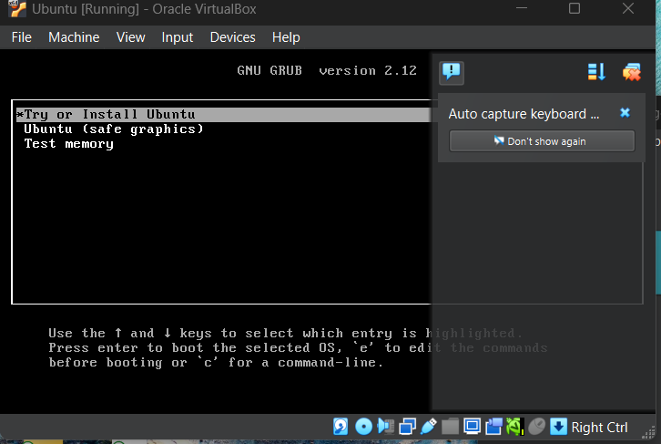
Step 6: Now enter the Login details on the screen and press Enter to login into the system. 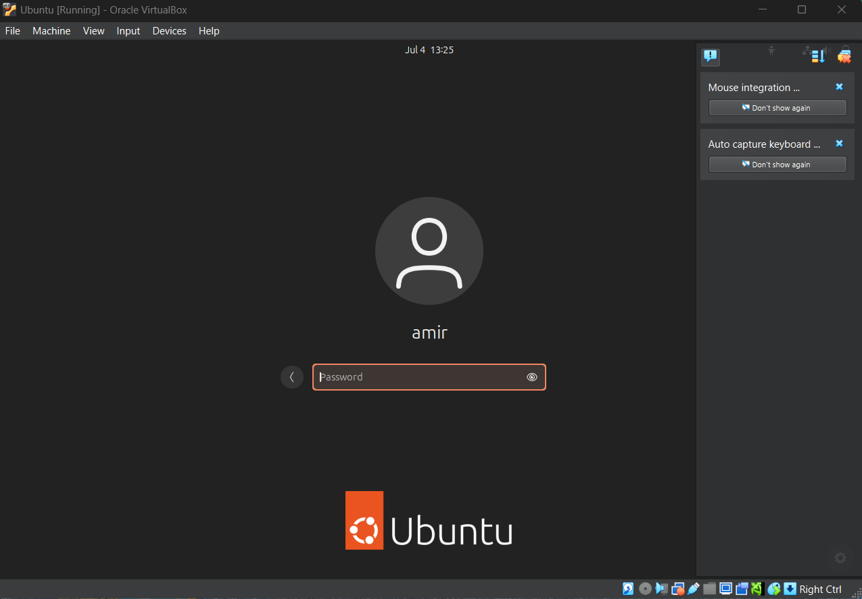
Step 7: Now our system is ready, and Ubuntu is installed completely.
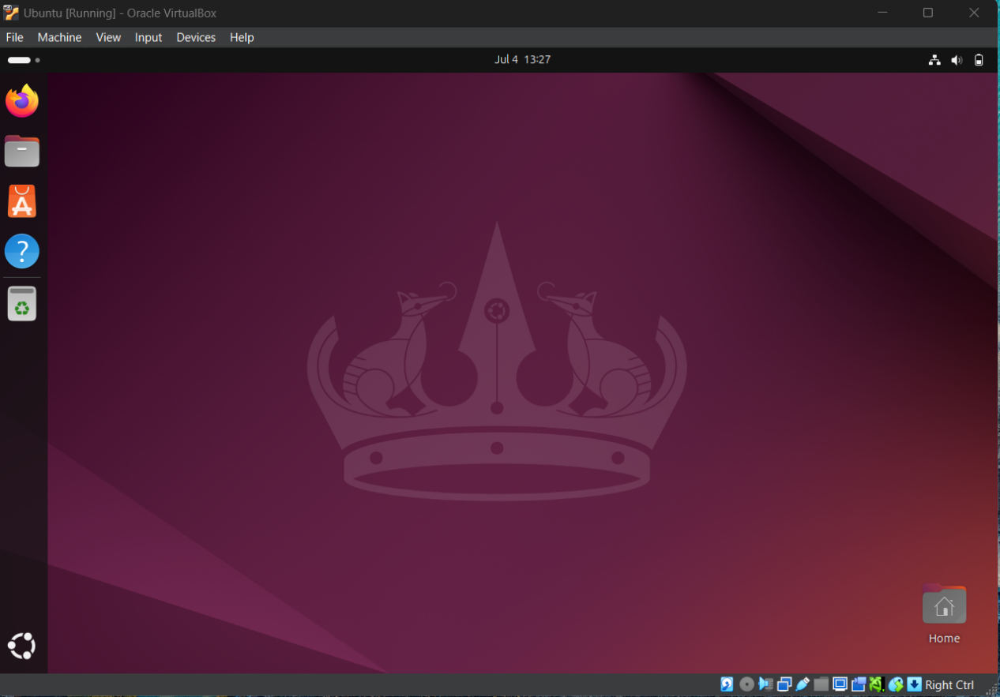
BASIC NETWORKING COMMANDS
1. PING
Ping (Packet Internet Groper) is a command-line utility used to test network connectivity between two hosts by sending ICMP echo request packets and waiting for ICMP echo reply to packets.
Syntax: ping <hostname/IP>
Uses: Used for checking whether any network is present and if a host is attainable.
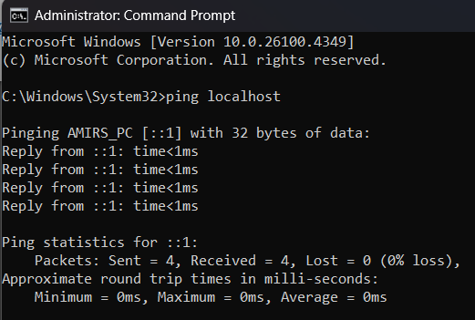

2. GETMAC
MAC address is the physical address, which uniquely identifies each device on a given network. It is assigned to the NIC (Network Interface card) of each device that can be connected to the internet.
Syntax: getmac
Uses: Commonly used in troubleshooting network problems and for network security purposes.
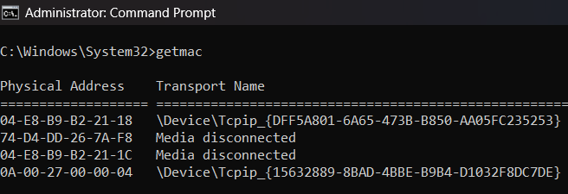

3. IPCONFIG
‘ipconfig’ refers to the Internet Protocol Configuration .It is a program of console application of a few computer OSes that shows every current value of TCP/IP network configuration and refreshes DNS and DHCP settings.
Syntax: ipconfig / ipconfig all
Uses: They are used to view and manage network configuration settings, renew DHCP leases, flush DNS cache, and configure network interfaces.
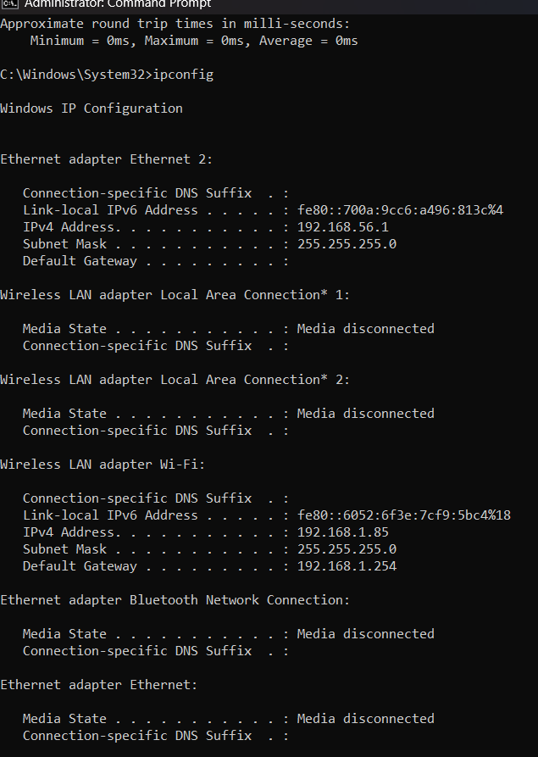

4. HOSTNAME
Hostname is a command-line utility used to display or set the name of the computer or device within a network. It can be accessed without using a particular IP address.
Syntax: hostname
Uses: Used to display the system name.
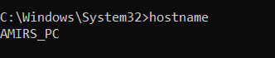
5. NSLOOKUP:
Nslookup is a command-line tool used to query DNS servers to obtain domain name or IP address mapping, DNS records (such as MX records), and other DNS-related information.
Syntax: nslookup <domain>
Uses: It is used for troubleshooting DNS issues, verifying DNS records, testing DNS configurations, and performing reverse DNS lookups.
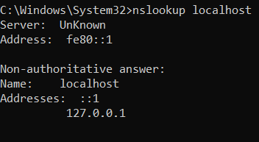
6. TRACERT
Traceroute (Unix/Linux) or tracert (Windows) is a command-line utility used to trace the route that packets take across an IP network to a specified destination, showing each hop and round-trip time (RTT).
Syntax: tracert<hostname>
Uses: It is used to diagnose network connectivity issues, identify network latency or routing problems, and analyze the path packets take through the network.
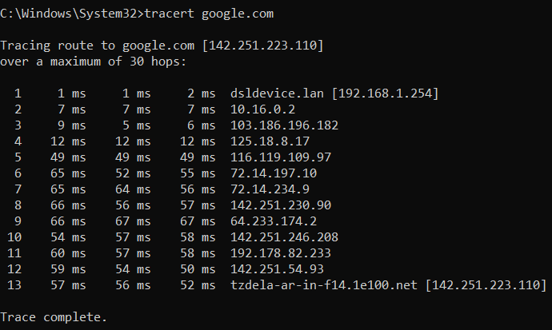

7. NETSTAT
Netstat is a command-line network utility used to display active TCP connections, listening ports, routing tables, and network interface statistics.
Syntax: netstat -an / netstat -b
Uses: It is used for monitoring network connections, identifying open ports, troubleshooting network performance issues, and analyzing network traffic.
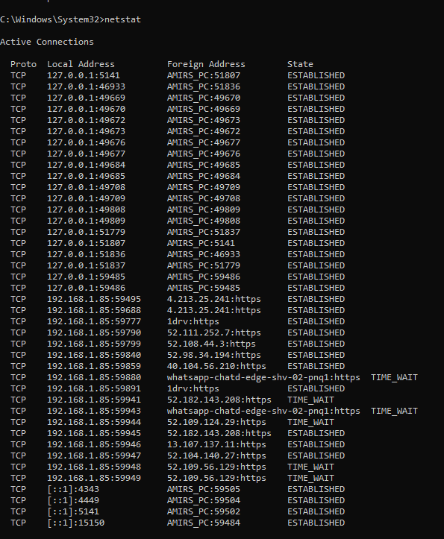

8. ROUTE PRINT
Route Print is a command-line utility used to display the current routing table of a Windows operating system.
Syntax: route print
Uses: It is used for viewing and troubleshooting the IP routing table, checking the default gateway, analyzing how packets are routed in the network, and diagnosing connectivity issues.
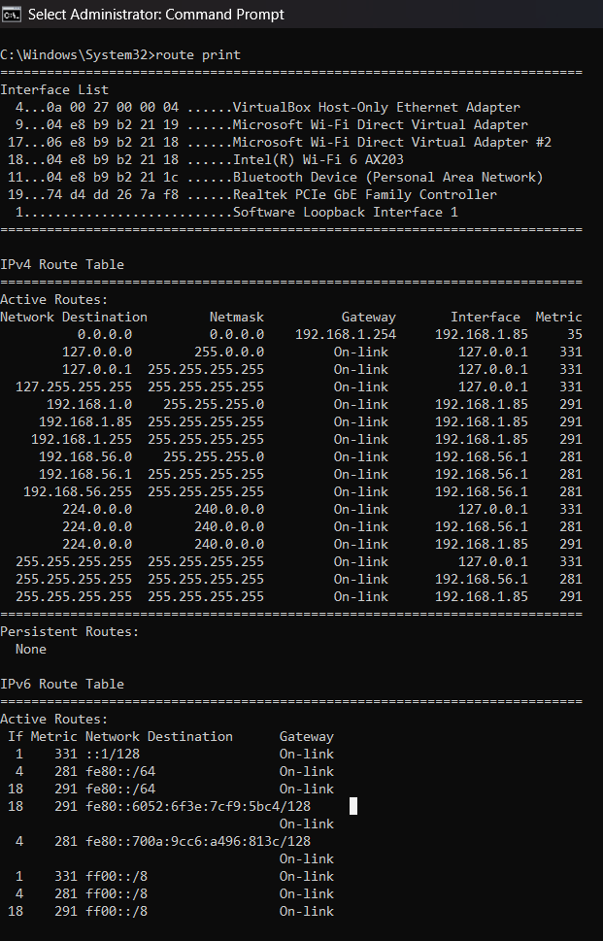
9. NMAP
Nmap (Network Mapper) is a powerful open-source command-line tool used for network discovery and security auditing.
Syntax: nmap < target >
Uses: It is used for scanning open ports, detecting services and operating systems on devices, identifying network vulnerabilities, performing security audits, and mapping networks.
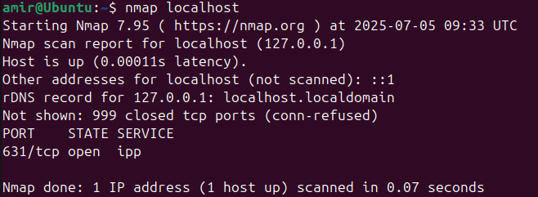

10. NETCAT
Netcat (often abbreviated as nc) is a versatile command-line networking tool used for reading from and writing to network connections using TCP or UDP.
Syntax: nc <target> <port>
Uses: It is used for port scanning, banner grabbing, transferring files, setting up backdoors, and testing network connections.
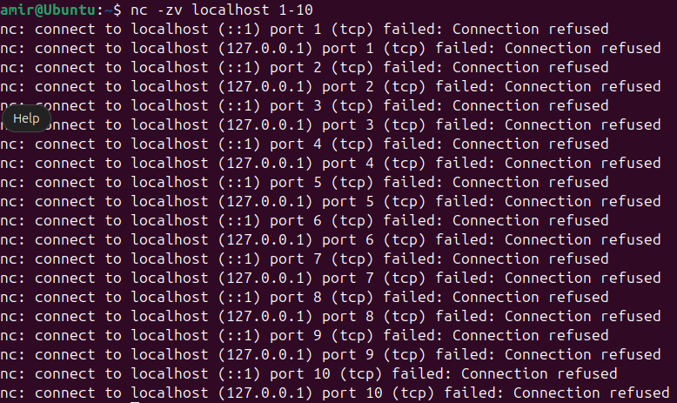
11. CURL
CURL (Client URL) is a command-line tool used to transfer data to or from a server using various protocols such as HTTP, HTTPS, FTP, and more.
Syntax: curl <URL>
Uses: It is used for downloading or uploading files, testing APIs, automating web requests, and checking server responses.
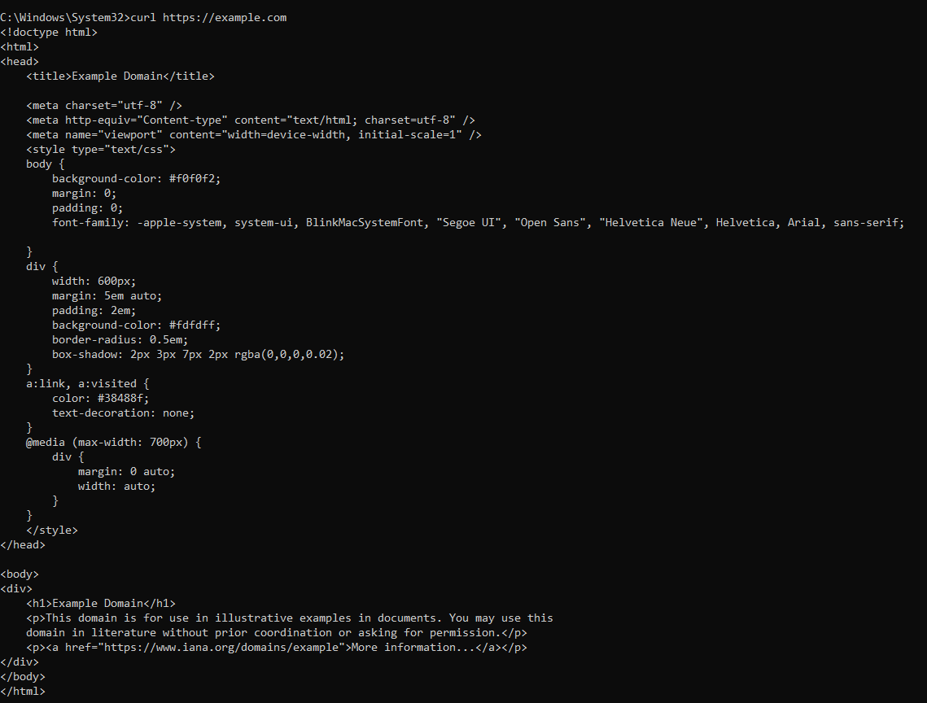

12. SYSTEMINFO
Systeminfo is a command-line utility on Windows systems used to display detailed configuration information about the computer's operating system, hardware resources, and network settings.
Syntax: systeminfo
Uses: Used to display detailed configuration information about a computer and its operating system.
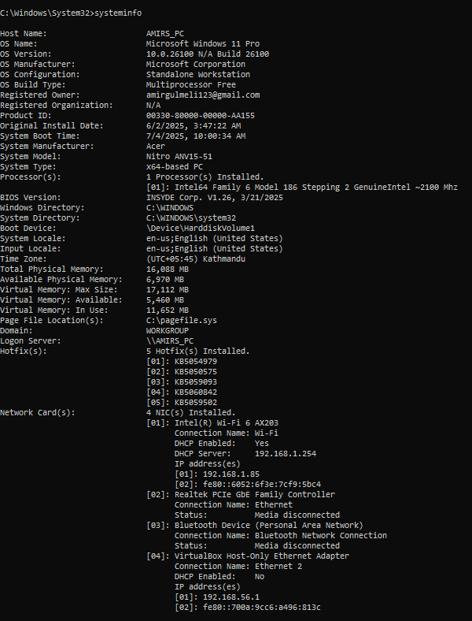
CONCLUSION:
In setting up the operating system, the installation of Linux through Oracle VM VirtualBox and experimentation with basic networking commands, including ping , nslookup, tracert, netstat, route print, systeminfo, curl , nmap and netcat, underscored their pivotal role in root cause analysis and system information gathering. These tools were essential in identifying and addressing technical issues promptly, ensuring the reliability and efficiency of system operations. This hands-on experience demonstrated the critical importance of meticulous system setup and proactive network management for seamless functionality and optimal performance.

