Lab Number: 08 Date: 2025/08/10
Title : Creating VLAN and VLAN Trunking using Packet Tracer
THEORY
A VLAN (Virtual Local Area Network) is a network configuration that divides a single physical network into multiple logical networks. Each VLAN operates as an independent network, even if multiple VLANs share the same physical infrastructure. VLANs enhance network security, minimize broadcast traffic, and allow administrators to segment traffic logically often based on departments, functions, or user groups within an organization.
VLAN Trunking
VLAN trunking is a technique that allows traffic from multiple VLANs to pass through a single network link between switches or other network devices. This is achieved by tagging Ethernet frames with a VLAN identifier, most commonly using the IEEE 802.1Q standard. Trunking enables VLANs to extend across multiple devices and locations, providing greater flexibility in network design and management.
VLAN Architecture

VLAN architecture logically groups devices into separate broadcast domains within the same physical network. Each VLAN typically represents a different logical network, and communication between VLANs is restricted unless routing or firewall rules are configured.
Key components include:
- Access ports – Connect end devices to a specific VLAN.
- Trunk ports – Carry traffic for multiple VLANs between devices.
- VLAN aware devices – Switches and routers that manage VLAN traffic.
This architecture improves scalability, security, and performance in modern networks.
Components Used
Hardware: 2 Switches, Ethernet cables, 4 End devices
Software: Cisco Packet Tracer

Network Diagram
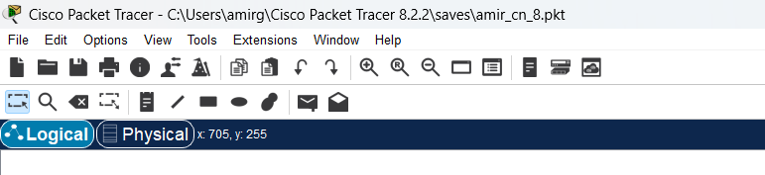
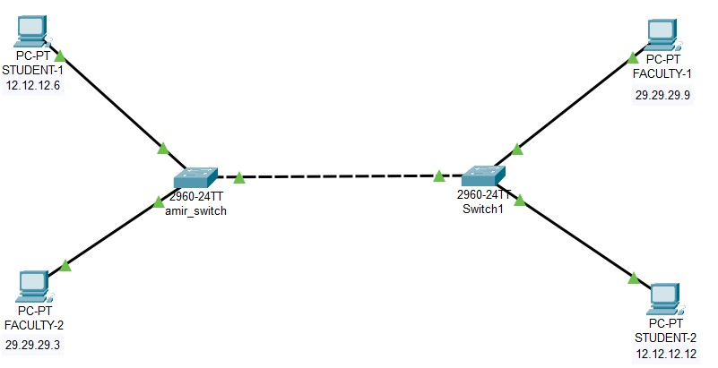
Fig: Network map for VLAN
Procedure
The following steps describe how to create the LAN network shown in the diagram using Cisco Packet Tracer:
Step 1: Launch Cisco Packet Tracer.
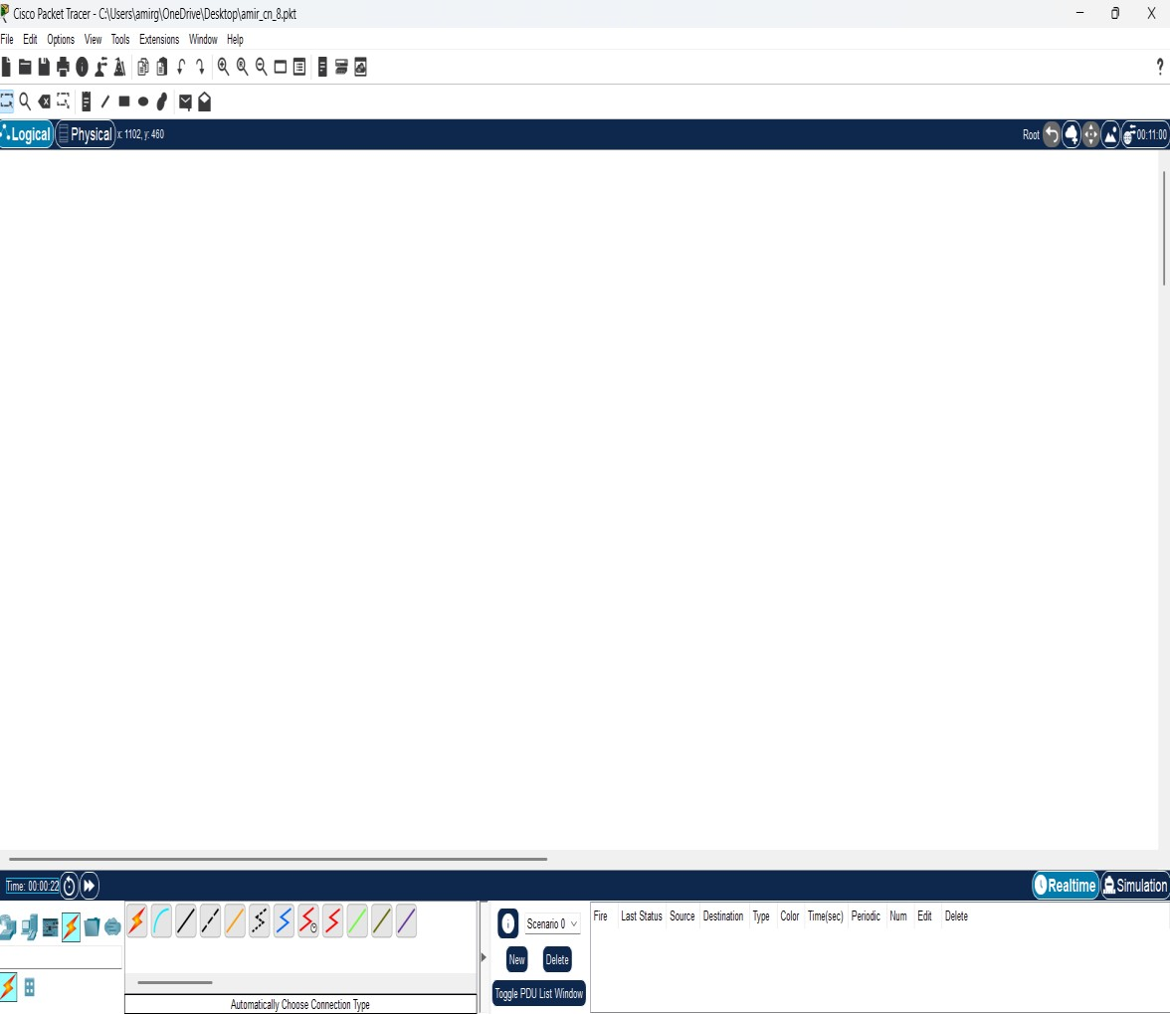
Fig: Workshop for network design
Step 2: Add Network Devices to the Workspace
- From the Device-Type Selection Panel, choose the following devices and place them in the workspace:
  - Two 2960-24TT Switch
  - Four PCs (labeled STUDENT-1 , STUDENT -2 , FACULTY-1 AND 2)

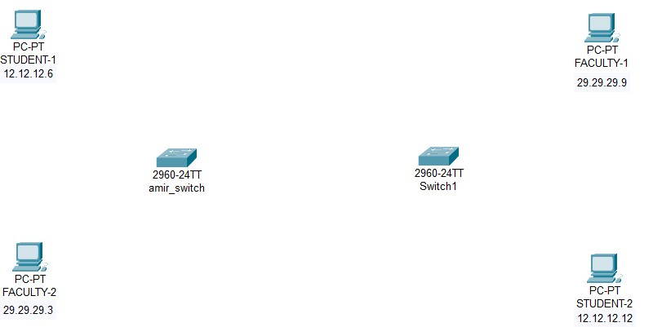
Fig: Switch and PCs for LAN creation
Step 3: Connect the Devices
- Select the Copper Straight-Through Cable from the connection options.
- Connect each PC to an available FastEthernet port on the switch.
- Ensure all connections are properly established, and link lights on the devices turn green to indicate connectivity.


Fig: Connection between all devices in VLAN
Step 4: Configure IP Addresses
- Right-click on each PC in the workspace and select IP Configuration from the Desktop tap.
- In the IP Configuration window, enter the IP address as and subnet mask for each PC.

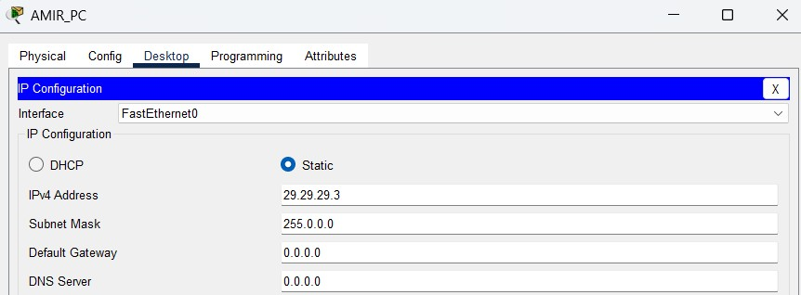
Fig: IP Configuration
Step 5: Configuring VLANs
- Create VLAN on both Switches & Assign Port to both switches.
- Create trunkation in both switches.
Code for VLAN configurations:
Switch(config)#vlan 10
Switch(config-vlan)#name student
Switch(config-vlan)#vlan 20
Switch(config-vlan)#name faculty
Switch(config-vlan)#exit
Switch(config)#exit
Code for Assigning ports:
Switch#config t
Switch(config)#int fa 0/1
Switch(config-if)#switchport mode access
Switch(config-if)#switchport access vlan 10
Switch(config-if)#int fa 0/2
Switch(config-if)#switchport mode access
Switch(config-if)#switchport access vlan 20
Switch(config-if)#exit
Switch(config)#exit
Code for Trunking Switches: Switch#config t
Switch(config)#int fa 0/4
Switch(config-if)#switchport mode trunk
Switch(config-if)#exit
Switch(config)#exit

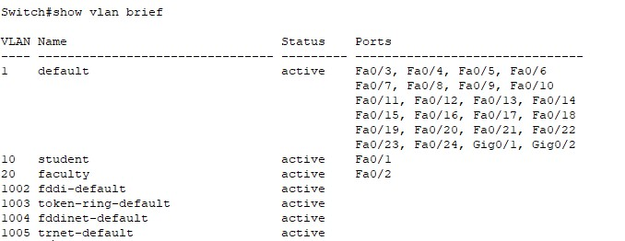
Fig: Assigning ports to VLAN

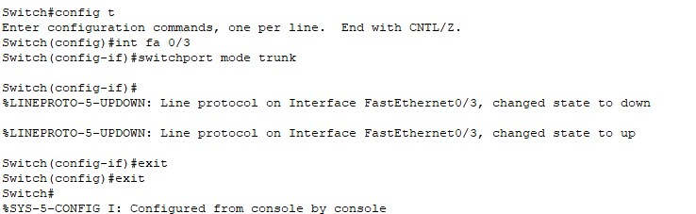
Fig: Configuring trunking between switches

Step 6: Testing and Validation
- To verify connectivity, use the ping command from one PC to another.
- On a PC, open the Command Prompt from the Desktop tab.
- Type: ping <IP address of the other PC>
- If the ping is successful, you will receive replies from the destination PC, confirming that the network is functioning correctly.


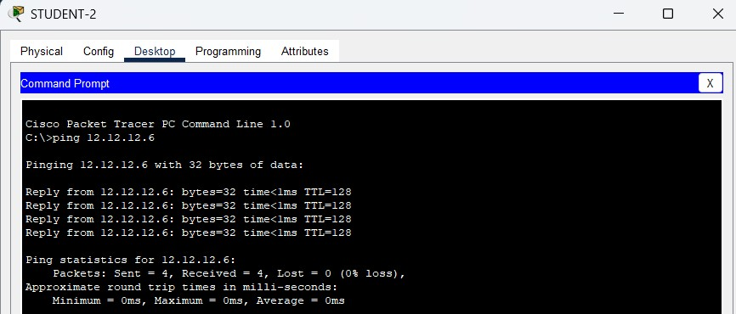
Fig: Successful connectivity test between STUDENT-1 to STUDENT-2

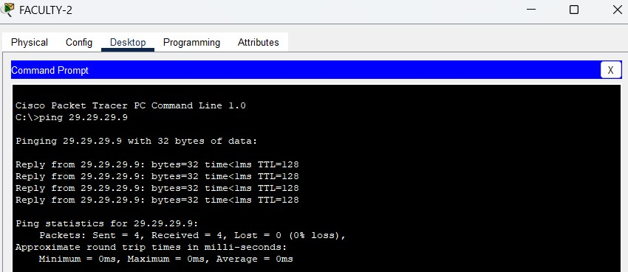
Fig: Successful connectivity test between FACULTY-1 and FACULTY-2

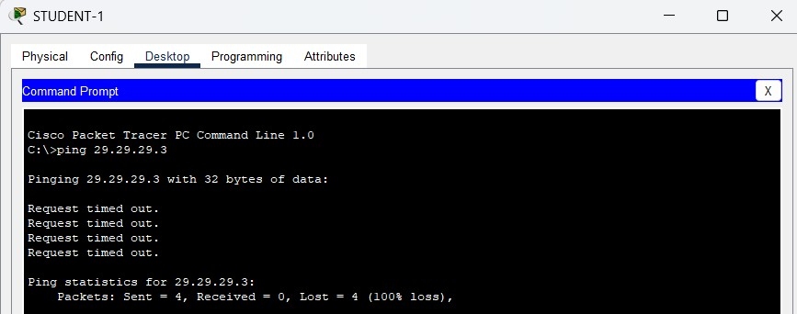
Fig: Connectivity test between STUDENT-1 to FACULTY-2

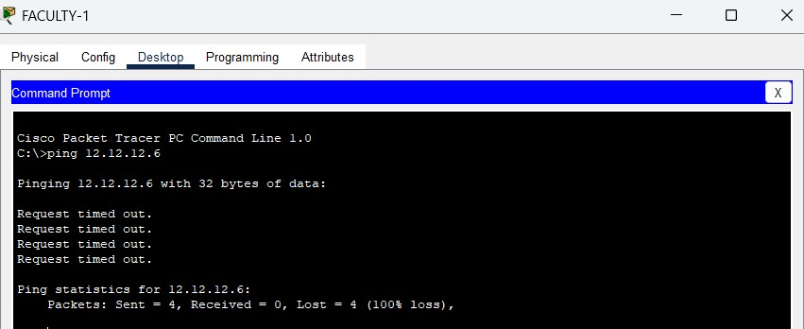
Fig: Connectivity test between FACULTY-2 to STUDENT-2
Addressing Table:
The addressing table is as follows:
Device | Interface | IPv4 Address | Subnet
STUDENT-1 | NIC | 12.12.12.6 | 255.0.0.0
STUDENT-2 | NIC | 12.12.12.12 | 255.0.0.0
FACULTY-1 | NIC | 29.29.29.9 | 255.0.0.0
FACULTY-2 | NIC | 29.29.29.3 | 255.0.0.0

CONCLUSION
In this lab, we created VLANs and implemented VLAN trunking using Cisco Packet Tracer to enhance network segmentation and management. By grouping devices into distinct VLANs, we effectively reduced broadcast domains, improved security, and optimized network performance. VLAN trunking, which facilitated the transmission of multiple VLANs across a single link, ensured efficient communication between VLANs across switches. This approach highlighted the importance of structured network design in minimizing broadcasting and simplifying network administration, contributing to the scalability and efficiency of modern networks.

