
Lab Number: 09 Date: 2025/08/17
Title: Basic router configuration and static routing in Packet Tracer
THEORY:
Router
A router is a network device that directs data packets between different computer networks. It manages traffic on the Internet, forwarding packets from one router to another across interconnected networks until they reach their destination.
Network Diagram
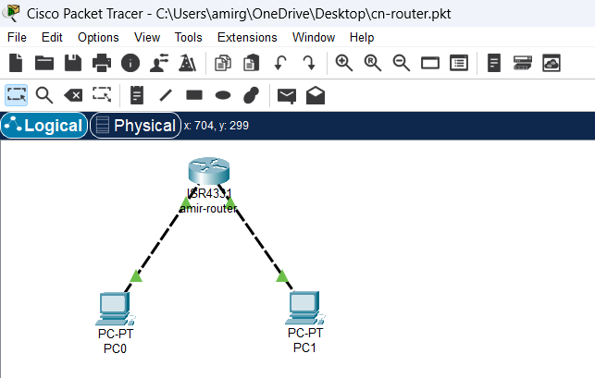
Fig: Network diagram including router and switch
IMPLEMENTATION SEQUENCE
Here is the implementation sequence for Basic router configuration and static routing in Packet Tracer.
- Basic router Configuration
- Configuring Global Parameters
Here are the steps to configure global parameters on a router:
Step 1: Open Packet Tracer and set up the devices (routers, PCs).

Fig: Simple Network setup
Step 2: Access the Router CLI
Use the console cable to access the router’s command-line interface (CLI)
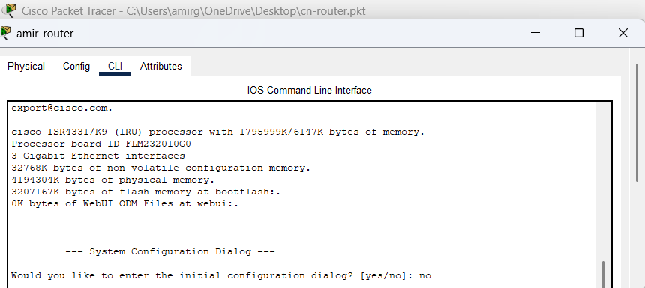
Fig: Accessing Router Command-Line Interface via Console Cable
Step 3: Configure Terminal
Type enable to enter privileged EXEC mode and use configure terminal to access global configuration mode.
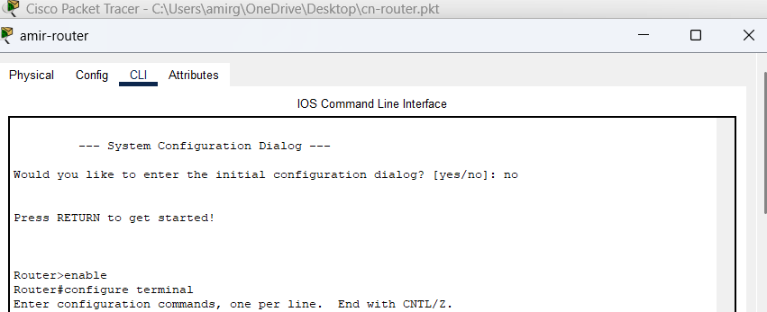
Fig: Entering Privileged EXEC and Global Configuration Mode on the Router
Step 4: Set a hostname for the router
Use the command hostname [RouterName] to assign a name to the router.
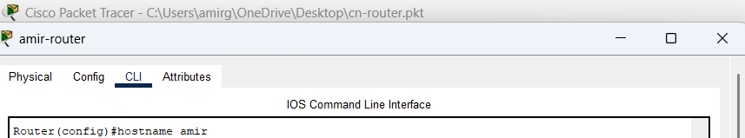
Fig: Setting the Hostname on the Router
Step 5: Configure a Password for Privileged Mode
Set an enable password using Router(config)#enable secret [password]
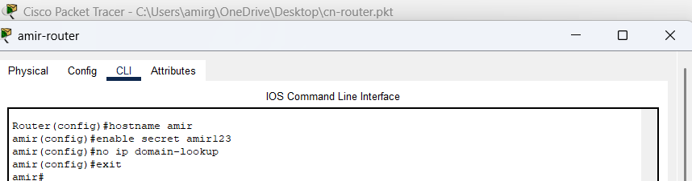
Fig: Configuring a Password
- Configuring Gigabit Ethernet
Here are the steps to configure gigabit Ethernet interfaces on a router:
Step 1: Configure Terminal
Type enable to enter privileged EXEC mode and use configure terminal to access global configuration mode.
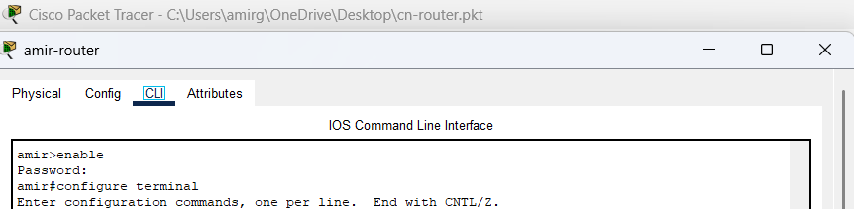Fig: Entering Privileged EXEC and Global Configuration Mode on Router
Step 2: Access the interface configuration mode
Use the command interface <interface_name> to enter the configuration mode
for a specific router interface.
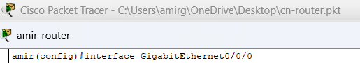
Fig: Accessing the interface configuration mode

Step 3: Assign an IP address
Once in the interface configuration mode, assign a unique IP address and subnet mask to the interface using the Ip address command.
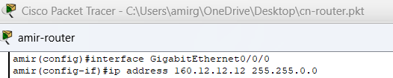
Fig: Enabling the Gigabit Ethernet Interface on Router
Step 4: Enable the interface
After assigning an IP address, use the no shutdown command to activate the interface.
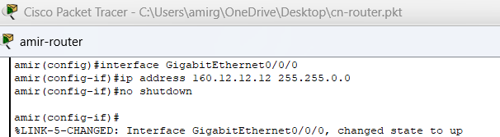
Fig: Enabling the Gigabit Ethernet Interface on a Router
- Static Routing Configuration
- Configuring Network (PCs and Routers)
Network Diagram
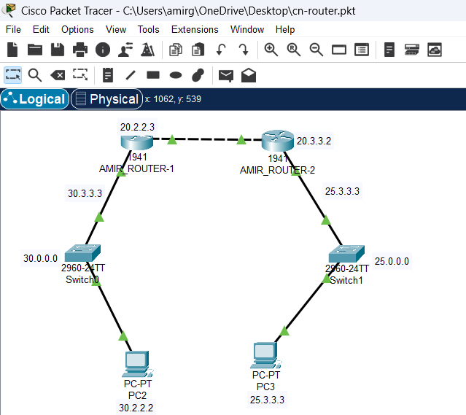
Fig: Network Diagram for static routing
Configuring PCs
Step 1: Assign IP addresses to the PC’s
Configure the IP addresses on the PCs within the same network as their respective router’s interface.
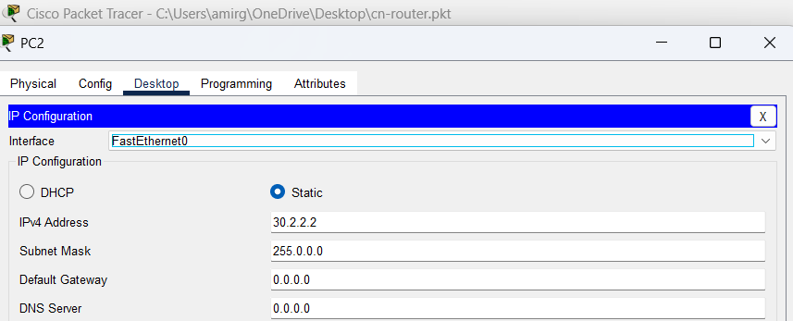
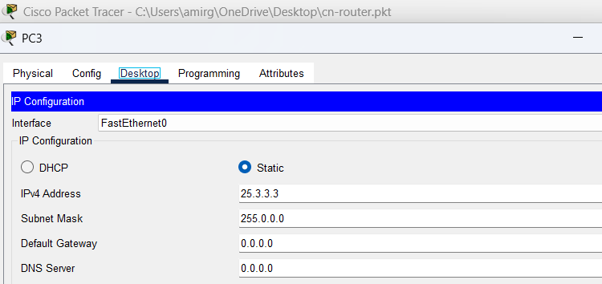
Fig: Assigning IP address to PC’s
Configuring Routers
Step 1: Set the IP address on the Gigabit Ethernet interface
For AMIR_ROUTER-1:
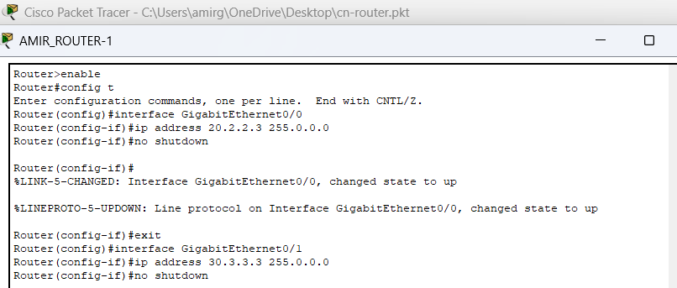Fig: Configuring IP Address on Gigabit Ethernet Interface
For AMIR_ROUTER-2:
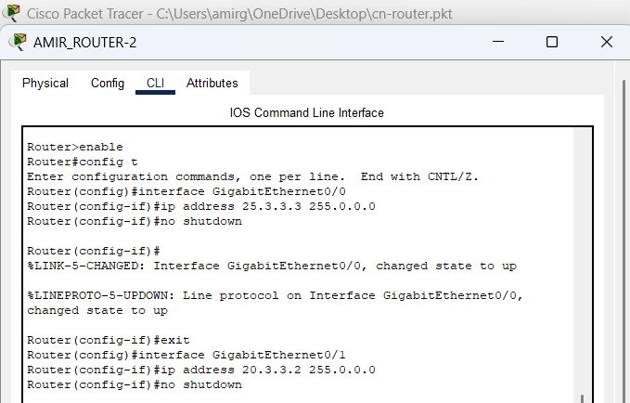
Fig: Configuring IP Address on Gigabit Ethernet Interface
Step 2: Checking Router is working or not
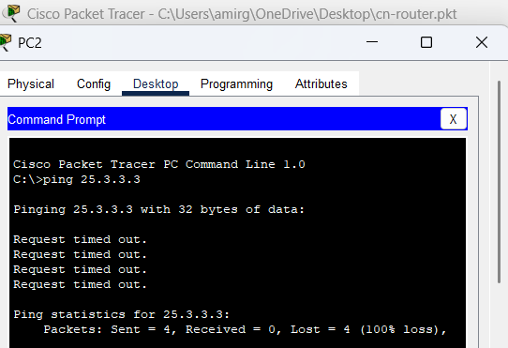
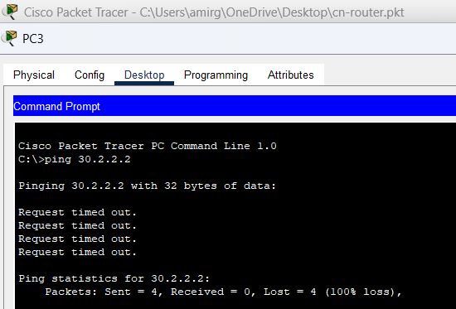
Fig: Router Connectivity Test Failure
Above figure shows two failed ping attempts from different PCs to check connectivity. Both PCs are trying to reach different Ips, but the destination hosts are unreachable. The error message 100% packet loss indicate a problem with the router’s configuration or connection between networks. This suggests that the router is not routing packets correctly between these networks.
Step 3: Adding a static route
Adding a static route to Router 2’s network
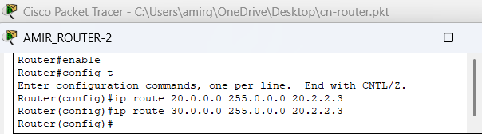
Fig: Adding Static Route to AMIR_ROUTER-2 Network
Add a static route to Router R1’s network
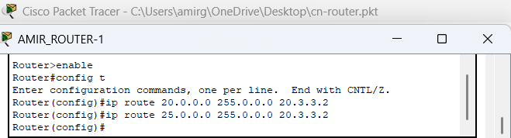
Fig: Adding Static Route to AMIR_ROUTER-1 Network
II. Testing and Validation
From each PC, use the ping command to test connectivity to a PC in a different network.
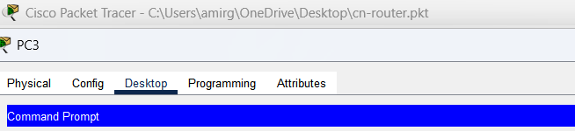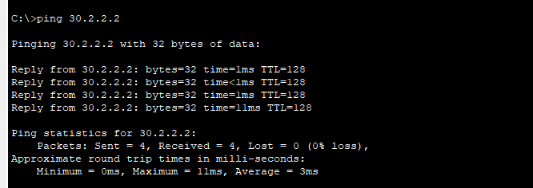
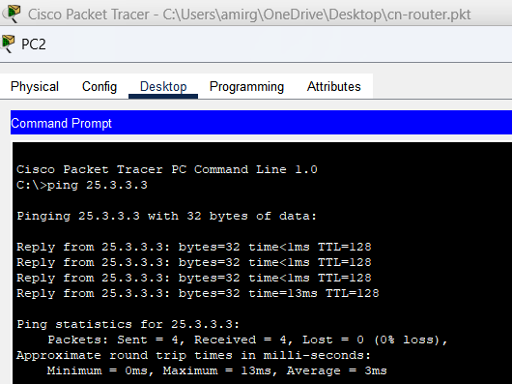
Fig: Testing Connectivity Between PC’s Using Ping Commands
The above shows successful ping tests between two PCs in different networks. PC2 pings 25.3.3.3 with no packet loss and low latency, while PC3 pings 30.2.2.2 with similar successful results. This confirms network connectivity between the PCs.

Addressing Table:
Device | Interface | IPv4 Address | Subnet | Default Gateway
PC2 | NIC | 30.2.2.2 | 255.0.0.0 | 30.3.3.3
PC3 | NIC | 25.3.3.3 | 255.0.0.0 | 25.3.3.3
The addressing table of the static routing is as follows:

CONCLUSION
In this lab, we explored basic router configuration and static routing using Cisco Packet Tracer. Routers and static routes were set up to enable communication between PCs on different networks, demonstrating essential networking skills and the role of routing in connectivity.

