
Lab Number : 6 Date:2025/08/01
Title: Creating a LAN and testing the connectivity using Packet Tracer
THEORY:
A Local Area Network (LAN) is a system designed to interconnect multiple computers and devices within a limited geographical area, such as a home, office, or educational institution. LANs typically operate over wired (Ethernet) or wireless (Wi-Fi) connections, offering high data transfer speeds and low latency.
Key Features of LAN
- LANs enable fast data transfer between connected devices.
- They cover a small geographical area, such as a building or campus.
- Devices can share files, printers, and internet connections.
- A LAN often has a server that controls network resources and access.
- LANs support both Ethernet and Wi-Fi connections for flexibility.
LAN Architecture
LAN architecture refers to the design and structure of a Local Area Network, including how its components are arranged, connected, and managed to facilitate communication and resource sharing. It encompasses several key elements:
Key Components
- Switches and Hubs: Switches intelligently forward data to specific devices, while hubs broadcast data to all devices.
- Ethernet Cables: Commonly used cables include Cat5e, Cat6, and fiber optics.
- Network Interface Cards (NICs): NICs are hardware components that allow devices to connect to the Ethernet.
Topologies
The layout or arrangement of devices (such as computers, switches, and routers) within a network and how they communicate with each other:
- Star Topology
- Bus Topology
- Ring Topology
- Mesh Topology
- Hybrid Topology

Protocols
LANs use protocols to ensure smooth communication. Some common protocols include:
- Ethernet – Manages wired data communication.
- TCP – Ensures reliable data delivery.
- IP – Routes data packets.
- e. – Assigns IP addresses automatically.
Components Used
Hardware: Switch (1) , Ethernet cables ,End devices (4 PCs)
Software: Cisco Packet Tracer
Network Diagram:
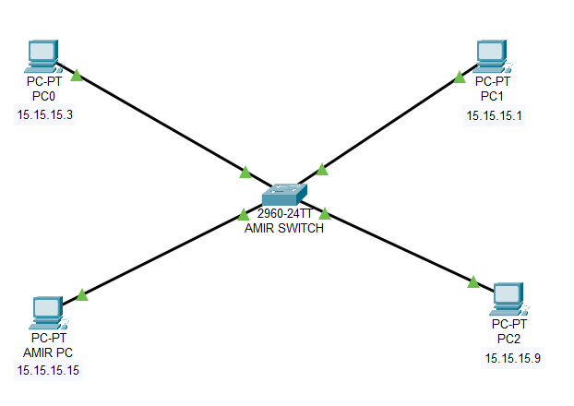
Fig: Network Diagram of LAN

Procedure
Using Cisco Packet Tracer LAN network is created as shown in the figure below
Step 1: Launch Cisco Packet Tracer
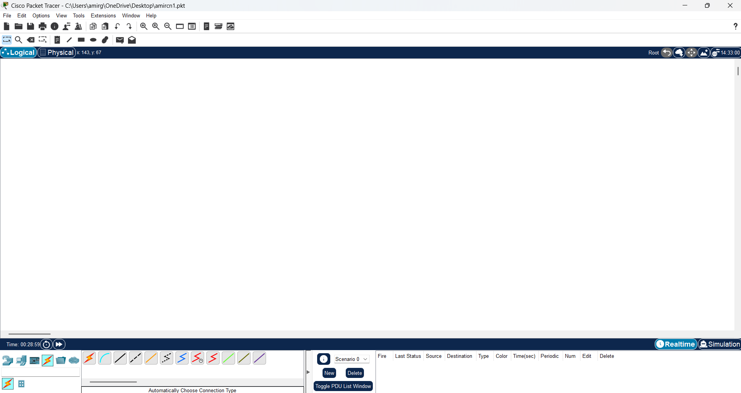
Fig: CISCO Packet Tracer workspace
Step 2: Add Network Devices to the Workspace
- From the Device Selection Box, add the following devices to the workspace:
- One 2960-24TT Switch
- Four PCs labeled as AMIR PC, PC0,PC1, and PC2
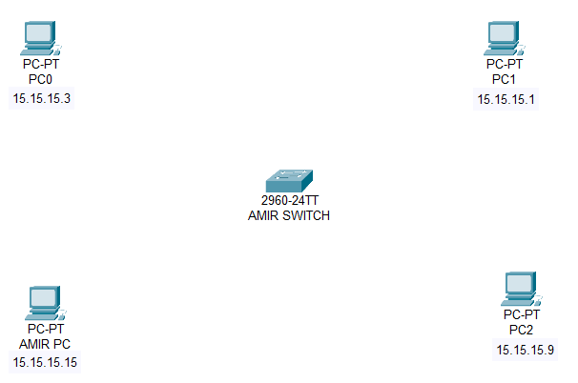
Fig: Switches and PC’s for LAN creation
Step 3: Connect the Devices
- Connect each PC to an available port on the 2960-24TT Switch using a Copper Straight-Through Cable. Assign the following IP addresses to each PC:
Device | IP Address
AMIR PC | 15.15.15.15
PC0 | 15.15.15.3
PC1 | 15.15.15.1
PC2 | 15.15.15.9
- Verify that all connections are correctly established between the PCs and the switch, ensuring proper network setup.

Fig: Connection between Switch and PC’s

Step 4: Configure IP Addresses
- On each PC, assign the IP address as above, with:
- Subnet Mask: 255.0.0.0
- Default Gateway: 0.0.0.0
- To verify the network setup, use the ping command from one PC to another . This checks connectivity and ensures there are no IP conflicts.
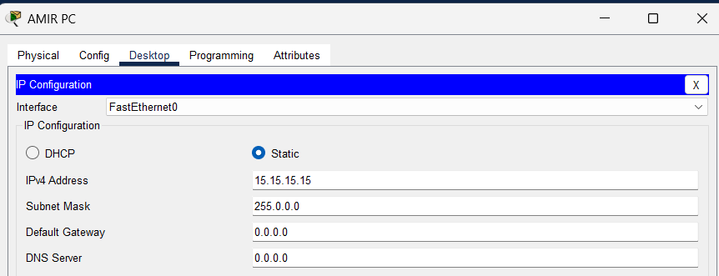
Fig : IP configuration
Step 5: Testing and Validation
- 5.1 Test whether each PC can communicate with other devices on the network by using the ping command.
- 5.2 From each PC, open the command prompt and ping the IP address of another device on the network.
- 5.3 If the ping is successful, you will receive replies from the target device confirming network connectivity.
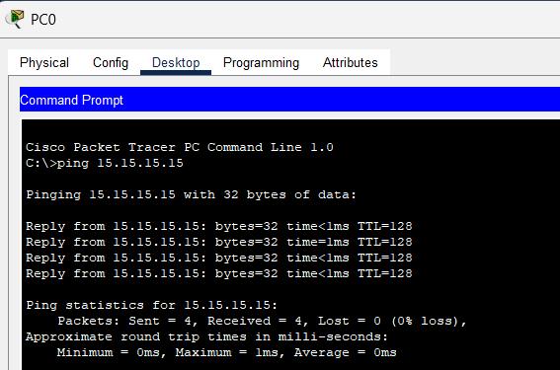
Fig : Testing connectivity between PC0 and AMIR PC using the ping command.
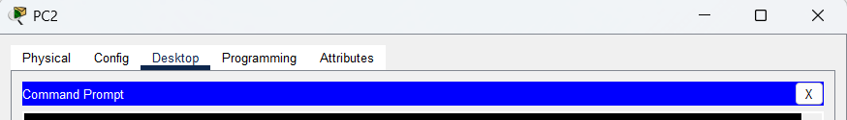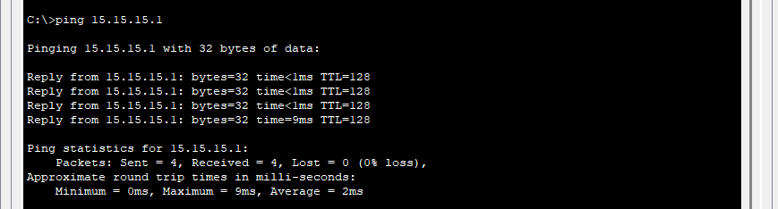
Fig: Testing connectivity between PC1 and PC2 using the ping command.
CONCLUSION
In this lab, we create a Local Area Network (LAN) using Cisco Packet Tracer to gain hands-on experience in how network devices connect and communicate with one another. The simulation guides us through designing and configuring a LAN, including placing and connecting switches, routers, and end devices. By testing connectivity within this virtual network, we verify that all devices are correctly configured and able to exchange data successfully.

