
Lab Number : 14 Date:2025/08/30
Title: Introduction to Network Traffic Analysis using Wireshark
THEORY:
Wireshark: Wireshark is a free, open-source network analyzer that captures and inspects data traveling across a network in real-time. It helps troubleshoot issues like network congestion, protocol errors, misconfigurations, and security vulnerabilities by providing detailed packet-level information.
Key Concepts
- Packets: Smallest units of data sent over a network.
- Protocols: Rules like TCP, UDP, HTTP that Wireshark can decode.
- Capture Filters: Specify which packets to record during capture.
- Display Filters: Narrow down and view specific packets after capture.
- Packet Details: Shows each packet’s layers, e.g., Ethernet, IP, TCP/UDP.
- Real-time Monitoring: Lets you watch network traffic live for quick analysis.
Interface
- Main Toolbar: Provides easy access to start/stop captures, open/save files, and adjust settings for smooth navigation.
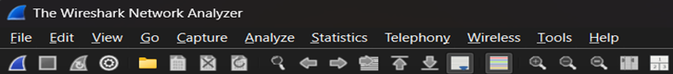
Fig: Main toolbar of Wireshark
Packet List Pane
Displays all captured packets in a list format, showing key information like packet number, timestamp, source/destination IP, protocol, and length.
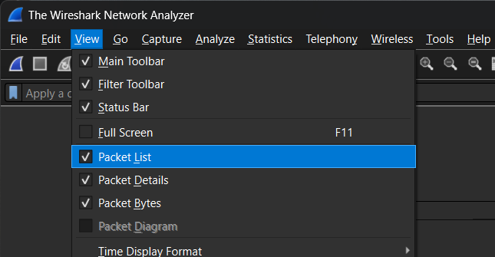Fig: Packet List Pane of Wireshark
Packet Details Pane
Shows a detailed breakdown of the selected packet, displaying information layer-by-layer (e.g., Ethernet, IP, TCP) to help analyze the packet structure.
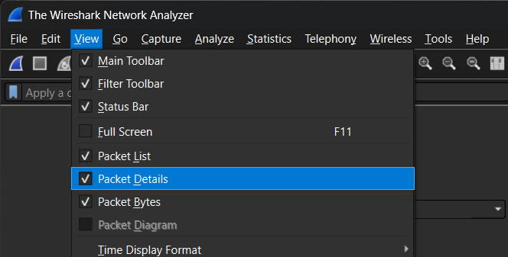
Fig: Packet Details of Wireshark
Packet Bytes Pane
Displays the raw data of the selected packet in hexadecimal and ASCII formats, allowing for a deeper look into the packet’s actual content.
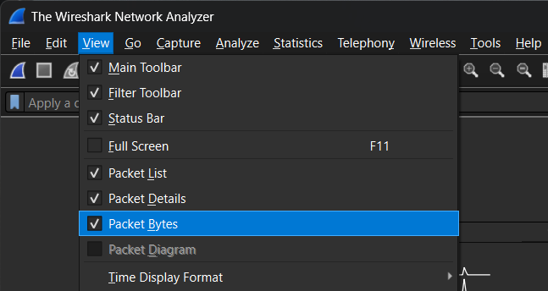
Fig: Packet Bytes Pane

Basic Network Capture and Analysis
Selecting a Network Interface
Step 1: Open Wireshark and click the “Capture” menu.
Step 2: Choose the correct network interface from the list (e.g., Ethernet or Wi-Fi).
Step 3: Look for the interface with active traffic.
Step 4: Choose the required interface by clicking on it.
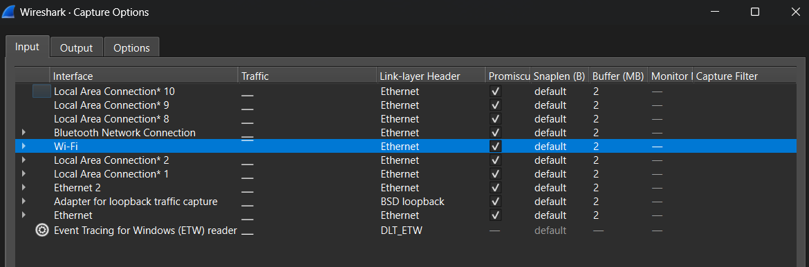
Fig: Choosing the Required Interface
Starting Packet Capture
Step 1: Click the blue “Shark Fin” icon (Start Capture) on the toolbar to begin capturing.
Step 2: Open a web browser and navigate to “google.com” to generate traffic.
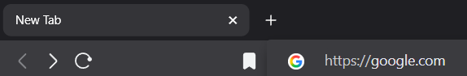
Fig: Navigate google.com in web browser
Step 3: With the use of filter bar packets related to example.com can be captured also type ip.addr = <ip address of src>x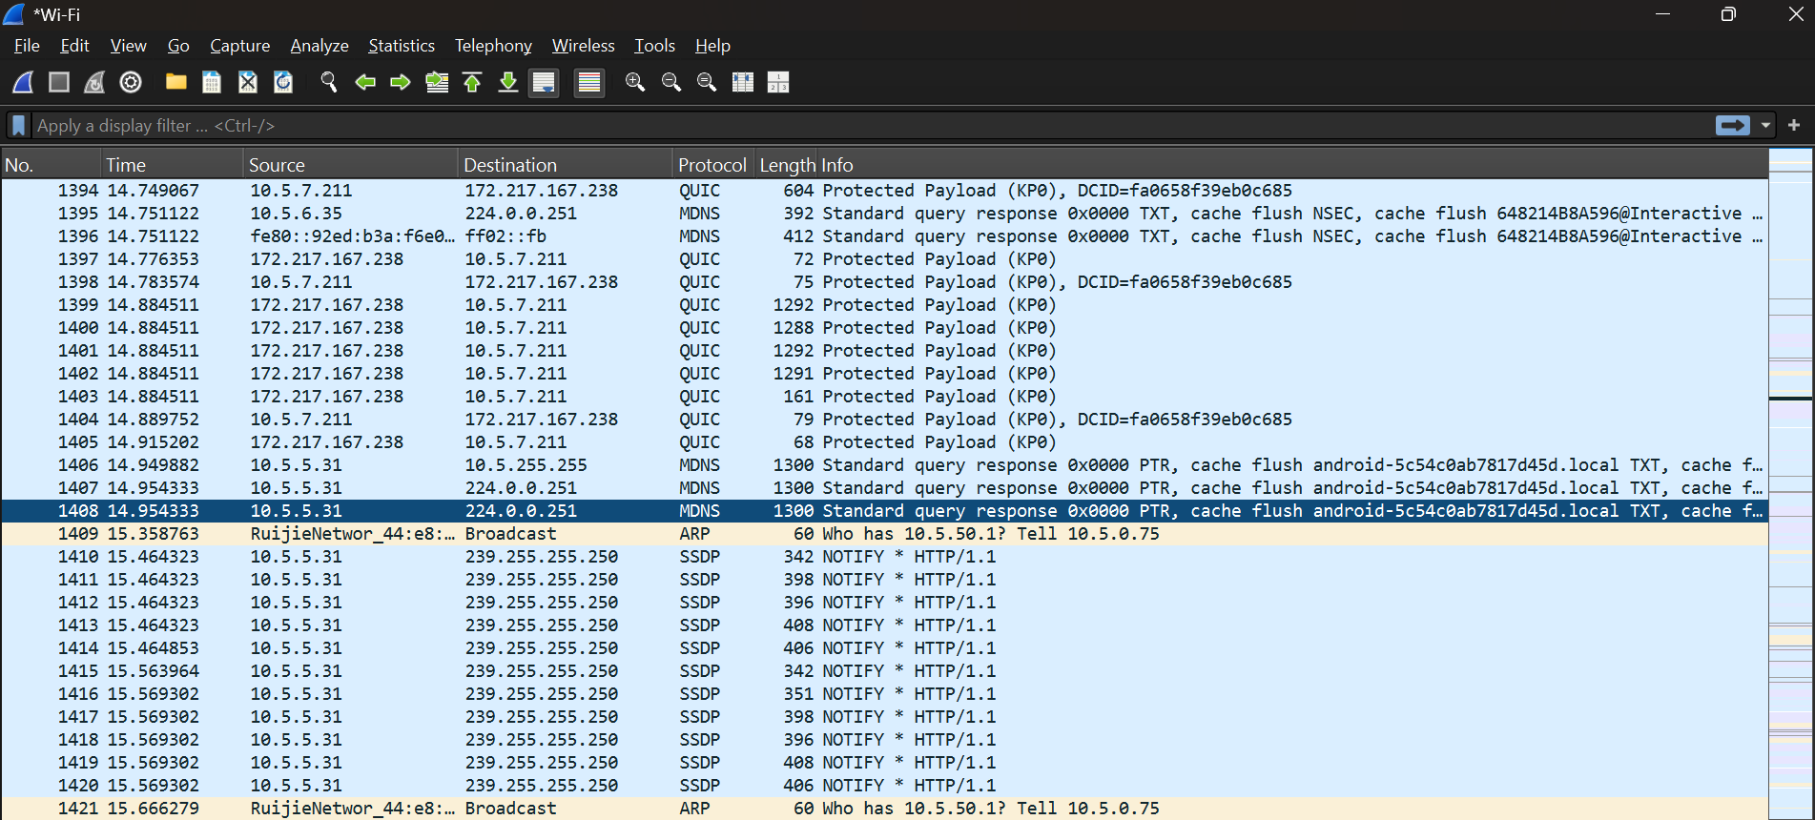Fig: Capturing Packet

Stopping and Saving Captures
Step 1: Click the red “Square” (Stop capture) on the toolbar when you have enough data.
Step 2: Go to “File” and select “Save As” to save the captured data in your preferred location.
Step 3: Choose the appropriate format (e.g., .pcap or .pcapng) for saving the file.
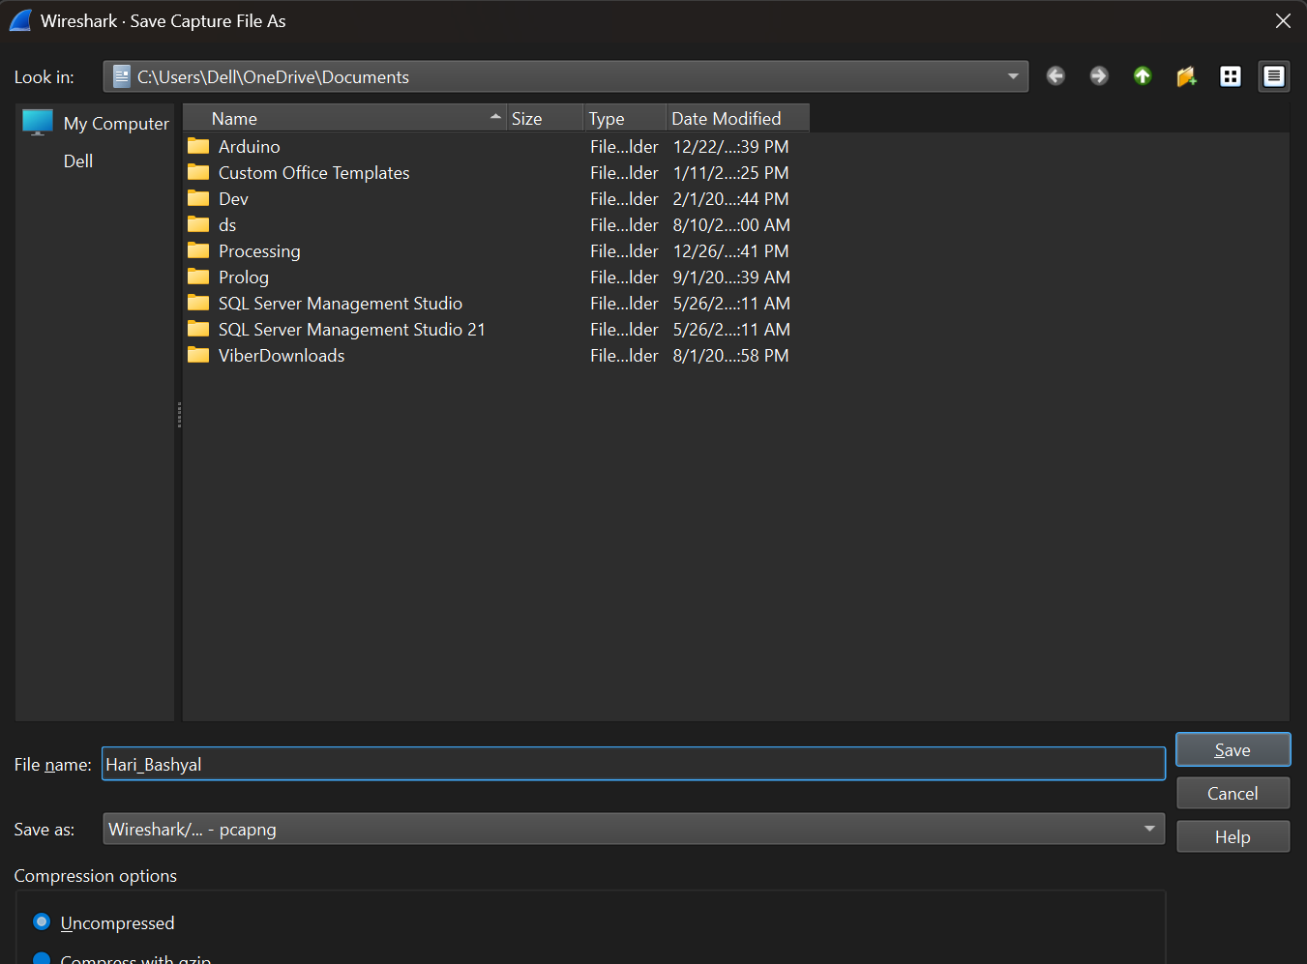
Fig: Saving a file
Export the Captured Data
Step 1: After stopping the capture, click on “File” and choose “Export Specified Packets”.
Step 2: Apply any filters if you only want to export specific packets (e.g., by IP address or protocol).
Step 3: Save the exported file in the destined format for further analysis or sharing with others.
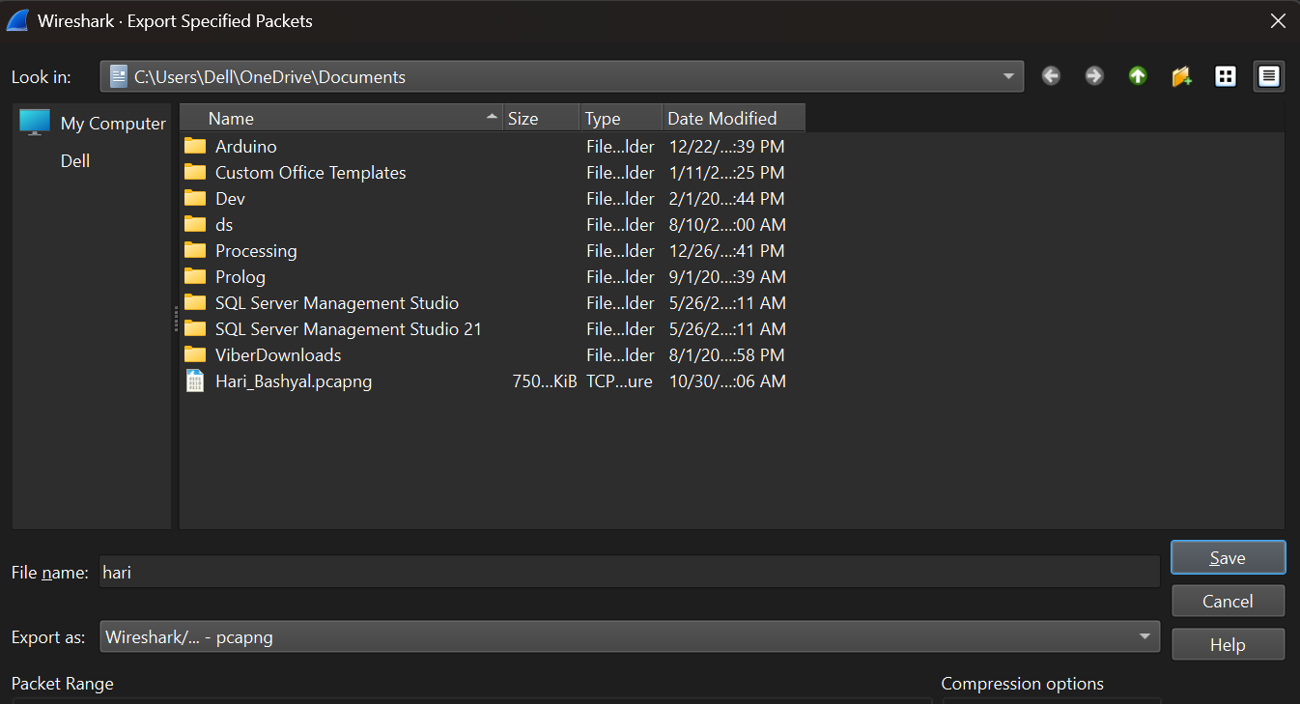
Fig: Exporting Capture Packet
CONCLUSION
In this lab, we used Wireshark to capture, inspect, and export network packets, showcasing its real-time traffic monitoring features. By choosing a network interface and using example.co as a test site, we demonstrated how Wireshark aids in troubleshooting network problems and conducting security checks. Its capability to identify protocols and display detailed packet information makes it an essential tool for network administrators to maintain performance and security.

