
Lab Number : 15 Date:2025/08/30
Title: Packet Capture and Header Analysis by Wireshark (TCP, UDP, IP)
THEORY:
Wireshark:
Wireshark is a powerful, open-source tool for capturing and analyzing network traffic in real-time. It helps identify problems like network congestion, misconfigurations, protocol errors, and security vulnerabilities. By visualizing traffic and examining protocol behavior, it supports efficient troubleshooting and ensures optimal network performance.
TCP, UDP, IP
- TCP: A connection-oriented protocol that guarantees reliable, ordered delivery of data. Commonly used in web browsing and email.
- UDP: A connectionless protocol that prioritizes speed over reliability, suitable for streaming, online gaming, and VoIP.
- IP: The main protocol for routing packets across networks, assigning addresses, and working with TCP/UDP for end-to-end communication.
IMPLEMENTATION
- Capture the Network Interface of Choice and Filter the traffic
Step 1: Open Wireshark and select the network interface (Wi-Fi or Ethernet) where traffic is to be captured.
Step 2: Click the start button to begin capturing live traffic
Step3: Apply a filter to focus on specific traffic, such as tcp for TCP traffic, udp for UDP, or IP for general IP traffic.
- TCP Header Analysis
After capturing TCP traffic, select a TCP packet to view its header details, which include:
Source Port: Identifies the port on the sender’s machine (e.g., port 443 for HTTPS).
Destination Port: Specifies the port on the recipient’s machine.
Sequence Number: Keeps track of the packet’s position in the communication stream.
Acknowledgement Number: Confirms the receipt of previous packets.
Flags: Control bits (e.g., SYN, ACK, FIN) used to manage the connection’s state.

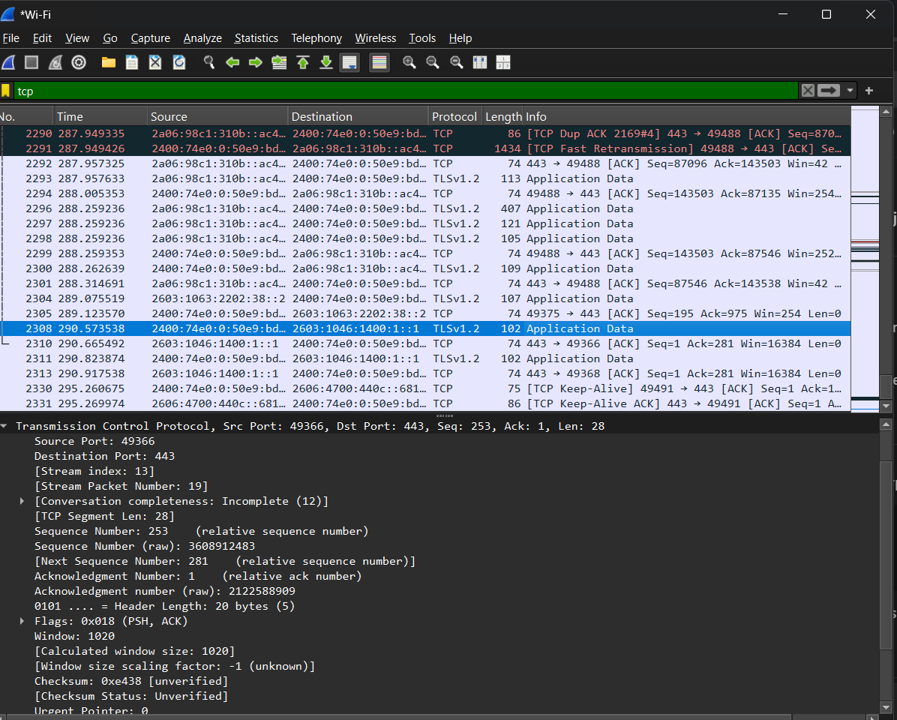
Fig: TCP header analysis of selected packet
TCP Header Analysis Result:
From above figure of TCP header analysis, we can deduce the following details for the website youtube.com
S.N. | Parameters | Details
1 | Source Port | 49366
2 | Destination Port | 443
3 | Sequence Number | 253
4 | Acknowledgement Number | 1
5 | Flags | ACK,PSH
Fig: TCP header analysis details table
- UDP Header Analysis
Select a UDP packet and analyze its header:
Source Port: The port on the sender’s side
Destination Port: The port on the receiver’s side.
Length: Indicates the size of the UDP packet, including the header and data.
Checksum: A verification field for ensuring data integer.
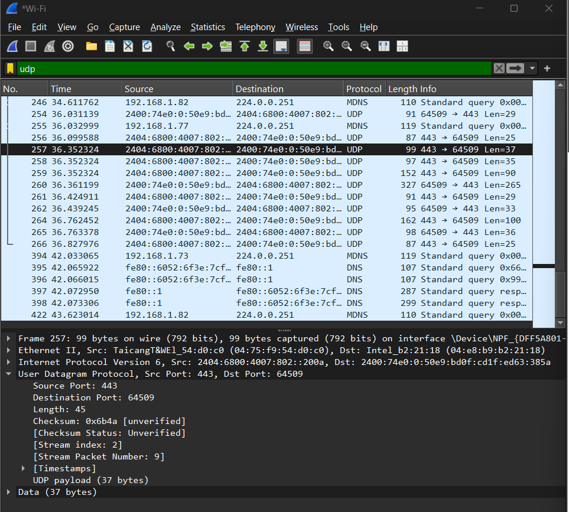
Fig: UDP header analysis of selected packet
UDP Header Analysis Result:
From above figure of UDP header analysis, we can deduce the following details of the website youtube.com
SN | Parameters | Details
1 | Source Port | 443
2 | Destination Port | 64509
3 | Length | 45
4 | Checksum | 0x6ba
5 | Stream Index | 2
6 | Stream Packet Number | 9
Fig; UDP header analysis details table
- IP Header Analysis
Source IP: The sender’s IP address.
Destination IP: The receiver’s IP address.
Header Length: Indicates the size of the IP header.
TTL (Time to Live): Limits the lifespan of the packet, decremented by each router.
Protocol: Specifies whether TCP, UDP, or another protocol is being used.
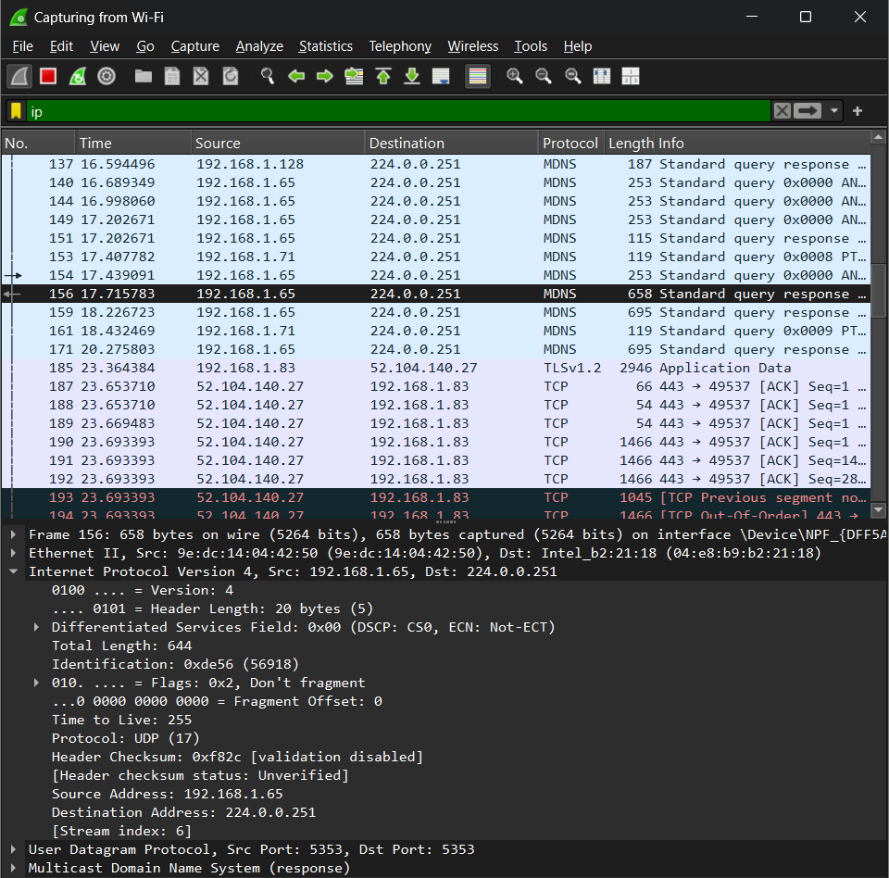
Fig: IP header analysis of selected packet
IP Header Analysis Result:
From above figure of IP header analysis, we can deduce the following details for the website youtube.com
SN | Parameters | Details
1 | Source IP | 192.168.1.65
2 | Destination IP | 224.0.0.251
3 | Header Length | 644
4 | TTL (Time to live) | 255
5 | Protocol | UDP
Fig: IP header analysis details table
CONCLUSION
This lab offered practical exposure to Packet Capture and Header Analysis with Wireshark, focusing on key protocols like TCP, UDP, and IP. By examining live traffic and packet headers, we developed a clear understanding of how data is transmitted and managed in networks. This experience is valuable for troubleshooting issues and improving security through careful analysis of ports, IPs, and control information.

