
Lab Number : 5 Date:2025/08/01
Title: Introduction to Packet Tracer
THEORY
Background Information
Cisco Packet Tracer is a powerful network simulation tool created by Cisco Systems. It is widely used for learning and practicing networking concepts. With this software, users can create, configure, and test virtual networks, making it an ideal platform for students and educators. It removes the need for physical networking hardware by allowing experimentation in a simulated environment.
Key Concepts of Packet Tracer
Cisco Packet Tracer includes several important features that help users learn about network infrastructure and behavior:
- Network Emulation: Users can replicate real-world networking environments using various devices and protocols.
- Real-Time and Simulation Modes: These modes provide flexibility to either observe live network operations or simulate data transfer in a controlled, step-by-step manner.
- Activity Wizard: This tool helps instructors design interactive learning activities that guide users through specific networking tasks.

INTERFACE OF CISCO TRACER
The user interface of Cisco Packet Tracer is built to support easy navigation and design. It includes tools and panels that let users place and connect devices smoothly.
- Workspace and Topology Design
The main workspace serves as the canvas where network designs are created. Users can place routers, switches, PCs, and other devices into the layout by dragging them from the device panel. Different cable types are available to interconnect devices. The grid layout helps align devices neatly, resulting in an organized and easy-to-read network diagram.
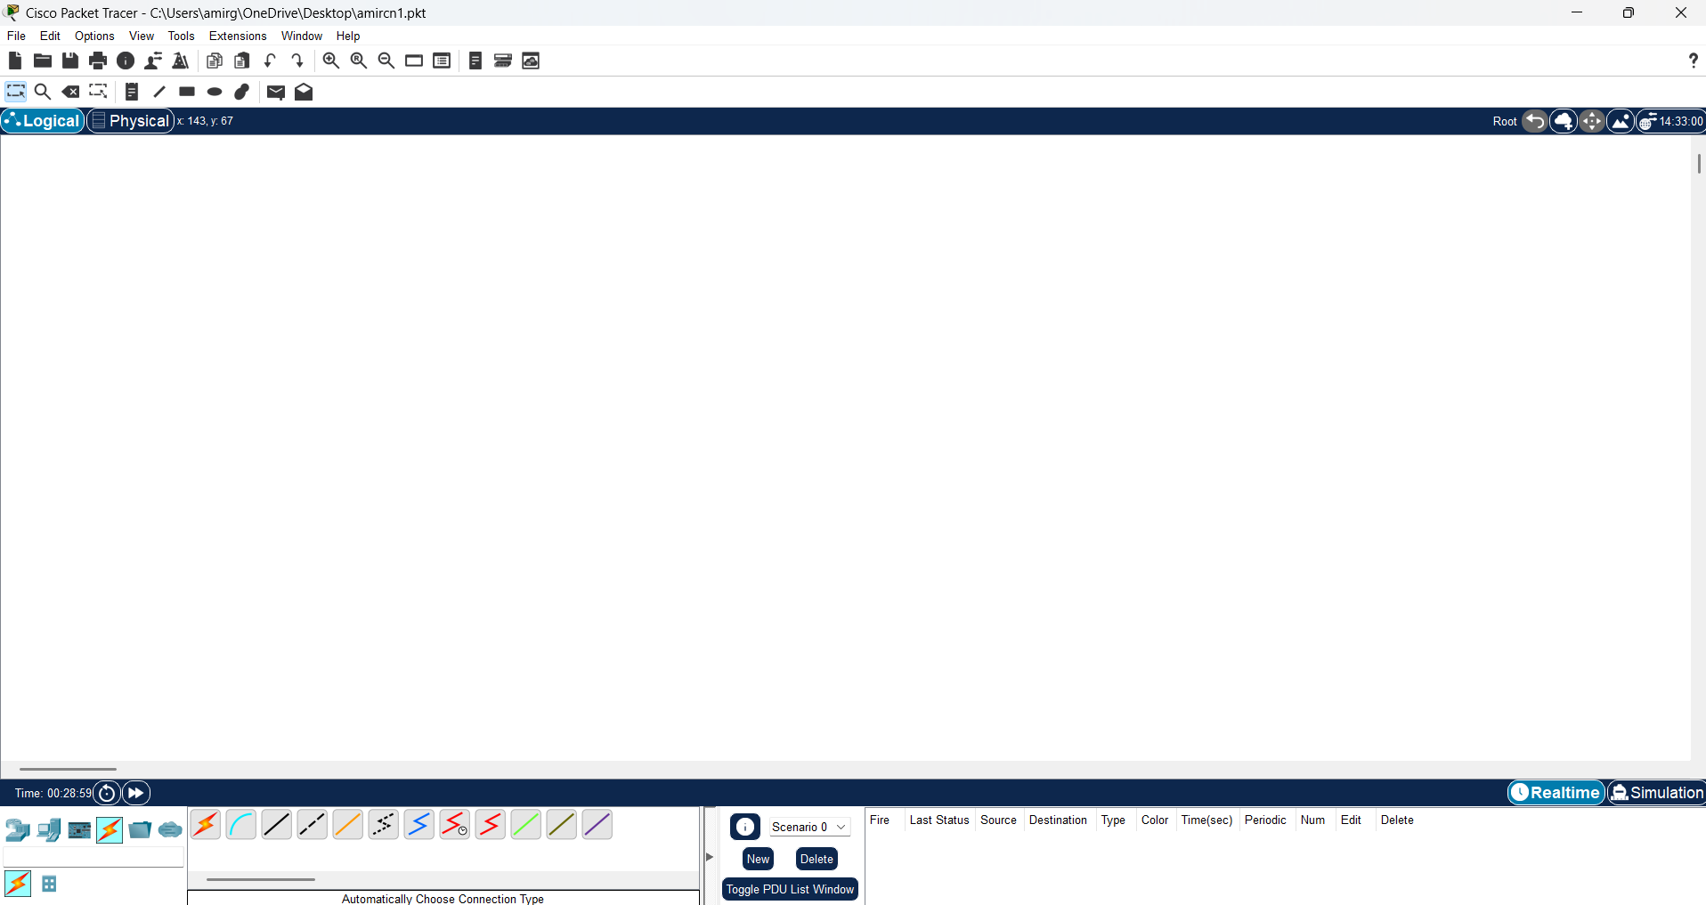
Fig: Cisco Packet Tracer Workspace
- Toolbar
The toolbar in Cisco Packet Tracer offers quick access to commonly used features such as opening or saving projects, zoom controls, and managing the simulation. It also enables switching between different views, including physical and logical layouts. This toolbar helps speed up your workflow by offering direct access to important tools and settings.
Fig: Toolbar in Cisco packet tracer

- Device-Type Selection Panel
Located on the left side of the interface, the Device-Type Selection Panel displays all the available networking devices categorized into groups like routers, switches, end devices, and more. You can drag and drop devices from this panel onto the workspace to include them in your network design.
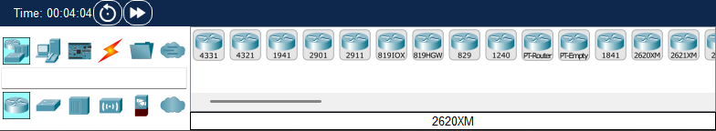
Fig: Device-Type Selection Panel
- Device Configuration
Once a device is added to the workspace, it can be configured through a dedicated configuration window. Users can assign IP addresses, enable routing protocols, or activate services like DHCP and NAT. Configuration can be done through both a graphical interface and the command-line interface (CLI), making it suitable for both beginners and advanced users.
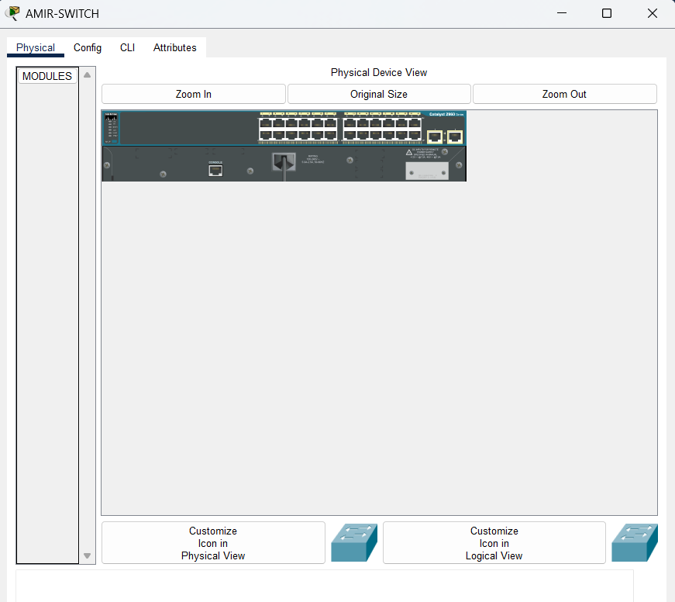
Fig: Device Configuration Window
- Simulation Mode
Cisco Packet Tracer provides two main modes of operation:
- Real-Time Mode, where all network actions happen instantly, mimicking a real-world network.
- Simulation Mode, which allows users to pause the network flow and step through events one at a time.
Simulation Mode is especially helpful for studying packet behavior, analyzing data transfer, and troubleshooting by visualizing how information travels across the network.
Fig: Different Modes in Cisco Packet Tracer
- Network Component Icons and Labels
In the workspace, each device and connection is shown using specific icons, making it simple to identify routers, switches, PCs, and other components. You can add labels to these icons to display details like device names, IP addresses, or VLAN numbers. These visual labels help keep the network diagram organized and easy to understand, improving clarity during both setup and analysis.
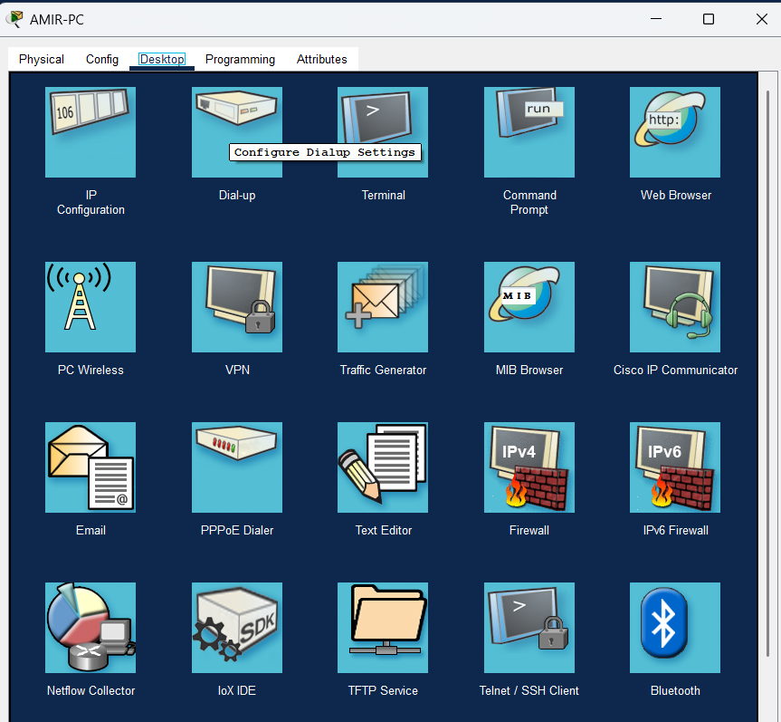
Fig: Network Component Icons and Labels
- Options and Preferences
The Options and Preferences section in Cisco Packet Tracer lets you customize your working environment. You can change visual elements such as background color and font size, set default values for devices, and control simulation speed. These settings allow you to personalize the software to match your workflow and improve your overall user experience.
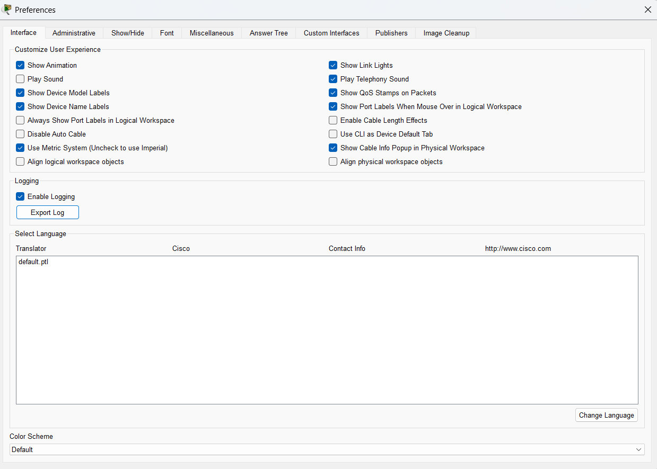
Fig: Options and Preferences Panel

- Activity Wizard
The Activity Wizard is a powerful tool designed to create interactive learning experiences within Packet Tracer. It allows instructors to develop structured tasks and provide step-by-step instructions that students can follow directly in the software. This feature is especially useful in educational settings, helping learners to practice and apply their networking knowledge in a guided and hands-on manner.
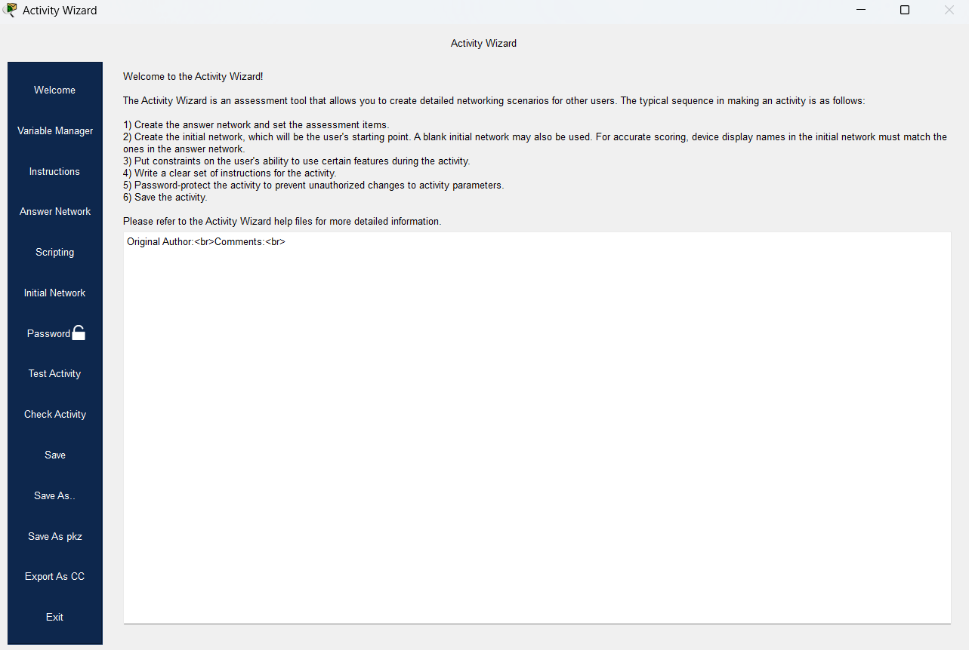
Fig: Activity Wizard Feature
CONCLUSION
In this lab, we explored Cisco Packet Tracer as a powerful simulation tool for learning computer networks. We became familiar with its interface, including the toolbar, device selection panel, and configuration settings. We practiced switching between Real-Time and Simulation modes to observe network behavior and used features like labels and the Activity Wizard for better organization and guided tasks. This lab provided hands-on experience in building and analyzing network topologies, helping us understand how Packet Tracer can be effectively used to simulate real-world networking scenarios in a safe and flexible environment.

