
Lab No: 7 Date: 2025/8/10
Title: Creating different network topologies using Packet Tracer

Theory:

Network Topologies:
- Ring Topology
A network topology in which each device (node) is connected to exactly two others, forming a closed loop. Data travels around the ring in one direction (or both, in a dual ring) until it reaches the destination. A break in the loop can disrupt the whole network unless redundancy is built in.

Star Topology
A network topology in which all devices connect to a single central device, like a switch or hub. This central device manages communication between nodes. It’s easy to add or remove devices, but if the central device fails, the whole network goes down.

Mesh Topology
A network topology in which every device has a direct link to all other devices. This provides multiple paths for data and makes the network very fault-tolerant, but it requires more cabling and is costlier to set up.

Components:
- Switches: Devices that connect multiple computers on a network within the same LAN. They learn which devices are connected to which port to efficiently forward data
- Cables: Physical media like Ethernet cables are used to transmit data between devices.
- End Devices: These are the devices that users interact with, such as computers, laptops, printers, and servers.

Ring Topology
Network Diagram:
Here are the steps that were taken to create a Ring Topology network.

Launch Cisco Packet Tracer.

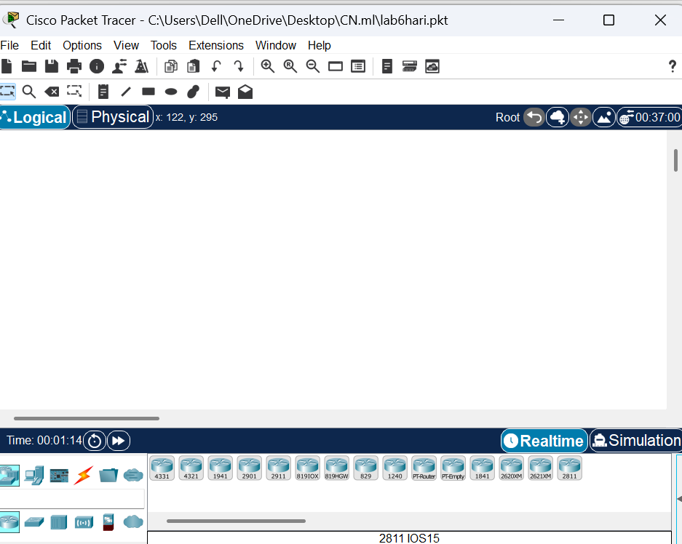
Fig: Cisco Packet Tracer

Add the network devices:
  - Select the following devices from the Network Devices section in the bottom left corner. Four 2960-24TT Switch and four PC-PT computers.
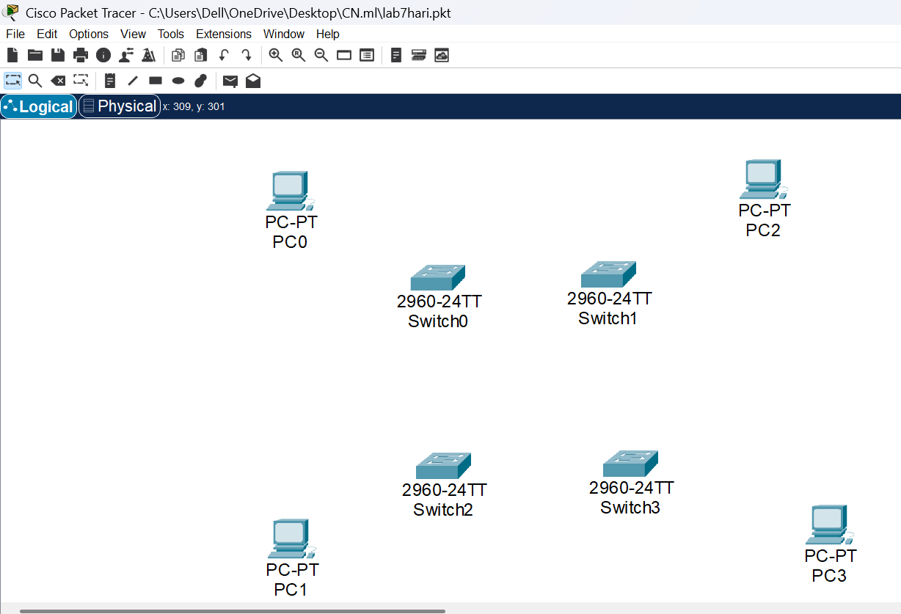
Fig: Network Diagram LAN

Connect Devices:
Connect the devices by selecting straight through copper wire cable from the connections section in the bottom left corner of packet tracer.

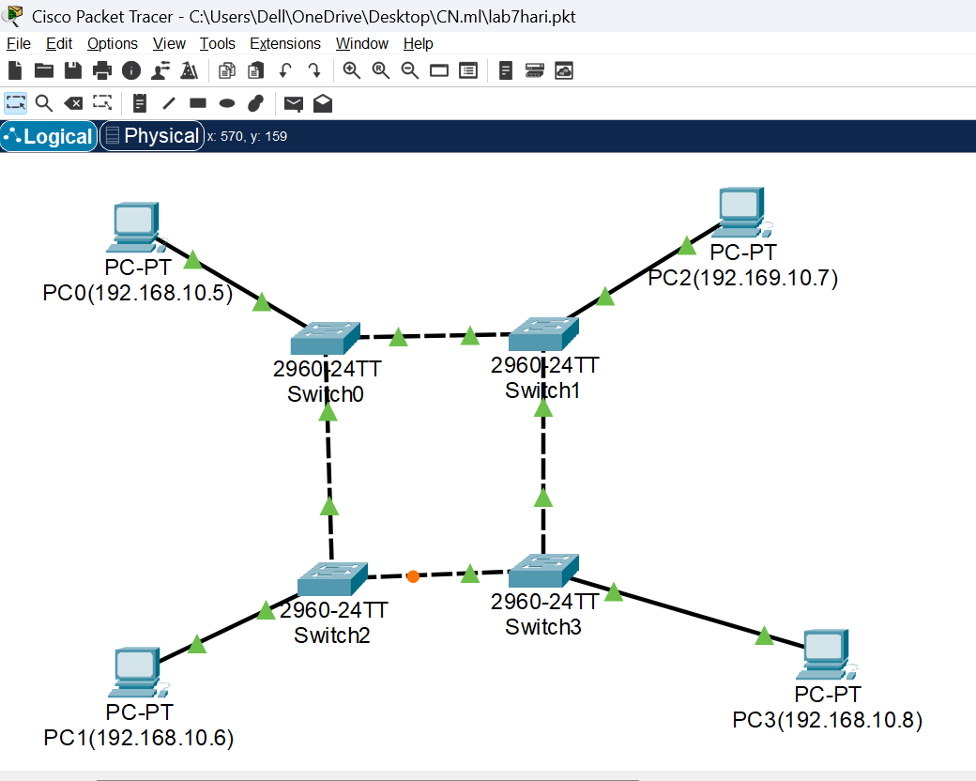
Fig: Connection between Network Devices

Configure IP address:
  - First click the PC for which you want to change the IP address.
  - Go to Desktop section and select IP-Configuration and change the IP as you wish.
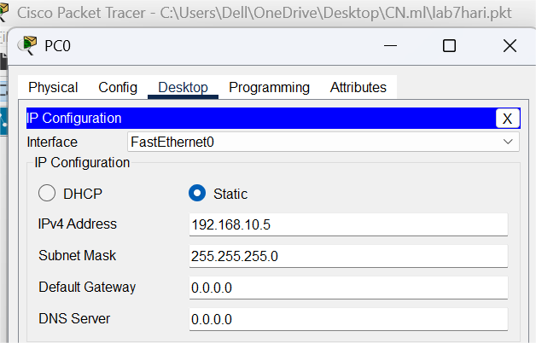
Fig:IP address configuration


Fig: Network Devices with their configured IP address

Connectivity Check:
  - At last, check the connection between the computers by pinging another computer on the same network.
  - Select the Command Prompt option in the desktop section.
  - Ping the other computer by entering the following command
ping <IP_address>

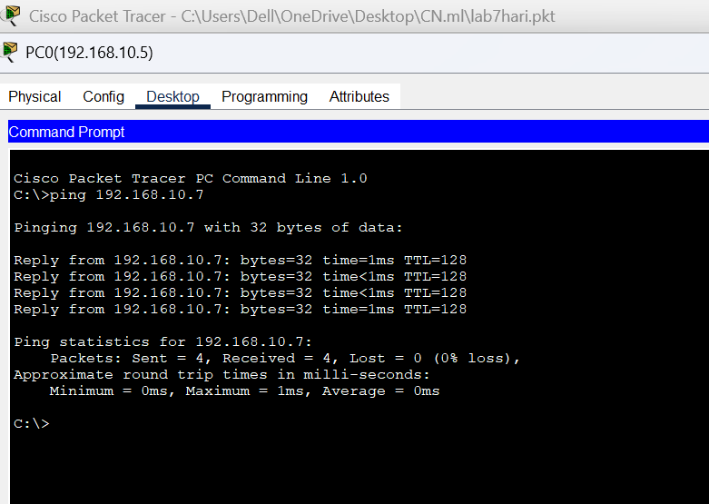

Fig: Connectivity Test between PC0 and PC2

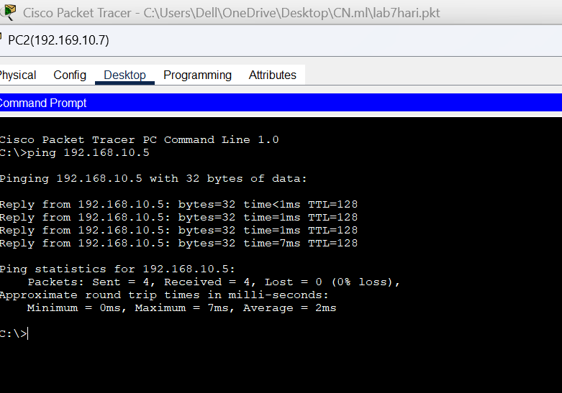

Fig: Connectivity test between PC2 and PC0

Star Topology
Here are the steps that were taken to create a Ring Topology network.

Launch Cisco Packet Tracer.
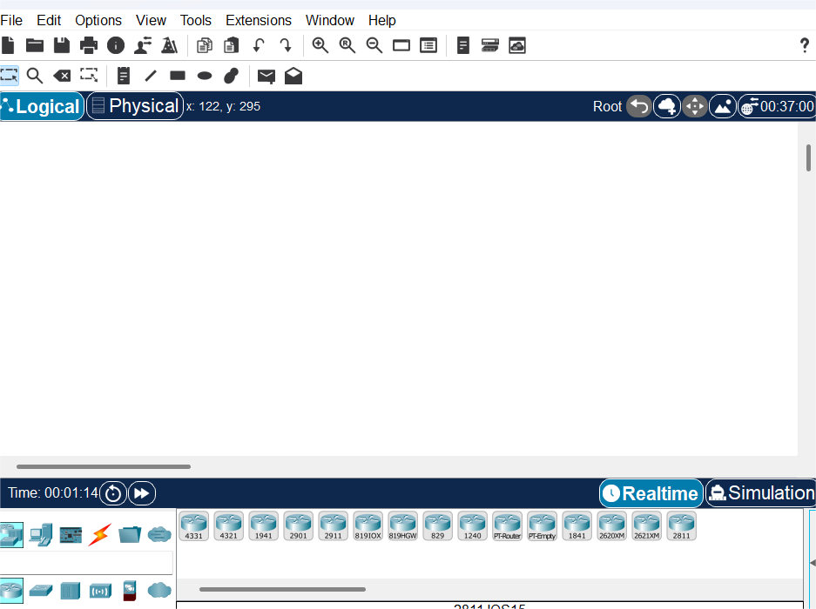
Fig: Cisco Packet Tracer

Add the network devices.
  - Select the following devices from the Network Devices section in the bottom left corner. One 2960-24TT Switch and five PC-PT computers.
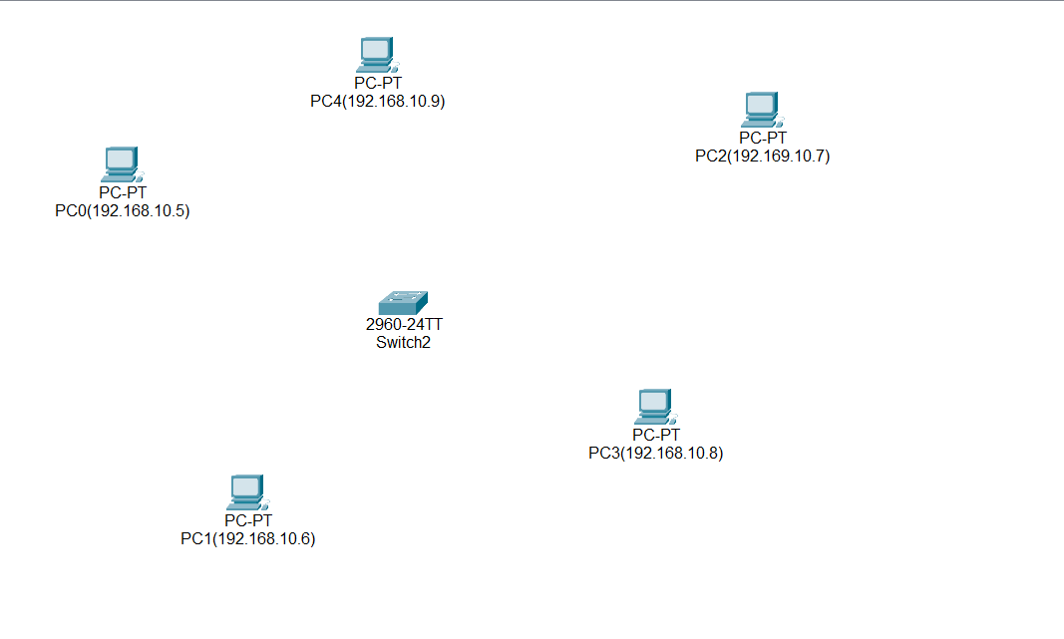

Fig: Network Diagram LAN

Connect Devices:
Connect the devices by selecting straight through copper wire cable from the connections section in the bottom left corner of packet tracer.
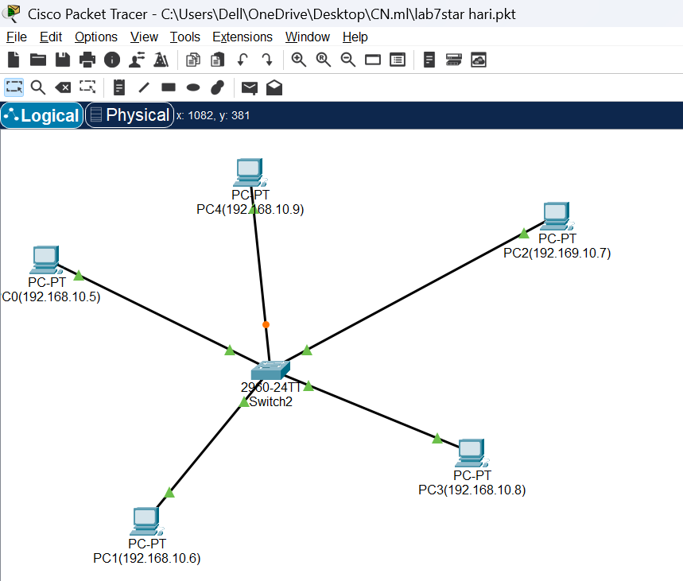
Fig: Connection between Network Devices

Configure IP address:
  - First click the PC for which you want to change the IP address.
  - Go to Desktop section and select IP-Configuration and change the IP as you wish.

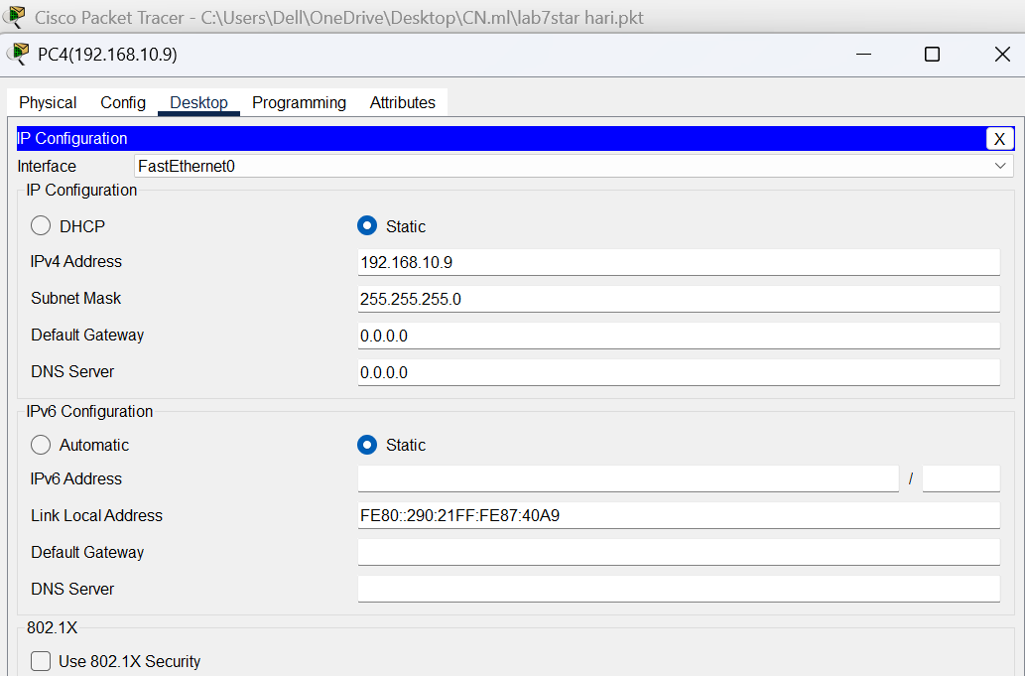
Fig:IP address configuration


Fig: Network Devices with their configured IP address

Connectivity check:
  - Check the connection between the computers by pinging another computer on the same network.
  - Select the Command Prompt option in the desktop section.
  - Ping the other computer by entering the following command

ping <IP_address>
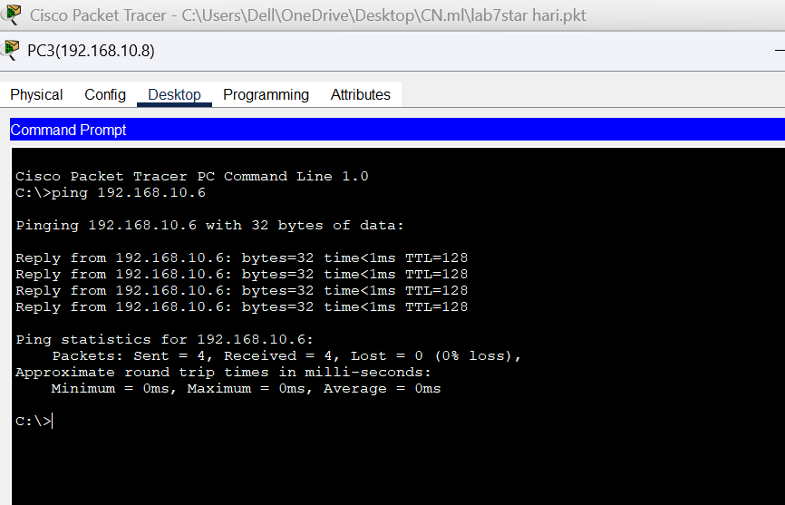

Fig: Connectivity Test between PC3 and PC1

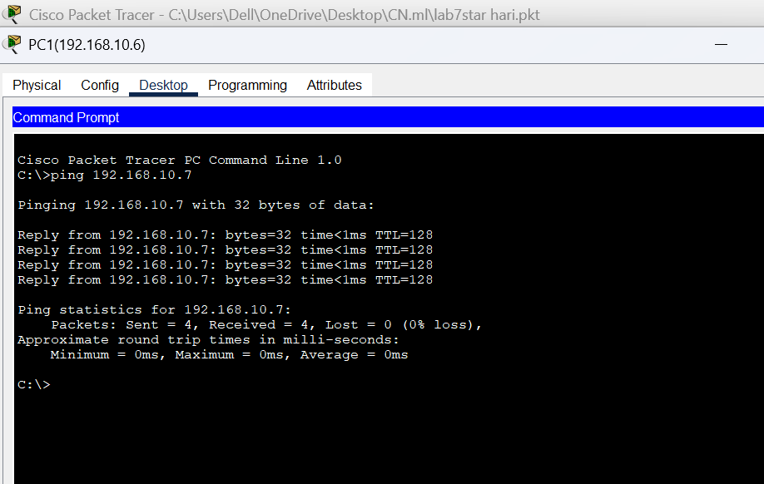

Fig: Connectivity test between PC1and PC2

Mesh Topology:
Here are the steps that were taken to create a Ring Topology network.

Launch Cisco Packet Tracer.
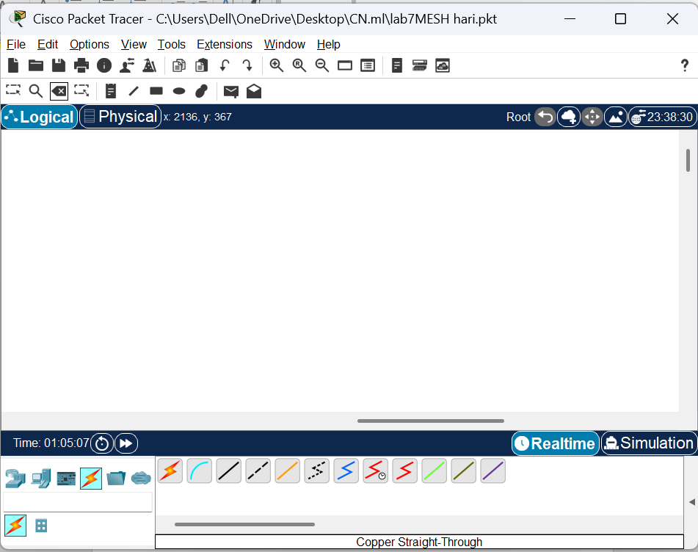
Fig: Cisco Packet Tracer

Add the network devices.
  - Select the following devices from the Network Devices section in the bottom left corner. Four 2960-24TT Switch and four PC-PT
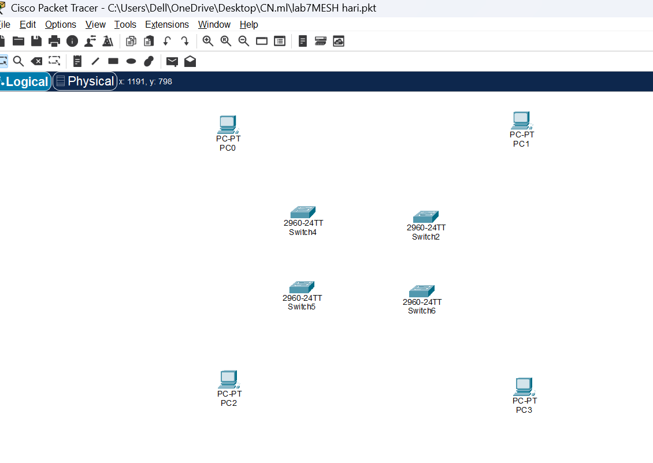

Fig: Network Diagram LAN

Connect Devices:
Connect the devices by selecting straight through copper wire cable from the connections section in the bottom left corner of packet tracer.In mesh topology each switch should be connected with each other.

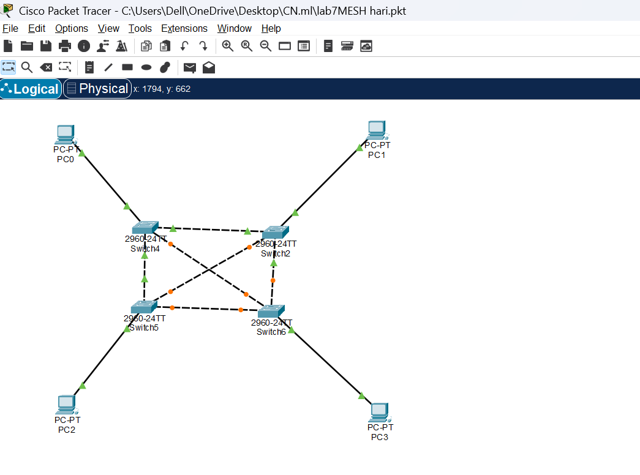

Fig: Connection between Network Devices

Configure IP address:
  - First click the PC for which you want to change the IP address.
  - Go to Desktop section and select IP-Configuration and change the IP as you wish.
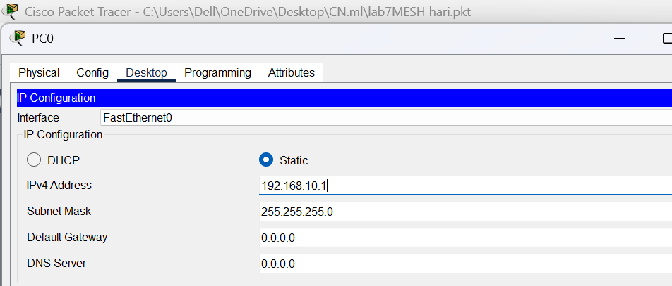
Fig:IP address configuration


Fig: Network Devices with their configured IP address

Connectivity Test:
  - At last, check the connection between the computers by pinging another computer on the same network.
  - Select the Command Prompt option in the desktop section.
  - Ping the other computer by entering the following command
ping <IP_address>
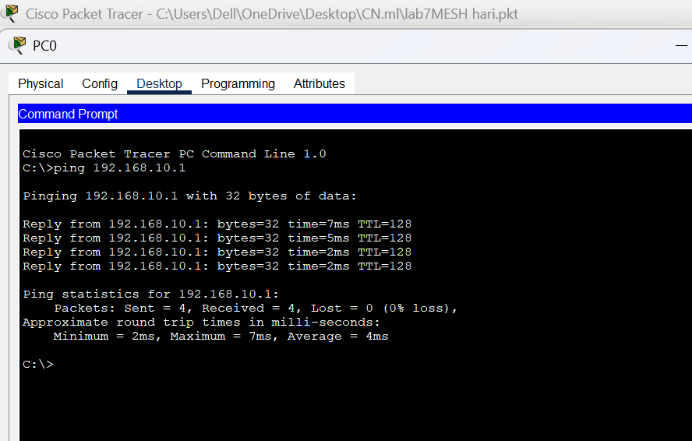
Fig: Connectivity Test between PC0 and PC1

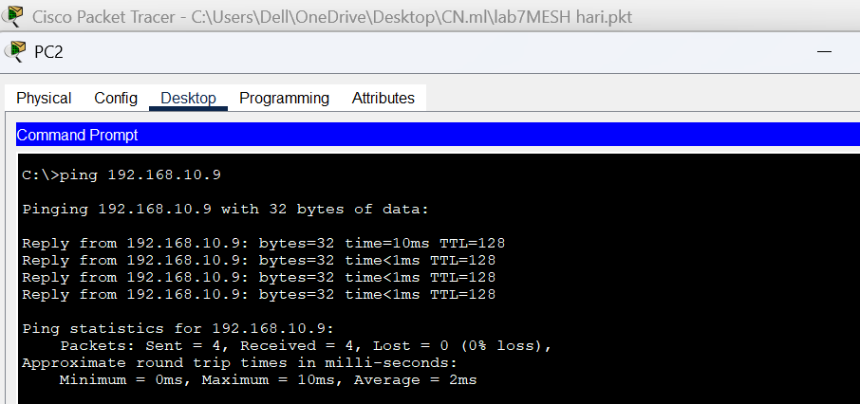

Fig: Connectivity test between PC2 and PC3

CONCLUSION
In this practical, we successfully created different network topologies using Cisco Packet Tracer. We learned how each topology—like bus, star, ring, mesh, and hybrid—has its own structure, advantages, and limitations. By designing and connecting devices, we understood how data flows in different layouts and how topology choice affects performance and reliability. This activity improved our basic networking skills and gave us confidence to build more complex networks in the future.

