
Lab Number : 11 Date:2025/08/17
Title: Implementing ACL in Packet Tracer
THEORY:
Access Control Lists (ACLs) are a set of filtering rules used on routers to decide which packets are allowed or blocked as they pass through an interface. They operate based on conditions such as source or destination IP addresses and specific protocols. ACLs are an essential part of network management because they help improve security, regulate traffic, and prevent unauthorized access. In Cisco Packet Tracer, ACLs can be configured to limit communication between devices, allowing administrators to enforce policies and control how data flows in the network. Standard ACLs restrict traffic based on source IP, while Extended ACLs provide more flexibility by filtering based on both source and destination as well as protocols.
There are two main types: Standard ACLs (filter based on source IP) and Extended ACLs (filter based on source, destination, and protocol).
Network Diagram
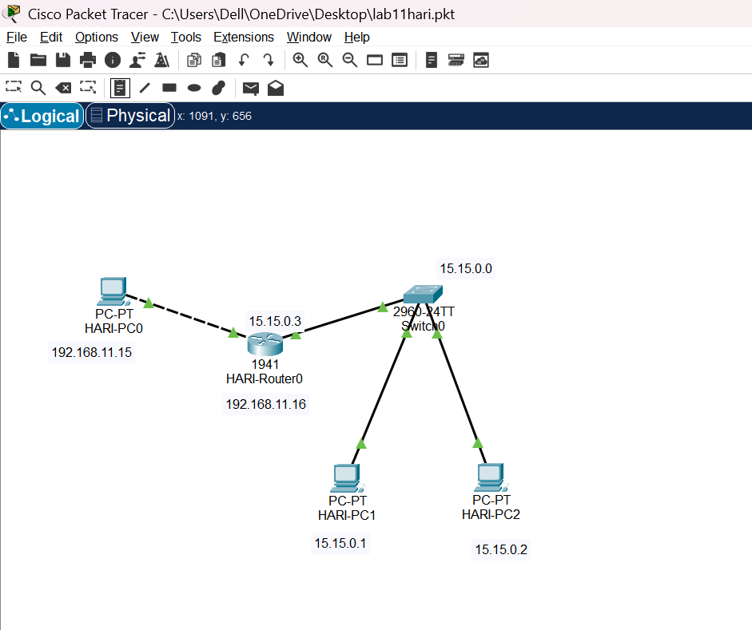
Fig: Network diagram including switch, router and pc’s
Component Used
Hardware:
- Switches
- Router
- Ethernet cables
- End devices
Software:
- Cisco Packet Tracer

Implementation Sequence
Here is the implementation sequence for Basic router configuration and static routing in Packet Tracer.
Configuring PCs and Routers
- Configure PCs
Step 1: Open Packet Tracer and set up the devices.

Fig: Simple Network Setup
Step 2: Assign IP addresses and subnet masks to each PC
- Hari-PC0: IP:192.168.11.15
- Hari-PC1: IP:15.15.0.1
- Hari-PC2: IP:15.15.0.2
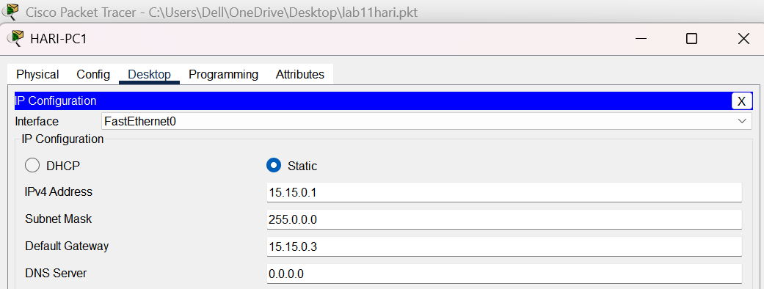
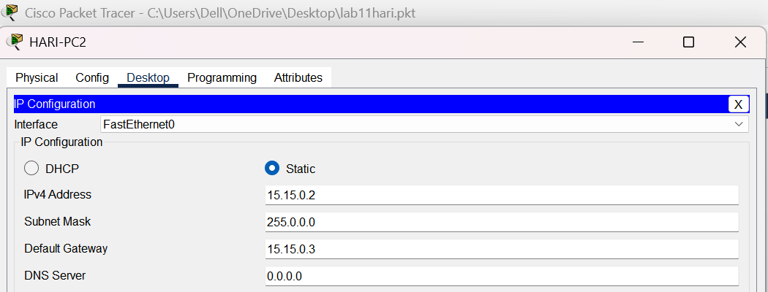
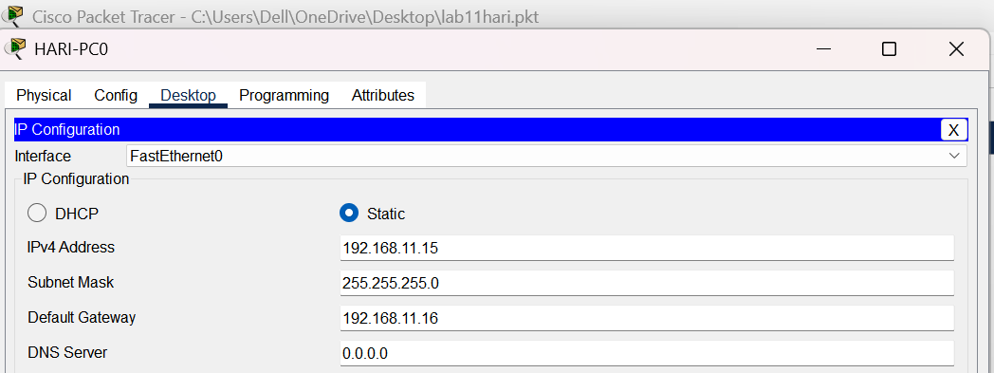
Fig: IP configuration on PCs

- Configure Router
Step 1: Configure the router with the correct IP addresses on its interfaces to connect the PC’s networks.
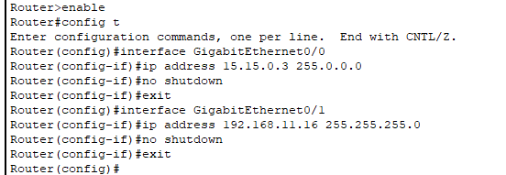
Fig: Router configuration
The figure shows the configuration of a router’s interfaces to connect different PC networks. The router is assigned IP addresses to its interfaces: 15.15.0.3 for GigabitEthernet0/0 and 192.168.11.16 for GigabitEthernet0/1. After assigning Ips, the interfaces are enabled using the no shutdown command, bringing them into an operational state for network communication.
Configuring Access List
- Configure the DENY and PERMIT lists
Step 1: Enter Global Configuration Mode and Apply the ACL
Access the router’s global configuration mode to configure and apply the Access Control List (ACL) to the interface connected to the PC. This will block the network access for the PC.
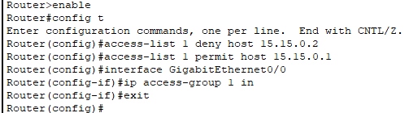
Fig: Configuring DENY and PERMIT list
Implementation
To verify network functionality, we should test connectivity between devices by using ping commands from each PC.
- Apply the ACLs to the relevant router interfaces.
- Use the ping command to check if the PCs can communicate with each other.
- Ensure that the ACL rules (DENY and PERMIT) are correctly enforced by observing the ping results.

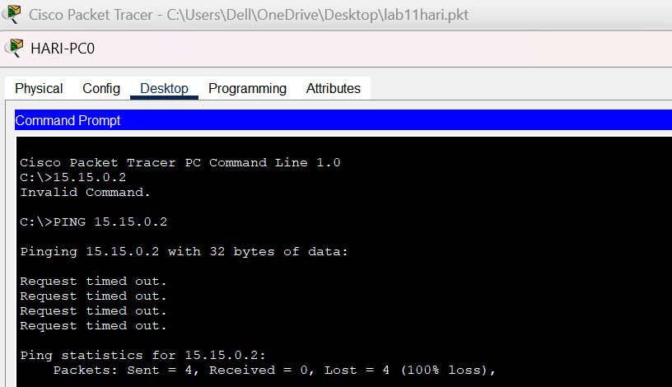
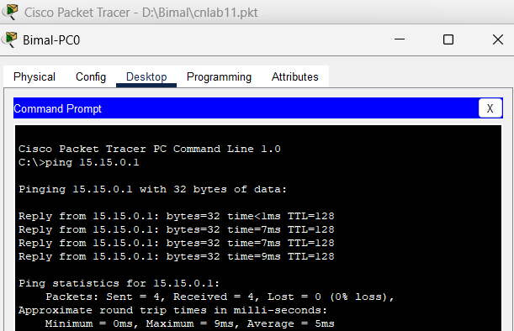
Fig: Connectivity test between PC’s
Above figure shows connectivity tests between two PCs using ping commands. The first ping to IP address 15.15.0.2 fails, indicating that access is denied (possibly due to an ACL rule). The second ping to 15.15.0.1 succeeds, showing a successful communication between the devices, indicating that the connection is permitted by the ACL. The results demonstrate that the ACLs are correctly applied to control traffic.
Addressing Table:
The addressing table of this lab is as follows:
Device | Interface | IPv4 Address | Subnet
PC0 | NIC | 192.168.11.15 | 255.255.255.0
PC1 | NIC | 15.15.0.1 | 255.0.0.0
PC2 | NIC | 15.15.0.2 | 255.0.0.0

CONCLUSION:
This lab showed how ACLs can be applied in Cisco Packet Tracer to manage and secure network communication. By configuring rules to allow or deny certain traffic, we were able to restrict access for specific devices while still permitting necessary connections. The results confirmed that ACLs are effective in controlling data flow and strengthening network security. Overall, this exercise highlighted the role of ACLs in enforcing policies, protecting network resources, and maintaining efficient traffic management.

