
Lab Number : 10 Date:2025/08/17
Title: Implementation of Dynamic Interior/ Exterior Routing (RIP, OSPF, BGP)
THEORY:
Dynamic Interior Routing
Dynamic Interior Routing deals with the automatic exchange and updating of routes within a single Autonomous System (AS). It enables routers inside the same organization or network to share routing information and determine the most efficient path to reach a destination. Commonly used interior routing protocols include RIP (Routing Information Protocol), OSPF (Open Shortest Path First), and EIGRP (Enhanced Interior Gateway Routing Protocol).

Dynamic Exterior Routing
Dynamic Exterior Routing, on the other hand, manages the flow of routing information between different Autonomous Systems (ASes). It allows communication across organizational or network boundaries, which is crucial for the functioning of the Internet. The primary protocol used here is BGP (Border Gateway Protocol), the standard exterior routing protocol. BGP maintains route information between ASes, ensuring reliable and optimized data exchange across global networks.

RIP (Routing Information Protocol) is a distance-vector routing protocol that determines the best route by counting the number of hops. Since it has a maximum limit of 15 hops, it is mainly useful in small-scale networks. The protocol is simple to configure, but it suffers from slow convergence and does not scale well, making it less effective for large or complex network environments.

OSPF (Open Shortest Path First) is a link-state routing protocol that relies on the Dijkstra algorithm to calculate the most efficient path. It is ideal for larger networks because it can be organized into multiple areas for better management. OSPF provides quick convergence, supports features such as route summarization and variable-length subnet masks (VLSM), but compared to RIP, it is more complex to set up and maintain.

BGP (Border Gateway Protocol) is a path-vector routing protocol designed to handle routing between different Autonomous Systems (ASes), such as Internet Service Providers and large organizations. Unlike interior protocols, BGP emphasizes policy-based routing, allowing administrators to control how traffic flows across the Internet. It is extremely scalable and essential for global connectivity, but it has slower convergence and requires careful, more complex configuration compared to protocols like OSPF.
Network Diagram
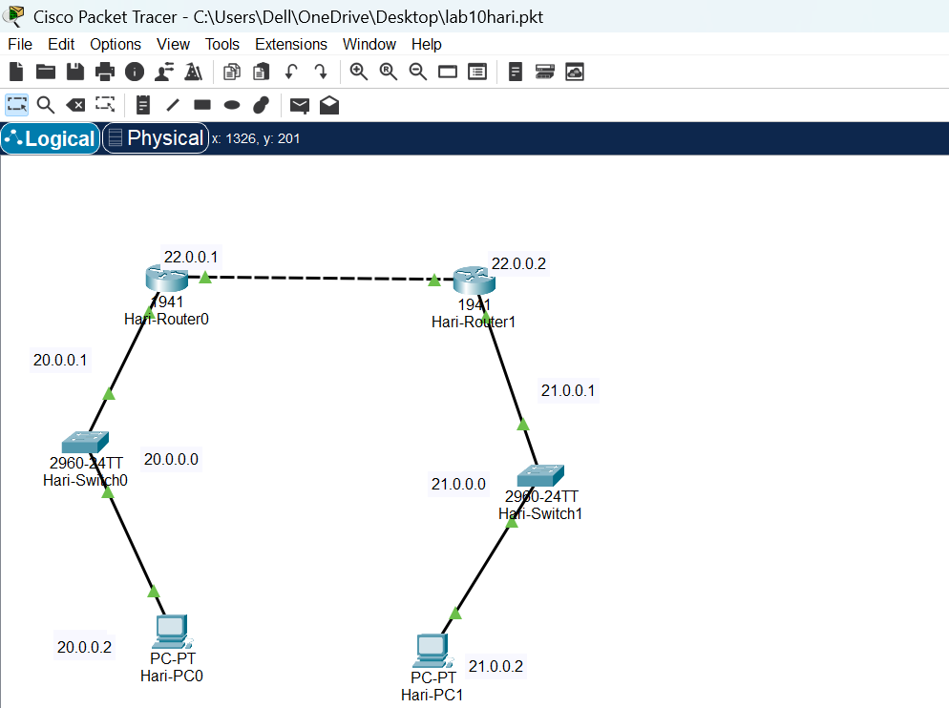
Fig: Network Diagram
Implementation Sequence
Here is the implementation sequence for Implementation of Dynamic Interior/ Exterior Routing (RIP, OSPF, BGP).
- Configuring Network
Configure the network for PCs and Routers
Step 1: Open Packet Tracer and setup the devices.

Fig: Simple Network setup
Step 2: Assign IP addresses to each PC.

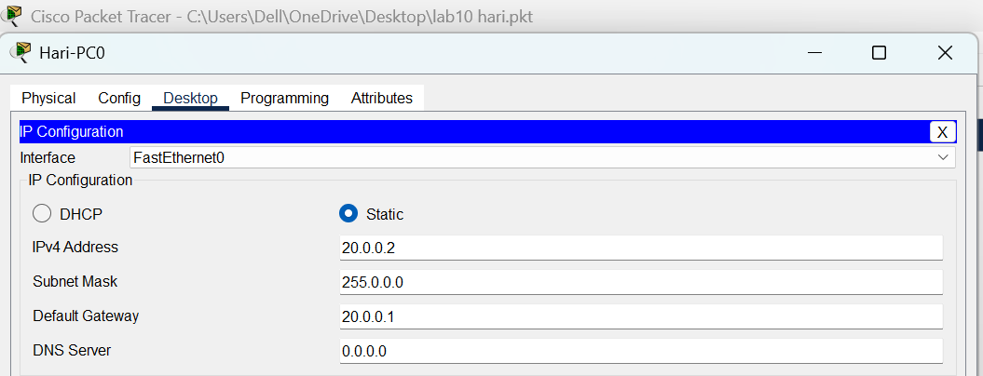

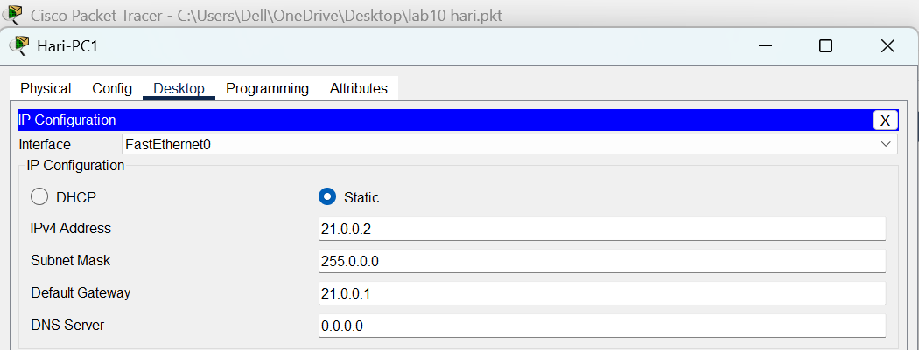
Fig: IP configuration
Step 3: Assign IP addresses to router interfaces.
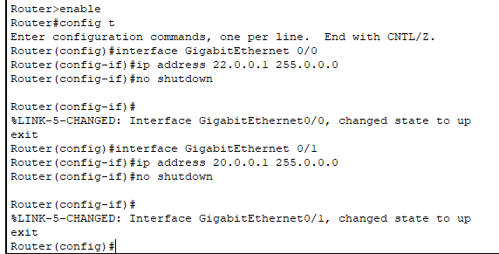
Fig: Gigabit Ethernet configuration on router0
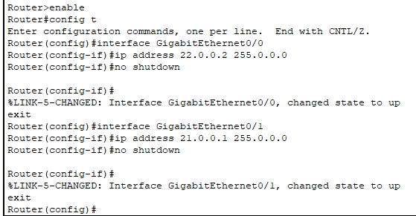
Fig: Gigabit Ethernet configuration on router1

Implementation & explain the need for Dynamic Routing
Dynamic routing protocols such as RIP, OSPF, and BGP allow routers to automatically learn and update routes as the network changes. The general steps for implementation are:
- Network Configuration
  - Set up the network topology by connecting routers, switches, and PCs.
  - Assign appropriate IP addresses and subnet masks to each interface.

- Dynamic Routing Setup
  - Enable the required dynamic routing protocol (e.g., RIP for small networks, OSPF for larger enterprise networks, or BGP for inter-AS communication).
  - Configure the routers so they can exchange routing updates with their neighbors.

- Testing and Verification
  - Use commands such as ping to check connectivity between devices.

Need for Dynamic Routing
Dynamic routing plays an essential role in modern networks because of the following benefits:
- Automatic Route Updates: When network conditions change—such as link failures or the addition of new devices—dynamic routing protocols automatically refresh routing tables. This ensures uninterrupted connectivity without manual intervention.
- Scalability: For large or frequently changing networks, manually configuring static routes becomes difficult. Dynamic routing protocols manage network growth more effectively, making expansion easier.
- Efficient Path Selection: These protocols continuously analyze network conditions to select the most optimal path for data transmission, improving overall performance and reducing latency.
- Redundancy and Fault Tolerance: In the event of failures, dynamic routing quickly adapts and redirects traffic through alternative routes, maintaining reliability and minimizing downtime.

- Load Balancing: Many dynamic routing protocols can spread traffic across multiple available paths, preventing congestion on a single route. This enhances both efficiency and network performance.

Dynamic Routing Configuration
  - Using RIP Command

Network Diagram
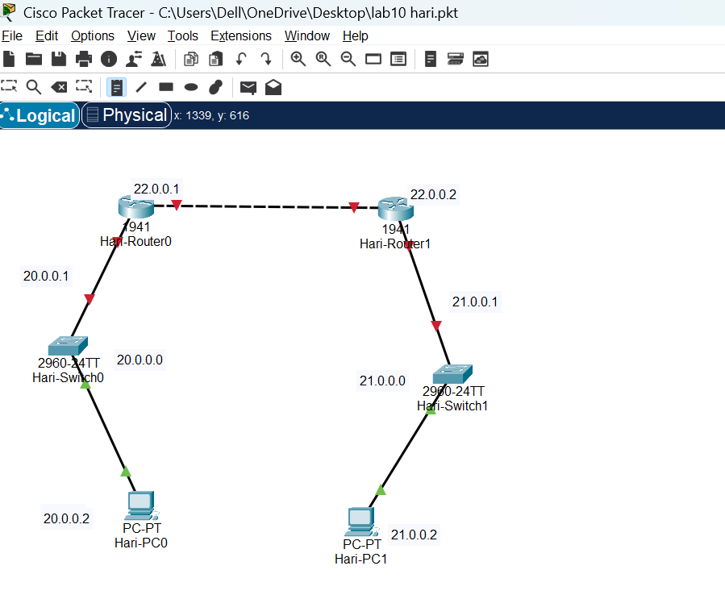
Fig: Network Diagram
Code for Dynamic Routing Configuration using RIP command
For Router 0
Router>enable
Router#configure terminal
Router(config)#router rip
Router(config-router)#version 2
Router(config-router)#network 22.0.0.0
Router(config-router)#network 21.0.0.0
Router(config-router)#exit

For Router 1
Router>enable
Router#configure terminal
Router(config)#router rip
Router(config-router)#version 2
Router(config-router)#network 20.0.0.0
Router(config-router)#network 22.0.0.0
Router(config-router)#exit

Steps for Dynamic Routing Configuration using RIP Command
Step 1: Access the Router CLI
- Open Packet Tracer
- Click on the router we want to configure to access its CLI (Command Line Interface).
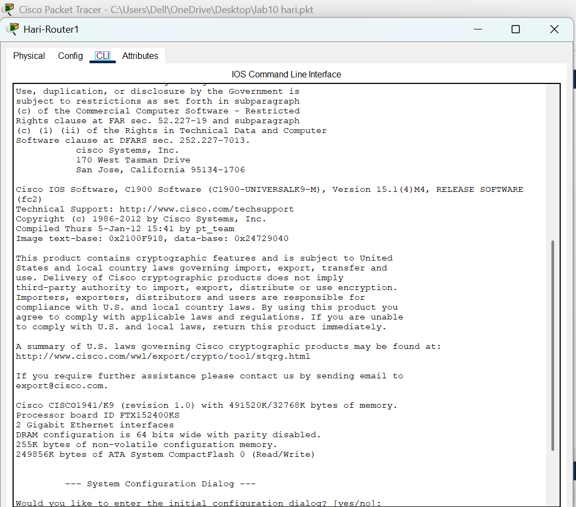
Fig: Accessing Router CLI via Console Cable
Step 2: Enter Global Configuration Mode
- Enable RIP Routing Protocol
- Specify the RIP Version
- Configure the RIP Networks
- Exit RIP Configuration Mode
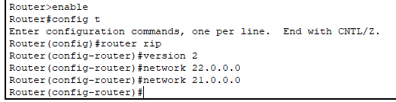
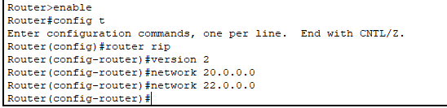
Fig: Router configuration of router0 and router1 using RIP command
Testing
To test whether the network is working, we can ping other devices on the network from each PC. If the ping is successful, we should see replies from the other device.
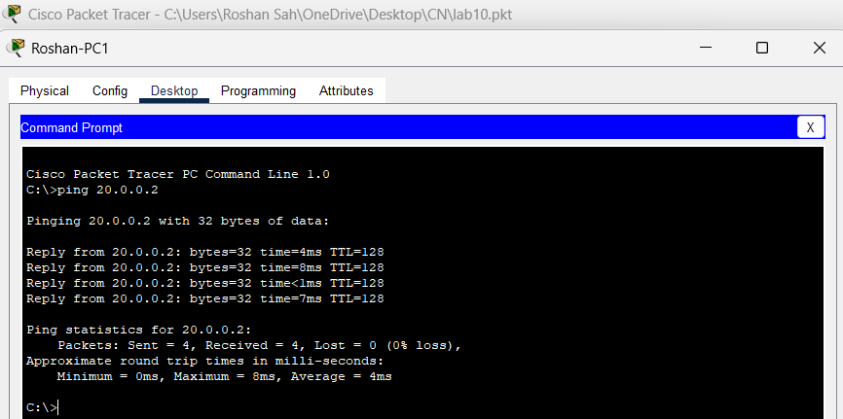
Fig: Connectivity test between Hari-PC1 to Hari-PC0

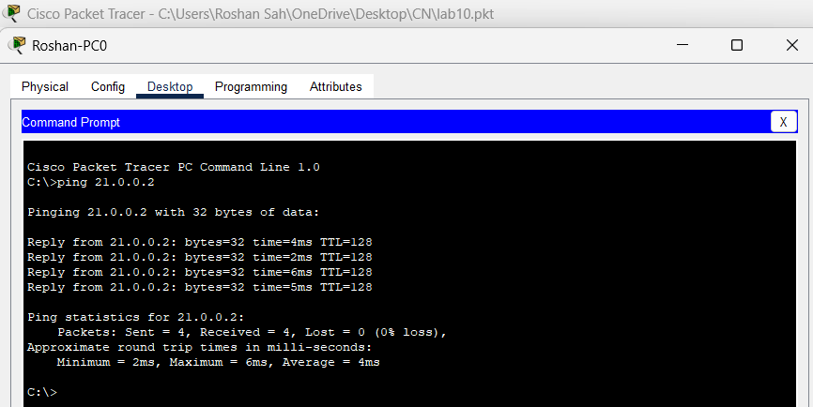
Fig: Connectivity test between Hari-PC0 to Haril-PC1
Above figure shows the results of a ping test between two PCs on a network. The ping test was successful, indicating that there is connectivity between the two devices. The output of the ping test shows the number of packets sent, received, and lost, as well as the approximate round trip time for each packet.

2.Using OSPF Command
Network Diagram
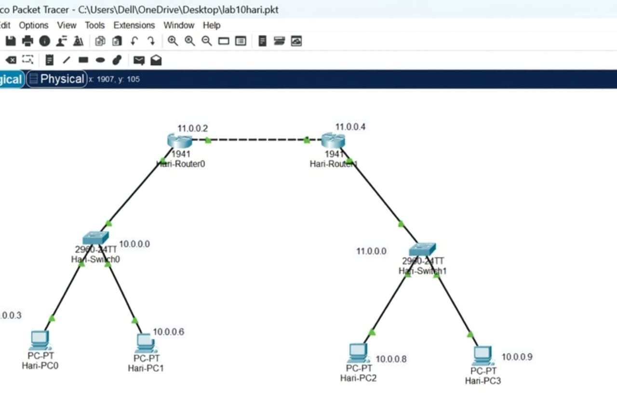
Fig: Network Diagram
Code for Dynamic Routing Configuration Using OSPF Command
For Router0
Router>enable
Router#config t
Router(config)#router ospf 1
Router(config-router)#network 10.0.0.0 0.0.0.255 area 0
Router(config-router)#network 10.0.1.0 0.0.0.255 area 0
Router(config-router)#exit
For Router1
Router>enable
Router#config t
Router(config)#router ospf 2
Router(config-router)#network 10.0.3.0 0.0.0.255 area 0
Router(config-router)#network 10.0.1.0 0.0.0.255 area 0
Router(config-router)#exit

Steps for Dynamic Routing Configuration using OSPF command
Step 1: Access the Router CLI
- Open Packet Tracer.
- Click on the router we want to configure to access its CLI (Command Line Interface).
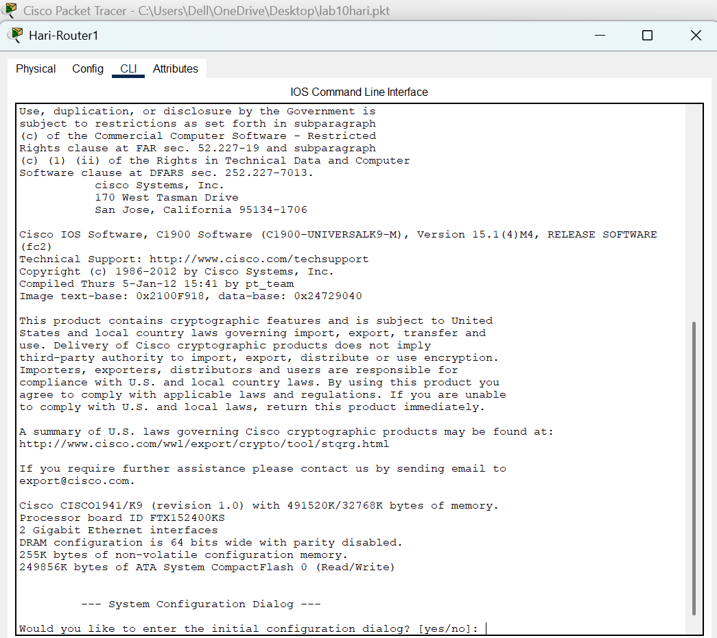
Fig: Accessing Router Command-Line Interface via Console Cable
Step 2: Enter Global Configuration Mode
- Enable OSPF Routing Protocol
- Start the OSPF process and assign it a process ID
- Assign a router ID
- Specify the networks connected to Router 1, and define the areas.
- Exit OSPF configuration.
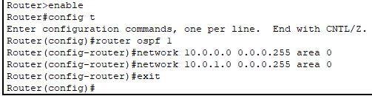

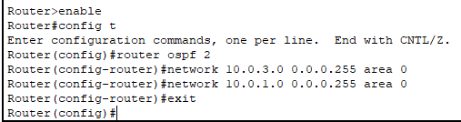
Fig: Router configuration for router0 and router1 using OSPF command
Testing
To test whether the network is working, we can ping other devices on the network from each PC. If the ping is successful, we should see replies from the other device.
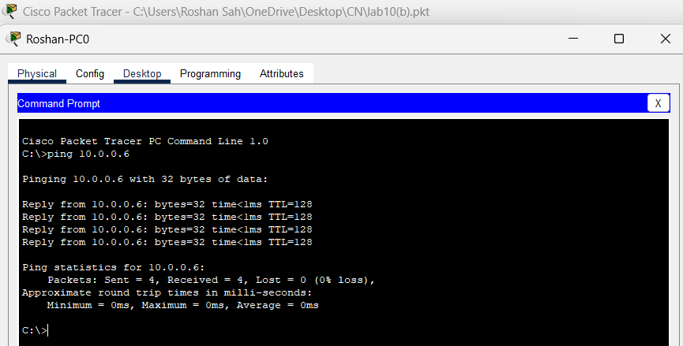
Fig: Connectivity test from Hari-PC0 to Hari-PC1

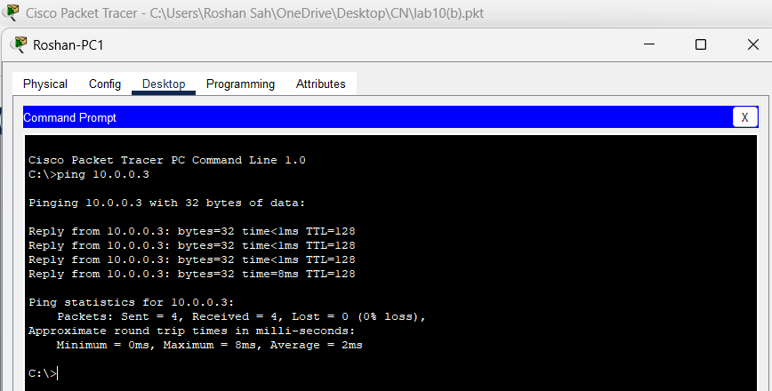
Fig: Connectivity test from Hari-PC1 to Hari-PC0
Above figure shows the results of a ping test between two PCs on a network. The ping test was successful, indicating that there is connectivity between the two devices. The ping output of the ping test shows the number of packets sent, received, and lost, as well as the approximate round trip time for each packet.
Addressing Table:
Device | Interface | IPv4 Address | Subnet | Router no.
PC0 | NIC | 10.0.0.3 | 255.0.0.0 | 0
PC1 | NIC | 10.0.0.6 | 255.0.0.0 | 0
PC2 | NIC | 10.0.0.8 | 255.0.0.0 | 1
PC3 | NIC | 10.0.0.9 | 255.0.0.0 | 1
The addressing table of the OSPF configuration is as follows:

3.Using BGP Command

Network Diagram
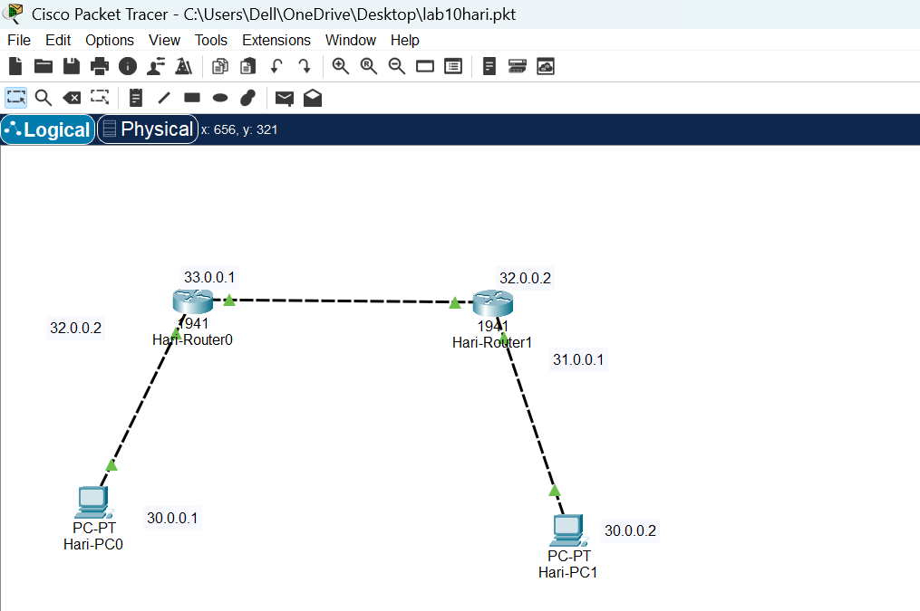
Fig: Network Diagram
Code for Dynamic Routing Configuration Using BGP Command
For Router 0
Router0> enable
Router0# configure terminal
Router(config)# router bgp 420
Router(config-router)# network 199.123.1.0
Router(config-router)# network 199.123.2.0
Router(config-router)# neighbor 199.123.2.2 remote-as 520
Router(config-router)# neighbor 199.123.3.2 remote-as 520
Router(config-router)# exit

For Router1
Router0> enable
Router0# configure terminal
Router(config)# router bgp 420
Router(config-router)# network 199.123.1.0
Router(config-router)# network 199.123.2.0
Router(config-router)# neighbor 199.123.2.1 remote-as 520
Router(config-router)# neighbor 199.123.1.2 remote-as 520
Router(config-router)# exit

Steps For Dynamic Routing Configuration Using BGP Command
Step 1: Access the Router CLI
- Open Packet Tracer
- Click on the router we want to configure to access its CLI (Command Line Interface).
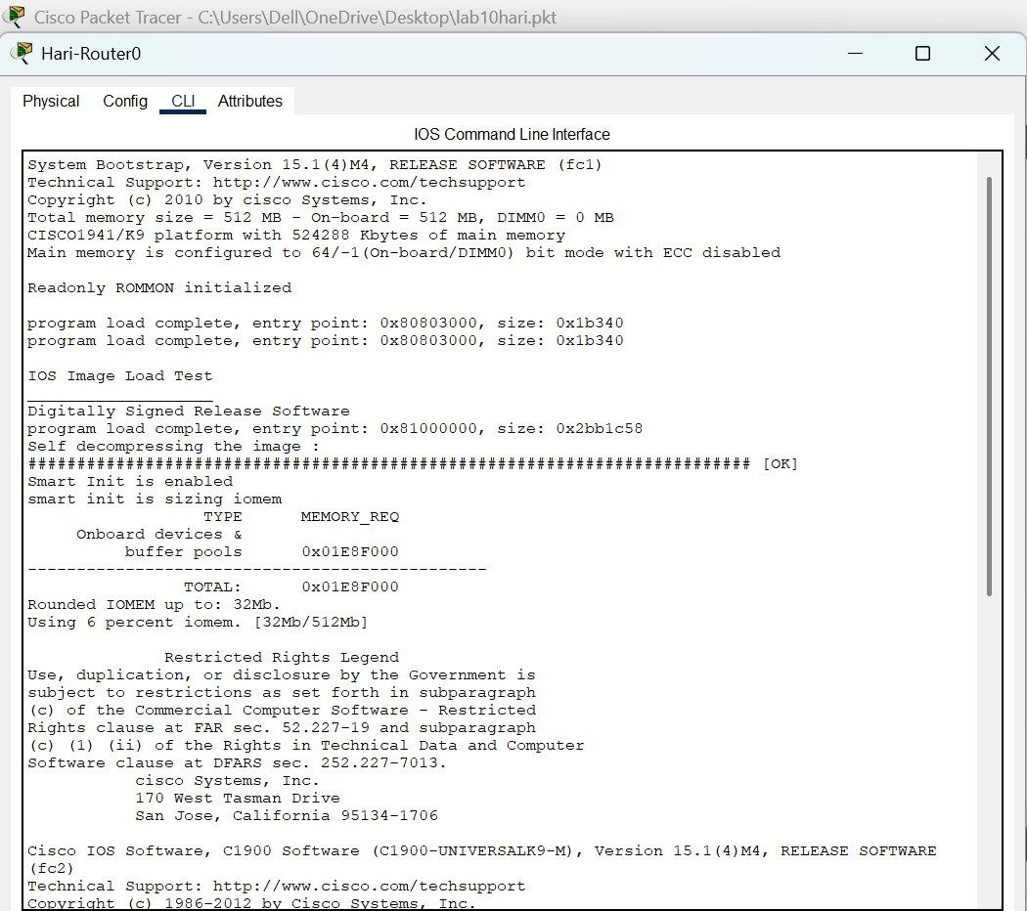
Fig: Accessing Router CLI via Console Cable

Step 2: Enter Global Configuration Mode
- Enable BGP Routing Protocol
- Start the BGP process and specify the AS number
- Configure Neighbor
- Advertise Networks
- Exit BGP configuration
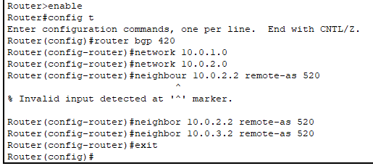
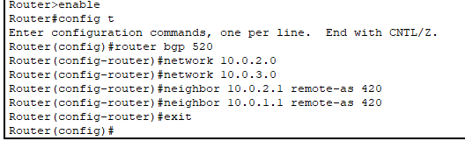
Fig: Router configuration for router0 and router1 using BGP command
Testing
To test whether the network is working, we can ping other devices on the network from each PC. If the ping is successful, we should see replies from the other device.
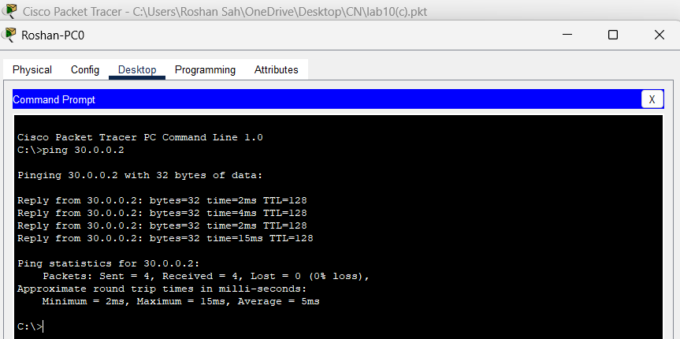
Fig: Connectivity test from Hari-PC0 to Hari-PC1
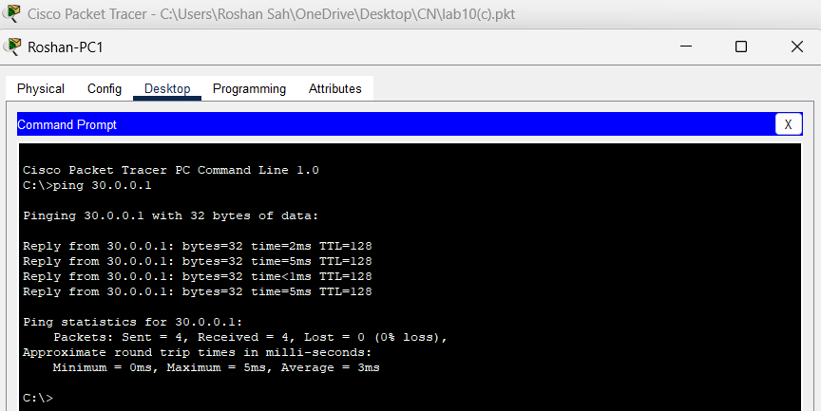
Fig: Connectivity test from Hari-PC1 to Hari-PC0
Above figure shows the results of a ping test between two PCs on a network. The ping test was successful, indicating that there is connectivity between the two devices. The output of the ping test shows the number of packets sent, received, and lost, as well as the approximate round trip time for each packet.
Addressing Table:
The addressing table of the BGP Configuration is as follows:
Device | Interface | IPv4 Address | Subnet | Router No | Link
PC0 | NIC | 199.123.1.2 | 255.255.255.0 | 0 | Access
PC1 | NIC | 199.123.3.2 | 255.255.255.0 | 1 | Access

CONCLUSION
In this lab, we configured and tested dynamic routing protocols—RIP, OSPF, and BGP to enable automatic route updates and ensure reliable network connectivity. RIP was shown to be simple and effective for smaller networks, while OSPF offered faster convergence and scalability, making it suitable for larger and more complex topologies. BGP demonstrated its importance in exterior routing by managing communication between Autonomous Systems and supporting global Internet traffic. Successful ping tests confirmed correct network setup and validated the smooth functioning of these routing protocols.

