Lab Number: 06  Date: 2025-08-01
Title: Creating a LAN and testing the connectivity using Packet Tracer

Theory
A Local Area Network (LAN) connects computers and peripheral devices within a limited area like a home, school, or office. It is commonly used to share resources such as files, printers, and applications. LANs typically use Ethernet cables and offer data transmission speeds between 10–100 Mbps, often running on high-speed internet. It operates under private ownership and usually does not require external network access for communication among connected devices.

Key Features of LAN
- LAN is a private network and is not controlled by any external regulatory body.
- It provides relatively higher speed compared to wide area networks (WANs).
- It supports various media access control methods such as Ethernet and Token Ring.
- It connects computers within a limited geographical area like a single building or campus.

LAN Architecture
LAN architecture refers to the overall design and arrangement of devices, transmission media, and communication protocols used in a Local Area Network.

Key Components
Switch: A device that connects multiple computers and forwards data to the intended destination.
Router: Connects LAN to external networks and assigns IP addresses. Ethernet Cable: A wired medium used to transfer data between devices. Network Interface Card (NIC): Allows a computer to connect to a network, either wired or wireless.

Topologies
Topologies define the layout of the network. Common types include:
- Star – All devices connect to a central switch.
- Bus – All devices share a single communication line.

- Ring – Devices form a circular data path.
- Mesh – Every device connects to every other device.

Protocols
Protocols ensure communication between devices. Some commonly used protocols are:
  - Ethernet
Ethernet are the standard for wired communication in LANs.
  - Wi-Fi
Wireless standard for connecting devices.
  - TCP/IP
A set of rules governing data transfer and addressing.

Component Used:
  - Hardware
Switch (1) Ethernet Cables End Devices (2)
  - Software
Cisco Packet Tracer

Network Diagram

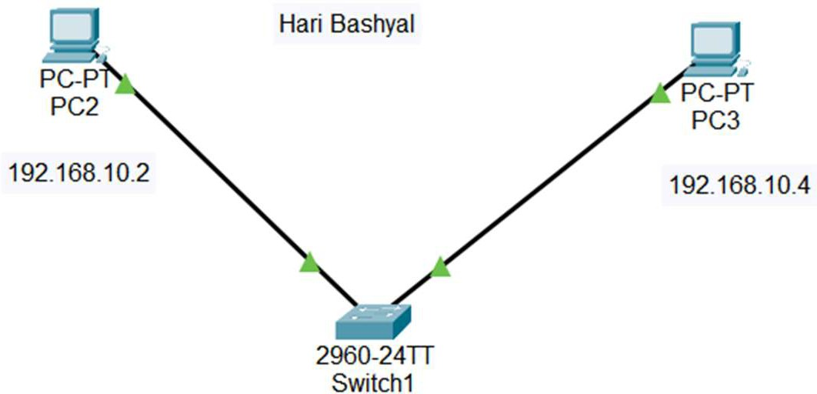

Figure: Network Diagram of LAN

Procedure
The procedure for creating the LAN network using Cisco Packet Tracer is shown in the image:

Step 1: Launch Cisco Packet Tracer
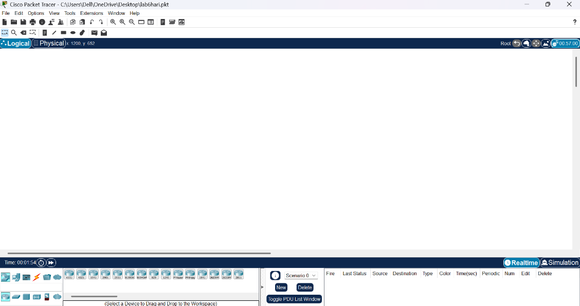
Figure: Workspace for Network Design

Step 2: Add the network devices to the workspace
  - From the Device-Type Selection box, choose the following devices and add them to the workspace:
  - One 2960-24TT Switch
  - Two PCs (labeled PC0 and PC1)

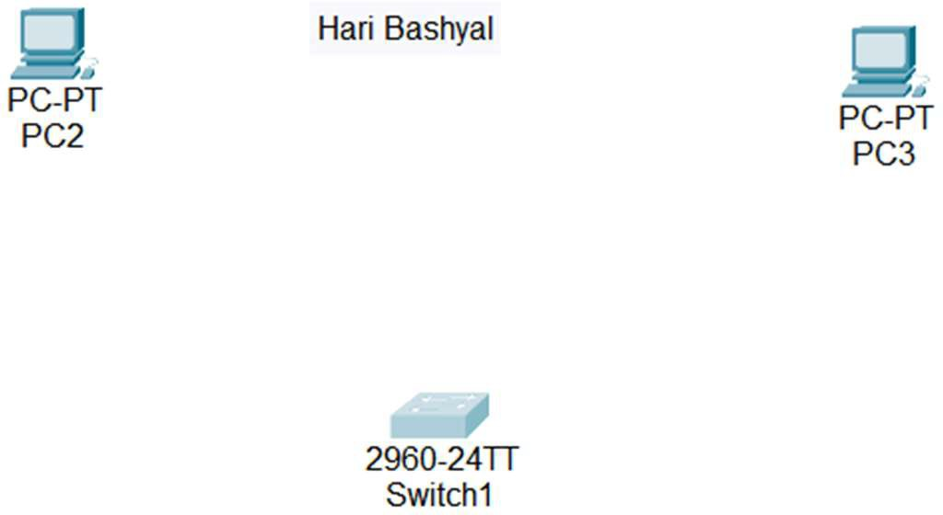

Figure: Switches and PC’s for LAN creation

Step 3: Connect the devices
  - Use the copper straight-through cable to connect each PC to one of the available ports on the switch.
  - Ensure that each connection is made properly

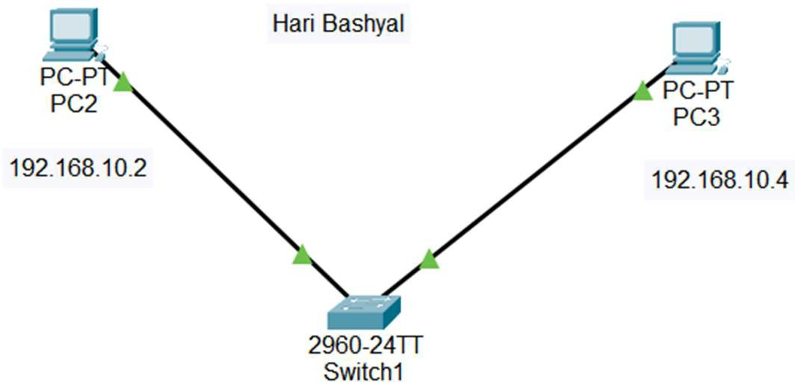

Figure: Connection between Switch and Pc’s

Step 4: Configure IP address
  - Right-click on each PC and select “IP Configuration”.
  - In the IP Configuration window, enter the IP address as (188.22.22.22 and 188.22.22.24), subnet mask and default gateway for both PC.

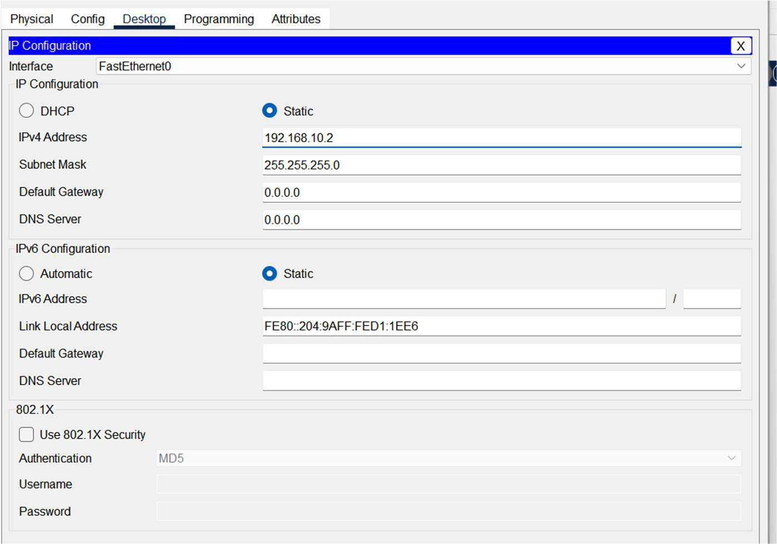
Figure: IP Configuration

Step 5: Testing and Validation
  - Use the ping command from each PC to check network connectivity.
  - Open Command Prompt and type ping <IP address of another PC>.
  - If replies are received, the connection is successful.
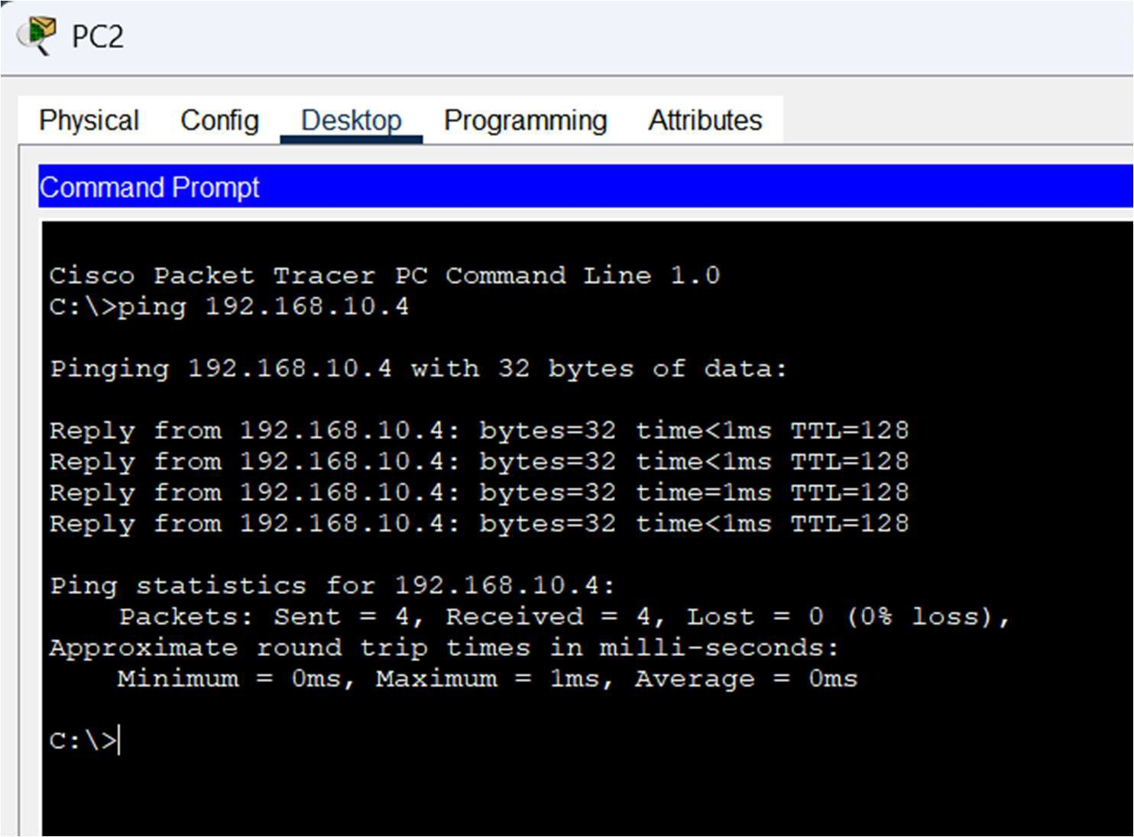
Figure: Connectivity test between network PC2 and PC3

Conclusion:
In this lab, a Local Area Network (LAN) was successfully designed and implemented using Cisco Packet Tracer. Devices were connected using a switch and configured with appropriate IP addresses. The ping command was used to test connectivity between devices. Successful replies confirmed that the network was functioning correctly, and communication between end devices was established without errors.

