
Lab Number : 12 Date:2025/08/27
Title: DNS and Web Server Configuration using Packet Tracer.
THEORY:
DNS (Domain Name System): DNS translates human-friendly domain names, such as google.com, into IP addresses like 192.168.1.1, which computers use to communicate. It works in the background whenever a user types a website address, allowing quick and easy access without remembering numeric IPs.
Web Server: A web server is a computer system that hosts websites and delivers web pages to users on request. It uses HTTP or HTTPS to process requests and send files like HTML, images, or scripts, handling both static and dynamic content efficiently.
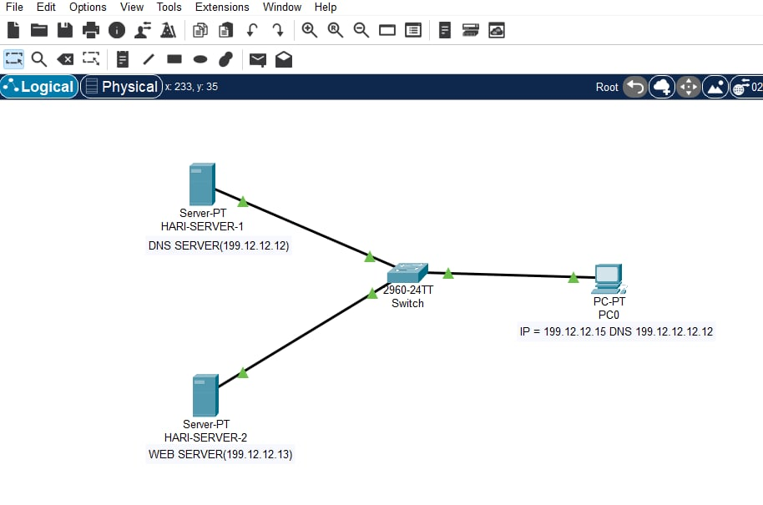
Network DiagramFig: Network Diagram
Implementation Sequence:
- Configuring DNS Server and Web Server
DNS Server Configuration:
Step 1: Go to the DNS Server and click on the Desktop tab.
Step 2: Set the IP Address to 199.12.12.12 and the Subnet Mask to 255.255.255.

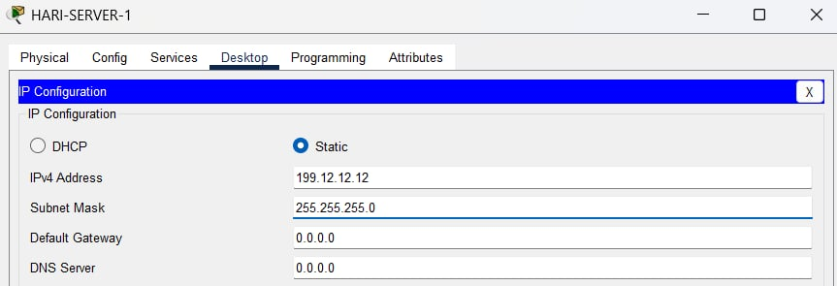
Fig: Configuring DNS server
Step 3: Click on the Services tab, then navigate to HTTP and turn it ON.
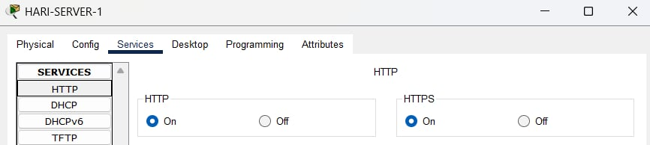
Fig: Turning ON HTTP
Step 4: And go to index.html, click edit, make the necessary changes to the file, and click Save.
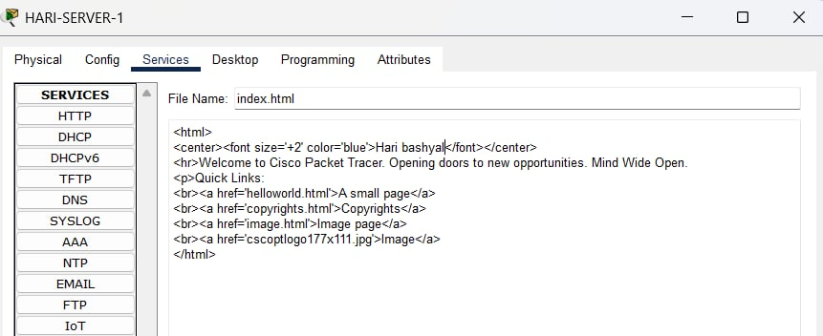
Fig: Configuring index.html file

Web Server Configuration:
Step 1: Click on the Web Server, then go to the Config tab.
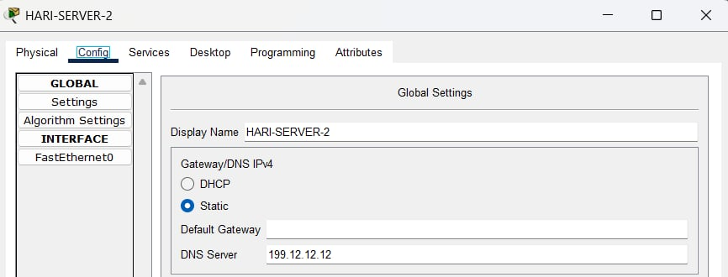
Step 2: Set the DNS Server to 199.12.12.12
Fig: Configuring DNS on WEB server

Step 3: Go to the Desktop tab and set the IP Address to 199.12.12.13, the Subnet Mask to 255.255.255.0, and the DNS Server to 199.12.12.12
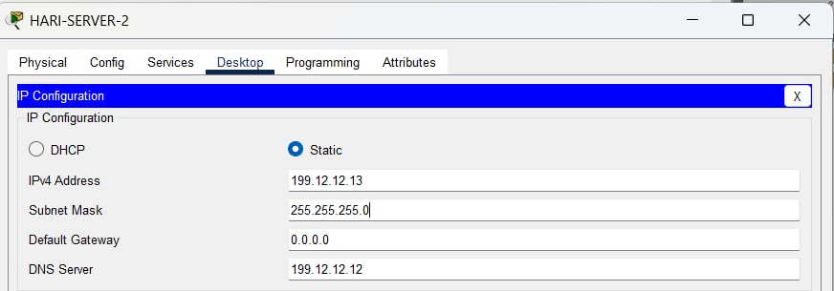
Fig: Configuring WEB server
PC Configuration:
Step 1: Go to the PC, then navigate to the Desktop tab.
Step 2: Set the IP Address to 199.12.12.15, the Subnet Mask to 255.255.255.0, and the DNS Server to 193.12.12.12

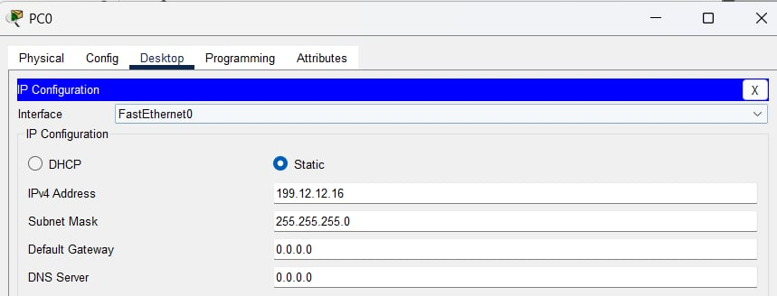
Fig: IP configuration on PC
Testing Web Server on PC:
Step 1: Go to the Desktop, click on Web Browser, and in the URL tab, enter the IP address of the Web Server, i.e., 199.12.12.13
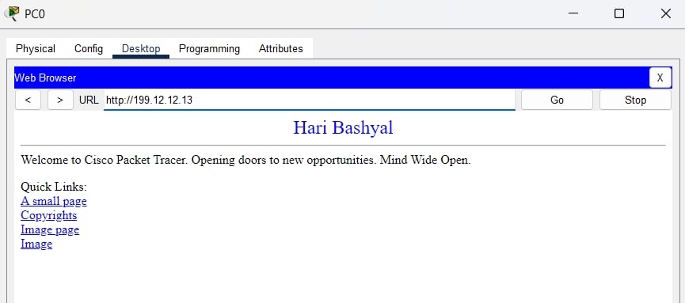
Fig: Checking WEB server on PC
Web Server in DNS Server Configuration
Step 1: Go to the DNS Server then click on Services, then select DNS.
Step 2: In the Name field, type amir.com, enter the IP address of the Web Server in Address field, i.e. 199.12.12.13 then click add and then save.

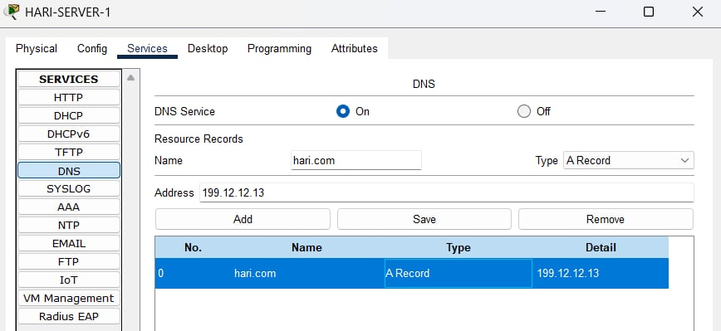
Fig: Adding WEB server on DNS server

Testing Web Server on PC after configuring in DNS
Step 1: Go to the Desktop, click on Web Browser, and in the URL tab, type google.com to access the webpage served by the Web Server.
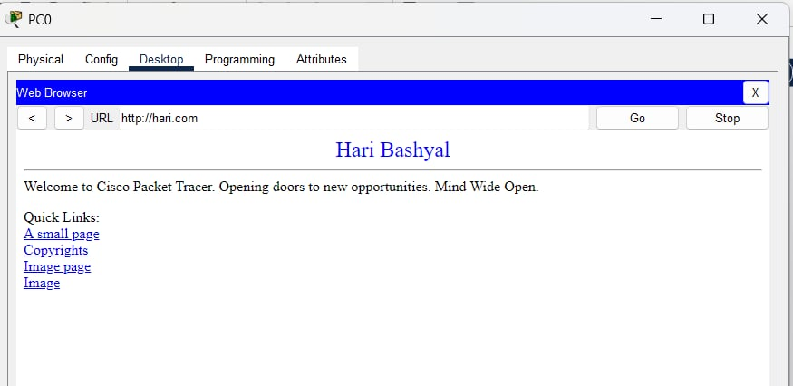
Fig: Checking Web Server after configuration in DNS
From above picture, we can verify that whether we type Name or IP address we will get the same web page.

Addressing Table:
Device | Interface | IPv4 Address | Subnet
PC0 | NIC | 199.12.12.15 | 255.255.255.0
HARI-SERVER-1 | NIC | 199.12.12.13 | 255.255.255.0
HARI-SERVER-2 | NIC | 199.12.12.12 | 255.255.255.0
The addressing table of this lab is as follows:

CONCLUSION
In this lab, we show how DNS makes it easier to access web services by converting user-friendly domain names into numerical IP addresses. The Packet Tracer setup highlights how DNS and web servers can be configured to work together in a network, allowing users to reach web resources more easily through familiar domain names.

