
Lab Number : 13 Date:2025/08/27
Title: FTP Configuration and Implementation using Packet Tracer
THEORY:
FTP (File Transfer Protocol):
FTP is a standard protocol used to transfer files between a client and a server over TCP/IP. It uses port 21 for control commands and port 20 for data transfer in active mode. FTP can work with anonymous access or authenticated login. It supports two modes: active (server connects to client) and passive (client connects to server’s chosen port, useful behind firewalls). FTP allows operations like uploading, downloading, and managing files using commands such as RETR, STOR, DELE, LIST, and MKD. It can transfer data in ASCII mode (for text files) or binary mode (for exact file copies). However, since FTP lacks built-in encryption, secure variants like FTPs or SFTP are preferred for sensitive data.
Key Concepts of FTP:
- Client-Server Model: Client requests file operations, and the server responds.
- Ports: Control connection uses port 21; data transfer uses port 20 (active) or a random port (passive).
- Modes: Active mode lets the server connect to the client; passive mode lets the client connect to the server.
- Authentication: Can be anonymous or username-password based.
- Commands: Common ones include LIST (view files), RETR (download), STOR (upload), and DELE (delete).
Network Diagram
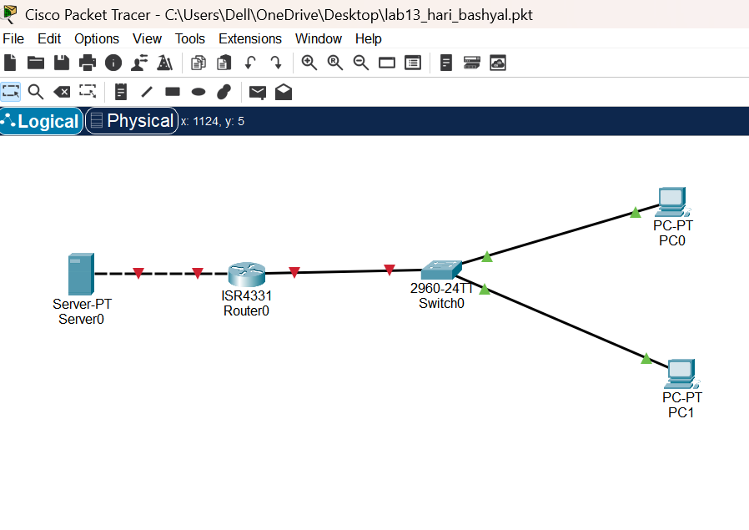
Fig: Network diagram
Implementation Sequence
- Configuring FTP Server and FTP Client
- FTP Server Configuration
Step 1: Click on server and go to IP configuration and set IP address and subnet mask.
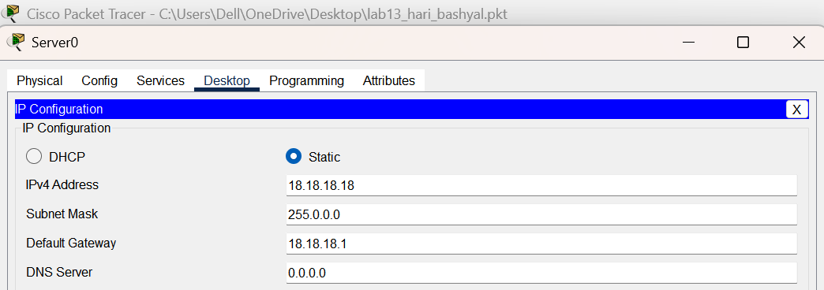Fig: IP configuration on Server
Step 2: Click on server go to service, click ftp and click on ON button. Set username, password, and tick write, read, delete, rename, and list. Click add.
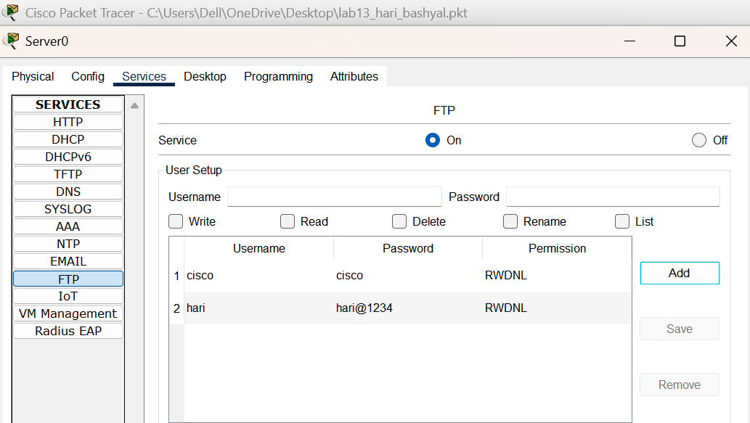Fig: Server Configuration

Step 3: Go to PC, click text editor write something and save the file as hari.txt
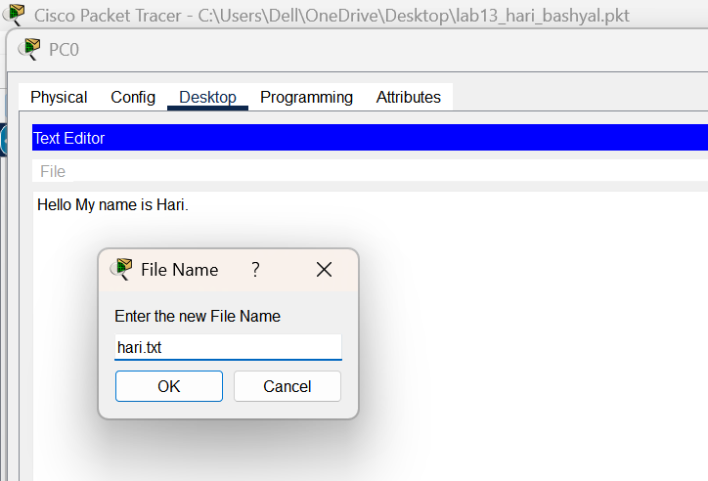
Fig: Creating a file name amir.txt
Step 4: In desktop, open command prompt and type dir command, we can see the file.
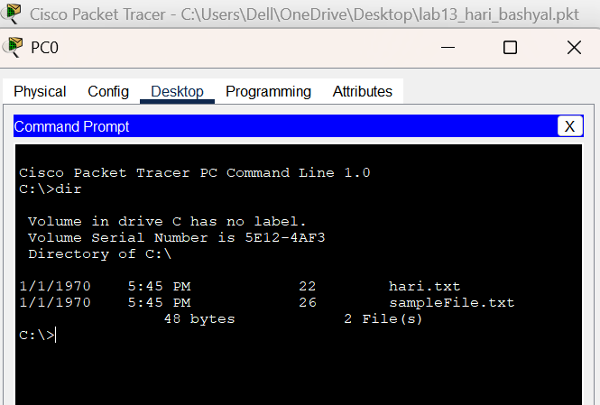Fig: Using dir command to see file
In command prompt type command ‘ftp 18.18.18.18’ then insert username and password, We will be connected to ftp server.
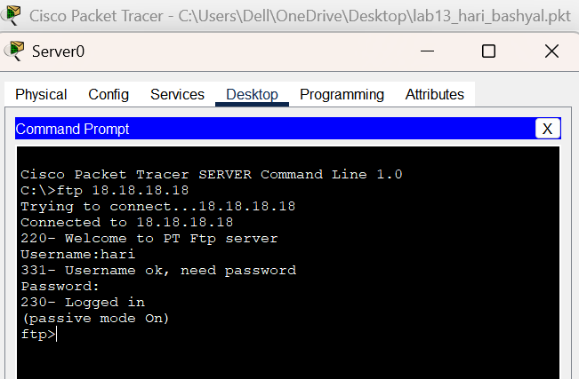
Fig: FTP Server Connection
- FTP Client Configuration
Step 1: Click on pc and go to IP configuration and set IP address and subnet mask.
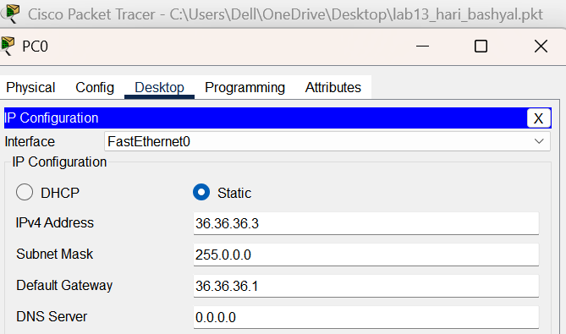
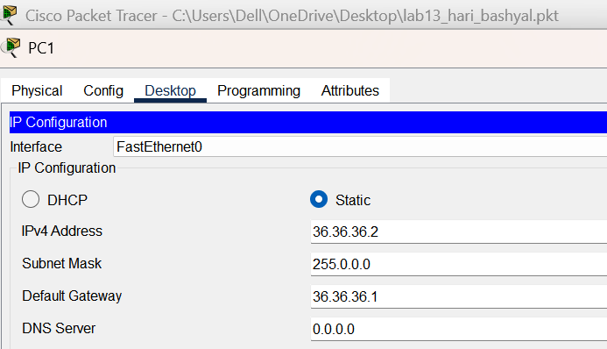
Fig: IP Configuration in Clients
- Implementation
- Transferring File Using PUT Command
Command: Ftp> put hari.txt
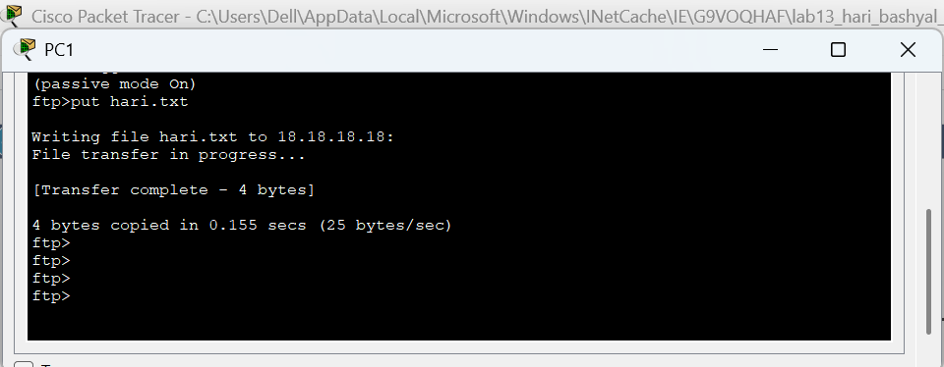
Fig: Transferring file using PUT command

- RENAME File
Command: Ftp>rename hari.txt abc.txt
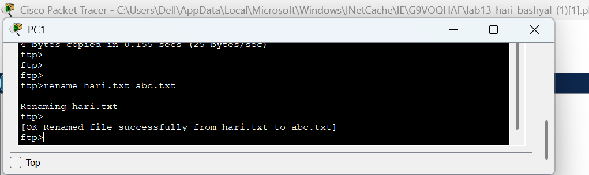
Fig: Renaming file
- Get The File and Save The Copy on PC0
Command: Ftp> get hari.txt
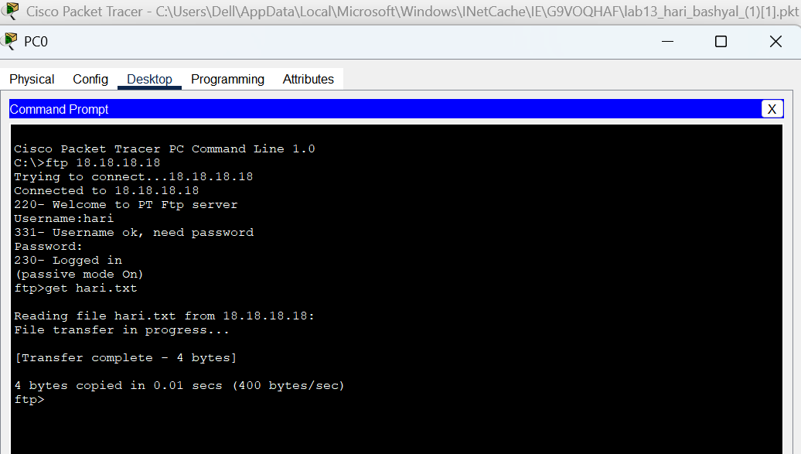
Fig: Downloading file hari.txt in another client
- Quit FTP in PC0
Command: Ftp> quit ftp
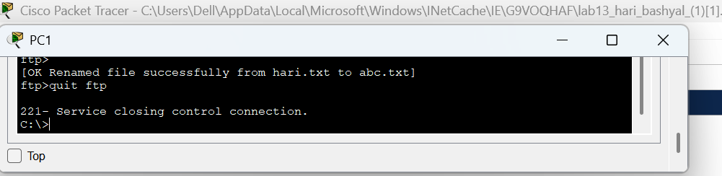
Fig: Quitting FTP

- Displaying The Files
Command: PC> dir
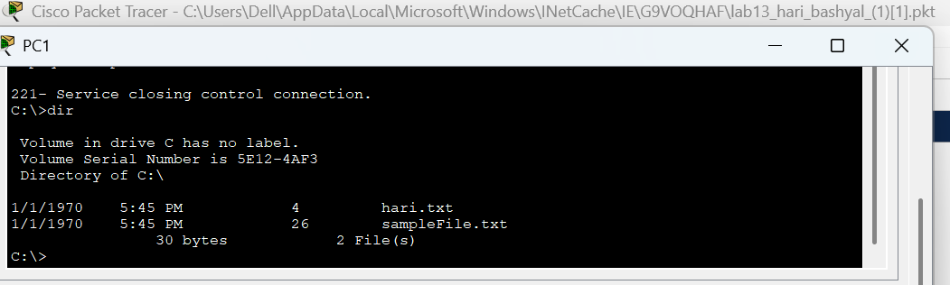
Fig: Displaying the file ‘hari.txt’
Addressing Table:
Device | Interface | IPv4 Address | Subnet
SERVER0 | NIC | 18.18.18.18 | 255.0.0.0
PC0 | NIC | 36.36.36.3 | 255.0.0.0
PC1 | NIC | 36.36.36.2 | 255.0.0.0
The addressing table of this lab is as follows:

CONCLUSION
In this lab, we set up and tested an FTP server and client in Packet Tracer. Through this exercise, we learned how to assign IP addresses, create user accounts, and perform file operations such as uploading, downloading, and renaming using FTP commands. The lab demonstrated the client-server model of FTP and highlighted how files can be managed efficiently across a network, emphasizing the significance of proper file transfer practices and security in networking.

