Introduction

Python is high level programming language, with application in numerous areas, including web programming, scripting, scientific computing, and artificial intelligence. It is processed at runtime by the interpreter. The three major versions of Python are 1.x, 2.x and 3.x. Code written for Python 3.x is guaranteed to work in all future versions. You can download python from www.python.org.

Installing python3

Setting up virtual Python3 environment
This is important because it determines how we run the python code.
At first we can see

Run
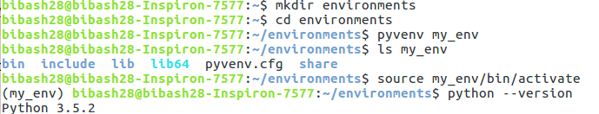
Running python from console
After downloading python it can be runned in the terminal
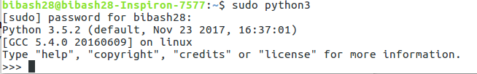
Running python
For making the python file
Then write the code
Compile using:
Basic Operations

Print Statement
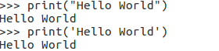

>>> → prompt sumbol on python console
Note: Python is an interpreted language which means that each line is executed as it is entered. It also includes IDLE(integrated development environment) which include tools for writing and debugging the entire program.

Simple Operations
Python has capability of carrying out calculations directly from console.
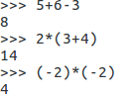

Also, floats are directly entered.
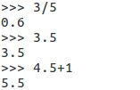

Exponentiation,Quotient and Remainder
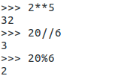

Comments
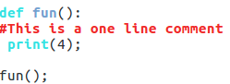

Variables
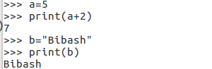

String
It is created by entering text between two single or double quotation marks.
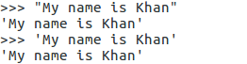

Some character must be escaped by using blackslash before them.
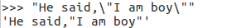

\n represents new line. Python provides easy way to avoid manually writing “\n” by using three set of quotes.
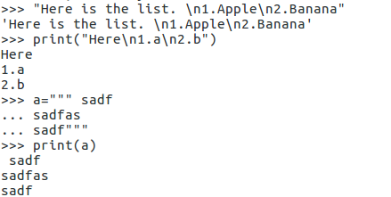

Taking Inputs
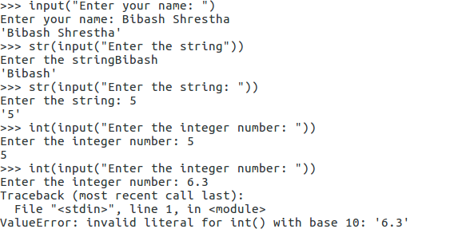
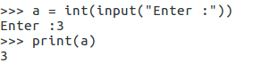

In-Place Operators
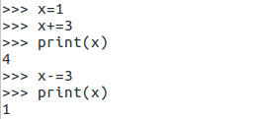

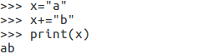

Sorting
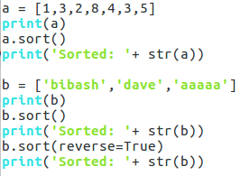

Output:
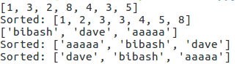

Zip
Returns an iterator of tuples, where the i-th tuple contains the i-th element from each of the argument sequences or iterables. The iterator stops when the shortest input iterable is exhausted.
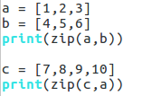

Output:
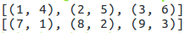

Some left in-built functions
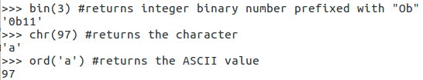

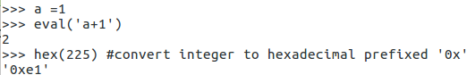

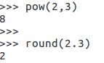

List
List are another type of object in Python. They are used to store an indexed list of items. A list is created using square brackets with commas separating items. The certain items in the list can be accessed by using its index.
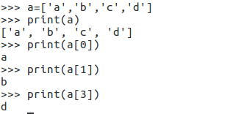

Also reverse indexing can be done.
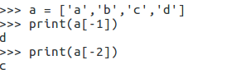

An empty list can be created with an empty pair of square brackets.
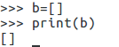

List can also be nested within other lists.
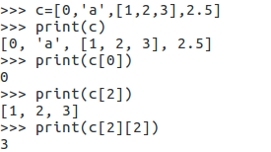

Range
The range function creates the sequential list of numbers. If range is called with one argument, it produces an object with values from 0 to that argument.
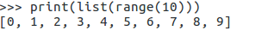

If range is called with two argument, it produces an object with values from first argument to the second.
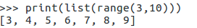

If range is called with three argument, it produces an object with values from first argument to the second and the third argument determines the interval of the sequence produced. The third argument must be an integer.
Also reverse can be performed.
Numberic functions(max, min, abs, sum, round)
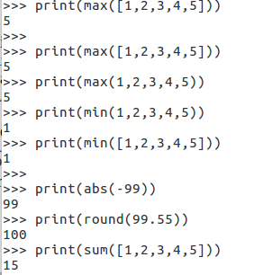

None
The None object is used to represent absence of value. It is similar to ‘null’ in other programming languages.
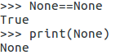

The None object is returned by any function that does not explicitly return anything.
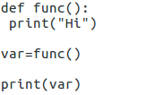

Ouput: None

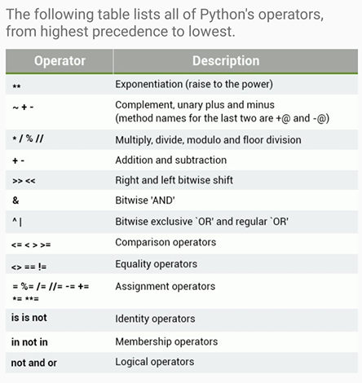
Operator Precedence

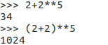

Code as both module and script
Most Python code is either a module to be imported or a script that does something. However, sometimes it is useful to make a file that can be both imported as a module and can run as script. To do this, script is placed inside if __name__ == “__main__”:. This ensures that it run if the file is not imported.
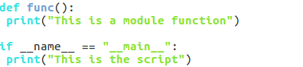

Ouput:

If the Python interpreter is running that module(source file) as the main program, it sets the special __name__ variable to a value “__main__”. If this file is being importes from another module, __name__ will be set to module’s name.

Using as module:
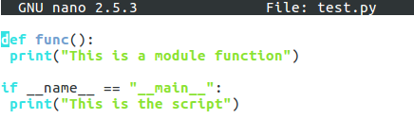

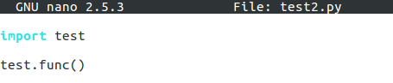

Output:

Control Structures

Booleans
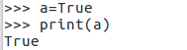

and, or, not
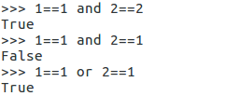
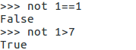

Comparison
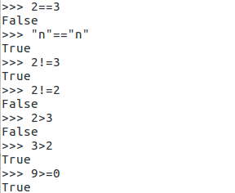

If Statement
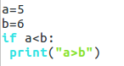

Output: a > b

else statement
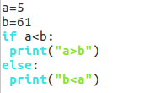

Output: a > b

elif statement
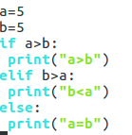

Output: a=b

Nested-if statement
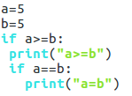

Output: a>=b
a=b

While loop
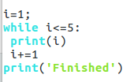
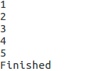
Output:

Break inside while
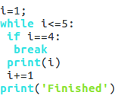
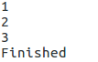
Output:

Continue inside while
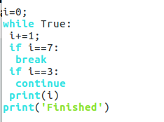
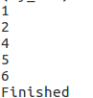
Output:

For loop
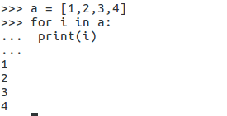
Using while loop acquires quite lot of code, so Python provides for loop as a shortcut that accomplishes the same task.

For using range
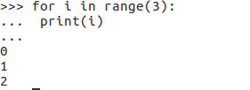

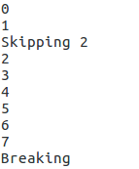
Break and Continue in for loop
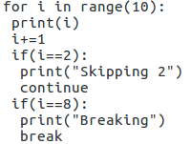
Output:

Ternary Operator
It checks the condition and returns the corresponding value.
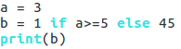

Output: 45

else in for/while
The else is executed if the loop is normally executed.
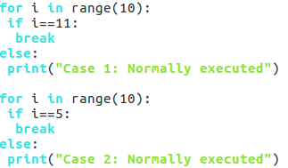

Output:

else in exceptional handling
The else is executed if no error occurs in the try statement.
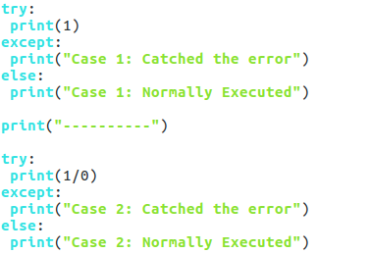

Output:
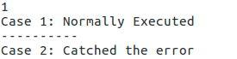

Strings

Concatenation
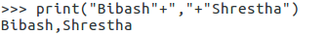

Multiply text by n
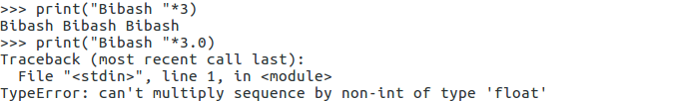
Type Conversion
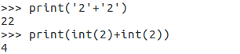

Indexing
String can be indexed like lists
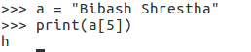

Length of string using len function
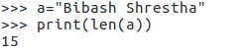

String Formatting
It provides more powerful way to embed non-string within strings. It uses string’s format method to substitute a number of arguments in the string.
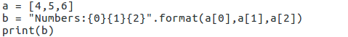

Output:

It can also done with named arguments.

Output:

upper, lower, join, split, replace, startswith, endswith method
To change the case of the string, we can us upper and lower.
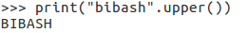

Join method joins a list of strings with another string as a separator.
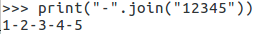

Split method is the opposite of the join,turning string with certain separator into a list.
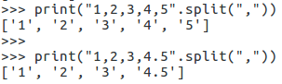

Replace method replaces one string with another.

\
Startswith and endswith determines if there is a substring at the start and the end of the substring respectively
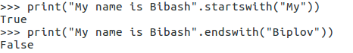

List

Reassigning to alter the value
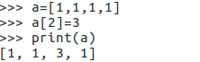

Arithmetic Operations
Lists can be added and multiplied in the same way as strings.
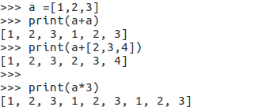

Checking the items in the list
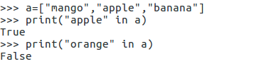

Two ways of using not operator is shown.
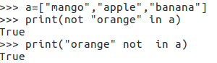

Adding the value using append method
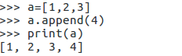

Removing the value using remove method
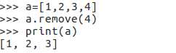

Length of list using len function
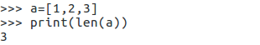

Insert method
It is similar to append but it allows to insert a new item at any position in the list.
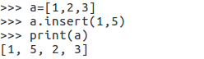

Index method
It finds the first occurrence of a list item and returns its index. If the item is not in the list, it raises Value error.
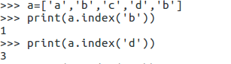

List Slices
It provides more advanced way to retrieve from the list. Indexing list with two colon-separated integers returns a new list containing the values in the old list between the indicies.
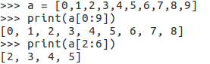

If the first number is omitted, it is taken to be the start of the list. If the second number is omitted, it is taken to be the end of the list.
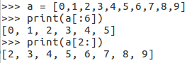

If it contains third number, it represents the step.
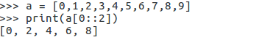

Negative value represent end of the list.
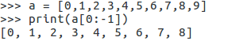

List Comprehensions
It is used to quickly create the lists.
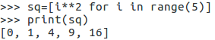

With if condition:
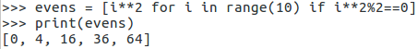

Trying to create a list in a very large range results in MemoryError.

Output: MemoryError

List Function
all and any take a list as an arguments return True if all or any of the arguments evaluate to true.
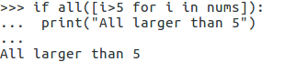

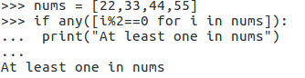

The enumerate can be used to iterate through the values and indicies of a list simultaneously.
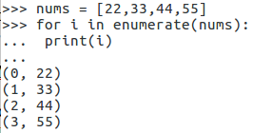

Dictionaries and Tuples

Dictionaries are the data structures used to map arbitrary keys to the values. List can be thought of as dictionaries with integer keys within a certain range. Dictionaries are kept inside the braces.
Dictionaries can be indexed in the same way as lists, using square brackets containing keys.

Output: 22

Indexing
Trying to index a key that is not a part of the dictionary returns KeyError.
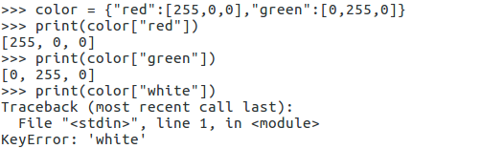

TypeError
Trying to use mutable object as a dictionary key causes a type error.
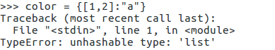

Assigning the values
Just like lists, dictionary keys can be assigned a value, not just the one that already exists.
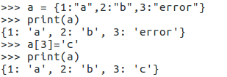

Adding the values
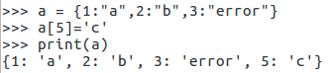

in, not in
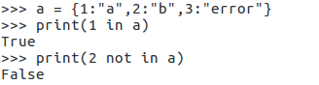

get method
It does the same thing as indexing, but if the key is not found in the dictionary it returns another specified value instead(‘None’ by default).
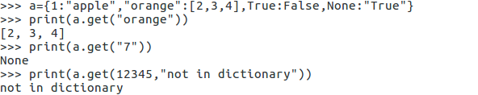

Tuples
Tuples are similar to lists,except that they are immutable(they cannot be changed). Also they are created using parantheses.
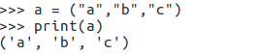

They can also be created without the parantheses, by just separating the values with commas.
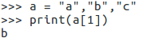

Accessing values
Like list,we can access values in the tuple with their index.
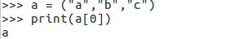

Tuple Unpacking
This allows each item in an iterable(often a tuple) to a variable.
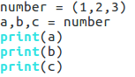
Output:

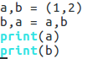
Output:
2
1

A variable that is prefaced with an asterisk(*) takes all values from the iterable that are left over from the other variables.
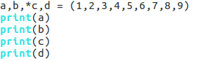

Output:
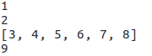

Sets

Sets are data structures,similar to list or dictionaries, creates using curly braces or set function.
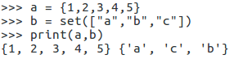

In, not in
They share some functionality with lists, such as the use of in. Due to the way they are stored, they are faster to check whether item is in it.
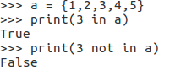

No dublicate elements
Sets cannot be indexed because they are unordered. Sets cannot contain dublicate elements.
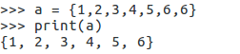

Add,Remove
Instead of append, add is used. The method remove removes a specific element. The pop removes an arbitrary elements.
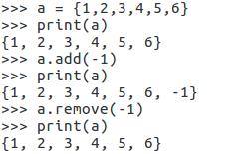

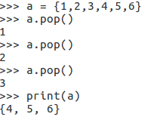

Mathematical Operations
Set can be combined using mathematical operation.
Union → | (combiines to sets)
Intersection → & (gets items only in both)
Difference → - (gets items in first but not in second)
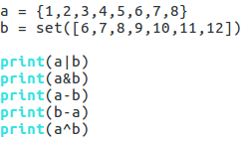
Symmetric Difference → ^ (gets items in either set but not in both)

Output:
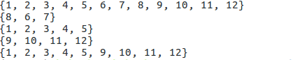

When to use:
list → collection of data that doesnot need random access, iterable collectiont that is easy to modify frequently
dictionary → logical relationi between key:value, easy to modify frequently
tuple → data cannot change
set → uniqueness of element

Functions

In addition to using pre-defined functions, we can create our own functions by using the def statement.
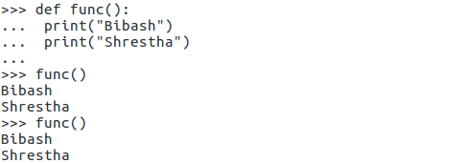

Arguments
All the funtions we have looked far have been functionof zero arguments, which are called empty parantheses. Most of the function takes the arguments.
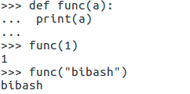

We can also define functions with more than one argument, separated with commas.
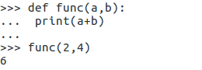

Returning from Functions
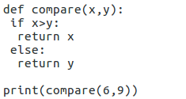

Output: 9

Docstrings
Documentation strings serves similar as a comment. They are the explanation of the function below the functions’s first line. Docstrings can be retained during runtime.
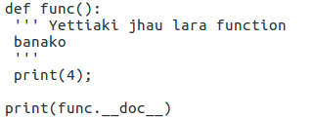

Output:
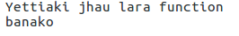

Function as Objects
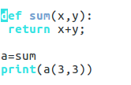

Output: 6

Function as argument of other functions
Higher order function take other functions as arguments, or return them as result.
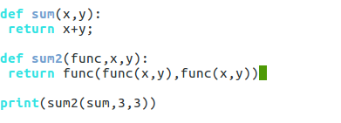

Output: 12

*args as a function parameter
This enables you to pass an arbitrary(varying) number of arguments to that function, Then the arguments are accessible as the tuple args in the body of the function. The parameter *args must come after the named parameters to the function. The name args is just a convention, we can choose another.
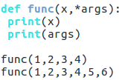
Output:
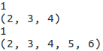

Default values
The named parameter to a function can be made optional by giving them a default value. These must come after named parameters without a default value.
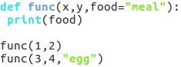
Output:
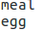

Keyword Argument
**kwargs → stands for keyword arguments
This allows us to handle named arguments that not defined in advance. The keyword argument returns the dictonary in which the keys are the argument names, and the values are the argument values.
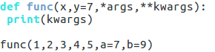

Ouput:

Modules

Modules are piece of code that other people have writtern to fulfill common tasksm such as generating random numbers, perfrorming mathematical operations and so on. The basic way to use module is to add import module_name at the top of the code, and then using module_name.var to access functions and values with the name var in the module.

Random module
This module generates the random numbers
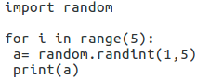
Output:

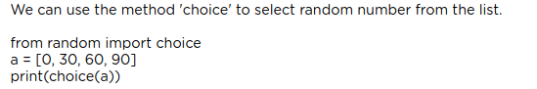

Importing specific functions from a module
No need to use module_name.var to access functions. Just var is suffuicient.
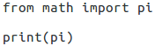

Output: 3.141592653589793

Import module as object
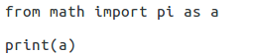
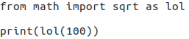

Output: 3.141592653589793 Output: 10.0

Types of modules in Python
a. those you write yourself
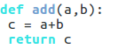

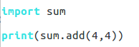

Also,
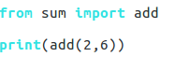

b. those you install from external sources
Many third party python modules are stored ont the PyPl(Python Package Index). The best way to install these is using pip(installed by default in modern python).
To install: pip install library_name

c. those are pre- installed with python( standard library)
This contain many useful modules. The task can be done by the standard library include string parsing, datat serialization, testing, debugging and manipulating dates,emails, command line arguments and much more. Some of the standard useful modules are: re, string, datetime, math, random, os, multiprocessing, subprocess, socket, email, json, doctest, unittest, pdb, argparse, sys and so on.

Functional Programming

Pure Functions
They have no side effect and return a values that depends only on their arguments. e.g cos(x) return same result for the same value of x
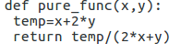

They are easier to reason about and test. They are more efficient.Once the function has been evaluated for an input, the result can be stored and referred to the next time the function of that input is needed, reducing the number of imes the functionis called. This is called memorization. It is easier to run in parallel.

The main disadvantage isnthat they majorly complicate the otherwise simple task of I/O, since this appears to inherently require side effects. They can also be more difficult to write in some situations.

Impure functions
It changes the state of value.
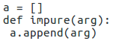

Lambdas
Lambdas(anonymous) function is creates without no name.
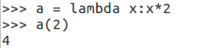

They are not powerful as function. They can only do the things that require single expression.
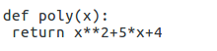

Equivalent:

Output:
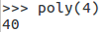

map & filter
The function map takes a functioin and an iterable as arguments, and returns a new iterable with the function applied to each argument.
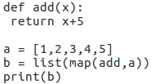

Output:

The function filter filters an iterable by removing items that doesnot match a predicate(a function that returns a Boolean)
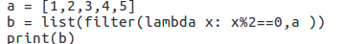

Output:

Generators
They are iterable like lists or tuples. Unlike lists, they don’t allow indexing with arbitrary intdicies, but they can still be iterated with for loop. They can be created using function and yield statements.
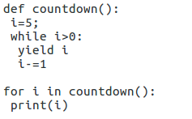
Output:

Since they yield one at a time there is no memory restriction.

Finite generators can be converted into the lists.
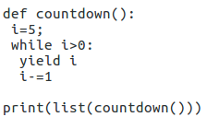

Output:

Decorator
It provides way to modify the function using other function.
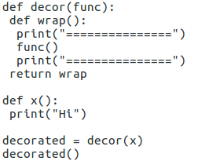

Output:
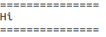

Different way:
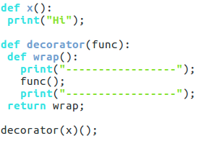
Output:
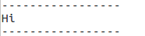

We can also decorate using @ symbol
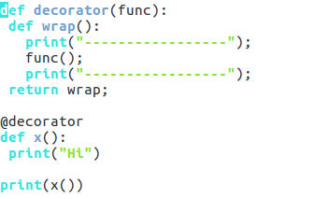
Output:
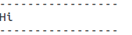

Recursion
This means itself again and again.
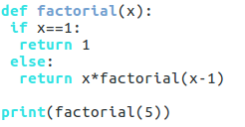

Output:120

Logic:
factorial(5)
5*factorial(4)
5*4*factorial(3)
5*4*3*factorial(2)
5*4*3*2*factorial(1)
5*4*3*2*1

Recursion can also be indirect..
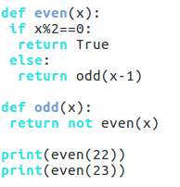

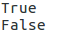
Output:

Itertools
count → counts up infintely from a value
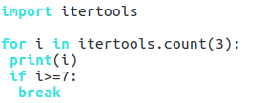

Output:

cycle → infinitely iterates through iterable
repeat → repeats an object
chain → chains several iterable in one

takewhile → takes items from iterable while a predicate function remains true
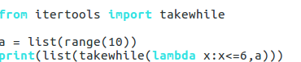

Ouput:

accumulate → returns a running total of values in an iterable.
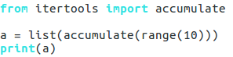

Output:

product
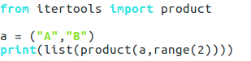

Output:

permutation
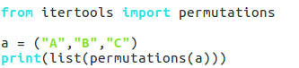

Output:

Object-Oriented Programming

Previously, we looked at two paradigms of programming
a) imperative(using statements, loops, and function as subroutines.
b) functional(using pure functions, higher order functions and recursion)

Another paradigm is object-oriented programming(OOP). Objects are created using classes, which are actually the focal point of OOP. Classes can be described as an object’s blueprint, description, or definintion. We can use the same class as a blueprint for creating multiple different objects.

Classes are created using keyword ‘class’ and an indented block, which contains class methods(which are functions).
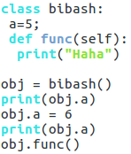

Output:
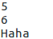

__init__
__init__ method is called the class constructor. This method is called when an object of class is created, using class name as a function. All method must have self as their first parameter,although it is explicitly passed, because self refers to the instance calling the method.

Instance of a class have attributes, which are pieces of data associated with them. Here, Cat instance have attributes colors and legs. This is accessed by putting a dot and attribute name after an instance. In an __init__ method, self.attribute is used to set the initial value of an instance’s attributes.
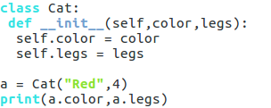

Output:
Red 4

Methods and attributes
Classes can have other methods defined to add functionality to them. All methods must have self as their first parameter.
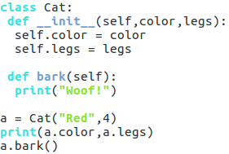

Output:
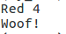

Classes can also have class attributes, created by assigning varibles within the body of the class. These can be accessed either from instances of the class, or the class itself.
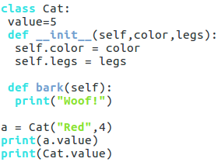

Output:
5
5

Inheritance
It provides a way to provide functionality between classes. The class can inherit from superclass which contains all the shared functionality. To inherit from another class, we just put the superclass name in parantheses after the subclass name.
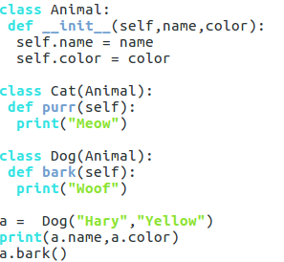

Output:
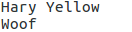

If a class inherits from another with same attributes or methods, it overrides them.
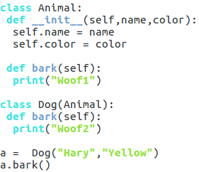

Output:
Woof2

Indirect Inheritance
One class can inherit from another, another class can inherit from third class.
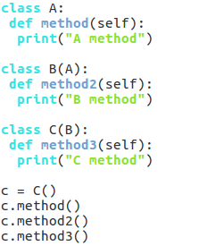

Output
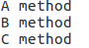

Super
This funtction is a useful inheritance- related function that refers to the parent class. It can be used to find the method with a certain name in an object’s superclass.
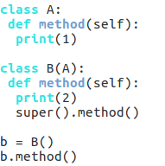
Output:

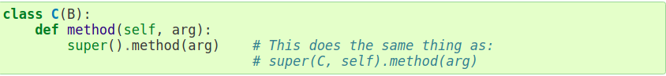

Magic Methods(Dunders)
They have double underscores at the beginning and the end of their names. We have just encountered __init__ but there are several. Tshey are used to create functionality that can’t be represented as a nomal method.

__add__ → allows for the definition of a custom behaviour for the + operator in our class. It adds the correspoding attributes of the objects and returns a new object, containing the result, Once it’s defined we can add two objects of the class together.
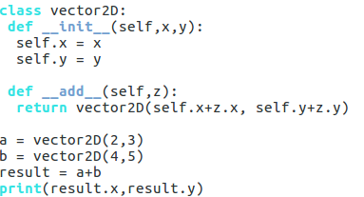

Output:
6 8

More magic methods for common operators:
__sub__ → -
__mul__ → *
__truediv__ → /
__floordiv__ → //
__mod__ → %
__pow__ → **
__and__ → &
__xor__ → ^
__or__ → |
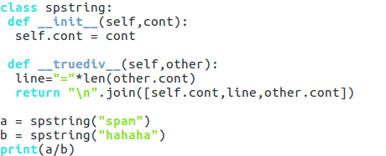

Output:
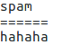

Python also provides magic methods for comparisons.
__lt__ for <
__le__ for <=
__eq__ for ==
__ne__ for !=
__gt__ or >
__ge__ for >=

If __ne__ is not implemented, it returns the opposite of __eq__. There are no other relationships between the other operators.
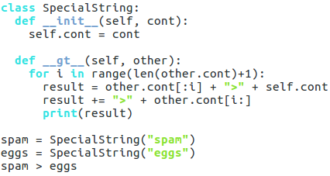

Output:
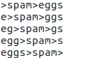

There are several magic methods for making classes act like containers.
__len__ for len()
__getitem__ for indexing
__setitem__ for assigning to indexed values
__delitem__ for deleting indexed values
__iter__ for iteration over objects (e.g., in for loops)
__contains__ for in
There are many other magic methods that we won't cover here, such as __call__ for calling objects as functions, and __int__, __str__, and the like, for converting objects to built-in types.

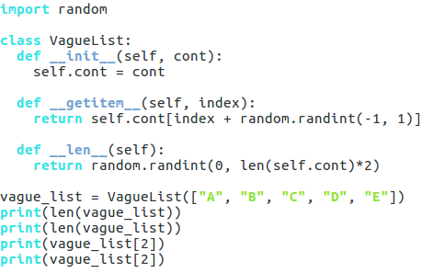

Output:
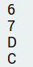

Data Hiding
A key part of OOP is encapsulation, which involves packaging of relates variables and functions into a single easy-to-use object-an instance of a class. This concept is called data hiding.

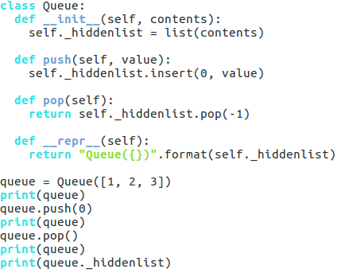
Weakly private methods and attributes have a single underscore at the beginning. We cannot import that variable. But can be accessed by using external code.

Ouptut
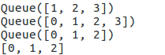

Strongly private methods and attributes have a double underscore at the beginning of their names. This causes their names to be mangled, which means that they can't be accessed from outside the class.

The purpose of this isn't to ensure that they are kept private, but to avoid bugs if there are subclasses that have methods or attributes with the same names.
Name mangled methods can still be accessed externally, but by a different name.
For e.g. The method__privatemethod of class Spam could be accessed externally with _Spam__privatemethod.
Example:
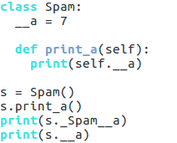

Ouput:
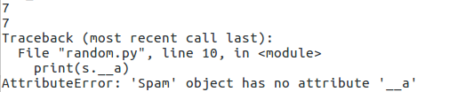

Class Methods
Methods of objects we've looked at so far are called by an instance of a class, which is then passed to the self parameter of the method.
Class methods are different - they are called by a class, which is passed to the cls parameter of the method.
A common use of these are factory methods, which instantiate an instance of a class, using different parameters than those usually passed to the class constructor.
Class methods are marked with a classmethod decorator.
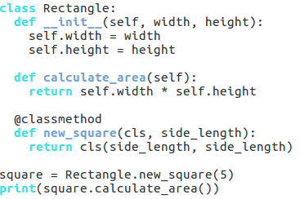

Output: 25

Here, new_square is a class method and is called on the class, rather than on an instance of the class. It returns a new object of the class cls.

Static Methods
Static methods are similar to class methods, except they don't receive any additional arguments; they are identical to normal functions that belong to a class. They are marked with the staticmethod decorator. Static methods behave like plain functions, except for the fact that you can call them from an instance of the class.
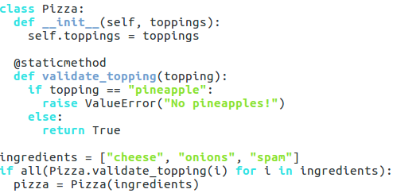

Output: No Output

Properties
Properties provide a way of customizing access to instance attributes.
They are created by putting the property decorator above a method, which means when the instance attribute with the same name as the method is accessed, the method will be called instead.
One common use of a property is to make an attribute read-only
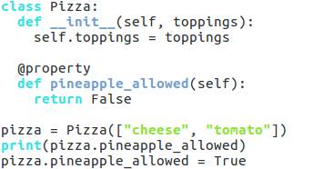

Output:
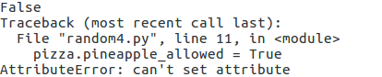

Properties can also be set by defining setter/getter functions. The setter function sets the corresponding property's value. The getter gets the value. To define a setter, you need to use a decorator of the same name as the property, followed by a dot and the setter keyword.
The same applies to defining getter functions.
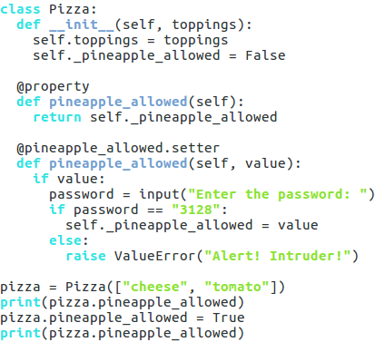

Output:
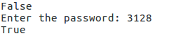

Exception Handling

Exceptions
Different exceptions are raised for different reasons. Common exceptions are:
ImportError: an import fails
IndexError: a list is indexed with an out-of-range
NameError: an unknown variable is used
SyntaxError: the code can’t be parsed properly
TypeError: a function is called on a value of an inappropriate type
ValueError: a functio is called on a value of the correct type, but with an inappropriate value.

Catching specific error
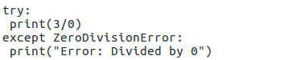
Output:

Catching all error
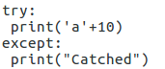
Output:

finally
This will run whether the exception is catched or not.
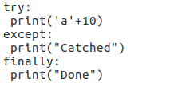
Output:
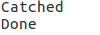

Raising Exceptions
We can raise exceptions by using the raise statement.
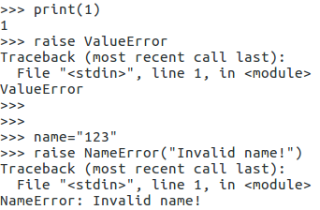

In except blocls, the raise statement can be used without arguments to re- raise whatever the exception occurred.
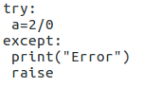
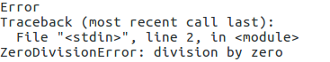
Output:

Assertion
It is an sanity-check that we can turn on or off when we finished testing the program. An expression is tested, and if the result comes up false, an exception is raised. Assertions are carried out through use of the assert statement.
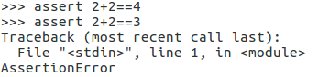
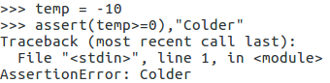

File Handling

Creating file
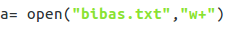

Result:
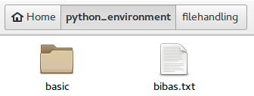

Opening Files
Files must be opened before performing any operations. Once a file has been opened and used, you should close it. This is done with the close method of the file object.
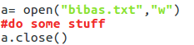

Writing in files
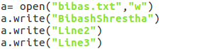

Result:
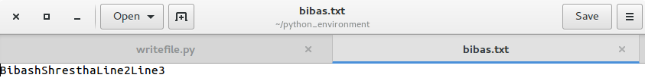

Reading from file

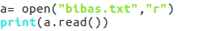

Output:

The above code can be replaced by which gives the same output
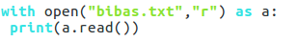

Note that the print statement has different spacing.

Byte-wise

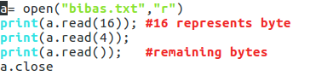
Output:
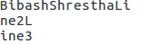

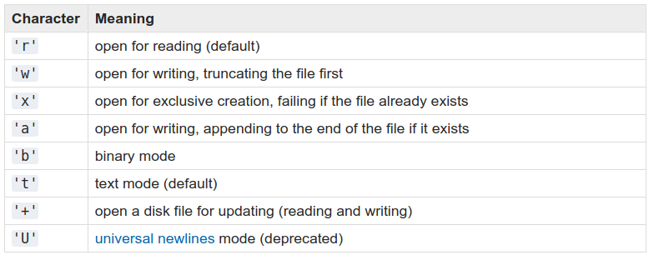

Regular Expressions(Regex)

Regular expressions are a powerful tool for various kind of string manipulation. They are a domain specific language(DSL) that is present as a library in most modern programming languages, not just in Python.
Uses:
a) verifying that strings match a pattern
b) performing substitution in the strings

Regular expressions in Python can be accesses using the re module, which is th part of the standard library.

To avoid the confusion while working with regular expressions, we would use raw strings as r”expression”.

Match
It can be used to determine whether it matches the beginning of the string.
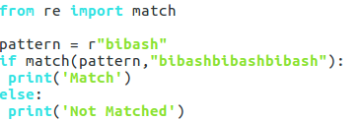

Output: Match

Search
It finds match of the pattern anywhere in the string.
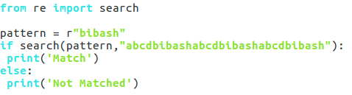

Output: Match

The search returns an object with several methods that gives details about it.
group → returns the string matched
start → returns the start position of first match
end → returns the end position of the first match
span → returns start and end position of first match

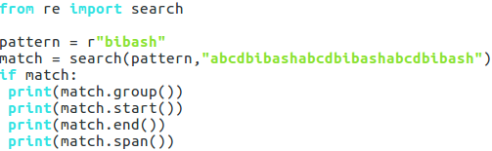

Output:
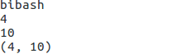

Findall
It returns a list of all substrings that match a pattern.
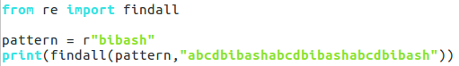

Output:

Sub
It replaces all occurrence of the pattern in string with repl unless max provided.
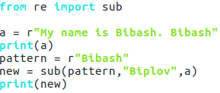

Output:
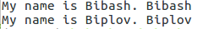

Metacharacters
Metacharacters make regular expressions more powerful than normal strings methods.

Dot(.) matches any character.
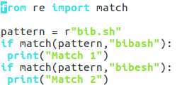
Output:

Caret(^) and Dollar($) sign matches the start and end of a string respectively.
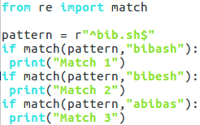

Output:

Character Classes
It provides a way to match only one of the specified set of characters. A character class is created by putting the characters it matches inside square brackets.
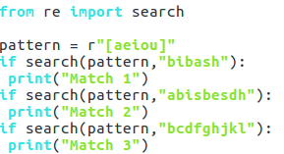

Output:

It also matches range of characters.
[a-z] → matches any lowercase alphabetic characters
[Y-Z] → matches uppercase Y and Z
[0-9] → matches any digits
It aso matches multiple range of characaters.
[A-Za-z] → matches any letter of any case

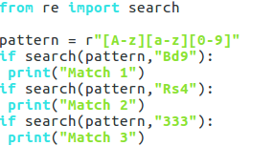
Output:

Place ^ at the start of the character class to invert it. The metacharacter ^ has no meaning unless it is the first character in the class.
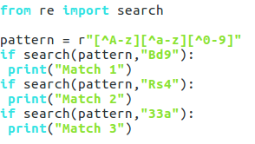

Output: Match 3

More metacharacaters
Some metacharacters are *,+,?,{,}.
* → zero or more repitions of the previous things
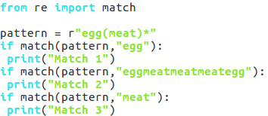
Output:

+ → one or more repetitions
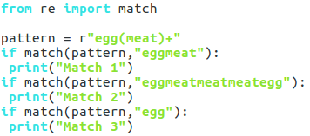

Outptut:

? → zero or one repetitions
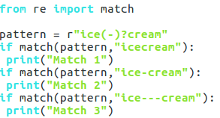

Output:

{x,y} → between x and y repetitions of something… Here {0,1} is same as ?. If the first number is missing, it is taken as 0. If the last number is missing, it is taken to be infinity.
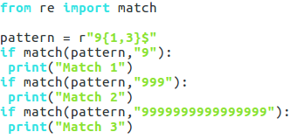

Output:

| → represents OR. red|blue matches either ‘red’ or ‘blue’.
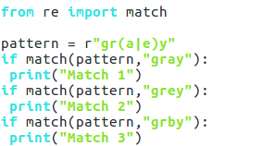

Output:

Groups
Groups can be created by surrounding the part of the regular expression with parantheses. The group can be given as an argument to metacharacter such as * and ?.

Here, (meat) represents the group in the example pattern shown above.
The content of the group can be accessed using group function.
group(0)/group() → returns while match
group(n) → returns nth group from left ; n>0
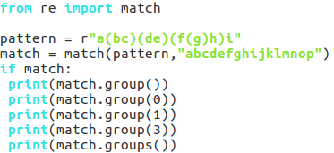

Output:
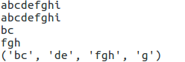

Named groups and non-capturing groups
Named groups:
They have format (?P<name>), where name → name of the group,
… → cotent.
They behave same as group except they can be accessed by group(name) in addition to number.

Non-Capturing groups
They have format(?:…). They are not accessible by group methods, so they can be added to an existing
regular expression without breaking the numbering,
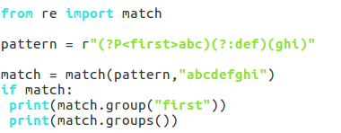

Output:
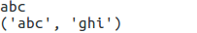

Special Sequences
They are written as a blackslash and a number between 1 and 99. e.g. \1 or \17. This matches the expression of the group of that number.
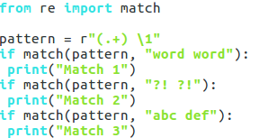
Output:

Note: “(.+) \1” is not same as “(.+) (.+)” because \1 refers to the first group’s subgroup’s subexpression which is the matched expression of itself and not the regular expression pattern.

Digits, Whitespace and Word Characters
\d → digits, equilvalent to [0-9]
\s → whitespace, equivalent to [\t\n\r\f\v]
\w → word characters, equivalent to [a-zA-Z0-9]

Version of these special characters with uppercase letters \D, \S and \W means the opposite to the lower case versions. e.g \D is euivalent to [^0-9]
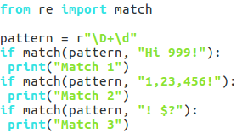

Output:
Match 1

\A → beginning of the strings
\Z → end of the string
\b → boundary between words
\B → matches empty string anywhere else
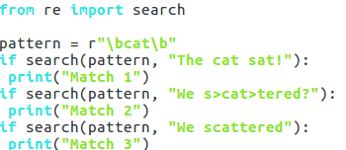

Output:

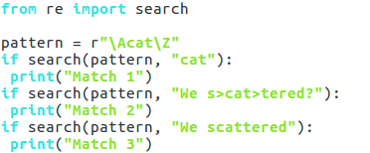
Output:
Match 1

Email Extraction

[\w\.-]+ → matches one or more words character, dot or dash

pattern = r"([\w\.-]+)@([\w\.-]+)(\.[\w\.]+)"

This regex says that the string should contain a word (with dots and dashed allowed), followed by the @ sign, then another similar word, then a dot and another word.

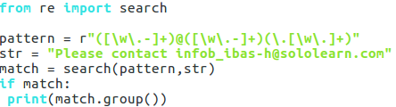

Output:

Need to improve this code. Works for ….com

