Installing the Zelle’s graphic library

At first install python in your computer

Save the following in the directory where you will save other files
http://mcsp.wartburg.edu/zelle/python/graphics.py
Install tkinter

Basic Tutorial
Reference: http://mcsp.wartburg.edu/zelle/python/graphics/graphics.pdf

Circle, Point, Line
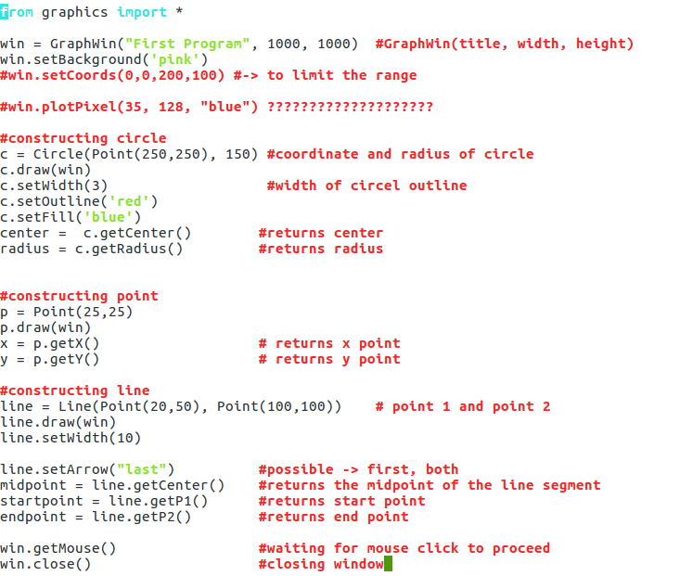

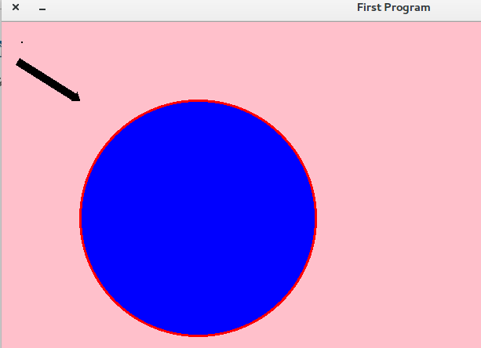
Output:

Rectangle, Oval, Polygon
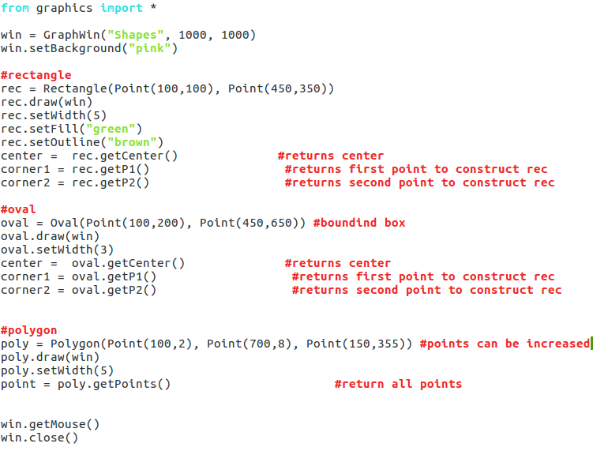

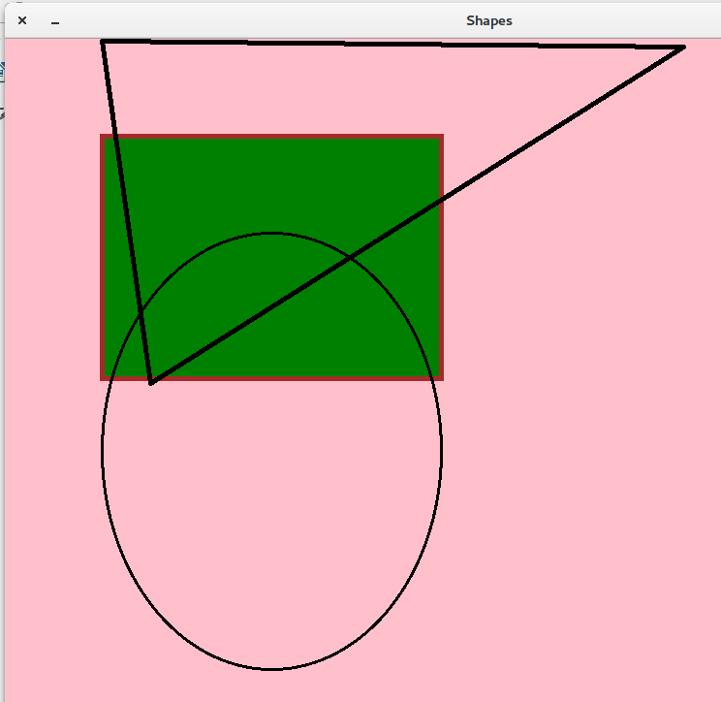
Output:

Text
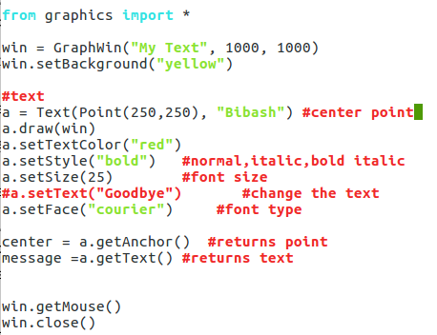

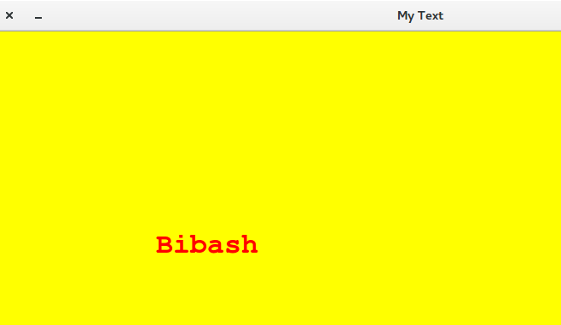
Output:

Entry Object
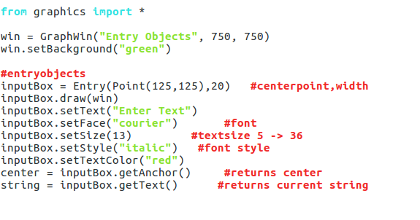

Output

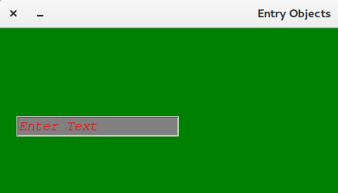

Image
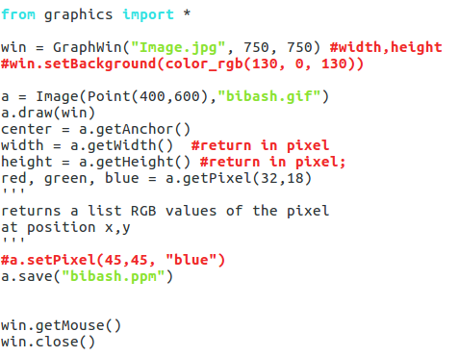

Output:
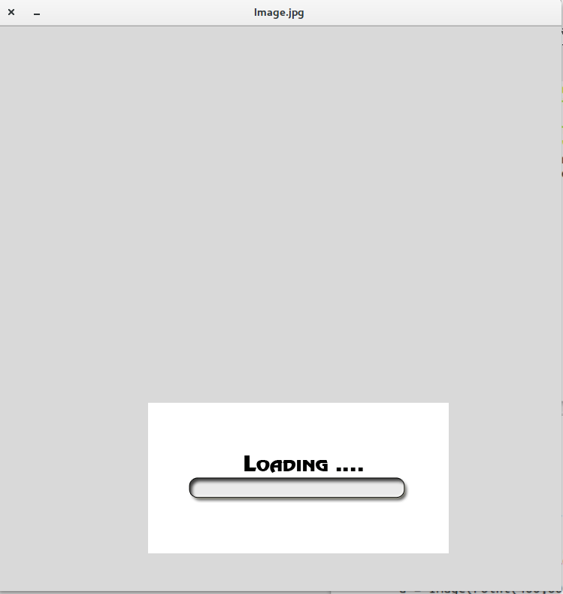

Using tkinter Module

Simple program

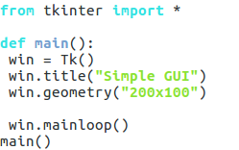
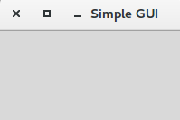
Output:

Frame and Label
Frame must be created in the window to hold other widgets
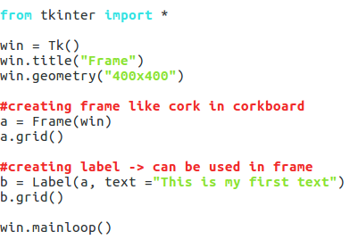

Output:
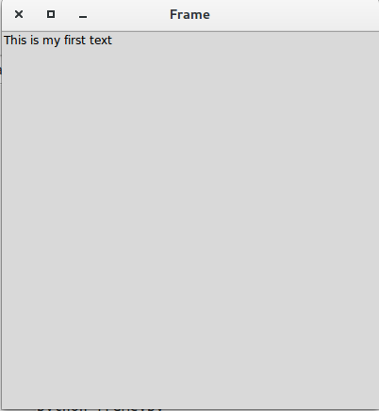

Laxy Buttons
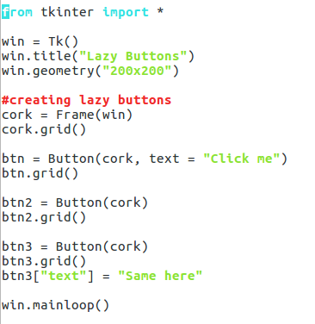

Output;
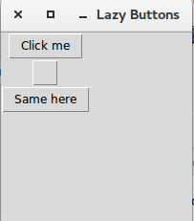

Creating GUI using class
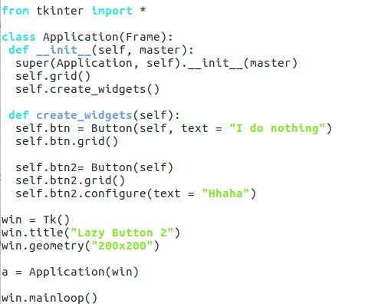

Output:
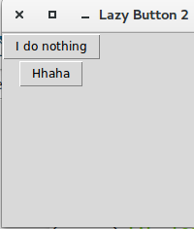

Button with timer
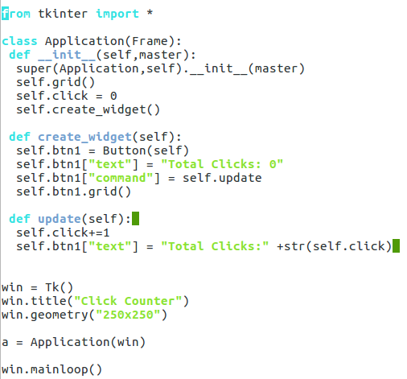

Output:
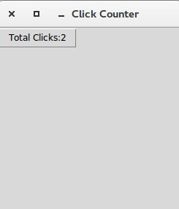
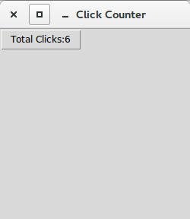

Write Click Submit
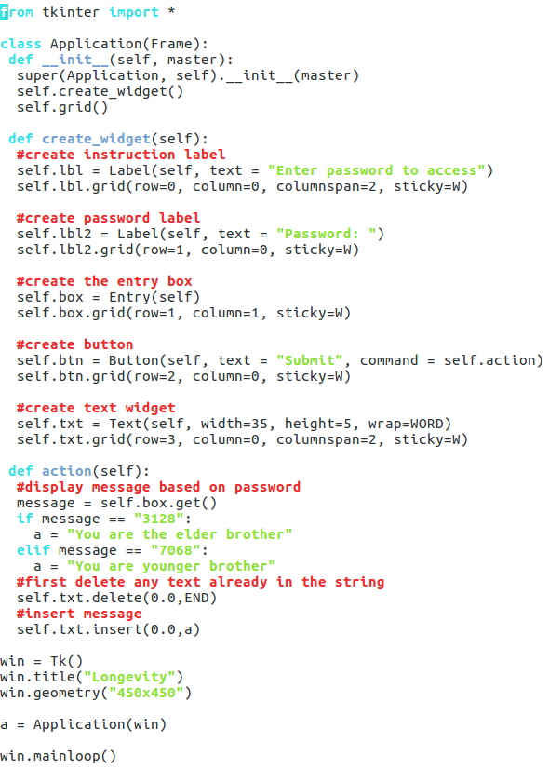

Output:
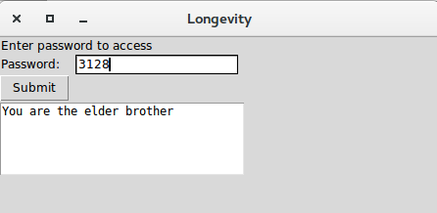
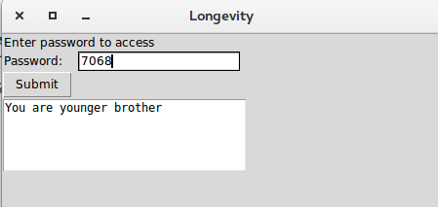

RGB Values

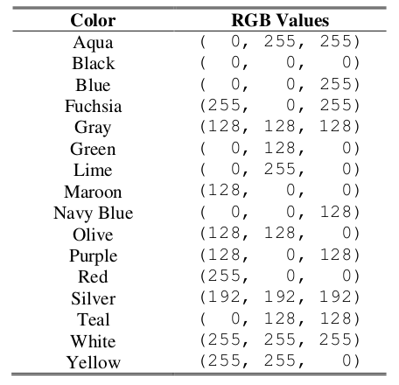

Check Buttons
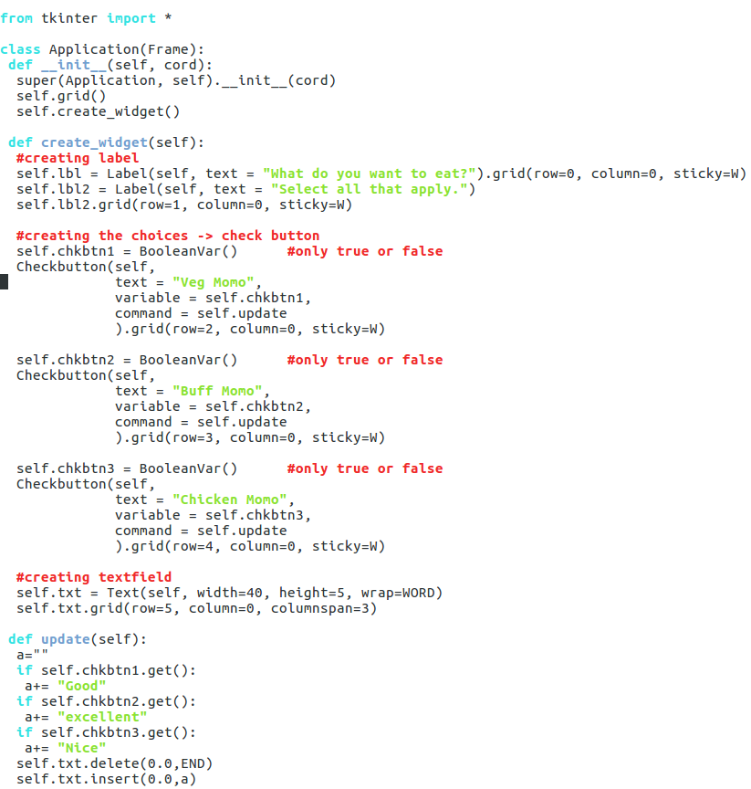
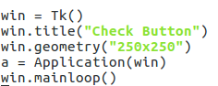
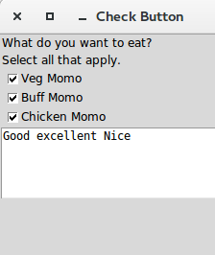
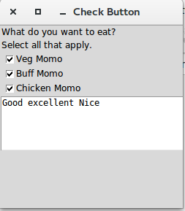

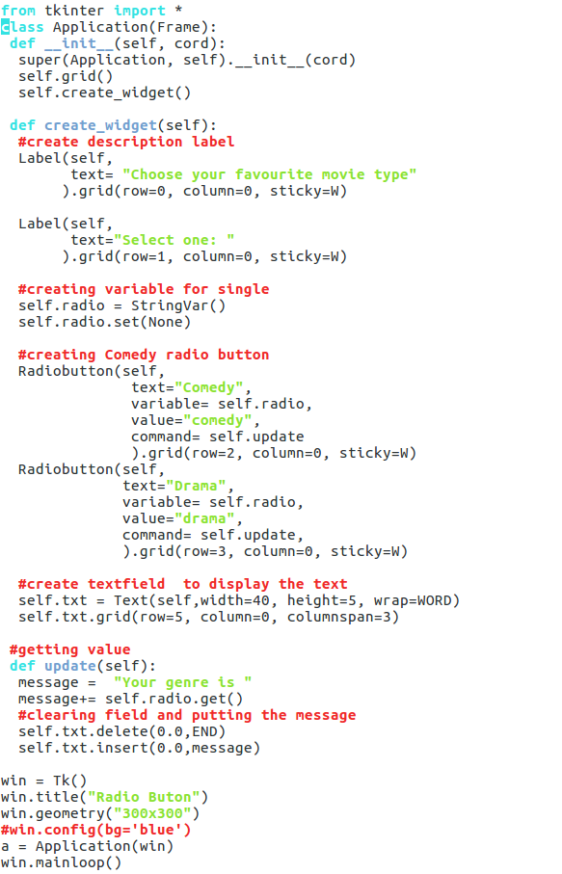
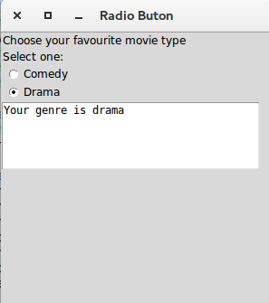
Radio Button

Pygame

Installing py game

Creating window
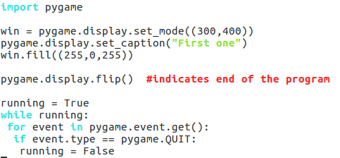

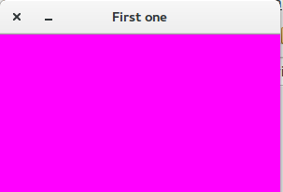
Output:

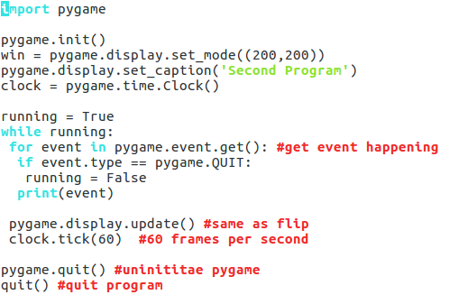
Get event

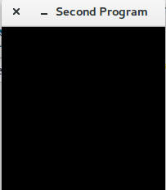
Output:

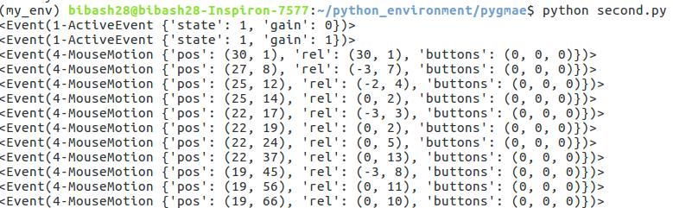
If we move mouse inside the window we get the event. It is one example of the event.

Drawing Functions
fill(color)
pygame.draw.polygon(surface, color, pointlist, width)
pygame.draw.line(surface, color, start_point, end_point, width)
pygame.draw.lines(surface, color, closed, pointlist, width)
pygame.draw.circle(surface, color, center_point, radius, width)
pygame.draw.ellipse(surface, color, bounding_rectangle, width)
pygame.draw.rect(surface, color, rectangle_tuple, width)

pygame.PixelArray Objects → faster method to draw
PixelArray object (we’ll call them PixelArray objects for short) of a Surface object and then set individual pixels. Creating a PixelArray object of a Surface object will ―lock‖ the Surface object. While a Surface object is locked, the drawing functions can still be called on it, but it cannot have images like PNG or JPG images drawn on it with the blit() method.

If you want to see if a Surface object is locked, the get_locked() Surface method will return True if it is locked and False if it is not.

The PixelArray object that is returned from pygame.PixelArray() can have individual pixels set by accessing them with two indexes. For example, line 28’s pixObj[480][380] = BLACK will set the pixel at X coordinate 480 and Y coordinate 380 to be black (remember that the BLACK variable stores the color tuple (0, 0, 0) ).

To tell Pygame that you are finished drawing individual pixels, delete the PixelArray object with a del statement. This is what line 33 does. Deleting the PixelArray object will ―unlock‖ the Surface object so that you can once again draw images on it. If you forget to delete the PixelArray object, the next time you try to blit (that is, draw) an image to the Surface the program will raise an error that says, ― pygame.error: Surfaces must not be lockedduring blit ‖.
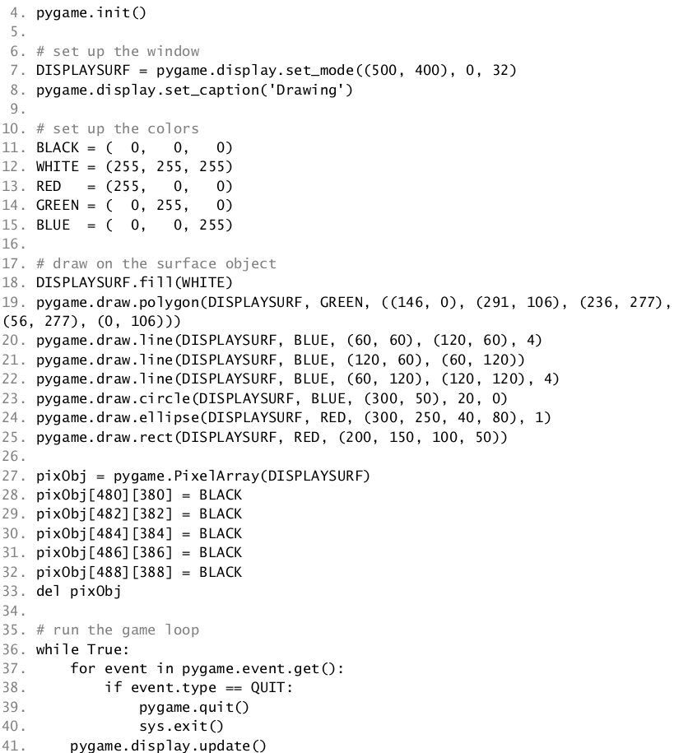
1. import pygame

Pixel Coordinates
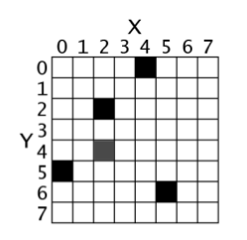
The window that the ―Hello World‖ program creates is just composed of little square dots on your screen called pixels. Each pixel starts off as black but can be set to a different color. Imagine that instead of a Surface object that is 400 pixels wide and 300 pixels tall, we just had a Surface object that was 8 pixels by 8 pixels. If that tiny 8x8 Surface was enlarged so that each pixel looks like a square in a grid, and we added numbers for the X and Y axis, then a good representation of it could look something like this:

We can refer to a specific pixel by using a Cartesian Coordinate system. Each column of the X- axis and each row of the Y-axis will have an ―address‖ that is an integer from 0 to 7 so that we can locate any pixel by specifying the X and Y axis integers. For example, in the above 8x8 image, we can see that the pixels at the XY coordinates (4, 0), (2, 2), (0, 5), and (5, 6) have been painted black, the pixel at (2, 4) has been painted gray, while all the other pixels are painted white. XY coordinates are also called points. If you’ve taken a math class and learned about Cartesian Coordinates, you might notice that the Y-axis starts at 0 at the top and then increases going down, rather than increasing as it goes up. This is just how Cartesian Coordinates work in Pygame (and almost every programming language).
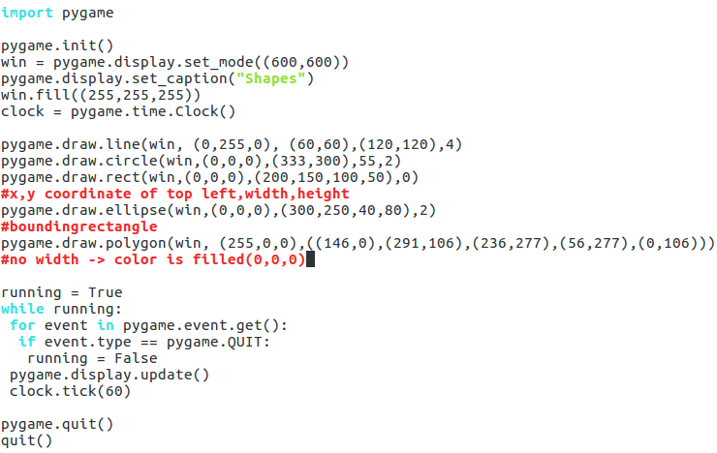
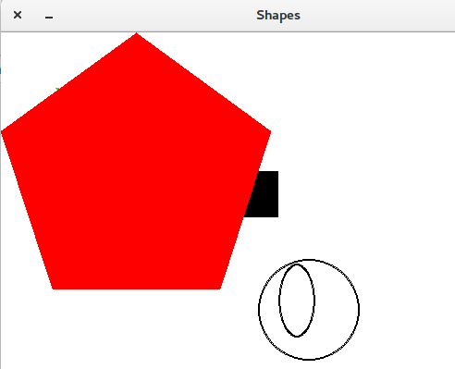

Redefining the pixel
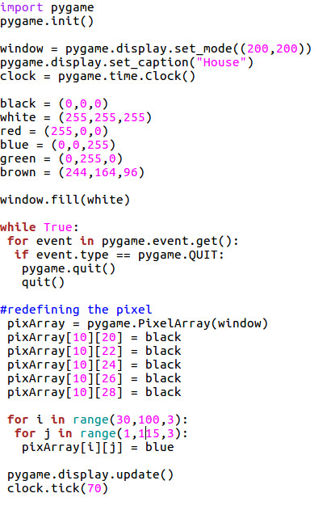

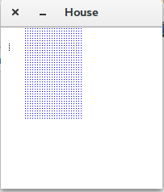
Output:

Object Movement
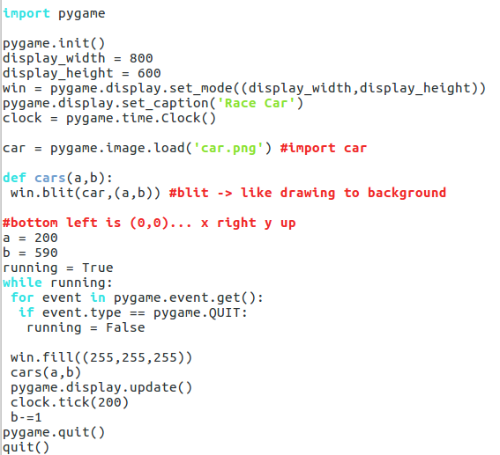

Output:
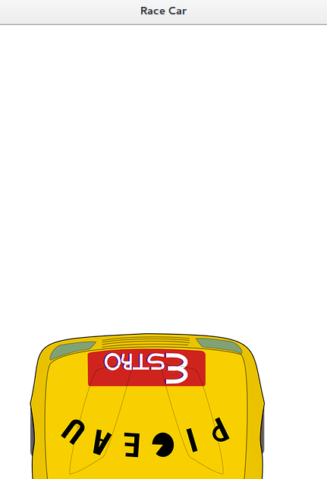
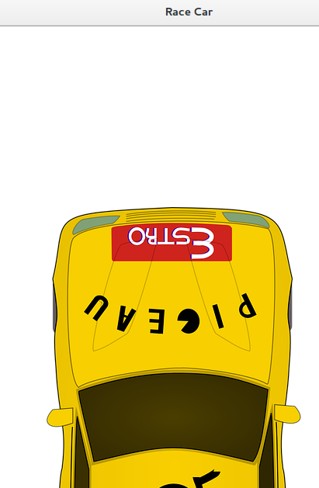
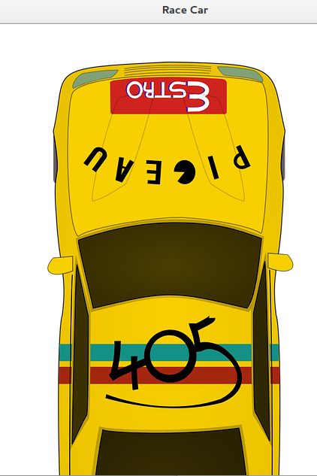

Text Display
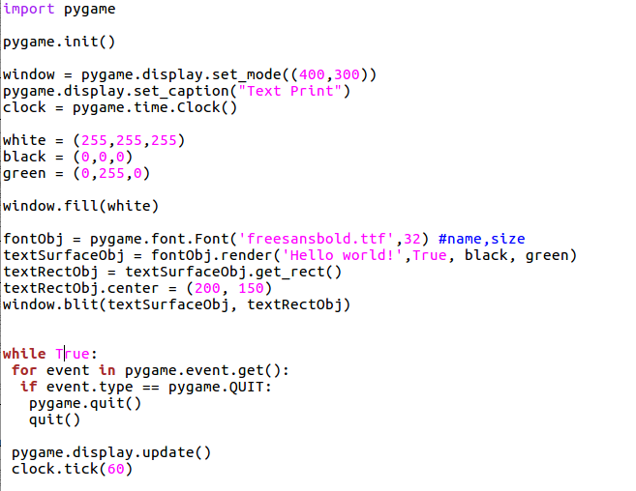

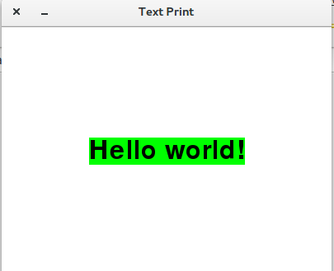

There are six steps to making text appear on the screen:
1. Create a pygame.font.Font object .
2. Create a Surface object with the text drawn on it by calling the Font object’s render() method.
3. Create a Rect object from the Surface object by calling the Surface object’s get_rect() method. This Rect object will have the width and height correctly set for the text that was rendered, but the top and left attributes will be 0
4. Set the position of the Rect object by changing one of its attributes. Here, we set the center of the Rect object to be at 200, 150.
5. Blit the Surface object with the text onto the Surface object returned by pygame.display.set_mode() .
6. Call pygame.display.update() to make the display Surface appear on the screen.

The parameters to the pygame.font.Font() constructor function is a string of the font file to
use, and an integer of the size of the font (in points, like how word processors measure font size).
On line 12, we pass 'freesansbold.ttf' (this is a font that comes with Pygame) and the
integer 32 (for a 32-point sized font).

The parameters to the render() method call are a string of the text to render, a Boolean value
to specify if we want anti-aliasing (explained later in this chapter), the color of the text, and the
color of the background. If you want a transparent background, then simply leave off the
background color parameter in the method call.
Keyboard press
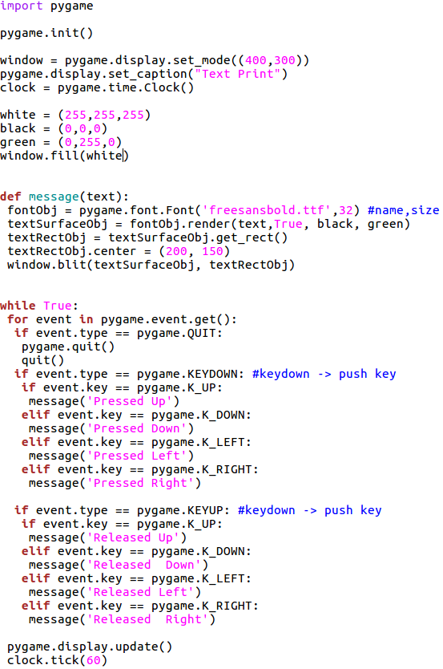

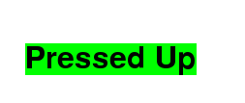

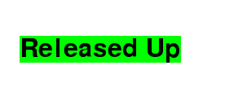

https://www.pygame.org/docs/ref/key.html
Mouse Activity
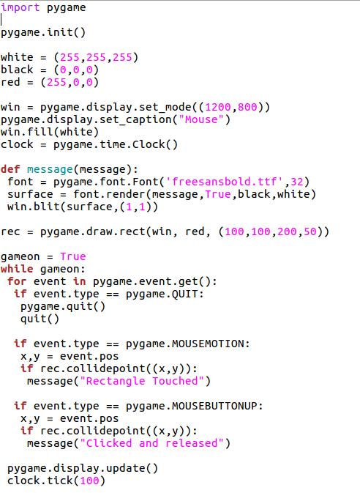

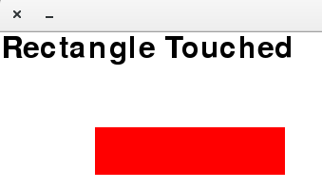

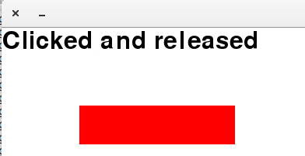

MOUSEBUTTONUP → effect is seen after pressing and releasing the mouse
MOUSEBUTTONDOWN → effect is seen after just pressing the mouse

event.button == 1: → left mouse button

Image Button
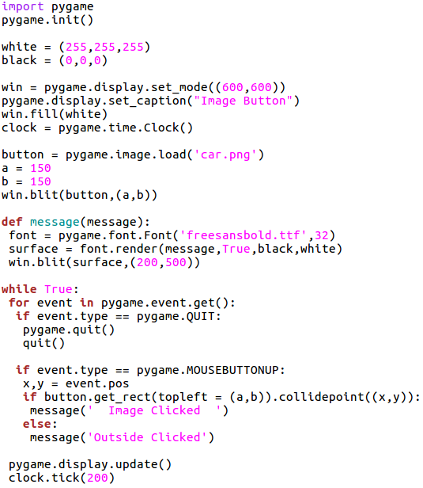

Output:
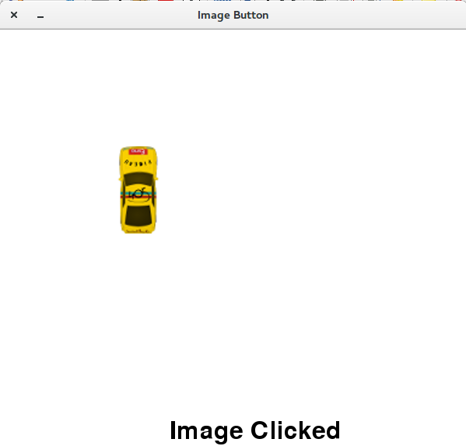
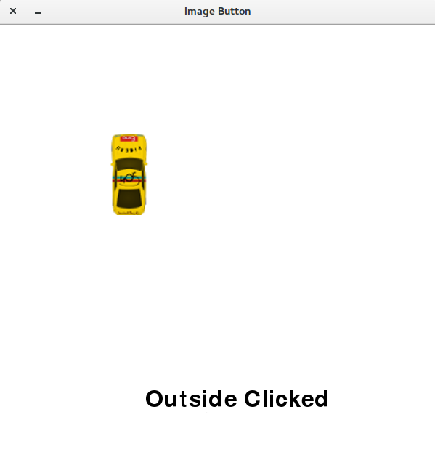

Sound
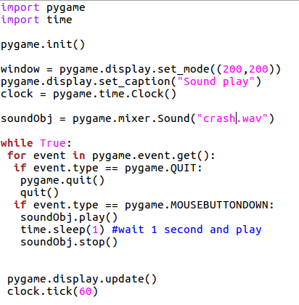

Output: Sound is produced for 1 sec after mouse is pressed in the window

Background Music
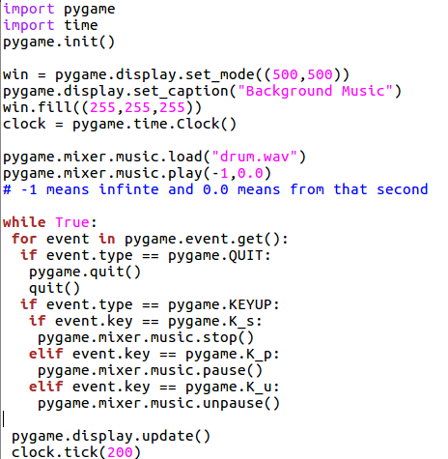

Output: Background music plays
p → pause
u → unpause
s → stop

House
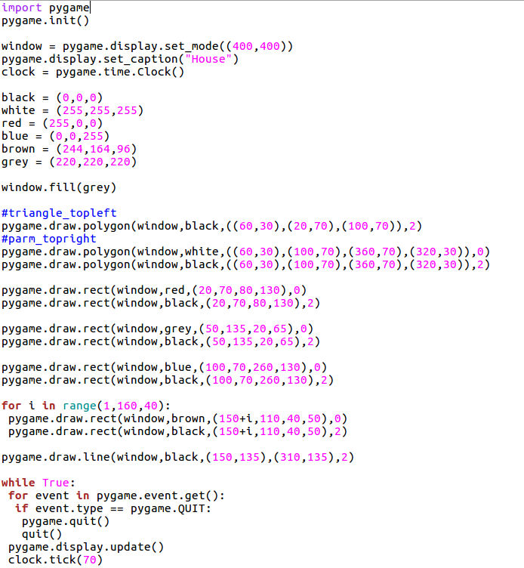

Output:
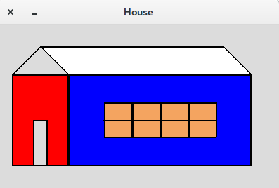

Get Resolution
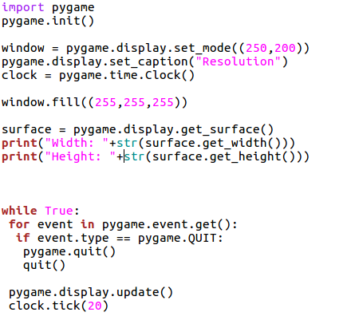

Output:
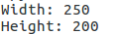

Converting .py file to .exe

#!/usr/bin/env python3

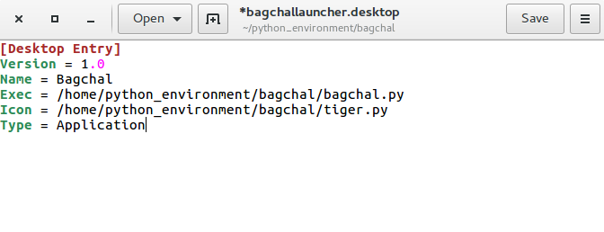

Converting to .exe using cx_Freexe
Install cx_Freeze
Check whether installed or not
