Change users password in raspberry pi
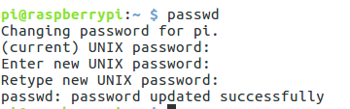

New pass: 3128bibash

