Contrrolling LED Using Raspberry Pi

Requirements: 1 LED, 2 Male-to-Female Wire, 1K ohm resistor(take at least 100 or 200 Ohms), Breadboard

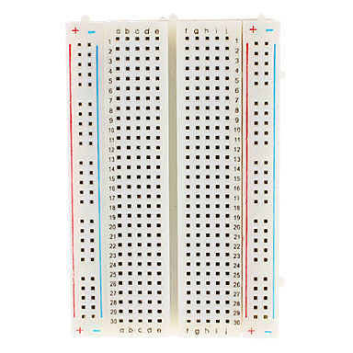


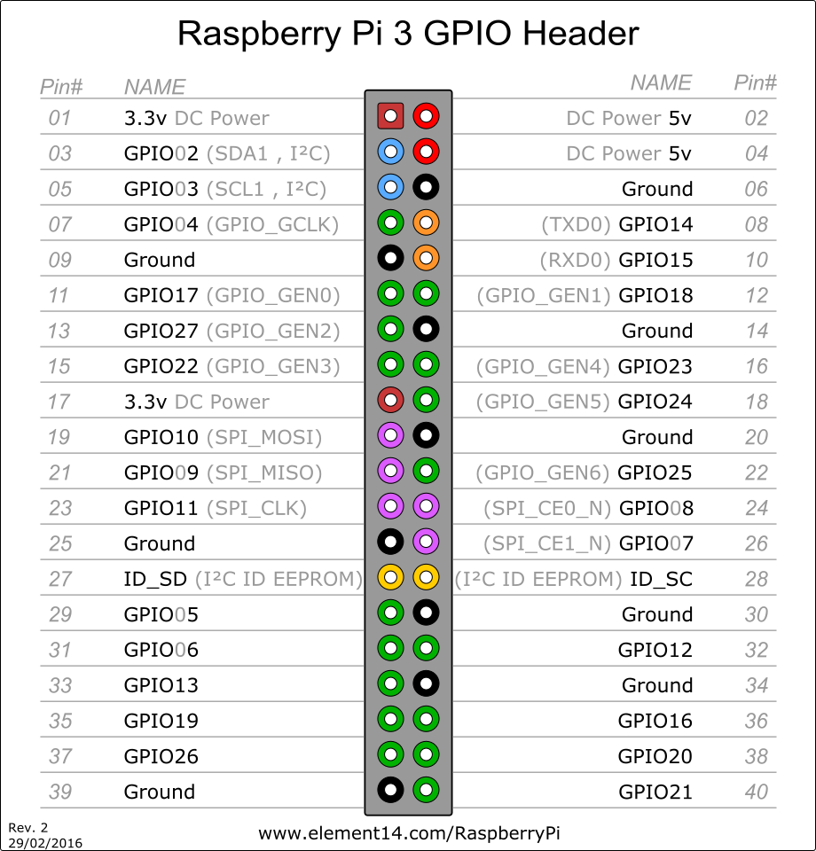

1. Connect LED. Notice that LED has one longer lid which is positive lid. You must know the circuit diagram of the breadboard.
+ve lid – e19
-ve lid – e21

2. Connect the resistor(around 200 to 300 Ohm). I have taken 1K Ohm resistor. Do not directly connect the LED. This may destroy the GPIO port.
+ve – c12
-ve – 19 ( connects with +ve lid of LED)

Now Connect the wire to raspberry pi in order to complete the circuit.

3. Take the row of the -ve lid of LED connection of breadboard(e.g a21) and connect to GND(right 3rd pin) of raspberry pi.

4. Take the row of the -ve lid of resistor connection of breadboard(e.g a12) and connect to GPIO 18 ^{P}ort(right 6th pin) of raspberry pi.


5. Remotely connect to the raspberry pi:
ssh pi@ipaddress e.g ssh pi@192.168.100.69
password:raspberry
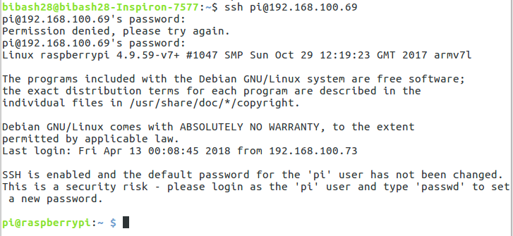

6. Make python file named led.py.
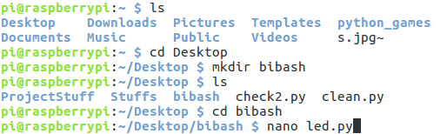

7. Write the code:
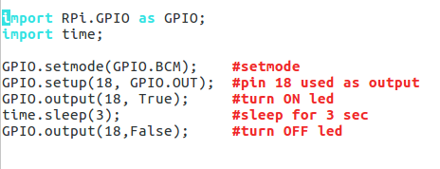

The GPIO.BOARD option specifies that you are referring to the pins by the number of the pin the the plug - i.e the numbers printed on the board (e.g. P1).
The GPIO.BCM option means that you are referring to the pins by the "Broadcom SOC channel" number, these are the numbers after "GPIO" in the green rectangles around the outside of the below diagrams:

8. Save and Compile using “python led.py”

