Controlling motors using H Bridge Motor Controller
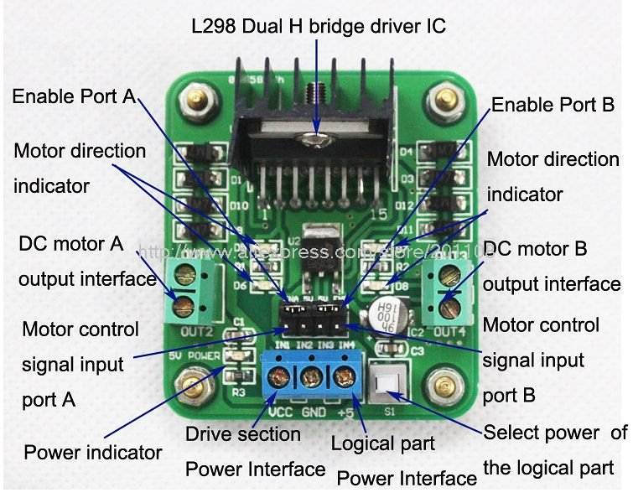

1. Connect Motor A and Motor B to DC motor A output interface and DC motor B output interface respectively
2. Connect signal input to any GPIO port of raspberry pi
IN1 → GPIO 17(Pin No.11)
IN2 → GPIO 22(Pin No.15)
IN3 → GPIO 23(Pin No.16)
IN4 → GPIO 24(Pin No.18)
3. Connect GND of Hbrige board to the GND of Pi
4. Connect 9V Battery to H Board
-ve → GND of Hboard
+ve → VCC of Hboard

5. Remotely access pi and write code and run

