Setting Up LCD on Raspberry Pi and Code with Python
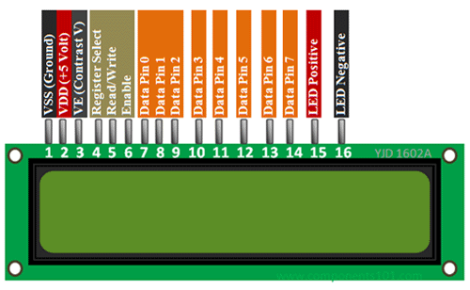
Basic:

https://components101.com/16x2-lcd-pinout-datasheet

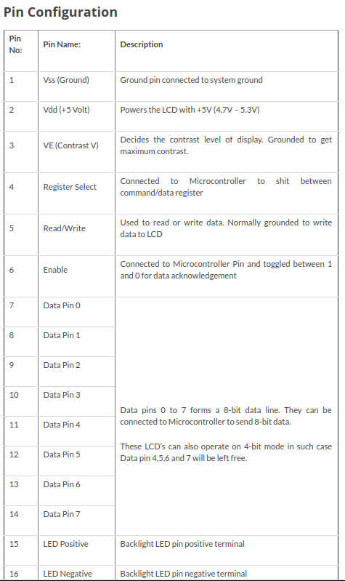

1. Solder the 16 header pins in LCD.
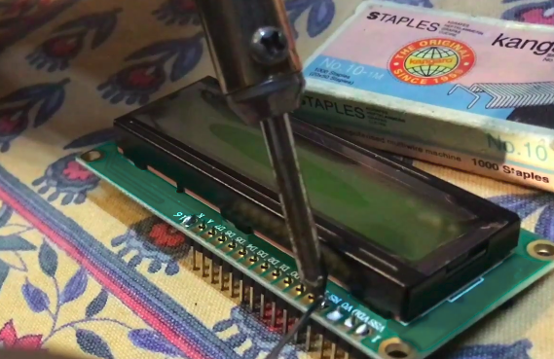

2. Connect the pins of LCD in breadboard(a30-a45)

3. Insert two 10k potentiometer.
a) One for contrast control(a51,a53,a55)
b) Other for backlight brightness(a38,a40,a42)

4. Vss, RW, K → -ve port of breadboard
VDD → +ve port of breadboard

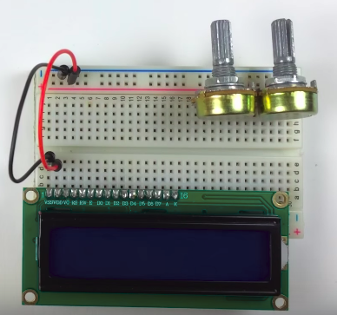

6. VO → to center pin(a53) of contrast control potentiometer
RS → GPIO 26(Pin No.37) of Pi
E → GPIO19(Pin No.35)

9.. D0 → GPIO21 (Pin No.40)
D1 → GPIO20 (Pin No.38)
D2 → GPIO16 (Pin No.36)
D3 → GPIO12 (Pin No.32)
D4→ GPIO13 (Pin No.33)
D5 → GPIO06(Pin No.31)
D6→ GPIO05Pin No29)
D7→ GPIO16(Pin No.36)
A→ centre of backlight potentiometer(a40)

12. One side of contrast potentiometer → -ve port of breadboard
One side of backlight potentiometer → +ve board of breadboard

13. +ve port of breadboard → 5V pin of pi (pin 02 or 04)
-ve port of breadboard → GND(pin 06)

14. Remove Wire from D0 to D3 (just to explain the use of D4 to D7 for use of 4 bit)

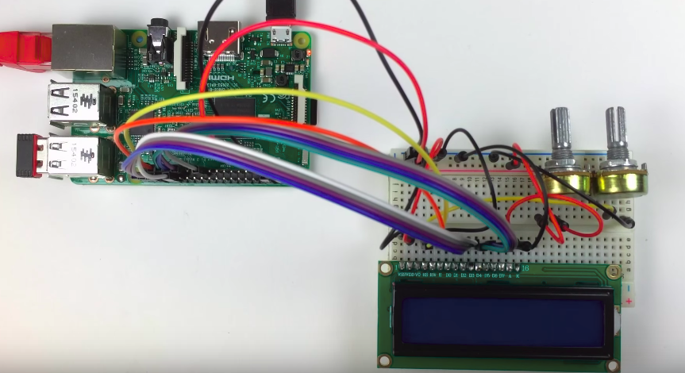

15. Establish remote connection

16. Install pip: sudo apt-get install python-pip (mero ma already installed raicha)

17. Install LCD library: sudo pip install RPLCD

18. Rebbot pi: sudo reboot

19. Again establish remote connection

(Note change 23 → 36)
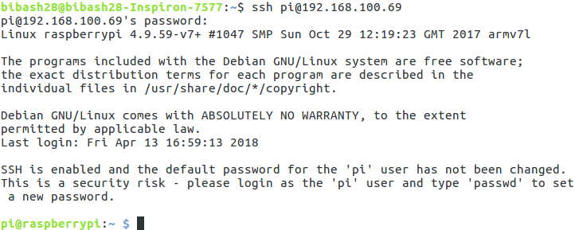

20. To print in LCD create the python program and run it
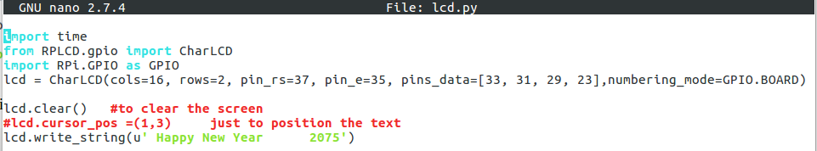

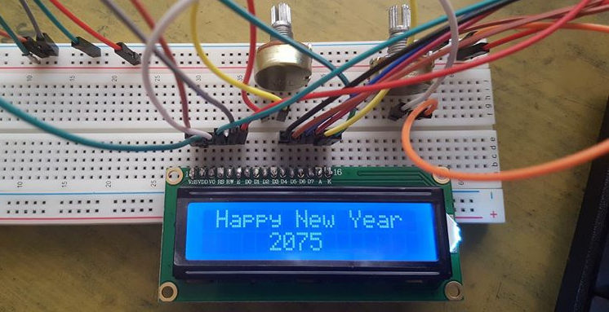
21. For blinking text

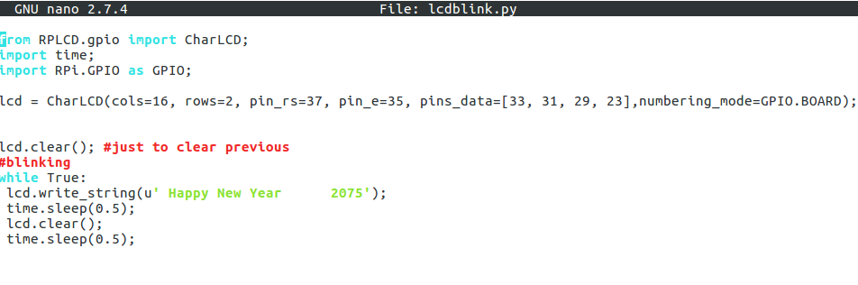
22. For Date and Time
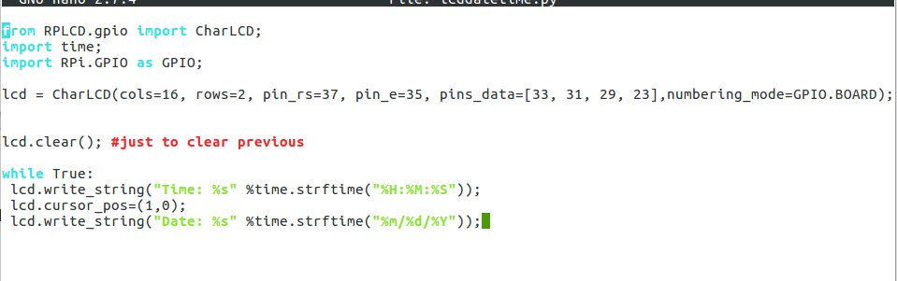
23. For smiley
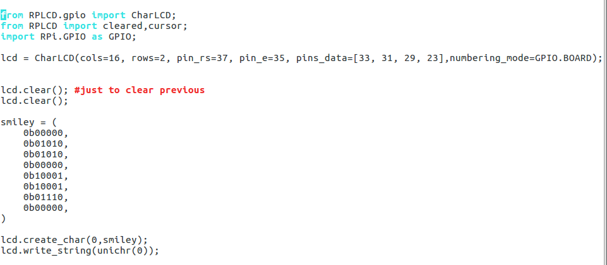

Reference: http://www.circuitbasics.com/raspberry-pi-lcd-set-up-and-programming-in-python/

