Using PI Camera
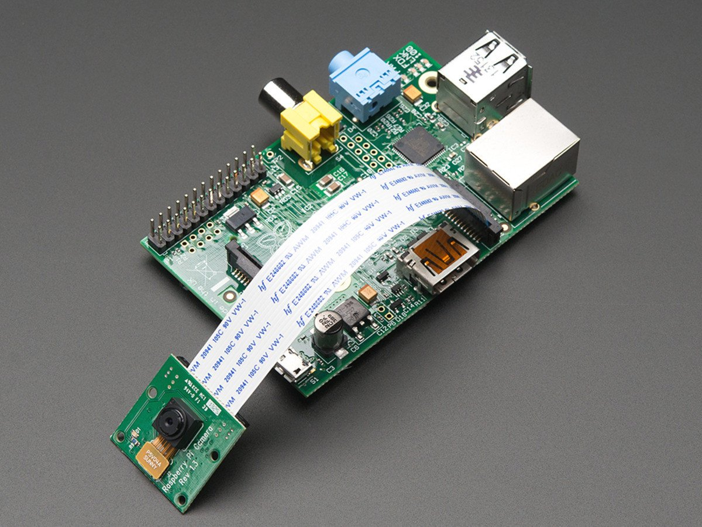

1. Establish remote connection

2. Follow below:
sudo apt-get update && sudo apt-get upgrade
sudo raspi-config

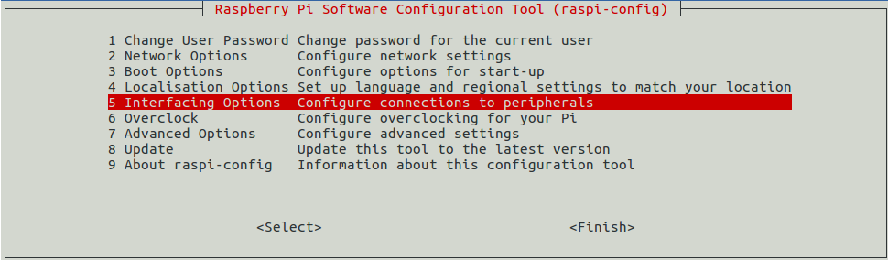
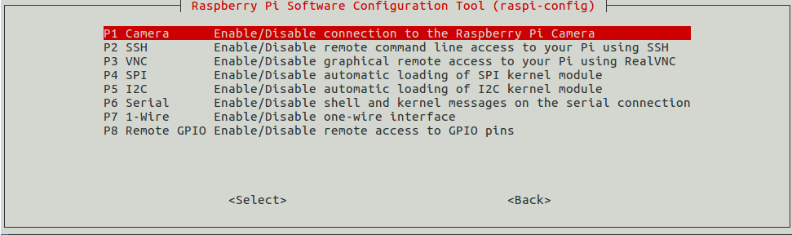

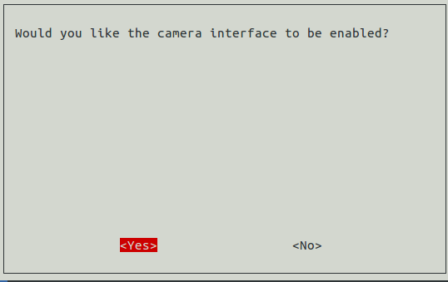

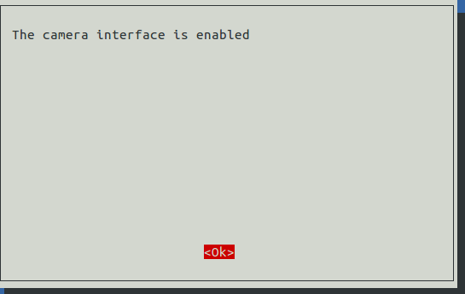
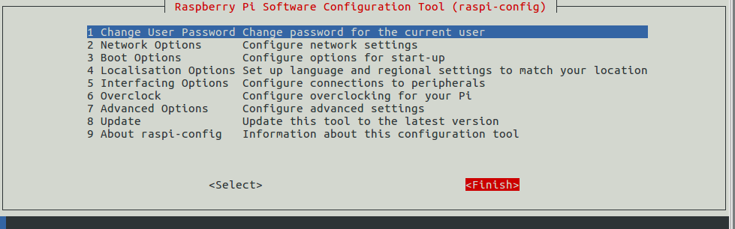

reboot pi: sudo reboot

3.

