Setting up Utrasonic sensor

About Ultrasonic Sensor
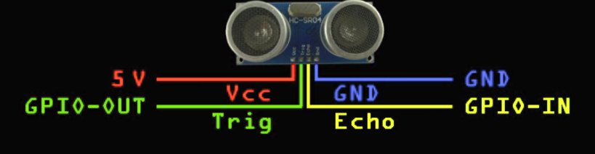

Mechanism:
1. 10 microsecond high pulse is sent from pi to ultrasonic transducer


2. Ultrasonic transducer vibrates across specific spectrum of frequencies and generates a 8 cycle sonic burst of sound waves at 40 Khz.
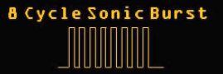

3. Whenever any obstactle comes ahead of ultrasonic sensor the sound waves will be reflected back in the form of echo and generates the electric pulse.It calculates the time taken between sending sound waves and receiving echo.
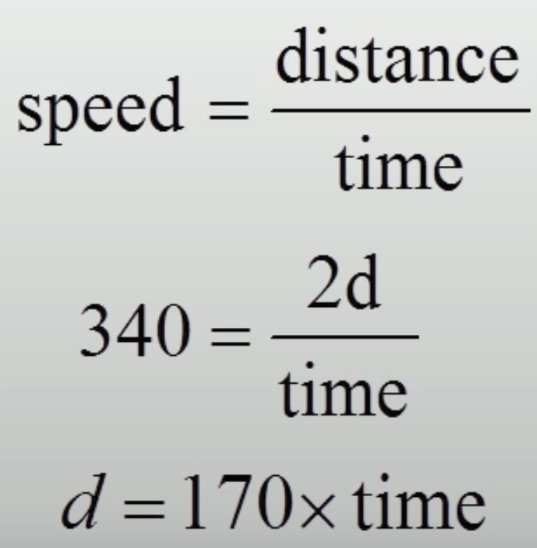

4. To communicate this back to the pi, it sends one high pulse equal to the length how long it took to hear the echo. So the length of the pulse is proprtional to the how far the object is.


Steps:
1. Make the circuit

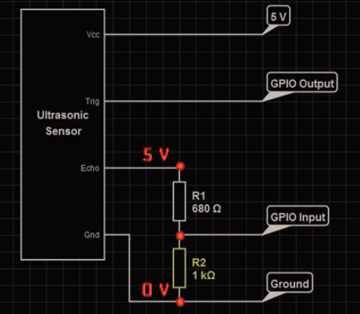

Here setting echo pin is imortant because it output will be high at 5V. To deal with this echo pin will be attached to voltage divider.

Here R2 is chosen 1 kohm because if mistakely GPIO Input is altered with GPIO output, the current flows from pin to R2 to ground. 1 Kohm will provide enough resistance to protect the pin from being damaged.

We want 3.3 V. So, Vout = 3.3 V, Vin = 5V, R2 = 1000ohm ,R1=?
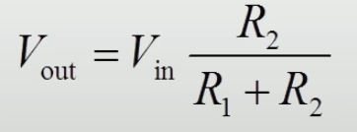

R1=515ohm

I have used 660Ohm. Then Vout = around 3V

2. Connect Trig to Pin7(GPIO04) and Echo to Pin12(GPIO18)

3. Establish remote connection to pi, write code and run
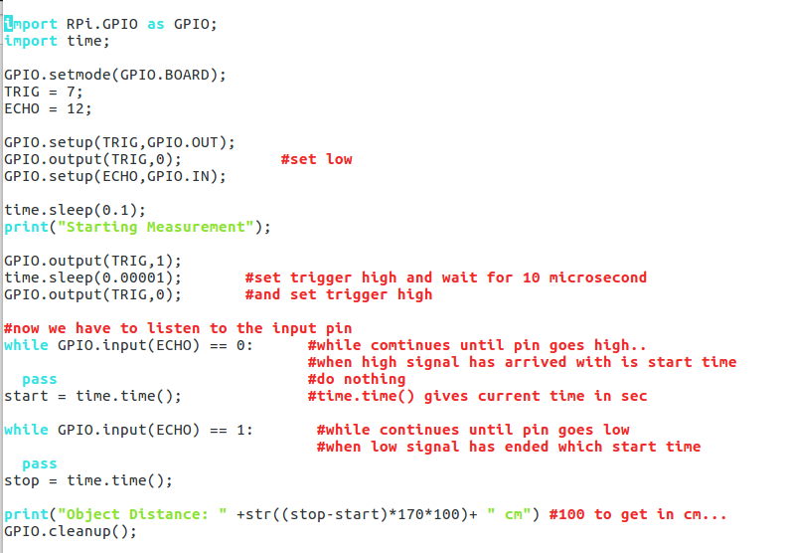

Output:

