The Internet, invention of the century, has completely revolutionized the world and brought people closer

to each other than ever before. The introduction of mobile devices and the influence of internet not only changed the

way we do business but changed our lifestyle too.

he Internet, invention of the century, has completely revolutionized the world and brought people closer

to each other than ever before. The introduction of mobile devices and the influence of internet not only changed the

way we do business but changed our lifestyle too



­

Clean Water Distribution System

Interactive Pervasive Computing

Rupesh Chaulagain

Dipesh Dahal

Bibash KC

Bibek Mahatara

**Group Member**

# Introduction

Clean water distribution is most challenging task in cities today because of increasing pollution and decreasing clean water resources. However 70% earth surface is covered by water, clean water is only 2% of that portion. Most of the clean water is being waste every day because of inefficient management so something need to be done to manage clean water distribution. Main reason of water wastage is overflow from water tanks. Traditionally, water tank is controlled by operator manually. In case sometimes person might be absent, it has more chance to water overflow until someone doesn’t switch it off. So, system must be automated to save the precious water. Clean water distribution, embed Water level and water leakage system which has more significance for home, industries etc. Here 3 types of sensors is used that are ultrasonic, PH and water sensor to gather data. Smart clean water distribution system is automated so if tanks is empty it supplies water to that empty tank until it is full. By Implementation of IOT hardware’s on Smart water tank allow user to control tank directly from mobile app and monitor it from anywhere. All smart water tank data is saved to internet server and can be accessed and visualize in multidimensional way through business intelligence tools which help to make better decision.

System automates water filling system and provide sensors information’s on user friendly way so they can make better decisions on water usage and resource maintenance.

# Aims and Objective

* To develop automatic smart clean water distribution system that can be monitored and controlled by mobile app, distribute water in city and identify the leakages when leakage occur and also provide information whether water is drinkable or not.

## Objectives

**Learning Objectives**

* Learn how ultrasonic sensor, PH sensor, water sensor work
* Learn to use multiple devices for one system
* Figure out how node mcu works
* Figure out how to send sensors data on server with node mcu
* Read blynk documentation.

**Development Objectives**

* Design Circuit diagram
* Wire the system
* write code to gather sensor data and send to server
* make app to monitor and control the system

**Outcome Objectives**

* To identify about water leakage and gives message on mobile
* To distribute the water where empty tank is present
* To understand the water is drinkable or non-drinkable
* To prevent water overflow and water waste
* To overcome manually work and automated controlled by mobile app
* To store data in server which can be shown in dashboard in different chart.
* To supply equally water in different tank to different location
* To show data on dashboard in different chart to take better decision

# Justification—Rich Picture and its description

Justification:

In countries like Nepal, Despite being rich in water resource, it does not have easy way to check the quality of water to make sure whether it is drinkable or not. In addition to that, everything is manual, there needs to be a human resource to check when to stop the flow of water in tank and its sub-tank and to check whether the water in the tank in full or not and being sure whether the water is being wasted or not from tank and its sub-tank. Our system will be able to solve the problem which will provide the automatic control of the water distribution along with checking the water quality to make sure user will be notified about water quality and distribution status.

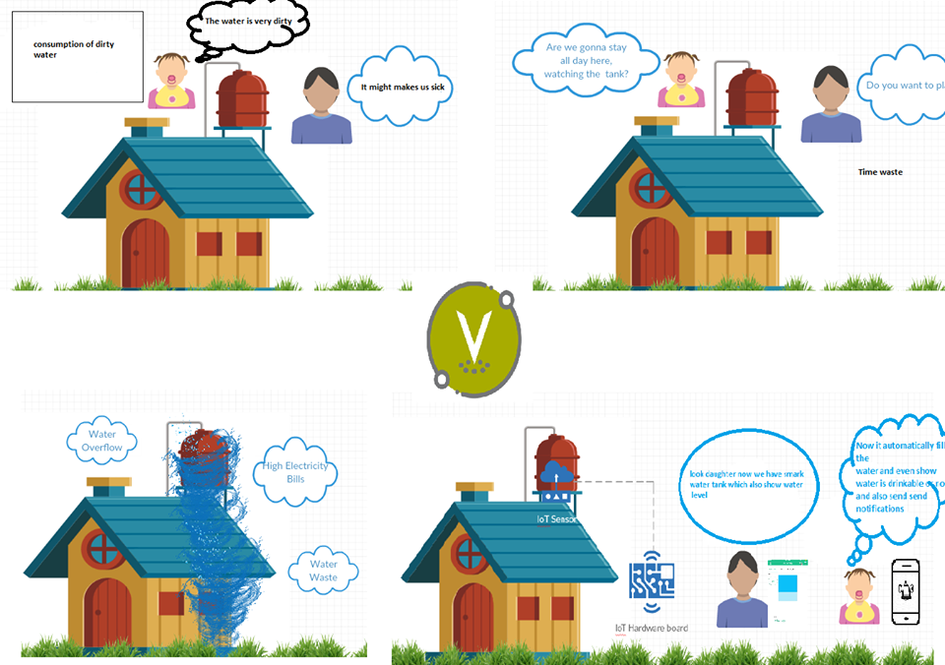

Figure 1: use case of system

In figure above problems of traditional water distribution system is described. And it also shows solution with clean water distribution systems using IOT sensors and hardware to monitor and control system. All of the system's information can be displayed in the application and it shows how smart water distribution system help to make life easier.

# Ethics and Privacy

Ethics is moral about what is wrong and right in a group. Ethical consideration of smart water distribution system is it might get hacked through network because system is controlled and monitored from mobile app. And it can give wrong data which will be more harmful to those who installed the system. That makes high chance of taking wrong decision and could impact badly to all of stakeholders. So one must be focus on data about how to verify, save and manipulate data. So that, data don’t get fully open as much as possible and make virtual private network to keep sensitive data. Security should be implemented so it can prevent data loss. Users must be proactive about someone is trying to access the system and better understand to access the system through mobile app. Sometimes hacker can attack by phishing, Wi-Fi attack, key logging. So that user must be understanding about hacker’s act as much can. User must be well aware of system security and prevent access of system on public.

The system is prototyped in small water cans and uses low power hardware’s. As system is developed in small scale some use case of ethical consideration was conducted such as individual’s safety and fairness.

# Project Plan

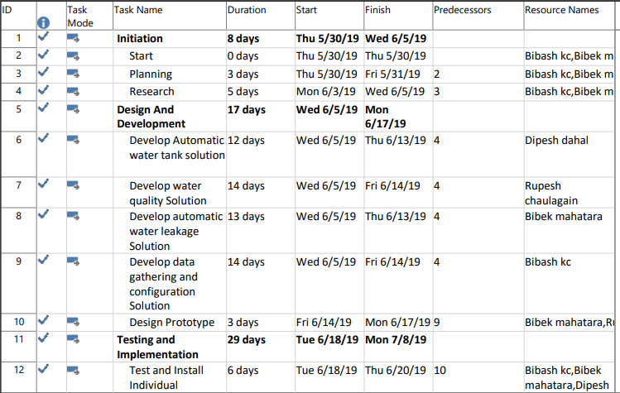

Figure 2: Project Plan

## Risk log

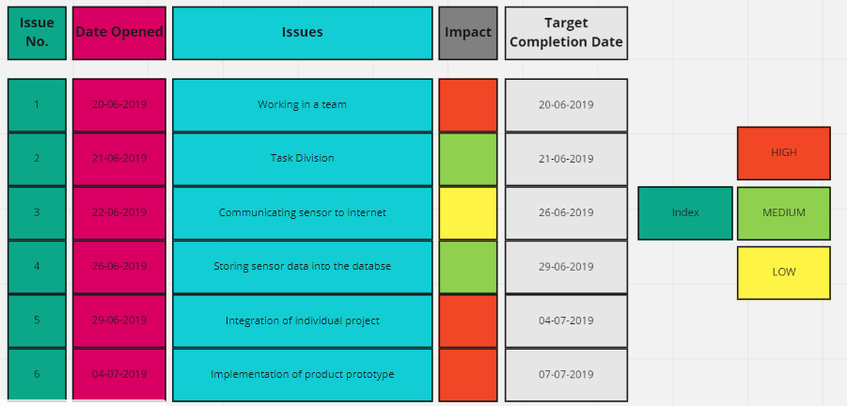

Figure 3: risk Log

## Gantt chart

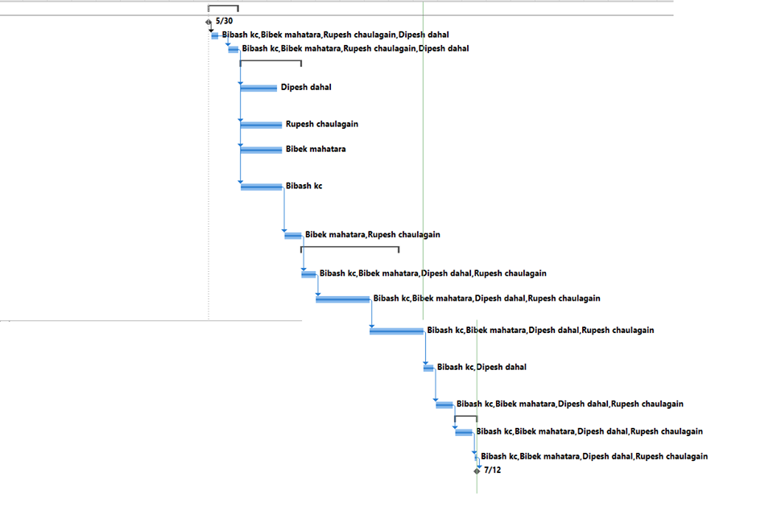

Figure 4: Gantt chart

# System Architecture

System that we have developed get all the data through sensors and send that data to server by hitting the certain API using Node MCU. After getting the request in server it perform event on trigger and do specific task in the Blynk like Data saving and Data Visualization in android app. In case of vice-versa if android app sends some instruction to server then it will comes to Node MCU and do certain function as prescribed.

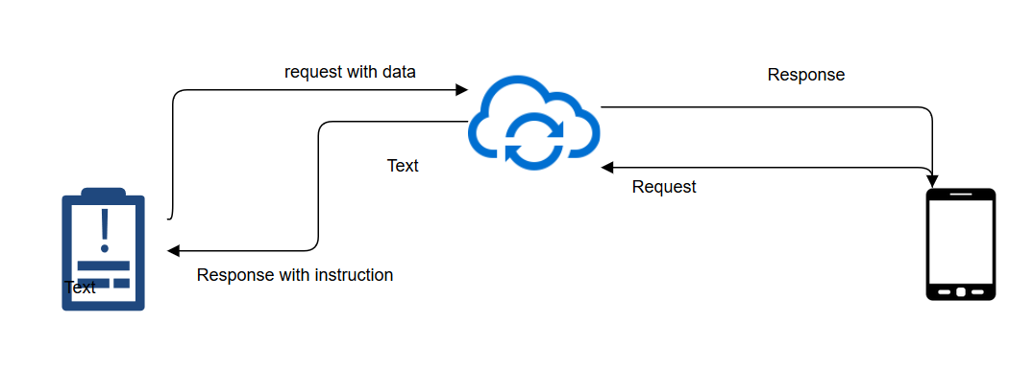

Figure 5: System Architecture

## Circuit Diagram

This is the final diagram for this project as we can see that all the connection of devices are shown below:-

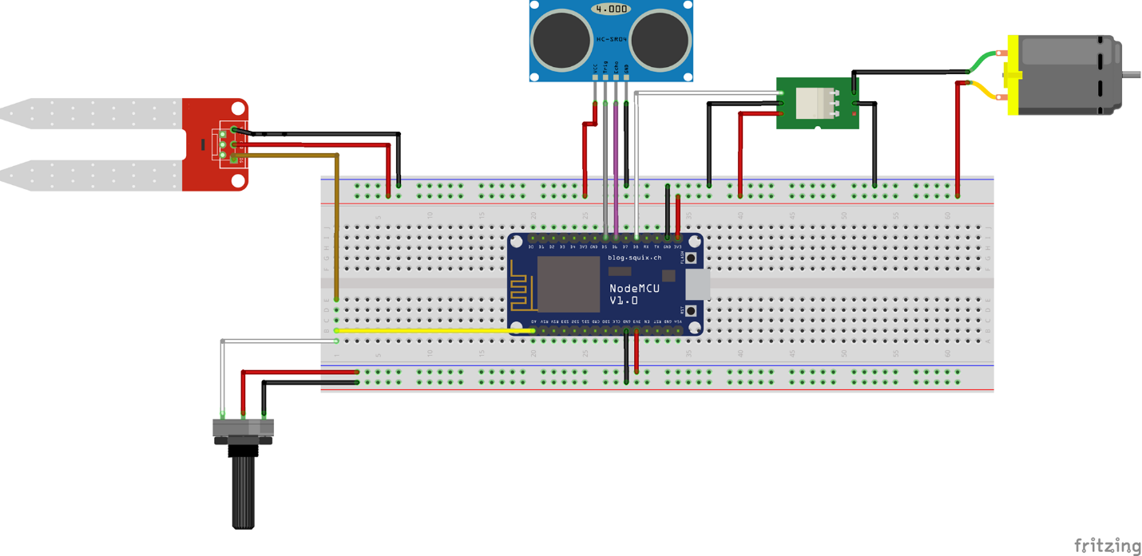

Figure 6: Circuit Diagram

## Schematics

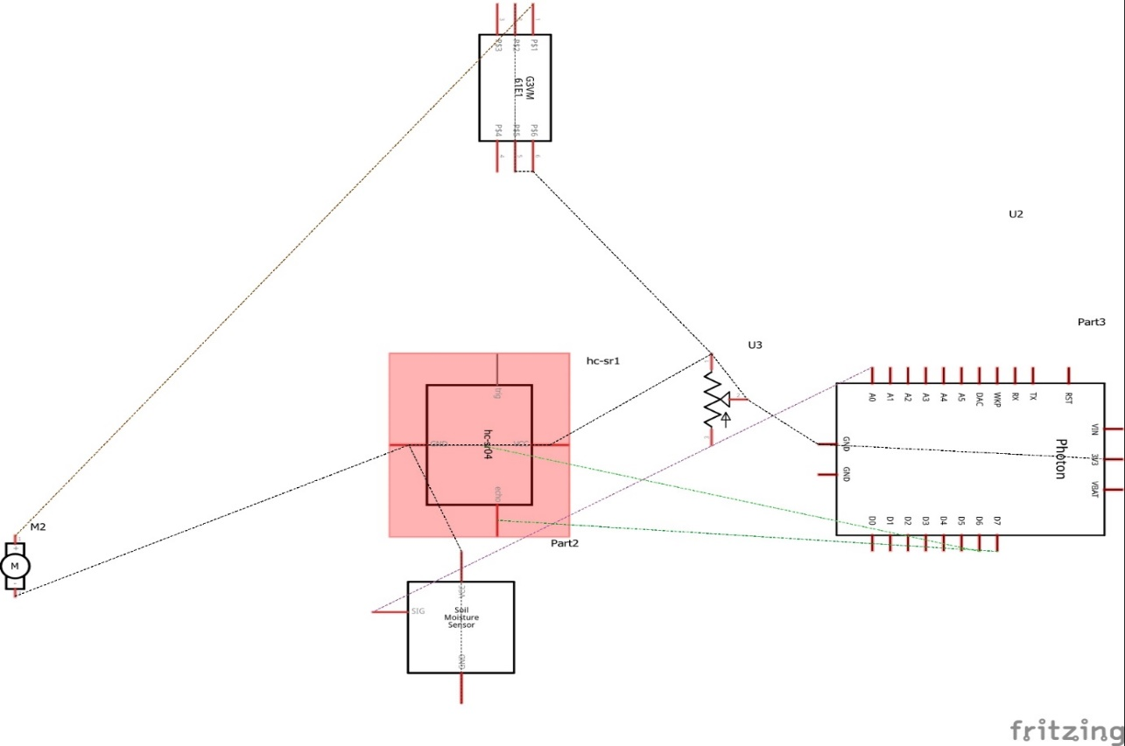

Figure 7: schematics Diagram

# Development

## Hardware’s and Sensors

**Node MCU**

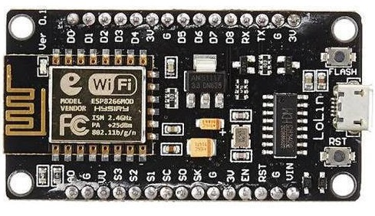

Figure 8: Node Mcu

It is open source iot board. The hardware is based on esp. 12 module and firmware. It runs on 3.3v and has 11 usable GPIO pins. It has built in Wi-Fi and it is powerful microcontroller on its own.

**Ultrasonic Sensor**

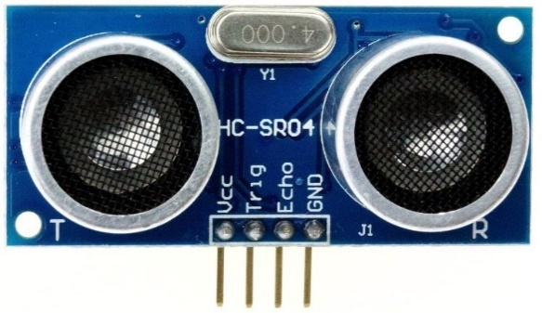

Figure 9: Ultrasonic Sensor

The sensor can measure distance. It has sound receiver and transmitter to calculate distance via sound travel duration. Here ultrasonic sensor is used to measure water level on tank.

**Water Level Sensor**

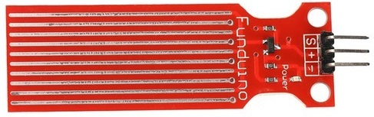

Figure 10: Water Level Sensor

Water sensor can read water value and can send via analog input. It has series of parallel wires which can sense water level or drop. Here the sensor help to find if there is leakage in pipeline.

**PH Sensor**

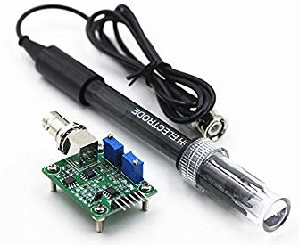

Figure 11: PH Sensor

The ph sensor used to measure water quality. It measures alkalinity and acidity. Here ph sensor is used to detect if water is drinkable. It has wide applications from lab to quality control.

**Relay**

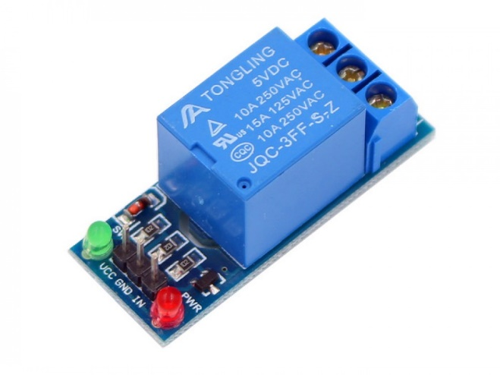

Figure 12: Relay

Relay is electrically operated switch that can be controlled through micro controllers. It allows machine to machine communications. Here relay is used to control motor power as power source of motor is different from board.

**Breadboard**

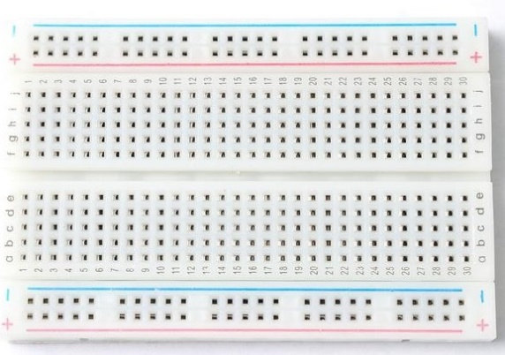

Figure 13: Breadboard

It is soldier less device to test circuit design and make prototypes.

**Jumper Wires**

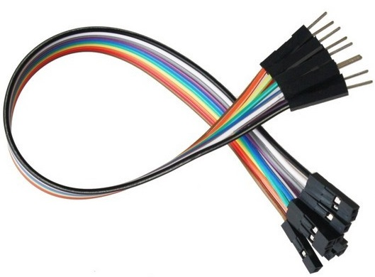

Figure 14: Jumper wires

These wires allows soldier less prototyping and help to maintain components reusability. It is easy to implement on common boards and sensors.

**Motor**

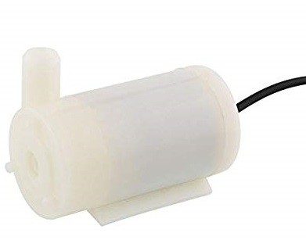

Figure 15: Motor

This is 5v DC motor used for prototyping water pump. It goanna be controlled through relay.

## Build

**Get Things Together**

Collect all required tools and hardware and get extra 5v power source as node mcu only flows 3.3v.

**Wiring**

Power all sensors and relay with 5v.

As Node mcu only has one analog pin connect both water sensor and ph sensor analog input to A0.

Connect Ultrasonic sensor echo and trigger to digital pin 12 and 13.

Connect relay input to digital pin 16.

|  |  |
| --- | --- |
| Power | 5v (all) |
| PH sensor Input | A0 |
| Water Sensor Input | A0 |
| Relay | 16 |
| Ultrasonic Echo | 12 |
| Ultrasonic Trigger | 13 |

**Install Required Libraries**

Required libraries need to be installed to function code properly. All required libraries are described below and can be installed through library manager on Arduino IDE.

**Compile and Upload Code**

Compile and upload code to Node MCU board with Arduino IDE. After uploading code to board system will be ready to implement and only require power further.

## Blynk -App

Founded in 2014 blynk is privately owned IOT company. The platform is designed to control iot machines remotely via app, display sensors data and even store data. It has app on download and claim to support over 400 iot hardware’s.

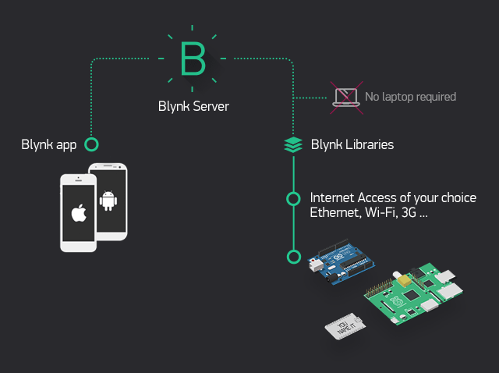

Figure 16: Blynk architecture

Blynk has easy drag and drop for app ui design and allow to assign virtual pins to its value container. By which data can be sent to app in one line Blynk.VirtualWrite (VirtualPinNumber, Value).

**Blynk Virtual Pins**

|  |  |
| --- | --- |
| V1 | Water Level - Ultrasonic Data |
| V2 | Leakage Detection - Water Sensor Data |
| V3 | Drinkable or not - PH sensor Data |

## APP

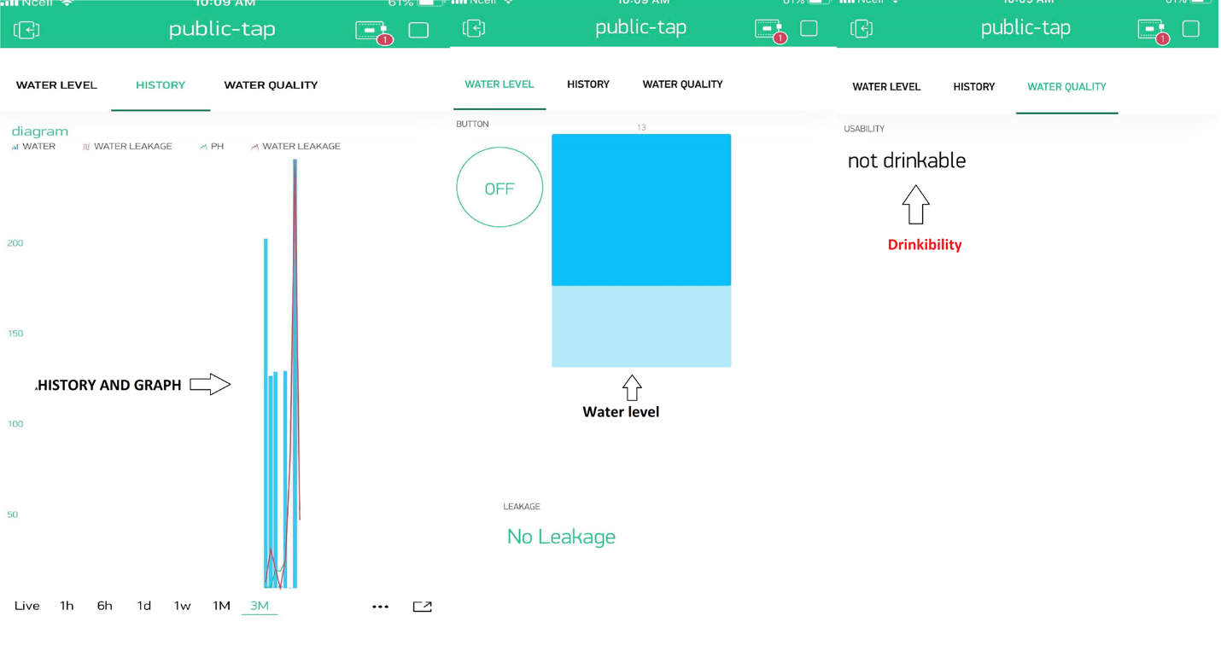

Figure 17: app screenshot

App has water level monitor, motor control switch and leakage detection alarm. And also shows water is **drinkable** or not. And store history with readable charts.

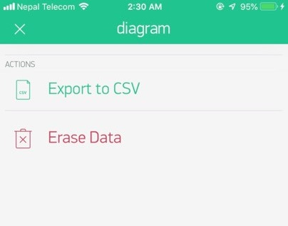

Figure 18: Export Data

Fig: Option to export data for further analysis.

## Development Environment

Arduino IDE is written in JAVA used to create and upload code on microcontroller. It is available to download on web and source code is released under GNU General Public License. It uses *to* load code on board's firmware

After successfully installing Arduino IDE. It needs configuration for board and port via tools menu after injecting board on usb. To configure Node MCU it needs ESP8266WiFi library. After Installing the library Node MCU 1.0 (12-E Module) can be selected on board option. It will automatically set CPU frequency to 80 MHz and flash size 4M.

### Required Libraries

**ESP8266WiFi.h**

The library is for Node MCU module. It can be used for any esp8266 Wi-Fi module. According to Arduino documentation esp8266 is all about WIFI.

**SoftwareSerial.h**

The library help to use multiple input / output serial port. Arduino has built in serial communication on pin 1 and 0. The library allows serial communications on other pins.

**Ultrasonic.h**

This is minimalist ultrasonic library to reduce code of ultrasonic sensor and make it more readable. It works with any ultrasound module. The author is Erick Simoes and code is released under MIT License.

**Blynk.h**

This library help to communicate board to blynk app. With just one line of code the program now sends information directly to the app on real-time. It can connects over 400 hardware models.

## Code

Include required libraries and set up basic variables.

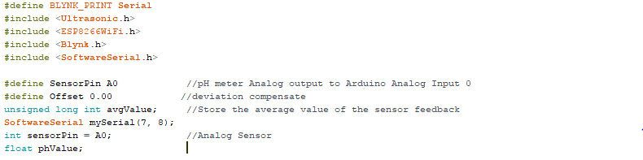

Blynk auth key and setting up the library.

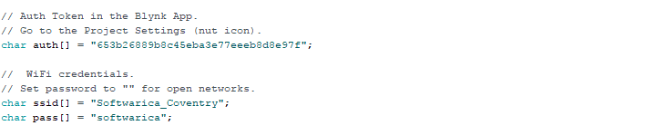

Pins initializations 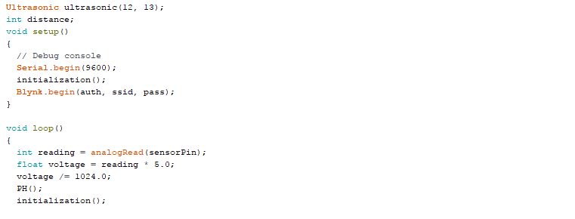

Leakage Detection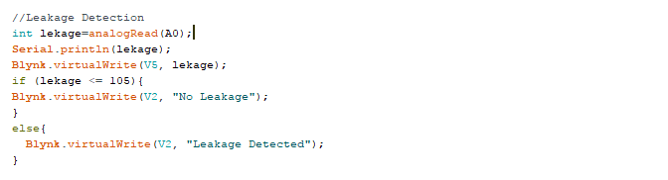

Water Level Detection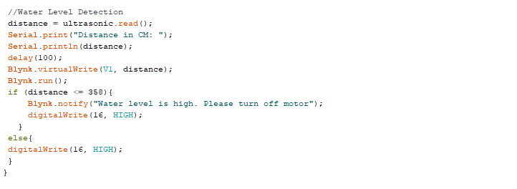

Water Quality Check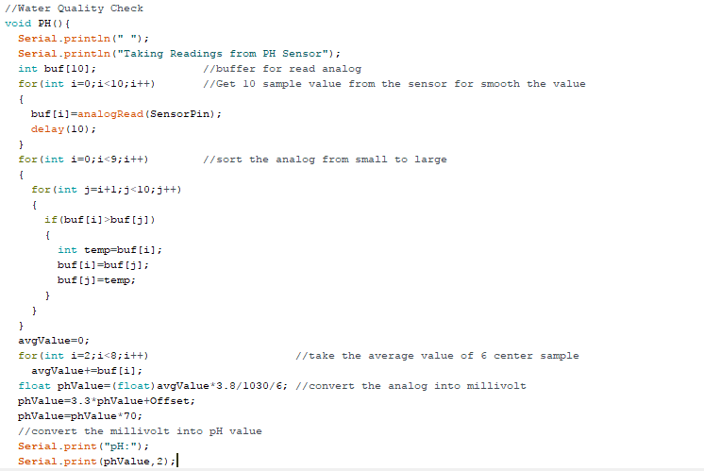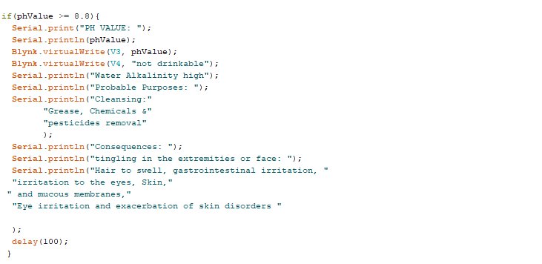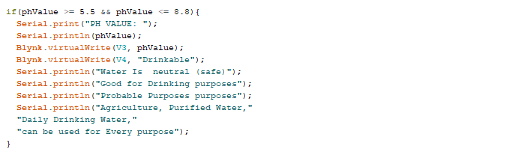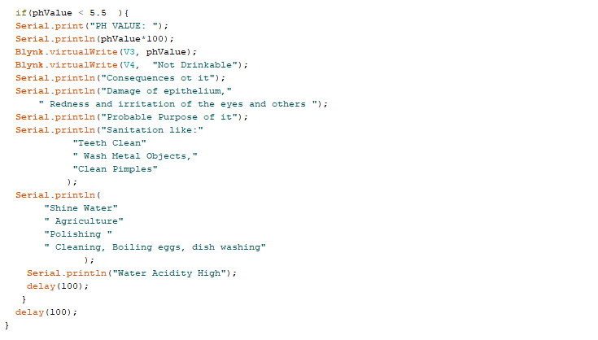

Code Initialization.

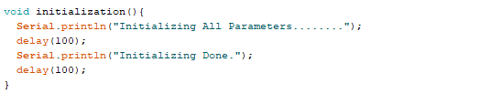

## Final Product

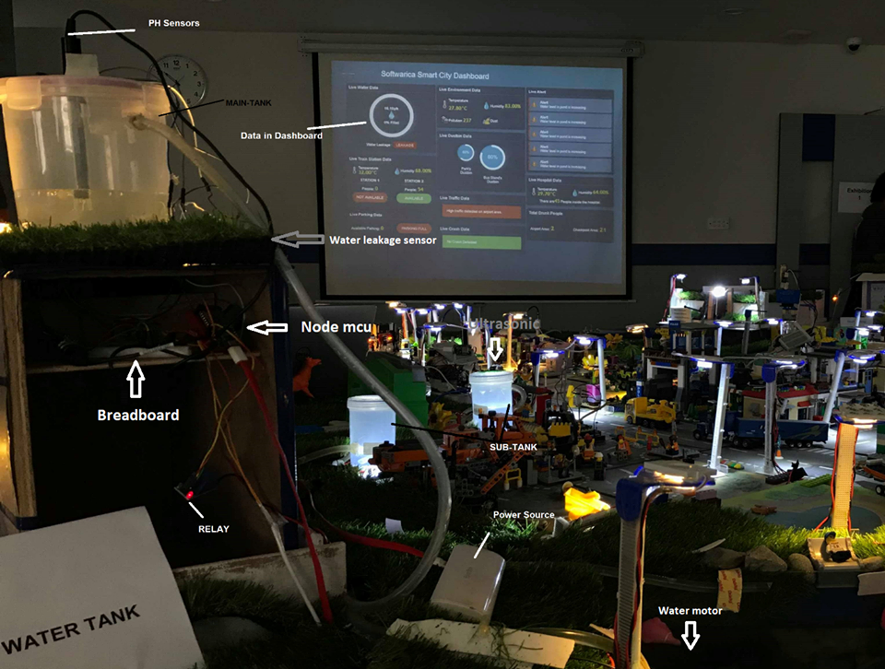

Demo: <https://www.youtube.com/watch?v=j2NTCdi1nPM&feature=youtu.be>

## Troubleshooting

**Code won’t upload**

If code is compiling but not uploading, this might be port issue. Make sure to select correct board and port via tools menu on ide before uploading.

**System Don't Work**

Confirm that all hardware’s are working. Check the wiring and all connections.

This might also occur because of low power supply. Make sure all sensors get 5v power.

**Sensor Don't Work**

Sometime sensors get damage while experimenting check sensors if it is working. To check sensors data see serial monitor of Arduino IDE if it is giving right values.

**Single analog pin**

Node mcu only has single analog pin but don't freak out it works with multiple sensors at once.

**App not connecting.**

Make sure internet is speed is usable.

Check if auth key is changed.

Make sure there is no barrier to connect Wi-Fi to system.

**Testing**:

Testing means checking whether the developed system is working correctly or not either logically or functionally.

**System Testing:**

It is a part of testing checking formerly whether the Assembled hardware and Sensors is connected properly or not. Videos of the working System is available in the given link [(link).](https://youtu.be/j2NTCdi1nPM)

**System Integrated Testing:**

Ph Sensors: Notification of Water status get from Ph Sensors in Blynk

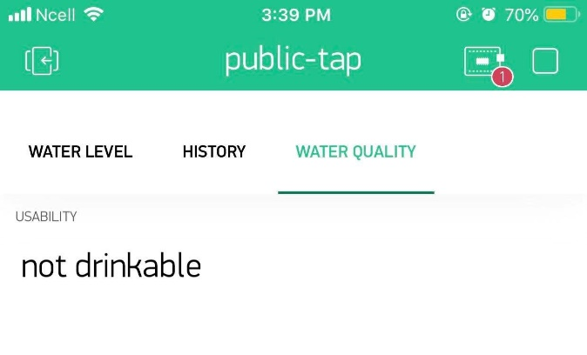

As Water status given then the Sensors and system regarding PH work correctly

**Ultrasonic Sensor Test:**

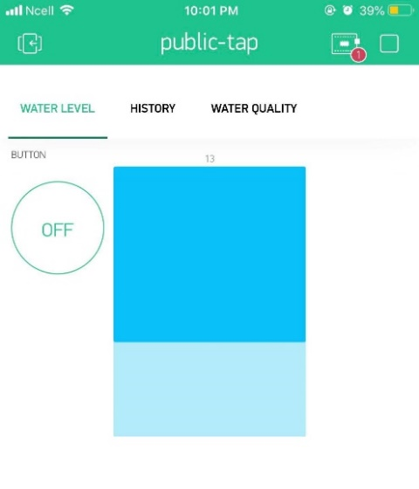

Data got from Ultrasonic sensors indicates the water level in the tank is populated in the app as in the visualization, so it also works perfectly.

**Node Mcu:**

Data got above two testing are transmitted through Node Mcu, so works fine.

**Water Leakage Sensors:**

Whenever device get interact with water, it will tell whether it is leakage or not in Blynk. As it shown in the Blynk, its works completely fine.

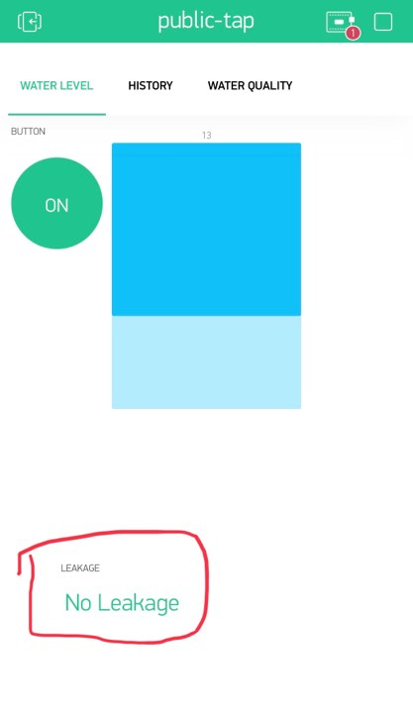

Figure 20:Leakage System Testing

**Data Storage Testing:**

Testing and seeing whether the data got from system are saved into database or not. Data get from System are stored in the Blynk database. We can Export the data in CSV File.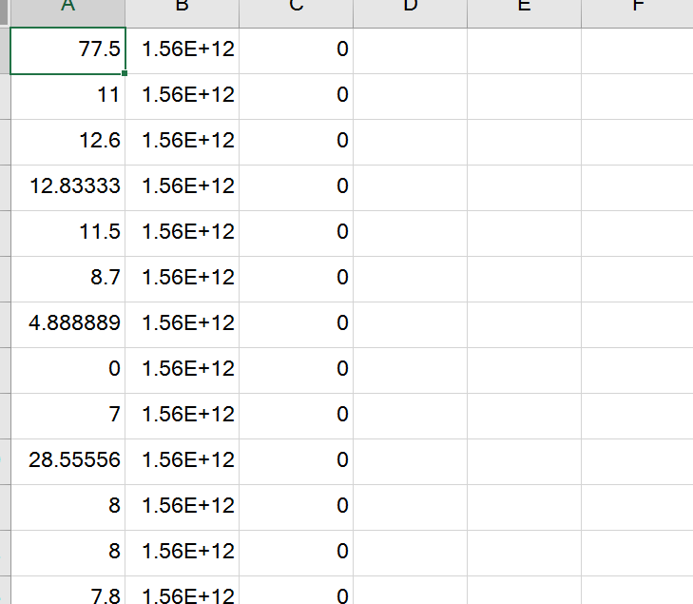

Figure 21::Data stored in database are exported into CSV files through Blynk

Functional Testing:

|  |  |  |  |  |
| --- | --- | --- | --- | --- |
| Test | Data parameter | Expected | Actual | Remarks |
| Ph Sensors | 11 | Not drinkable | Not drinkable | Passed |
| Ph Sensors | 7 | drinkable | drinkable | passed |
| Ultrasonic Sensors | 2 | Water tank full | Water Tank full | Passed |
| Ultrasonic Sensors | 10 | Water is Empty | Water is Empty | Passed |

**Real Time Data of Data History:**

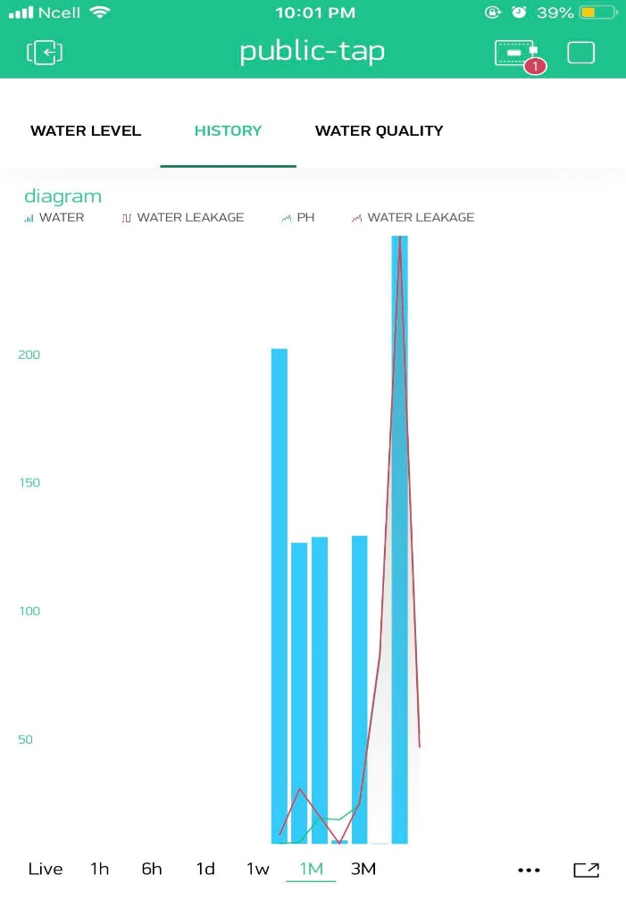

Figure 22:Real Time Data Tracking from devices

# FUTURE APPLICATIONS

This system as a whole or core parts can be used in multiple areas to distribute clean water i.e.

* Private houses.
* City
* Apartment
* Hospital
* Bank
* Institution like college and schools, hostels
* Offices

# Future Work

* Implementing water filtering system.
* Adding additional sensor helps to open up more application area.
* Adding new automated filtering and water checking system.
* Adding intruder detection system and leakage detector in water tank and pipe.

# CONCLUSION

All living thing need clean water to live in the world. Due to uncontrolled use or miss use and lack of water monitoring, clean water being wasted. To overcome these issues in daily life, implementation of smart clean water distribution system can be done, which is automated and can be monitored through mobile app. Main intension of this project was to make clean water distribution, easy to manage and flexible. The system can solve major problems of water scarcity. Water sensor, ultrasonic sensor and PH sensor are used in system to gather data cost. This system can notify when leakage occurred and give message about water is drinkable or non-drinkable which is more significance to users. With help of IOT hardware’s, problems of water scarcity is solved in this project.