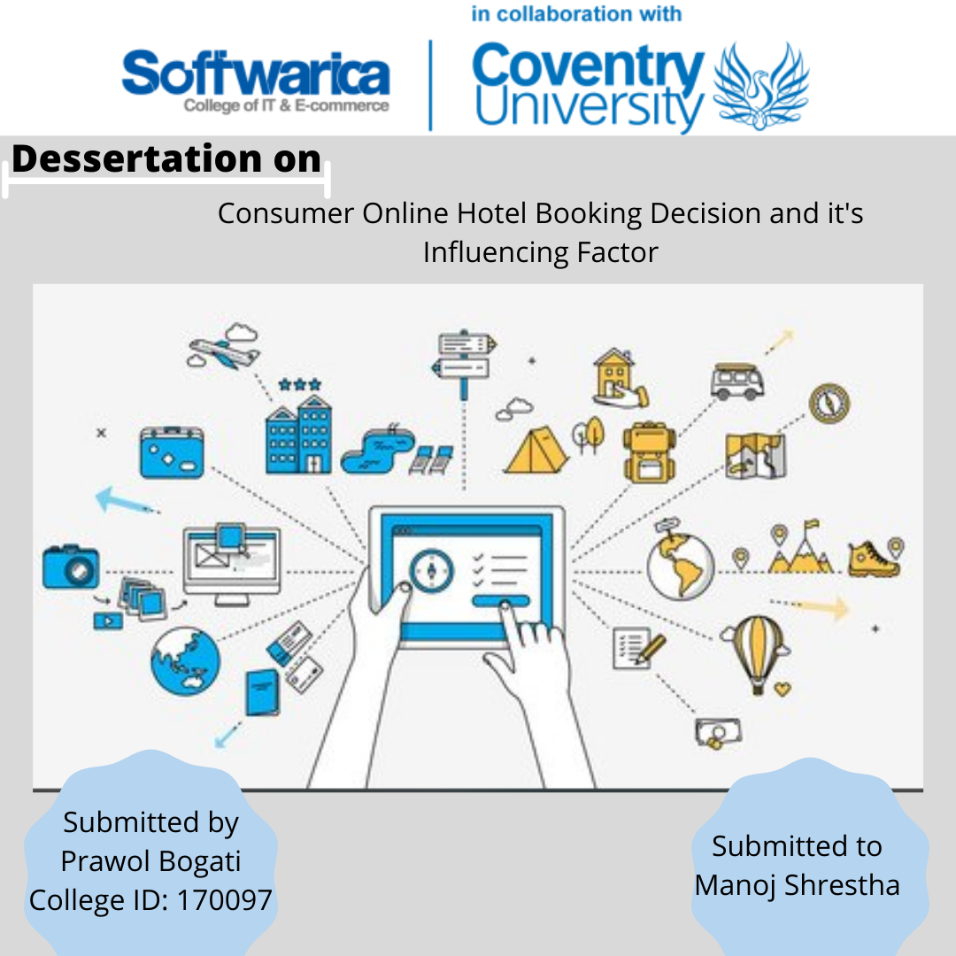

# Introduction

Hotel industry can be defined as part of service industry which deals with guest housing or lodging. When we say hotel industry, it doesn’t refer to hotels only, there are different forms of overnight accommodation which comes under it, like motels, guest houses, inns. (*Hotel Industry; Everything You Need to Know About Hotels!* 2020) Hotel industry is one of the fastest growing and more earning industry in the world which contribute great sum of revenue to world economy. In the year 2017, 2018 and 2019, the total revenue in hospital industry was US$343,924m, US$355,306m and US$368,359m respectively. The revenue in the hotel segment is increasing every year but the revenue is decreased in the year 2020. The revenue for the year 2020 amounts to US$210,915 which is due to impact of COVID-19. By the year 2023, the annual growth rate of revenue is expected to be 23.0% resulting in an amount of US$392,391m. In the year 2020, the penetration rate id 8.5% which is expected to increase to 14.7% by the year 2023. In 2020 the average revenue per year (ARPU) amounts to US$334.65 in the hotel industry. The hotel industry contributes in every country economy. The revenue in United States in the year 2020 is US$51,282m which is the most generated revenue comparing globally.

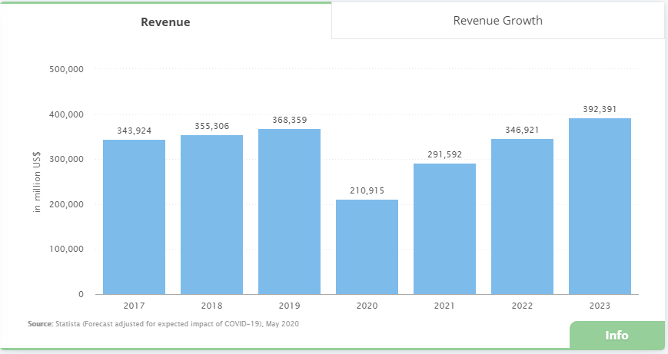

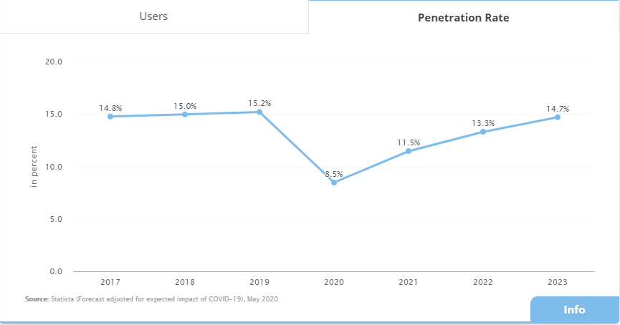

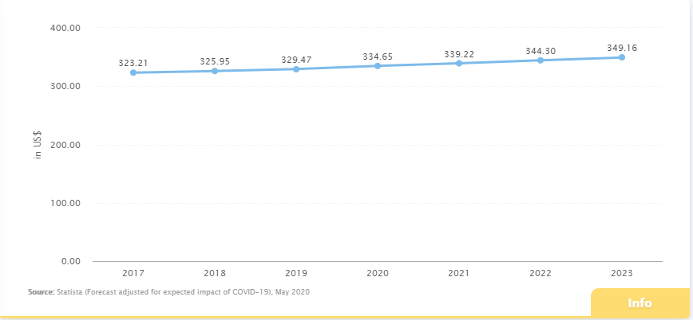

Traditionally, there were not any online booking facility and hotel rooms were sold from the counter. Some hotels could be booked by calling through phone but in most of the hotel, the guest would seek the hotel, go there and make a booking. The guest could not know if room is vacant or not, its condition, price and other details before. It creates problems for the guest, more time and effort were needed. The business was not growing much bigger and more profit could not be made. The problem was solved as this industry started using internet for running business. The use of internet and world wide web have increased all over the world now. People use internet to get information about different topic, communication purpose, entertainment purpose, setting up business relationships. Internet and technologies are playing great role for running business and their growth as it helps to perform many business processes easily like marketing, communication and advertising. It is very important to be able to access and transfer information fast and easily for business to survive in this competing world. Hotel industry is using internet for running its business processes like sharing information, communication, booking rooms and now, hotel industry is one of the growing business in the world and is progressing rapidly by using e-commerce and more recently m-commerce.

The market for online hotel booking is increasing every year. It is expected that 76% of total revenue will be produced through online booking in hotel field by the year 2023. In the year 2018, there was increase in hotel and accommodation searches on search engines by 23% than the year 2017. 31% of hotel and accommodation searches was done. In 2018, 82% of all travel bookings were done online by using website or mobile application. The average online conversion rate of hotels is 2.2%. Customer can make online hotel booking by using hotel owned website or mobile application and through Online Travel Agents (OTAs). Online Travel Agents is defined as a distribution channel which is established for selling travel related products to customers. Hotels, travel packages, fights come under these products. Online Travel Agents serves as marketing as well as distribution channels for hotel. Most of the people use OTA for online hotel booking because customer can search for hotel easily, read reviews, compare prices and they can book, view other travel related products also from same website. Some of the famous Online Travel Agents are Booking.com, Expedia, TripAdvisor. In July 2019 there were 697 million and 224 million visits to Booking.com and TripAdvisor website respectively.

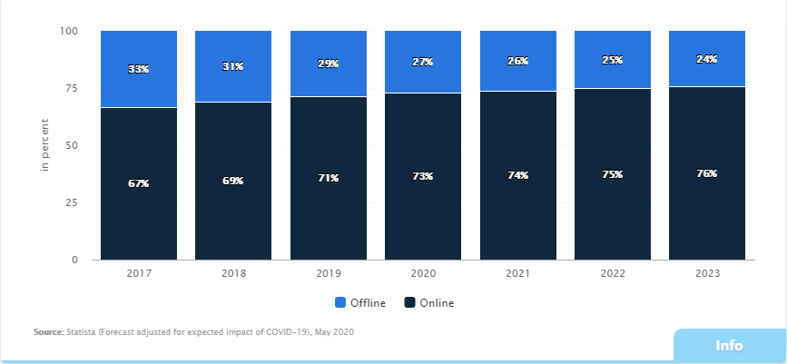

The motive of this paper is to build a dashboard of visual analytics which demonstrates how customer make decision while booking hotel from online. The hotel industry is growing bigger and bigger and online hotel booking rate is also increasing. With these things, competition is also increasing. So, investing in business, opening hotels and running it is not sufficient now. For surviving in business and making profit, we must have knowledge about how a customer behaves, think while booking online. The thorough research about the customer of business, their needs and how they respond is must. Customer perform certain research and gather as much information while booking the hotel. They compare the price of hotel in different websites. Customer look picture of rooms of hotels, they look for the facilities provided. Different customer has different strategy, idea for choosing the hotel. Different information from different internet sources like good and bad side of hotel, review and ratings, photos and videos by other customers, recommendation from website might brainwash the customer mind which effects in decision making process. In this paper, the factors affecting customer hotel booking decision will be discussed in detail.

## Factors influencing booking decision

There are different factors that influences a customer while making decision. In 2016, TripAdvisor (one of the popular Online Travel Agent) conducted a study among 34,026 participants and list out the top 10 influencing factor for decision making.

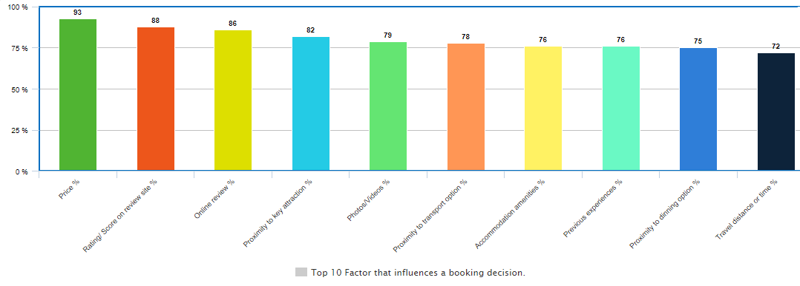

## Online Hotel Booking Platforms in Nepal

* **Booking.com**

Booking.com is an industry and traveler favorite founded in 1996 that stands out for three main reasons. The first is its sheer size: the website lists more than 29 million accommodation options, from hotels, hostels, and B&Bs to vacation homes and luxury resorts. This means that when you search for a hotel by destination, you have more choice on Booking.com than on any other OTA. Secondly, the website performs well in terms of cost, typically returning lower-than-average prices for flights and hotels.

Thirdly, Booking.com takes care of every aspect of your vacation, offering tours, activities, and airport taxis in addition to the standard services provided by most OTAs. The interface is also easy to use. On the home page, search for a hotel by entering your chosen destination and dates. Then, use the extensive list of filters to narrow the results down and find the best fit for you. You can also search for a specific hotel, or seek inspiration by clicking through portfolios grouped by destination or property type. The flights, car rental, and other tabs are just as intuitive.

* **Expedia**

Expedia is the flagship for Expedia Group in the same way that Booking.com is the flagship for Booking Holdings. The two websites are aesthetically very similar and the basic premise is the same (although Expedia also offers cruises). However, Expedia is a particularly good option for those wanting to book a package vacation, i.e. to select and pay for flights, accommodation, and car rental in one go. There are several ways to do this. Under the Hotels tab, you can choose to add a flight and/or car rental to your booking.

Alternatively, the Bundle and Save tab allows you to book two or more of the following options: flights, hotel, and car rental. Often, you can make significant savings by booking these services at the same time. Making changes to a package booking can be complicated, so make sure that you’re happy with your plans before paying. If you’re not sure yet where you’d like to go, it’s well worth browsing the Deals tab, which groups discount hotels and hotel/flight packages under themes like Family-Friendly Hotels or Extraordinary Luxury Hotels.

* **TripAdvisor**

TripAdvisor is the place to go to read candid guest reviews of everything from hotels to restaurants and attractions. Reading about the experiences of others is a great way to book (or not) with confidence. Best of all, the site doubles as a metasearch engine, providing third-party links that allow you to make those reviewer-inspired bookings without having to search from scratch on a separate OTA. Travel services offered by TripAdvisor include hotels and vacation rentals, tours and tickets, flights, and restaurant reservations.

The website also stands out for its intuitive design, which allows you to search for each service under its own specific tab and then filter results according to a pretty specific set of personal criteria. For example, if you’re looking for a place to stay in London, you can set a budget limit, choose your preferred star rating and property type, select must-have amenities, and even narrow your search to a specific neighborhood. Under the restaurant tab, you can browse traveler-ranked options according to themes including Cheap Eats, Local Cuisine, and Fine Dining.

* **Agoda**

Now owned by Booking Holdings, Agoda was founded in Thailand and is headquartered in Singapore. Although its two million listings include properties in destinations across the world, it has a reputation for returning the best prices and widest availability for hotels and vacation rentals in Asia specifically. The hotel section of the website functions as an independent OTA and allows for direct bookings. Simply enter your chosen destination, dates, and room requirements to receive a list of results that you can order according to Best Match, Lowest Price, or Top Reviewed.

Agoda doesn’t have as many filter options as other OTAs and some users find the layout (which is cluttered with incentivizing marketing slogans and Just Missed It properties) off-putting. However, the company makes up for it with a best-price guarantee that offers to match any price on the web or refund the difference. The flight section operates as a metasearch engine, redirecting you to the cheapest third party site to make your booking. Agoda also partners with Mozio, Rentalcars.com, and Viator to offer airport transfers, car rentals, and tour tickets respectively.

* **Priceline.com**

Priceline.com is owned by Booking Holdings, the same company that operates Booking.com. However, the Priceline.com company has its headquarters in Norwalk, Connecticut, in the United States. Click here to list your hotel to Booking.com. The main difference between Priceline.com and Booking.com is that Priceline.com focuses even more heavily on the discount travel market. To achieve this, it offers a ‘Name Your Own Price’ model, where customers are able to set their ideal price, location and hotel star level, and the service will then find a suitable option.

* **Travel velocity**

The Travelocity.com brand was founded in 1996, making it one of the older active OTAs on the market, and it too is now owned by the Expedia Group. The company has its headquarters in Dallas, Texas, in the United States. In terms of how it differentiates itself from its parent brand, Travelocity places an increased focus on package deals and on providing positive travel experiences. One of its unique features is a ‘Travel for Good’ scheme, where customers are rewarded if they participate in volunteering opportunities while on their travels.

# Aims and objectives of study

## Aims

To learn and understand customer behavior while making online booking decision on the basis of different influencing factor mentioned in the figure below:

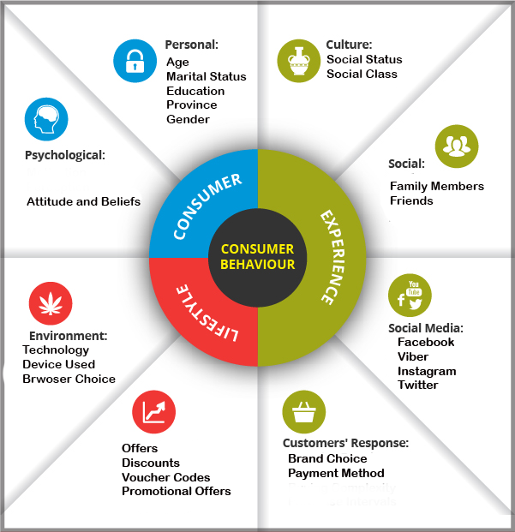

## Objectives

**Personal Objectives**

* Learn about the hotel industry and Online Travel Agents (OTA) and understand how they are running business online.
* Understand the customer behavior while making online booking decision.
* Learn about the factors that influence customer decision while making online booking.
* Collect data from interviews, survey and measure the effect on decision making on the basis of age, gender, residence.
* Study different books, website, journals, past research paper and implement the knowledge gained for doing research.
* Perform citation for content from other sources used in research paper and provide credit to original source.

**Academic Objectives**

* Completion of research providing proper finding and solution for the problem.
* Complete the research within the estimated time.
* Prepare the standard document for the research.
* Completion of bachelor degree with good marks.

**Technical Objectives**

* Learn to use different tools and technology.
* Learn about the data visualization tool and understand the customer behavior through visualization.

# Research Questions

* Does price of hotel have effect on hotel booking decision?
* Does payment system have effect on booking decision?
* Do online reviews have effect on booking decision?
* Does rating of hotel have effect on booking decision?
* Do recommendation from friend or relatives effect booking decision?
* Does photos or videos of hotel and room have effect on booking decision?

# Problem Statement

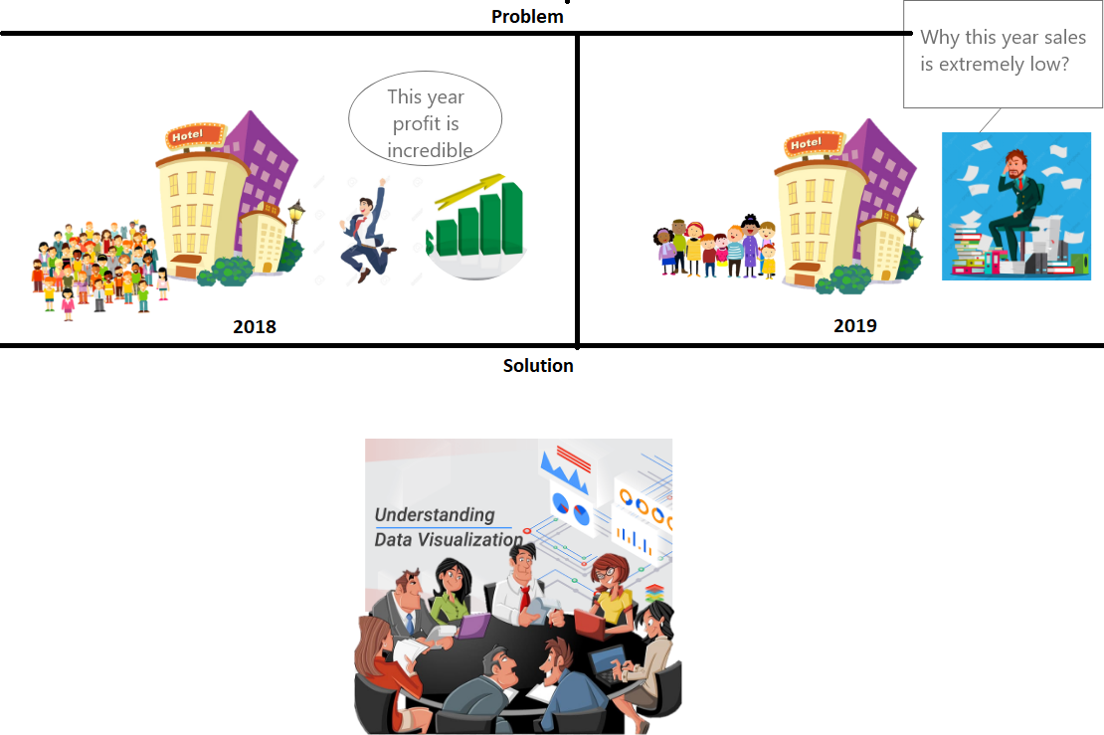

In 2018, increased consumer flow had direct effect on profit gained by the hotel. The consumer flow eventually decreased the following year directly affecting the profit gain. The problem of decreased consumer flow could have been addressed earlier if proper statistics of consumer flow and their preferences was studied; visualization of changes in consumer choices and factor affecting booking decision would help to avoid the loss suffered in 2019. Data visualization of change in pattern of customer behavior while booking would have helped the manager to identification of the problem earlier; this would aid the hotel management to make necessary changes according to consumer preferences to keep the steady profit. Further, besides profit and increased consumer flow, it would also help the hotel to maintain its reputation within the industry by accommodating the changes in consumer demands. Supply of facilities according to consumer demands would be possible only with the proper management of data and its timely analysis; this would aid to keep the hotel in top tier of preferences.

# Ethical Considerations

The research in any topic must consider ethical issues seriously. Ethical consideration is one of the most important part of any research and the research can be invalid or complete failure without this part. When data and information are collected from customer or different source, then ethical issues arise. I have also collected data from different source, surveys and interviews but I have considered all ethical issues while doing research. So, my research is ethical. Some of the ethical consideration are:

* Informed Consent

The participant in the research should be fully informed about the ongoing research. The participant should be made known of purpose of research, how finding of the research will be used, who can access the finding, impacts of participation. The participant can make decision whether they will be part of the research or not through this.

* Voluntary Participation

The participant in the research should be free from any force or threats. Participant should be free to stop their participation at any time without any negative on anything like their future involvement, relationship with other person. The participant is not required to give any explanation if they want to leave.

* Do not harm

The research could harm in both mental and physical form like giving pain, stress, privacy insecurity. The research should not harm any religion, people, society directly or indirectly. The researcher should make sure that no harms are made while doing research.

* Confidentiality

Confidentiality means the data and information should be protected. The personal information of customer and their data should be protected and archived. The personal information should not be published in any document or given access to outsource.

* Anonymity

Anonymity means the identity of participant should be unknown to researcher as well. It is stricter form of privacy.

* Intellectual Property

The researcher takes data and information from different source while doing research like website, journal, book, past research and that information should be cited and credit should be given to original source.

# Literature Review

## Website Quality Factor

Shopping on an e-commerce website or booking a hotel deal from an OTA website involves the interaction of the consumers with the website. Hence, the website quality has played a certain part in consumers’ decision-making process. The website quality is a logical foundation for building consumers’ trust and forming their intention to purchase. According to previous research, there were several factors which contributed to the success of a website. Those factors were secure payment methods with built-in controls to protect consumers’ data; a range of varying prices for the available products so that consumers might have an option to make a choice for product or service within their price limit; user friendly websites which were easily accessible, easy to use, organized in terms of information and content, and offered good speed and navigation features to the consumers.

According to Wong and Law (2005) information quality is one of the most important factors to determine the success of a hotel website. The quality of information on a hotel website is very importance because hotel customer will normally browse the hotel website to obtain the hotel information. Information is ‘data that are processed, manipulated or organized into or within a context so that they get a meaning’. In the previous study, there are two approaches that can be used to conceptualize information quality, ‘information-as-artifacts’ and ‘information-as-deliverables’. All the details and information should be communicated to the customers in a clear and concise manner. Customers will be satisfied and loyal to the hotel if the hotel website can provide information accurately. From the research, it is suggested that when consumers shop hospitality products, the information quality about the product from the website has a significant effect in determining their intention to purchase that product. The information quality on a website which is also related with playfulness (elements of information design in which a consumer experiences involvement and engagement) and attractiveness feature increases consumers’ satisfaction and tends to fulfill their expectations from a website. Therefore, it contributes to the success of websites. The quality of written, graphical, or other content which presents information on a website has been found to be a factor contributing to consumers’ decision to book a hotel from a particular website. According to research done by scholars, there are five different indicators to identify whether a website provides quality information or not. They are variety of hotel web characteristic, connection to other sites, useful of content, visual appearance and information of rate.

When it comes to booking from a hotel website or a travel agent website, the interaction of consumers is with the company’s website. In this case, the service quality which the consumers experience is important. The overall evaluation of quality regarding the functionality of a website is known as service quality. The layout of the website, the quality of website content, and the way a website handles its consumers are several factors which have an effect on service quality of a website. Website responsiveness describes how well a website responds to consumers queries and provides service to consumers and the navigational and information search response. In addition, fast loading, quick response, and timely and reliable service are generally perceived to enhance the service quality of the website. Many consumers are interested in finding other travel related products on the same website while booking a hotel online. This allows consumers to have convenience of finding various elements of their trip on the same website. The more diversity of hotel rooms, hotel brands, and other available travel products on websites results in an increased tendency of attracting potential consumers.

## Price and Promotion

Having a basic hotel website may not be enough to convert online browsing into hotel booking. Price and promotion factors also play important roles to induce website visitor attention and turn it into online booking intention. Price refers the amount of money expected, required, or given in payment for something. Promotion refers to raising customer awareness of a product or brand to generate sales and create brand loyalty. Promotion can be done by good design of product. Product design is perceived from a travel website in the form of hotel images and room images. Usually, it is the design which forms the initial impression of the product on consumers. It defines both the appearance and functionality of the product. Design plays a role of a strategic device in developing an organization’s branding strategies. Consumer decisions in majority purchases are not only based on a rational analysis of the available choices but are also influenced by other factors. The available images on the shopping websites trigger emotional states of the consumers who may also influence their purchase decision. The perception of hotel design from an aesthetic sense influences consumers’ intention to book a reservation for a hotel room and triggers their purchase behavior.

Kim and Singh, (2012), noted that one of the chief advantages use of electronic platform for reaching out to the customers is the reduction in cost. It kills the various marketing related costs ion making to product known and available to the customer. The drop in costs has had a dual effect. On one hand the hotels can sustain business and generate profitability by controlled costs, and on the other hand customers also get a competitive price. Importantly, the advent and growth of digital shopping has also encouraged transparency in pricing of the hospitality products. The customer can know about price of different hotels in different websites. In almost all cases, consumers are very concerned with the price of the product which they consider to purchase from a travel website including hotel accommodations. While shopping online, consumers are exposed to reference prices or competitor prices in addition to the price offered by their selected vendor. This is where consumers form their perceptions of a product price by comparing the offered price with the available reference prices across other shopping websites. Consumers also tend to have an internal price standard (memory based standard) which they often use as a reference for comparing the offered prices and making a judgment. Thus, if the product price offered by hotel booking website is higher than their internal reference standard, they will perceive the price as ‘high’ and be more likely to leave the booking website [18] and move to another travel agent website.

Price is always a key factor for users when purchasing hotel accommodations and tourism products online. Generally, when hotel accommodation and facilities are reasonably priced through effective promotion strategy, the intention to book will be higher. According to Law and Chung (2003), the price and promotion given by the hotel should suitable with the value of hotel room and facilities in their property. This will lead to higher customer satisfaction. The pricing method should follow the season which is peak and off season.

## Convenience

Chen, H. (2014), stated that customers can freely browse in the comfort of their surroundings, any time of the day and any time closer or far from actual booking date. This leads to huge convenience. Also information, comparison, virtual tours and information leads to easy access and helps decision making process. Kim and Singh, (2012), quoted that it is clear that travelers increasingly prefer interacting with travel businesses online to conveniently gather information on destinations, prices, and schedules.

Safety and Privacy

While shopping on the Internet, the consumers are generally concerned with the security and privacy of their data and information. Security issues may cause many online shoppers to negate their intentions to purchase products and leave the websites without buying. To inspire visitors’ interest to book hotel accommodation through hotel website, hoteliers need to ensure safety and privacy issue are taken cared adequately. Safety refers to the condition of being protected from some likelihood for danger, risk, or injury. Privacy on the other hand, refers to the ability of an individual or group to seclude critical information about themselves. Since hotel websites are available online and can be accessed by everyone, hotel customers concern with the security and privacy of the information they share on the website. For instance, customers may be asked to reveal their personal information such as name, address, age, gender, personal financial position, credit card number, and social insurance or social security number to make online booking. This information may be exposed to various risks such as online scam, online hacked and so on. Therefore, the hotel website should be able to provide great protection and all customers’ personal information is kept in a secure location.

## Secure Payment Options

When the consumers interact with an e-commerce website for purchasing a product, they go through a series of steps in the buying process which requires the consumers to pay for the product (product payment). Travel agent websites offer different currencies for payment and various payment methods. Consumer purchase intention which leads to the final purchase decision increase when there are many available numbers of payment options across a travel agent website. Consumers likely choose a payment method which is most convenient for them. Travel agent websites have different payment policies. Some of the travel agent websites do not charge the consumers at the time of making a reservation. However, it requires the consumers to provide their credit card information as it is required by the hotel they book. Security statements relating to product payment which are provided by the travel agent website increase the perceptions of security, trust, and influence consumers’ intention to purchase. A secure online payment system enriches the quality of travel agent websites to a large extent.

## Hedonic and Utilitarian motivation

Scholl-Grissemenn, (2017), endorsed that one of the most extensively prevalent techniques to learn the determinants of hospitality pricing, is hedonic pricing. Hanks, (2012), shared that broadly, hedonic products are regarded as experimental, fun, luxurious, pleasurable and enjoyable. Utilitarian in contrast, are thought of as, instrumental, functional and necessary. Sarkar, (2011), highlighted that utilitarian motivation is that which appeals to the logical side of the mind of a person, which rationalizes and reasons. Motivation on the other hand, stems from a person’s feelings and emotions. Hence, hedonic value is more subjective than utilitarian, and arises from amusement and entertainment than task completion. Franke, (2003), stressed on the significance of customization such as functionality and style. These in turn fetch maximum value to the consumers. In recent years, the concept of mass customization has gained enormous interest as well as application in marketing and tourism research. Utilitarian motivation has its base in economic utility theory and is often the underlying reason of consumer preference. It refers to attributes such as durability, price or reliability. The hedonic (experiential) motivation comprises emotions and views consumers as more than just thinkers and as feelers and doers.

## Reviews and Word-of-mouth

According to Tsao, Hsieh, Shih, and Lin (2015), Internet platform is the most popular channel to exchange information about travel experiences, views, opinion or knowledge. Tsao et al. (2015) found that positive comments on the Internet give more impact on traveler intention to book online rather than negative comments. Sparks and Browning (2011) revealed that online reviews increases sellers’ reputation, creates buyers’ confidence and greater intention to make hotel reservation. Another study claimed that when a hotel receives many good customer reviews, the hotel receives higher online room sale because hotel customers try minimize uncertainty and risk. The recent survey by PhoChus Wright has revealed that around 80% of tourist read the online review before they decide to book hotel accommodation and about 53% of the tourist will not book a hotel if there is no review from other customers.

Varkaris, (2017) accounted how negative content on social media platforms does not essentially exclude hotels, but makes potential travelers a bit “hesitant” in selecting a specific hotel. Nunthapirat, (2016), explained how increasing number of prospective guests depend on reviews before making a purchase. Specifically, in case of lodging and boarding, it was seen that consumers especially believe the online reviews as a yardstick for buying decision. Review is no longer considered just as a mere feedback, but as significant and legitimate information that is a predecessor to buying decision. It is not just hotels that provide information to customers, now the customers themselves freely express and voice their individual experiences. Chen, (2014), mentioned that hotel guests give reviews and ratings based on their personal experience, satisfaction and revisit intention. This greatly influences and affects hoe potential customers view the said product, and thereby affects buying decision. Seung Hyun, (2012), stated that it is clear that customers increasingly prefer ascertaining information on places, prices, and schedules. Chung, (2010), elaborated on two distinct types of customer pre-purchase uncertainty: knowledge and choice uncertainty. He established the relation between uncertainty and the degree of consumer external information search in online room booking. Inadequate information often leads to customers navigating more for information, and through other information sources. Pathaketal, (2010), also discovered that recommendations have a positive impact on sale of products. Furthermore, the impact on sales is significantly higher if the recommended product is newly introduced in the market. It also positively affects the price. Chen et al. (2004) found that systems based on recommendation increase the sales of products and the effects of recommendation are strong.

## Perceived Behavioral Control

Perceived behavioral control is an indicator that accompany with on predicting individual intention to perform a specific action, which is a part of theory named “the theory of planned behavior” (TPB) by Ajzen (1991). Perceived behavioral control refers to the “individual perception of the ease or difficulty of performing the behavior of interest”. In the relevant studies of the information system in a business, the perceived behavioral control might represent the perception of individual of the ease or difficulty of adopting the system. There are many studies argue the relationship between perceive behavioral control and intention to purchase in m-commerce scheme. Park and Huang (2017) state the perceived behavioral control in the online booking system of hotel is related to how traveler feel ease or difficult to obtain information about hotel and booking. Al-Swidi et al. (2012) indicates when individuals perceive technology easily manipulated, they will feel confidence for using a new technology and intend to buy products or service via a certain device. The study of m-commerce by Maity (2010) also discovered that consumers have a higher chance to book a hotel via online reservation system if they feel confidence to use a mobile device, as it represents the higher level of perceived behavioral control.

## Perceived benefits (PB)

Buhalis and Law (2008) define the perceived benefit in online hotel booking system is relevant to how technology can improve the benefit for consumers to purchase a product or service. It might be helpful for an individual to complete the hotel-booking task, such as the system provide a location-based recommendation, price or discount to the consumers who search a useful information. Kim et al. (2008) indicate that benefit might include convenience of using the device for booking service by reducing time and cost. Akturan and Tezcan (2012) represent that online hotel reservation system allows the customer to search a relevant information for enhancing their purchase decision. There are many relevant studies that confirmed that the perceived benefits significantly impact online booking intention. Park and Huang (2017) discovered the consumers would book a hotel via smartphone if they perceived benefits from using it. Liebermann and Stashevsky (2009) found the individual who perceived benefits of using the information technology will likely to purchase product or service from online channels.

## Perceived Costs (PC)

The perceived costs refer to the trade-off between perceived benefits and costs that occurred during the buying decision Park and Huang (2017). Hauser and Wernerfelt (1990) also state that cost perceived by an individual could be monetary and nonmonetary aspects. In case of nonmonetary, sometime the difficulty of using the technological device is individually requiring person for take much effort to learn how to use it. The difficulty of use represents how technological device is difficult for people to obtain customized information and produces unsatisfied search results. For example, it would explain that consumers might trade-off their effort and time using mobile device for booking a hotel. There are many studies confirmed on the information system which is ease to use can lead person to adopt the certain system. Maity (2010) explains that consumers intend to book hotel via online reservation system in mobile device when they perceived it is easy for use. The study of m-commerce by Park and Huang (2017) confirmed on that the less perceived cost of learning to use the system might increase the likelihood to book the hotel via mobile device.

## Anxiety and Self efficacy

Çelik (2011) defined the anxiety in e-commerce is relevant to “a transitory unpleasant and negative emotions in cognitive states evoked in actual or imaginary interactions”, which occurred in online shopping experiences. It consists of the feeling of fearful, worried, apprehensive and uneasy when try to adopt a new technology. Moreover, anxiety could arise from losing control if the online transaction is unsmooth or occurred some errors. For example, the online travelers may feel anxiety when they were request to provide their personal information, such as credit card or home address in the monetary transaction. From many related studies, it found that highly anxious and uncomfortable individuals toward technology intend avoid e-commerce. The study of mobile commerce by Lu and Su (2009) found negative relationship between intention to shop online and anxiety. If they feel nervous during a shopping, the likelihood to avoid e-commerce would occur. Beaudry and Pinsonneault (2010) found that persons who possessed the high level of anxiety behave more cautiously during adoption of new technology compared to those who are less likely to be anxious.

According to the social cognitive theory by Bandura (1994), self-efficacy represents the confidence level of person have for successful completion of a task within their ability. Park and Huang (2017) defined the self-efficacy in the context of mobile technology as a level of confidence in the capability to reserve a hotel via the smartphone. There are many relevant studies determine the impact of self-efficacy in technological experiences. Kim et al. (2011) studies the effect of factors affecting on using new mobile communication services, which found the positive correlation between self-efficacy and intention to adopt service. The empirical study of e-commerce by Pavlou and Chai (2002) states that the greater level of perceived self-efficacy significantly improves perceived ease of performing an action, thereby motivating individual to perform purchase decision in e-commerce via electronic device. In the opposite, the low degree of self-efficacy considers the technology to be a threat that improve the higher degree of stress and negative feeling, which finally lead into avoiding the adoption of technology. The empirical study of technological acceptance by Fagan et al. (2003) discovered that individual self-efficacy negatively influenced the intention to adopt new technology.

## Behavioral Intention

Behavioral intention is defined as the chance of consumers to perform specific action or behavior in the future. Shah et al. (2012) also states that intention of consumers could be change by a particular stimulus, which can be either internal or external factor. In order to examine consumer’s intention to adopt new technology in the hospitality area, it would need a useful measurement for understanding how consumers perceive and behave toward subjects. There is the notable theoretical framework that commonly applied in study in technological adoption, which named Technological Acceptance Model (TAM) by Davis (1989). The measurement of constructs from TAM model is widely applied to explain how intention of person to adopt new technology can be influence by perceiving a usefulness and ease of use from the system. The perceived usefulness refers to the level of individual perception toward the system would be effective for their performance, while perceived ease of use is the belief of individual think how the system is easy to use without any effort. By the way, the current study emphasized Thai consumer’s intention to book hotel via online reservation system after they perceived any value from using the actual system as well as the trade-off of cost and anxiety.

## Brand

Barreda, (2017), believed internet is a strong branding tool for businesses as it offers numerous ways to promote a business online. Online branding is in fact important for hospitality service providers, who don't have a tangible product. It is an influential means that has affected how hotels conduct their business and the way travelers and hotel brands interact. Chen, (2014), extensively worked on usage and buying intention, word of-month, relationship marketing and brand loyalty. Liu and Zhang (2014) advised that the building consumer relations will be more effective than a price war as a means to boosting online room bookings and preventing loss of market share. Bailey, (2006), indicated that lodging is a brand value business. By growing brand value, a hotel firm has the capability to trade its brand name to reach customers, thereby generating demand for sustained growth.

## Trust and Loyalty

Essawy, (2013), noted that trusting websites of hotels attracted ample attention. Hotel websites enabling booking publish information which reduces the perceived risk in dealing with the website and/or with the company in general. The primary reason is that trust reduces the transaction costs of inspection and monitoring and promotes the customers’ commitment to the service provider. Furthermore, O’Connor, (2005), argued that the acceptance of hotel websites depends not only on customer acceptance of internet technologies as viable transaction means, but also on customer recognition of websites as reliable merchants. Pavlou, (2003), found that trust is one of the determinants of the perceived usefulness of commercial websites. Rowan, (2002), mentioned that digital consumers will increasingly anticipate integration amid physical and virtual channels. Obviously they will trust companies which succeed in meeting their expectations. Similarly, on the virtual retail market, the study of Ang et al., (2001), recommended that trust as perceived by customers in the digital milieu has three dimensions, which are ability of online establishments to provide a product as promised, their readiness to correct inconvenience if consumers are not pleased with their purchase, and the existence of privacy policy statements.

Chen, (2014), commented that internet is useful to engage customers by means of loyalty programs. These facilitate the service providers in tailor-made offering suited to the customers’ varied wants. Additional benefit to the customers, apart from personalized products, is also that one-on-one communication is possible, in a faster and instantaneous way. This helps relationship building and promotes loyalty.

## Customer Attitude

Essawy, (2013) proposed a framework for bookers’ intent to reserve hotel rooms online. He adopted and further worked on the model from Davis (1989), Gretzel and Fesenmeir (2005), Jeong and Lambert (2001), Luo et al. (2007), Monsuwe et al. (2004), and Wand and Qualls (2007). Bruner & Kumar, in their researches, found that consumers’ attitude toward websites is a valid measure of website helpfulness and considerably concurrent to consumers’ attitude toward the brand and subsequent purchase. This was reinforced by website features that include ease of use, product information, entertainment, trust, and accuracy. A study conducted by Sukpanich & Chen found that there were three variables that affected attitude toward online shopping. These three factors consist of awareness, preference and intention. Different people have different attitudes towards online shopping. These attitudes vary not only as the result of the activities performed, but as the result of personalities, lifestyles, social classes and other factors.

## Meta-Search Sites and Social Media

Chen, (2014) advocated the importance of meta search engines like google, bing, etc. Though these websites are not able to complete buying transactions, they facilitate by means of directing potential customers to travel and hotel websites, increase footfall by means of clicks, thereby increasing the likelihood of sale. They give visibility and accessibility to booking sites and thus are a precursor to the online booking process. Social media websites provide user-generated-content platforms for users to voice their travel-related information, product reviews and comments and personal experience. Kim and Singh, (2012) added that social media and other intermediaries influence potential customers and direct traffic to a hotel, thereby acting as gatekeepers. Nielsen (2010) claimed that almost all social sites such as Facebook, are now the most widespread homepages for users. People now spend most of their internet time using social media or blogs. The emergence of Internet based social platforms have affected on integrated marketing communication for companies, as social media can influence numerous areas of consumer behavior including general awareness, information, reviews, attitudes and buying behavior. Sheng, (2002), studied the growth and effect of social media. It has become very popular. In comparison to Web 1.0, Web 2.0 is characterized by services rather than software, and any and as many devices can be connected to the web rather than just personal computers. Web 2.0 is one of the fastest growing segments on the web, and it includes social sharing of opinions through video sharing (Flickr and YouTube), blogs (i.e. Blogger and Twitter), sharing of knowledge (Wikipedia), and various other emerging forms.

## E Service Quality

Kim and Singh, (2012) studied the effect of e-service quality with reference to online hotel room booking. Due to the rapid expansion of internet users and channels, service firms have realized the importance of electronic service quality for survival in the competitive online market. In other words, electronic medium needs to be handled in such a way that it provides best quality interface and usage, and hence is critical to consumer behavior.

## Demographics

According to the research, demographic factors are also considered. A business can be benefitted by targeting consumers with a certain demographics such as gender or age. Internet usage is influenced by gender, age, and level of education. All businesses including online are prone to be affected by demographics.

# Reference

*Hotel Industry; Everything You Need To Know About Hotels!* (2020) available from <https://www.revfine.com/hotel-industry/> [25 May 2020]

C.-H. Lien, M.-J. Wen, L.-C. Huang, and K.-L. Wu, “Online hotel booking: The effects of brand image, price, trust and value on purchase intentions,” Asia Pacific Management Review, vol. 20, no. 4, pp. 210–218, 2015.

J. Wong and R. Law, “Analysing the intention to purchase on hotel websites: A study of travellers to Hong Kong,” International Journal of Hospitality Management, vol. 24, no. 3, pp. 311–329, 2005.

Jylhä, T., & Suvanto, M. E. (2015). Impacts of poor quality of information in the facility management field. *Facilities*, *33*(5/6), 302 – 319. <http://doi.org/doi:10.1108/F-07-2013-0057>

Lillrank, P. (2003). The quality of information. *The International Journal of Quality & Reliability Management*,*20*(6), 691 – 703. <http://doi.org/10.1108/02656710310482131>

Tan, C. (2015). the Impact of Website Quality on customer reservation

J. Jaevelaeinen, “Preferring offline bookings: An empirical study of channel choice motives of online information seekers,” in 16th Bled eCommerce Conference, Bled, Slovenia, June 9–11, 2003, pp. 80–94.

C. Liu, K. P. Arnett, L. M. Capella, and R. D. Taylor, “Key dimensions of web design quality as related to consumer response,” Journal of Computer Information Systems, vol. 42, no. 1, pp. 70–82, 2001.

R. R. Perdue, “Internet site evaluations: The influence of behavioral experience, existing images, and selected website characteristics,” Journal of Travel & Tourism Marketing, vol. 11, no. 2-3, pp. 21–38, 2002

Wong, J., & Law, R. (2005). Analysing the intention to purchase on hotel websites: a study of travellers to HongKong. *International Journal of Hospitality Management*,*24*(3), 311 – 329. <http://doi.org/10.1016/j.ijhm.2004.08.002>

A. Ahmad, O. Rahman, and M. N. Khan, “Consumer’s perception of website service quality: An empirical study,” Journal of Internet Commerce, vol. 15, no. 2, pp. 125–141, 2016.

G.-G. Lee and H.-F. Lin, “Customer perceptions of e-service quality in online shopping,” International Journal of Retail & Distribution Management, vol. 33, no. 2, pp. 161–176, 2005.

P. O’connor and G. Piccoli, “Marketing hotels using global distribution systems revisited,” Cornell Hotel and Restaurant Administration Quarterly, vol. 44, no. 5-6, pp. 105–114, 2003.

J. N. Liu and E. Y. Zhang, “An investigation of factors affecting customer selection of online hotel booking channels,” International Journal of Hospitality Management, vol. 39, pp. 71–83, 2014.

Azmi, A., Sulaiman, S., Aszyanti, D., Mohd, A., & Razali, M. A. (2015). Shopping Tourism and Trading Activities at the Border Town of Malaysia-Thailand: A Case Study in Padang Besar.

*International Academic Research Journal of Social Science*,*1*(2), 83 – 88.

R. Brunner, S. Emery, and R. Hall, Do you matter? How great design will make people love your company. Upper Saddle River: FT Press, 2008.

P. Desmet, “Designing emotions,” phdthesis, Delft University of Technology, 2002, unpublished.

J. Baek and C. M. Ok, “The power of design: How does design affect consumers’ online hotel booking?” International Journal of Hospitality Management, vol. 65, pp. 1–10, 2017.

R. Law and T. Chung, “Website performance: Hong Kong hotels,” Hospitality Review, vol. 21, no. 1, pp. 33–46, 2003.

H.-W. Kim, Y. Xu, and S. Gupta, “Which is more important in internet shopping, perceived price or trust?” Electronic Commerce Research and Applications, vol. 11, no. 3, pp. 241–252, 2012.

Law, R., & Chung, T. (2003a). Website Performance: Hong Kong Hotels.*Hospitality Review*,*21*(1), 32 – 46.

Law, R., & Chung, T. (2003b). Website performance: Hong Kong hotels website performance: Hong Kong hotels. *Hospitality Review*,*21*(1).

G. J. Udo, “Privacy and security concerns as major barriers for e-commerce: A survey study,” Information Management & Computer Security, vol. 9, no. 4, pp. 165–174, 2001.

Y.-H. Chen, I.-C. Hsu, and C.-C. Lin, “Website attributes that increase consumer purchase intention: A conjoint analysis,” Journal of Business Research, vol. 63, no. 9-10, pp. 1007–1014, 2010.

I. Wen, “An empirical study of an online travel purchases intention model,” Journal of Travel & Tourism Marketing, vol. 29, no. 1, pp. 18–39, 2012.

R. Law and K. Leung, “Online airfare reservation services: A study of Asian-based and North American-based travel web sites,” Information Technology & Tourism, vol. 5, no. 1, pp. 25–33, 2002.

S. Beldona, A. M. Morrison, and J. O’Leary, “Online shopping motivations and pleasure travel products: A correspondence analysis,” Tourism Management, vol. 26, no. 4, pp. 561–570, 2005.

M. A. Bonn, H. L. Furr, and A. M. Susskind, “Using the internet as a pleasure travel planning tool: An examination of the sociodemographic and behavioral characteristics among internet users and nonusers,” Journal of Hospitality & Tourism Research, vol. 22, no. 3, pp. 303–317, 1998.

Hanks, L., & Mattila, A. S. (2012). Verifying the hedonic vs. utilitarian consumer attitudes categorization: the case of spas and salons. Managing Leisure, 17(1), 47-53. doi:10.1080/13606719.2011.638201.

Lim, W. M. (2014). The Antecedents and Consequences of Customer Hedonism in Hospitality Services. Journal of Hospitality Marketing & Management, 23(6), 626-651. doi:10.1080/19368623.2014.846838.

Li-Ming, A. (2013). Exploring consumers’ attitudes and behavior toward online hotel room reservation. American Journal of Economics. 3 (5c), 6

Miao, L., Lehto, X., & Wei, W. (2014). The Hedonic Value of Hospitality Consumption: Evidence From Spring Break Experiences. Journal of Hospitality Marketing & Management, 23(2), 99-121. doi:10.1080/19368623.2013.766582.

Nunthapirat, D. (2016). Dealing with Customers' Online Reviews: what Approach Hotel Managers Need to Address. Annual International Conference On Tourism & Hospitality Research, 57-62. doi:10.5176/2251-3426_THoR16.14.

Ogut, A. (2016). Analyzing conversion rates in online hotel booking. The role of customer reviews, recommendations and rank order in search listings. International Journal of Contemporary Hospitality Management. 28 (2), 286-304.

Pal, S. K., & Mishra, P. (2017). Portfolio of online distributions channels across mid-market hotels: An evaluative review. Enlightening Tourism, 7(1), 19-35.

Rianthong, N. (2016). Organizing customer searching experience of online hotel booking by sequencing hotel choices and selecting online reviews: A mathematical approach. Tourism Management Perspectives, 20, 54-65.

Scholl-Grissemann, U. (2016). Room with a view: How hedonic and utilitarian choice options of online travel agencies affect consumers’ booking intentions. International Journal of Culture, Tourism and Hospitality Research, 10 (4), 361-376.

Seung Hyun, K., Singh, A. J., & Sungsik, Y. (2012). Evaluating Applicability of E-service Quality in Online Hotel Bookings. FIU Hospitality Review, 30(1), 75-91. 16. Ulrich, S. (2015). Negative online consumer reviews: effects of different responses. Journal of product and brand management. 24 (1), 66-77.

Bollen, K. A., & Long, J. S., Eds. (1993). Testing structural equation models. Newbury Park, CA: Sage

Casalo, L. V., Flavian, C., Guinaliu, M., & Ekinci, Y. (2015). Do online hotel rating schemes influence booking behaviors? International Journal of Hospitality Management, 49, 28-36.

Fornell, C. R., and Larcker, F. F. (1981) Structural equation models with unobservable variables and measurement error. Journal of Marketing Research, 18, 39-51

George, D., & Mallery, M. (2010). SPSS for windows step by step: A simple guide and reference, 17.0 update (10a ed.) Boston: Pearson.

Hu, L., & Bentler, P. M. (1999). Cutoff criteria for fit indexes in covariance structure analysis: Conventional criteria versus new alternatives. Structural Equation Modeling, 6, 1–55.

Jeon, M. M., & Jeong, M. (2016). Influence of website quality on customer perceived service quality of a lodging website. Journal of Quality Assurance in Hospitality & Tourism, 17(4), 453-470.

Kenny, D. A., & McCoach, D. B. (2003). Effect of the number of variables on measures of fit in structural equation modelling. Structural Equation Modeling, 10, 333-3511.

Khatibi, A; Haque, P. and Karim, K. (2006), “E-Commerce: A study on internet shopping in Malaysia”, Journal of Applied Sciences, Vol. 6: 696-705.

MacCallum, R. C., Browne, M. W., & Sugawara, H. M. (1996). Power analysis and determination of sample size for covariance structure modelling. Psychological Methods, 1, 130-149.