
Tribhuvan University
Faculty of Humanities and Social Science

A project report on

“PetHub - Pet Adoption System”

SUBMITTED TO:
Department of Bachelor of Computer Application

In partial fulfillment of the requirements for the Bachelor of Computer Application

SUBMITTED BY:
Bibash Japrel
Registration No: 6-2-469-5-2022
Binisha Shahi
Registration No: 6-2-149-32-2022
Date: 23-FEB-2025

UNDER THE SUPERVISION
Mr. Harendra Raj Bista
Vedas College
Jawalakhel, Lalitpur, Nepal


Tribhuvan University
Faculty of Humanities and Social Sciences

SUPERVISOR’S RECOMMENDATION

I hereby recommend that this project prepared under my supervision by Bibash Japrel (T.U Registration Number: 6-2-469-5-2022), Binisha Shahi (T.U Registration Number: 6-2-149-32-2022) entitled “PetHub - Pet Adoption System” in partial fulfillment of the requirements for the degree of Bachelor of Computer Application is recommended for the final evaluation.

______________
SIGNATURE
Harendra Raj Bista
SUPERVISOR

Tribhuvan University
Faculty of Humanities and Social Sciences

LETTER OF APPROVAL
This is to certify that this project prepared by Bibash Japrel (T.U Registration Number: 6-2-469-5-2022) Binisha Shahi (T.U Registration Number: 6-2-149-32-2022) entitled “PetHub - Pet Adoption System” in partial fulfillment of the requirements for the degree of Bachelor of Computer Application has been evaluated. In our opinion it is satisfactory in the scope and quality as a project for the required degree.
Harendra Raj Bist  Supervisor  Vedas College, Lalitpur | Harendra Raj Bist  Program Coordinator-BCA  Vedas College, Lalitpur
Internal Examiner | External Examiner

ABSTRACT
The Pet Adoption System is a comprehensive web-based platform designed to connect prospective pet adopters with pets in need of loving homes. This system streamlines the adoption process by offering users a seamless experience to browse available pets, submit adoption applications, and donate pets for consideration. The platform incorporates robust user authentication and administrative oversight to ensure transparency and quality control.
Key features of the system include an intuitive and responsive user interface that adapts to various devices, providing an accessible experience for all users. A robust admin dashboard supports administrators in reviewing and approving adoption applications, managing user accounts, and monitoring donation submissions. The platform incorporates real-time updates on pet availability and the status of applications, promoting transparency and engagement. Security features such as encrypted authentication and data privacy protocols ensure a safe environment for all participants.
The system adopts agile development methodologies to ensure continuous enhancement and flexibility in response to evolving user needs. By actively incorporating user feedback, the platform grows more effective with each iteration, addressing pain points in the adoption process and building a reliable ecosystem. In addition to its technical capabilities, the platform is designed to foster a compassionate community dedicated to animal welfare, helping reduce the number of homeless pets and encouraging responsible pet ownership.
By combining technology with compassion, the Pet Adoption System acts as a powerful tool for animal welfare organizations and individuals, fostering meaningful connections and helping pets find loving homes. Beyond simplifying the adoption process, this initiative addresses logistical challenges while supporting broader efforts to ensure the humane treatment and care of animals.

ACKNOWLEDGEMENT
In this accomplishment, we would like to express our special gratitude to all our teachers and most importantly our supervisor Mr. Harendra Raj Bista, without his guidance and feedback it wouldn’t have been possible to work on this project. We also extend our thanks to Vedas College for their support and encouragement throughout this endeavor.
In addition, we extend our sincere thanks to our friends, seniors and guardians for their direct/indirect contribution in this project and helping us to bring this project in existence. We will be always looking forward to hearing the comments. Suggestions for further improvement will be highly solicited
Sincerely,
Bibash Japrel,
Binisha Shahi

Table of Contents
SUPERVISOR’S RECOMMENDATION i
LETTER OF APPROVAL ii
ABSTRACT iii
ACKNOWLEDGEMENT iv
ABBREVIATIONS ix
CHAPTER 1: INTRODUCTION 1
1.1 Introduction 1
1.2 Problem statement 2
1.3 Objective 2
1.4 Scope and Limitation 3
1.5 Report organization 3
CHAPTER 2: BACKGROUND STUDY AND LITERATURE REVIEW 5
2.1 Background Study 5
2.2 Literature Review 6
CHAPTER 3 SYSTEM ANALYSIS AND DESIGN 7
3.1. System Analysis 7
3.1.1. Requirement Analysis 7
3.1.2 Feasibility Analysis 9
3.1.3 Data Modeling: ER Diagram 11
3.1.4 Process Modeling: DFD 13
3.2 System Design 15
3.2.1 SDLC Model 15
3.2.2 Architectural Design 16
3.2.3 Database Schema Design 17
3.2.4 Interface Design (UI/UX) 18
3.2.5 Physical DFD 22
CHAPTER 4. IMPLEMENTATION AND TESTING 24
4.1. Implementation 24
4.1.1. Tools Used 24
4.1.2 Implementation detail of modules 24
4.2 Testing 25
CHAPTER 5: CONCLUSION AND FUTURE RECOMMENDATIONS 27
5.1 Lesson Learned 27
5.2 Conclusion 27
5.3.2. Future Recommendations 27
Reference 28
Appendices A 29
Appendices B 30

LIST OF FIGURE
Figure 3.1: Use Case of Pet doption System 8
Figure 3.2: Gantt Chart 11
Figure 3.3: Entity Relationship Diagram of Pet adoption System 12
Figure 3.4: level 0 DFD 13
Figure 3.5: Level 1 DFD 14
Figure 3.6: Agile Model 15
Figure 3.7: Architectural Design of Pet Adoption System 16
Figure 3.8: Database Schema of Pet Adoption System 17
Figure 3.9: Startup figure of Pet Adoption System 18
Figure 3.10: Main menu of Pet Adoption System 19
Figure 3.11: My request of Pet Adoption System 19
Figure 3.12: Home page of Pet adoption System 20
Figure 3.13: About Us page of Pet adoption System 20
Figure 3.14: Donate Request of Pet adoption System 21
Figure 3.15: Admin Dashboard of Pet adoption System 21
Figure 3.16: Physical DFD of Pet adoption System 22

LIST OF TABLE
Table 4.1 User Registration Test Cases 25
Table 4.2 User Login Test Cases 26
Table 4.3 Adoption validation Test Cases 26

ABBREVIATIONS

DFD Data Flow Diagram
E-R Entity Relationship
ID Identification
JS Java Script
LED Light-emitting Diode
UI User Interface
UX User Experience

CHAPTER 1: INTRODUCTION

Introduction
Adopting a pet is indeed a heartwarming and rewarding experience, but the traditional adoption process often presents obstacles, such as outdated systems and fragmented platforms. These challenges can make finding the right pet a lengthy and frustrating journey. PetHub addresses this problem by offering a modern, user-friendly, and web-based solution that brings together all the elements needed for a smooth adoption process. Designed with both prospective pet owners and adoption centers in mind, PetHub aims to create a more efficient and enjoyable experience for everyone involved. By centralizing and simplifying the process, PetHub makes it easier for people to find their perfect pet companion without the usual hassle.

PetHub serves as an integrated bridge connecting animal shelters, pet donors, and individuals seeking pets. The platform prioritizes accessibility, transparency, and efficiency, creating a cohesive space for adopters to browse available pets, donors to list animals in need of homes securely, and administrators to manage operations with minimal complexity.

The platform offers several advanced features designed to cater to the needs of different users. For adopters, PetHub provides detailed pet profiles, including photographs, age, breed, and personality traits, allowing prospective owners to make informed decisions. Real-time notifications ensure that users stay updated on pet availability and the status of their applications. For donors, the platform enables a secure and efficient process for submitting pets for adoption, with submissions reviewed and approved by administrators prior to being listed. Administrators, in turn, are equipped with a centralized dashboard to efficiently manage adoption requests, donations, and user interactions.

Developed using Agile methodologies, PetHub is structured to evolve continually through iterative design, testing, and user feedback. This approach ensures that every aspect of the platform, from its interface to its backend operations, remains adaptive to changing requirements and user needs.

But PetHub isn’t just about functionality—it’s about heart. By bringing together a community of animal lovers, PetHub not only simplifies the adoption process but also promotes responsible pet ownership and helps reduce the number of animals without homes.

Problem statement
Pet adoption is often viewed as a fulfilling process; however, it is frequently hindered by inefficiencies in traditional methods. Prospective adopters face challenges such as limited access to updated pet profiles, fragmented communication channels, and the absence of a centralized platform that connects them with shelters or pet donors. Donors and animal shelters, on the other hand, encounter difficulties in reaching a wider audience and ensuring a structured process for managing adoption requests.
Existing systems often lack user-friendly interfaces, transparency, and features that cater to the diverse needs of adopters, donors, and administrators. These shortcomings lead to delays, reduced adoption rates, and missed opportunities to place animals in loving homes. Additionally, there is a pressing need to promote responsible pet ownership and reduce the population of homeless animals through efficient and accessible solutions.

PetHub aims to address these challenges by providing an intuitive, secure, and reliable platform that simplifies the pet adoption process, fosters transparency, and ensures effective communication between all stakeholders.

Objective
The primary goal of the PetHub project is to design and develop a web-based platform that enhances the pet adoption process. To achieve this, the following objectives are established:
- To provide users with a seamless interface to browse pets based on species, breed, age, size, and availability.
- To offer a secure and transparent system for donors to submit pet listings for adoption.
- To equip administrators with tools to manage pet profiles, oversee adoption requests, and maintain platform integrity.
- To ensure the platform evolves through user feedback and iterative improvements, maintaining a user-centered approach.

Scope and Limitation
Scope:
The scope of the PetHub project includes the development of a comprehensive web-based platform to streamline the pet adoption process. The platform will allow:
Prospective adopters to browse, search, and apply for pet adoptions seamlessly.
Donors to list pets for adoption through a secure and efficient submission process.
Administrators to manage the platform effectively, including approval processes for pet listings and oversight of adoption applications.
The system will emphasize ease of use, accessibility, and transparency while fostering a community of responsible pet owners. It will be designed to support shelters, individual donors, and animal welfare organizations.

Limitation:
PetHub requires internet connectivity for most of its functionalities, as it operates as a web-based platform.
The platform will initially focus on specific regions, with plans for future scalability to a wider audience.
While the system can facilitate communication and transactions, the physical transfer of pets and related logistics must be managed by users independently.

1.5 Report organization
The report for the PetHub project is structured as follows:

Chapter 1: Introduction This chapter introduces PetHub, emphasizing the need for a streamlined and accessible pet adoption platform. It outlines the challenges of traditional adoption processes, the objectives of the project, and its scope and limitations.

Chapter 2: Existing System Analysis This chapter examines current pet adoption systems, identifying limitations such as lack of transparency, user-friendliness, and centralized platforms. It highlights the gaps that PetHub aims to address, including the inefficiencies faced by adopters, donors, and administrators.

Chapter 3: System Analysis and Design This chapter details the design and architecture of PetHub, covering database design, user interface layouts, and process flows. It focuses on how these elements work together to provide an intuitive, secure, and efficient adoption experience for all stakeholders.

Chapter 4: Tools and Implementation This section discusses the technologies and tools used in the development of PetHub, including the frameworks, programming languages, and methodologies. It also explains the implementation process, highlighting key milestones and testing strategies to ensure system reliability.

Chapter 5: Conclusion and Recommendations. The final chapter summarizes the project's outcomes, including its impact on the pet adoption process and its contribution to animal welfare. It also provides recommendations for future enhancements, such as expanding regional coverage, integrating mobile applications, and incorporating user feedback for continuous improvement.

CHAPTER 2: BACKGROUND STUDY AND LITERATURE REVIEW

2.1 Background Study
A well-structured PetHub platform aims to revolutionize the pet adoption experience by providing a seamless and user-friendly system. Central to its design are features that simplify the process of finding and adopting pets, tailored to meet the diverse needs of users, shelters, and donors. To establish a solid foundation for this system, it is important to explore several key aspects:

First, understanding the target audience is crucial. This includes demographic information such as age, location, and preferences, as well as psychographic traits such as attitudes toward pet adoption and pet ownership. By identifying these characteristics, PetHub can tailor its features to effectively meet user needs.

In addition, examining current trends in online platforms provides valuable insights into common challenges faced by adopters and donors. Issues such as slow navigation, limited transparency in adoption requests, and difficulty managing multiple pet listings are areas that need to be addressed. Analyzing existing platforms allows for the identification of gaps that PetHub can fill, offering features that enhance user experience and differentiate it from competitors.

User feedback is another critical component. Surveys and interviews with adopters, donors, and administrators help uncover pain points, including difficulties in tracking adoption statuses, managing donation approvals, and ensuring data security. This feedback guides the development of a more intuitive, efficient, and compassionate platform.

Behavioral science principles can also play a significant role in increasing user engagement. By promoting repeat visits and fostering meaningful interactions, PetHub aims to create a community-centered platform where responsible pet adoption is prioritized.

Finally, conducting a thorough market analysis is essential for identifying competitors and developing strategies to set PetHub apart. By addressing the challenges faced by existing systems and integrating innovative features, PetHub aims to provide a streamlined, transparent, and compassionate solution for pet adoption.

2.2 Literature Review
Numerous platforms have developed innovative solutions to enhance the adoption process for pets. For example, platforms like Adopt-A-Pet [1] offer detailed pet profiles with filters for species, breed, age, and adoption status, making it easier for prospective adopters to find suitable matches. Additionally, PetMatch [2] integrates recommendation algorithms that use user data to suggest pets with high compatibility, improving the adoption experience. PetSafe [3] employs AI-driven tools for real-time communication and secure donation processes for pet donors, ensuring transparency at every stage.

Some platforms, such as PawPal [4], focus on automating the adoption process with appointment scheduling for virtual consultations, enhancing the convenience of managing pet-related activities. However, many existing systems still face gaps, such as limited customization, lack of user-friendly interfaces, and challenges in tracking application progress.
For instance, RescueMe [5] provides features like automated alerts for new pet listings but may lack flexibility in user interface design. Similarly, platforms like FurEver Home [6] offer design-based filters, but fail to account for real-time updates in adoption statuses, which may leave users frustrated with outdated information.

In addition, some platforms rely on third-party apps or hardware to access advanced features, reducing accessibility for users. By addressing these shortcomings, a well-rounded platform like PetHub aims to deliver a more inclusive, easy-to-navigate, and highly interactive adoption experience for all stakeholders involved.

CHAPTER 3 SYSTEM ANALYSIS AND DESIGN

3.1. System Analysis
System Analysis is a process of gathering, analyzing, and interpreting data to understand the system's needs and improve its components. This ensures that the system operates efficiently and meets its objectives effectively.

3.1.1. Requirement Analysis
Requirement Analysis is a crucial step in the development of a pet adoption system. It involves studying existing systems, collecting data, and identifying hardware and software requirements. This process ensures that the system fulfills its intended purpose and meets user needs.
Functional Requirements
- Admin Management: The administration should be able to input and update pet profiles, manage adoption requests, and oversee pet donations.
- User Interaction: Users should be able to browse and apply for pets based on specific criteria such as species, breed, age, and size.
- User Authentication: The system should allow users to register and log in securely to manage their adoption applications and profiles.
- Application and Approval: Users should be able to submit adoption applications, which require admin approval before finalizing the adoption process.
- Search and Filtering: Advanced search filters should be available for pets to ensure users can easily find suitable matches.
- Data security: Users data should be secured within the platform by hashing the user password, storing image uri instead of entire image maintain user data effectively within the platform.

Description of Use Case
- Manage User Account: Allows users to register for an account, login, and edit their profile information.
- Manage Pet Listings: Enables pet donors to input, update, and delete pet profiles including species, breed, age, size, and photos.
- Admin Dashboard: Manages adoption requests, monitors pet donations, and oversees overall system operations.
- User Browsing and Adoption: Allows users to search for pets based on specific criteria and view detailed pet profiles, including images, descriptions, availability status, and adoption status.
Use case
Use Case Diagram is a diagrammatic representation that helps the user to represent the interaction of user with the system. The use case diagram consists of use cases and actors and shows the interaction between them.
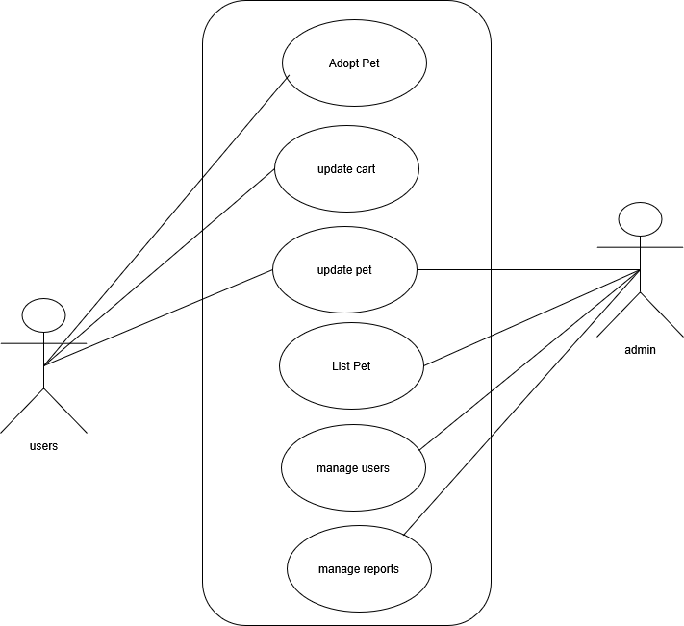

Figure 3.1: Use Case of Pet Adoption System
Non-functional Requirement
Availability: The system should maintain a minimum uptime of 99.9% to always ensure continuous availability for users.
Security: User data must be securely encrypted, and all transactions should be protected with SSL certificates to maintain data integrity and confidentiality.
Usability: The interface should be user-friendly and intuitive, ensuring accessibility for users of all age groups and technical expertise.
Performance: The system should load seamlessly to provide a smooth and efficient user experience.
Scalability: The system must be able to handle increased traffic and a growing number of listings without compromising performance or reliability.
Compatibility: The website should function seamlessly across all major web browsers and devices, ensuring a consistent experience for all users.

3.1.2 Feasibility Analysis
A feasibility study provides a comprehensive evaluation of a project’s viability. For PetHub, developed using the MERN stack (MongoDB, Express.js, React.js, Node.js), four key feasibility aspects are analyzed to ensure its successful implementation.
Technical feasibility
The technical feasibility assesses whether the proposed technology can meet the project's requirements. The PetHub platform utilizes the MERN stack, a modern and robust technology suite well-suited for scalable web applications.
MongoDB: A NoSQL database ideal for handling dynamic data related to pets, users, and adoption records.
Express.js and Node.js: Provide a reliable backend framework for building APIs and managing server-side operations.
React.js: Ensures an interactive and responsive user interface, enhancing the overall user experience.
Cloudnary: provide Store, transform, optimize, and deliver all our media assets with easy-to-use APIs, widgets, or user interface for storing our pet images.

Economic Feasibility
Economic feasibility evaluates the project’s financial viability. The PetHub platform is designed to operate with minimal expenses by leveraging free and open-source tools provided by the MERN stack.
Evaluation
No licensing costs are associated with MongoDB, Express.js, React.js, or Node.js.
Hosting requirements, such as deploying on platforms like Vercel, AWS, DigitalOcean, or Heroku, are cost-effective for academic and small-scale applications.

Operational Feasibility
Operational feasibility examines the practicality of the system’s use by its target audience. The PetHub platform is designed to provide an engaging user experience with a feature-rich, intuitive interface.
Evaluation:
The React.js front end ensures fast and dynamic updates, offering users seamless navigation.
Mobile responsiveness ensures accessibility across devices.
The platform’s user-centric design and operational simplicity ensure high usability and stakeholder satisfaction.

Schedule feasibility
Schedule feasibility evaluates the likelihood of completing the project within the set timeframe. The modular structure of the MERN stack facilitates parallel development of front-end and back-end components.
Evaluation:
The use of React.js for the front end and Node.js for the back end allows for independent development cycles, reducing overall development time.
Agile methodologies, such as iterative testing and development, can address potential delays effectively. The project can be completed within the academic schedule.
Gantt Chart
The development of PetHub, a pet adoption platform built using the MERN stack (MongoDB, Express.js, React.js, Node.js), follows a structured timeline to ensure smooth progress and timely delivery. The Gantt Chart below outlines the key tasks and milestones, providing a clear view of how the project is planned over the development period. It breaks the process into manageable phases such as planning, design, development, testing, and deployment, ensuring all aspects of the platform are systematically addressed
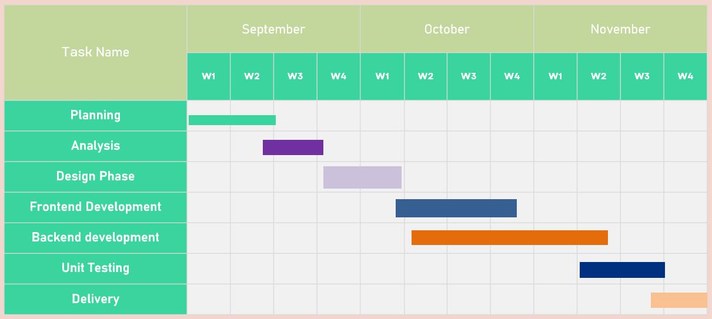
Figure .2: Gantt Chart

3.1.3 Data Modeling: ER Diagram
A data model is a mechanism that provides this abstraction for the database application. Data modeling is used for representing entities and their relationship in the database. E-R (Entity Relationship) Model can be referred to as a Data Model. E-R Model is a popular high-level conceptual data model. This model and its variations are frequently used for the conceptual design of database applications and many database design tools employ its concept.

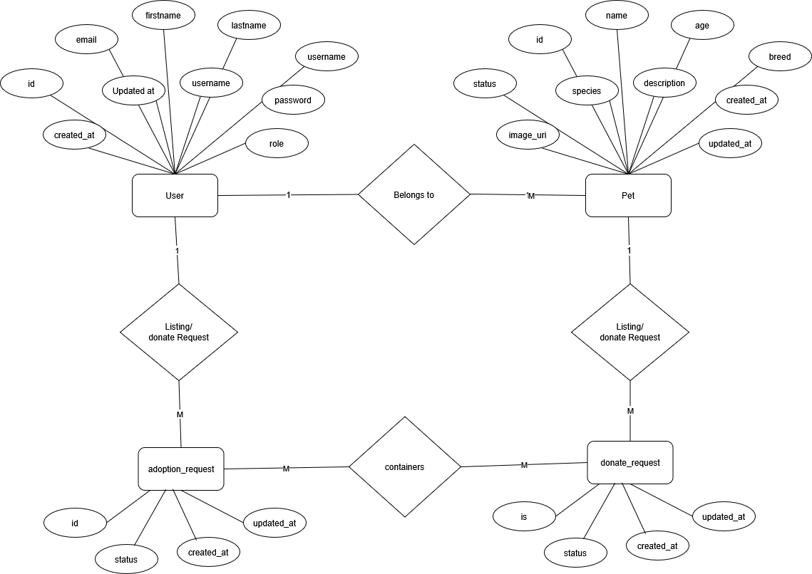

Figure 3.3: Entity Relationship Diagram of Pet Adoption System

This ER diagram serves as a blueprint for the PetHub pet adoption system. It highlights the relationships between key entities, including Users, Pets, Adoption Requests, and Admins.
Users: Represents individuals who interact with the system, either as adopters or donors. Users have attributes such as a unique ID, name, email, and password. They can log in, browse pet profiles, submit adoption applications, and donate pets for adoption.
Pets: This entity includes attributes like pet ID, name, species, breed, age, and health status. Each pet is linked to a donor and requires admin approval before becoming visible on the platform.
Adoption Requests: Tracks applications submitted by users interested in adopting a pet. Each request is associated with a user and a specific pet. It includes attributes such as request ID, application status, and submission date.
Admins: Represents administrators who manage the system. Admins oversee the approval of pet listings, review adoption requests, and ensure the platform operates smoothly.
Relationships:
Users can donate multiple pets, and each pet is associated with one donor.
Users can submit multiple adoption requests, each linked to a specific pet.
Admins interact with pets and adoption requests, approving or rejecting listings and applications.
This ERD ensures a clear understanding of how data flows within the system, enabling efficient management of users, pets, and the adoption process. It also provides the foundation for database design, ensuring scalability and reliability for PetHub.

3.1.4 Process Modeling: DFD

3.1.4.1. DFD level 0
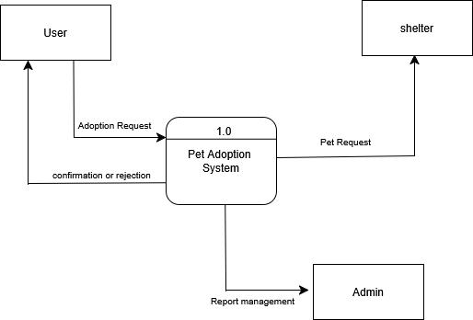

Figure 3.4: Level 0 DFD

This DFD Level 0 serves as a basic blueprint for a Pet Adoption System. It depicts a single process – "adopt pets" – which interacts with two external entities. Users, the external entity, browse the website and log in with their credentials. The system validates the login and retrieves inventory information (another external entity) to display available pets. Users can then proceed to adopt pets and complete the adopt process. This simplified view highlights the core functionality of user authentication, database interaction, and adoption processing.

3.1.4.2 DFD level 1

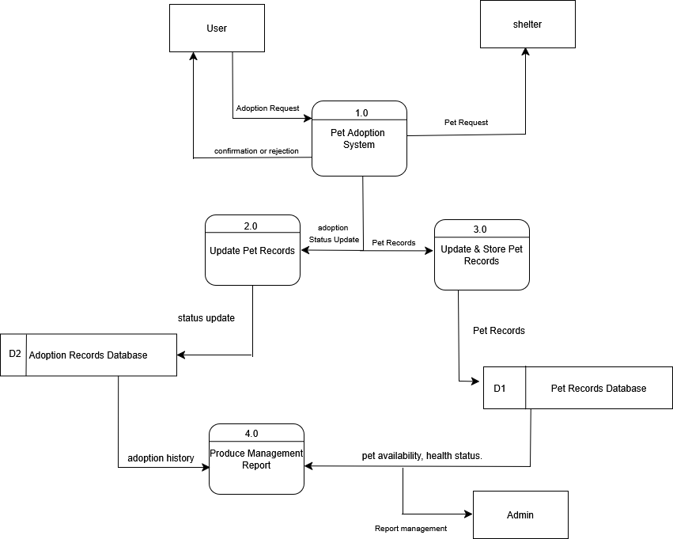
Figure 3.5: Level 1 DFD

This Level 1 DFD provides a deeper view of the Pet Adoption System. The system interacts with two external entities: User and Database. Users can request to log in, browse pets, add pets to their cart, and complete the adopt process. The system validates the login request and responds accordingly. Once logged in, users can browse available pets, select pets, and add them to my request cart. The system stores the pet’s selection in the database. After the submission of adoption request, admin need to approve adoption request. Once request Approved user can get notifications for adoption approved.

3.2 System Design

3.2.1 SDLC Model
- Agile Model
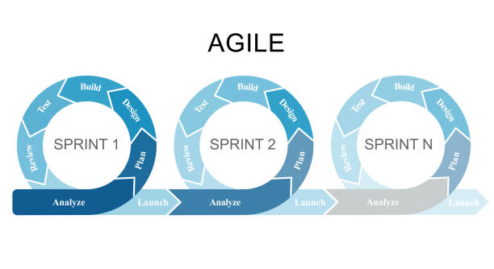
Figure 3.6: AGILE MODEL
The project utilized the agile model due to its iterative and flexible development process. The use of the Agile model was the most suitable approach for the development of the system, as it allowed for continuous feedback, adaptability to changing requirements, and iterative delivery of functional components throughout the development lifecycle.
This approach ensured that the system was developed incrementally, with regular collaboration and adjustments based on stakeholder input.

3.2.2 Architectural Design
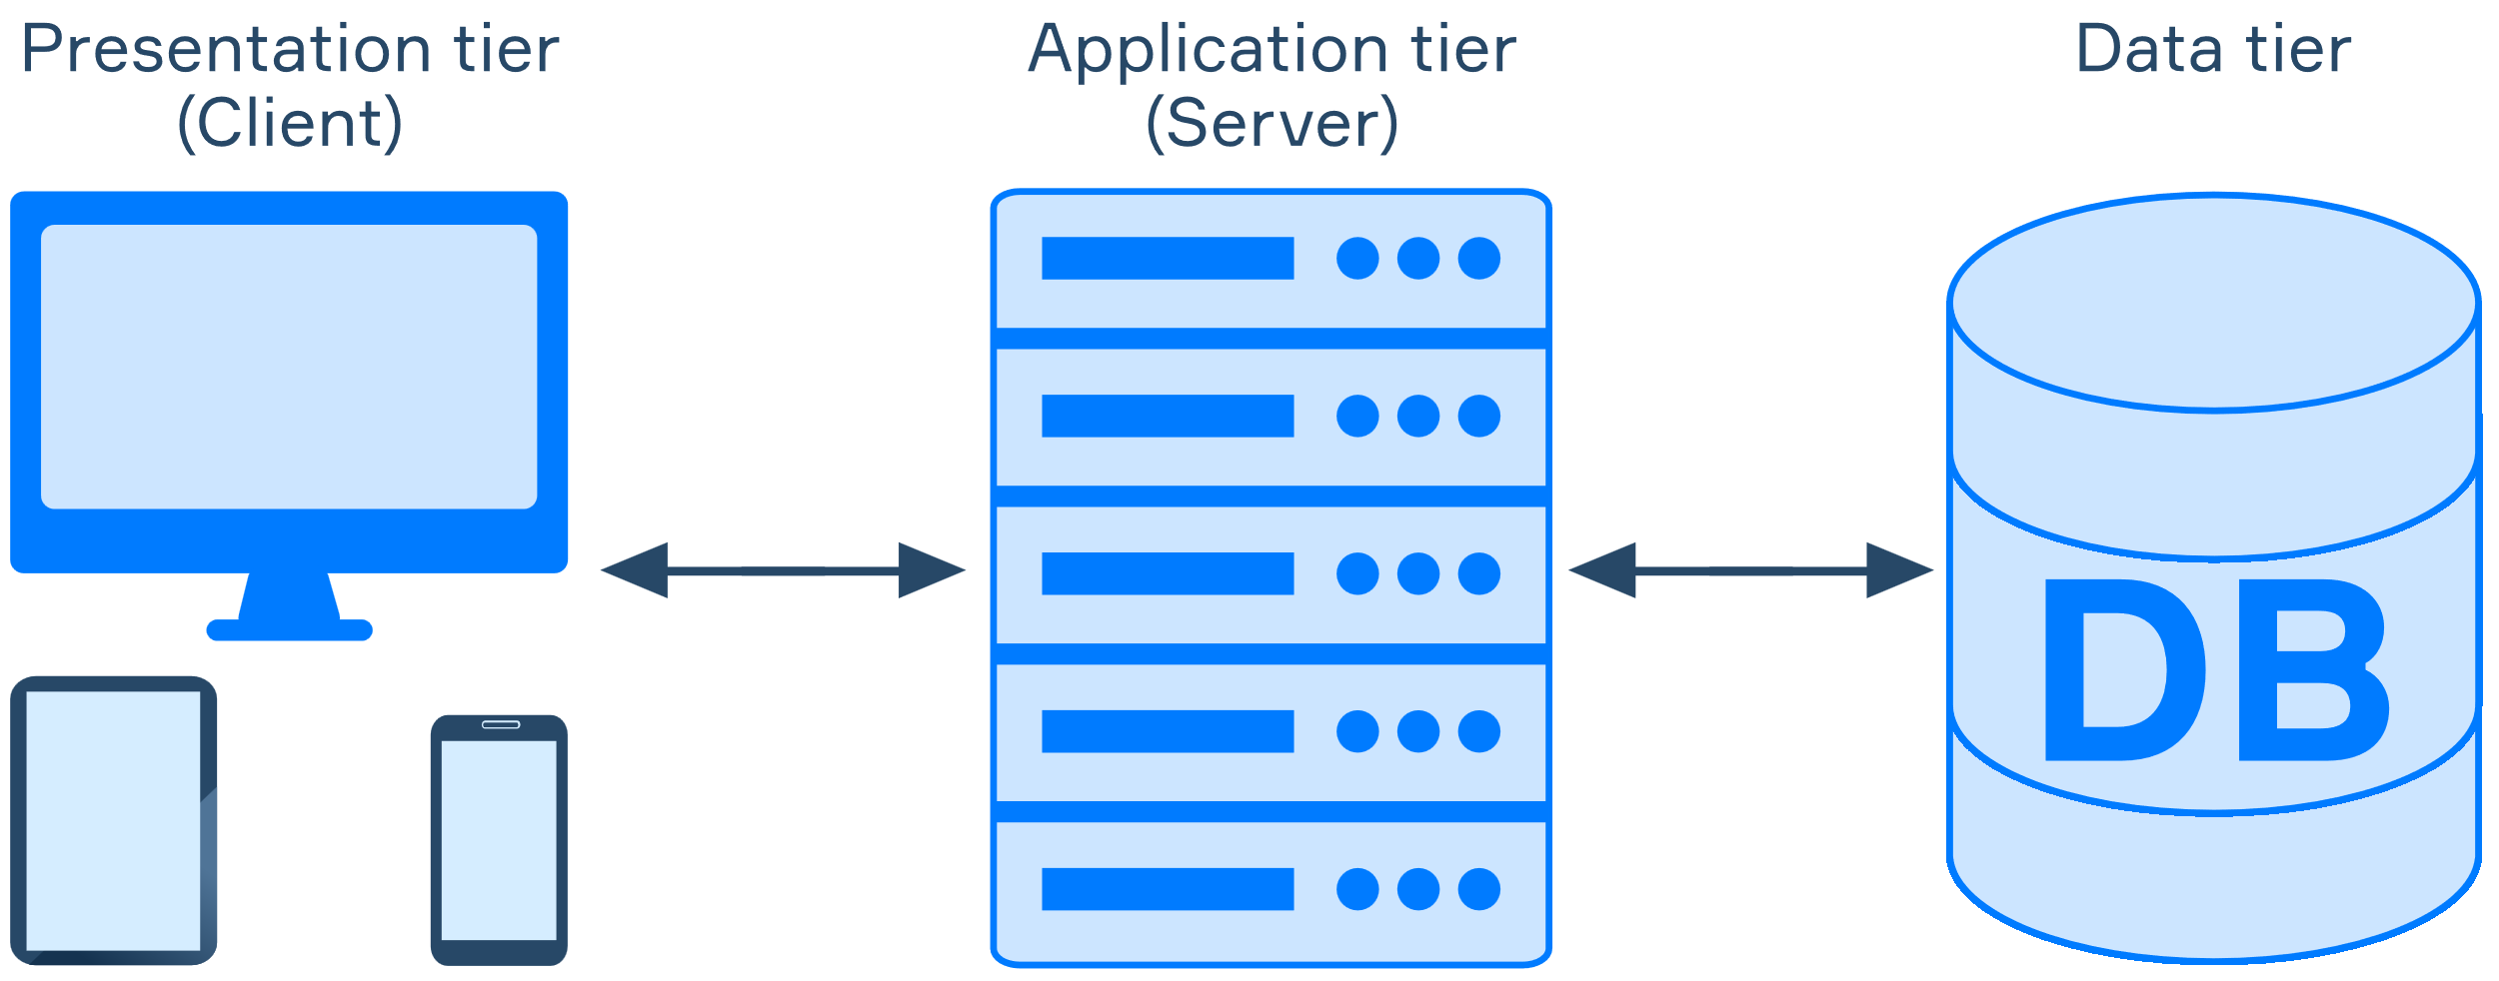

Figure 3.7: Architectural Design of Pethub
PetHub utilizes a client-server architecture to manage user data and functionalities. Users interact with the platform through a web browser on their devices, enabling seamless access to pet profiles, adoption requests, and donation features. These interactions are transmitted as requests to a central application server, which serves as the core processing unit of the system.

The application server handles critical operations, such as user authentication, browsing pet profiles, submitting adoption requests, and approving donations. It communicates with a robust database, likely MongoDB or PostgreSQL, which stores all essential data, including user information, pet details (e.g., species, breed, age, health status, and approval status), adoption request histories, and admin actions.

When a user interacts with PetHub, such as searching for adoptable pets or submitting a request, their input is sent to the server. The server processes the request by retrieving or updating relevant information from the database. For example:
For adopters, the server retrieves pet profiles and adoption status
For donors, the server processes pet donation details and tracks approval by admins.
For admins, it manages user statuses, approves or rejects pets and adoption requests, and oversees platform activity.

The processed information is then relayed back to the user's browser in real-time, ensuring a responsive and intuitive experience. This client-server architecture guarantees data security, efficient communication between components, and organized data management, all while providing a user-friendly interface for adopters, donors, and administrators.

This setup allows PetHub to effectively connect users with pets in need of homes, promoting a streamlined and compassionate adoption process.

3.2.3 Database Schema Design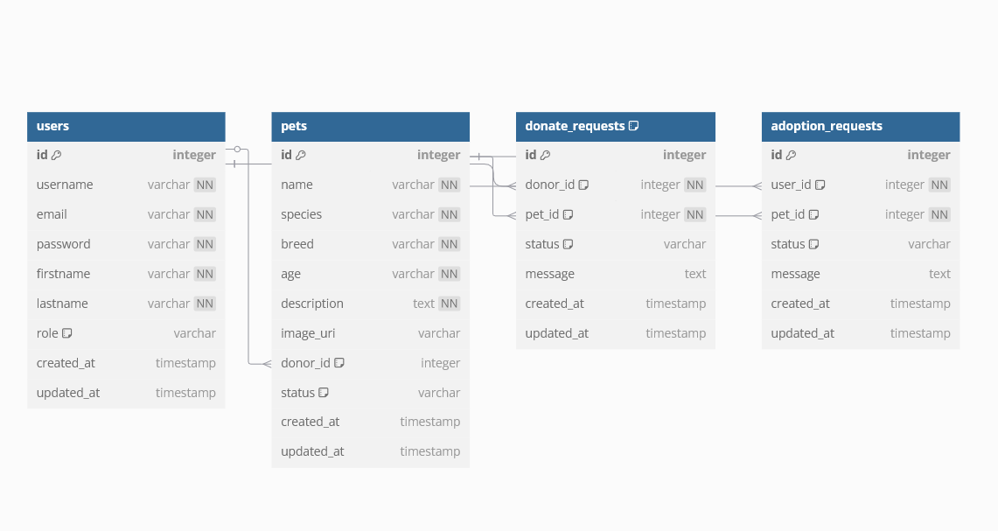
Figure 3.8: Database Schema of PetHub
Database Schema consists of three tables: User, Pet, Adoption and Donate Request.
- User Table: This table stores information about the users of the system, including their username, email address, and password.
- Pet Table: The Pets table holds information about the pets available for adoption. Each pet has attributes such as name, species, breed, age, description, and an image.
- Adoption Request: The Adoption Requests table manages user applications for adopting pets. Each request is linked to a user (requester) and a pet. A message field allows applicants to provide reasons for adoption. Timestamps track the submission and updates of requests.
- Donate Request: The Donate Requests table records users who wish to donate a pet. Each donation request links to a specific user (donor_id) and a specific pet (pet_id). The request can have a status of "Pending," "Approved," or "Rejected", depending on admin approval.

3.2.4 Interface Design (UI/UX)
Interface Design focuses on anticipating what users might need to do and ensuring that the interface has elements that are easy to access, understand, and use to facilitate those actions. UI brings together concepts from interaction design, visual design, and information architecture.

Home page
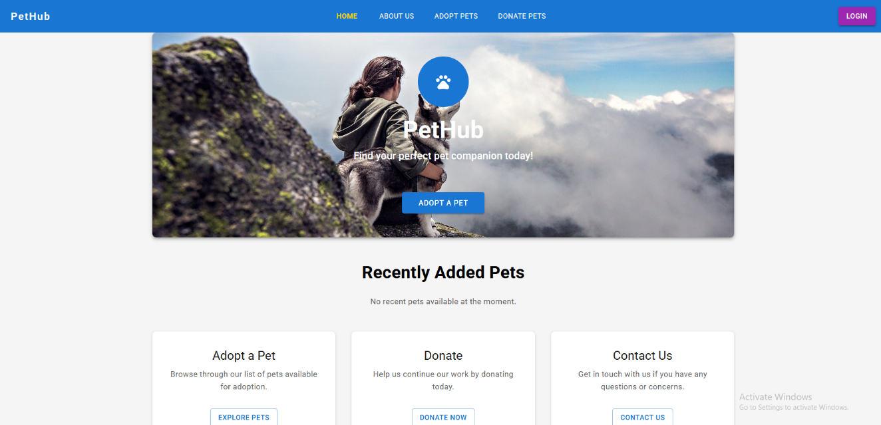

Figure 3.9: Startup figure of Pethub
The homepage of Pethub, the pet adoption system, serves as the main entry point for users. It provides a simple and intuitive interface for users landing page. The home page features a "Login" button, allowing users to access their accounts. Clicking on the login button redirects users to the Login Page. On the Login Page, users can enter their email and password to securely log in. Once logged in, users can view available pets, submit adoption requests, or donate pets.

- Adoptions Pets
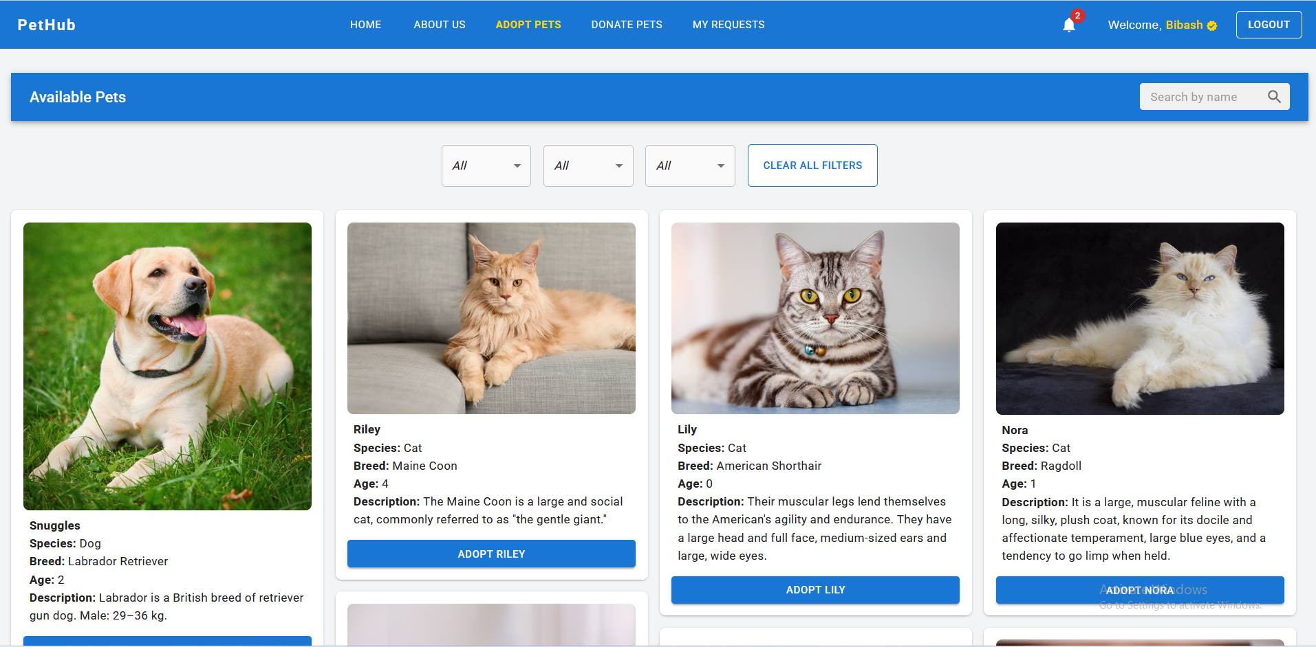
Figure 3.10: Main Page
This image shows the available pets with their name, species, breed, age, and description. Here, you can see details. All the necessary items are shown here with proper alignments which makes user to see it clearly. Finally, tap ‘to Text’ to add it(cart).

- My-Request section
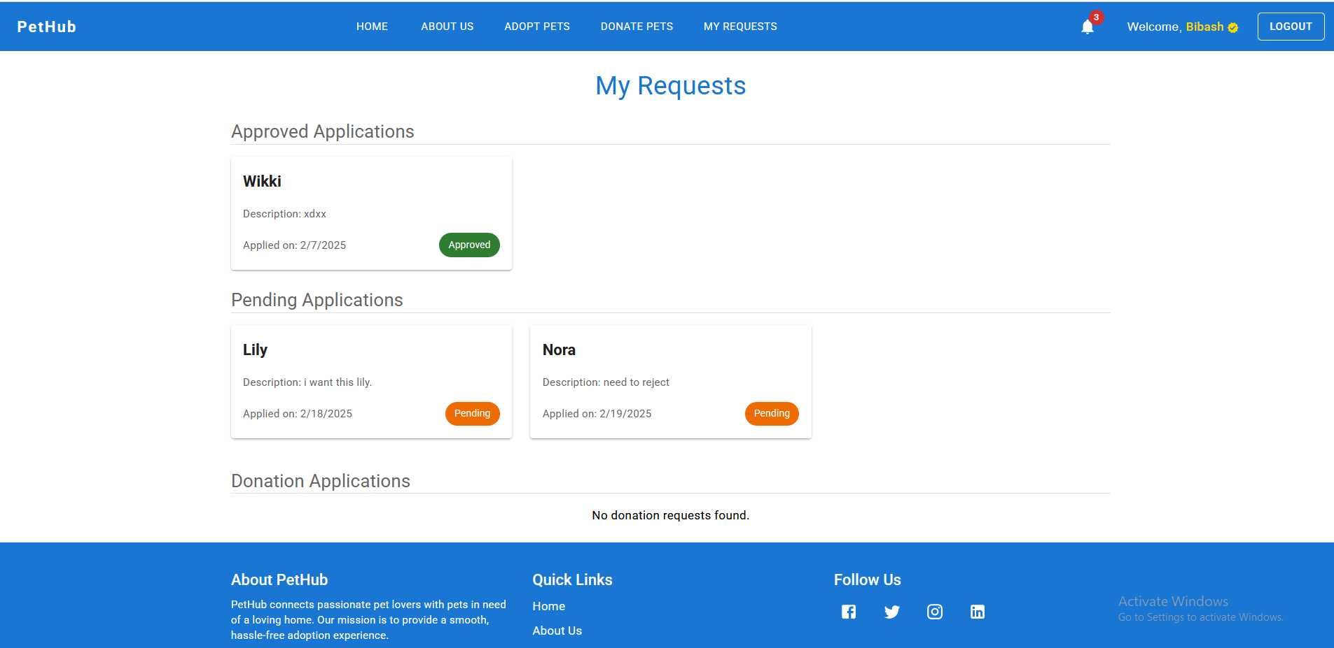
Figure 3.11: My Request
The image shows the users adoption request as well as donate request by the users. It includes the pet name, application date as well as adoption status for the pets.

- Home Page
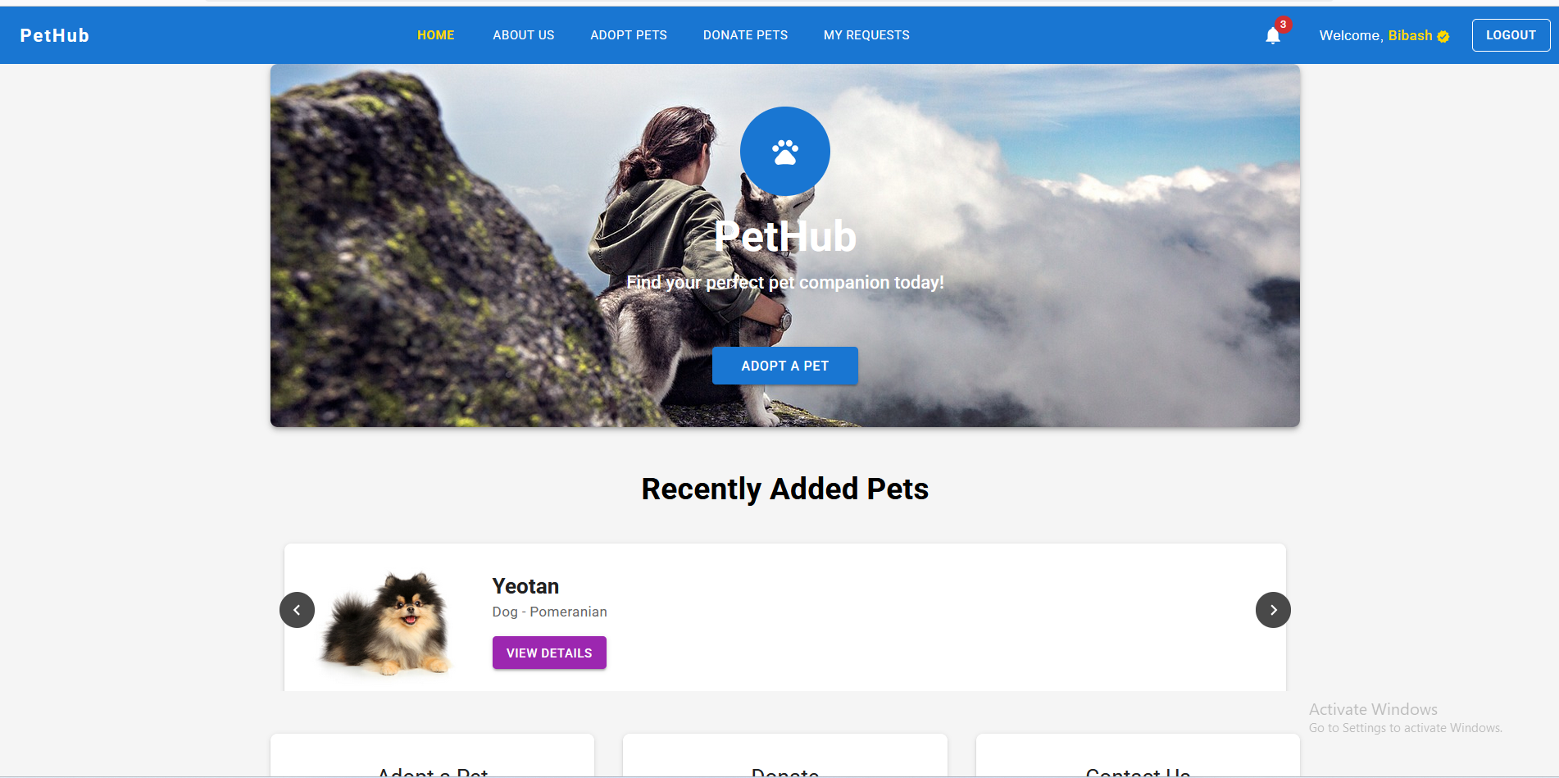

Figure 3.12: Home Page
The homepage of Pethub, the pet adoption system, serves as the main entry point for users. It provides a simple and intuitive interface for users landing page. The home page features a Recently added pets, about us page, adopt pets as well as notification icon to view their request on the cart.

- About Us
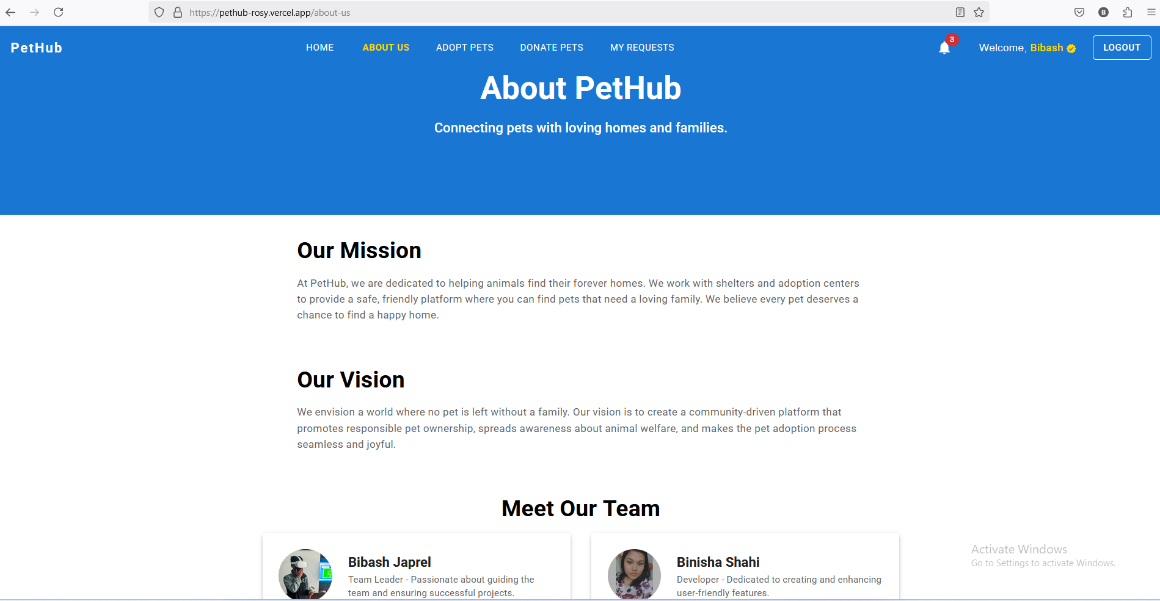
Figure 3.13: About Us

The about page display basic information about our mission, and our vision along with our team member section.
Donate Request
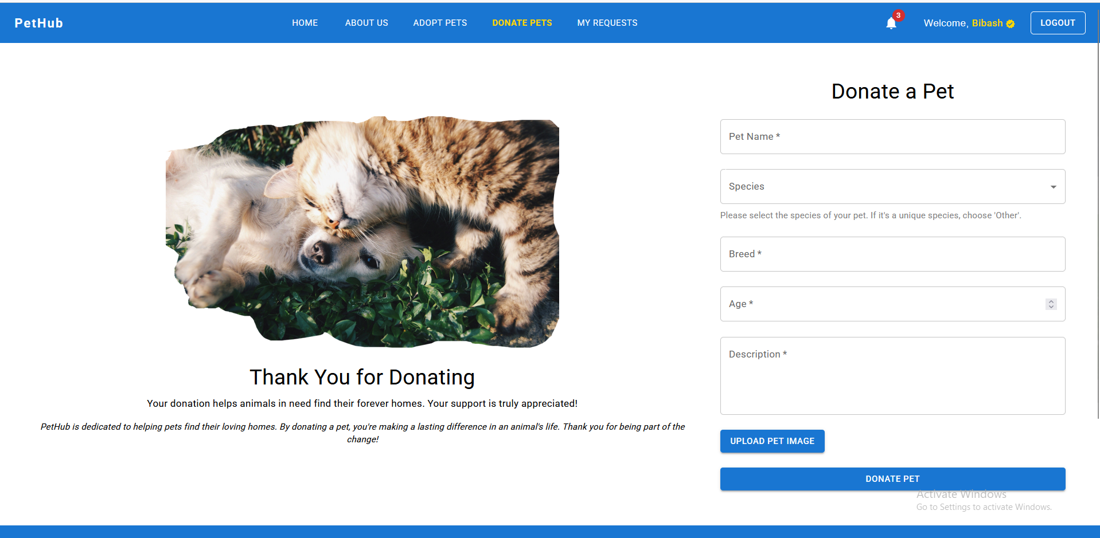
Figure 3.14: Donate Request
This interface is for showing the donation form for the user if user want to donate pets. A after the submission of the donate pet’s user need to wait for user approval. After that user can see that change status in my request section.

Admin Dashboard
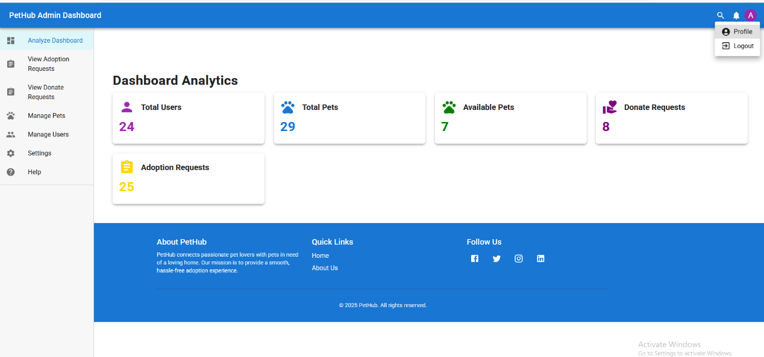

Figure 3.15: Admin Dashboard

This interface is for showing the reports for admins to analyze the visual as well as managing the flatforms users.

3.2.5 Physical DFD
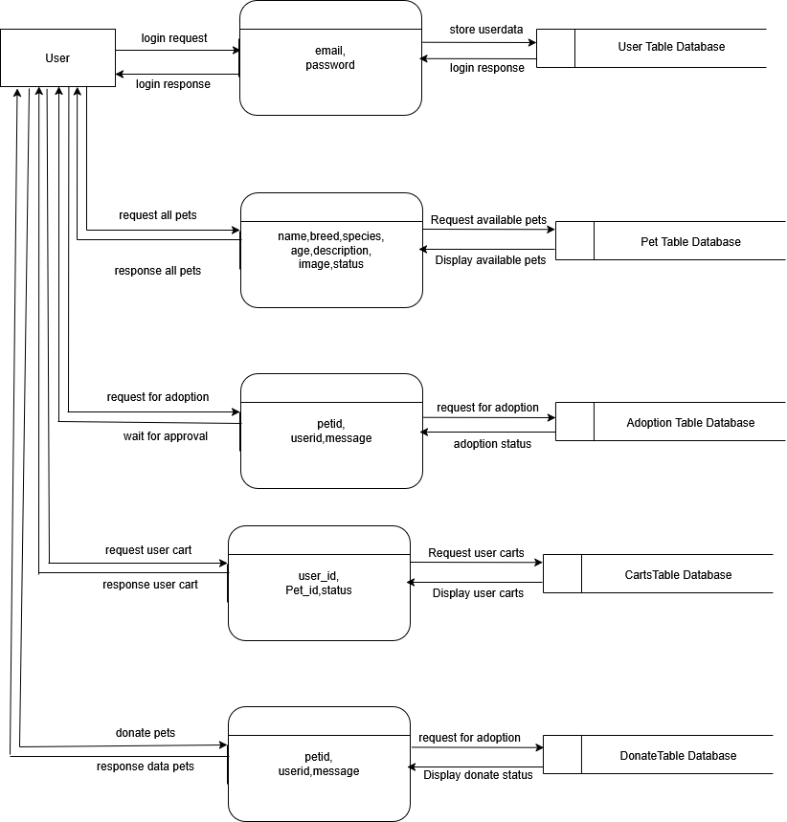

Figure 3.15: Physical DFD
This physical data flow diagram represents the flow of data in an e-commerce system, outlining user interactions and backend processes. The process begins with the user logging in by providing credentials such as a username and password. These details are verified against the User table database, and upon successful authentication, the system responds with a confirmation. Once logged in, the user can browse general products, where details like Product_name, description, and price are retrieved from the Products table database and displayed. For limited edition items, the system fetches additional details such as Product_name, description, price, image path, and size from the Limited products table database and displays them to the user. The user can then add items to the cart, with product details such as Product_id, image path, quantity, and user_id being stored in the Cart table database. The cart's contents are readily accessible for review. During the checkout process, the user provides personal and order-related details, including user_id, full_name, email, phone, order_note, city_address, landmark, total_price, and checkout_date. These details are stored in the Checkout table database, and the system waits for approval to finalize the order.

CHAPTER 4. IMPLEMENTATION AND TESTING

4.1. Implementation
This section talks about the implementation of the system.

4.1.1. Tools Used
i) Front End
- ReactJS
- Tailwind CSS
- Material UI
ii) Back End
- MongoDB
- Nodejs/Express

Implementation detail of modules
- Authentication Module:
The authentication module acts as the security guard for our pet adoption system. It handles user registration with secure password storage, allows users to log in. Token management ensures only logged-in users can access their data. This module works with other parts of the app to make sure only authorized users can manage their sensitive medication information.

- Adoption Module:
The adoption module in our Pet adoption System allows users to manage their shopping selections effectively. It enables users to submit the adoption request and view the available pets in real-time. The adoption module also supports saving items for later and seamlessly transitions to the checkout process.

- Database Module:
Users, which stores account details like username, email, and hashed passwords; pets, which holds pets’ information such as name, description, breed, species, status, and age. This structure ensures efficient data management and enables a personalized adoption experience.

4.2 Testing

4.2.1 Test cases for Unit Testing

Table 4.1 User Registration Test Cases

S.N. | Payload | Expected  Result | Actual Result | Result | Appendix
1. | First name: bibash  Last name: japrel  Username: bibash444  email:  Password: | Fields are required. | Please fill out this  field | Pass | 1
2. | First name: bibash  Last name: japrel  Username: bibash444  Email: bibash@superadmin.com  Password: 8p.U+8'Z}7P+_+s | Registered and logged in. Then, redirected to main dashboard. | Registered, logged in and redirected to main menu. | Pass | 2

Table 4.2 User Login Test Cases
S.N. | Payload | Expected  Result | Actual Result | Result | Appendix
1 | email: bibash@superadmin.com  Password: testpassword | Invalid Password | Invalid Password | Pass | 3
2 | email: bibash@superadmin.com  Password: 8p.U+8'Z}7P+_+s | Logged in and redirected to main menu. | Logged in and redirected to main menu. | Pass | 4

Table 4.3 Adoption form
S.N. | Payload | Expected  Result | Actual Result | Result | Appendix
1 | uid: 100  pid:109  message: I need this | Select Pets | Selected | Pass | 5
2 | Uid: 100  Pid: | Most logged in. | Needs to be registered first | pass | 6

CHAPTER 5: CONCLUSION AND FUTURE RECOMMENDATIONS

5.1 Lesson Learned
From this lesson from the project, we have learned how to use latest frontend and backend technology effectively. The author also learned the importance of teamwork and managing time well. Facing different challenges during the project helped improve problems solving skills. The author successfully handled both technical and non-technical issues.

5.2 Conclusion
In conclusion, the PetHub Adoption System has the potential to make pet adoption much easier and more accessible. The platform’s simple design and streamlined process offer clear advantages in helping users find pets quickly. However, there are still areas that could use some improvement, like refining the user interface, providing real-time pet availability, and enhancing security. With continuous updates and by listening to user feedback, the system could become even more reliable and user-friendly. Ultimately, the goal is to create a platform that not only meets the needs of potential pet adopters but also offers a smooth, enjoyable experience for everyone involved.

5.3 Future Recommendations
Looking toward the futures, there are several key areas where the pet adoption system could be improved to better. One more step is refining the user interface to make it more functional. Additionally providing real time update on pet availability that ensure users always have access to the most current information. Finally, actively collection and responding to user feedback will be essential for the platform’s long-term success. Through this enhancement, Pethub can become an even more valuable tool responsible for pet adoption and donating process.

Reference

- "NetNinja- For Authentication, netNinja [Online]. Available: https://www.youtube.com/@netninja

- "Hitesh Choudhary – online backend Course", Youtube. [Online]. Available: https://www.youtube.com/@HiteshCodeLab

- "w3school – Online learning platform ", w3school. [Online]. Available: https://www.w3schools.com/.

Appendices A
• Register Account

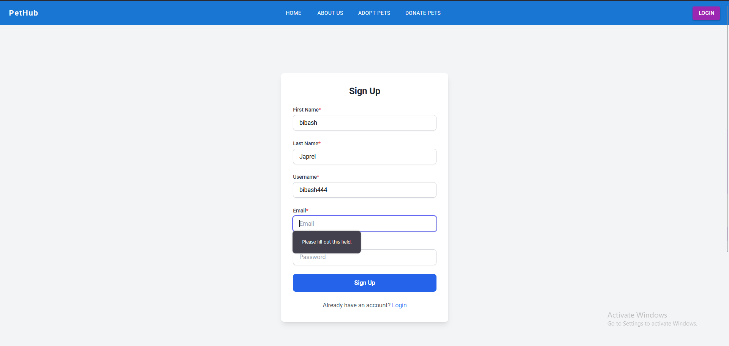

Appendix: 1

- Login account

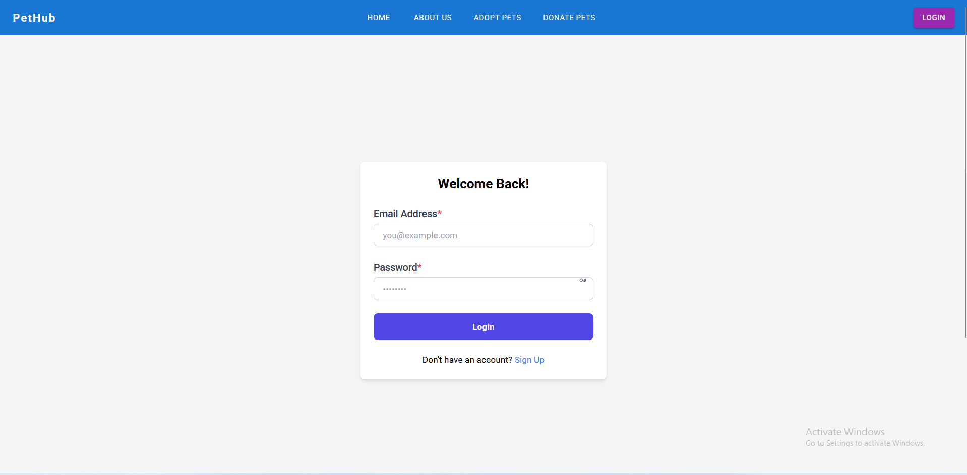

Appendix: 2

- Invalid Credentials

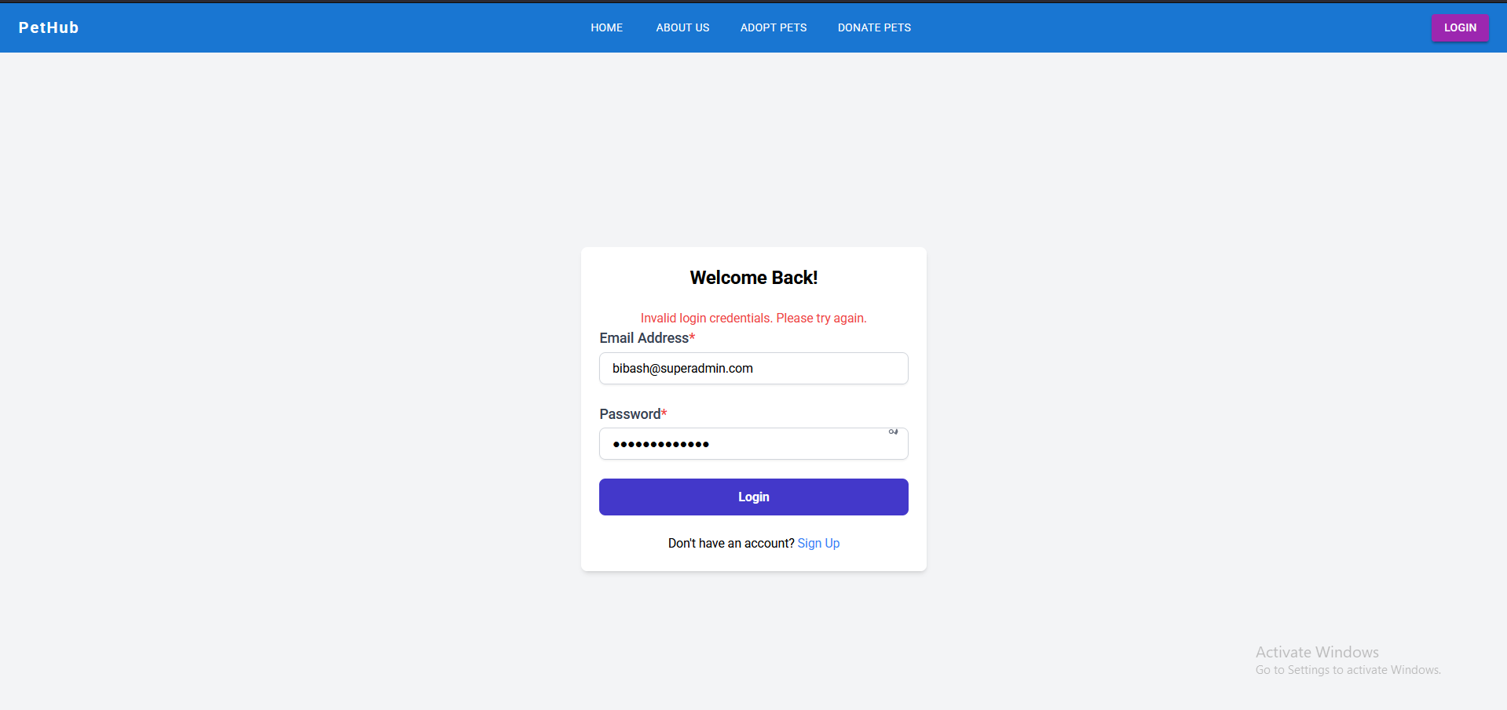
Appendix 3

- Home Page

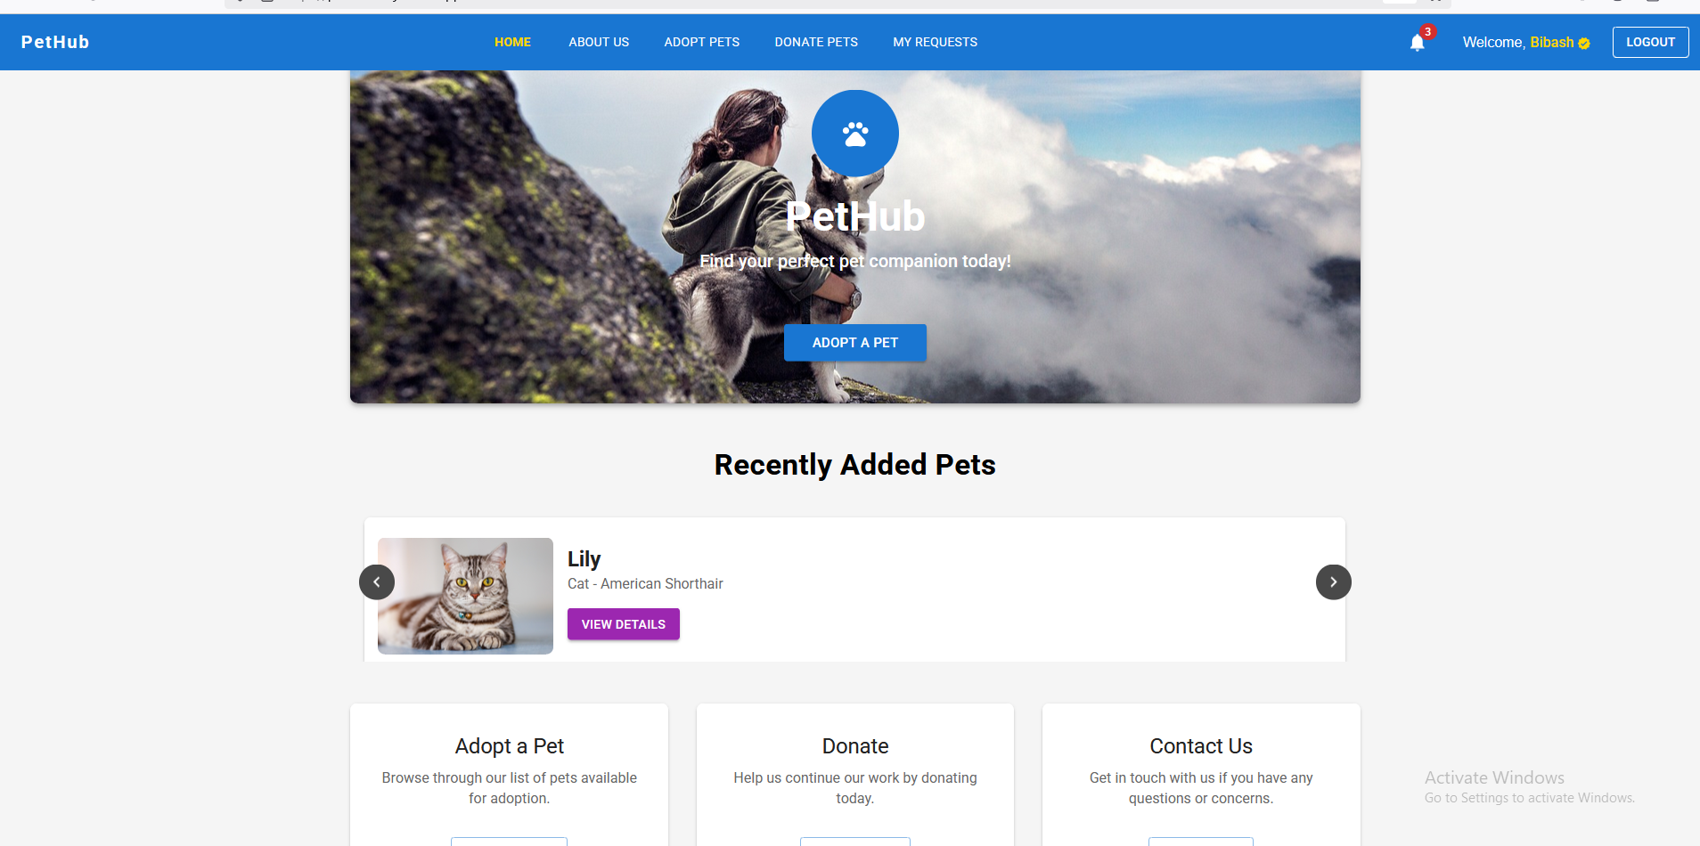
Appendix: 4

- Adoption Form

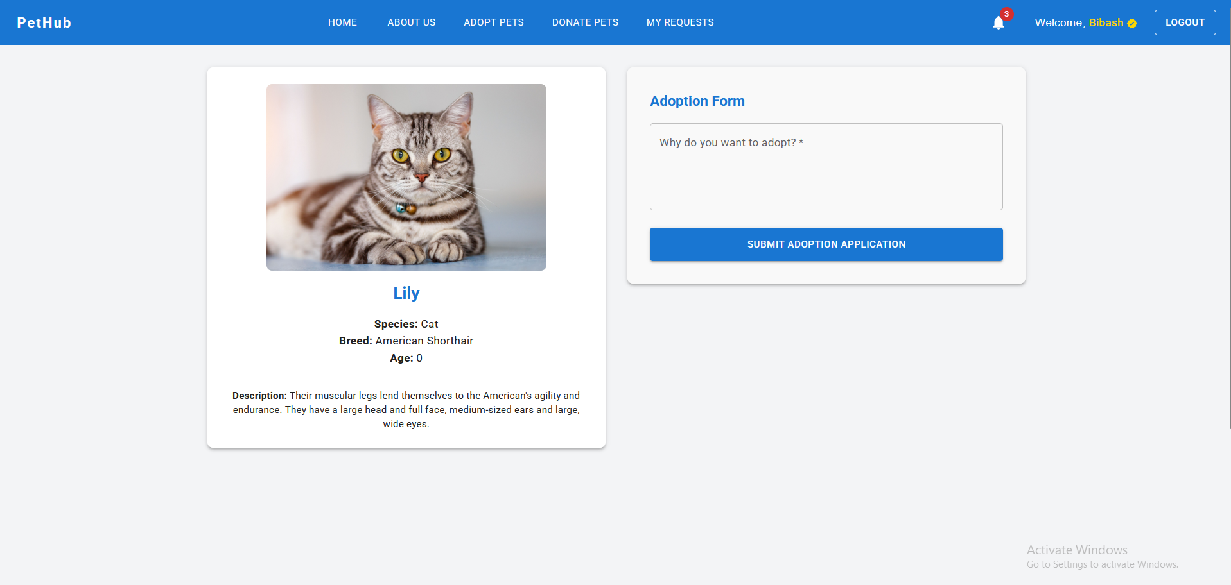

Appendix: 5

• Unauthorized Page

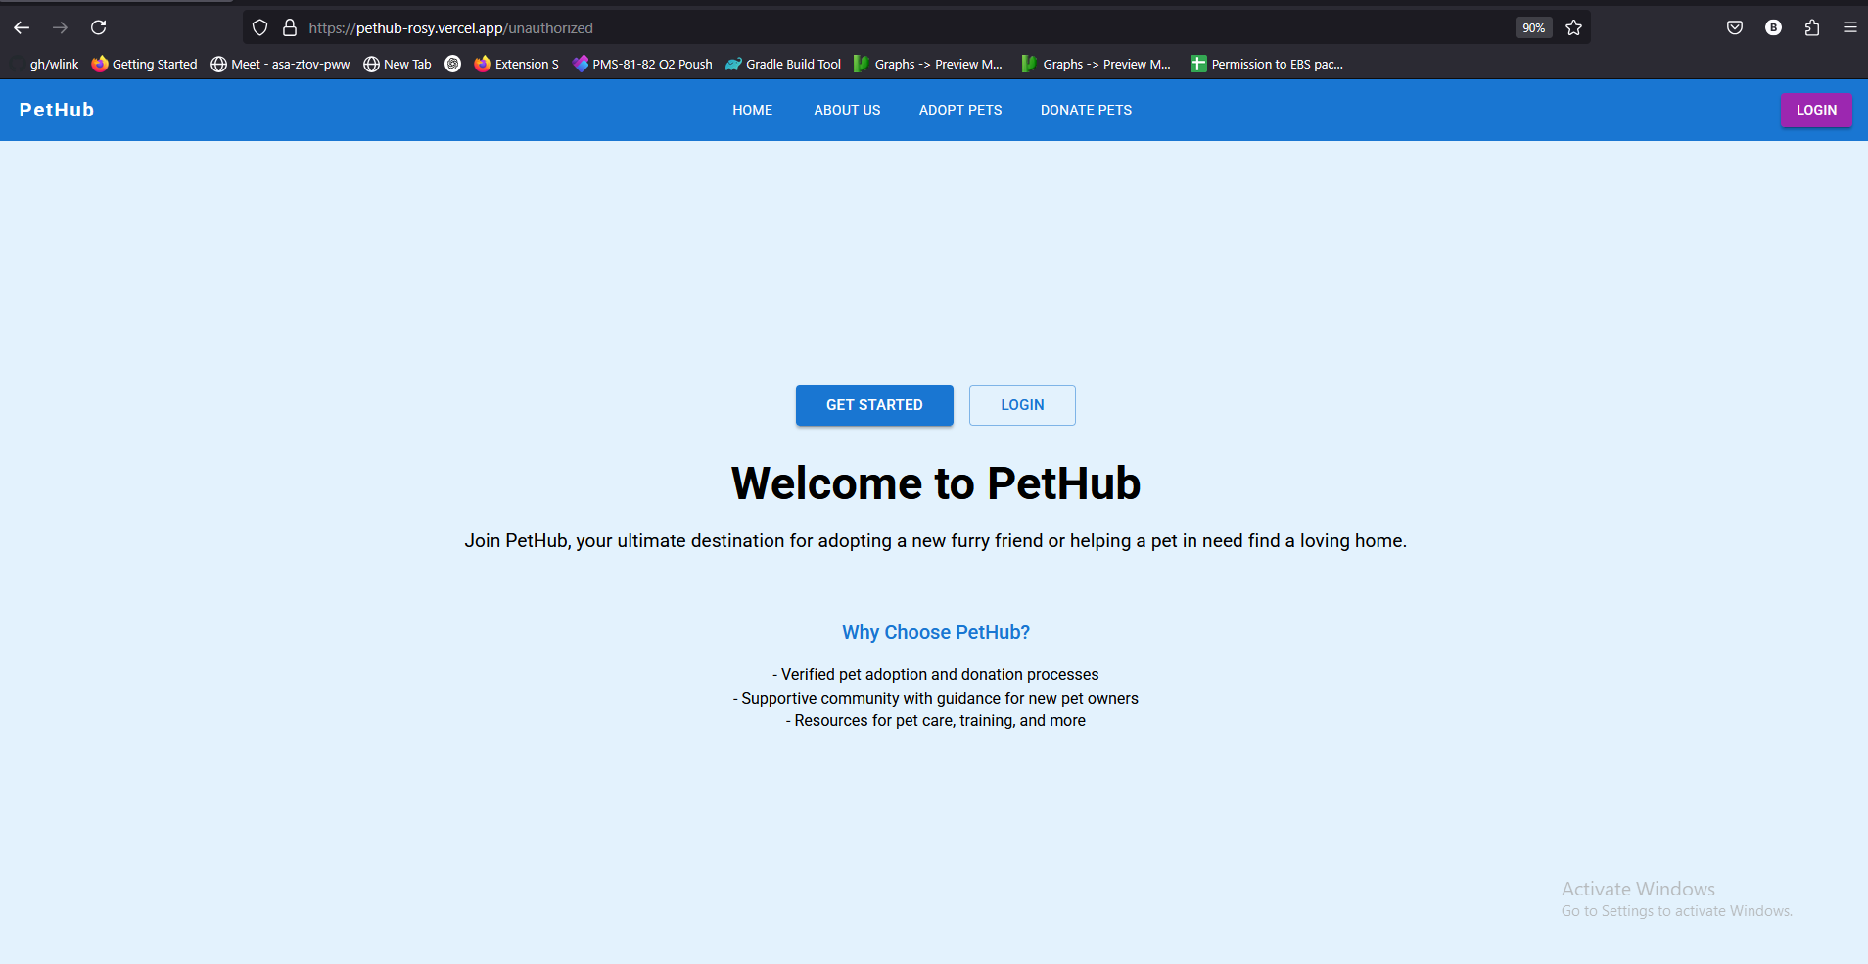

Appendix: 6

• About Us Page

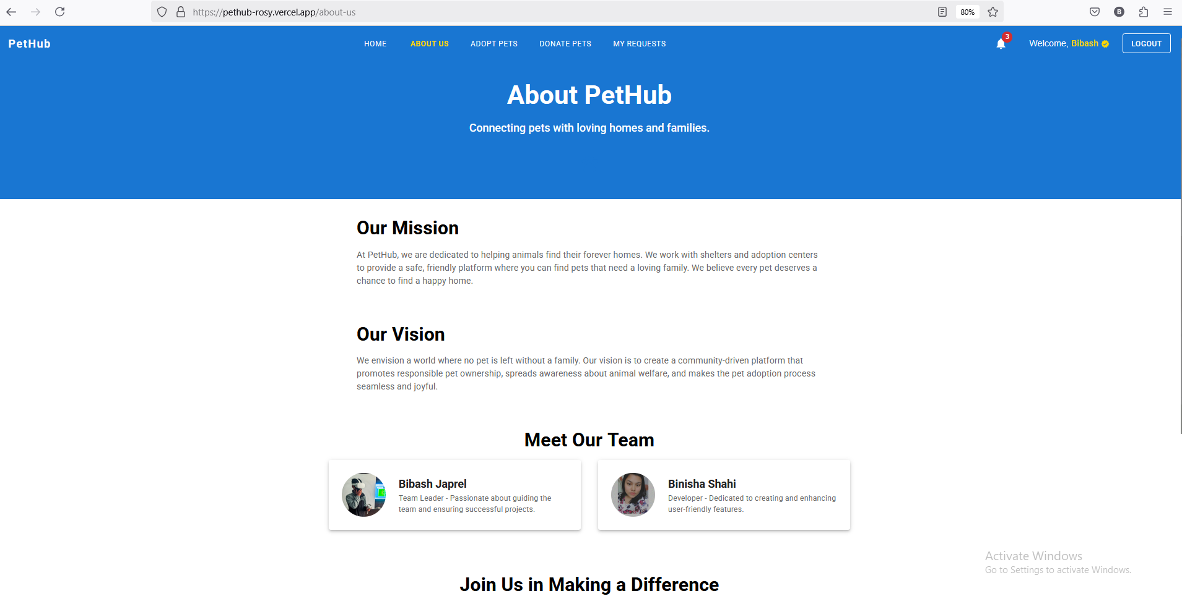

Appendix: 7

- Adopts Pet

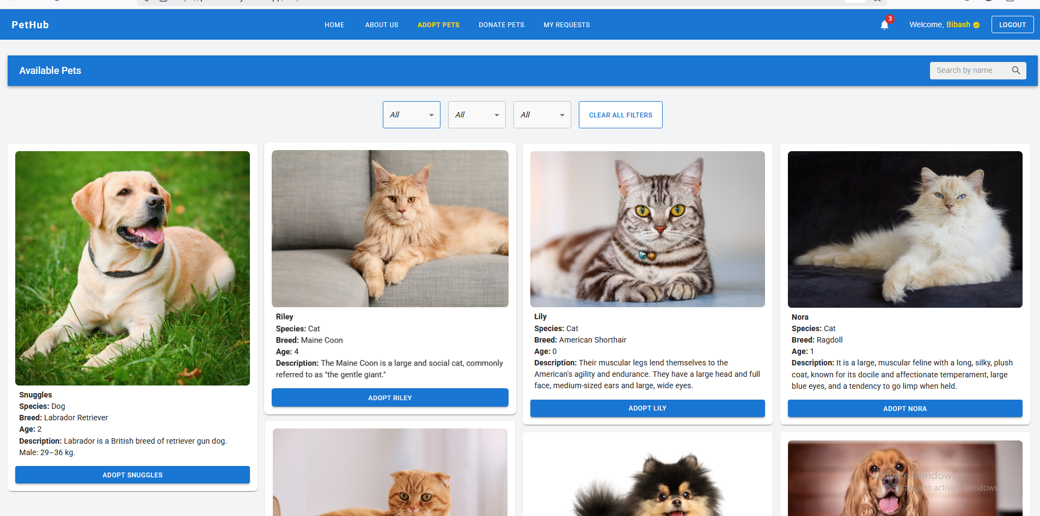

Appendix: 8

- Donate Pet

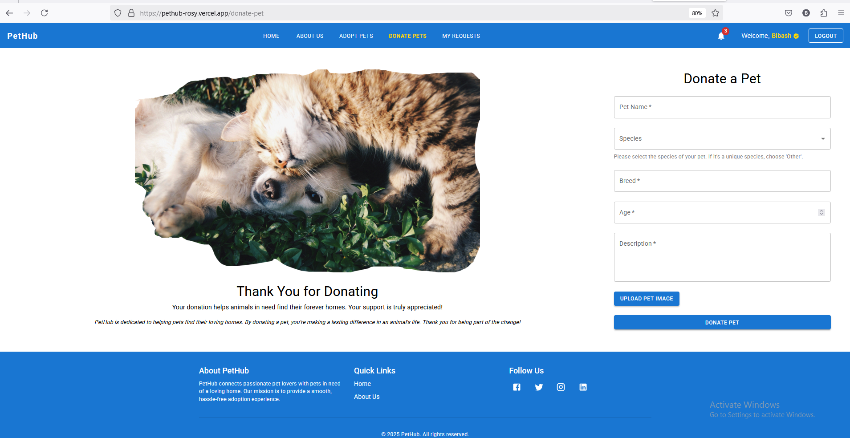

Appendix: 9

- My Request Section

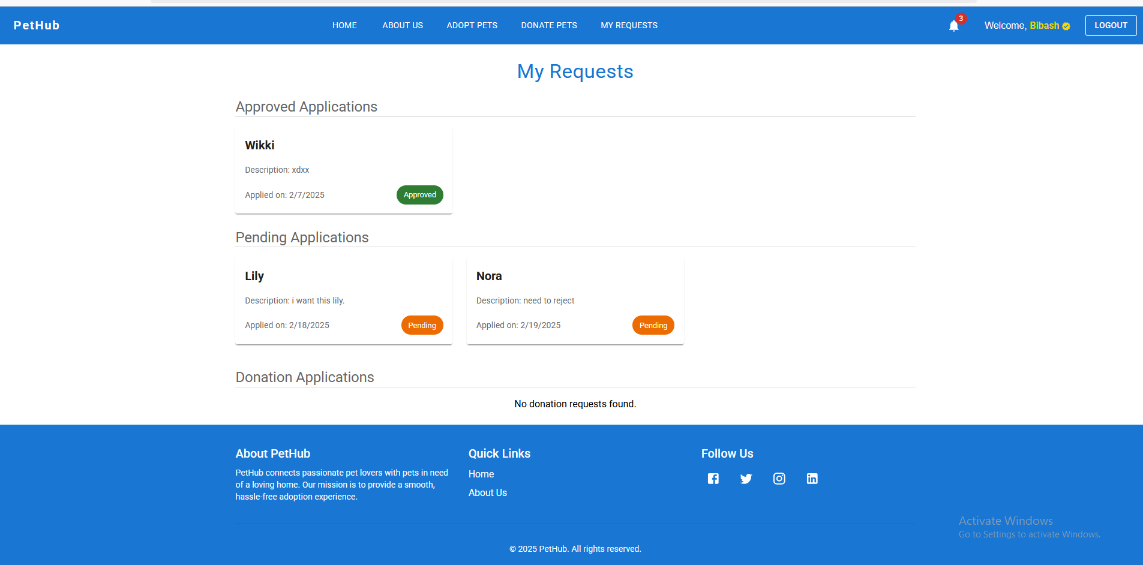
Appendix: 10

- Analyze Dashboard

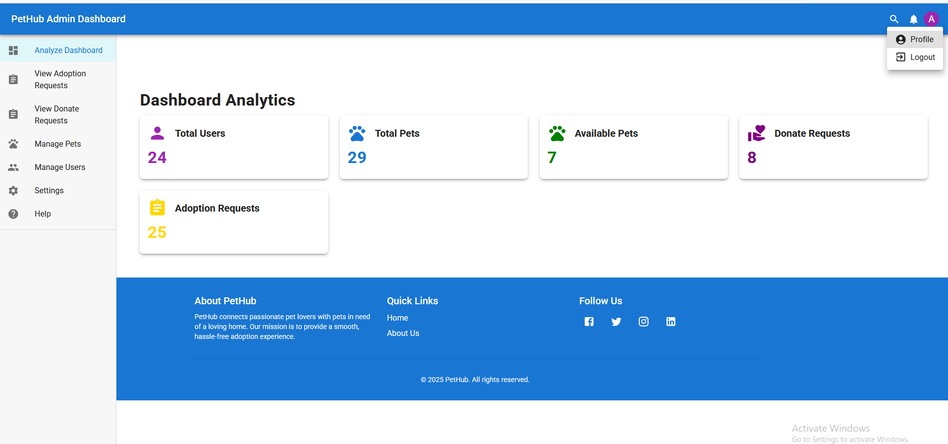

Appendix: 11

- View Adoption Request

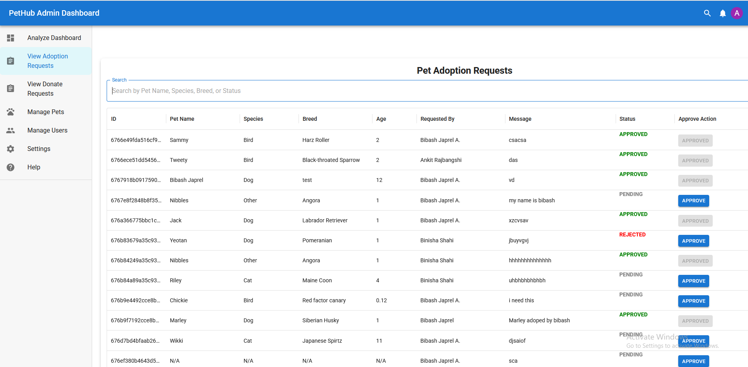
Appendix: 12

- View Donate Request

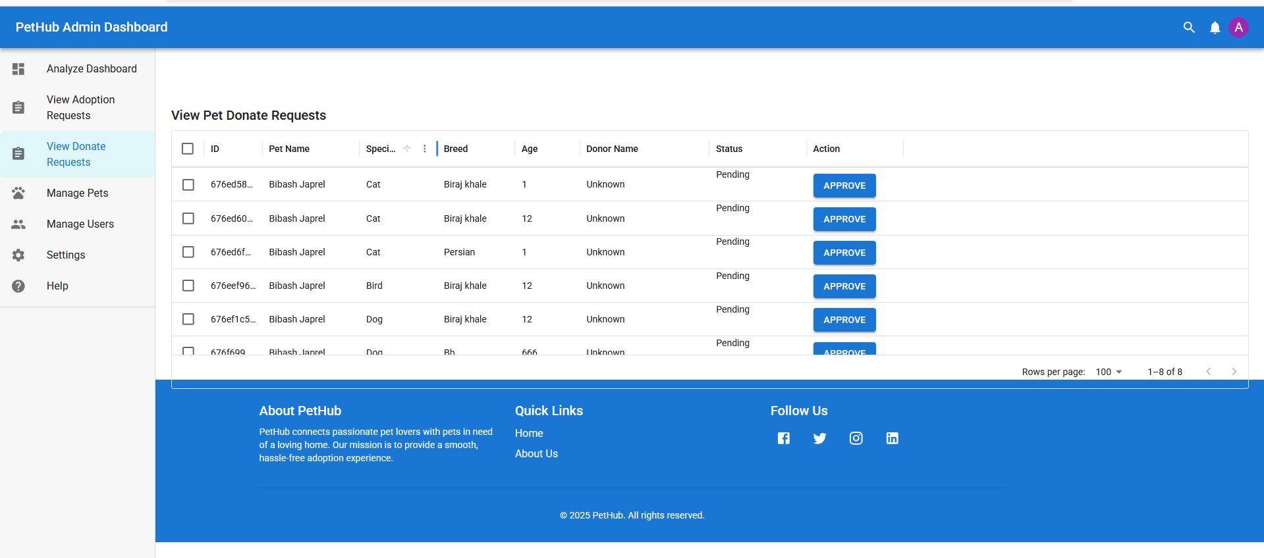
Appendix: 13

- Manage Pets

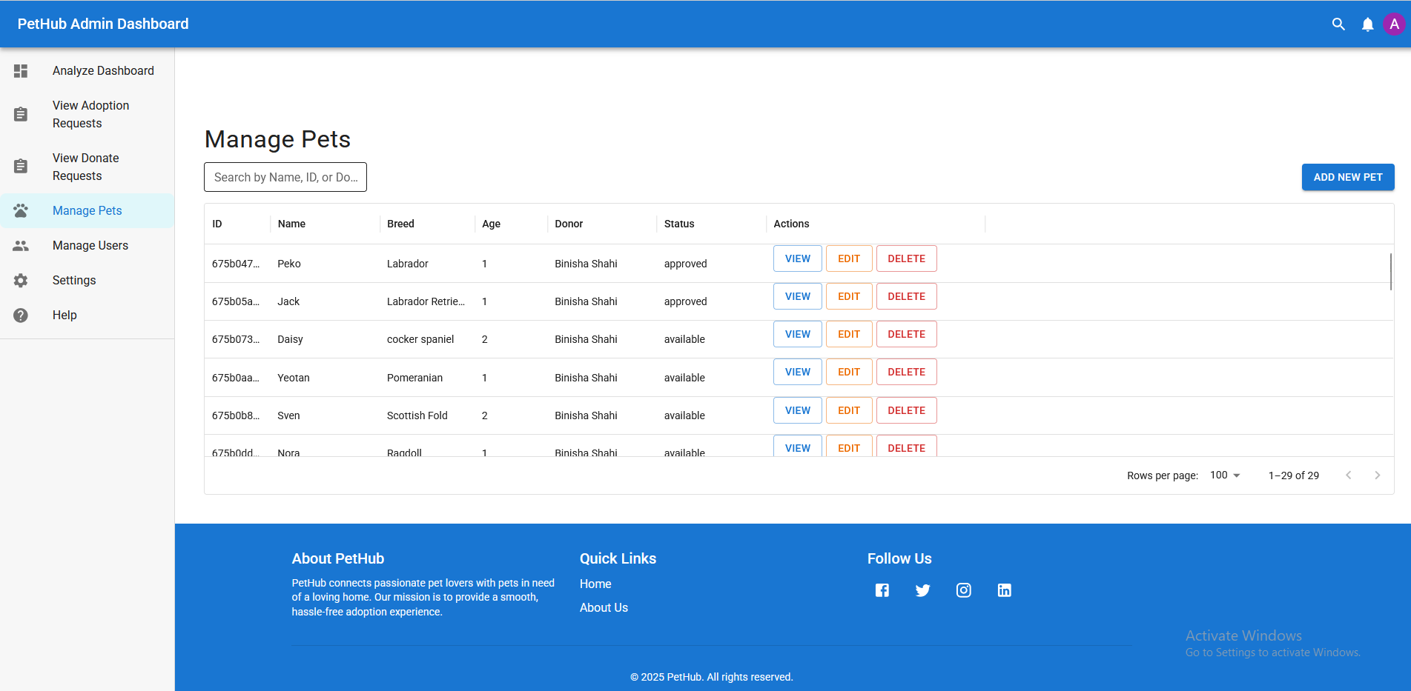
Appendix:14

- Manage Users

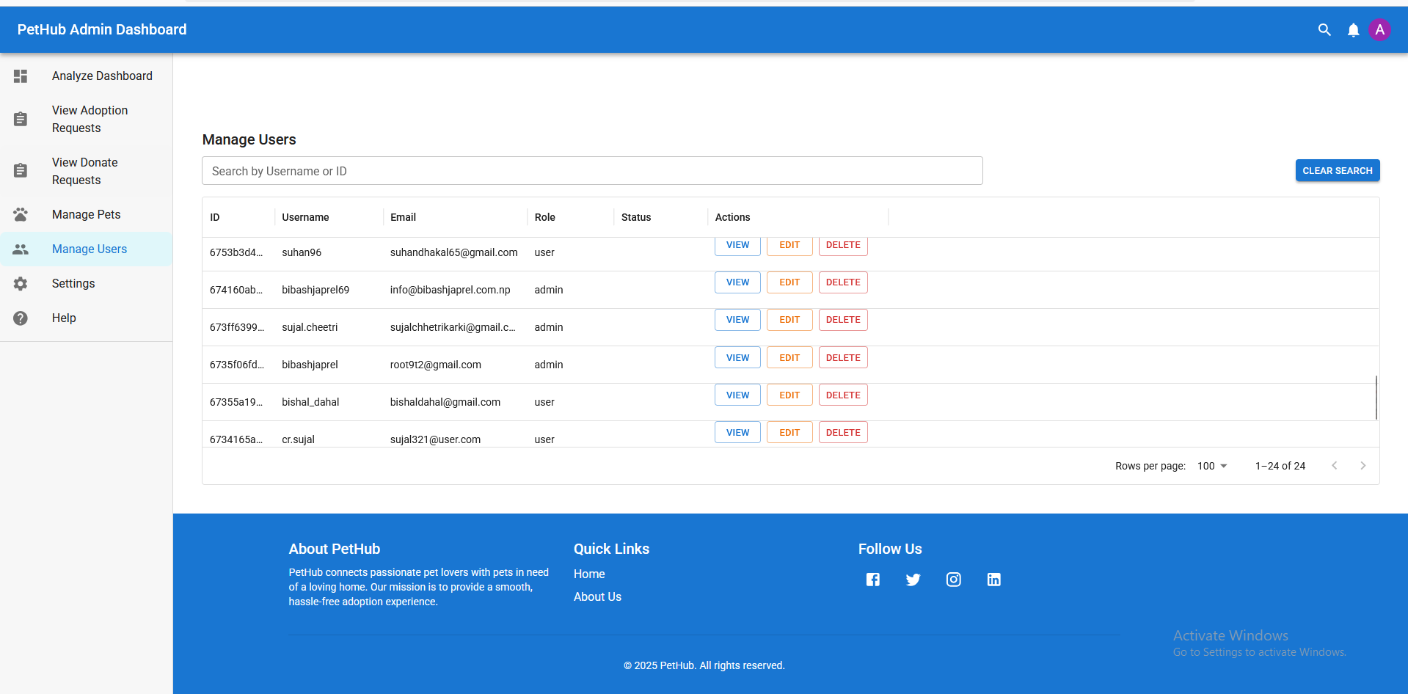

Appendix:16
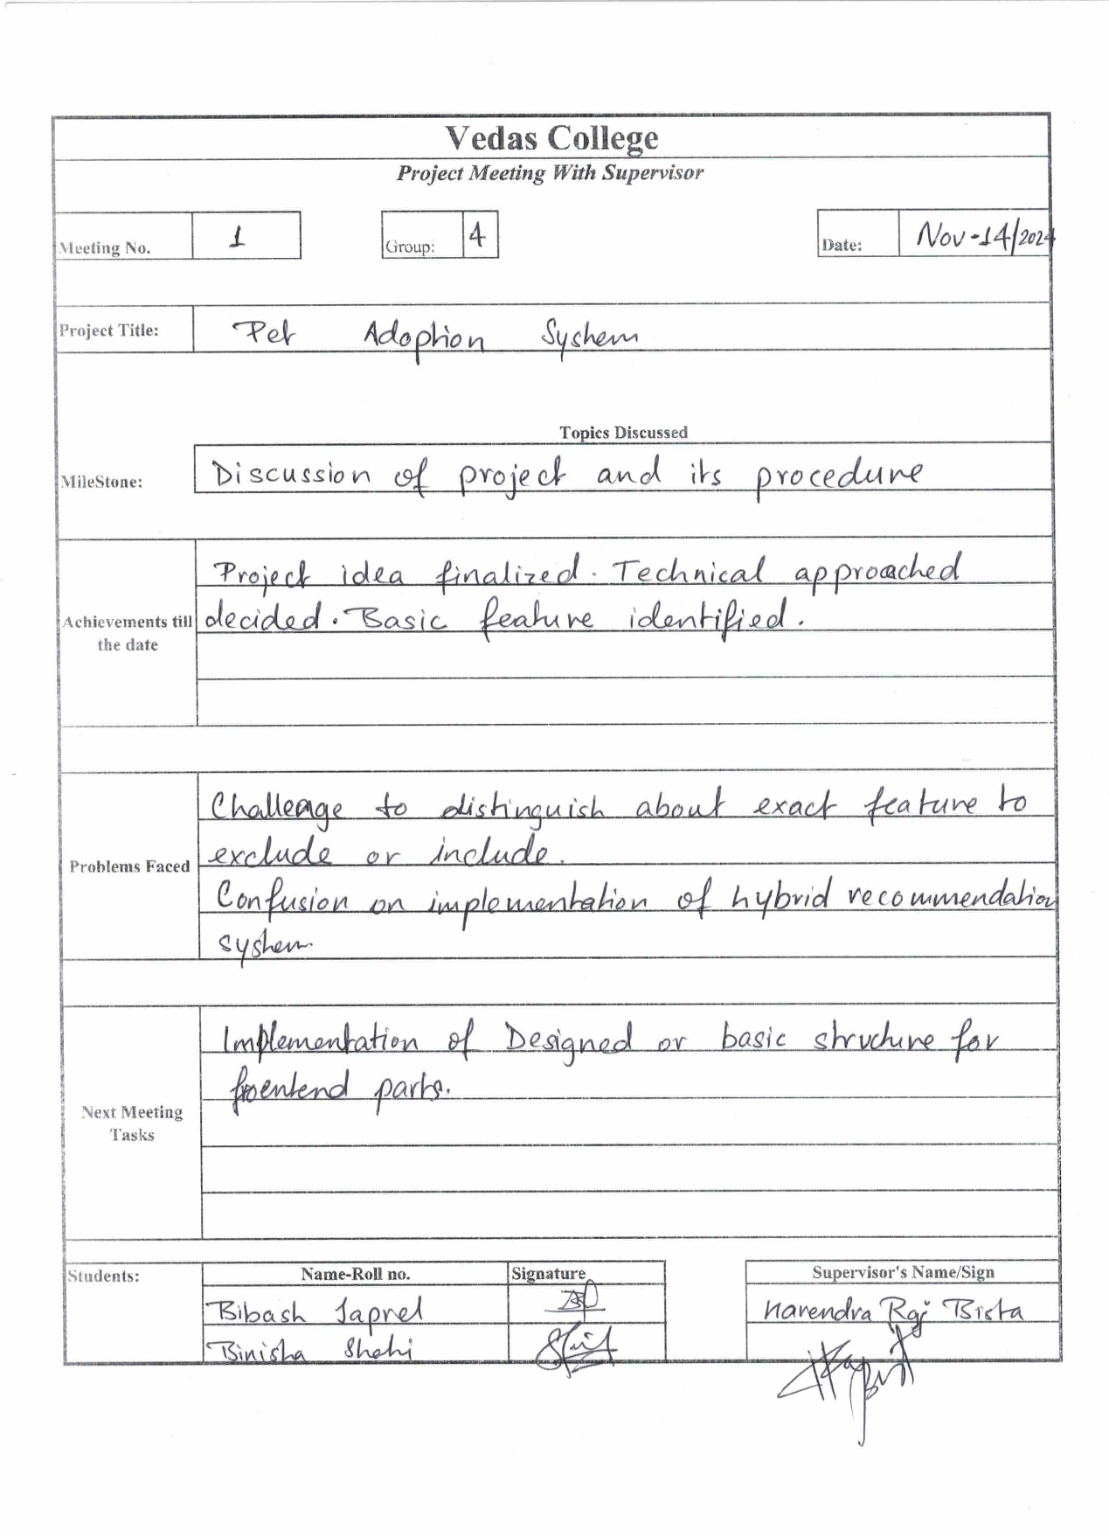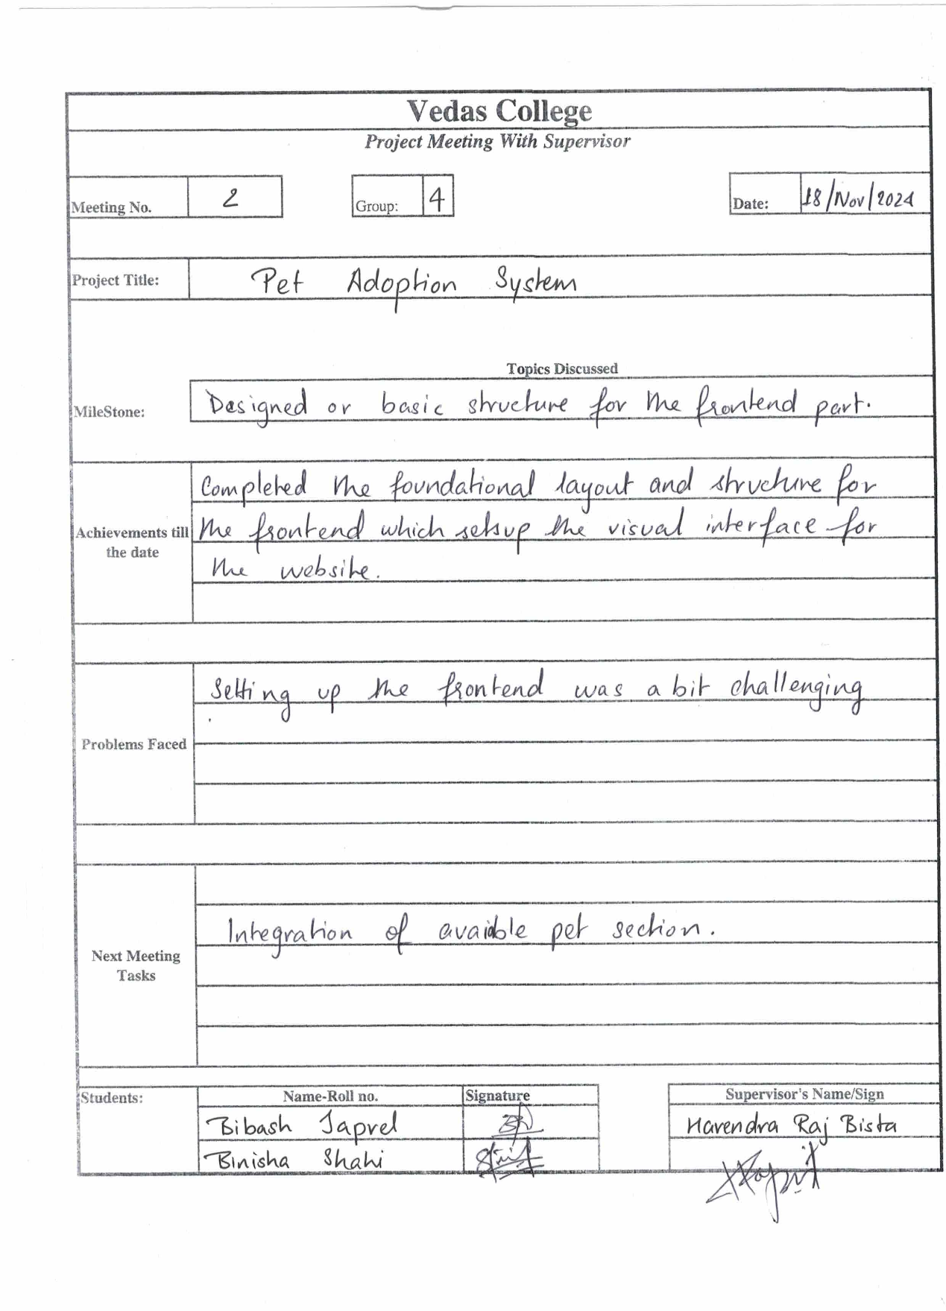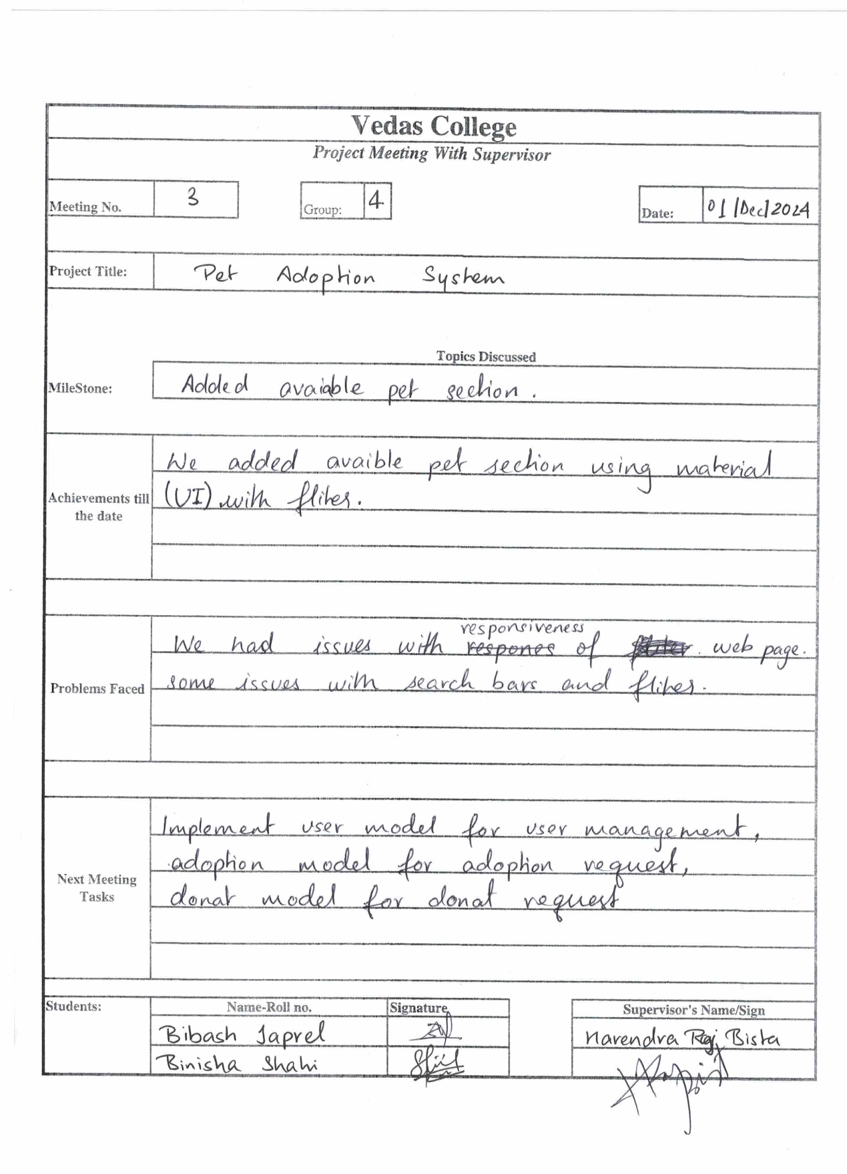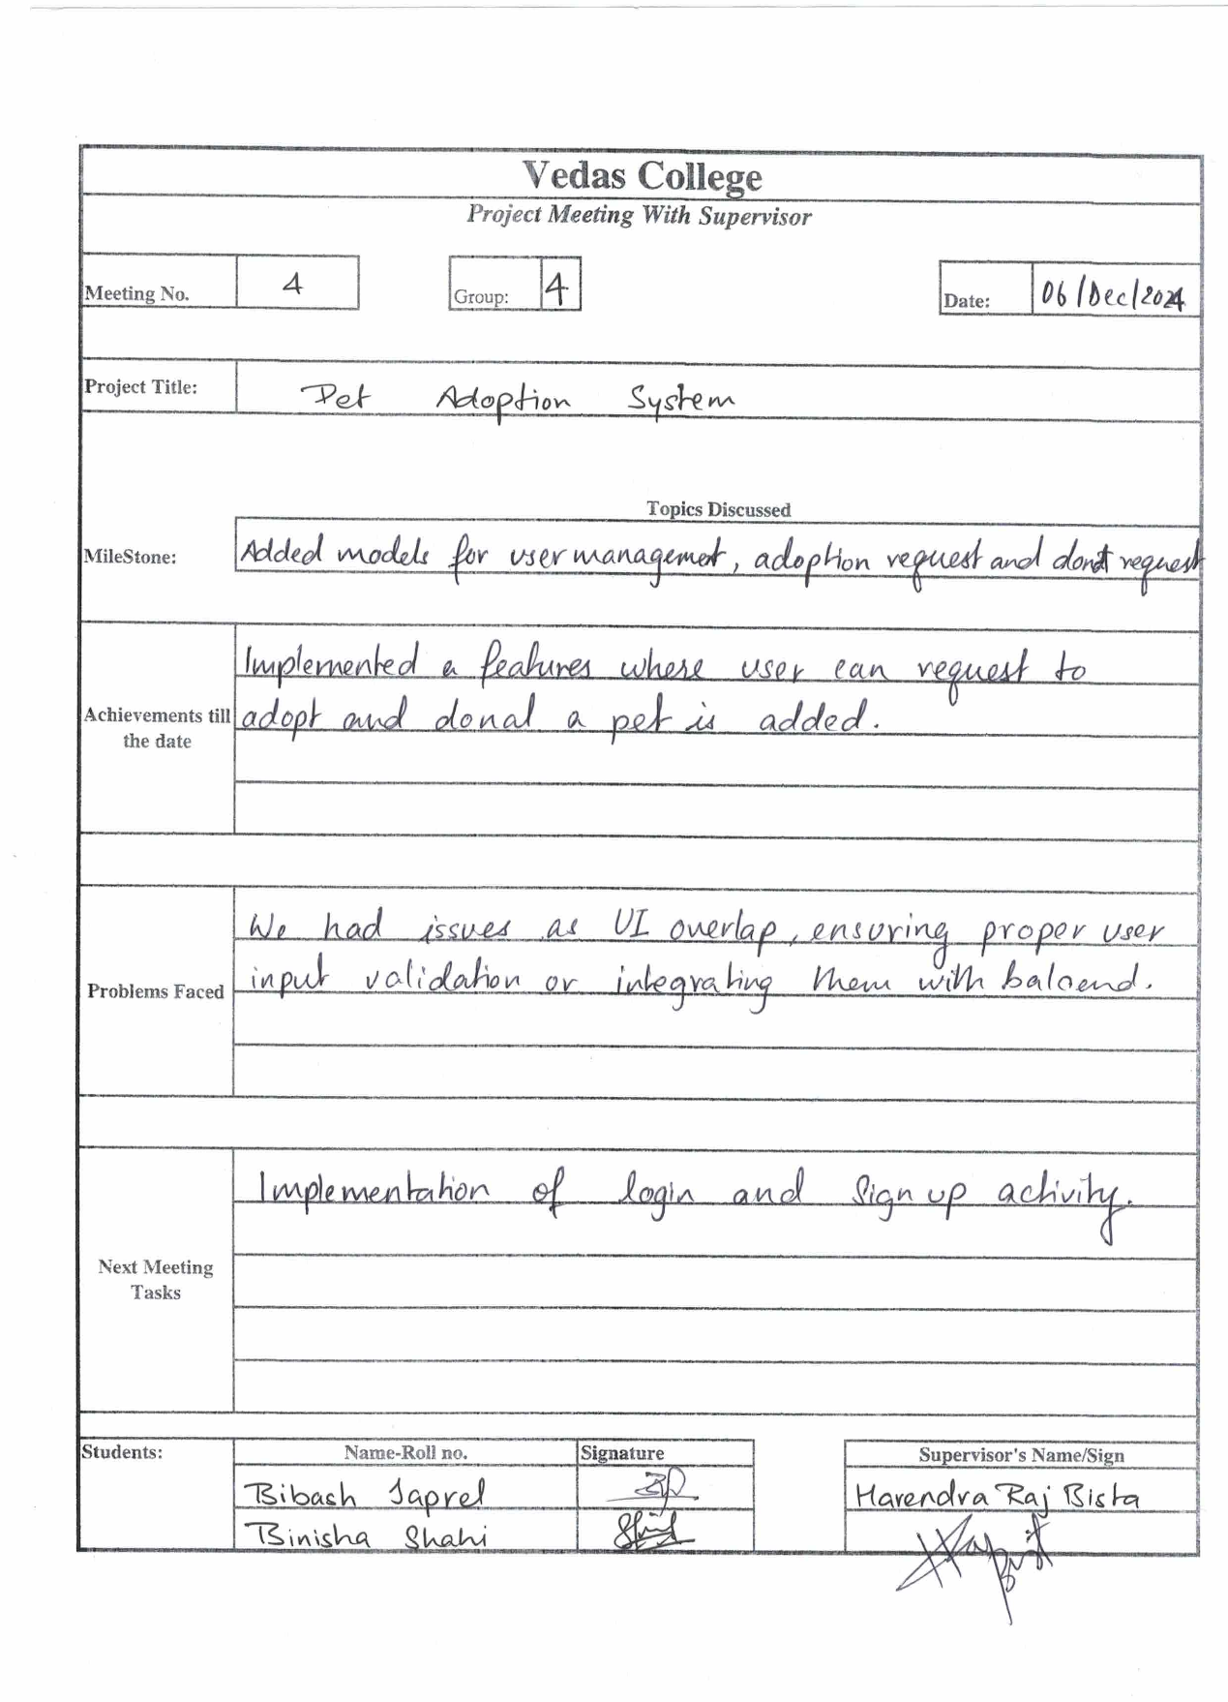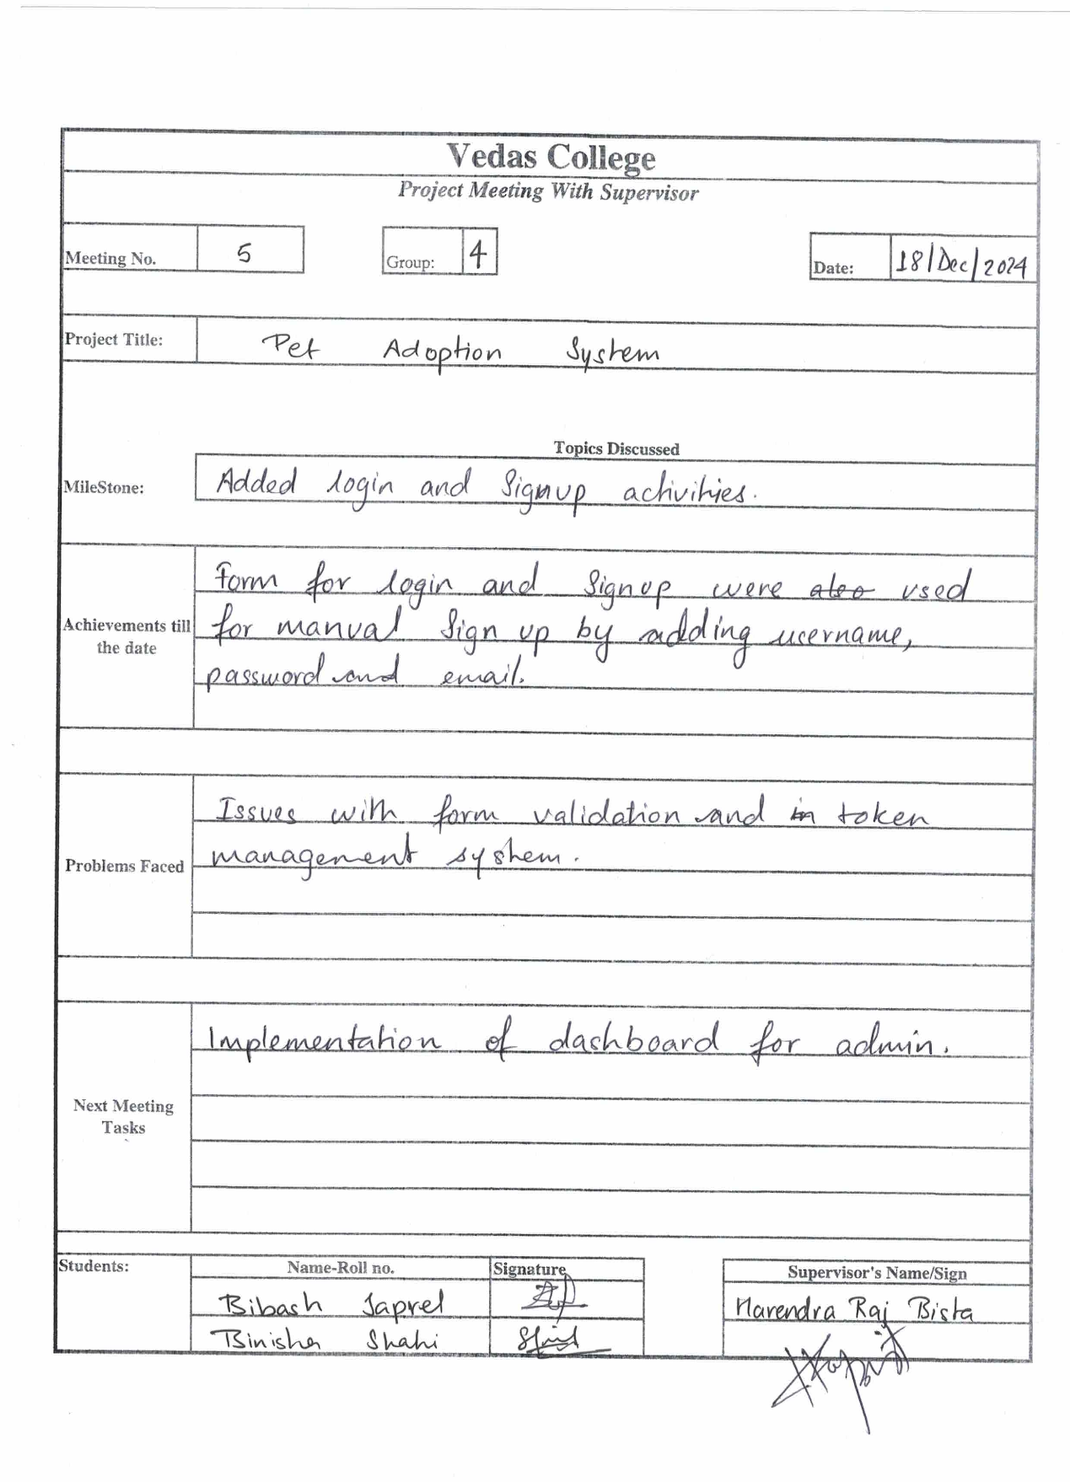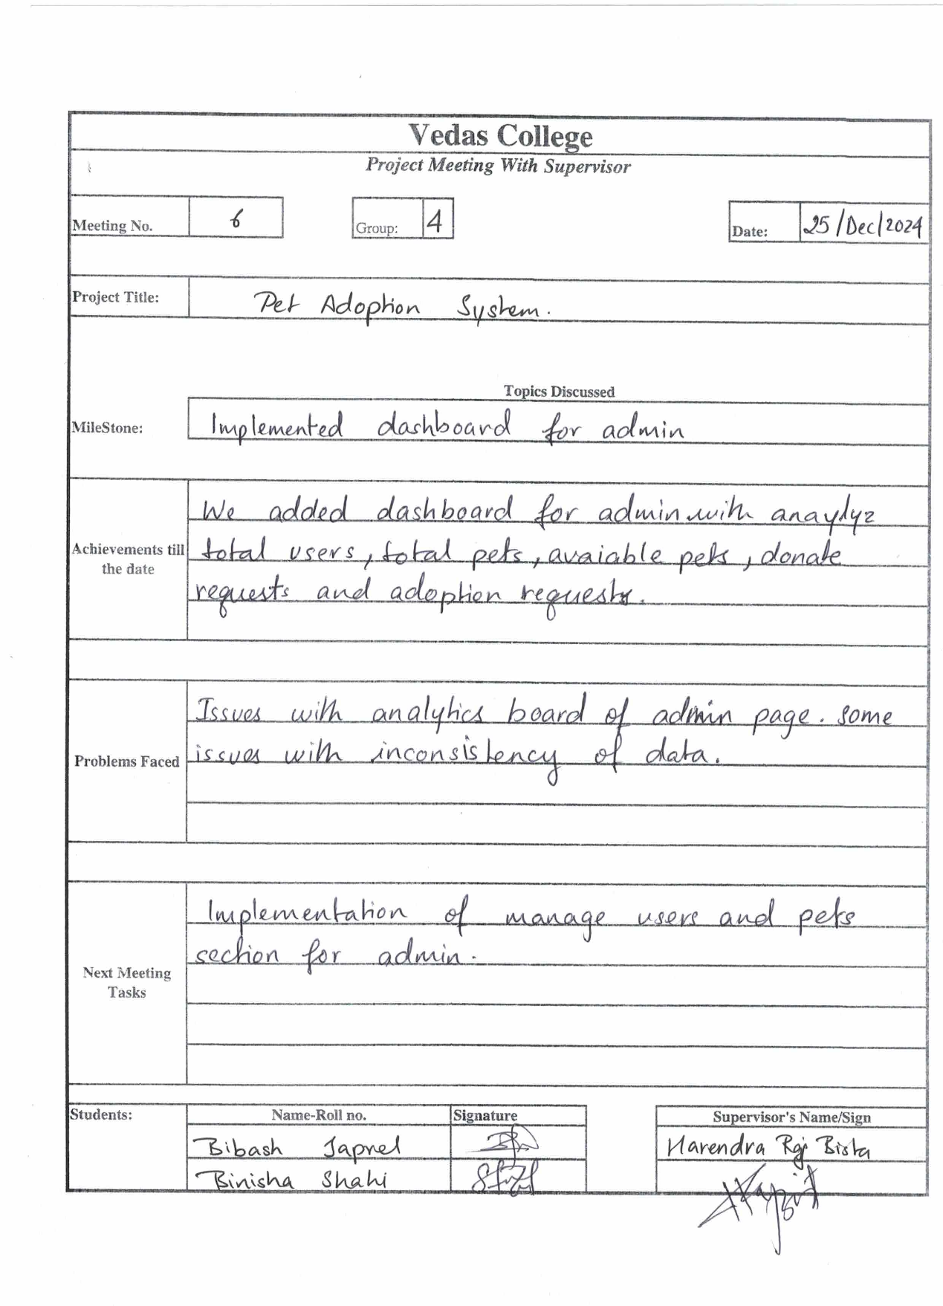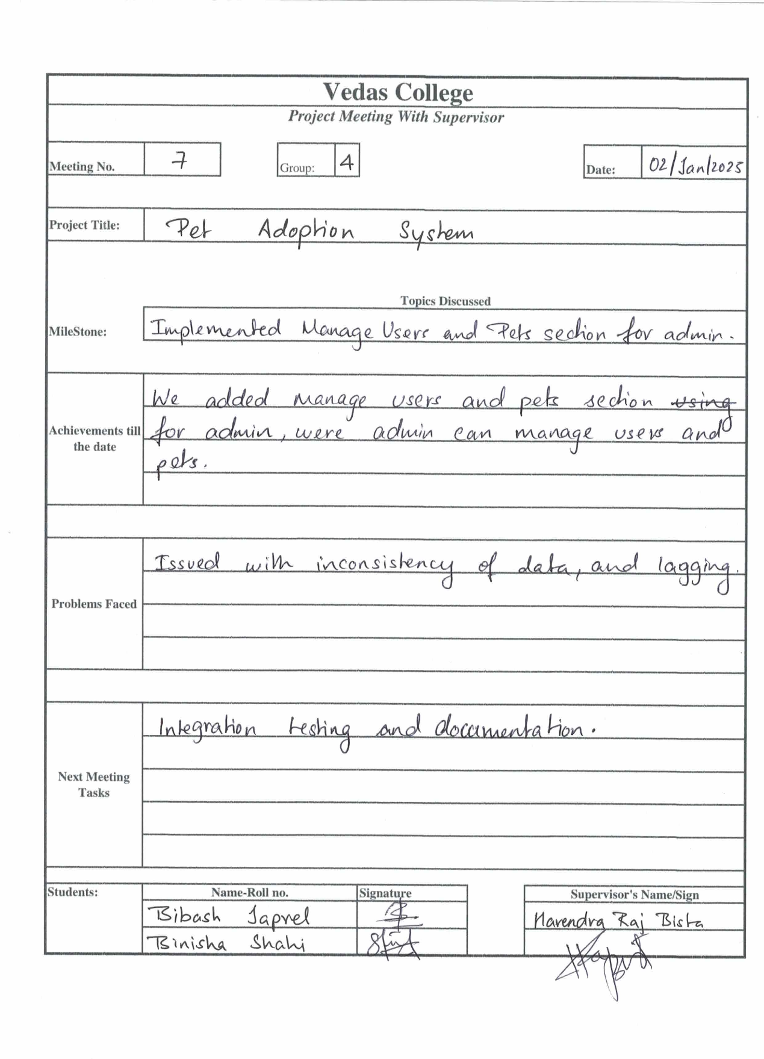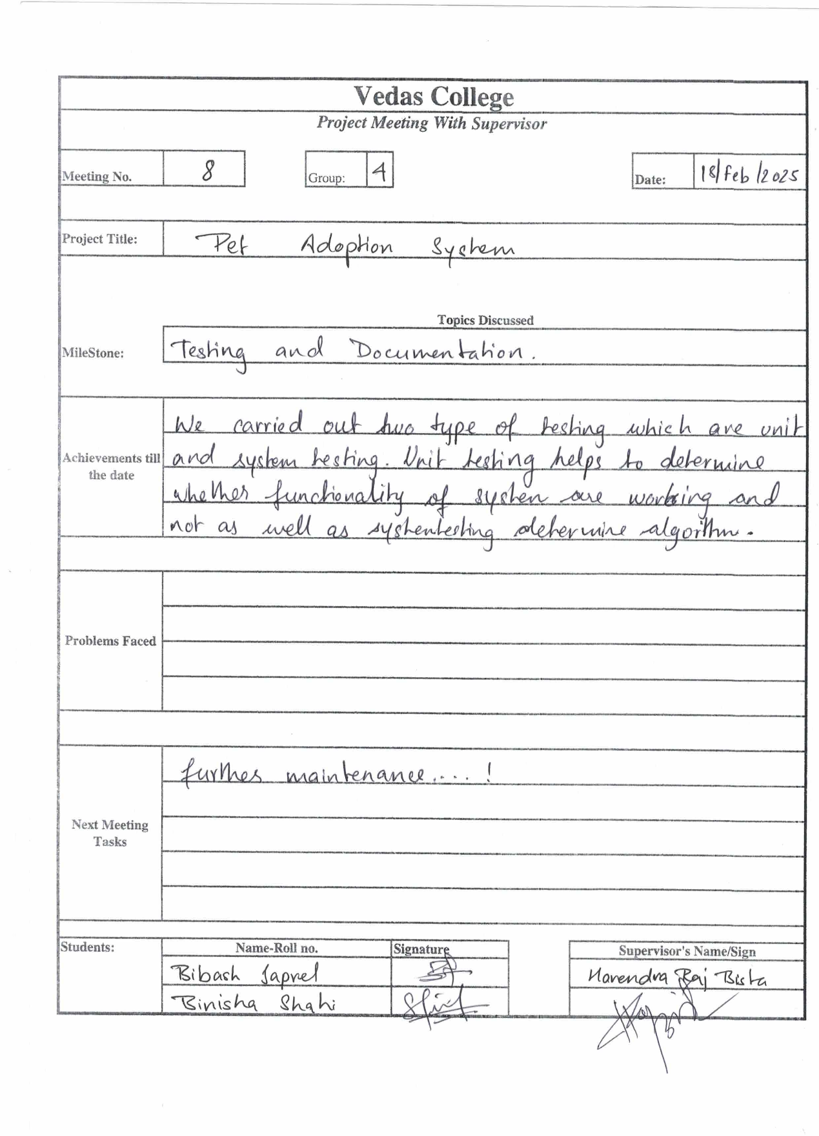

Appendices B

