PYTHON PROGRAMMING-SELECTION AND CONDITIONAL
NAME: BIBASH KUMAL
SUBJECT: CIS093-1 MATHEMATICS CONCEPTS FOR COMPUTATIONAL THINKING
SECTION: C
DATE: 5th Oct. 2026

1. Basic Conditionals:
P1: Multiple if statement:
Questions: Ask the user to enter A, B, OR C. Display Apple, Banana, or Coconut.
Code:
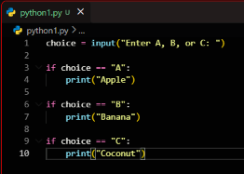
Output:
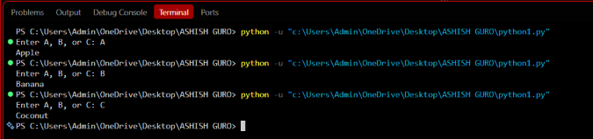

2. P2: Using if/elif:
Code:
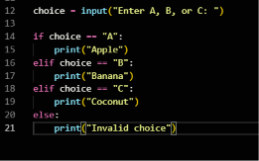
Output:
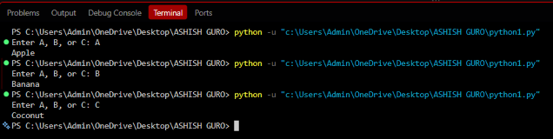

Difference between multiple if and if/elif/else:
Multiple if | If/else/elif
Every if condition is checked. | Stops after the first true condition.
Conditions are independent. | Conditions are part of one decision.
More than one condition can be true. | Only one branch is executed.
Good for independent conditions. | Good for mutually exclusive choices.

3. P3: College Credits.
A common selection exercise is to determine a student’s academic level based on the number of college credits.
For example:
- Less than 30 Freshman
- 30-59 Sophomore
- 60-89 Junior
- 90 or more Senior
Code:
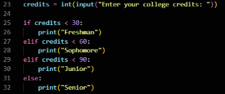
Output:
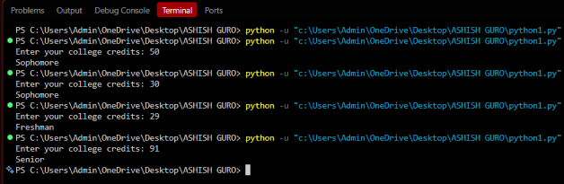
4. Loops and Accumulators:
P4: Sum positive integers, excluding numbers greater than 100
The program should accept positive integers from the user and add only numbers 100 or less.
A simple way is to use 0 as a stopping value.
Code:
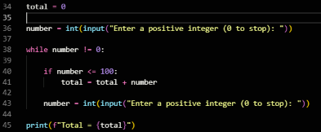
Output:
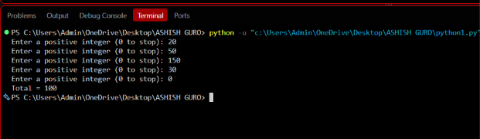
The 150 is greater than 100 so it is ignored.

5. P5: Count positive and negative values.
Code:
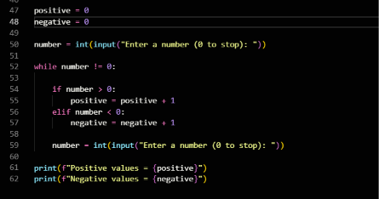
Output:
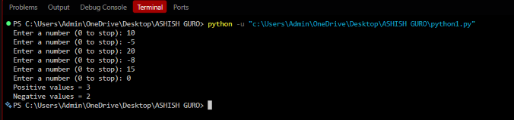
6. P6: Display 1-100, ten numbers per row:
This question requires nested while loops.
Code:
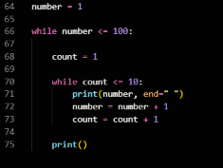
Output:
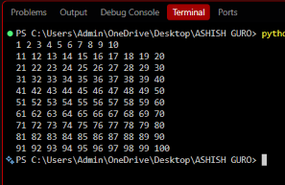
7. P7: Display 1-100 using only one while loop.
We can use the modulus operator% to decide when to start a new line.
Code:
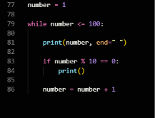
Output:
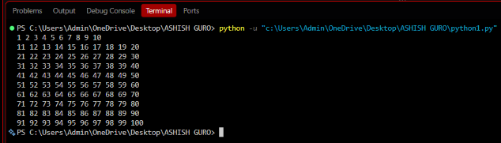

Final Analysis

P1 vs P2
P1 uses multiple independent if statements, so Python checks every condition. P2 uses an if/elif/else structure, so once a condition is true, the remaining conditions are skipped. Therefore, if/elif/else is more suitable when only one choice should be selected.

P4 and P5
Both programs use the accumulator/counter pattern. P4 uses total to continuously add accepted numbers. P5 uses positive and negative counters to keep track of how many positive and negative values are entered.

P6
P6 uses nested while loops. The outer loop controls the numbers from 1 to 100, while the inner loop prints ten numbers before moving to the next row.

P7
P7 achieves the same output using only one while loop. The modulus operator % checks whether the current number is divisible by 10. When the remainder is 0, a new line is printed. This avoids the need for a nested loop.

