A Minor Project II Report on

**FITT**

Submitted in partial fulfilment of the requirements for the degree of Bachelor of Engineering in Software Engineering at Pokhara University

***By***

**BIBASH THAPA MAGAR**

**RAJAN ARYAL**

**SANKET ADHIKARI**



**Department of Research and Development**

**GANDAKI COLLEGE OF ENGINEERING AND SCIENCE**

Lamachaur, Kaski, Nepal

**(June 2022)**

A Minor Project II Report on  
**FITT**  
Submitted in partial fulfilment of the requirements for the degree of Bachelor

of Engineering in Software Engineering at Pokhara University

***By***

**BIBASH THAPA MAGAR**

**RAJAN ARYAL**

**SANKET ADHIKARI**

***Supervisor***

**Er. RAJENDRA BAHADUR THAPA**



**Department of Research and Development**

**GANDAKI COLLEGE OF ENGINEERING AND SCIENCE**

Lamachaur, Kaski, Nepal  
**(June 2022)**

# APPROVAL CERTIFICATE

This project entitled **FITT** prepared and submitted by **Bibash Thapa Magar, Rajan Aryal, Sanket Adhikari** under the supervision of **Er. Rajendra Bahadur Thapa** in partial fulfilment of the requirements for the Degree of Bachelor of Engineering in Software Engineering has been examined and is recommended for approval and acceptance.

**Date of Evaluation:** June 6, 2022

**……………………………………**

**Er. Rajendra Bahadur Thapa**

**Supervisor’s name**

(Project Supervisor)

**…………………………………**

**Er. Rajendra Bahadur Thapa**

(Acting Coordinator)

**Research Management Committee**

**Gandaki College of Engineering and Science**

**ABSTRACT**

The project is to build an app that allows users to stay fit and achieve their body goal. Lack of workout knowledge, exercise, nutrition and time management have led to an unfit lifestyle of the people. So, in order to address the following issues this app will help by providing a proper exercise routine and necessary information that is required for a fit lifestyle. This app will provide facilities to access the exercise types based on the body parts, the level of the exercise as required and the intensity of the exercise. This app will also have a section where the user can see their weekly progress report according to their daily data.

**TABLE OF CONTENTS**

APPROVAL CERTIFICATE i

Chapter 1 INTRODUCTION 1

1.1 BACKGROUND 1

1.2 PROBLEM STATEMENT 1

1.3 OBJECTIVES 2

1.4 IMPLICATION 2

Chapter 2 LITERATURE REVIEW 3

Chapter 3 TOOLS AND METHODOLOGY 4

3.1 REQUIRED TOOLS 4

3.2 METHODOLOGY 5

3.2.1 USE CASE DIAGRAM 5

3.2.2 SYSTEM SEQUENCE DIAGRAM 6

3.2.3 ENTITY RELATIONSHIP DIAGRAM 7

Bibliography 8

Timeline Chart 9

Wireframe 10

**List of Figures**

Figure 3.2.1: Use Case Diagram (UCD) of FITT 5

Figure 3.2.2: System Sequence Diagram (SSD) of Users 6

Figure 3.2.3: Entity Relationship Diagram (ERD) of FITT 7

# Chapter 1 INTRODUCTION

## 1.1 BACKGROUND

Lack of physical activity leads to heart disease, other risk factors including obesity, high blood pressure, high blood cholesterol, and type 2 diabetes. Exercise strengthens your heart and improves your circulation. The increased blood flow raises the oxygen levels in your body. This helps lower your risk of heart diseases such as high cholesterol, coronary artery disease, and heart attack. So, in regard to those problems we are planning to make an app for proper fitness and wellness of the users. The following app will include the exercise routines based according to requirements and experience of the user. It will also keep track of the user's progress report and the basic physical parameters of the user's body. Similarly, this app advises users on the nutrients they should consume in order to maintain their health and achieve their body objectives.

## 1.2 PROBLEM STATEMENT

Most people nowadays are not physically fit because of which they prefer going to the gym but as being a new gym-goer, they don’t know how to exercise properly which will not benefit them. They also are unaware of gym equipment and how to use it using a proper body position which may cause injuries. It is also hard for them to manage their fitness routine and keep track of their progress accordingly. Similarly, some people also hire private trainers to train them by providing a lot of money which causes unnecessary expenditure, but sometimes they don’t even see the results that are worth the money.

## 1.3 OBJECTIVES

FITT app will include the exercise routines based according to requirements and experience of the user. It will also keep track of the user's progress report and the basic physical parameters of the user's body

* To provide the user with instructions for exercise & nutritional programs.
* To keep track of the user's progress.
* To calculate BMI index and calorie count.

## 1.4 IMPLICATION

This app can be used by any type of people who are interested in fitness and the well-being of their health. Also, this app will provide a proper workout routine and track their progress. So, this site solves the ultimate problem faced by the users during their fitness lifestyle by providing proper workout plans and reports based on their past data. Another use of fitness apps is that users can receive general and free tips and guidelines that help them to meet their goals. This app offers different exercise options like on day one, you may have cardio, and strength exercises on the next day. The app will give your ideas according to your preferences. So, this app can be implemented.

# Chapter 2 LITERATURE REVIEW

Numerous apps have already been developed in the market which provides a platform for providing proper health and workout tips. Apart from these established apps our goal is to provide a more user-friendly app which makes the workout done smoothly.

This app (TrueCoach, 2015) is brought by Xplor, the first global platform integrating software, payments, and commerce-enabling services to help businesses thrive. They're on a mission to help coaches save time, deliver a better experience for their clients, and grow their training businesses. They built TrueCoach to enable 1-to-1 coaching that scales, freeing up time for coaches to get out of the gym and work on their businesses rather than in their businesses.

Following app (Freeletics, 2016) helps working out anytime, anywhere with the best digital personal trainer - no gym required. Whatever your fitness level, achieve your goals quickly and build healthy habits with personalised HIIT workouts and audio coaching. Losing weight, gaining muscle or improving your fitness has never been so simple.

This app (Workouts, 2018) provides daily workout routines for all main muscle groups. In just a few minutes a day, it helps to build muscles and keep fitness at home without having to go to the gym. The app has workouts for abs, chest, legs, arms and butt as well as full body workouts.

# Chapter 3 TOOLS AND METHODOLOGY

## 3.1 REQUIRED TOOLS

The following tools was used for the development of the app:

* Programming languages to be used
  + - Dart
* Scripting languages to be used
  + - JavaScript
* Database
  + - Mongo DB
* For making diagrams
  + - Draw.io
* For making Gantt chart
  + - MS Excel
* For making wireframe
  + - Figma

## 3.2 METHODOLOGY

### 3.2.1 USE CASE DIAGRAM

Figure 3.2.1: Use Case Diagram (UCD) of FITT

### 3.2.2 SYSTEM SEQUENCE DIAGRAM

**Figure 3.2.2: System Sequence Diagram (SSD) of User**

### 3.2.3 ENTITY RELATIONSHIP DIAGRAM

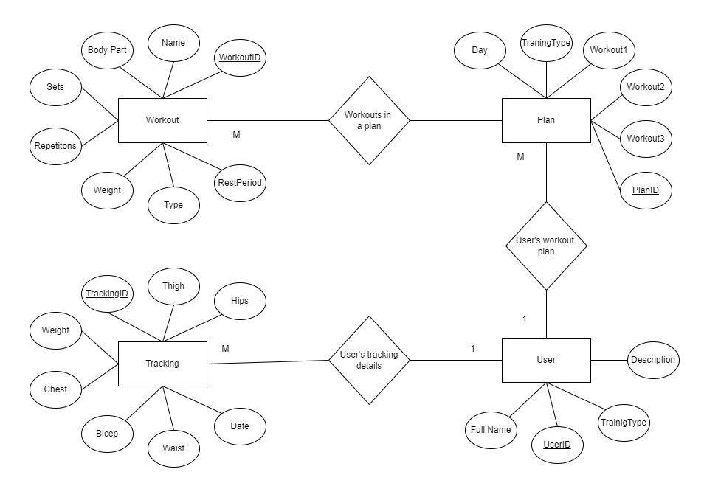

Figure 3.2.3: Entity Relationship Diagram (ERD) of FITT

# Bibliography

Centr. (2017, January 19). *Centr*. Retrieved from Centr: https://centr.com/centr?sscid=61k6_3faxv

Freeletics. (2016, May 30). *Freeletics*. Retrieved from Freeletics: www.freeletics.com

Le-Sweat. (2014, November 31). *Le-Sweat*. Retrieved from Le-Sweat: https://tv.le-sweat.com/

Obefitness. (2019, November 21). *Obefitness*. Retrieved from Obefitness: https://obefitness.com/

Onepeloton. (2014, June 08). *One peloton*. Retrieved from One peloton: https://www.onepeloton.com/app

TrueCoach. (2015, September 4). *TrueCoach*. Retrieved from TrueCoach: www.truecoach.com

Workouts, H. (2018, July 4). *Home Workouts*. Retrieved from Home Workouts: www.homeworkouts.com

# Timeline Chart

**Figure: Gantt Chart of FITT**

# Wireframes

Figure: Get Started Screen

Figure: Main Screen