A Minor Project I Report on

**GCES SPORTS**

Submitted in partial fulfillment of the requirements for the degree of Bachelor of Engineering in Software Engineering at Pokhara University

***By***

**BIBASH THAPA MAGAR**

**RAJAN ARYAL**

**SANKET ADHIKARI**



**Department of Research and Development**

**GANDAKI COLLEGE OF ENGINEERING AND SCIENCE**

Lamachaur, Kaski, Nepal

**(November 2021)**

A Minor Project I Report on  
**GCES SPORTS**  
Submitted in partial fulfillment of the requirements for the degree of Bachelor

of Engineering in Software Engineering at Pokhara University

***By***

**BIBASH THAPA MAGAR**

**RAJAN ARYAL**

**SANKET ADHIKARI**

***Supervisor***

**Er. RAJENDRA BAHADUR THAPA**



**Department of Research and Development**

**GANDAKI COLLEGE OF ENGINEERING AND SCIENCE**

Lamachaur, Kaski, Nepal  
**(November 2021)**

**BONAFIDE CERTIFICATE**

This is to certify that this project titled **GCES SPORTS** in partial fulfilment of the requirements for the degree of BACHELOR OF ENGINEERING IN SOFTWARE ENGINEERING is a bona fide work of **Bibash Thapa Magar, Rajan Aryal, Sanket Adhikari** under the supervision of **Er. Rajendra Bahadur Thapa**. It is further certified that this work doesn’t form part of any other project work on the basis of which a degree or award was conferred on any earlier occasion on this by any other candidate.

**Date of Evaluation**: November 11, 2021

|  |  |
| --- | --- |
| ……………………………...…  Er. Rajendra Bahadur Thapa  Supervisor | ……………………………...…  Er. Sujan Tamrakar  Project Head |
| ……………………………...…  Ashok Raj Parajuli  Vice Principal | ……………………………...…  Er. Shiva Ram Dam  External Evaluator |

**ABSTRACT**

The project is to build a website that allows players to stay updated about sports meet events. Lack of information flow, systematic arrangement and time control have led to the high faulty conduct of the sporting events organised yearly based by student on the behalf of college. So, in order to address following issues this website will be successful in solving problems generated at early years sporting events. This website will let colleagues know all the details of sports events. This website will provide facilities to access team members, fixtures, venues of various sporting events. Website will have a section where the result of the various sporting event conducted on the particular day will be mentioned.

TABLE OF CONTENTS

Chapter 1 INTRODUCTION 1

1.1 BACKGROUND 1

1.2 PROBLEM STATEMENT 1

1.3 OBJECTIVES 1

1.4 IMPLICATION 2

Chapter 2 LITERATURE REVIEW 3

Chapter 3 TOOLS AND METHODOLOGY 4

3.1 REQUIRED TOOLS 4

3.2 METHODOLOGY 5

3.2.1 USE CASE DIAGRAM 5

3.2.2 SYSTEM SEQUENCE DIAGRAM 7

3.2.3 ENTITY RELATIONSHIP DIAGRAM 8

Chapter 4 TEST CASES 9

4.1 SOFTWARE TESTING 9

4.2 TEST OBJECTIVES 9

4.3 TEST RESULTS 10

Chapter 5 RESULTS AND DISCUSSIONS 12

5.1 LIMITATIONS 12

5.2 FUTURE IMPROVEMENTS 12

Chapter 6 CONCLUSION 13

Bibliography 14

Appendix 15

**List of Figures**

Figure 3.2.1: Use Case Diagram (UCD) of GCES Sports 5

Figure 3.2.2: System Sequence Diagram (SSD) of Players 7

Figure 3.2.3: Entity Relationship Diagram (ERD) of GCES Sports 8

**List of Tables**

Table 4.1: Test Case.................................................................................10

# Chapter 1 INTRODUCTION

## 1.1 BACKGROUND

Till the present context, we have been facing lots of problems during sports meets due to bad management of organizers. So, in the regards of those problems we are planning to make a website for the sport meets. We provide information regarding sports meet within this website so that there will be no delay or mismanagement during sports meet events. Whether sharing information regarding sports meet event, or sharing captured memories during the event, or providing the user the service to access the team and fixture to manage their respective team, GCES Sports will make the sports meet events run smoothly.

## 1.2 PROBLEM STATEMENT

There are many problems we have been observing and facing during GCES Sports meet events like being unable to start the game in given time, lack of team members during the game play, and so on. Due to these, it will take much more time for the organizers to finish their events which directly affects the other curriculum activities of the college. In order to minimize the above problems “GCES Sports” is developed.

## 1.3 OBJECTIVES

GCES Sports is a website that provides a platform for sharing information regarding sports meet events. This project fulfils the following goals: -

* To inform the participants and others about the schedule regarding sports meet events.
* To provide a platform where people can share their captured memories of sports meet events.

## 1.4 IMPLICATION

This website can be used by group of people who are participating in the GCES Sports meet events. Also, this website will provide a service to the login user to manage teams. So, this site solves the ultimate sporting circumstances prevailed in GCES. Either providing information or memories about sports meet events or providing service to manage their teams, GCES Sports website can be implemented.

# Chapter 2 LITERATURE REVIEW

Numerous websites have already been developed in the market which provides a platform for smooth management of sports event. Apart from these established websites our goal is to provide a more user-friendly website which makes the jobs done smoothly.

(BBC, 2020) operates a subsite of BBC outline which supplements the television and radio services of the department. The website features sports and analysis from a variety of sports. The site also includes news, stories related to teams or particular sports and live broadcast coverage of same sports.

(Reynolds, 2020) was founded by sports media executives with more than 40 years of combined experience working with print and digital content platforms with the most influential medias companies in the industry. Their mission: bring engaging, quick-hitting and well-written sports news and analysis direct to sports fans on the device they consume content on.

# Chapter 3 TOOLS AND METHODOLOGY

## 3.1 REQUIRED TOOLS

The following tools was used for the development of the website:

* Programming languages to be used
  + - HTML
    - CSS
* Scripting languages to be used
  + - JavaScript
    - PHP
* Database
  + - MySQL
* For making diagrams
  + - Photoshop
* For making Gantt chart
  + - MS Excel
* For making wireframe
  + - Adobe XD

## 

## 3.2 METHODOLOGY

### 3.2.1 USE CASE DIAGRAM

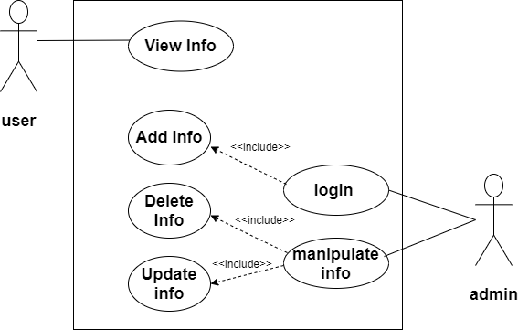

Figure 3.2.1: Use Case Diagram (UCD) of GCES Sports

**Use Case UC1: View Info**

**Primary Actor:** User

**Precondition:**

**Postcondition:** User can see the update of the games, fixtures & results which are added by admin.

**Alternate flow:** If the user is unable to open the website then he/she must reopen the website.

**Use Case UC2: Manipulate Info**

**Primary Actor:** Administrator

**Precondition:** Admin must login

**Postcondition:** Admin can add, delete and update information. Admin can also use image, videos and texts for manipulation.

### 3.2.2 SYSTEM SEQUENCE DIAGRAM

### 

### Figure 3.2.2: System Sequence Diagram (SSD) of Players

### 3.2.3 ENTITY RELATIONSHIP DIAGRAM

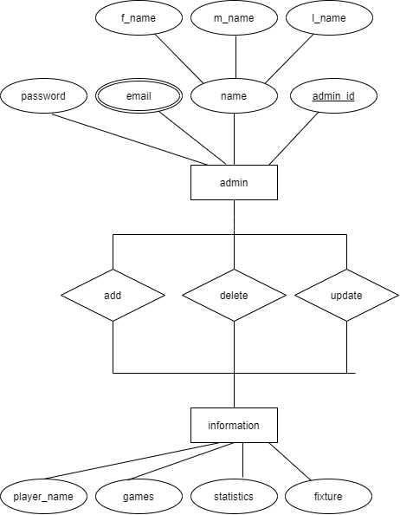

Figure 3.2.3: Entity Relationship Diagram (ERD) of GCES Sports

# Chapter 4 TEST CASE

## 4.1 SOFTWARE TESTING

Software testing is a process, to evaluate the functionality of a software application with an intent to find whether the developed software met the specified requirements or not. It also identifies the defects to ensure that the product is defect-free in order to produce a quality product.

## 4.2 TEST OBJECTIVES

The main objectives of testing GCES Sports were to:

* Check whether the web application is as per the requirements or not.
* Ensure defects get a fix from the developers before deployment.
* Gain confidence in the level of quality of the system.

## 4.3 TEST RESULTS

|  |  |  |  |  |
| --- | --- | --- | --- | --- |
| S.N. | TEST CASES | EXPECTED | OBSERVED | RESULT |
| 1. | Authentication for admin | A specific email with its respective password should be used | Only specific emails with its respective correct password are logged in | Ok |
| 2. | Surf Site | - Stay updated about game fixture, result, news and players stats  - View the photos of the sports meet  - Necessary feedback can be submitted | - Game fixture, result, news and players stats were checked  - Pictures was successfully viewed and downloaded ………  - Feedback was successfully submitted by user and received by admin | Ok |
| 3. | Add data | - All details about the sport meet events should be provided  - When the estimated timeframe of the game crossover, the result to be published goes for the pending section | - The request is sent only when all details are provided  - Pending matches will be updated by admin in the admin panel | Ok |
| 4. | Search necessary details | - Specific team search by selecting the name of team in the search bar | - Available team members and their info are shown when searched via the search bar | Ok |

Table 4.1: Test Case

# Chapter 5 RESULTS AND DISCUSSIONS

Our project GCES Sports helped us to learn in detail about the development of web application. It provided us the opportunity to get expertise in various web development languages. Our product can be used in the real-world for GCES sports meet. This project was completed within the estimated time and with the coordination of team members.

## 5.1 LIMITATIONS

This website was designed in focus of sport events in GCES and its arising issue to conduct events efficiently. But there are some limitations. They are listed below:

* Internet access is required.
* Technical persons needed to manage the system.
* Digital devices are required for accessing the website and developing quality content.

## 5.2 FUTURE IMPROVEMENTS

Some of the improvements that can be implemented in the future are as follows:

* Optimization of the system.
* Addition of new features and functionalities.

# Chapter 6 CONCLUSION

GCES Sports is a website for organizing sports meet event efficiently in GCES. This website provides a platform for GCES users to achieve the benefit of having their own professional website for sports meet. Users as a admin can manage data of sports meet. Users as a guest can view fixtures, results, news, pictures and players stats. Overall, GCES sports is a website that provides a platform for sharing information regarding sports meet events.

# Bibliography

BBC. (2020, June 07). *BBC Sports*. Retrieved from BBC Online: https://www.bbc.com/sports

EPL. (2020, June 07). *Everest Premier league*. Retrieved from Everest Premier league: https://eplt20.com.np/home

Phils, H. (2020, July 21). *Home*. Retrieved from Premeir League: www.premeirleague.com

Reynolds, D. H. (2020, June 08). *Field Level Media*. Retrieved from Field Level Media: https://fieldlevelmedia.com/

Smith, K. (2020, July 21). *Home*. Retrieved from LaLiga: www.laliga.com

# Appendix

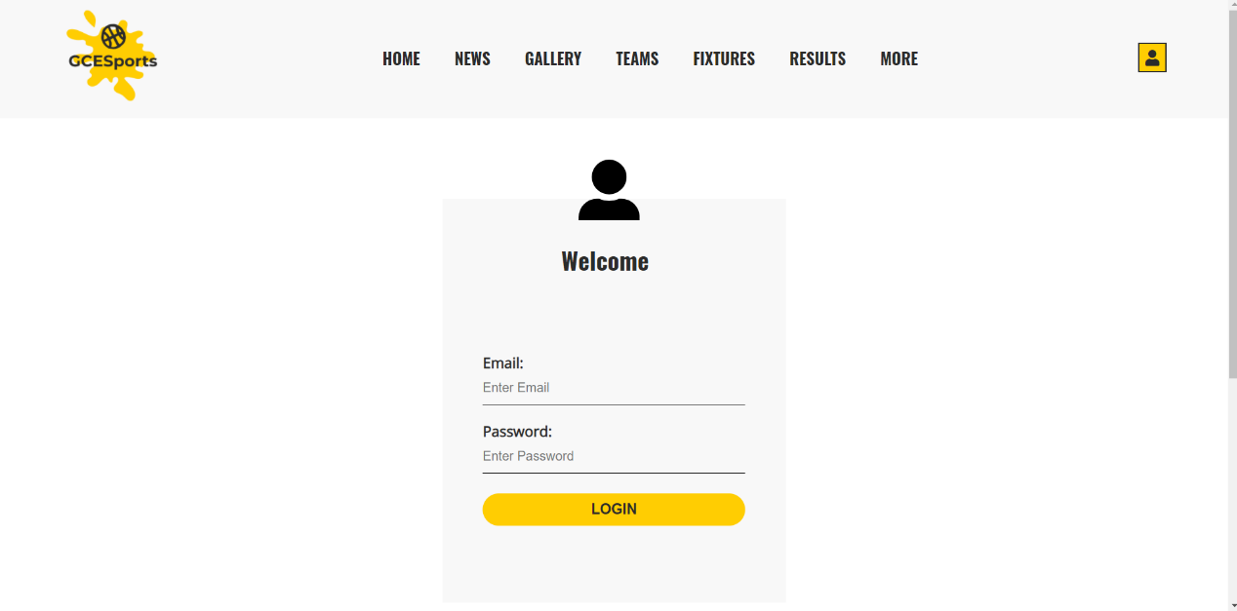

### Figure 01: Login page

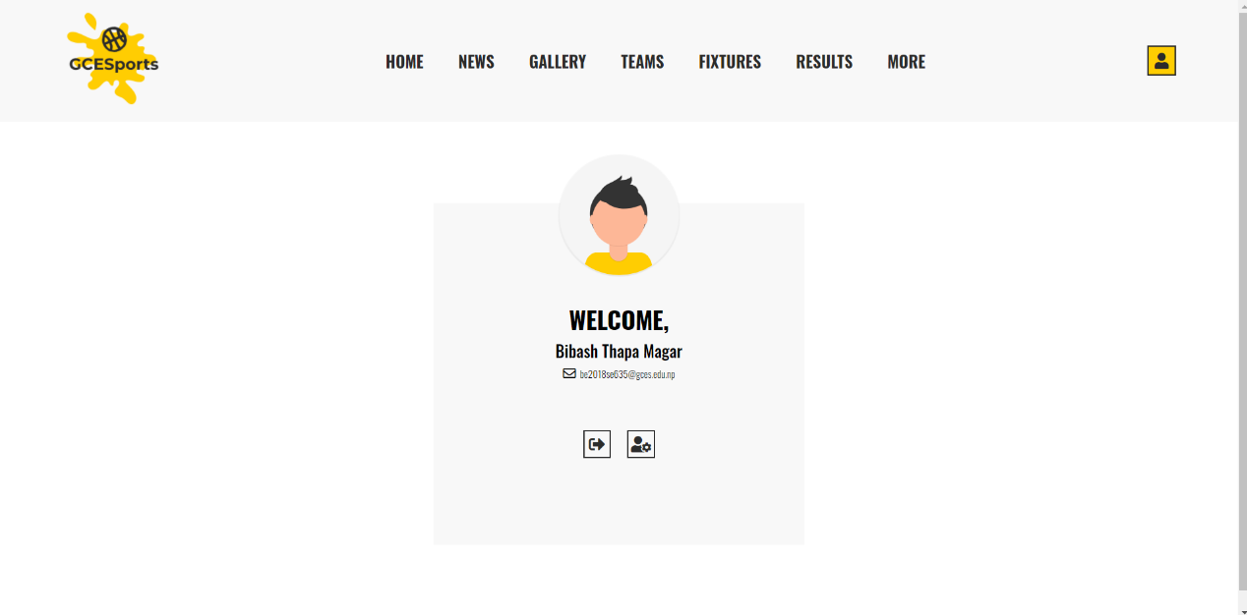

### Figure 02: Profile page

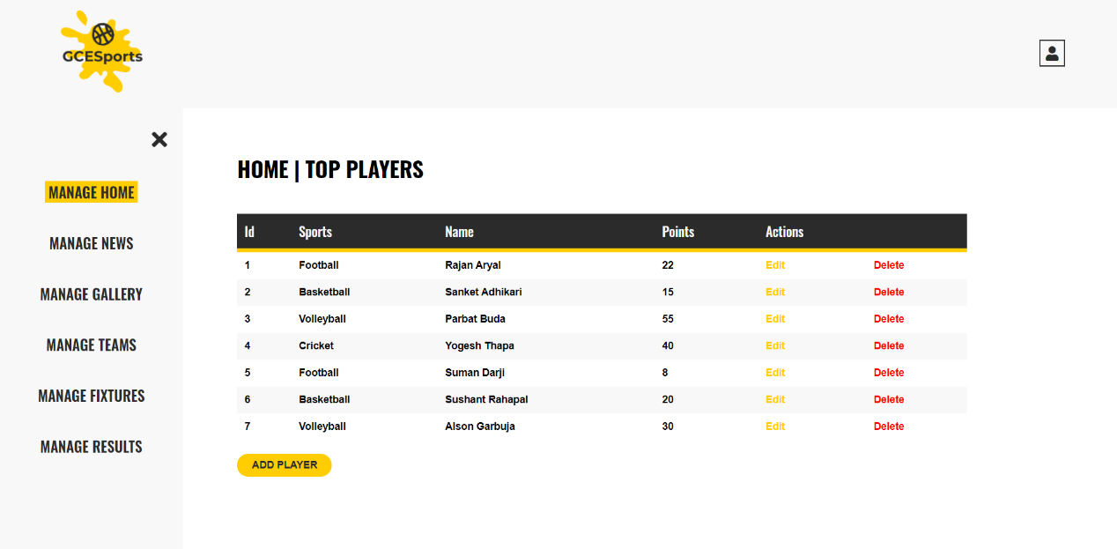

### Figure 03: Admin-panel-1 page

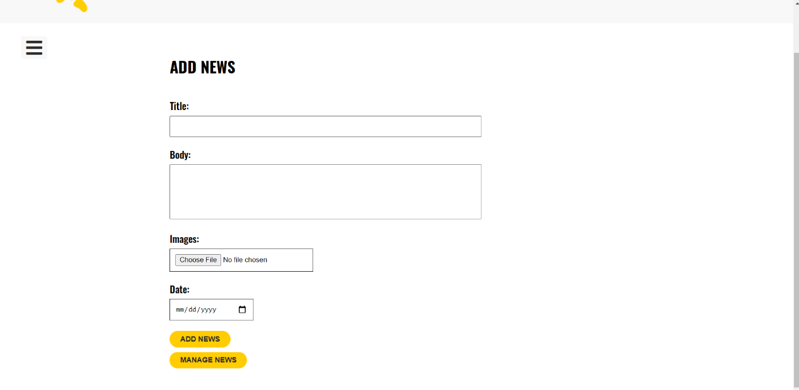

### Figure 04: Admin-panel-2 page

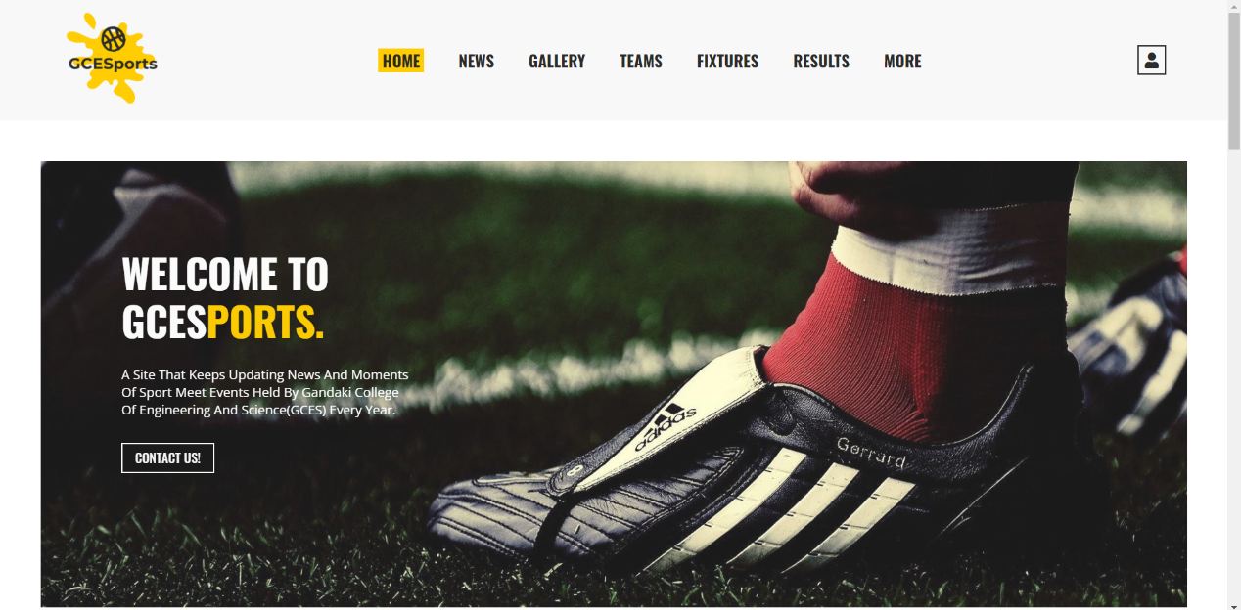

### Figure 05: Home-1 page

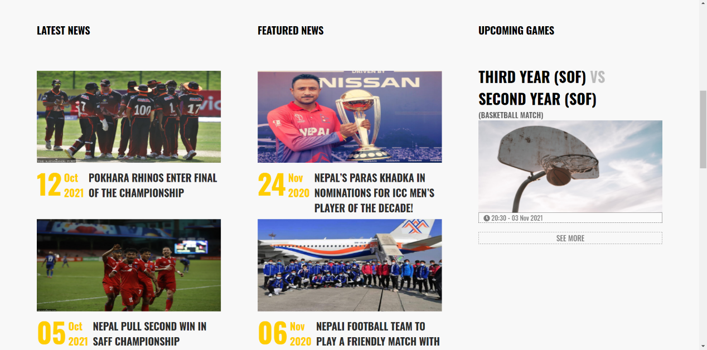

### Figure 05: Home-2 page

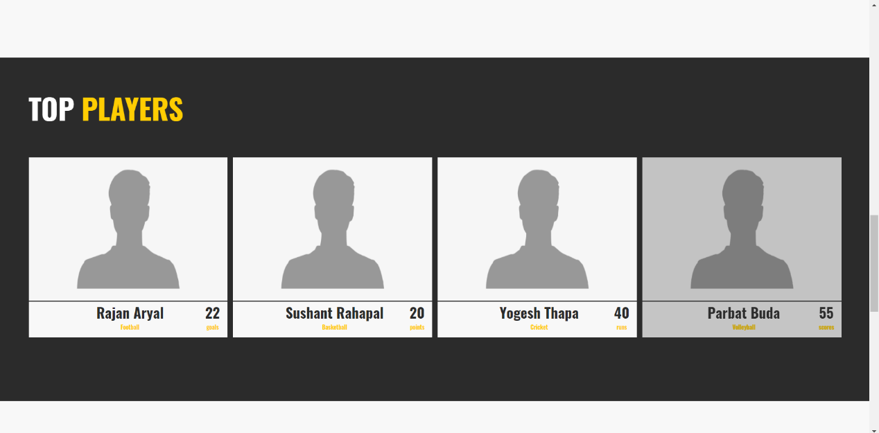

### Figure 06: Home-3 page

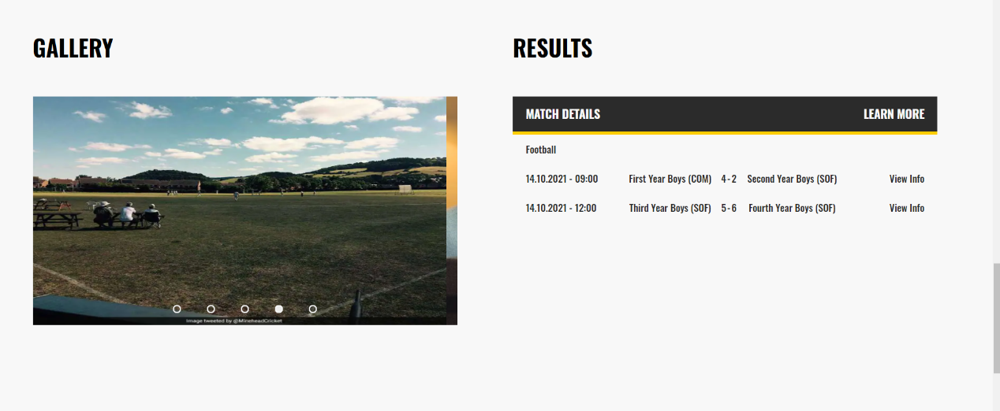

### Figure 07: Home-4 page



### Figure 08: Home-5 page

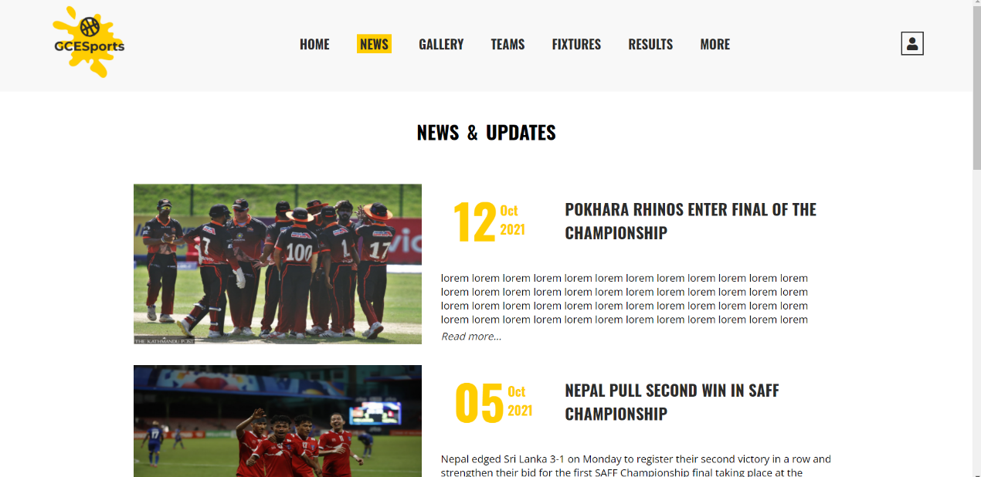

### Figure 09: News page

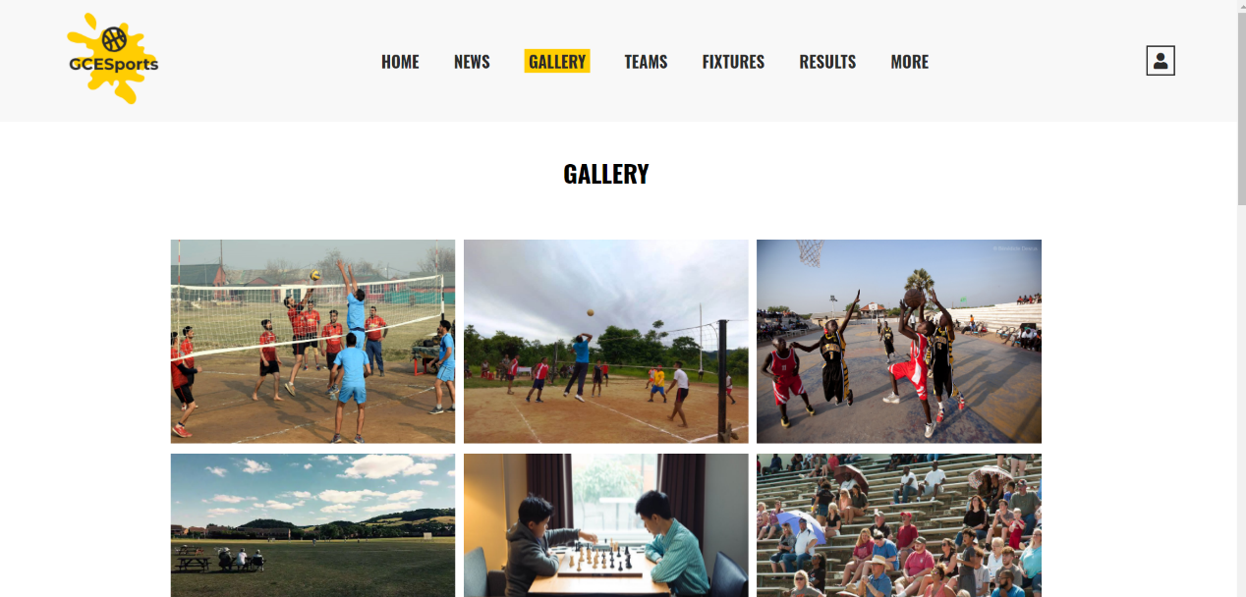

### Figure 10: Gallery page

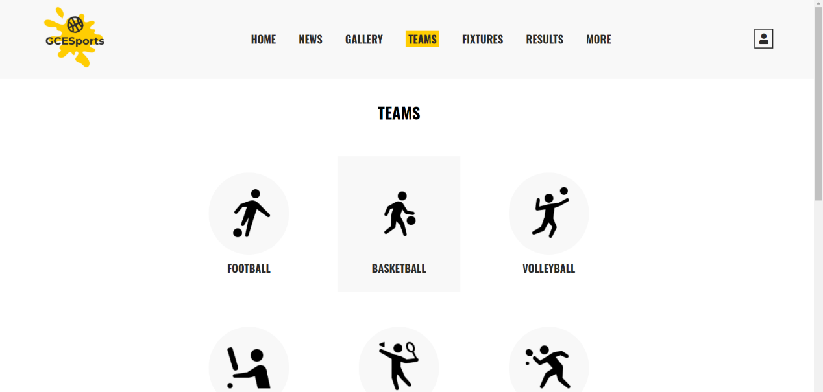

### Figure 10: Team page

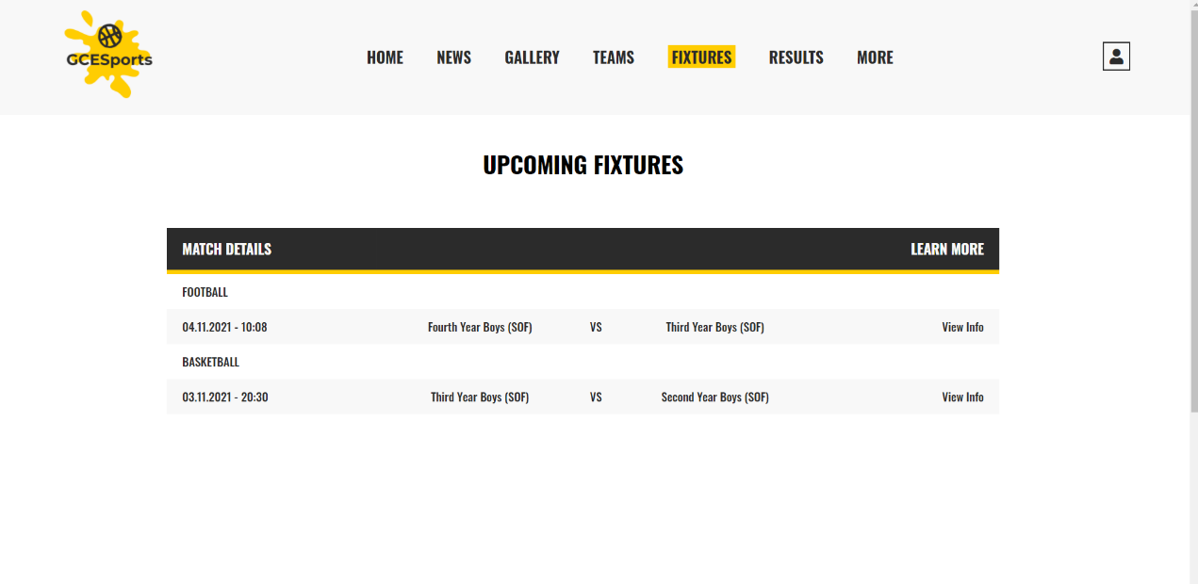

### Figure 11: Fixture page

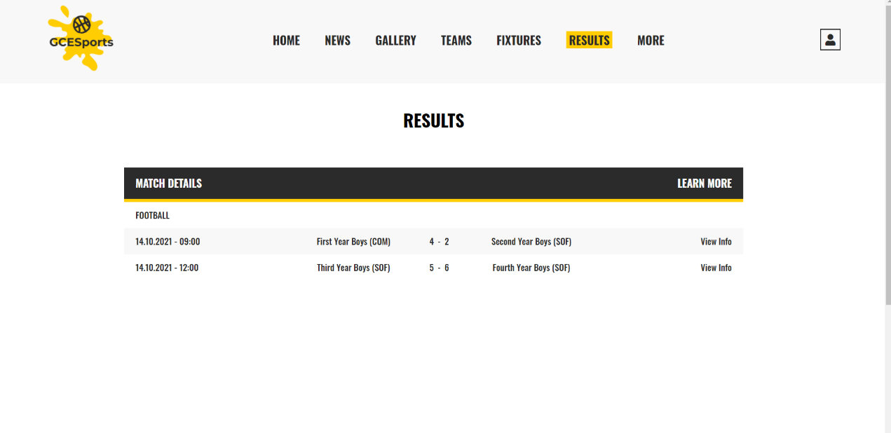

### Figure 12: Results page