REGIONAL SALES FORECASTER
T10 | MBA DSDA | SCIT, Pune
Bibaswan Kundu | 26030242013 | Batch 2026–28

1. Executive Summary
Purpose. The project builds a regional monthly-sales forecasting workflow using an LLM-assisted Python implementation. The assignment requires three baseline methods—3-month moving average, simple exponential smoothing, and simple linear regression—followed by a 6-month back-test using MAPE and a 6-month forecast for each region.
Result. Across the four regions, the back-test produced an overall average MAPE of 8.77% for Simple Linear Regression, compared with 10.25% for Exponential Smoothing and 10.91% for Moving Average. The selected model was therefore Simple Linear Regression, which was also the lowest-MAPE method in each region.
Forecast. The April–September 2026 forecast totals INR 18.01 Cr across all regions. West has the largest six-month projected sales at INR 5.97 Cr; East has the smallest at INR 2.36 Cr.

2. Project Objective
- Develop an end-to-end regional sales forecaster from the supplied Monthly Sales data.
- Compare Moving Average, Simple Exponential Smoothing, and Simple Linear Regression using a chronological 30-month/6-month back-test.
- Select a model using MAPE, refit the selected model on all 36 known months, and forecast the next 6 months by region.
- Present a sales-review chart and an interactive Streamlit dashboard, supported by an AI-use log.

3. Project at a Glance
Data | 144 monthly observations; 4 regions; 36 months each
Historical period | April 2023 to March 2026
Back-test | First 30 months train; last 6 known months test
Forecast horizon | April 2026 to September 2026
Build | Python in VS Code + Streamlit dashboard
Source basis: T10 task brief and supplied Monthly Sales workbook. The workbook states that the data is synthetic and created for teaching; figures are treated as business data for the purpose of the exercise.

4. Data Understanding and Preparation
Dataset structure. The Monthly Sales sheet contains 144 rows and five columns: month, region, net_sales_inr, orders, and active_sales_reps. The data dictionary confirms 36 distinct months and four regions. Programmatic checks found zero missing values and zero duplicate rows; every region contains 36 observations.

5. Forecasting Methodology

5.1 Chronological Back-test Design
The time series was sorted by region and month before splitting. For every region, months 1–30 (April 2023–September 2025) were used for training, and months 31–36 (October 2025–March 2026) were reserved for out-of-time back-testing. This preserves temporal order and avoids using future test observations during model fitting.

5.2 Three Forecasting Methods
- 3-month Moving Average: each future value is estimated from the most recent three observations; multi-step forecasting is recursive, so each new forecast is appended to the history.
- Simple Exponential Smoothing: a level-only model implemented with statsmodels; the initial level is estimated and the smoothing parameter is optimized on the training series.
- Simple Linear Regression: monthly sales are regressed on a sequential time index t = 1, 2, …, n; future sales are obtained by extrapolating the fitted linear trend.

5.3 Accuracy Metric and Model Selection
MAPE was calculated as the mean absolute percentage error across the six test months for each region and method. To make the metric safe for zero-actual edge cases, the implementation was updated to exclude periods where actual sales equal zero. The overall comparison used the simple mean of the four regional MAPE values for each method.

5.4 Final Forecasting Stage
After back-testing, the selected model was refit on all 36 known months for each region. The future horizon was generated dynamically from the maximum date in the dataset, producing April–September 2026. The final pipeline was also changed so the forecast function is selected from the model name returned by back-testing rather than hardcoded to regression.

6. LLM-Assisted Improvement Rounds
Round 1 – Model-selection consistency: The AI review identified a mismatch: the pipeline selected a model dynamically but Step 10 always called Linear Regression. The final code was changed to dispatch the selected forecasting function dynamically.
Round 2 – Dynamic forecast dates: The AI review identified hardcoded future dates. The code now derives the forecast start from the maximum available month and generates the next six months programmatically.
Round 3 – Safer MAPE: The AI review identified division-by-zero risk in MAPE. The function now masks zero actual values before calculating percentage error.
AI support was used for code generation, review, debugging and interpretation. The final outputs were verified locally before being placed into the completed workbook and dashboard.

7. Back-test Results
The six-month back-test was run independently for East, North, South, and West. Lower MAPE indicates lower average absolute percentage error over the six held-out months.
Region | Moving Average | Exponential Smoothing | Linear Regression
East | 7.78% | 7.62% | 6.39%
North | 10.39% | 7.57% | 6.96%
South | 16.25% | 16.23% | 13.57%
West | 9.22% | 9.57% | 8.17%
Overall Average | 10.91% | 10.25% | 8.77%
Table 1. Back-test MAPE comparison from the completed forecasting pipeline.
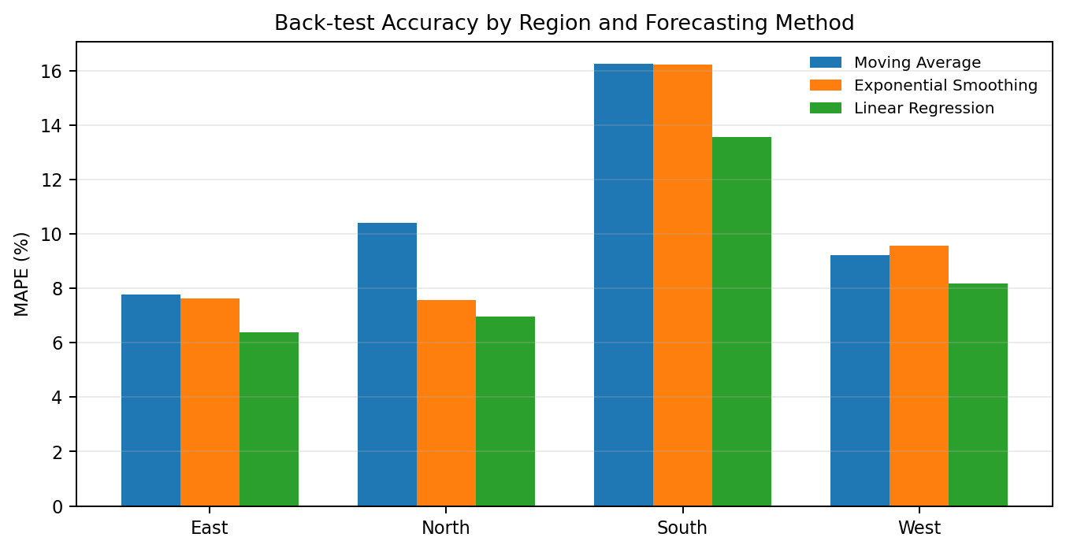
Figure 1. MAPE comparison by region and forecasting method.

8. Interpretation of Accuracy Results
- Overall average MAPE: Moving Average = 10.91%, Exponential Smoothing = 10.25%, Linear Regression = 8.77%.
- Linear Regression had the lowest MAPE for all four regions in the held-out test window: East 6.39%, North 6.96%, South 13.57%, and West 8.17%.
- South has the highest regression MAPE (13.57%), so its forecast should be treated with more monitoring attention than East or North. East has the lowest regression MAPE (6.39%).
- The comparison supports using one selected method for the final six-month forecast because the same method had the lowest back-test MAPE in every region.

9. April–September 2026 Forecast
The selected Simple Linear Regression model was refit on all 36 known months. The resulting company-level six-month forecast totals INR 18.01 Cr. The table below summarizes the start, end, total and change across the six-month horizon.
Region | 6-Month Total | Apr 2026 | Sep 2026 | Apr→Sep Change | Back-test MAPE
East | INR 2.36 Cr | INR 38.35 L | INR 40.41 L | +5.37% | 6.39%
North | INR 4.15 Cr | INR 67.35 L | INR 71.02 L | +5.45% | 6.96%
South | INR 5.53 Cr | INR 89.66 L | INR 94.64 L | +5.55% | 13.57%
West | INR 5.97 Cr | INR 96.85 L | INR 102.06 L | +5.38% | 8.17%
All Regions | INR 18.01 Cr |  |  |  | 8.77%
Table 2. Six-month forecast summary by region.
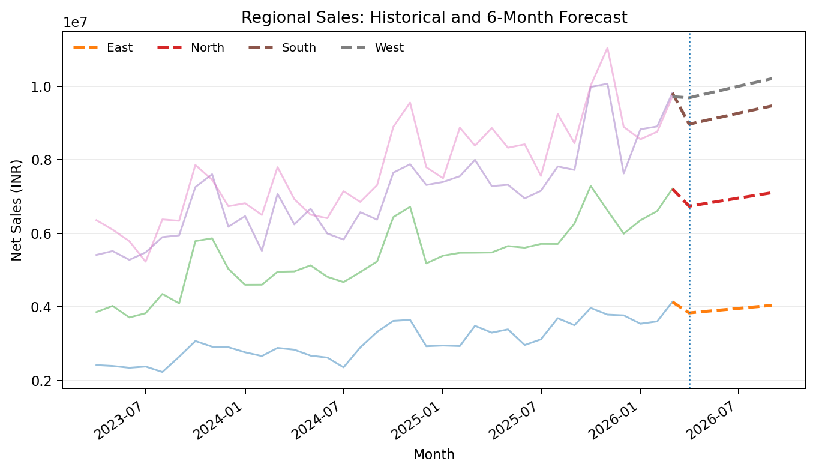
Figure 2. Historical sales through March 2026 with April–September 2026 forecast shown as dashed extensions.

10. Key Forecast Observations
- West has the largest projected six-month total at INR 5.97 Cr and reaches roughly INR 102.06 L in September 2026.
- East has the smallest projected six-month total at INR 2.36 Cr.
- South shows the largest percentage increase from April to September (5.55%), although all four regions show a similar upward trajectory under the fitted linear trend.
- The forecast is intentionally a trend extrapolation. It does not model seasonality or use orders and active sales reps as predictors.

11. Business Recommendations

11.1 Capacity and Coverage Planning
West first in volume, not priority ranking. West contributes the largest projected six-month sales total (INR 5.97 Cr), so capacity, fulfillment and account coverage plans should explicitly test whether operational resources can support that projected run-rate.

11.2 Higher-MAPE Monitoring for South
Use closer forecast-vs-actual monitoring in South. South has the highest regression back-test MAPE (13.57%), so monthly review of actual sales against forecast is especially relevant there. Operational teams can use scenario or buffer planning rather than treating the point forecast as a guaranteed value.

11.3 Consistent Trend-Based Targets
Use the forecast as a baseline. Because the selected method is a simple time-trend model, management should combine the point forecasts with known commercial events, pipeline changes, staffing changes and market conditions before setting commitments.

12. Limitations
- Linearity: Simple Linear Regression assumes that the historical trend continues at a constant rate over the forecast horizon.
- No explicit seasonality: recurring monthly peaks or dips are not separately modeled, so the point forecast may miss seasonal effects.
- Univariate forecasting: the current model uses time as the predictor. The available orders and active_sales_reps fields were not used as explanatory variables.
- Single back-test window: model selection is based on one six-month holdout, so performance reflects that specific historical period. Rolling-origin validation could provide a broader assessment in future work.
- MAPE zero handling: zero actual periods are excluded from MAPE; this should be disclosed whenever the metric is reported.

13. Responsible AI Use and Reflection
The project used a free Gemini chatbot to assist with code generation, code review, debugging, model interpretation, dashboard review and business-insight drafting. The completed AI Use Log contains 15 project-specific entries (#2–#16), supported by screenshot evidence. The interaction history also records three concrete improvement rounds: dynamic model dispatch, dynamic forecast dates and zero-safe MAPE.
Reflection. The most useful role of the AI tool was iterative review rather than one-shot generation. Early outputs were checked against the supplied data and project requirements, and the code was retained only after local execution and verification. The final workflow separates validation from forward forecasting, makes dates and model choice data-driven, and keeps the limitations of a simple baseline model explicit.
Submission package should include the completed workbook with outputs and AI Use Log, the working Streamlit app/code, the forecast chart(s), and the AI evidence screenshots referenced in the log.

14. Conclusion
The project delivers an end-to-end regional forecasting workflow for four regions over a 36-month history. Using a six-month chronological back-test, Simple Linear Regression recorded the lowest overall average MAPE at 8.77% and was then refit on all 36 known months to generate the April–September 2026 forecast. The resulting forecast is useful as a transparent baseline for sales review, while operational decisions should account for regional error differences and the model’s lack of explicit seasonality and business-driver variables.

