**A**

**Summer project**

**ON**

**E-KANOON: LEGAL sEARCH PORTAL OF NEPAL**

**By**

**Bibek Karki**

**7145/16**

**KCMIT**



A Summer Project Report Submitted to

**Faculty of Management, Tribhuwan University**

In partial fulfillment of the requirements for the Course

**Bachelors in Information Management**

Kirtipur

September,2019

**STUDENT DECLARATION**

This is to certify that I have completed the Summer Project entitled **“**(e-Kanoon: Legal Search Portal of Nepal)**”** under the guidance of **“**(Mr. Dinesh Bajracharya)**”** in partial fulfillment of the requirements for the degree of **Bachelor of Information Management** at Faculty of Management, Tribhuvan University. This is my original work and I have not submitted it earlier elsewhere.

Date: 10/28/2019

Signature:

Name: Bibek Karki

i

**CERTIFICATE FROM THE SUPERVISOR**

This is to certify that the summer project entitled **“**e-Kanoon: Legal Search Portal of Nepal**”** is an academic work done by **“**Bibek Karki**”** submitted in the partial fulfillment of the requirements for the degree of **Bachelor of Information** **Management** at Faculty of Management, Tribhuvan University under my guidanceand supervision. To the best of my knowledge, the information presented by him/her in the summer project report has not been submitted earlier.

______________________

Signature of the Supervisor

Mr. Dinesh Bajracharya

Lecturer

10/28/2019

ii

**Acknowledgement**

This is my intense delectation to present the summer project of Bachelor in Information Management (BIM) assigned by Tribhuvan University. Firstly, I would like to thank Tribhuvan University for including summer project in our syllabus. Like ever internee, I have extended a lot of pragmatic knowledge while devising the task.

I am highly obliged to the Kantipur College of Management and Information Technology for giving me the opportunity to complete my summer project. I convey respect and deepest appreciation to all those who provided me the possibility to complete my project.

Besides, I would like to extend my deep appreciation to Kantipur College of Management and Information Technology for providing me an opportunity to enhance my skill. Many thanks goes to Mr. Dinesh Bajracharya for his proper guidance in this project.

Bibek Karki (T.U. Exam Roll No. 7145/16)

iii

**Executive Summary**

Nepal being a democratic country has sets of prevailing laws that govern the citizens and the entire nation. Even when laws empower citizens in a large number of ways, a significant fraction of the population is completely ignorant of their rights and privileges. As a result, common people are afraid of going to police and rarely go to court to seek justice. People continue to live under fear of unknown laws and a corrupt police.

A number of attempts have been made to bring the knowledge of law to the common people. The Government of Nepal took active efforts to present all laws along with their amendments and all court judgments. Also, there are few other private companies which do similar work. However, a majority of these have failed to implement an efficient and effective law search engine hence making the effort futile as people spend a lot of time manually searching through a huge set of links and gauging their relevance.

While it is commendable to make law documents available to common people, it is still quite difficult for common people to easily find the required information. The first problem is that acts are very large and in most scenarios just a few section of laws is applicable. Finding most applicable sections from hundreds of pages of law documents is too challenging for common people. Secondly, laws are often vague and one needs to see how they have been interpreted by the judicial courts.

In order to remove the above two structural problems, **‘**e-Kanoon**’** is started. It achieves them by breaking law documents into smallest possible clause and by integrating law/statutes with court judgments. A tight integration of court judgments with prevailing laws allows automatic determination of the most relevant clauses and court judgments.

Developed using the tools like HTML, CSS, JavaScript, Bootstrap, PHP, MYSQL: **‘**e-Kanoon**’** will be a web centric service which will be completely based on Waterfall Software Model. e-Kanoon offers a simple, easy and effortless way to search for precedents & the related laws governing the society along with the solved court judgements. It is aiming to help Judge, Attorney, Judicial Officer

* the common Nepali citizens, in searching Nepali law database digitized and powered with an effective search. Also the database of lawyers and law firms with their areas of specialization will definitely assist people in obtaining judicial support.

With the completion of this project, it is supposed to bring a change in the way Nepali citizens deal with the legal issues. Planning to turn the law fearing nation into law friendly nation, e-Kanoon will be a digital/smart change regarding the legal practices in Nepal.

iv

|  |  |  |  |
| --- | --- | --- | --- |
|  |  | **Table of Contents** |  |
| **Acknowledgement .............................................................................................................** | | | **iii** |
| **Executive Summary ..........................................................................................................** | | | **iv** |
| **Table of Contents ...............................................................................................................** | | | **v** |
| **List of Figures ....................................................................................................................** | | | **vi** |
| **CHAPTER I - INTRODUCTION ....................................................................................** | | | **1** |
| 1.1 | Introduction of the Organization ................................................................................ | | 1 |
| 1.2 | Current situation of the organization .......................................................................... | | 1 |
| 1.3 | Issue/Problem of the project ....................................................................................... | | 1 |
| 1.4 | Objective of the project .............................................................................................. | | 1 |
| 1.5 | Literature Review ....................................................................................................... | | 2 |
| 1.6 | Methodology/Procedure adopted for writing the report: ............................................ | | 5 |
| 1.6.1 | | Project Framework ............................................................................................... | 5 |
| 1.6.2 | | Project Schedule................................................................................................... | 5 |
| 1.6.3 | | Data and Information ........................................................................................... | 6 |
| 1.6.4 | | Tools used ............................................................................................................ | 6 |
| 1.6.5 | | Techniques of Project report analysis .................................................................. | 7 |
| 1.6.6 | | Project Workflow and Schedule .......................................................................... | 8 |
| **CHAPTER II – TASKS AND ACTIVITIES PERFORMED ........................................** | | | **9** |
| 2.1 | Analysis of tasks, activities, problems, issues ............................................................ | | 9 |
| 2.1.1 | | System Analysis ................................................................................................... | 9 |
| 2.1.2 | | Analysis of Tasks ................................................................................................. | 9 |
| 2.1.3 | | Problems and Issues ............................................................................................. | 9 |
| 2.2 | System Design .......................................................................................................... | | 10 |
| 2.2.1 | | System Flow Chart ............................................................................................. | 10 |
| 2.2.2 | | Entity-Relationship diagram (ER Diagram) ...................................................... | 11 |
| 2.2.3 | | Data Flow Diagram ............................................................................................ | 12 |
| 2.2.4 Level 1 DFD ...................................................................................................... | | | 13 |
| 2.2.5 | | UML State Diagram ........................................................................................... | 14 |
| 2.2.6 | | Use Case Diagram.............................................................................................. | 15 |
| 2.2.7 UML Sequence Diagram ................................................................................... | | | 16 |
| 2.2.8 | | UML Activity Diagram ...................................................................................... | 17 |

v

2.2.9 UML Class Diagram 18

2.2 Analysis of possible solution: 18

2.3.1 Requirement Gathering 18

2.3.2 Testing 19

2.4 Implementation 19

**CHAPTER III– DISCUSSIONS AND CONCLUSION****22**

3.1 Findings/Result: 22

3.1.1 Home Screen 22

3.1.2 Search Results Page 22

3.1.3 Individual Result Page 23

3.2 Code Screenshots 24

3.2.1 Index.php 24

3.2.2 Search.php 25

3.2.3 Autocomplete.js 26

3.3 Critical Analysis 26

3.4 Limitations and Future Enhancements 27

3.5 Conclusion 27

**References****28**

**List of Figures**

Figure 1: Gantt Chart 6

Figure 2: System Flow Chart 10

Figure 3: ER- Diagram 11

Figure 4: Context Diagram 12

Figure 5: Level 1 DFD 13

Figure 6: UML state diagram 14

Figure 7: Use case diagram 14

Figure 8: UML sequence diagram 15

Figure 9: UML activity diagram 16

Figure 10: UML Class Diagram 17

Figure 11: e-Kanoon: English version homepage 21

Figure 12: Search results display page in Nepali version of site 21

Figure 13: Law Document view page in English 22

Figure 14: Homepage search function code 22

Figure 15: Search results display page php code 23

Figure 16: Search box autocomplete feature js code 24

vi

**CHAPTER I - INTRODUCTION**

**1.1 Introduction of the Organization**

Nepal prides herself as the democratic country in the world. There are three broad pillars of Nepali democracy: the legislatures who make laws, the executives who enforce laws and the judiciary that interprets laws. The laws regulate a number of activities like criminal offense, civil cases, taxation, trade, social welfare, education and labor rights.

Even when laws empower citizens in a large number of ways, a significant fraction of the population is completely ignorant of their rights and privileges. As a result, common people are afraid of going to police and rarely go to court to seek justice. People continue to live under fear of unknown laws and a corrupt police. This project aims in creating a one stop destination to find all the central and state acts of Nepal, and create an effective and advanced legal search portal.

**1.2 Current situation of the organization**

A number of attempts have been made to bring the knowledge of law to the common people. The Government of Nepal took active efforts to present all laws along with their amendments and all court judgments. Also, there are few other private companies which do similar work. However, a majority of these have failed to implement an efficient and effective law search engine hence making the effort futile as people spend a lot of time manually searching through a huge set of links and gauging their relevance in general search engines like Google.

**1.3 Issue/Problem of the project**

While it is commendable to make law documents available to common people, it is still quite difficult for common people to easily find the required information. The first problem is that acts are very large and in most scenarios just a few section of laws is applicable. Finding most applicable sections from hundreds of pages of law documents is too challenging for common people. Secondly, laws are often vague and one needs to see how they have been interpreted by the judicial courts. Currently, the laws and judgments are separately maintained and to find judgments that interpret certain law clauses is difficult. This is the problem e-Kanoon is aiming to solve after its completion.

**1.4 Objective of the project**

The main objective of this system is to solve the following problems:

* To create the complete database of the prevailing laws of Nepal (Constitution, Ordinances, International Treaties/Conventions, Rules & Regulations, Formation Orders and others)
* To create a study and research portal for the Judge, Attorney, Judicial Officers, Lawyers and the Law Students regarding legal practices in the nation.
* To help people find the most applicable law and even the most applicable section from hundreds of pages of long and vague law documents.
* To help people know about the rights and privileges empowered by the law of nation.
* To save the time and effort of manually searching through huge sets of links and gauging their relevance in general search engine like Google.

1

**1.5 Literature Review**

In the electronic world, the ways of receiving and imparting information have changed beyond all recognition because of the ease in sharing information over the Internet. We can scarcely begin to conceive the gigantic amount of information put there at our disposal by private and public suppliers. It is even more impossible to monitor where all this information comes from or how it is being sorted and selected by those who make it available to us. Luckily, we are not left alone to dig out the particular piece of news that interests us nor do we lack a system that lists items of potential interest **–** as library catalogues once were able to do. Search Engines are the librarians of the Internet. They are the magic little helpers of the electronic information supply. Once the computer is switched on, using a search engine may even be faster than consulting any catalogue, encyclopedia or dictionary, even if they sat on the shelf next to us. Additionally, the use of the search engine is likely to yield many more results, simply because the storage place on the web outdoes many times that of any shelf. Search engines play a central role in knowledge acquisition and knowledge transfer in today**’**s information society. They are to a large extent responsible for making information on the Internet easily accessible. Search engines have become an essential part of the way in which digital information is made easily accessible. They are used by virtually all Internet users, who moreover believe that searching using search engines is the best way of finding websites. **“**Googling**”** has become an autonomous concept and an independent form of leisure activity, similar to **“**zapping**”** through television channels. Anybody who cannot be found via Google does not exist: **“**To exist is to be indexed by a search engine.**”** (Eijk, 2010)

Legal research is the backbone for building a strong case. For decades, lawyers have been dependent on the duopoly of Lexis.com and WestLaw to provide vast information databases, combined with internal expertise and experience in searching, to uncover relevant results. While the industry has always focused on expanding coverage of legal information sources, it is ultimately the relative ease and accuracy of finding relevant resources that can generate maximum value for the legal community. Information service providers are providing options to allow lawyers to search more efficiently, but the overall results are still largely a measure of the lawyer**’**s inputs. The industry has operated in a **“**pay-per-search**”** or flat-rate subscription model, which has forced lawyers to be judicious in their use of search. While large law firms have often negotiated flat-rate subscriptions to large comprehensive databases, smaller firms and sole practitioners have felt the pinch. In many cases, the emphasis has been on paying for search rather than the results. Attorneys**’** clients pay for results, not the process. A similar practice can be adopted in the legal information search industry, with revenues derived from returned results **—** not the search process. (Sagar, 2011)

In the science, technology, and society (STS) community, the prevalent attitude toward the law is usually a negative one: that the law is unable to keep up with the fierce technological development and innovation that denote our time (this journal has published several essays on the issue; see Tranter, 2010; Trosow, 2010; Vanderburg, 2007). But is this really an inability, or is it not rather the point? And if so, is this necessarily a bad thing, even, or especially, from the STS perspective? The following outline attempts to shed light on this issue.

On one hand, law prescribes behavior and penalizes noncompliance. With law, in the current context, we mean positive law, law that formally exists in a given space in time and that is enforced by the state that exists**—**definitions of law abound, but this is the function one we mean. Law as a system in a specific place in time is therefore the normative utopia that the state in question wants to achieve (see Drechsler, 2003). It freezes the ethical desire**—**and/or the power structure**—**of the current regime, more so in common or statutory law than in case law. On the other hand, technological development, as well as innovation, is about progress, about profits, and about change**—**neither normative nor frozen. In most discourses today, all this is positively connoted, and it takes reminding that this is not necessarily the case. But as Max Weber (1922) famously pointed out, change is the default but stability is the civilizatory achievement. It can be argued that law measures technology against what is desirable now,

2

and it is by and large not interested in economic advancement. This is, of course, an obstacle for technology; legal practice may delay the development of technology and hence the competitive advantage of an entrepreneur, a form, or even a state. (Drechsler & Kostakis, 2014)

As advances in law technology revolutionize today**’**s legal landscape, the role of the legal professional has evolved. The automation of legal processes has prompted lawyers, paralegals, legal secretaries and other legal professionals to become proficient at an ever-increasing array of word processing, spreadsheet, telecommunications, database, presentation and legal research software. Law technology has impacted every aspect of the legal field, from law firm and corporate practice to courtroom operation and document management.

Federal Rules of Civil Procedure enacted in late 2006 have further fueled the need for tech-savvy legal professionals. The new Federal Rules require parties in litigation to preserve and produce documents that exist only in electronic form (**“**e-documents**”**) such as e-mails, voicemails, graphics, instant messages, e-calendars and data on handheld devices. The time-intensive process of reviewing and producing millions of pages of electronic information has spawned a new host of litigation database management tools. This database technology allows legal professionals to image, code, analyze, review and manage the massive amounts of electronic evidence, a process called **“**electronic database discovery**”** (EDD).

E-discovery and the growing use of electronic litigation database tools have even given birth to a brand new profession, the litigation support professional, to implement and manage these new technology tools. Although the conservative legal industry has been slow to embrace technology, it now infiltrates every aspect of law practice. The American Bar Association**’**s legal blog directory provides more information on technology in the legal field. (Kane, 2018) Technology and law practice are intertwined like never before.

* 31% use **“**The Cloud**”** for law-related tasks.
* 58% email confidential or privileged information to clients at least once every day.
* 91% use a smartphone for law-related tasks while away from the office, while 48% use a tablet.
* 43% have downloaded a legal-specific app for their smartphone.
* 35% of firms maintain a presence on Facebook, 56% on LinkedIn, and 19% of Twitter.
* 75% of solo practitioners, and 57% of small firms, have no in-house technical support.

Lawyers now have an ethical responsibility to be technology competent. (Black, 2014)

The federal government has provided funding for the delivery of legal services to poor persons throughout the United States since 1964. Those services, which have been administered by the Legal Services Corporation (**“**LSC**”**) since 1974, are intended to increase the quantity and quality of legal services available to the poor. LSC estimates that no more than 20% of poor persons with civil legal needs are able to get assistance. But new technology may enable the provision of more and better legal assistance. Technology has revolutionized the delivery of services throughout the public and private sectors of the United States and the world. Can the use of modern technology increase the capability of the civil legal services community to meet the legal needs of poor persons in this country, even if funding levels remain constant?

In 1998, LSC conducted the first summit on the use of technology to improve access to justice. The attendees represented courts as well as legal services organizations. Over two days, the participants drew on a series of white papers prepared in advance of the summit to develop an ambitious plan that led to the creation of LSC**’**s Technology Initiative Grant (**“**TIG**”**) program in 2000. By 2012, TIG had provided over $40 million in grants to courts, legal services agencies, and nonprofit organizations to develop and implement technologies to enhance access to justice in this country. TIG funding has supported the development of websites to provide information about civil legal issues in every state. It

3

has also helped create document assembly applications that assist legal services staff in preparing legal documents for their clients quickly and effectively. These document assembly applications are also used by self-represented litigants (**“**SRLs**”**). Technology has changed dramatically since LSC**’**s 1998 summit, bringing about the development of web-based business processes, the widespread use of smartphones, and the rise of social media. In recognition of these changes, LSC began planning a second summit in 2011 **—** the Summit on the Use of Technology to Expand Access to Justice. An advisory committee consisting of representatives of legal services organizations, courts, the organized bar, and governmental entities decided to hold the Summit in two sessions. The first session focused on developing a new vision for the use of technology to enhance access to justice, and the upcoming second session will focus on developing a plan for implementing that vision. (Cabral, Chavan, Clarke, & Greacen, 2012)

Online technologies offer innovative ways to deliver legal services. By automating tasks traditionally performed by attorneys and by making legal products available on the Internet, these technologies make legal services more affordable and accessible. For example, many vendors now offer downloadable bill-of-sale documents. For reasons that will be discussed below, legal service technologies are likely to evolve into fully integrated, multi-sided platforms that automate simple tasks and interface with attorneys for more complex ones. Although these technologies threaten to disrupt traditional models for delivering legal services, they should be embraced by consumers and legal professionals alike. (Johnson, 2009)

**‘**Law and Information Technology**’** are often thought of as being at odds with each other. Whilelawyers complain that law is always running behind regulating an ever-faster developing information technology, information technologists often regard law as a hindrance to the implementation of already existing or future software applications and business models. Yet, it is felt within both groups that, on the one hand, law should not unduly hinder the deployment of information technology, and that whenever information law contradicts fundamental values, it should at least somehow be regulated by law. One should thus pose the question whether law and information technology are in an uneasy marriage, or is there a way in which they both can get along with each other, or even better, help and complement each other in shaping our information society? (Dierer, 2005)

Many professionals now rely on information technology (**“**IT**”**) to simplify, automate, or better understand aspects of their work. Such software comes in varying degrees of sophistication: less sophisticated tools include word processors, e-mail and instant messaging systems, file servers, and the like, while more sophisticated tools reach into the analytical core of a professional**’**s work. Although modern law firms and courts are awash in these less sophisticated tools, legal practice often lacks analogues to the more sophisticated tools found in many other industries. A broad variety of industries have incorporated sophisticated data-manipulation techniques in recent decades. High-profile examples include the use of statistical data-mining techniques to detect credit card fraud, as well as the use of related anomaly-detection methods to identify potential terrorist activity. Businesses have shifted toward data-driven decision-making; this shift is reflected in the incorporation of data-mining techniques into leading relational database management systems. In addition to data-mining techniques, machine learning techniques are now central to applications ranging from cars that drive themselves, to spam filtering, to the classification of astronomical objects. Although modern legal practice has adopted IT in many areas, these legal tools do not typically match the sophistication of tools found in other industries. Besides basic office software like word processors and e-mail, law firms often have comprehensive, networked document retrieval systems, while courts and government agencies have electronic filing systems. However, these tools lack the analytical power of IT used in other sectors of the world. (Jenkins, 2008)

4

**1.6 Methodology/Procedure adopted for writing the report:**

**1.6.1 Project Framework**

The author has implemented the project using JavaScript, bootstrap, HTML and CSS. By programming in JavaScript and PHP, the author has been able to work quickly and efficiently and has been able to implement some of the proposed advanced functionality. Bootstrap is the most popular HTML, CSS, and JavaScript framework for developing responsive, mobile-first web sites. The author has used Bootstrap as it has many benefits from scratch for every web development project, and one such reason is the huge number of resources accessible for Bootstrap. The author has also used CSS for designing part as it has various advantages such as easier to maintain and update greater consistency in design, more formatting options, and lightweight code, faster download times, search engine optimization benefits, ease of presenting different styles to different viewers and greater accessibility.

Project management can be defined as the process of applying knowledge, skills, tools as well as techniques to project activities to meet the project requirements. According to Project Management Institute's "A Guide to the Project Management Body of Knowledge", project management processes can be categorized into five groups- initiating, planning, executing, monitoring and controlling and closing Objectives of projects management are: (Rouse, 2009)

* Understanding the importance of linking the information system to business needs.
* Being able to create a system request.
* Ability to perform a feasibility analysis.
* Understand how projects are selected in some organizations

**1.6.2 Project Schedule**

***1.6.2.1 Time Schedule/Gantt Chart***

|  |  |  |  |  |  |  |  |
| --- | --- | --- | --- | --- | --- | --- | --- |
| **Task** |  |  | **Start date** |  | **End Date** | **Duration** |  |
|  |  |  |  |  |  |  |  |
| **Research** |  |  | 10-Jun |  | 25-Jun | 15 days |  |
|  |  |  |  |  |  |  |  |
| **Identification** | **&** | **selection** | 25-Jun |  | 05-Jul | 10 days |  |
| **Strategies** |  |  |  |  |
|  |  |  |  |  |  |  |
|  | |  |  |  |  |  |  |
| **Coding & Designing** | |  | 05-Jul |  | 05-Aug | 30 days |  |
| **Testing** |  |  | 05-Aug |  | 20-Aug | 15 days |  |
|  | | |  |  |  |  |  |
| **Evaluation & Modification** | | | 20-Aug |  | 20-Sep | 30 days |  |
|  | | |  |  |  |  |  |
| **Implementation & Review** | | | 20-Sep |  | 15-Oct | 25 days |  |
|  |  |  |  |  |  |  |  |
|  |  |  | *Table 1: Gantt Chart* | |  |  |  |

5

**Gantt Chart**

10.Jun 30.Jun 20.Jul 09.Aug 29.Aug 18.Sep 08.Okt 28.Okt

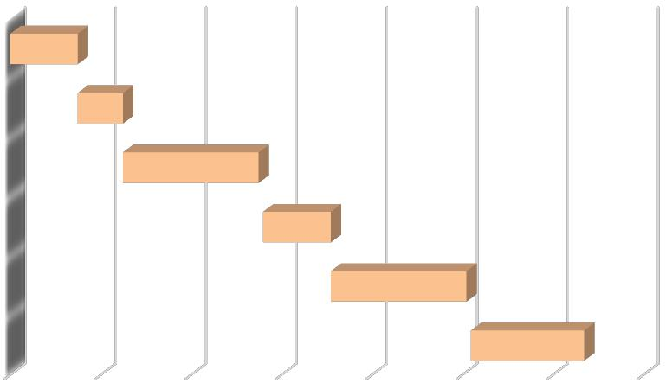

Research

Identification & selection Strategies

Coding & Designing

Testing

Evaluation & Modification

Implementation & Review

|  |  |  |  |  |  |  |  |  |  |
| --- | --- | --- | --- | --- | --- | --- | --- | --- | --- |
|  |  |  | Implementation | Evaluation & |  | Coding & | Identification & |  |  |
|  |  |  | Testing | selection | Research |  |
|  |  |  | & Review | Modification | Designing |  |
|  |  |  |  | Strategies |  |  |
|  |  |  |  |  |  |  |  |  |
|  |  | Start date | 20.Sep | 20.Aug | 05.Aug | 05.Jul | 25.Jun | 10.Jun |  |
|  |  |  |  |  |  |  |  |  |  |
|  |  | Duration | 25 | 30 | 15 | 30 | 10 | 15 |  |
|  |  |  |
|  |  |  |
|  |  |  |  |  |  |  |  |  |  |

*Figure 1: Gantt Chart*

**1.6.3 Data and Information**

The data and information plays important roles for the identification of possible threats and opportunities of any organization. When it comes to our service: e-Kanoon, it has the efficient platform for managing the information and solves the current issues of the legal condition of Nepal.

**Primary Data Collection:** Primary data will be collected from research, and visiting websites relatedto legal fields of Nepal like KanoonNepal.com, LawCommissionNepal.gov.np, and such.

**Secondary Data Collection:** Secondary data will be collected from case studies of previous years,books, and pdfs, newspaper articles, websites and other legal resources.

**1.6.4 Tools used**

***1.6.4.1 HTML5***

HTML5 is the latest evolution of the Hyper Text Markup Language (HTML) standard. It is a new version of HTML and has new elements, attributes, and behaviors as well as a larger set of technologies that allow more diverse and powerful Web sites and applications [27]. Since this project is a web based application, HTML5 serves the best for the content of the application as it has more precise semantics, support for multimedia and higher performance. HTML5 features are used for email validation, designing content for web pages. (sheppy, 2017)

***1.6.4.2 CSS3***

CSS3 is the latest evolution of the Cascading Style Sheets (CSS) language that styles the contents of a HTML document. It has a lot of new features like rounded corners, shadows, gradients, transitions, animations and new layouts like multi-columns, flexible box and grid layouts. CSS3 has been used in

6

this project for the design of the canvas and to give users a full-fledged operation that a common paint application usually provides. CSS3 is implemented in the project for designing HTML content and proper placement of HTML content. (tutorialspoint, tutorialspoin, 2017)

***1.6.4.3 Bootstrap***

Bootstrap is a free collection of tools for creating websites and web applications. It contains HTML and CSS-based design templates for typography, forms, buttons, navigation and other interface components, as well as optional JavaScript extensions. Bootstrap is a free front-end framework for faster and easier web development. Bootstrap gives the ability to easily create responsive designs. Advantages of Bootstrap:

* Easy to use: Anybody with just basic knowledge of HTML and CSS can start using Bootstrap
* Responsive features: Bootstrap's responsive CSS adjusts to phones, tablets, and desktops
* Mobile-first approach: In Bootstrap 3, mobile-first styles are part of the core framework
* Browser compatibility: Bootstrap is compatible with all modern browsers (Chrome, Firefox, Internet Explorer, Safari, and Opera)

***1.6.4.4 PHP***

PHP (recursive acronym for PHP: Hypertext Preprocessor) is a widely-used open source general-purpose scripting language that is especially suited for web development and can be embedded into HTML. PHP is a general purpose scripting language that is especially suited to server-side web development where PHP generally runs on a web server. PHP code is embedded into the HTML source document. (skysnake, 2009)

***1.6.4.5 Java Script***

JavaScript (JS) is a light-weight interpreted programming language. It is a most well-known scripting language for Web pages. Many non-browser environments also use it, such as node.js. JS is a prototype-based, multi-paradigm, dynamic scripting language, supporting object-oriented, imperative, and declarative styles. It has been widely used throughout this project. Almost all features of this project revolve around JavaScript. (codeacademy, 2014)

***1.6.4.6 Draw.io***

Draw.io is a basic diagram web application that utilizes a large amount of equally basic images to create a project. With simple drag and drop techniques, it is easy to use this website that provides a method for design that virtually anyone can use. It is based on jGraph technology and is supported in all browsers. On top of all features, it provides the user with an option to save the diagram locally or in cloud. Draw.io is used for making use-case diagrams like DFD, ERD. (draw.io, n.d.)

***1.6.4.7 Sublime Text 3***

Sublime Text is a text editor and source code editor for use with Microsoft Windows. It supports tabbed editing, which allows working with multiple open files in a single window. Auto-completion: Word completion, Function completion and Function parameters hint, Multi-Document (Tab interface), Multi-View, Zoom in and zoom out, Multi-Language environment supported, Launch with different arguments are some distinctive features of this editor.

**1.6.5 Techniques of Project report analysis**

**1.6.5.1 Problem Analysis**

e-Kanoon: A service designed to create a one stop digital repository of all Central & State acts of Nepal. The aim of the project is to provide an effective and efficient legal search. As we know the legal situation of Nepal, most of the common individual and even the law people are unaware of the rights and privileges empowered by the law of nation. Most of the people live under legal fear. They are facing various issues on finding the suitable law and the applicable section within that particular law

7

document. Law workers are facing a shortage of information and resources regarding legal practices.

So, this service is supposed to remove these problems in Nepal.

**1.6.5.2 User Friendly Search Interface**

User Friendly Interface is the most needed features of any system. It means providing an interface that can be easily handled by the user. There is a saying, **“**the simpler the better**”**. And I have focused on this feature. The system has a simpler as well as attractive layout, which can be easily handled by the user of this system. Also, the overall law search and the internal document advance search has been created in such a manner that even a common people can get what he/she is looking for.

**1.6.6 Project Workflow and Schedule**

***16.6.1 Project Subject and role***

|  |  |  |  |  |  |
| --- | --- | --- | --- | --- | --- |
|  | **Subject** |  | **Role** |  |  |
|  | Mr. Dinesh Bajracharya |  | Supervisor | |  |
|  | Bibek Karki |  | Full Stack Developer | |  |
|  |  |  |  |  |  |
|  |  | *Table 2: Project Subject and Role* | |  |  |
| ***1.6.6.2 Project Subject and Responsibilities*** | | | |  |  |
|  |  |  |  | |  |
|  | **Subject** |  | **Responsibilities** | |  |
|  |  |  | Project planning | |  |
|  |  |  | Scheduling | |  |
|  | Supervisor |  | Tracking Information | |  |
|  |  |  | Sharing Documentation | |  |
|  |  |  | Monitoring | |  |
|  |  |  | Analyze and design | |  |
|  | Website- Developer |  | Development and testing | |  |
|  |  |  | System | Installation and | Implementation |
|  |  |  | Project | Documentation | andReport |
|  |  |  | Submission | |  |
|  | *Table 3: Project Subject and Responsibilities* | | | |  |

8

**CHAPTER II – TASKS AND ACTIVITIES PERFORMED**

**2.1 Analysis of tasks, activities, problems, issues**

**2.1.1 System Analysis**

It a process of studying a procedure or business in order to identify its goals and purposes and create systems and procedures that will achieve them in an efficient way. The field of system analysis relates closely to requirements analysis or to operations research. System Analysis also includes subdividing of complex process involving the entire system, identification of data store and manual processes. (meram, n.d.) The major objectives of systems analysis are to find answers for each business process: What is being done How is it being done, Who is doing it, When is he doing it, why is it being done and How can it be improved? It is more of a thinking process and involves the creative skills of the System Analyst. The result of this process is a logical system design. Systems analysis is an iterative process that continues until a preferred and acceptable solution emerges.

**2.1.2 Analysis of Tasks**

The author visited various websites that were related about the review of technologies or gadgets for requirements. The major obstacles to be faced were pointed out. After the collection of information, analysis of that information was conducted. The major objectives of task analysis were to find out the core problem that needs to be address. Problems and ways to address those problems which in time-frame of summer project was also analyzed.

**2.1.3 Problems and Issues**

After the brief analysis of the task and requirement, problems and issues were discovered. Most of the people are unaware about the rights and privileges empowered by the law of nation. They are facing various issues on finding the applicable law and even the most applicable section within that large and vague law document. Also the people wasted a lot of time on general search engine like Google going through various links and checking their relevance. Taking a sight at all these problem and issues author designed a website that creates a one stop search destination for all of the Nepali acts.

9

**2.2 System Design**

**2.2.1 System Flow Chart**

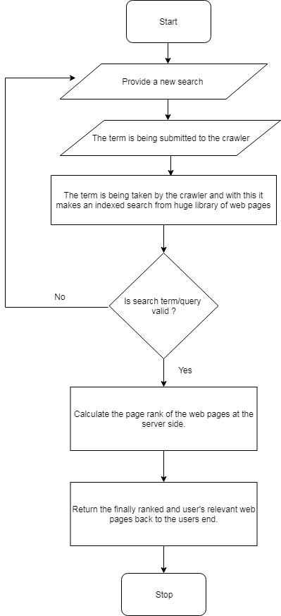

*Figure 2: System Flow Chart*

10

The diagram in Figure 2 shows the system flowchart of the project **“**e-Kanoon**”**. The flowchart describes the procedures of search input, data extraction and result output. In this flowchart, the author has prepared a pictorial definition and the procedure of how the program works in the form of symbol. The website begins with a search query by the user. The search query is submitted to the system and the crawler crawls the database to check the matching result. If the query matches any law document, the result is shown as output or else an error message is shown to re-enter the query.

**2.2.2 Entity-Relationship diagram (ER Diagram)**

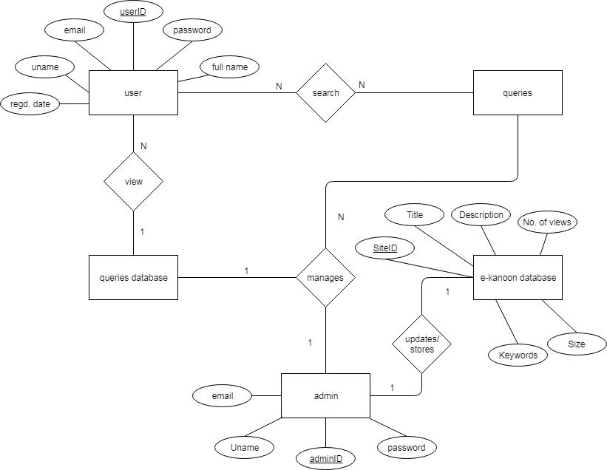

*Figure 3: ER- Diagram*

Figure 3 shows the ER diagram for this system. The ER diagram of e-Kanoon. Firstly, the entity user includes userID as the primary key and other attributes such as gender, address, username. User can search the required legal information from the database which is managed and updated by the admin.

11

**2.2.3 Data Flow Diagram**

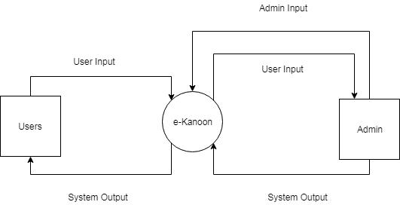

*Figure 4: Context Diagram*

A Context diagram in the figure 4, basically represents a high-level view of the overall system. It defines the system**’**s domain that is under investigation within an environment. A context diagram is a data flow diagram, also called a data flow diagram level 0. It has only one massive central process that represents everything inside the scope of the system. It shows how the system will receive and send data to the external entities involved.

Here, first entity is the user which is responsible for requesting the information and retrieving the information. Second entity is the admin which is responsible for updating all the data and extracting the reports from the system, managing website and checking how the system is working.

12

**2.2.4 Level 1 DFD**

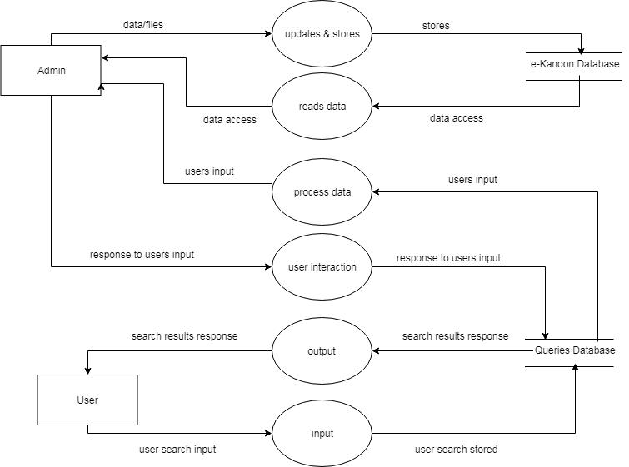

*Figure 5: Level 1 DFD*

Figure 5 illustrates a level-1 Data Flow Diagram of informative website for viewing different information that is provided to the users. The diagram also shows the entity related directly with the website. The diagram represents the actual flow of processes and data in the system. As explained in the Context Diagram, the two entities interact with various processes throughout the system. The processes are follows:

* Search query input.
* Data extraction from the server
* Matching result output

13

**2.2.5 UML State Diagram**

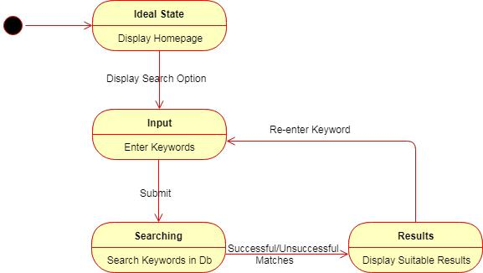

*Figure 6: UML state diagram*

Figure 6 shows the state diagram of the project. Initially the site is in ideal state where the search screen is displayed to the end user. Then the user inputs the search query in next step which gets submitted to the back end. The input keyword is matched with the database to find out the matching results. If query matches the available database, then it is forwarded to the end user as the search results. In case of unmatched results, an error message is sent to the user with the suggestion to re-enter the query in other keywords relating to the query.

14

**2.2.6 Use Case Diagram**

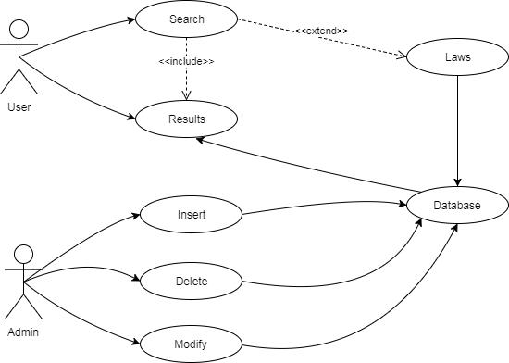

*Figure 7: Use case diagram*

Here, in figure 4, there exists two actors i.e. User and admin. The user can enter the search query and see the matching results. The update facility is only given to the admin. They are the ones who can update the laws, manage website and control login platform that controls over website access.

15

**2.2.7 UML Sequence Diagram**

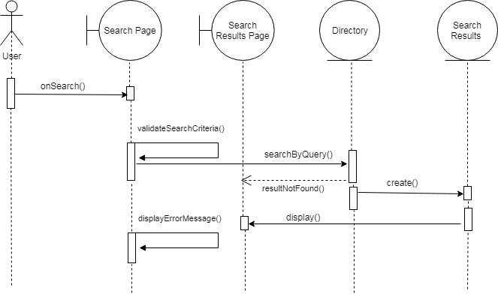

*Figure 8: UML sequence diagram*

16

**2.2.8 UML Activity Diagram**

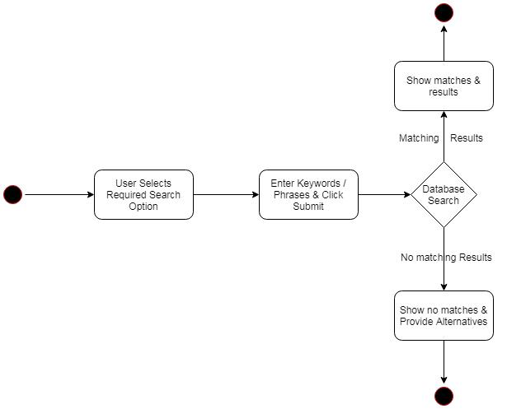

*Figure 9: UML activity diagram*

17

**2.2.9 UML Class Diagram**

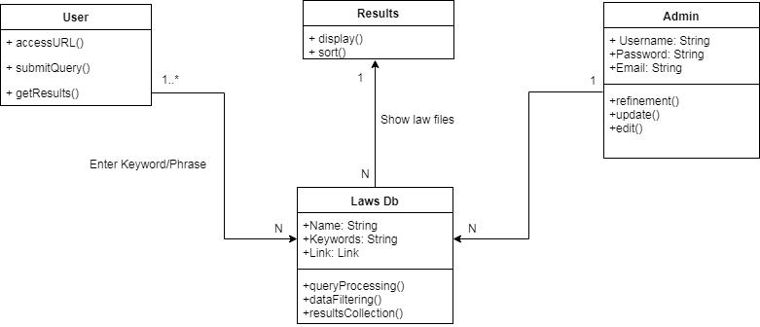

*Figure 10: UML Class Diagram*

**2.2 Analysis of possible solution:**

**2.3.1 Requirement Gathering**

The main objective of this stage is to identify and evaluate the requirements of the proposed system. This stage aims to recognize the user requirements, system requirements, functional and nonfunctional requirements for the project. Evaluation of current situation will also contribute to ensure the availability of trending functionalities (requirements) in the proposed system. The main purpose of it is to describe the functional and non-functional requirement of the project. (rouse, n.d.)

***2.3.1.1 Functional Requirements***

The functional requirement of the system is divided into two categories:

***2.3.1.2 Interface Requirements***

* Accepts alpha numeric multilingual (both Nepali & English) search query
* Retrieve output
* Ability to show matching search results

***2.3.1.3 Regulatory Requirements***

* Admin Authentication
* The system database is limit access to limited admin

***2.3.1.4 Non-Functional Requirements***

The non-functional requirement of the system is divided into:

***2.3.1.5 Performance Requirements***

* The system provides the features of searching the law documents in the system.
* The system also provides the features of updating or deleting the data in the system.

18

***2.3.1.6 Security Requirements***

* There is an admin authentication login to the system.
* The system security is depended on the user.

**2.3.2 Testing**

Testing is evaluation of the software against requirements gathered from users and system specifications. Software system testing identifies important defects, flaws, or errors in the application code that must be fixed. Testing is conducted at the phase level in software development life cycle or at module level in program code. Software testing comprises of Validation and Verification. Testing is executing a system in order to identify any gaps, errors, or missing requirements in contrary to the actual requirements. (tutorialspoint, tutorialspoint, n.d.)

***2.3.2.1 Purpose of Testing***

System testing is a stage of implementation, which is aimed at ensuring that the system works accurately and efficiently as per the user need, before the live operation commences. As started before, testing is vital to the success of a system. System testing makes a logical assumption that if all parts of them as system are correct, the goal will be successfully achieved. A series of tests are performed before the system is ready for the user acceptance test. (schargel, 2011)

***2.3.2.2 Verification and Validation***

Software testing is used in association with verification and validation (V&V). Verification was done for checking of or testing of items, including software, for conformance and consistency with an associated specification. Validation was done for checking what has been specified is what the user actually wanted.

Verification: Have we built the software, right? (i.e. does it match the specification).

Validation: Have we built the right software? (i.e. Is this what the customer wants?

***2.3.2.3 Level of testing***

**a) Unit testing**

Each unit (basic component) of the software was tested to verify that the detailed design for the unit has been correctly implemented. In an Object-oriented environment, this is usually at the class level, and the minimal unit tests include the constructors and destructors.

**b) System testing**

This was done to test a completely integrated system to verify that it meets its requirements. **c) Acceptance testing**

This was conducted by the end-user, customer, or client to validate whether or not to accept the product. Acceptance testing may be performed as part of the hand-off process between any two phases of development.

For testing of the service:

1. All the features of the website are tested by running each function available in the website.
2. The results of the tests conducted on the website are analyzed properly. Only after getting satisfactory results of testing the website can be uploaded on the network i.e. internet. (STF, n.d.)

**2.4 Implementation**

System implementation ensures that the system meets the quality standards. It is the test program that exercises the complete system in its actual environment to determine its capabilities and limitations which also demonstrates that the system is functionally operative, and is compatible with the other

19

subsystems and supporting elements required for its operational deployment. The implementation

phase is where you and your project team actually do the project work to produce the deliverables i.e.

anything your project delivers. The deliverables for your project include all of the products or services

that you and your team are performing for the client, customer, or sponsor, including all the project

management documents that you put together. System implementation specifies how the system is

installed, operated and maintained. It also ensures that the system meets the quality standards. System

implementation is the test program that exercises the complete system in its actual environment to

determine its capabilities and limitations which also demonstrates that the system is functionally

operative, and is compatible with the other subsystems and supporting elements required for its

operational deployment. (Margaret, 2014)

Software for system implementation:

Software for the system implementation:

|  |  |  |
| --- | --- | --- |
| **Software** |  | **Description** |
| XAMPP |  | Cross-platform standalone server that integrate |
|  |  | the Apache server and MySQL database system. |
|  |  |  |
| MySQL |  | Database interface. |
| Microsoft Word |  | Purposely for documentation |
| Microsoft Excel |  | Purposely for documentation |
|  | *Table 4: Software used for system implementation* | |

|  |  |  |
| --- | --- | --- |
| **Software** |  | **Description** |
|  |  |  |
| Microsoft Windows 10 |  | Operating System |
| Apache |  | Application Server |
|  |  |  |
| MySQL |  | Database Server |
|  | *Table 5: Software for system implementation (server)* | |

|  |  |
| --- | --- |
| **Software** | **Description** |
|  |  |
| Any Web Browsers (Mozilla Firefox, Internet | Browser to run the website online. |
| Explorer, Opera, Netscape Communication) |  |
|  |  |

*Table 6: Software for system implementation (clients)*

|  |  |
| --- | --- |
| Hardware for the system implementation: |  |
| **Hardware** | **Description** |
|  |  |
| Personal computer with minimum requirement: | For development, store application and database |
| **•** 512 MB RAM | and system testing. |
| **•** 80 GB Hard Disk |  |
|  |  |
| Printer | To print report |
|  |  |

*Table 7: Hardware for system implementation*

20

|  |  |  |
| --- | --- | --- |
| **Hardware** | | **Description** |
| Personal computer with minimum required: | | To store application and database. |
| **•** | 512 MB RAM |  |
| **•** | 80 GB Hard Disk |  |

*Table 8: Hardware for system implementation (server)*

21

**CHAPTER III– DISCUSSIONS AND CONCLUSION**

**3.1 Findings/Result:**

3.1.1 Home Screen

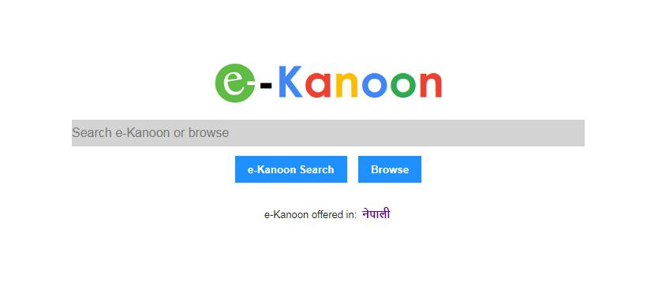

*Figure 11: e-Kanoon: English version homepage*

3.1.2 Search Results Page

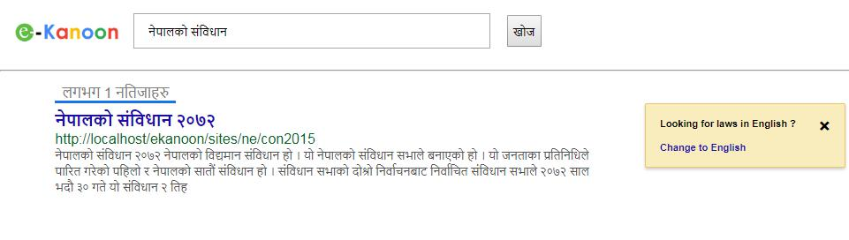

*Figure 12: Search results display page in Nepali version of site*

22

3.1.3 Individual Result Page

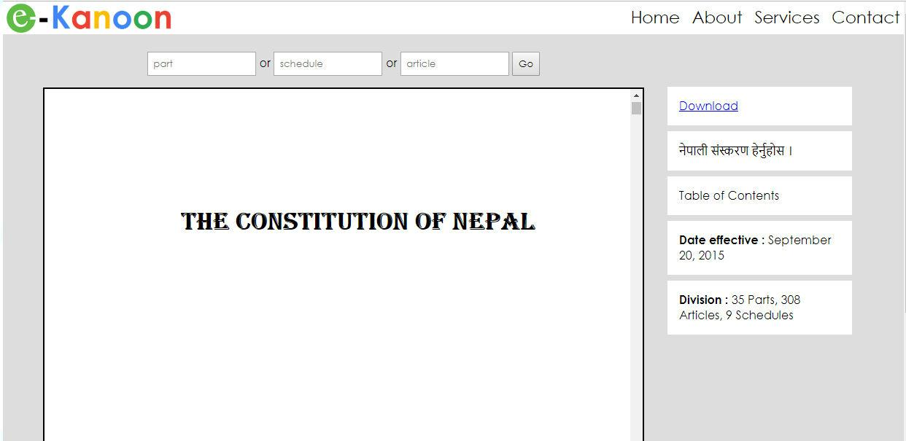

*Figure 13: Law Document view page in English*

23

**3.2 Code Screenshots**

3.2.1 Index.php

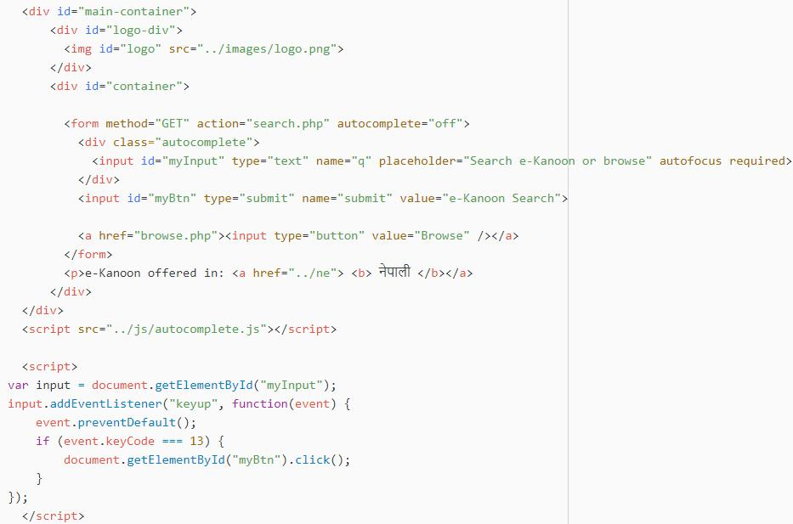

*Figure 14: Homepage search function code*

24

3.2.2 Search.php

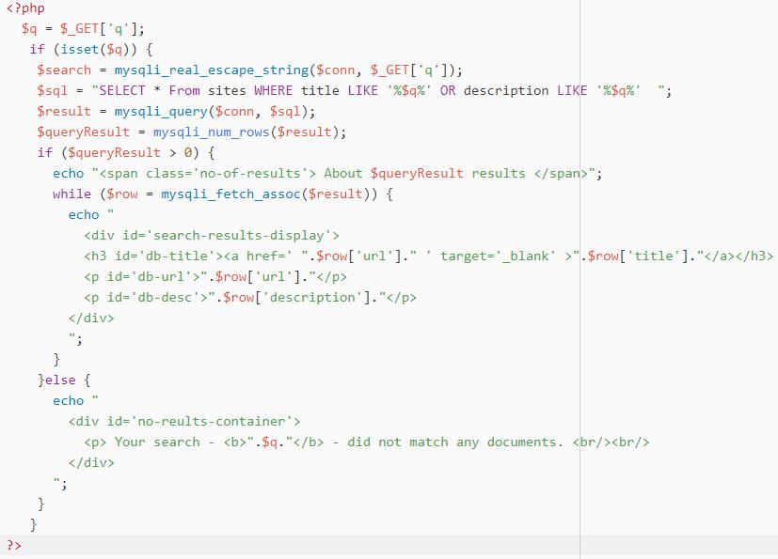

*Figure 15: Search results display page php code*

25

3.2.3 Autocomplete.js

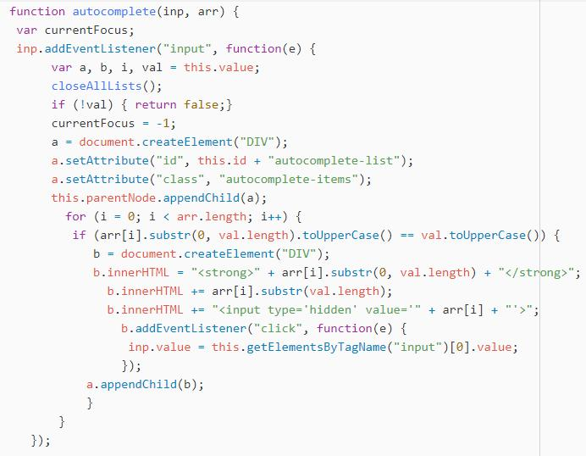

*Figure 16: Search box autocomplete feature js code*

**3.3 Critical Analysis**

Law has been one of the major concern in the globalization era. There are many online projects taken out to uplift the standard of Nepalese people in the field of legal system, which helps in understanding of rights and privileges of empowered by the law. However, the concept is somewhat new to the developing country like Nepal. Slow and steady steps in the right direction are enough to bring greatness ahead. Though there are many project launched by Nepalese tech people for the legal development of Nepal. They are not well effective enough.

The project consists of platform for looking the suitable and most applicable acts. The process of creating web page is free of cost and easier to handle. Using this project, it makes work lot easier and cheap. However, there are some limitation on providing legal information which could be enhanced in upcoming time. The layout design of the system is kept simple for user friendliness.

Many might raise questions like why this system is important. Well, the answer is simple, this system aims to involve as many legal resources as possible. This system is mainly focused on legal purpose. This project has been developed in a limited time due to which there are a lot of rooms for improvement which shall take place with the course of time in future.

26

**3.4 Limitations and Future Enhancements**

Though a lot of effort and study has been invested on this project, this project still lags in few places, which can be improved in the future. Some of the limitations of the project are:

1. Use of third party website for calibration
   * This project uses other sites for extracting the law documents used as the main ingredient of this site.
2. Since this project is based on law repository, it is focused on central and state laws only.

On the basis of the given limitations following would be the future enhancements:

1. Court judgements can be further added in the site so as to create a meaningful understanding of real time legal practices in the nation.
2. Court, law firms and lawyers**’** directory can be much more helpful for the people.

**3.5 Conclusion**

In this project, the site **‘**e-Kanoon **’**have been successfully implemented. With the help of various coding tools, I have been able to provide a site which was to ensure that this product could be valid in today real challenging world. This had helped to take care of the needs of both the users as well as the administrator.

This project is being developed in the hope to solve the current issues of the legal condition of Nepal. The situation of global era of media is changing. It is demanding more of legal changes than any other thing. It is really hard to keep up with all of that hence, a medium is a must. Thus, a service e-Kanoon is established putting those values before us that offer to enrich the lives of people and keep them up with legal practices. The law database will be updated according to the real time law update in the nation for faster performance. The aim of the project is to provide the overall legal information online in Nepal. It makes an ease for every individual to sort out their issues regarding best and applicable laws. Administrative module provides administrator related functionality. Administrator manages all information and has access rights to add, delete, edit and view the data related. Users of this application can search the central and state laws of Nepal.

This project has helped me in numerous stages. After completion of the project I am well known about various programming languages that are used for development of website. During the development phase we had to face various obstacles helped to build self-confidence on project management issues.

To sum up, e-Kannon: a service is designed to introduce the rights and privileges empowered by the nation to the common people and help them search the applicable law and even the section within that particular law document for effective and efficient law practices in Nepal.

27

**References**

trout, c. (2008). *engadget*. Retrieved from engadget: https://www.engadget.com/2017/10/05/what-to-expect-from-the-engadget-experience-our-immersive-art/

Black, N. (2014, October 6). *Teaching technology to the "Techie" generation.* Retrieved from

Wildapricot:

https://maall.wildapricot.org/Resources/Documents/TEACHING%20TECHIE%20GENERAT

ION.pdf

Cabral, J. E., Chavan, A., Clarke, T. M., & Greacen, J. (2012). Using technology to enhance access to justice. *Harvard Journal of Law & Technology*.

codeacademy. (2014). *codeacademy*. Retrieved from codeacademy:

https://www.codecademy.com/learn/introduction-to-javascript

Dierer, T. (2005). Law and Information Technolog - An Uneasy Marriage or Getting Along with Each Other? *Information & Communications Technology Law*.

draw.io. (n.d.). *draw.io*. Retrieved from draw.io: https://www.draw.io/

Drechsler, W., & Kostakis, D. (2014). Should Law Keep Pace With Technology? *Bulletin of Science,* *Technology & Society*.

Eijk, N. v. (2010). Search Engines: Seek and Ye Shall Find? The Position of Search Engines in Law.

*IRIS : Legal Observations of the European Audiovisual Observatory*.

Jenkins, J. (2008). What Can Information Technology Do For Law ? *Harvard Journal of Law &* *Technology* .

Johnson, C. (2009). Leveraging technolofy to deliver legal services. *Harvard Journal of Law &* *Technology* .

Kane, S. (2018). Legal Technology and the Modern Law Firm. *Legal Careers*.

Margaret. (2014, 11 22). *techtarget*. Retrieved from techtarget:

http://searchcrm.techtarget.com/definition/implementation

meram. (n.d.). *merriam-webster*. Retrieved from merriam-webster: https://www.merriam-webster.com/dictionary/systems%20analysis

pmi.org. (2015). *PMI*. Retrieved from PMI: https://www.pmi.org/about/learn-about-pmi/what-is-project-management

Rouse, M. (2009). *techtarget*. Retrieved from techtarget:

http://searchcio.techtarget.com/definition/project-management

rouse, m. (n.d.). *searchsoftwarequality*. Retrieved from searchsoftwarequality:

http://searchsoftwarequality.techtarget.com/definition/requirements-analysis

Sagar, A. (2011). The Future of Legal Search: Meeting Lawyer Requirements by Delivering More Contextually-Sensitive and Relevant Results. *Cognizant*.

28

schargel, F. (2011, 01 11). *huffpost*. Retrieved from huffpost:

https://www.huffingtonpost.com/franklin-schargel/what-is-the-purpose-of-te_b_1066144.html

sheppy. (2017). *developer*. Retrieved from developer: https://developer.mozilla.org/en-US/docs/Web/Guide/HTML/HTML5

skysnake. (2009). *php.net*. Retrieved from php.net: http://php.net/manual/en/intro-whatis.php

STF. (n.d.). *Softwaretesting*. Retrieved from Softwaretesting:

http://softwaretestingfundamentals.com/software-testing-levels/

tutorialspoint. (2017). *tutorialspoin*. Retrieved from tutorialspoin:

https://www.tutorialspoint.com/css/css3_tutorial.htm

tutorialspoint. (n.d.). *tutorialspoint*. Retrieved from tutorialspoint:

https://www.tutorialspoint.com/software_testing/

29