**APPENDIX**

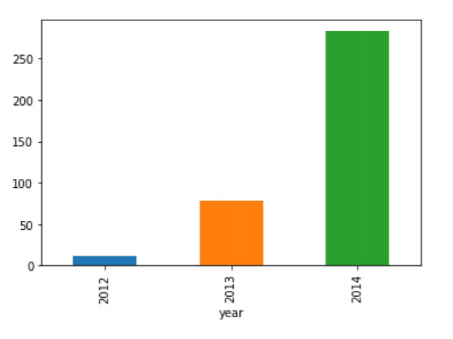

Figure 9. 1: Increasing traffic as year pass by (Hypothesis 1).

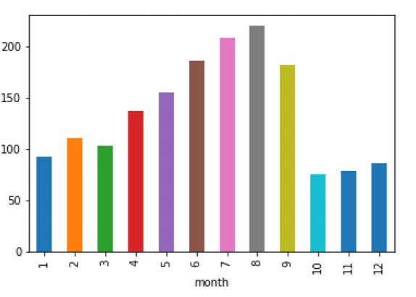

Figure 9. 2: Traffic will increase in May to October (Hypothesis 2).

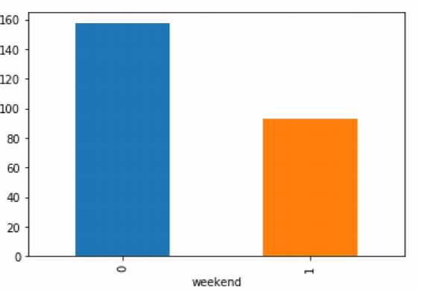

Figure 9. 3:Weekend (1) and Weekdays (0) (Hypothesis 3).

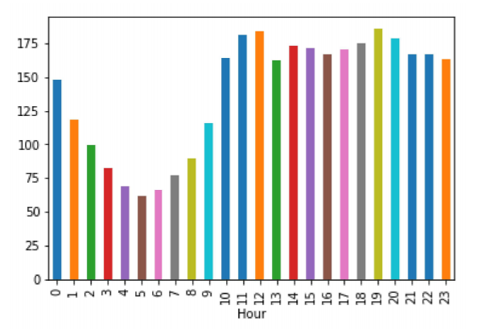

Figure 9. 4: Traffic will be more during peak hour (Hypothesis 4).

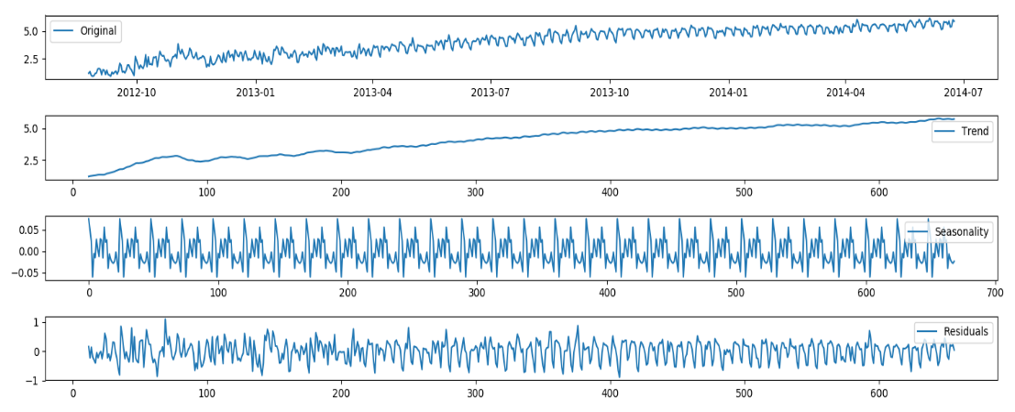

Figure 9. 5: Subplots (Original, Trend, Seasonality and Residuals).

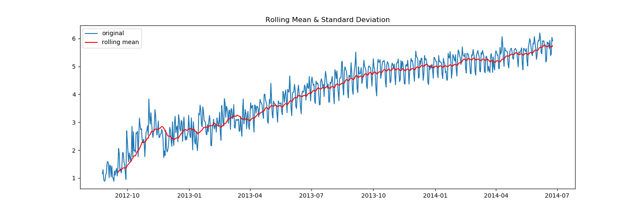

Figure 9. 6: Rolling mean of trained data set.

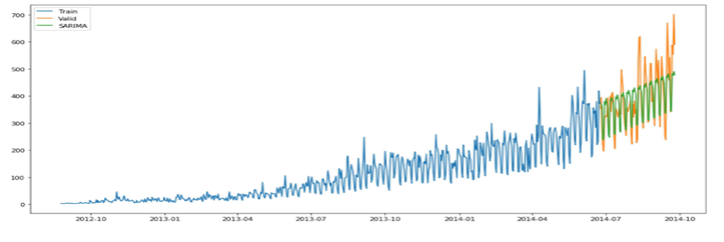

Figure 9. 7: Insertion of validation model data set in test data set.

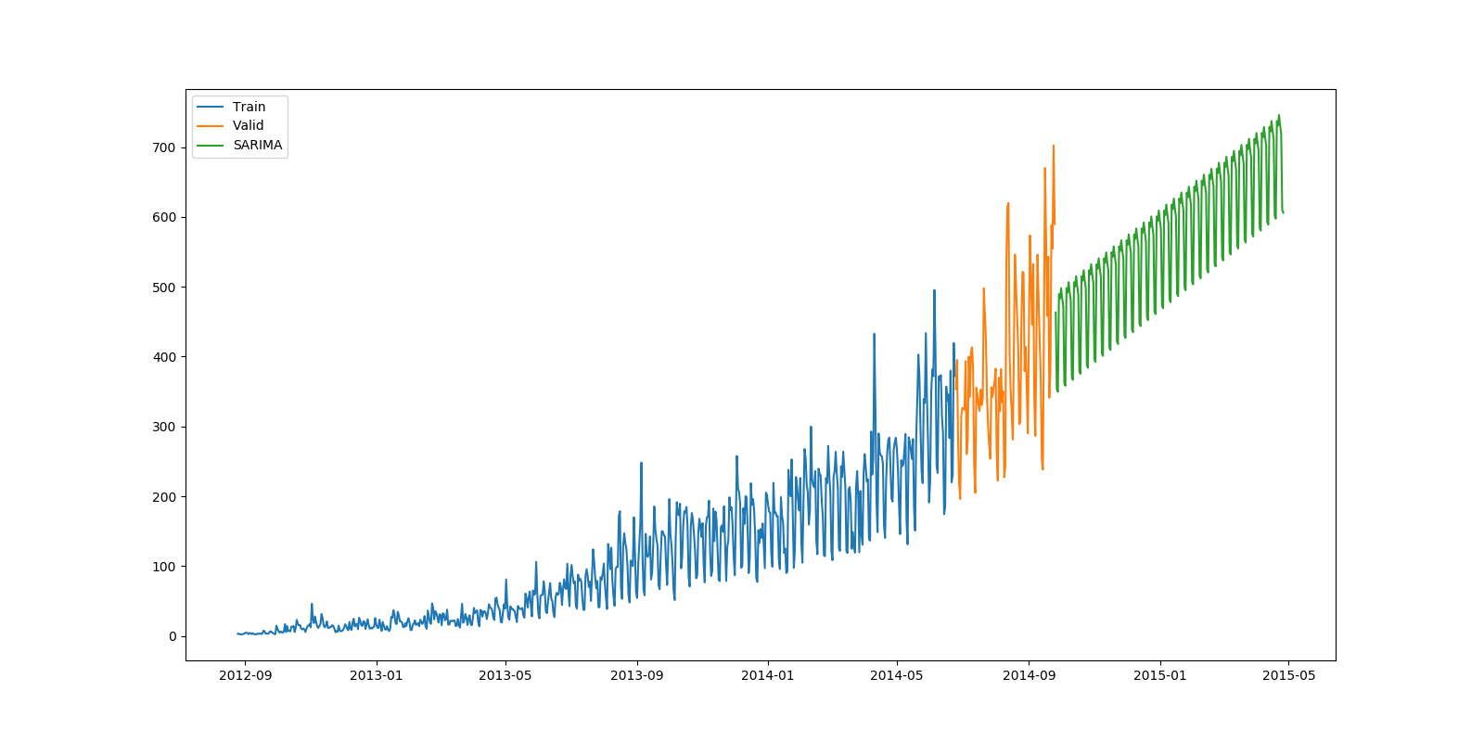

Figure 9. 8: Prediction of data according to model.