

**Chessnut**© **User Manual**

**Version 1.0**

By: Overcompens8 © (Team 8)

**Authors:**

Kevin Flaieh

Bibek Adhikari

Jose Fregoso

Nicholas (Grant) Carson

Andrew Dertli

**Affiliation**: University of California, Irvine

**Table of contents**

**Glossary Page No.**

1. **Computer Chess** …………………………………………………………………….4-5

1.1. Usage scenario…………………………………………………………………… 4

1.2. Goals ………………………………………………………………………………. 5

1.3. Features……………………………………………………………………………..5

**2. Installation** ……………………………………………………………………………..6

2.1 System requirements………………………………………………………………6

2.2 Setup and Configuration…………………………………………………………...6

2.3 Uninstalling ………………………………………………………………………….6

**3. Chess Program Functions and Features**…………………………………………..7

3.1. Computer player …………………………………………………………………..7

3.2. GUI…………………………………………………………………………………..7

3.3. Timer………………………………………………………………………………...7

3.4 Withdraw one move……………………………………………………………….7

3.5 Human Log…………………………………………………………………………7

3.6 Choose your color…………………………………………………………………7

**4. Copyright**………………………………………………………………………………..8

**5. Error messages**………………………………………………………………………...9

**6.** **Index**……………………………………………………………………………………10

**Glossary**

**B**

**Bishop:**move diagonally across the board.

**C**

**Castling:**is a special move in the game of chess involving the king and either of the original rooks of the same color. It is the only move in chess (except promotion) in which a player moves two pieces at the same time. Castling consists of moving the king two squares towards a rook on the player’s first rank (row), then moving the rook onto the square over which the king crossed. Castling can only be done if the king has never moved, the rook involved has never moved, the squares between the king and the rook involved are not occupied, the king is not in check, and the king does not cross over or end on a square in which it would be in check.

**E**

**En passant**: is a special pawn capture which can occur immediately after a player moves a pawn two squares forward from its starting position, and an enemy pawn could have captured it had the same pawn moved only one square forward. The opponent captures the just-moved pawn as if taking it "as it passes" through the first square. The resulting position is the same as if the pawn had moved only one square forward and the enemy pawn had captured normally. The en passant capture must be done on the very next turn, or the right to do so is lost. Such a move is the only occasion in chess in which a piece captures but does not move to the square of the captured piece. If an en passant capture is the only legal move available, it must be made.

**K**

**King:**can move in any direction, but only one step at a time. Also, the king must never move into check. There is also a special "castling" move for the king.

**Knight:** jump to eight different squares which are two steps forward plus one step sideways from its current position.

**P**

**Pawn:**move only forward towards the end of the board, but captures sideways. From its initial position, a pawn may make two steps, otherwise only a single step at a time. If the pawn reaches the end of the board, it is automatically promoted to another piece (usually a queen). There is also a special "en passant" move for the pawn.

**Q**

**Queen:**move diagonally across the board.

**R**

**Rook:** move horizontally and vertically across the board

1. **Computer Chess**

**1.1 Usage scenario**

Initial Setup of the Game. You select which color of the pieces you’d like to play.

Figure 1: Settings Window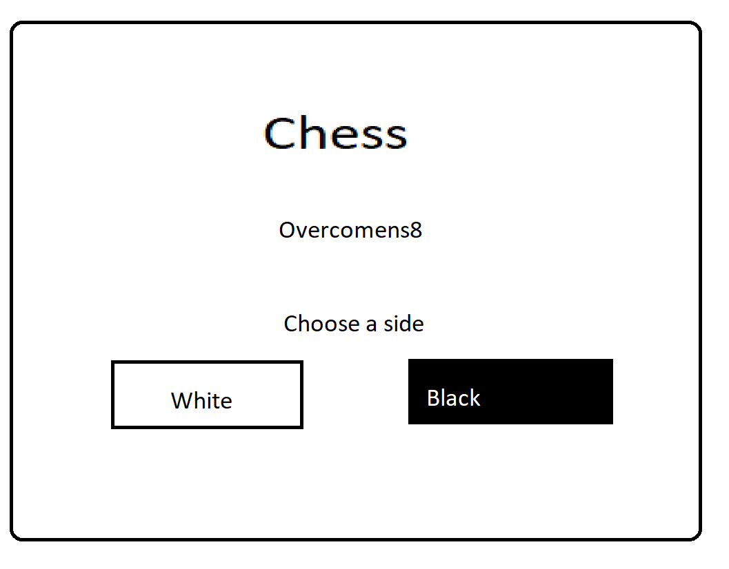

The following image shows the chessboard with all its corresponding pieces. On the right hand side there is a log that will trace previous movements by the user.

**Figure 2: Game Board**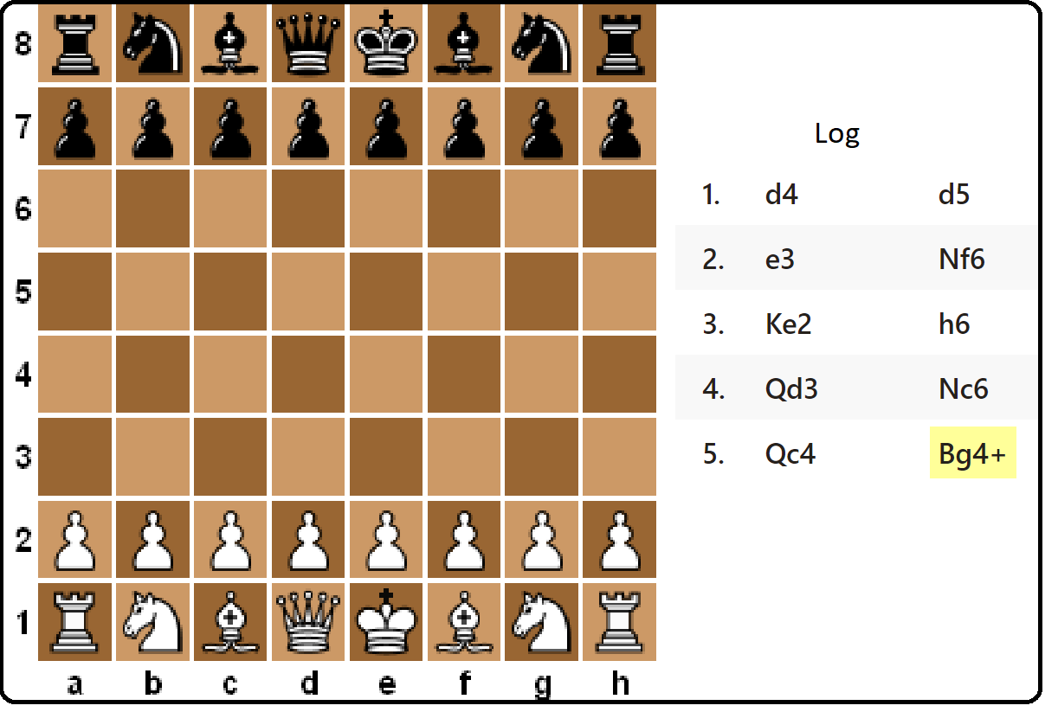

**1.2 Goals of the game**

**Threatening your opponent’s King:**

Once a king is at a reach of a piece of the enemy, but is still free to move to any square around him, we say that that King is in **Check** mode. There are three ways to move out of Check:

* Capture the checking piece.
* Get any of the pieces (on the Checked King’s side) to block the opponent’s attack. (Except for the Knight, which cannot be blocked).
* Simply move the King away from check.

**Get your opponent on Checkmate:**

The ultimate goal of chess is to put your opponent’s King in **Checkmate** mode. In order to do that there are two conditions that have to be met; all movements of the King have to be blocked (put your opponent on Check mode); and there has to be no way for the opponent to get out of Check in only one movement. Checkmate immediately ends the game and the player on Check mode loses.

**1.3 Features**

**Choose your color:**

The player will be able to choose its pieces color (from Black or White).

**Timer:**

There will be a countdown time for each player to take their turns. If the clock gets to 0, the current player’s turn will be skipped.

**Undo one movement:**

The current player will be able to undo their last movement.

**Movement Log:**

There will be a visible table that will show any movements done by the player’s pieces.

**Player vs Player:**

A mode to play a match of chess with two human players!

**Computer vs Computer:**

The ability to watch a game of chess with two computer players going head to head!

1. **Installation**

**2.1 System Requirements**

* **Operating System:** Linux CentOS 6.9
* **Disk Space:** 20 MB free.
* **RAM:** 512 MB or more highly recommended.
* **CPU:** Single core Intel processor or better

**2.2 Setup and configuration**

To install this software, copy the Chess_V1.0.tar.gz and Chess_V1.0_src.tar.gz file from the host server to your personal Linux server using the *~cp* command.

**2.3 Uninstalling**

To uninstall this software, type:

*rm Chess_V1.0.tar.gz Chess_V1.0_src.tar.gz*

into the command line from the directory where those files are installed.

1. **Chess Program Functions and Features**

**3.1 Computer player**

The user will be able to play a game against the computer. This will make the game more fun for solo players.

**3.2 GUI**

The program shows a game interface where the player can see the game board and make moves. The user will be able to click anywhere on the board where there is a piece and then click the next place where they want to make a move. If a movement is legal, the piece will move to the destination box. (For legal movements check the glossary)

**3.3 Timer**

The program will provide clocks for both players so that player can make moves in reasonable time (less than 1 minute per move). If the time runs out, the player at action will be skipped.

**3.4 Withdraw one move**

The player at action will be able to withdraw one movement made by him..

**3.5 Human Readable log**

The program keeps a human readable log of all the moves on the right hand side of the board.

**3.6 Choose your color**

The user will be able to select the color of pieces they wish to play from the provided colors white or black.

1. **Copyright**

* *Goals of chess* were based on those written by www.[Flyordie](https://www.flyordie.com/games/help/chess/en/games_rules_chess.html).com [(Link)](https://www.flyordie.com/games/help/chess/en/games_rules_chess.html)**.**
* *Title page image* was retrieved from[www.pexels.com](http://www.pexels.com)as a free for commercial and/or personal use image.
* Overcompens8 © 2018
* This piece of Software is the sole property of Overcompens8 ©. You, the end user, have been given permission to use the software.

1. **Error Messages**

Note to the End user: This software has been written by students, therefore, we are not responsible for any glitches, or other errors that may occur.

1. **Index**

Bishop,3

Castling,3

Check,3,6,

Checkmate,6

En Passant,3

King,3,6

Knight,3,6

Pawn,3

Queen,3

Rook,3,4

Installation,6

Features, 7