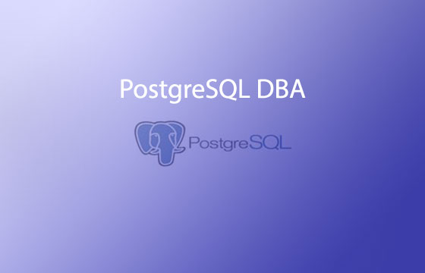

1.Create user test and grant permission to crud on employees table of hr database.

2. prepare well document about the back and restore in PostgreSQL database

1. Physical backup

2. Logical backup

3. how to setup Incremental backup in PostgreSQL.

Guidelines for hint:

1. Firstly must be completed full backup

2. incrementally backup

4. write the advantage and disadvantage of full backup and incremental backup