**Steps to Create an ERD (E-R Diagram)**

Following are the steps to create an ERD.

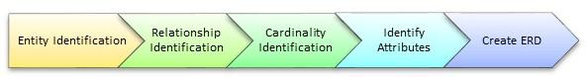

Let's study them with an example:

In a university, a Student enrolls in Courses. A student must be assigned to at least one or more Courses. Each course is taught by a single Professor. **To maintain instruction quality, a Professor can deliver only one course**

**Step 1) Entity Identification**

We have three entities

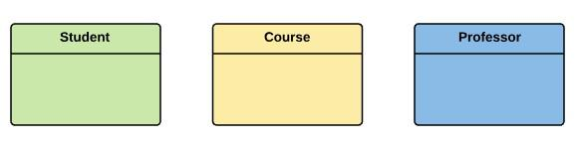Student Course Professor

**Step 2) Relationship Identification**

We have the following two relationships

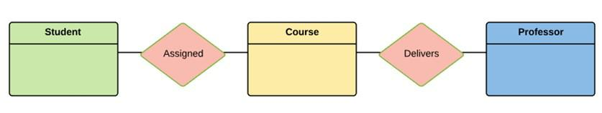The student is assigned a course Professor delivers a course

**Step 3) Cardinality Identification**

For them problem statement we know that,

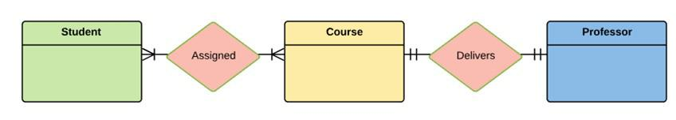A student can be assigned multiple courses A Professor can deliver only one course

**Step 4) Identify Attributes**

You need to study the files, forms, reports, data currently maintained by the organization to identify attributes. You can also conduct interviews with various stakeholders to identify entities. Initially, it's important to identify the attributes without mapping them to a particular entity.

Once, you have a list of Attributes, you need to map them to the identified entities. Ensure an attribute is to be paired with exactly one entity.

Once the mapping is done, identify the primary Keys. If a unique key is not readily available, create one.



|  |  |  |
| --- | --- | --- |
| Entity | Primary Key | Attribute |
| Student | Student_ID | StudentName |
| Professor | Employee_ID | ProfessorName |
| Course | Course_ID | CourseName |



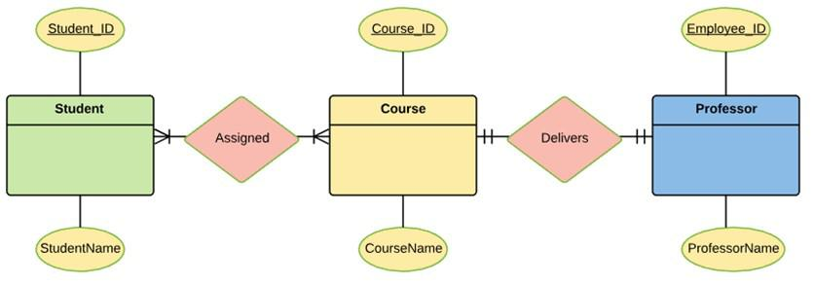

For Course Entity, attributes could be Duration, Credits, Assignments, etc. For the sake of ease we have considered just one attribute.

Step 5) Create the ERD

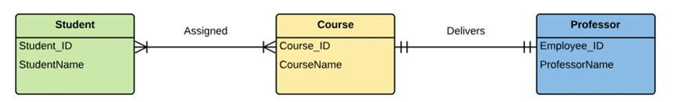A more modern representation of ERD Diagram

**Best Practices for Developing Effective ER Diagrams**

* Eliminate any redundant entities or relationships
* You need to make sure that all your entities and relationships are properly labeled
* There may be various valid approaches to an ER diagram. You need to make sure that the ER diagram supports all the data you need to store.
* You should assure that each entity only appears a single time in the ER diagram
* Name every relationship, entity, and attribute are represented on diagram
* Never connect relationships to each other
* You should use colors to highlight important portions of the ER diagram