Incremental Backup in MySQL

Backing up a MySQL database regularly is an important task of any system administrator to prevent data loss in case of application bugs or system failure. There are two types of backup full and incremental. A full backup contains a collection of all MySQL queries. A full backup is not a recommended solution for a large backup. An incremental backup is a type of backup that only saves data that has been changed or created since the previous backup activity was conducted. incremental backup saves the storage space and uses fewer resources. To setup incremental backup in MySQL we have to follow below steps:-

Step -I : open and modify mysqld.cnf file

nano /etc/mysql/mysql.conf.d/mysqld.cnf

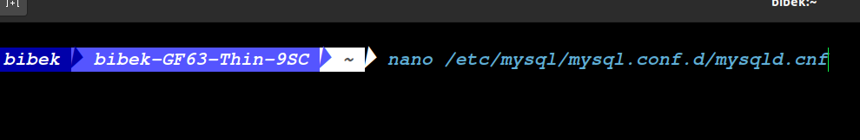

Add or modify the following lines:

log_bin = /var/log/mysql/mysql-bin.log
expire_logs_days = 10
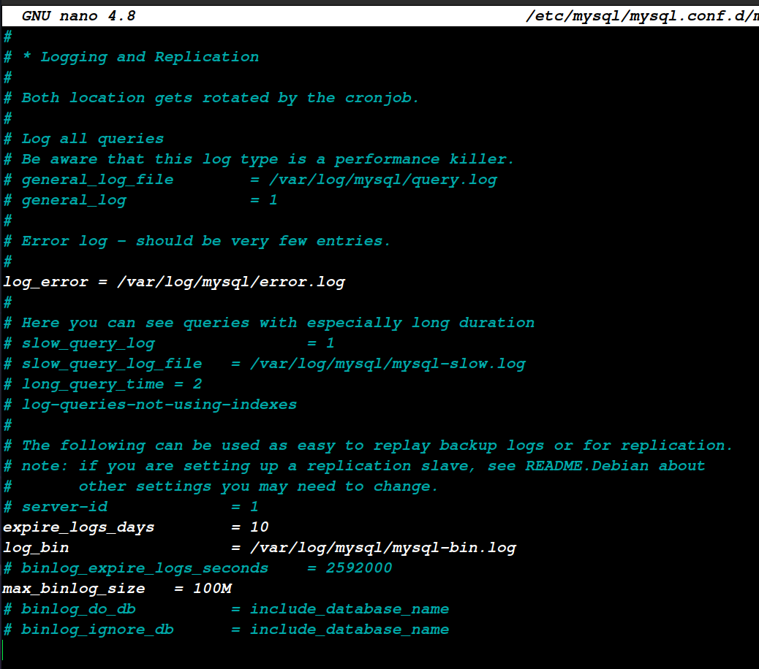
Save and close the file then restart the MySQL service to apply the changes:
systemctl restart mysql

Now, check the MySQL binary log with the following command:

ls -l /var/log/mysql/

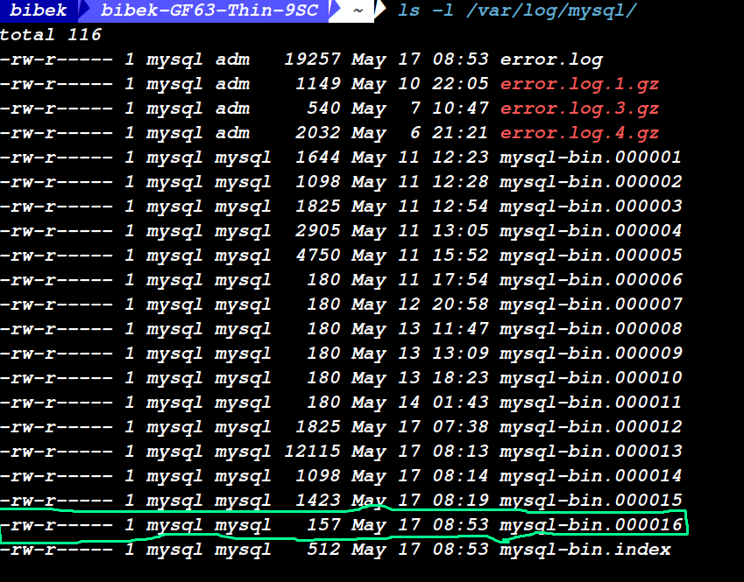
As you can see, mysql-bin.000016 is a MySQL latest binary log file. All changes in all MySQL databases will be stored in this file.

Step -II :- Create a Database and Table

Next, we will create a test database, table and insert some rows in the table.
First, connect to MySQL with the following command:

--------------------------------*--------------------------*---------------------*----------------
mysql
---------------------------------*----------------------------*-----------------------*------------
Once you are connected, create a database name mydb with the following command:

--------------------------------*--------------------------*---------------------*--------------
mysql> CREATE DATABASE mydb;
--------------------------------*--------------------------*---------------------*---------------
Next, change the database to mydb and create a new table named my_tbl:
--------------------------------*--------------------------*---------------------*--------------
mysql> USE mydb;
mysql> create table my_tbl(
my_id INT NOT NULL AUTO_INCREMENT,
my_field VARCHAR(100) NOT NULL,
submission_date DATE,
time_created TIMESTAMP NOT NULL DEFAULT CURRENT_TIMESTAMP,
PRIMARY KEY ( my_id )
);
--------------------------------*--------------------------*---------------------*----------------
Next, insert some rows with the following command:
--------------------------------*--------------------------*---------------------*-----------------
mysql> INSERT into my_tbl (my_field) VALUES ('val1');
mysql> INSERT into my_tbl (my_field) VALUES ('val2');
mysql> INSERT into my_tbl (my_field) VALUES ('val3');
Next, exit from the MySQL shell:
mysql> exit;

--------------------------------*--------------------------*---------------------*------------------

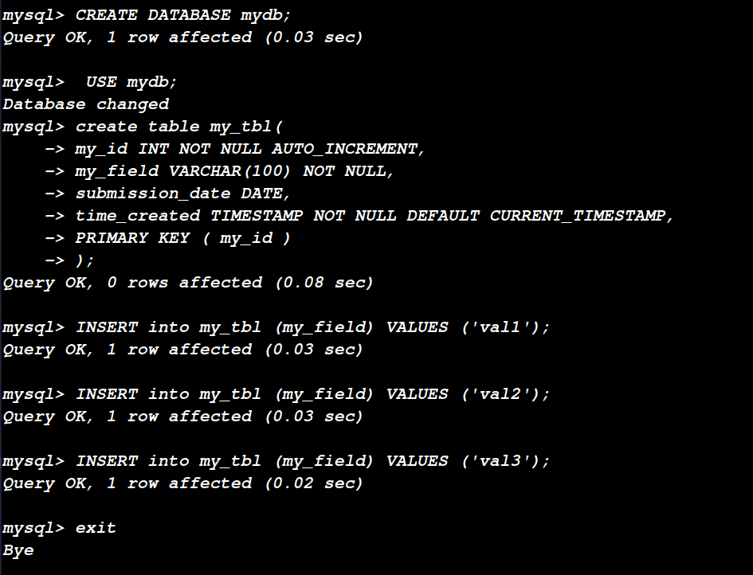

Step III :- Take a Full MySQL Database Backup

--------------------------------*--------------------------*---------------------*------------------

mysqldump -uroot -p mydb --flush-logs > full.sql

--------------------------------*--------------------------*---------------------*------------------

where,
--flush-logs will close current logs (mysql-bin.000016) and create a new one (mysql-bin.000017).
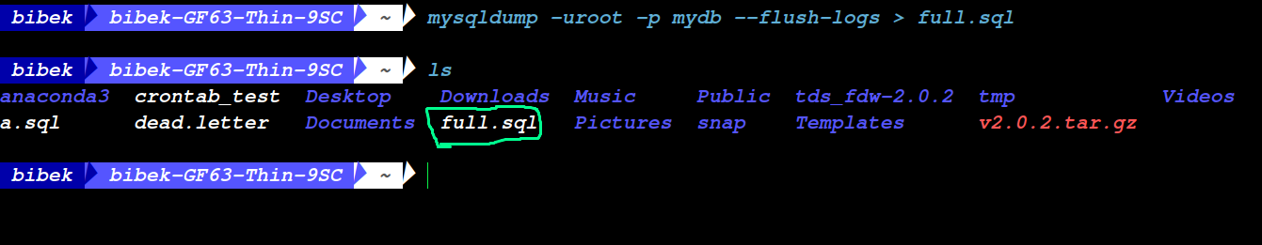
You can check the new MySQL binary log file with the following command:
--------------------------------*--------------------------*---------------------*------------------
ls -l /var/log/mysql/
--------------------------------*--------------------------*---------------------*------------------
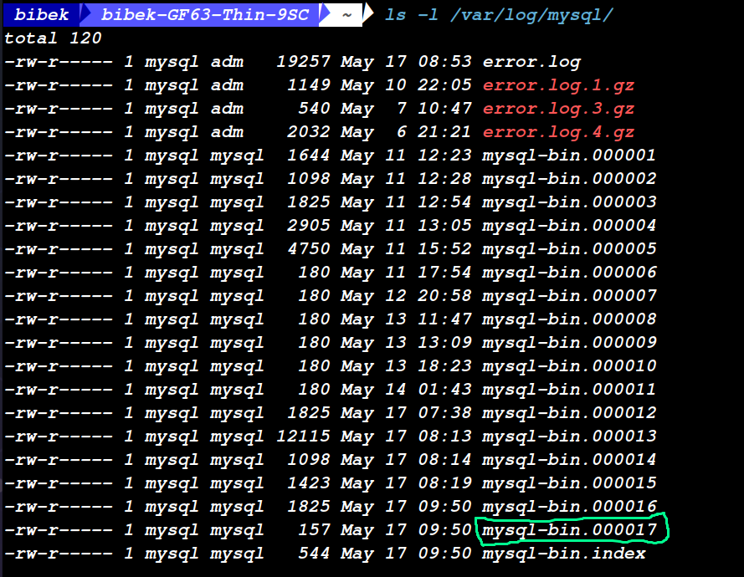

Now, all database changes will be written in mysql-bin.000017 file.

Next, login to MySQL again and insert more rows:
--------------------------------*--------------------------*---------------------*------------------

mysql
mysql> USE mydb;
mysql> INSERT into my_tbl (my_field) VALUES ('val4');
mysql> INSERT into my_tbl (my_field) VALUES ('val5');
mysql> INSERT into my_tbl (my_field) VALUES ('val6');
mysql> exit;

--------------------------------*--------------------------*---------------------*------------------

At this point, we have new database changes saved in the file mysql-bin.000017 after the full backup.

Step IV :- Take an Incremental MySQL Backup

In order to take an incremental backup. You will need to flush the binary log again and save binary logs created from the last full backup.
To flush the binary log, run the following command:

--------------------------------*--------------------------*---------------------*------------------

mysqladmin -uroot -p flush-logs

--------------------------------*--------------------------*---------------------*------------------
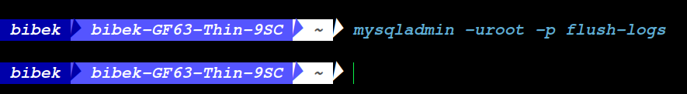
This will close the mysql-bin.000017 file and create a new one. You can check it with the following command:
--------------------------------*--------------------------*---------------------*------------------
ls -l /var/log/mysql/
--------------------------------*--------------------------*---------------------*------------------

You should see the following output:

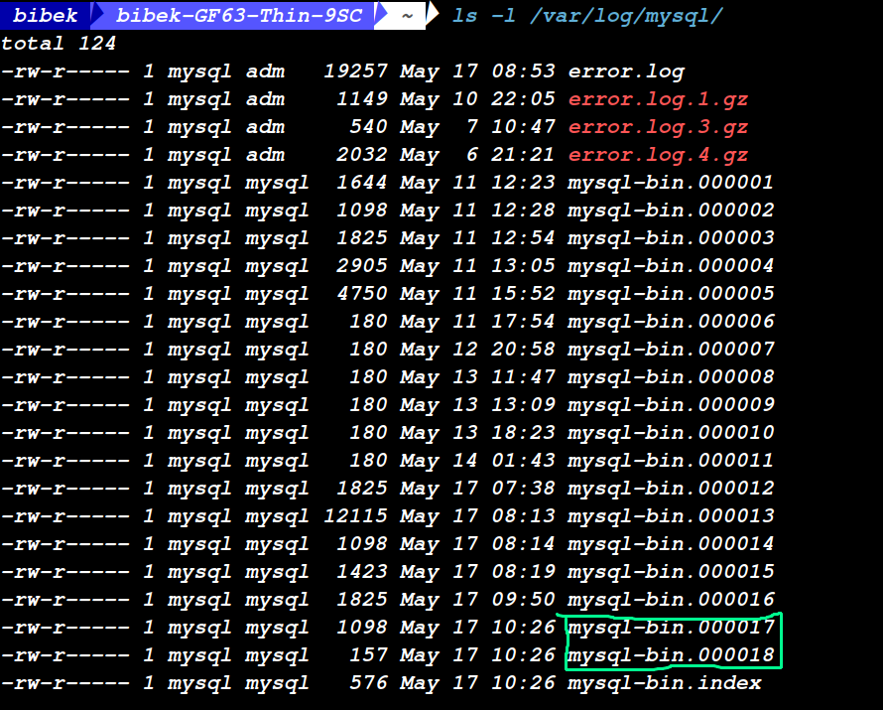

Step V :- Delete a MySQL Database Table Records and Restore it From Incremental Backup
Before Delete
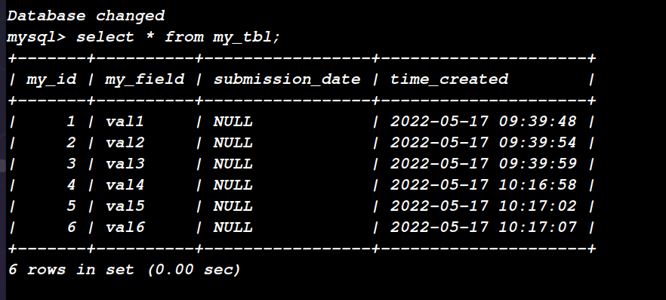
Now, Let’s Delete latest inserted records.
--------------------------------*--------------------------*---------------------*------------------
mysql
use database mydb;
delete from my_tbl where my_id > 3;
--------------------------------*--------------------------*---------------------*------------------

After Delete
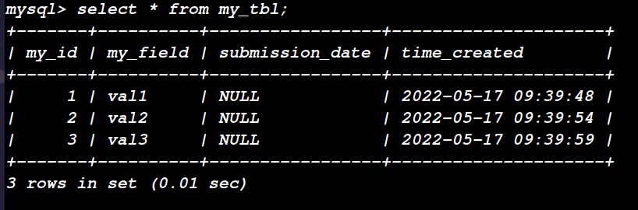
Now Let’s Restore form Binary Log files.

--------------------------------*--------------------------*---------------------*------------------
sudo mysqlbinlog /var/log/mysql/mysql-bin.000017 | mysql -uroot -p mydb

--------------------------------*--------------------------*---------------------*------------------

Step IV :- Login to MySQL again and Verify

You should see that all rows are restored:

