Backup Using Cron Job

What are cron jobs in Linux?
Any task that you schedule through crons is called a cron job. Cron jobs help us automate our routine tasks, whether they're hourly, daily, monthly, or yearly.

Basic command For Cronjob

- crontab -e: edits crontab entries to add, delete, or edit cron jobs.
- crontab -l: list all the cron jobs for the current user.
- crontab -u username -l: list another user's crons.
- crontab -u username -e: edit another user's crons.

Basic Syntax For Cronjob

* * * * * sh /path/to/script/script.sh
| | | | | |
| | | | | Command or Script to Execute
| | | | |
| | | | |
| | | | |
| | | | Day of the Week(0-6)
| | | |
| | | Month of the Year(1-12)
| | |
| | Day of the Month(1-31)
| |
| Hour(0-23)
|
Min(0-59)
For Fixing a proper time you can visit:-
https://crontab.guru/

Backup of postgreSql Using Cronjob
Step I :- crontab -e
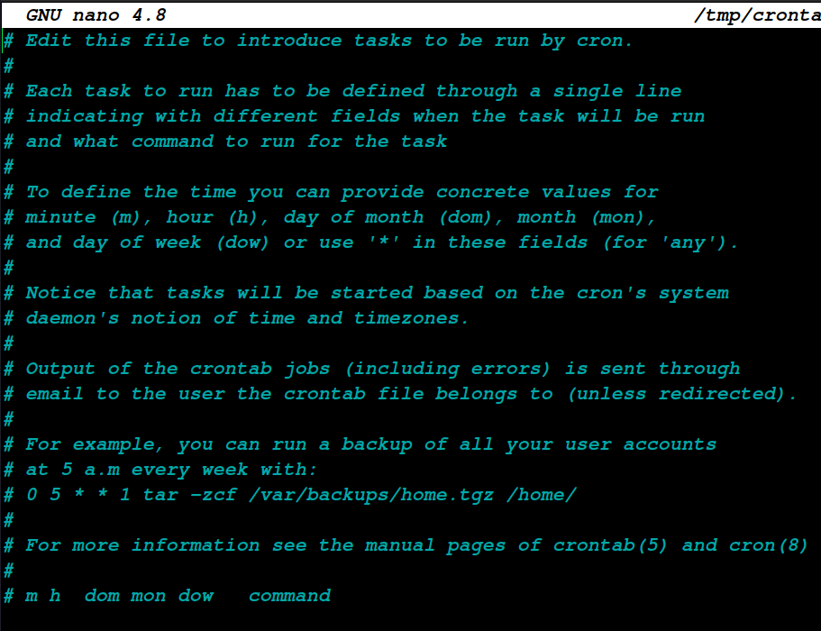
Step II :- 0 5 * * 1 pg_dump "host=localhost port=5432 user=postgres password=Your_db_Password dbname=db_name" > /home/bibek/Desktop/db_name_dump.sql

Explanation→ Taking backup at every week 5 a.m

Backup of Mysql Using Cronjob

Step I:- create a .my.cnf file in a home directory
Step II:- Edit .my.cnf file like this
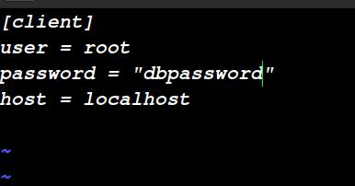

Step III:- create a jobs using crontab -e like this

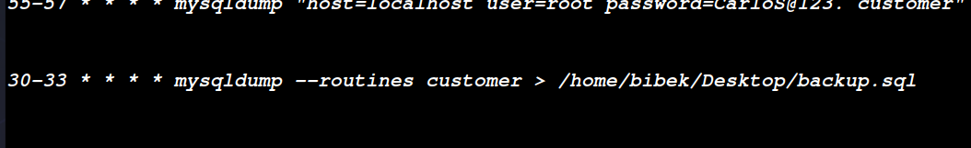

Dynamic PostgreSql Backup using Cronjob

Step I:- Create a bash script like this
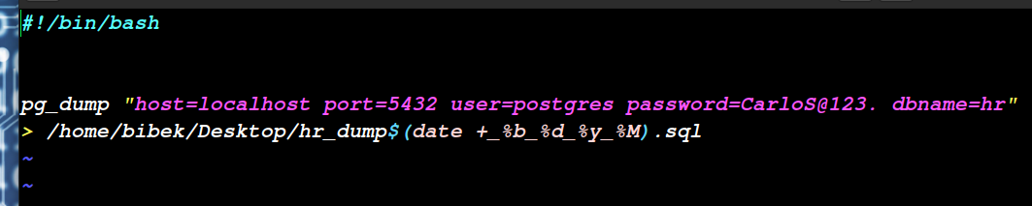

Step II:- create a jobs using crontab -e like this
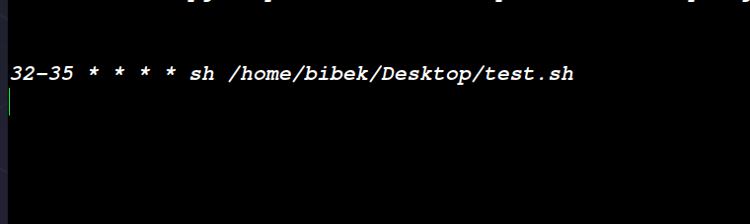
Explanation:- Create a backup at every 32 and 35 min
using name like hr_dump_May_05_22_48.sql

Now files looks like this,

