Send an Email Alert When Your Linux Server Disk Space Gets Low Through Shell Script

Introduction
Linux mail command is a command-line utility that allows us to send emails from the command line. It will be quite useful to send emails from the command line if we want to generate emails programmatically from shell scripts or web applications. The mail command can be used directly by the terminal as well as the Shell script. However, many other commands are available in Linux that can be used to send the emails from the command line such as sendmail, mutt, SSMTP, telnet, and more.

Step I – Install mailutils

To install the mailutils package, execute the below command:

sudo apt install mailutils
The above command will ask for a system password, type the password, and press ENTER key. It will verify the installation, type 'y' to confirm the installation. Consider the below snap of output:

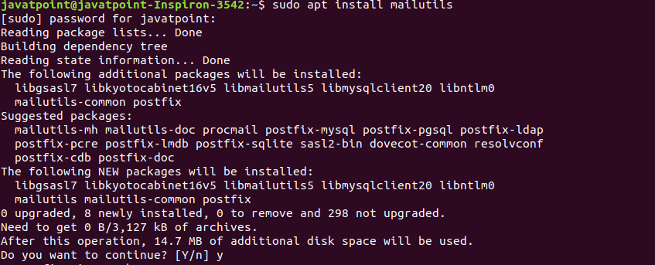

It will start a daemon process and ask for the postfix configuration, select your desired postfix option.
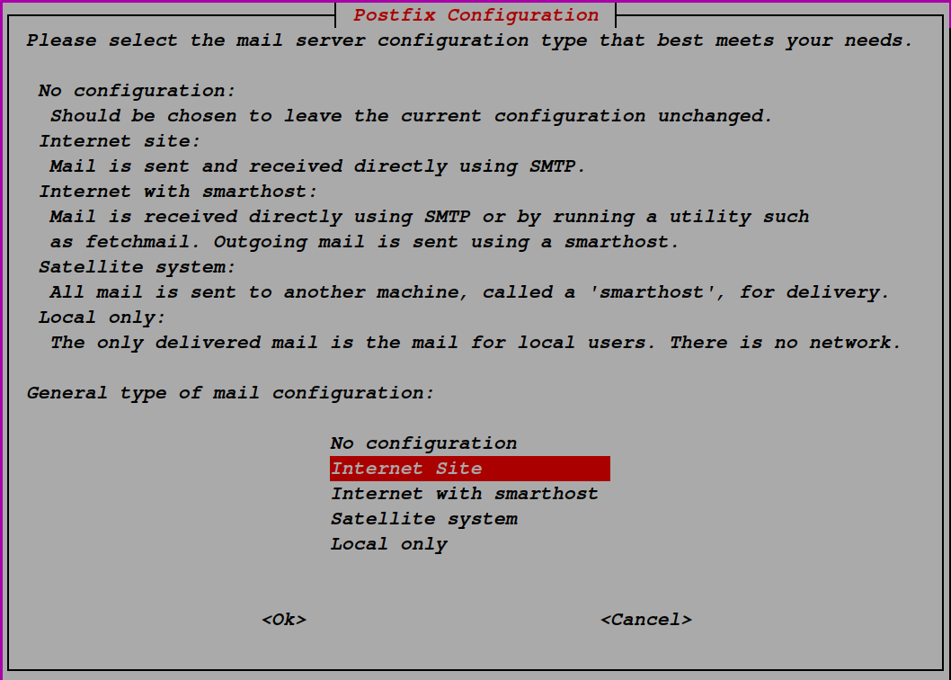

There four postfix options are available for installation. They are as follows:

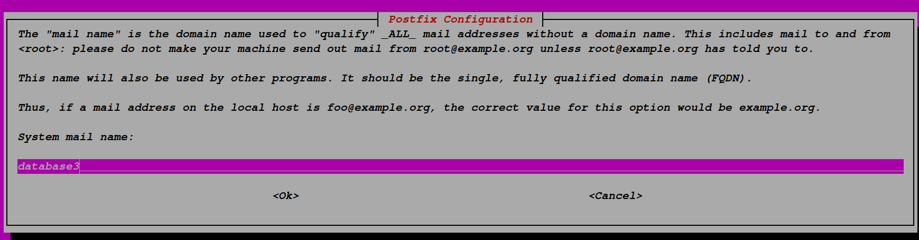

Step -II Create a Linux Script File

create a linux script file with executable permission

sudo touch disk_alert.sh && sudo chmod +x disk_alert.sh

Step -III Open a Script File and Edit

sudo vim disk_alert.sh

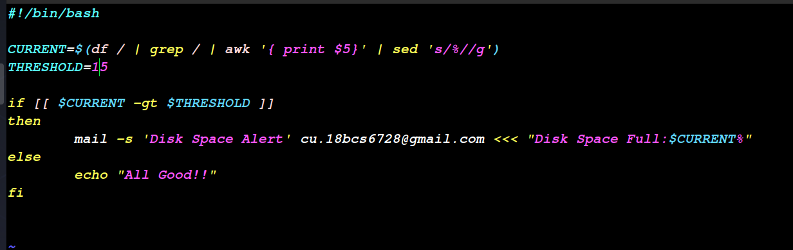

Step -Iv Execute disk_alert.sh File

sudo disk_alert.sh || ./disk_alert.sh

Step -V Output

case -I
if CURRENT < THRESHOLD

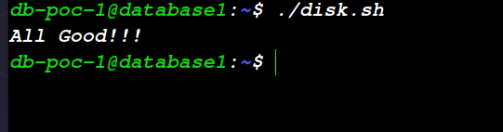
Case -II
if CURRENT > THRESHOLD
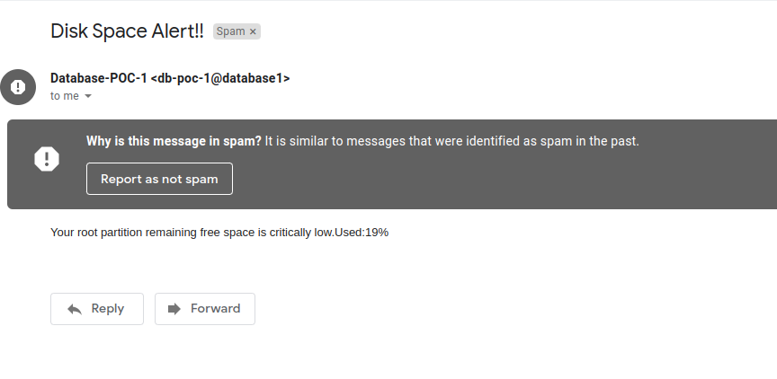

Thank You

