Attendance Marking System Using Face Recognition

Bibek Rawat, Shubham Sah,

Shreyansh Raut, Md Tauhid Alam

Chandigarh University, Gharuan, Punjab

**ABSTRACT**

The face recognition system is developed to be operated in real time, scanning, comparing and giving the desired output with minimal time delays.Whole world and administrators of Educational institutions around the world are concerned about regularity of student attendance. Student’s overall academic performance is affected by the student’s attendance in his institute. Mainly there are two conventional methods for marking attendance and they are: calling students by their names or by taking their’s signature on paper. Both of them are time consuming and inefficient.Hence, there is a requirement of efficient and less time consuming attendance management system which will assist the faculty for maintaining attendance of presence. For this reason we have come up with the idea of Attendance marking using Face recognition. The paper reviews various computerized attendance management system. In this paper basic problem of student attendance management is defined which is traditionally taken manually by faculty. One alternative to make student attendance system automatic is provided by Computer Vision. In this paper we review the various computerized system which is being developed by using different techniques. Based on this review a new approach for student attendance recording and management is proposed to be used for various colleges or academic institutes.

**KEYWORDS:**

*Facial Features, Face Extraction, Face Registration, Normalization of faces, Error correcting output coding, Error Back Propagation algorithm, Face Recognition, Face Database, Face Detection, Face Recognition.*

*Email:- cu.18bcs6728@gmail.com*

**INTRODUCTION**

Organizations of all sizes use attendance systems to record when student or employees start and stop work, and the department where the work is performed. Some organizations also keep detailed records of attendance issues such as who calls in sick and who comes in late. An attendance system provides many benefits to organizations. There was a time when the attendance of the students and employees was marked on registers. However, those who have been a part of the classes when attendance registers were used know how easy it was to abuse such a method of attendance and mark bogus attendances for each other. [3]

Old conventional methods for student attendance is still used by most of the universities. As this method is used, many students are helping their friends by signing in their attendance in case of their absent in the institute. So while this method is used, attendance records are analysed and maintained manually by the faculty to know the present and absent student list. The faculty has to take attendance again if the attendance sheet is being lost and in this case absent students get chance to make their present in new sheet. This procedure, besides being troublesome for lecturer, it will also affect students as time is expended on signing, verifying and submitting the attendance sheet manually.[2]

Of course, technology had to play its role in this field just as well as it has done in other fields. The attendance monitoring system was created and it changed the way attendances were marked. The attendance monitoring system has made the lives of teachers and employers easier by making attendance marking procedure a piece of cake.[3] In present scenario, Human face detection by computer systems has become a major field of interest. Face detection algorithms are used in a wide range of applications, such as security control, video retrieving, biometric signal processing, human computer interface, face recognitions and image database management. Hence, it has become an active area of research at industrial, commercial and defence level.[1]

When it comes to schools and universities, the attendance monitoring system is a great help for parents and teachers both. Parents are never uninformed of the dependability of their children in the class if the university is using an attendance monitoring system. The registers could easily be exploited by students and if information was mailed to the parents, there were high chances that mails could be made to disappear before parents even saw them. With the monitoring system in place, the information can easily be printed or a soft copy can be sent directly to parents in their personal email accounts.[3]The system started with two basic processes - Manual processes and Automatic processes. Manual processes are eliminated as the staff needed to maintain them. It is often difficult to comply with regulation, but an automated attendance system is valuable for ensuring compliance with regulations regarding proof of attendance.[3]

References in abstract and introduction

1. Face Recognition in Real Time for Attendance Marking System Shubhankar Sharma*, Tanushree Gupta, Risheek Kumar
2. Development of a Student Attendance Management System Using RFID and Face Recognition: A Review
3. IMPLEMENTATION OF CLASSROOM ATTENDANCE SYSTEM BASED ON FACE RECOGNITION IN CLASS Ajinkya Patil1 , Mrudang Shukla2

**Literature Survey**

Shubhankar et al. explain that face recognition system is developed to be operated in real time scanning, comparing and giving the desired output with minimal time delays. His paper describe an error correcting output codes(ECOC)based model. ECOC is an output representation method capable of discovering some of the errors produced in classification tasks. ECOC classifier is used for training and improving the generally use feed forward neural networks (FFNN), in order to enhance the precision of the classification systems.

ASha et al. proposed a system that describe to overcome attendance problem with the help of viola-jones algorithm .the proposed system involves face detection features extraction and matching. In the feature extraction stage, the binary format is used for the different extraction process. A DRLBP operator is used for obtaining the edge values for every position of the pixel and results in the code generation. The obtained results are matched with the previously stored images of an individual for verification.

Unnati et al. describe that Attendances of every students are being maintained by every school, college and university. Faculty has to maintain proper record for the attendance. The manual attendance record system is not efficient and requires more time to arrange record and to calculate the average attendance of each student. Hence there is a requirement of a system that will solve the problem of student record arrangement and student average attendance calculation. He proposed a system that store present and absent details in a digital form .

Ajinkya et al. describe that The attendance is taken in every schools, college and library. Traditional approach for attendance is professor calls student name & record attendance. It takes some time to record attendance .This method takes so much time . To avoid these losses, He use automatic process which is based on image processing .He use The Raspberry pi module is used for face detection & recognition. The camera will be connected to the Raspberry pi module. The student database is collected. The database includes name of the students, there images & roll number.

Jomon et al. explain that ,the current attendance method are more monotonous and time consuming .Manually recorded attendance can be easily manipulated. Moreover ,it is very difficult to verify one by one in large class room environment with distributed branches whether the authenticated student are actually responding or not .The proposed system consists of high resolution digital camera to monitor the class room or office room ,which is embedded on a micro-controller based monitor system which enables it to rotate left and right directions.

Senthamil at al. explain that Automatic face recognition (AFR) technologies have seen dramatic improvements in performance over the past years, and such systems are now widely used for security and commercial applications. An automated system for human face recognition in a real time background for a college to mark the attendance of their employees. So Smart Attendance using Real Time Face Recognition is a real world solution which comes with day to day activities of handling employees. The task is very difficult as the real time background subtraction in an image is still a challenge . To detect real time human face are used and a simple fast Principal Component Analysis has used to recognize the faces detected with a high accuracy rate. The matched face is used to mark attendance of the employee.Our system maintains the attendance records of employees automatically.

**Over View of existing system**

From the overall existing system ,we consolidate these method

a>Finger print based automation

disadvantage of this method are:-

* This system may lead to false rejections.
* Expensive
* This system also leads to false acceptances.

b>Iris based recognition

Disadvantage are:

* Expensive
* Face scanning is possible only if the person is in still position.

**Proposed System**

In order to overcome the drawbacks associated with the existing system, the proposed system has been designed in which the Face recognition that is based on, dlib and cnn (convolutional neural network) .dlib builds resnet model and it is cnn model.The output layer of resnet model has 128 nodes. . Initially, a database is created consisting of all the students in a particular class with the required number of samples. When the students enter the class the camera captures the picture of the student and matches the faces with the already-created database. And generate a CSV(comma separate file) with name and time as a column.

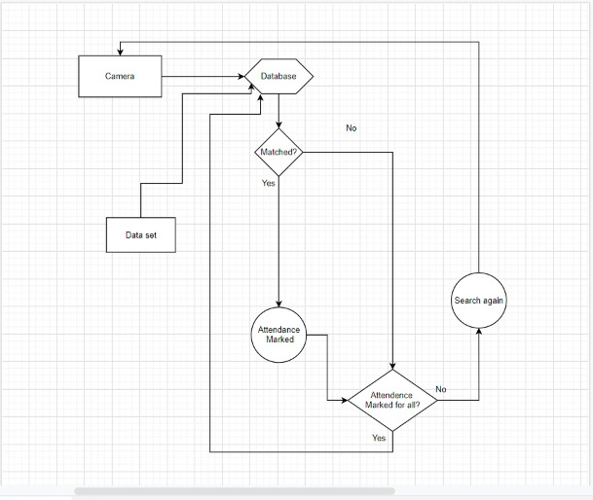

**Fig 1 :-Architecture Diagram**

Firstly we take images from camera as a input through face-recognition library which is based on dlib it firstly extract the face properties and try to detect face in camera ,after that it compare the camera image and database image through this it detect the person and according to the system time it will update automatically.

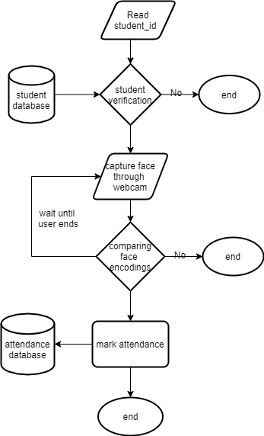

**Fig 2 :- Data Flow Diagram**

Firstly we will take the samples of each and every student in a particular class. Now the detection of a face is done where required regions of the face are being detected. Then the extraction process is done in order to obtain trained images After the creation of the database the extracted data and current data are matched. When the student enters the class a video clip is recorded and then divided into single frames. Each frame is converted to pixel values and

then performs matching with the trained features available in the database (Figure-2). If both features match with each other then the individual is given present else absent. Thus, we can develop an effective attendance marking system**.**

**Model Description**

* Face Detection:

Face detection is a process in which image is detected using some criteria .here , through the face-recognition library which is based on dlib and dlib builds ResNet model in a background. Every architecture uses more layers in a deep neural network to reduce the error rate. This works for less number of layers, but when we increase the number of layers, there is a common problem in deep learning associated with that called Vanishing/Exploding gradient. This causes the gradient to become 0 or too large. Thus when we increases number of layers, the training and test error rate also increases..To overcome this problem this architecture introduced the concept called Residual Network. In this network we use a technique called skip connections . The skip connection skips training from a few layers and connects directly to the output.

* Encoding face

This process of training a convolutional neural network to output face embeddings requires a lot of data and computer power. After the cnn is run our face images through their pre-trained network to get the 128 measurements for each face.

* Decoding Face

This last step is actually the easiest step in the whole process. All we have to do is find the person in our database of known people who has the closest measurements to our test image.

**Result and Description:**

In order to test the application, we run it and captured the video snapshot. Below are the screenshot of the application we developed.

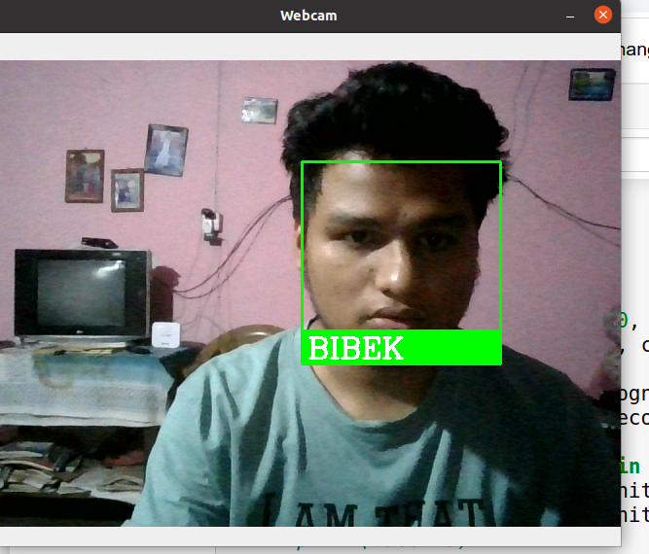

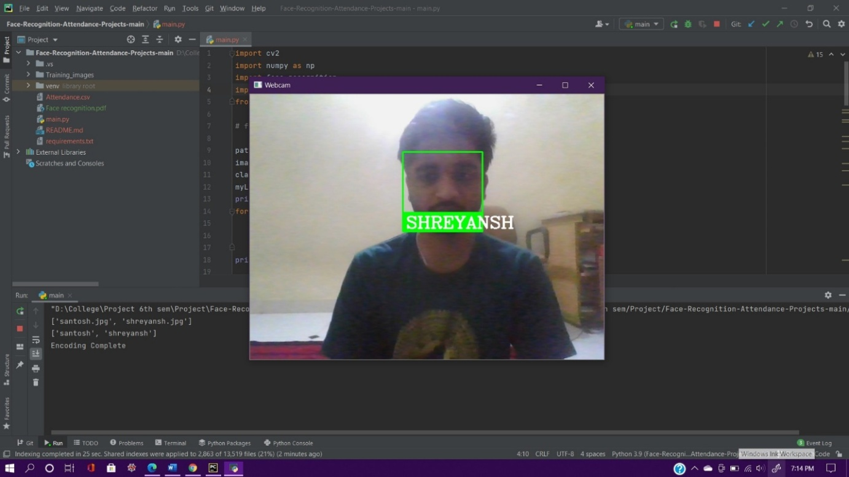

The design of Automatic Face Recognition and Detection for Security Lock Technology is based on the parameters like User friendly structure, varying surrounding light condition, facial expression and distance between person from camera. The distance is varied from 35 cm to 85cm. The results have been compared using the metric Recognition rate.

The equation of recognition rate is: Recognition Rate = (𝑁𝑢𝑚𝑏𝑒𝑟 𝑜𝑓 𝑐𝑜𝑟𝑟𝑒𝑐𝑡𝑙𝑦 𝑖𝑑𝑒𝑛𝑡𝑖𝑓𝑖𝑒𝑑 𝑖𝑚𝑎𝑔𝑒𝑠 / 𝑇𝑜𝑡𝑎𝑙 𝑛𝑢𝑚𝑏𝑒𝑟 𝑜𝑓 𝑚𝑎𝑔𝑒𝑠) × 100

**Conclusions:**

Face recognition systems are currently associated with many top technological companies and industries making the work of face recognition easier. The use of python programming and OpenCV makes it an easier and handy tool or system which can be made by anyone according to their requirement. The proposed system discussed in this project will be helpful for many as it is user friendly and cost_ efficient system. Hence by the use of python and OpenCV the face recognition system can be designed for various purposes. Research in face recognition is an exciting area for many years to come and will keep many scientists and engineers busy. In this paper we have given concepts of face recognition methods & its applications. The present paper can provide the readers a better understanding about face recognition methods & applications. In the future, 2D & 3D Face Recognition and large-scale applications such as e-commerce, student ID, digital driver licenses, or even national ID is the challenging task in face recognition & the topic is open to further research.

**Acknowledgement:**

We would like to sincerely thank our project mentor sir for guiding us throughout this project work also would like to thank our other faculty members from the computer engineering department at Chandigarh University for allowing us to perform our project work.

**Methodologies:**

The concept of OpenCV was put forth by Gary Bradski which had the ability to perform on multi-level framework. OpenCV has a number of significant abilities as well as utilities which appears from the outset. The OpenCV helps in recognizing the frontal face of the person and also creates XML documents for several areas such as the parts of the body. Deep learning evolved lately in the process of the recognition systems. Hence deep learning along with the face recognition together work as the deep metric learning systems. In short deep learning in face detection and recognition will broadly work on two areas the first one being accepting the solidary input image or any other relevant picture and the second being giving the best outputs or the results of the image of the picture. We would be using dlib facial recognition framework that would be the easy way to organize the face evaluation. The two main significant libraries used in the system are dlib and face_recognition. Python being a very powerful programming languages and one of the programming languages that are being used all over the world has proven to give best results in the face recognition and detection systems. Together face recognition and detection becomes very easy and fruitful with the help of the python programming language and OpenCV.

System design and assessment methodology for face recognition algorithms

Computing Methodologies

Aritificial Intelligence Machine Learning

Computer Vision Machine Learning Algorithm

Computer Vision Problem Feature Selection

Object Recognition

**References:**

1. R. Jafri and H. R. Arabnia, “A survey of face recognition techniques,” *Journal of Information Processing Systems*, 2009.View at: [Publisher Site](https://doi.org/10.3745/JIPS.2009.5.2.041) | [Google Scholar](https://scholar.google.com/scholar_lookup?title=A%20survey%20of%20face%20recognition%20techniques&author=R.%20Jafri%20&author=H.%20R.%20Arabnia&publication_year=2009)
2. X. Liu, T. Chen, and B. V. K. Vijaya Kumar, “Face authentication for multiple subjects using eigenflow,” *Pattern Recognition*, 2003.View at: [Publisher Site](https://doi.org/10.1016/S0031-3203(02)00033-X) | [Google Scholar](https://scholar.google.com/scholar_lookup?title=Face%20authentication%20for%20multiple%20subjects%20using%20eigenflow&author=X.%20Liu&author=T.%20Chen&author=&author=B.%20V.%20K.%20Vijaya%20Kumar&publication_year=2003)
3. D. Bryliuk and V. Starovoitov, “Access control by face recognition using neural networks and negative examples,” in *Proceedings of the 2nd International Conference on Artificial Intelligence*, September 2002.View at: [Google Scholar](https://scholar.google.com/scholar_lookup?title=Access%20control%20by%20face%20recognition%20using%20neural%20networks%20and%20negative%20examples&author=D.%20Bryliuk%20&author=V.%20Starovoitov)
4. W. Ping, “Research on the embedded system teaching,” in *Proceedings of the International Workshop on Education Technology and Training and the International Workshop on Geoscience and Remote Sensing*, December 2008.View at: [Publisher Site](https://doi.org/10.1109/ETTandGRS.2008.182) | [Google Scholar](https://scholar.google.com/scholar_lookup?title=Research%20on%20the%20embedded%20system%20teaching&author=W.%20Ping)
5. S. Nedevschi, I. R. Peter, and A. Mandrut, “PCA type algorithm applied in face recognition,” in *Proceedings of IEEE International Conference on Intelligent Computer Communication and Processing (ICCP '12)*, 2012.View at: [Google Scholar](https://scholar.google.com/scholar_lookup?title=PCA%20type%20algorithm%20applied%20in%20face%20recognition&author=S.%20Nedevschi&author=I.%20R.%20Peter&author=&author=A.%20Mandrut)
6. J. Javed, H. Yasin, and S. F. Ali, “Human movement recognition using euclidean distance: a tricky approach,” in *Proceedings of the 3rd International Congress on Image and Signal Processing (CISP '10),* 2010.View at: [Publisher Site](https://doi.org/10.1109/CISP.2010.5648214) | [Google Scholar](https://scholar.google.com/scholar_lookup?title=Human%20movement%20recognition%20using%20euclidean%20distance:%20a%20tricky%20approach&author=J.%20Javed&author=H.%20Yasin&author=&author=S.%20F.%20Ali)
7. P. Viola and M. Jones, “Rapid object detection using a boosted cascade of simple features,” in *Proceedings of IEEE Computer Society Conference on Computer Vision and Pattern Recognition*, December 2001.View at: [Google Scholar](https://scholar.google.com/scholar_lookup?title=Rapid%20object%20detection%20using%20a%20boosted%20cascade%20of%20simple%20features&author=P.%20Viola%20&author=M.%20Jones)
8. R. Lienhart and J. Maydt, “An extended set of Haar-like features for rapid object detection,” in *Proceedings of the International Conference on Image Processing (ICIP '02),* 2002.View at: [Google Scholar](https://scholar.google.com/scholar_lookup?title=An%20extended%20set%20of%20Haar-like%20features%20for%20rapid%20object%20detection&author=R.%20Lienhart%20&author=J.%20Maydt)
9. E. Gumus, N. Kilic, A. Sertbas et al., “Eigenfaces and support vector machine approaches for hybrid face recognition,” *The Online Journal on Electronics and Electrical Engineering*, 2010.View at: [Google Scholar](https://scholar.google.com/scholar_lookup?title=Eigenfaces%20and%20support%20vector%20machine%20approaches%20for%20hybrid%20face%20recognition&author=E.%20Gumus&author=N.%20Kilic&author=A.%20Sertbas%20et%20al.&publication_year=2010)
10. M. Effros, H. Feng, and K. Zeger, “Suboptimality of the Karhunen-Loève transform for transform coding,” *IEEE Transactions on Information Theory*, 2004.View at: [Publisher Site](https://doi.org/10.1109/TIT.2004.831787) | [Google Scholar](https://scholar.google.com/scholar_lookup?title=Suboptimality%20of%20the%20Karhunen-Lo%C3%A8ve%20transform%20for%20transform%20coding&author=M.%20Effros&author=H.%20Feng&author=&author=K.%20Zeger&publication_year=2004)
11. L. Yinli, Y. Hongli, and Z. Pengpeng, “The implementation of embedded image acquisition based on V4L2,” in *Proceedings of the International Conference on Electronics, Communications and Control (ICECC '1)*, September 2011.View at: [Publisher Site](https://doi.org/10.1109/ICECC.2011.6067740) | [Google Scholar](https://scholar.google.com/scholar_lookup?title=The%20implementation%20of%20embedded%20image%20acquisition%20based%20on%20V4L2&author=L.%20Yinli&author=Y.%20Hongli&author=&author=Z.%20Pengpeng)
12. Z. Hong, S. Chao, and C. Jie, “Integration schemes for IoT application systems with diverse domain,” *Journal of Beijing Institute of Technology”*, 2012.View at: [Google Scholar](https://scholar.google.com/scholar_lookup?title=Integration%20schemes%20for%20IoT%20application%20systems%20with%20diverse%20domain&author=Z.%20Hong&author=S.%20Chao&author=&author=C.%20Jie&publication_year=2012)