**C# switch**

The C# *switch statement* executes one statement from multiple conditions. It is like if-else-if ladder statement in C#.

**Syntax:**

1. switch(expression){
2. case value1:
3. //code to be executed;
4. break;
5. case value2:
6. //code to be executed;
7. break;
8. ......
10. default:
11. //code to be executed if all cases are not matched;
12. break;
13. }

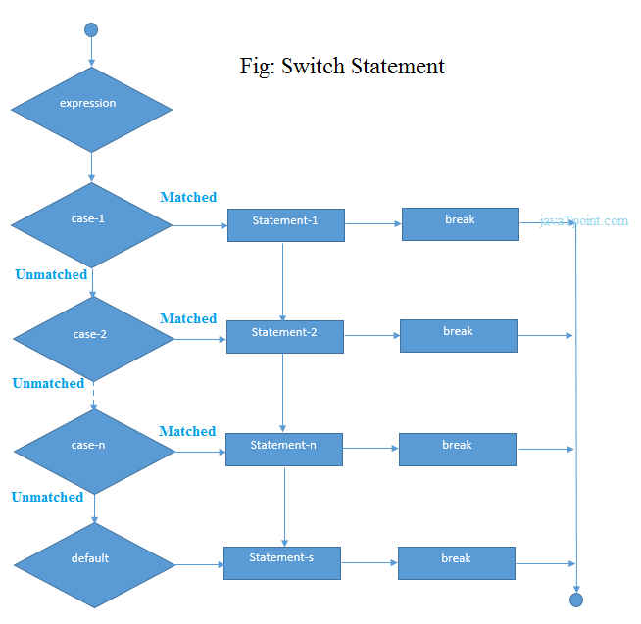

**C# Switch Example**

1. using System;
2. public class SwitchExample
3. {
4. public static void Main(string[] args)
5. {
6. Console.WriteLine("Enter a number:");
7. int num = Convert.ToInt32(Console.ReadLine());
9. switch (num)
10. {
11. case 10: Console.WriteLine("It is 10"); break;
12. case 20: Console.WriteLine("It is 20"); break;
13. case 30: Console.WriteLine("It is 30"); break;
14. default: Console.WriteLine("Not 10, 20 or 30"); break;
15. }
16. }
17. }

Output:

Enter a number:

10

It is 10

Output:

Enter a number:

55

Not 10, 20 or 30