**# Data Types**

A data type specifies the type of data that a variable can store such as integer, floating, character etc.

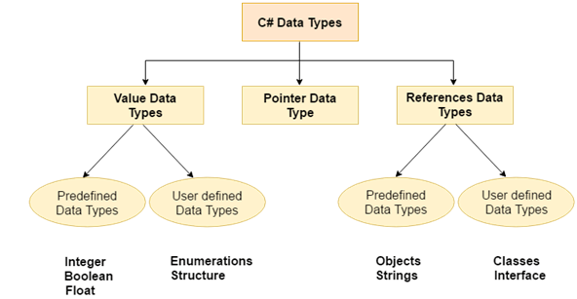

There are 3 types of data types in C# language.

|  |  |
| --- | --- |
| **Types** | **Data Types** |
| Value Data Type | short, int, char, float, double etc |
| Reference Data Type | String, Class, Object and Interface |
| Pointer Data Type | Pointers |

**Value Data Type**

The value data types are integer-based and floating-point based. C# language supports both signed and unsigned literals.

There are 2 types of value data type in C# language.

**1) Predefined Data Types** - such as Integer, Boolean, Float, etc.

**2) User defined Data Types** - such as Structure, Enumerations, etc.

The memory size of data types may change according to 32 or 64 bit operating system.

Let's see the value data types. It size is given according to 32 bit OS.

|  |  |  |
| --- | --- | --- |
| **Data Types** | **Memory Size** | **Range** |
| char | 1 byte | -128 to 127 |
| signed char | 1 byte | -128 to 127 |
| unsigned char | 1 byte | 0 to 127 |
| short | 2 byte | -32,768 to 32,767 |
| signed short | 2 byte | -32,768 to 32,767 |
| unsigned short | 2 byte | 0 to 65,535 |
| int | 4 byte | -2,147,483,648 to -2,147,483,647 |
| signed int | 4 byte | -2,147,483,648 to -2,147,483,647 |
| unsigned int | 4 byte | 0 to 4,294,967,295 |
| long | 8 byte | ?9,223,372,036,854,775,808 to 9,223,372,036,854,775,807 |
| signed long | 8 byte | ?9,223,372,036,854,775,808 to 9,223,372,036,854,775,807 |
| unsigned long | 8 byte | 0 - 18,446,744,073,709,551,615 |
| float | 4 byte | 1.5 * 10-45 - 3.4 * 1038, 7-digit precision |
| double | 8 byte | 5.0 * 10-324 - 1.7 * 10308, 15-digit precision |
| decimal | 16 byte | at least -7.9 * 10?28 - 7.9 * 1028, with at least 28-digit precision |

**Reference Data Type**

The reference data types do not contain the actual data stored in a variable, but they contain a reference to the variables.

If the data is changed by one of the variables, the other variable automatically reflects this change in value.

There are 2 types of reference data type in C# language.

**1) Predefined Types** - such as Objects, String.

**2) User defined Types** - such as Classes, Interface.

**Pointer Data Type**

The pointer in C# language is a variable, it is also known as locator or indicator that points to an address of a value.

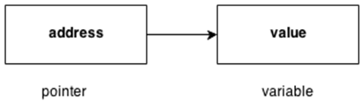

**Symbols used in pointer**

|  |  |  |
| --- | --- | --- |
| **Symbol** | **Name** | **Description** |
| & (ampersand sign) | Address operator | Determine the address of a variable. |
| * (asterisk sign) | Indirection operator | Access the value of an address. |