# C# if-else

In C# programming, the if statement is used to test the condition. There are various types of if statements in C#.

* if statement
* if-else statement
* nested if statement
* if-else-if ladder

## C# IF Statement

The C# if statement tests the condition. It is executed if condition is true.

**Syntax:**

1. if(condition){
2. //code to be executed
3. }

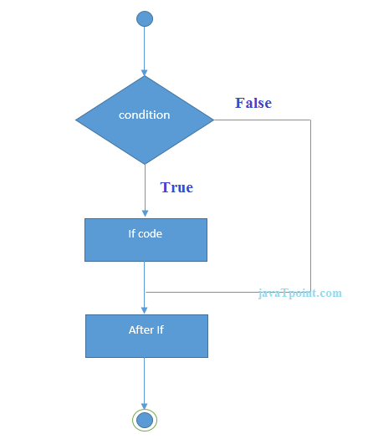

### C# If Example

1. using System;
2. public class IfExample
3. {
4. public static void Main(string[] args)
5. {
6. int num = 10;
7. if (num % 2 == 0)
8. {
9. Console.WriteLine("It is even number");
10. }
12. }
13. }

Output:

It is even number

## C# IF-else Statement

The C# if-else statement also tests the condition. It executes the if block if condition is true otherwise else block is executed.

**Syntax:**

1. if(condition){
2. //code if condition is true
3. }else{
4. //code if condition is false
5. }

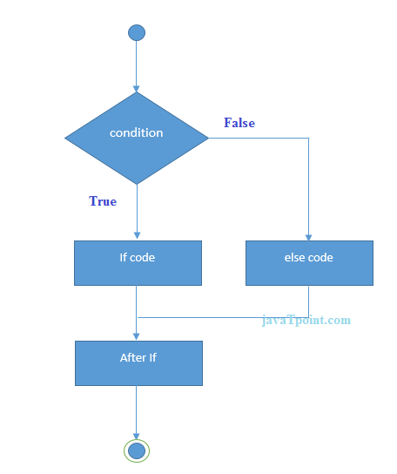

### C# If-else Example

1. using System;
2. public class IfExample
3. {
4. public static void Main(string[] args)
5. {
6. int num = 11;
7. if (num % 2 == 0)
8. {
9. Console.WriteLine("It is even number");
10. }
11. else
12. {
13. Console.WriteLine("It is odd number");
14. }
16. }
17. }

Output:

It is odd number

## C# If-else Example: with input from user

In this example, we are getting input from the user using **Console.ReadLine()** method. It returns string. For numeric value, you need to convert it into int using **Convert.ToInt32()** method.

1. using System;
2. public class IfExample
3. {
4. public static void Main(string[] args)
5. {
6. Console.WriteLine("Enter a number:");
7. int num = Convert.ToInt32(Console.ReadLine());
9. if (num % 2 == 0)
10. {
11. Console.WriteLine("It is even number");
12. }
13. else
14. {
15. Console.WriteLine("It is odd number");
16. }
18. }
19. }

Output:

Enter a number:11

It is odd number

Output:

Enter a number:12

It is even number

## C# IF-else-if ladder Statement

The C# if-else-if ladder statement executes one condition from multiple statements.

**Syntax:**

1. if(condition1){
2. //code to be executed if condition1 is true
3. }else if(condition2){
4. //code to be executed if condition2 is true
5. }
6. else if(condition3){
7. //code to be executed if condition3 is true
8. }
9. ...
10. else{
11. //code to be executed if all the conditions are false
12. }

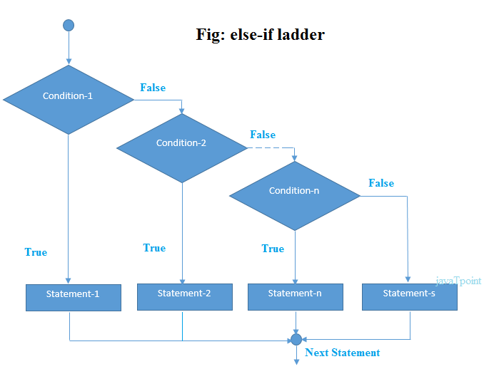

### C# If else-if Example

1. using System;
2. public class IfExample
3. {
4. public static void Main(string[] args)
5. {
6. Console.WriteLine("Enter a number to check grade:");
7. int num = Convert.ToInt32(Console.ReadLine());
9. if (num <0 || num >100)
10. {
11. Console.WriteLine("wrong number");
12. }
13. else if(num >= 0 && num < 50){
14. Console.WriteLine("Fail");
15. }
16. else if (num >= 50 && num < 60)
17. {
18. Console.WriteLine("D Grade");
19. }
20. else if (num >= 60 && num < 70)
21. {
22. Console.WriteLine("C Grade");
23. }
24. else if (num >= 70 && num < 80)
25. {
26. Console.WriteLine("B Grade");
27. }
28. else if (num >= 80 && num < 90)
29. {
30. Console.WriteLine("A Grade");
31. }
32. else if (num >= 90 && num <= 100)
33. {
34. Console.WriteLine("A+ Grade");
35. }
36. }
37. }

Output:

Enter a number to check grade:66

C Grade

Output:

Enter a number to check grade:-2

wrong number