**C# Break Statement**

The C# *break* is used to break loop or switch statement. It breaks the current flow of the program at the given condition. In case of inner loop, it breaks only inner loop.

**Syntax:**

1. jump-statement;
2. break;

**Flowchart:**

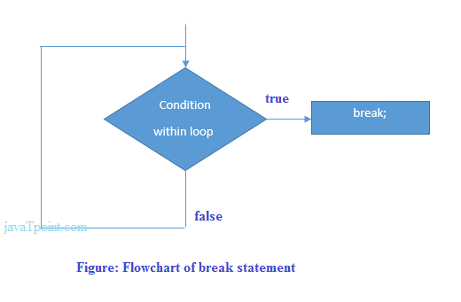

**C# Break Statement Example**

Let's see a simple example of C# break statement which is used inside the loop.

1. using System;
2. public class BreakExample
3. {
4. public static void Main(string[] args)
5. {
6. for (int i = 1; i <= 10; i++)
7. {
8. if (i == 5)
9. {
10. break;
11. }
12. Console.WriteLine(i);
13. }
14. }
15. }

Output:

1

2

3

4

**C# Break Statement with Inner Loop**

The C# break statement breaks inner loop only if you use break statement inside the inner loop. Let's see the example code:

1. using System;
2. public class BreakExample
3. {
4. public static void Main(string[] args)
5. {
6. for(int i=1;i<=3;i++){
7. for(int j=1;j<=3;j++){
8. if(i==2&&j==2){
9. break;
10. }
11. Console.WriteLine(i+" "+j);
12. }
13. }
14. }
15. }

Output:

1 1

1 2

1 3

2 1

3 1

3 2

3 3