NOTES

REMAINDER

Sort by Most Recent

New To-Do Item

Search To-Do Items

Dd mm yyyy

Add To-Do

Add To-Do

Dd mm yyyy

New Priority Item

Search Priority Items

To-do task

Priorities

iorities

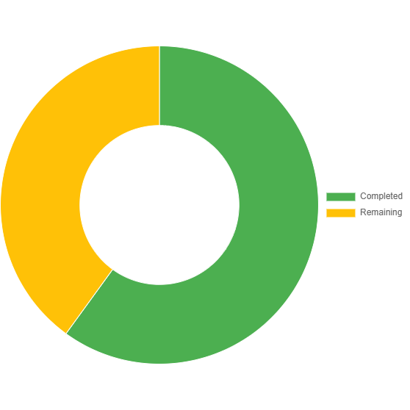

Progress Tracker

Task Tracker

To-do list

Import

Export

To-Do

Priority

Notes

Remainder

BackToTop